PHONEPE
Payments Growth OS
From UPI Leadership to Active, Habitual & Monetizable Payment Relationships
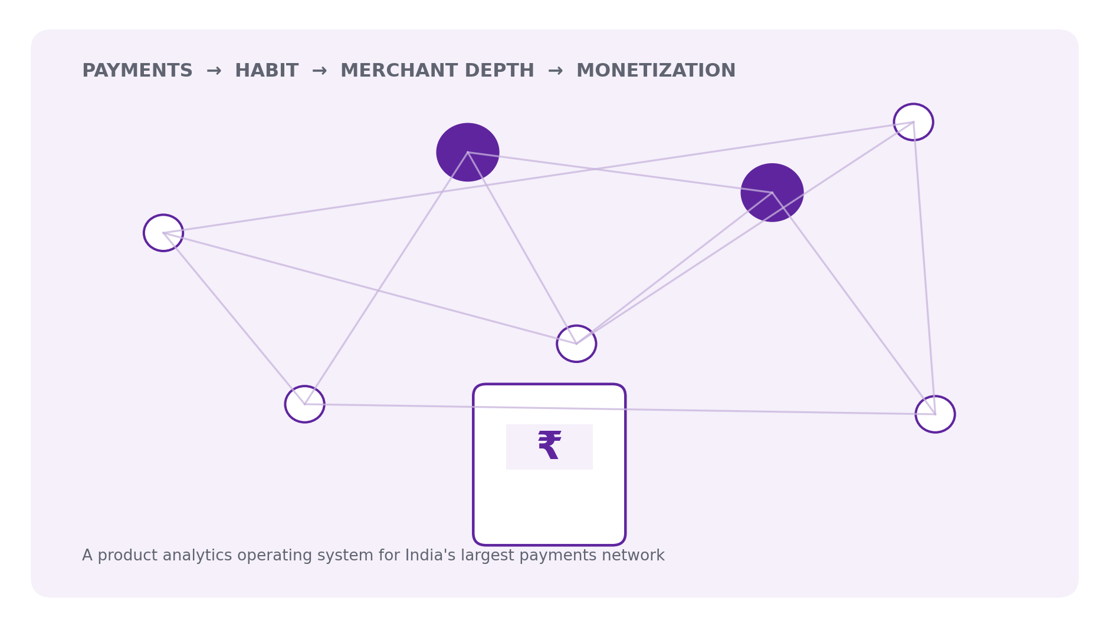
711.7M  Q2 2026 registered users | 50.7M  Q2 2026 registered merchants | 11B  Jul-2026 customer transactions | 24.51B  India UPI txns, Aug-2026

Product Analytics | Merchant Growth | Experimentation | Geographic Strategy | SQL
Research cut-off: 8 September 2026 • Public data + clearly labeled modeled analytics layer

01 Executive Summary
The strategic problem is activation quality, not registration scale.
CORE QUESTION Where should PhonePe invest next to maximize durable payments growth: registrations, activation, habit, merchant depth, monetization, or new access channels?

618.4M  Registered users, Mar-25 | 230.08M  MAC, Mar-25 | 44.87M  Registered merchants, Mar-25 | 11.31M  MAM, Mar-25

PhonePe already operates at population scale. Yet its filing separates lifetime registered populations from monthly active relationships. This creates a large activation-depth question - while the users and merchants who are active are simultaneously becoming more habitual.
- Consumer TPC increased from 25.50/month in Mar-2023 to 38.10 in Mar-2025; habitual users (>30 TPC) rose from 28.41% to 41.43% of MAC.
- Merchant TPAM increased from 147.87 to 379.16 between Mar-2023 and Sep-2025; DAM/MAM rose from 44.18% to 60.77%.
- Q2 2026 PhonePe Pulse shows Business payments at ~64% of transaction count but only ~23% of value - merchant payments are a high-frequency engine.
- FY25 revenue was ₹7,114.9 Cr; FY26 revenue increased to ₹7,920.5 Cr while reported net loss widened to ₹2,791.6 Cr, raising the importance of durable monetization.

Recommendation
- P0 - Merchant Launchpad: first transaction → 30-day retained merchant.
- P0 - Geographic activation: target large, already-distributed but lower-intensity states.
- P1 - Consumer Habit Ladder: migrate developing users into recurring multi-use-case behavior.
- P1 - Merchant depth: devices/business tools/financial services after usage fit.
- Strategic - UPI 123Pay: optimize feature-phone activation and retention, not pre-installs.
Source basis: PhonePe UDRHP-I, PhonePe Pulse Q2 2026, PhonePe current releases, NPCI and current regulatory-filing coverage. Reported, derived and modeled numbers are explicitly separated.

02 Market & Current Scale
UPI is already national infrastructure; PhonePe is optimizing within a mature, enormous rail.
22.35B  UPI txns Apr-26 | 23.20B  UPI txns May-26 | 22.72B  UPI txns Jun-26 | 24.51B  UPI txns Aug-26

NPCI monthly statistics show UPI processing more than 22B transactions per month through Q1 FY27, and Reuters reported a new record of 24.51B transactions worth ₹29.82T in Aug-2026.
718M  LTD users, Jul-26 | 50M+  LTD merchants, Jul-26 | 11B  PhonePe customer txns, Jul-26 | 98%+  postal-code merchant reach

DATA DISCIPLINE PhonePe Pulse Total Transactions is not the same metric as NPCI payer-app volume. Pulse includes transactions initiated by PhonePe customers OR received by registered PhonePe merchants; market-share analysis must use NPCI/TPAP definitions separately.

Why this matters for the case
At this scale, acquisition remains useful at the margin but is no longer a sufficient growth strategy. The product system must distinguish reach, activation, retention, transaction depth, trust and revenue quality.

03 Business Model & Monetization
Payments create distribution; monetization increasingly sits on merchant and financial-service layers.
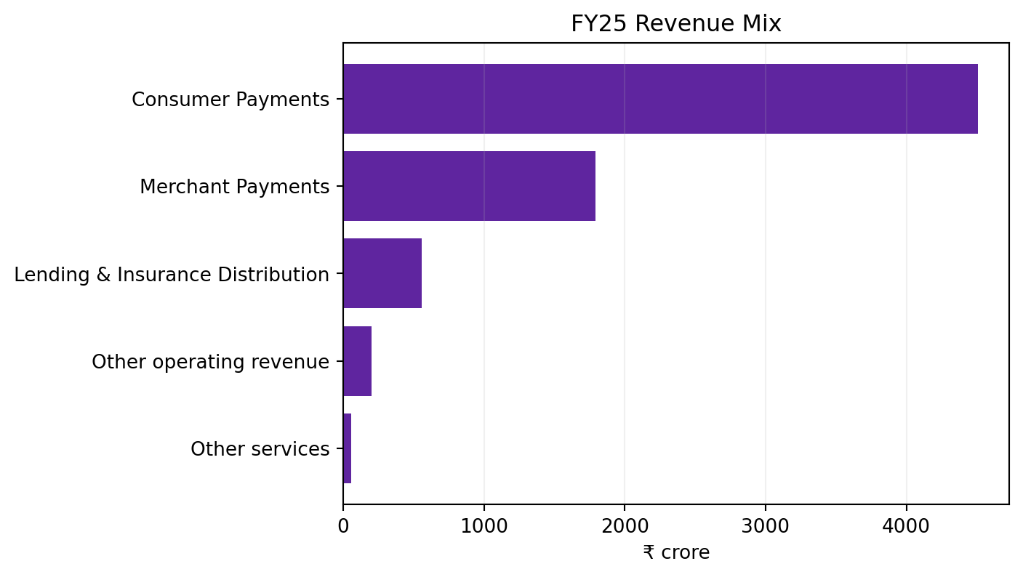
REPORTED: PhonePe UDRHP FY25 revenue streams. ₹ crore.
Stream | FY25 ₹ Cr | Share %
Consumer Payments | 4,506.9 | 63.3%
Merchant Payments | 1,792.8 | 25.2%
Lending & Insurance Distribution | 557.6 | 7.8%
Other services | 57.2 | 0.8%
Other operating revenue | 200.2 | 2.8%

MONETIZATION SIGNAL Lending & Insurance Distribution revenue grew from ₹28.1 Cr in FY23 to ₹557.6 Cr in FY25; H1FY26 alone reached ₹452.6 Cr. Payment scale is increasingly a distribution surface for higher-monetization services.

FY26 current filing context: revenue from operations ₹7,920.5 Cr (+11.5% YoY); reported net loss ₹2,791.6 Cr. Detailed stream analysis above uses UDRHP FY25 because it provides the cleanest public breakdown.

04 KPI Architecture
Do not optimize “users” or “transactions” as isolated vanity metrics.
CONSUMER NORTH STAR Habitual Monthly Active Customers: MAC crossing the >30 transactions/month threshold used in PhonePe's filing.

MERCHANT NORTH STAR Retained Monthly Active Merchants: transacting merchants retained across a defined cohort window, paired with TPAM to capture depth.

Layer | Metrics | Decision question
Acquisition | LTD registrations, new merchant onboardings | Reach, not quality
Activation | first successful payment, D7 active | Does the relationship become real?
Retention | M1/M3/M6 active cohort | Does usage persist?
Depth | TPC, TPAM, DAM/MAM, use-case breadth | How habitual is the relationship?
Monetization | revenue/active relationship, devices, financial services | Does activity create durable economics?
Trust | success rate, fraud, disputes, support | Can growth scale safely?

Interview principle: if a feature raises transaction count but worsens success rate, fraud, support cost or retention, it is not automatically a product win.

05 Consumer Habit Diagnosis
Active customers are transacting more frequently over time.
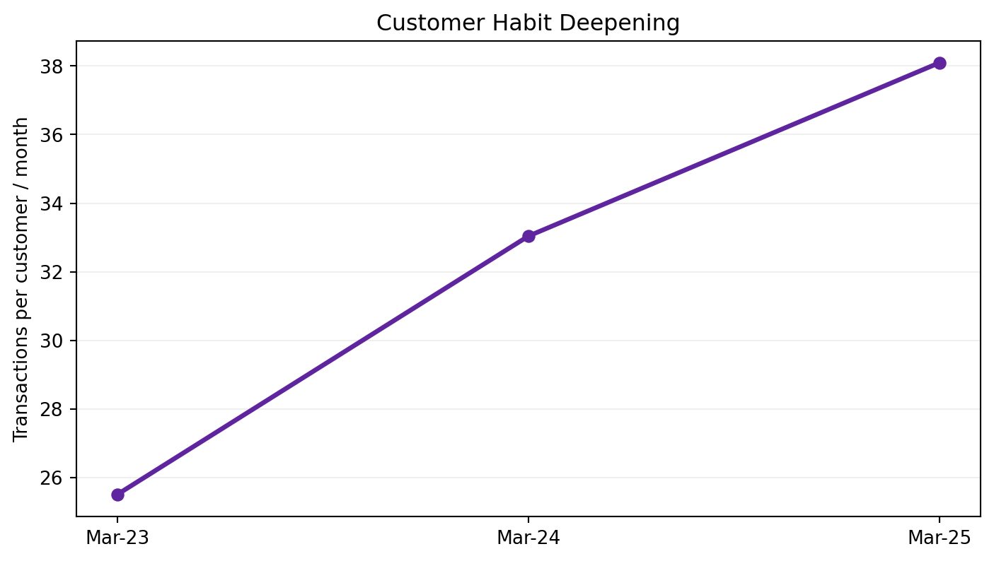
REPORTED: PhonePe UDRHP. TPC = monthly transactions / monthly active customer.
25.50  TPC Mar-23 | 38.10  TPC Mar-25 | 28.41%  Habitual / MAC Mar-23 | 41.43%  Habitual / MAC Mar-25

The filing states that transaction frequency increases as customer cohorts age and newer cohorts ramp faster in their first 12 months. This suggests product breadth and familiarity create habit, not merely acquisition volume.

Product implication
- Segment by current monthly frequency and dominant use case.
- For developing users, recommend one next recurring payment habit rather than the entire PhonePe surface.
- For habitual users, prioritize reliability, security and relevant financial-service discovery over generic payment nudges.

06 Merchant Engagement Diagnosis
The merchant network is becoming more daily and more transaction-dense.
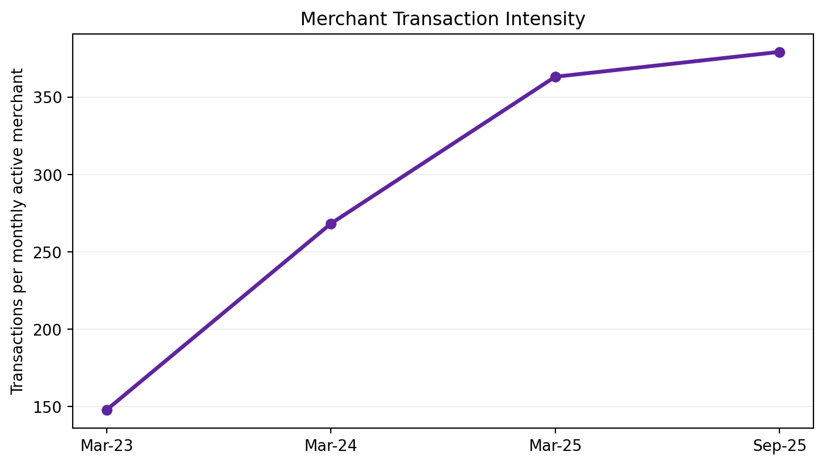
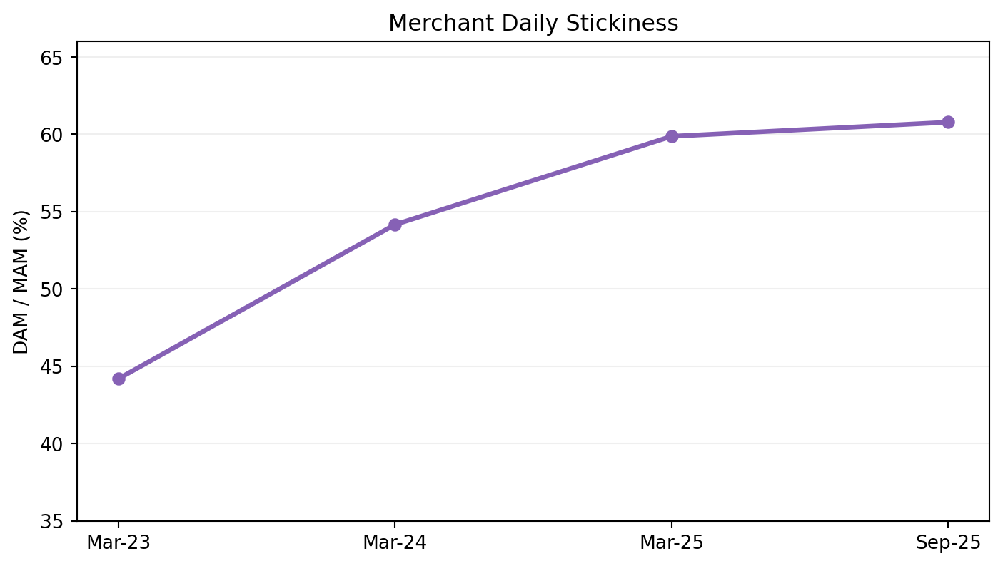
REPORTED: PhonePe UDRHP. DAM/MAM captures daily merchant stickiness; TPAM captures monthly transaction intensity.
147.87  TPAM Mar-23 | 379.16  TPAM Sep-25 | 44.18%  DAM/MAM Mar-23 | 60.77%  DAM/MAM Sep-25

07 Merchant Infrastructure
Physical payment devices deepen engagement and create a recurring monetization surface.
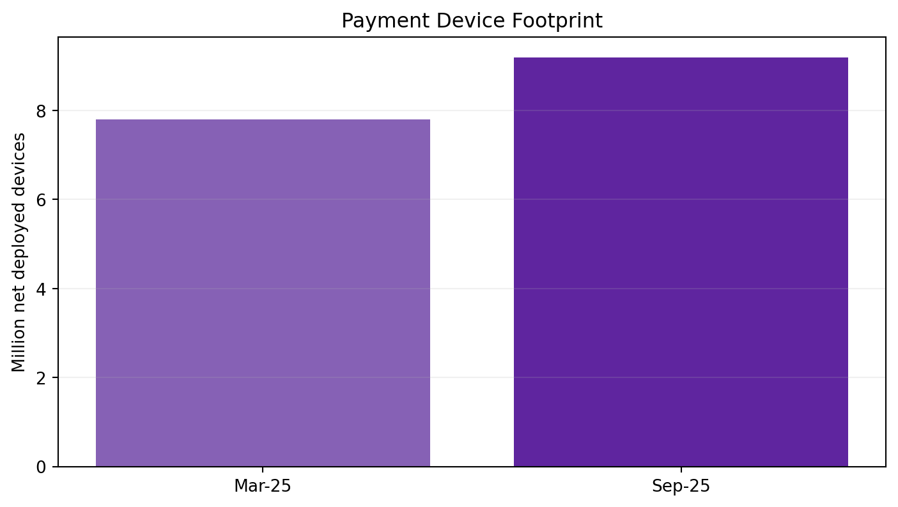
REPORTED: 9.19M net deployed payment devices as of Sep-2025.
PhonePe identifies Smartspeakers and EDC machines as a merchant-engagement strategy and a recurring-revenue source. Device deployment, however, should be treated as an eligibility decision: hardware cost is better deployed where transaction density and retention justify it.
CAUSALITY WARNING If device merchants retain better, that does not prove the device caused retention. High-quality merchants may be more likely to receive a device. Use randomized eligibility, propensity matching or difference-in-differences where practical.

Eligibility signals
- TPAM and active days
- transaction stability / TPV trend
- merchant category and payment mix
- refund/dispute rate
- existing QR usage
- expected subscription/device lifetime

08 Q2 2026 Transaction Mix
Merchant/business payments dominate count; P2P dominates value.
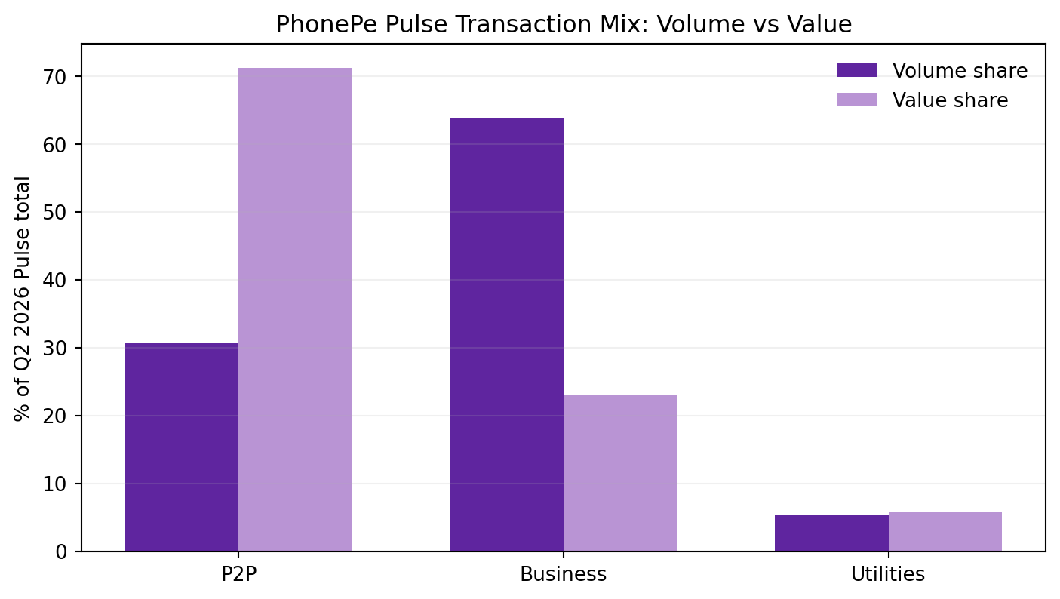
REPORTED + DERIVED from Q2 2026 PhonePe Pulse. Business/P2P/Utilities are mutually exclusive in the refreshed dataset.
Category | Tx Bn | Vol % | TPV ₹T | Value % | ATV ₹
P2P | 11.89 | 30.8% | 32.39 | 71.2% | 2,724
Business | 24.69 | 63.9% | 10.48 | 23.0% | 425
Utilities | 2.08 | 5.4% | 2.62 | 5.8% | 1,259

INSIGHT Business transactions represent ~63.9% of Pulse count but ~23.0% of value, with derived ATV ~₹425. That makes merchant payments a frequency engine and a strong surface for habit, devices and merchant services.

09 Geographic Growth Lens
Distribution and engagement are not equally deep across large states.
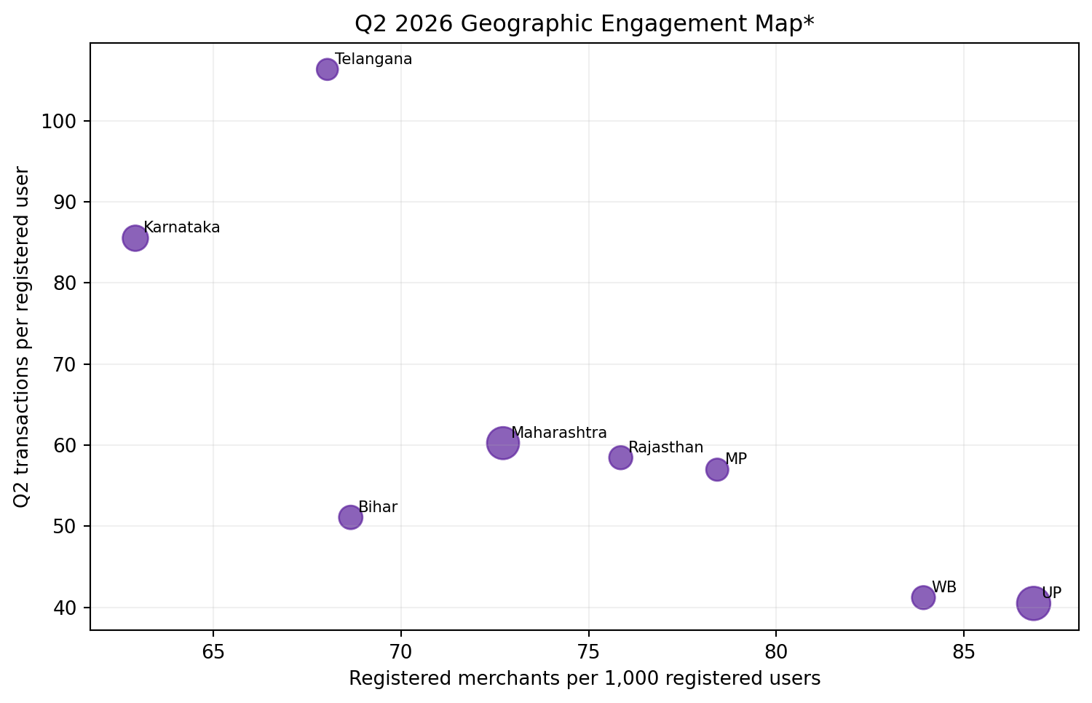
*DERIVED from Q2 2026 Pulse top-state aggregates. Ratios use LTD registered bases, not active-period denominators.
State | Tx/User Q2 | Merchants/1k users | Modeled score | Read
Uttar Pradesh | 40.5 | 86.9 | 100.0 | Activate at Scale
Maharashtra | 60.2 | 72.7 | 69.9 | Grow & Deepen
West Bengal | 41.2 | 83.9 | 61.6 | Merchant Engagement
Madhya Pradesh | 57.0 | 78.4 | 45.1 | Grow & Deepen
Rajasthan | 58.4 | 75.9 | 44.3 | Grow & Deepen
Bihar | 51.1 | 68.7 | 41.5 | Grow & Deepen
Karnataka | 85.5 | 62.9 | 22.9 | Defend & Monetize
Telangana | 106.3 | 68.0 | 5.3 | Defend & Monetize

10 Activation Opportunity Index
A decision framework, not a company metric.
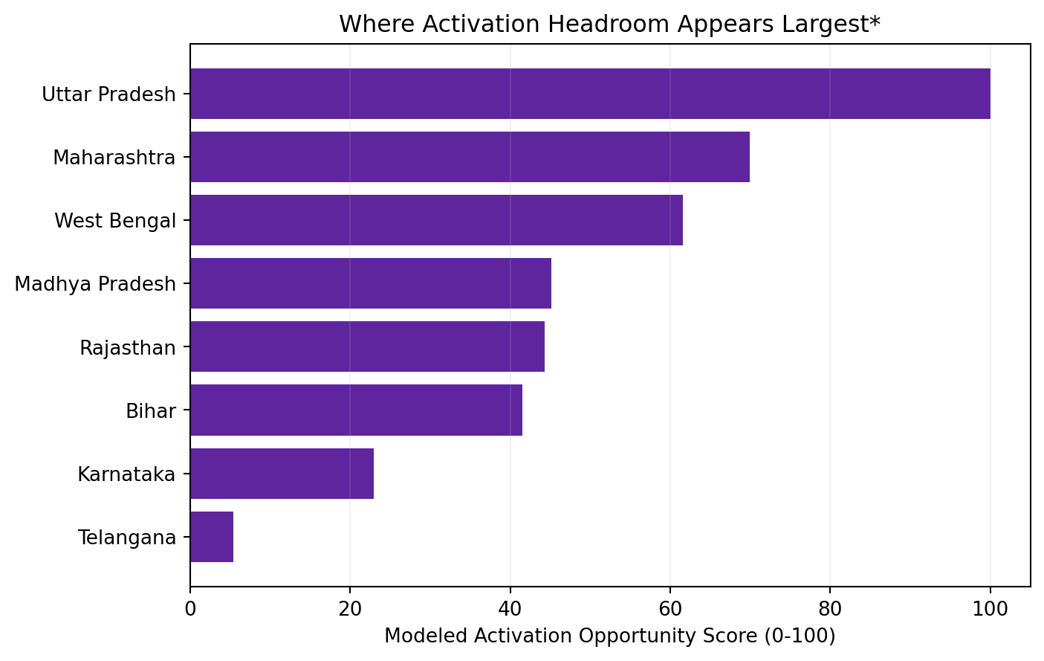
MODELED score = 40% user scale + 35% inverse transaction intensity + 25% merchant density, normalized within the displayed top-state sample.
- Uttar Pradesh: very large registered user and merchant base with comparatively low Q2 transaction intensity → activation-at-scale.
- West Bengal: high registered merchant density but lower activity intensity → merchant engagement focus.
- Telangana and Karnataka: very high observed transaction intensity → defend, deepen and monetize.
- Maharashtra: scale + meaningful intensity → defend network, selectively deepen monetization.
WHAT INTERNAL DATA WOULD IMPROVE THIS Replace LTD-base ratios with MAC/MAM, cohort retention, contribution/revenue per active relationship, acquisition cost, merchant category, success rate and district-level competitive density.

11 Merchant Activation Funnel
Public aggregate data cannot answer funnel questions, so the project includes a synthetic analytics layer.
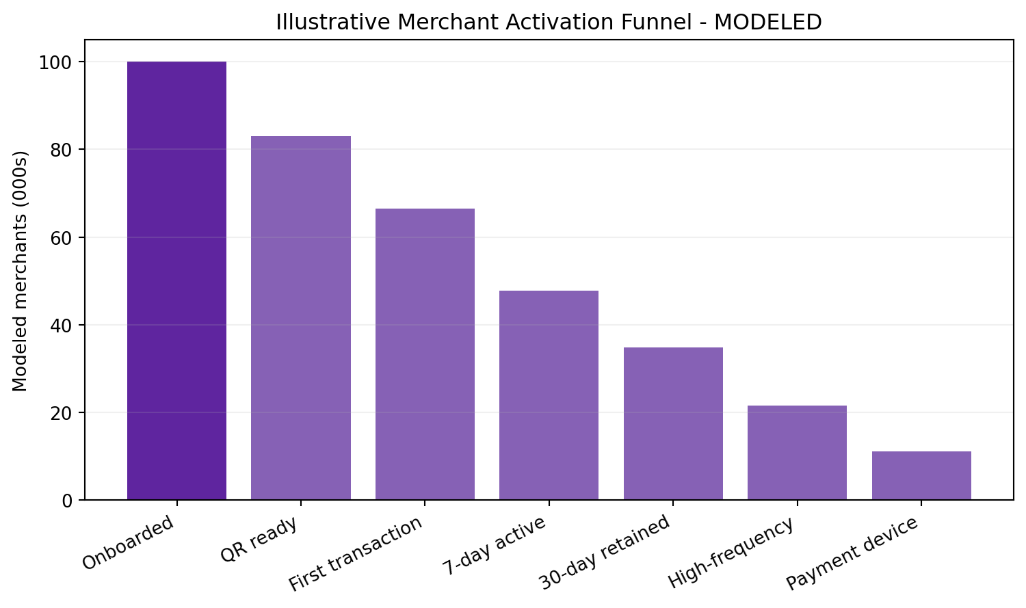
MODELED: illustrative funnel only. No PhonePe internal conversion rates are claimed.
The analytical objective is to locate the first stage where meaningful network value fails to materialize. A merchant QR on a wall is not equivalent to an active merchant; a first transaction is not equivalent to retention.

Diagnostic cuts
- acquisition channel × business category
- state × city tier
- time-to-first-transaction
- first-7-day transaction count
- D30/D90 retention
- device deployment × matched merchant quality
- support/fraud events around activation

12 Cohort Retention
Aggregate MAM can grow while newer cohorts quietly weaken.
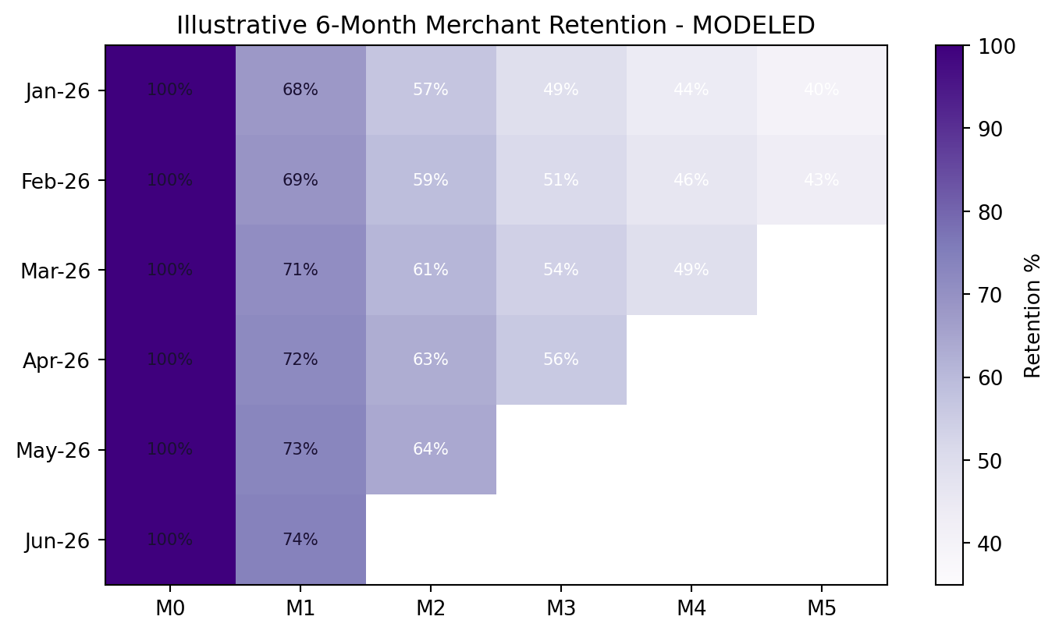
MODELED: synthetic cohort matrix for demonstrating SQL and retention analysis.
The repository includes SQL that assigns merchants to onboarding cohorts and calculates M0-M5 retained transacting merchants. In a real PhonePe environment, this should be extended to M12, TPAM retention, TPV retention and revenue retention.
INTERVIEW POINT Cohort analysis controls for calendar-time mix better than a single aggregate retention number. If April acquisition doubled, MAM may rise even while the retention quality of April merchants is poor.

13 Workstream A - Merchant Launchpad
Optimize for retained transacting merchants, not distributed QR codes.
HYPOTHESIS Structured first-30-day onboarding can reduce the QR→first-payment and early-retention drop without relying on blanket transaction subsidies.

Stage | Intervention | Metric
Day 0-1 | QR readiness + first-payment test | First successful payment
Day 2-7 | Settlement/reconciliation + local-language guidance | 7D active rate
Day 8-30 | Business insights + reliability nudges | 30D retained rate
Post-fit | Device / Udyam / lending or other service eligibility | Retained TPAM + monetization

Experiment
- Control: existing onboarding.
- Treatment: Launchpad sequence with personalized activation tasks.
- Primary: 30-day Retained Merchant Rate.
- Secondary: first payment in 72h, D30 TPAM, active days, support contacts.
- Kill criteria: fraud increase, cost/retained merchant above hurdle, or support burden materially worsens.

14 Workstream B - Consumer Habit Ladder
Move from “more notifications” to next-best-use-case sequencing.
Segment | Illustrative frequency | Product job
Occasional | <10 tx/month | Find one recurring high-fit use case
Developing | 10-29 tx/month | Build repeat weekly/monthly loop
Habitual | 30+ tx/month | Protect reliability + relevant monetization

The >30 transaction threshold is aligned to PhonePe's disclosed definition of habitual users; <10 and 10-29 are analytical segments introduced for this case.

Example next-use-case logic
- P2P-heavy → merchant scan/pay or recurring utility
- utility-heavy → AutoPay / recurring bill reliability
- merchant-pay-heavy → transit / recurring merchants / credit-on-UPI where eligible
- habitual multi-use-case → security, reliability and relevant financial-service discovery
PRIMARY METRIC Incremental share of MAC crossing the habitual threshold, with transaction success, fraud/disputes, notification opt-out and 60/90-day persistence as guardrails.

15 Workstream C - Merchant Depth & Monetization
Monetize after usage fit, not by indiscriminate cross-sell.
9.19M  payment devices Sep-25 | ₹1,792.8 Cr  FY25 merchant-payments revenue | ₹557.6 Cr  FY25 lending & insurance revenue | ₹452.6 Cr  H1FY26 lending & insurance revenue

The merchant relationship can become a distribution platform for devices, payment gateway, business tools, formalization support and partner-led lending/insurance. Eligibility should depend on transaction behavior, not just merchant registration.
Level | Merchant state | Potential next layer
1 | QR active | First transactions + reliability
2 | Retained merchant | Stable TPAM / active days
3 | High-frequency | Device / reconciliation tools
4 | Business depth | Udyam / payment gateway / settlement services
5 | Financial eligibility | Partner lending / insurance where suitable

16 Workstream D - Bharat Access / UPI 123Pay
The next growth frontier should be measured as active digital inclusion.
200M+  feature-phone users cited by PhonePe | No internet  SMS-based UPI architecture | 12  Indian-language voice support + English | 31 Aug 2026  launch date

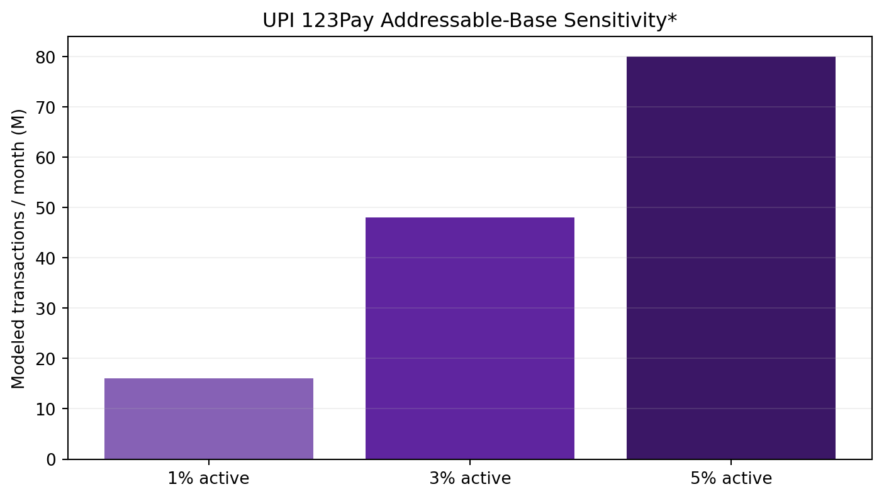
MODELED: assumes 8 transactions/month per activated user. Addressable base is a reported PhonePe figure; adoption and usage assumptions are scenarios.
The correct funnel is OEM/pre-bundle → registration → bank linking/PIN setup → first successful payment → D30 retained payer → recurring merchant/P2P use. A pre-installed app without activation is not payments growth.

17 Experimentation Operating System
Each growth idea needs an explicit causal test, guardrails and kill rule.
Test | Population | Primary | Guardrails
Merchant Launchpad | New merchants | 30D retained merchant | fraud; cost/retained; support
First-payment nudge | QR ready / zero transaction | 7D first payment | opt-out; support
Device eligibility | High-TPAM non-device | incremental TPAM + revenue | device inactivity; churn
Habit Ladder | Developing customers | habitual conversion | success; spam; disputes
123Pay onboarding | Feature-phone users | 30D active payer | setup failure; support

STATISTICAL DISCIPLINE Pre-register the primary metric and minimum detectable effect, randomize at the correct unit, calculate confidence intervals, check sample-ratio mismatch, run long enough to capture weekly/monthly behavior, and evaluate heterogeneous effects before rollout.

Modeled A/B demonstration
The included SQLite dataset contains a synthetic Launchpad experiment with Control vs Treatment outcomes. SQL 06_experiment_readout.sql calculates D30 retention, support-contact and fraud rates. The result is demonstrative, not a PhonePe result.

18 Quantified Opportunity Envelope
Public baselines + explicit scenario assumptions.
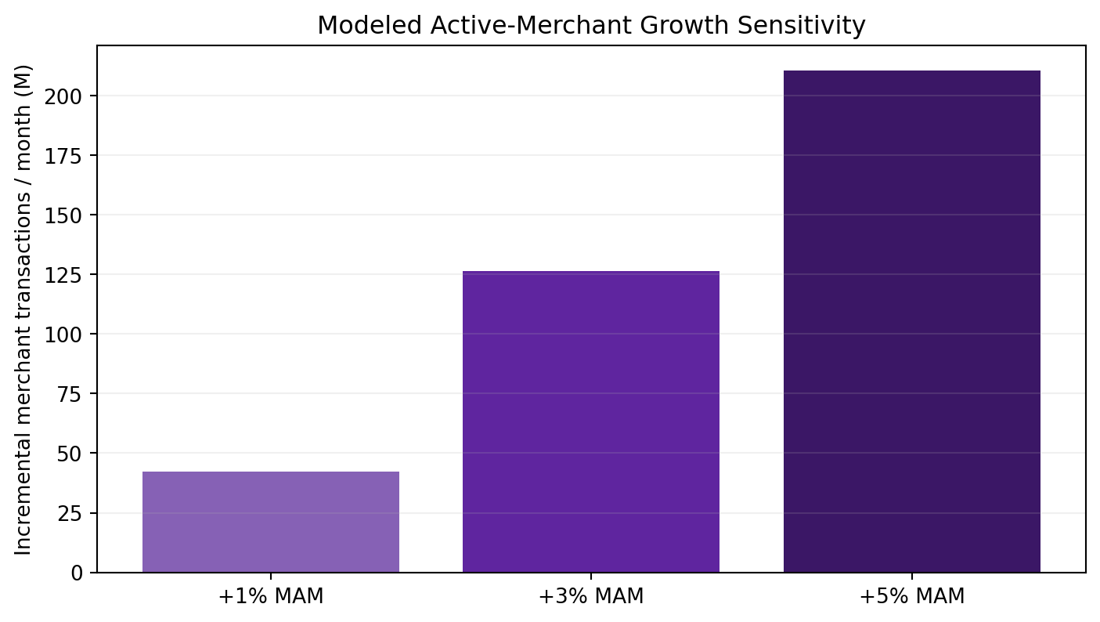
MODELED using Sep-2025 MAM = 11.11M and TPAM = 379.16.
Scenario | Incremental MAM | Txn/month | Annualized txn
+1% MAM | 0.111M | 42.1M | 0.51B
+3% MAM | 0.333M | 126.4M | 1.52B
+5% MAM | 0.556M | 210.6M | 2.53B

INTERPRETATION A 3% increase in active merchants at mature-base TPAM corresponds to ~126M additional merchant transactions/month. New merchants will typically ramp below mature TPAM, so this is an opportunity-envelope sensitivity, not a forecast.

Financial-services sensitivity: annualizing H1FY26 Lending & Insurance Distribution revenue gives ~₹905 Cr. A 5% / 10% / 15% uplift on that run rate equals ~₹45 Cr / ₹91 Cr / ₹136 Cr. This is not profit and not company guidance.

19 SQL & Analytics Architecture
The project demonstrates how the strategic thesis becomes an analytical workflow.
REAL PUBLIC LAYER PhonePe Pulse Q2 2026 state aggregates, category mix, company engagement/revenue disclosures.

SYNTHETIC ANALYTICS LAYER 20,000 merchants + monthly activity + modeled experiment outcomes generated only for funnel/cohort/SQL demonstration. Every relevant file is labeled synthetic.

Repository SQL
- 01_state_opportunity.sql - rank geographies using public aggregates
- 02_merchant_activation_funnel.sql - stage conversion by channel
- 03_cohort_retention.sql - M0-M5 active cohort retention
- 04_habitual_segmentation.sql - transaction/TPV depth
- 05_device_conversion.sql - association analysis + causality caveat
- 06_experiment_readout.sql - control/treatment retention + guardrails

What I would request internally
- user/merchant event-level payment logs and success/failure reasons
- merchant acquisition source and acquisition cost
- merchant category, TPV, fee/device revenue and service cost
- device assignment logic and hardware economics
- fraud/dispute/support events
- district/pincode MAC/MAM and cohort retention
- cross-product eligibility and conversion

20 Prioritization & 12-Month Roadmap
Sequence diagnosis → causal tests → selective scale.
Priority | Workstream | Impact | Confidence | Effort
P0 | Merchant Launchpad | High | High | Medium
P0 | Geographic activation | High | Med-high | Medium
P1 | Habit Ladder | High | Medium | Medium
P1 | Merchant services eligibility | High | Medium | Med-high
P1 staged | UPI 123Pay | Strategic | Medium | High
Avoid | Blanket registration incentives | Low quality | Low | High

Window | Execution
0-3m | Define activation; build cohorts; state/district diagnostics
3-6m | Launchpad + Habit Ladder + device experiments
6-9m | Scale winners by geography; automate experiment readouts
9-12m | 123Pay activation optimization; deeper merchant monetization

RESOURCE PRINCIPLE Spend growth resources where incremental retained activity is strongest, not where registrations are easiest to buy.

21 Risks, Counterarguments & What Would Change My Mind
A strong case study should be falsifiable.
Claim risk | Why incomplete | Correction
Registered/MAC ratio looks low | LTD denominator is not a cohort | Use cohort activation/retention
Device merchants retain better | Selection bias | Randomized eligibility / matching
More transactions = growth | May add fraud/support/cost | Use trust/economic guardrails
Pulse = UPI market share | Metric definitions differ | Use NPCI TPAP data for share
123Pay addressable base is huge | Addressable ≠ activated | Measure D30 retained payer
Geo score says UP is best | Weights are modeled | Replace with internal contribution/CAC/MAM

What would change the recommendation?
- If internal data shows merchant activation already saturates quickly, shift P0 toward monetization/service economics.
- If incremental TPAM has negative processing economics, optimize revenue-generating use cases rather than transaction count.
- If device deployment produces weak incremental retention after causal adjustment, reduce hardware expansion.
- If feature-phone setup/support cost overwhelms retained usage, narrow 123Pay rollout to high-readiness segments.

22 Final Recommendation
Acquire reach once; compound value through retained activity, depth, trust and relevant monetization.
P0  Merchant activation | P0  Geo targeting | P1  Habit depth | P1  Merchant monetization

PhonePe should manage the next phase of payments growth as a quality-of-engagement problem. The public data shows scale, but it also shows that the active base is much smaller than lifetime registrations and that active users/merchants are becoming increasingly habitual. This is the exact environment where activation quality and monetization fit matter more than a generic acquisition push.

Resume-ready bullets
- Analyzed PhonePe's 711.7M Q2'26 registered users, 50.7M merchants, payment mix and geographic Pulse data alongside UDRHP engagement metrics to separate acquisition scale from active payment depth.
- Built a state-level activation framework across transaction intensity, merchant density and user scale, identifying high-distribution / lower-engagement markets for targeted activation.
- Designed merchant funnel, cohort-retention and A/B testing frameworks across first transaction → D7 activation → D30 retention → high-frequency usage → device/services monetization; implemented reproducible SQL using clearly labeled synthetic merchant-level data.
- Modeled a 3% lift in active merchants at Sep-2025 TPAM as ~126M incremental merchant transactions/month, with fraud, support, retention and monetization guardrails.

30-second interview pitch
PITCH I treated PhonePe as an activation-and-depth problem rather than a market-share case. It already has 700M+ registered users and 50M+ merchants, but public filings show a much smaller active base while active users and merchants are becoming highly habitual. I combined Pulse geography and transaction data with disclosed engagement metrics to locate activation headroom, then built merchant activation, consumer habit, device/financial-service and feature-phone workstreams. The repository includes SQL funnel/cohort/experiment workflows on synthetic merchant data because public Pulse is aggregated, and every modeled number is separated from reported facts.

23 Methodology & Source Discipline
Why the project is credible in an interview.
- REPORTED: figures quoted directly from PhonePe, NPCI, regulatory filings or current reporting on those filings.
- DERIVED: ratios calculated directly from reported numerators/denominators, e.g. Q2 transactions per LTD registered user.
- MODELED: opportunity scores, funnel conversion, cohort tables, experiment outcomes and impact sensitivities.
- PhonePe Pulse current release restates historical data under new definitions; old and refreshed releases are not joined into one growth series.
- Pulse total transaction definitions are not used as payer-app UPI market-share definitions.
- Synthetic merchant data exists solely because public aggregate data cannot demonstrate merchant-level SQL funnel/cohort analysis.
# | Source | Date | URL
1 | PhonePe Updated Draft Red Herring Prospectus-I | 2026-01-23 | https://www.phonepe.com/apollo/investor-relations/phonepe-limited-updated-draft-red-herring-prospectus-1.pdf
2 | PhonePe Pulse | Q2 2026 | https://www.phonepe.com/pulse/
3 | PhonePe Pulse open dataset | updated through Q2 2026 | https://github.com/PhonePe/pulse
4 | PhonePe Pulse Metric Definitions | 2026 | https://www.phonepe.com/pulse/metric-definitions/
5 | PhonePe - In the Press / By the Numbers | 2026-07 | https://www.phonepe.com/press/
6 | UPI Product Statistics | 2026 | https://www.npci.org.in/product/upi/product-statistics
7 | India preparing rollout of agentic payments on UPI | 2026-09-01 | https://www.reuters.com/world/india/india-preparing-rollout-agentic-payments-upi-sources-say-2026-09-01/
8 | PhonePe reaches 50M registered merchants | 2026-04-28 | https://www.phonepe.com/press/phonepe-reaches-50-million-registered-merchants-across-india/
9 | PhonePe crosses 700M registered users | 2026-04-29 | https://www.phonepe.com/press/phonepe-surpasses-700-million-registered-users-accelerates-growth-momentum/
10 | PhonePe UPI 123Pay launch | 2026-08-31 | https://www.phonepe.com/press/phonepe-launches-upi-payments-for-indias-feature-phone-users
11 | PhonePe FY26 financials | 2026-07-25 | https://www.business-standard.com/companies/quarterly-results/phonepe-fy26-net-loss-widens-to-rs-2-792-cr-despite-11-5-pc-revenue-growth-126072501086_1.html
12 | PhonePe PulsePro launch | 2026-07-30 | https://www.phonepe.com/press/phonepe-launches-pulsepro-actionable-data-intelligence-for-indian-businesses/

Independent educational case study. Not affiliated with or endorsed by PhonePe. No confidential data used. Not investment advice.

