|  |
| --- |
| Paper Code : ‘BCA-16-605’  Session : 2021 - 22 |

**Submitted to: Submitted by:**

Mrs. Navdeep Ma’am Aastha Mittal

(Assistant Professor, DCSA) ROLL NO: 6191

Pupin- 19048924

***Department of Computer Science and Applications***

***MCM DAV College for Women, Chandigarh***

**Acknowledgement**

On this great occasion of accomplishment of our project on Canteen Management System, we would like to sincerely express our gratitude to Mrs. Navdeep Ma’am, who has been supported through the completion of this project.

We are also grateful to our college for giving us the opportunity to work with them and providing us the necessary resources for the project.

Finally, as one of the team members, I would like to appreciate all my group members for their support and coordination; I hope we will achieve more in our future endeavors.

**Introduction**

The "Canteen Management Approach" was created to solve the issues occurring in the previous manual system. This software is designed to eliminate or, in some circumstances, reduce the difficulties that this system now encounters. Furthermore, this system is personalized to the company's specific requirements for smooth and efficient operations.

To eliminate data entry errors, the programme is kept as simple as feasible. When entering invalid data, it also displays an error notice. The user does not require any formal knowledge to use this system. As a result, it demonstrates that it is user-friendly. As previously stated, the Canteen Management System can lead to error-free, secure, dependable, and rapid management systems. It might help the user focus on their other tasks rather than maintaining track of their records. As a result, it will assist organizations in making better use of their resources.

Every organization, large or small, faces obstacles in overcoming and managing employee, canteen, stock, customer, and sales information. Because each Canteen Management System has unique requirements, we provide custom personnel management solutions that are tailored to managerial objectives. Our systems also include remote access options for those busy executives who are always on the go, allowing you to manage your staff at any time. These systems will allow you to better manage your resources in the long run.

**System Study Details**

**Modules to be Covered**

**EMPLOYEE MODULE**

The main objective of this module is to provide all the functionality related to employees. It tracks all the information of the employee. We have developed all types of Create, Read, Update and Delete operations for employees. This is a role based module where the admin can perform each and every operation on data but the employee will be able to view only his/her data, so access level restrictions have also been implemented on the project.

**ITEM MODULE**

The main aim for developing this module is to manage the item. This item module is the main module in this project Canteen Management System which has been developed on VB.net and MySQL. So all items will be managed by the admin

**STOCK MODULE**

Main Objective is to manage the stock

**SALES MODULE**

The main aim of this module is to provide all the functionality related to sales. It tracks all the information and details of the sales.

**DFD Diagrams**

**Database Design**

**1. Login**

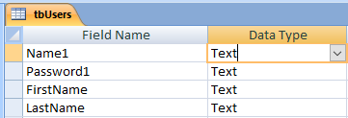

**2. Employee Management**

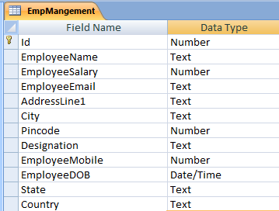

**3. Item Management**

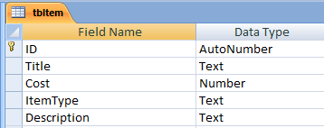

**4. Stock Management**

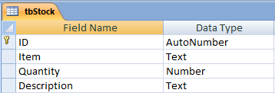

**5. Sales Management**

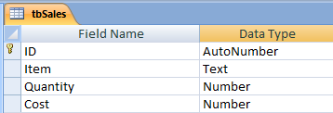

**Screen design of all Forms**

**Conclusion**

Our project is only a humble venture to satisfy the needs to manage their project work. Several user friendly coding have also adopted. This package shall prove to be a powerful package in satisfying all the requirements of the school. The objective of software planning is to provide a frame work that enables the manger to make reasonable estimates made within a limited time frame at the beginning of the software project and should be updated regularly as the project progresses.

At the end it is concluded that we have made effort on following points...

• A description of the background and context of the project and its relation to work already done in the area.

• Made statement of the aims and objectives of the project .The description of Purpose, Scope and applicability. We define the problem on which we are working in the project.

• We describe the requirement Specifications of the system and the actions that can be done on these things. . We understand the problem domain and produce a model of the system, which describes operations that can be performed on the system we included features and operations in detail, including screen layouts.

• We designed user interface and security issues related to system finally the system is implemented and tested according to test cases

**Bibliography**