EXECUTIVE SUMMARY REPORT

Assignment Week 3

Daksh Shah

Northeastern University

College of Professional Studies

ALY6050 – Enterprise Analytics

Prof – Roy Wada

March 15, 2022

**Introduction:**

As an investor you are looking to invest in Costco Wholesale and Coco-Cola share prices denoted by COST and KO. We have a 252 market days record with, and we will perform time series forecasting in Excel and R to determine in which stock we must invest and predict some values and check how well is our study based on multiple parameters like MAPE and MASE.

The Forecasting will be done in 3 stages Short-Term forecasting, Long-Term forecasting and Time Series forecasting using R. Then we will perform analytical and numerical evaluation to check the accuracy of our analysis.

**Part 1:**

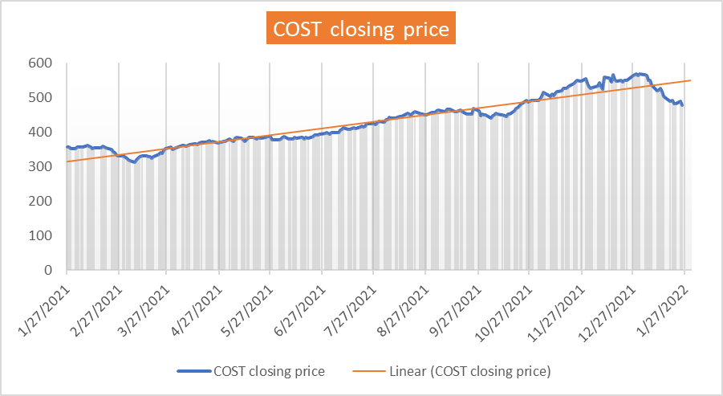Figure 1: Costco trend

**Summary Costco Wholesale:**

* From the above trend we understand that over the time the Costco Stock price in up trend.
* We can see few dips Feb – Mar, Sep – Oct and Dec 21 – Jan 22.
* The trend line seems a bit seasonal with some irregularities.

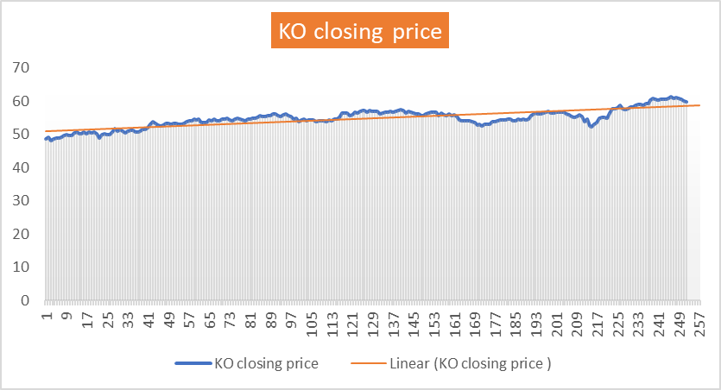

Figure 2: Coco-cola Trend

**Summary Coco-Cola:**

* From the above trend we can see that the stock price has remained stable.
* We can see 1 dip with small rise in the stock price.

**Part 1.2:**

Performing exponential smoothing to forecast price for the 253rd Day with 𝜶=𝟎.15, 0.35, 0.55 and 0.75.

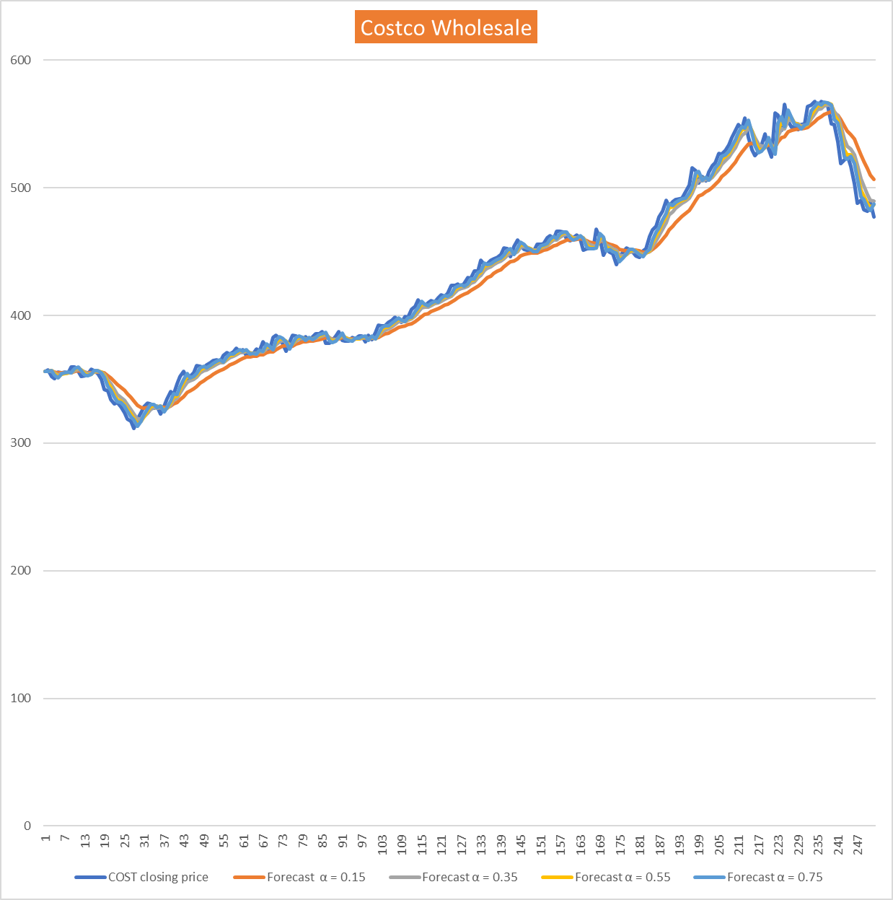

Figure 3: Exponential Smoothing

|  |  |  |  |  |
| --- | --- | --- | --- | --- |
|  |  | Costco |  |  |
| **α** | 0.15 | 0.35 | 0.55 | 0.75 |
| **MAD** | 9.76342629 | 5.96047809 | 4.84685259 | 4.38960159 |
| **MSE** | 158.62 | 62.21 | 42.07 | 35.33 |
| **MAPE** | 2.21% | 1.34% | 1.10% | 0.97% |
| **Forecasted Stock Price** | 502.4 | 485.41 | 481.62 | 479.81 |

* From the above table we can see that the forecasted values for each exponential smoothing value where the 479.81 forecasted value seems more accurate as compared last closing value of 477.32 with α=0.75 and MAPE 0.97%

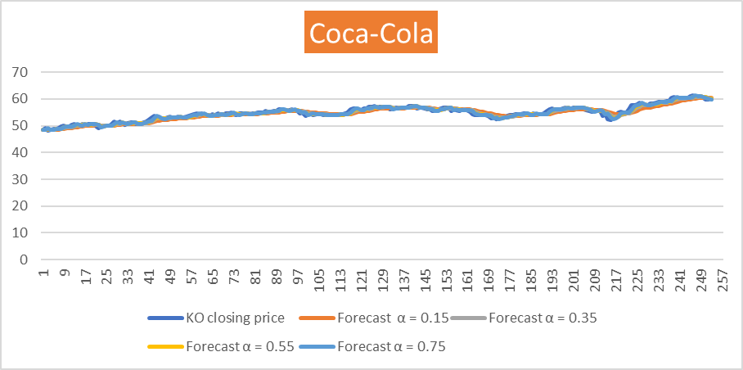Figure 4: Coco-Cola Exponential Smoothing

|  |  |  |  |  |
| --- | --- | --- | --- | --- |
|  |  | KO |  |  |
| **α** | 0.15 | 0.35 | 0.55 | 0.75 |
| **MAD** | 0.724661 | 0.463187 | 0.393108 | 0.371952 |
| **MSE** | 0.84 | 0.40 | 0.29 | 0.25 |
| **MAPE** | 1.29% | 0.82% | 0.70% | 0.63% |
| **Forecasted Stock Price** | 60.3 | 60.23 | 60.02 | 59.89 |

* From the above table we can see that the forecasted values for each exponential smoothing value where the 59.89 forecasted value seems more accurate as compared last closing value of 59.82 with α=0.75 and MAPE 0.97%

**Part 1.3:**

We will again perform exponential smoothing α=0.55 and trend parameters β values of 0.15, 0.25, 0.45 and 0.85. We will calculate MAPEs to determine which combination of α and β yield a good forecast value.

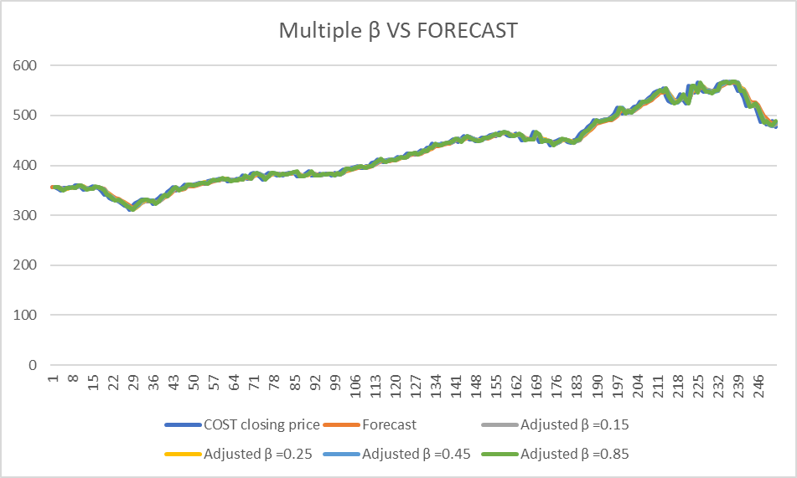

Figure 5: Costco VS β – Forecast

|  |  |
| --- | --- |
| **α = 0.55** | **MAPE** |
| **β =0.15** | **1.00%** |
| **β =0.25** | **0.95%** |
| **β =0.45** | **0.96%** |
| **β =0.85** | **0.95%** |

* From the above table we can conclude that for the β = 0.85 the MAPE is the least i.e., 0.95% as compared to other adjusted trend parameters. Hence, we suggest that the forecasted value using the β = 0.85 481.62 should be the 253rd value.

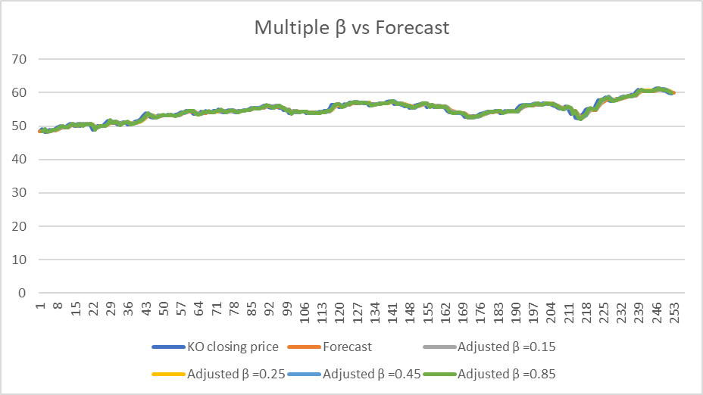Figure 6: Coco-Cola VS β –Forecast

|  |  |
| --- | --- |
| **α = 0.55** | **MAPE** |
| **β =0.15** | **0.70%** |
| **β =0.25** | **0.68%** |
| **β =0.45** | **0.69%** |
| **β =0.85** | **0.68%** |

* From the above table we can conclude that for the β = 0.85 the MAPE is the least i.e., 0.68% as compared to other adjusted trend parameters. Hence, we suggest that the forecasted value using the β = 0.85 60.02 should be the 253rd value.

**Part 2:**

We will use the 3-Period weighted moving averages to forecast the values through 1 to 100. The suggested weights are 0.5 for the most recent, 0.3 for the period before the most recent and 0.2 for two periods ago. After that we will use the observed value from 101 as base linear trend and forecast stock from periods 101 through 257.

|  |  |  |  |  |  |
| --- | --- | --- | --- | --- | --- |
| Date | Period | COST/$(Actual) | COST/$(Forecasted) | KO/$(Actual) | KO/$(Forecasted) |
| 1/26/2022 | 253 | $483.47 | $557.35 | $59.60 | $57.93 |
| 1/27/2022 | 254 | $482.52 | $558.09 | $59.65 | $57.95 |
| 1/28/2022 | 255 | $492.43 | $558.82 | $60.84 | $57.97 |
| 1/29/2022 | 256 | $505.13 | $559.56 | $61.01 | $57.98 |
| 1/30/2022 | 257 | $508.41 | $560.30 | $60.56 | $58.00 |
|  |  | MAPE | 2.546% | MAPE | 1.92% |

* From the above table we compare the actual stock price for COSTCO and COCO-COLA collected from Yahoo Finance website and the Forecasted value of the stocks. The Forecast has an error of MAPE 2.546% for Costco and MAPE of 1.92% for Coco-Cola

**Part 3:**

We will use time series in R to perform prediction of the COSTCO stock price and COCO-COLA using time series models of AR1 and auto Arima. Further predict the price of dry wine.

After downloading the data of last 5 years we use AR (1) model and plot the actual price vs the forecasted values.

1. Costco Whole Stock AR1 and Auto Arima Model.

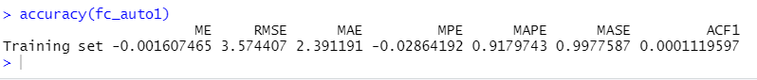

* From the above images of the models AR (1) and auto Arima (2,1,4) model RMSE and MAPE are almost same. We can conclude that both AR (1) and Arima (2,1,4) model are better for forecasting the stock price of Costco.

1. Coco-Cola Stock Price.



* From the above models of AR (1) and auto Arima (2,1,2) model MAPE and RSME are almost same. We can conclude that both AR (1) and Arima (2,1,2) model are better for forecasting the stock price of Coco-cola.

* The above graph is for the dry wine forecasting using the Auto Arima.

Predicted values for dry wine.

* From the study in Excel and Time series in R from the below table we can see that the MAPE achieved in auto Arima model is better then the MAPE obtained using trend parameter method.

|  |  |  |  |
| --- | --- | --- | --- |
|  | Excel |  | R - Auto Arima |
| MAPE - COSTCO | 2.546% |  | 0.97% |
| MAPE - KO | 1.92% |  | 0.82% |

**Summary:**

1. The purchase of COSTCO stock is suggested over the purchase of Coco-cola Stock since it is expected to rise from our study.
2. The MAPEs from Exponential smoothing, Trend Parameter method, AR (1) model and Arima model give different understanding.
3. The use of methods and models in R is convenient as compared to Excel.
4. The Auto Arima method is preferred above others as it yields accurate results.
5. To improve the Analysis we can perform the decomposition model and make the data Stationary.

**Reference:**

1. *RPubs - Time Series and Stock Analysis*. (2021, July 5). Rpub. <https://www.rpubs.com/AurelliaChristie/time-series-and-stock-analysis>
2. *RPubs - Forecasting Stock Price Using Arima Model in R*. (2020, June 26). RpUB. https://rpubs.com/kevinTongam/arimaforecast
3. M. (2021, September 23). *Estimating AutoRegressive (AR) Model in R*. Finance Train. <https://financetrain.com/estimating-autoregressive-ar-model-in->r