Game Design Document

Fill up the Following document

1. Write the title of your project.

ans. Balloon saver

1. What is the goal of the game?

ans. Save the balloon from obstacles.

1. Write a brief story of your game?

ans. Balloon will start moving up and a defender will also go with it and save it from obstacles. Time you survived = score, and it's a infinite runner game like T-rex game. There will only two lifelines for the player. There will a power given to player when he will press space button player will shoot an arrow.

1. Which are the playing characters of this game?

* Playing characters are the ones which respond to the user based on the input from the user
* Cars, monkeys, dinos, wizards etc, are the playing characters in the game.

|  |  |  |
| --- | --- | --- |
| Number | Character Name | What can this character do? |
| 1 | Balloon(NPC) | It will flow upwards. |
| 2 | Defender(PC) | It will save the balloon from obstacles. |
| 3 |  |  |
| 4 |  |  |
| 5 |  |  |
| 6 |  |  |
| 7 |  |  |
| 8 |  |  |

1. Which are the Non Playing Characters of this game?

* Non Playing characters are the ones which don't have an action or a behaviour when the user interacts with the game.
* Hurdles, stones, bananas, coins, etc are non playing characters in the game.

|  |  |  |
| --- | --- | --- |
| Number | Character Name | What can this character do? |
| 1 | Obstacle1(NPC) | It will try to blast the balloon. |
| 2 | Obstacle2(NPC) | It will try to destroy the live of player. |
| 3 |  |  |
| 4 |  |  |
| 5 |  |  |
| 6 |  |  |
| 7 |  |  |
| 8 |  |  |

Draw your imagination of this game. What does this game look like?

* Draw the game either on your computer or on paper,
* Add images of scenes of the game to show each of the playing and non-playing characters at least once.

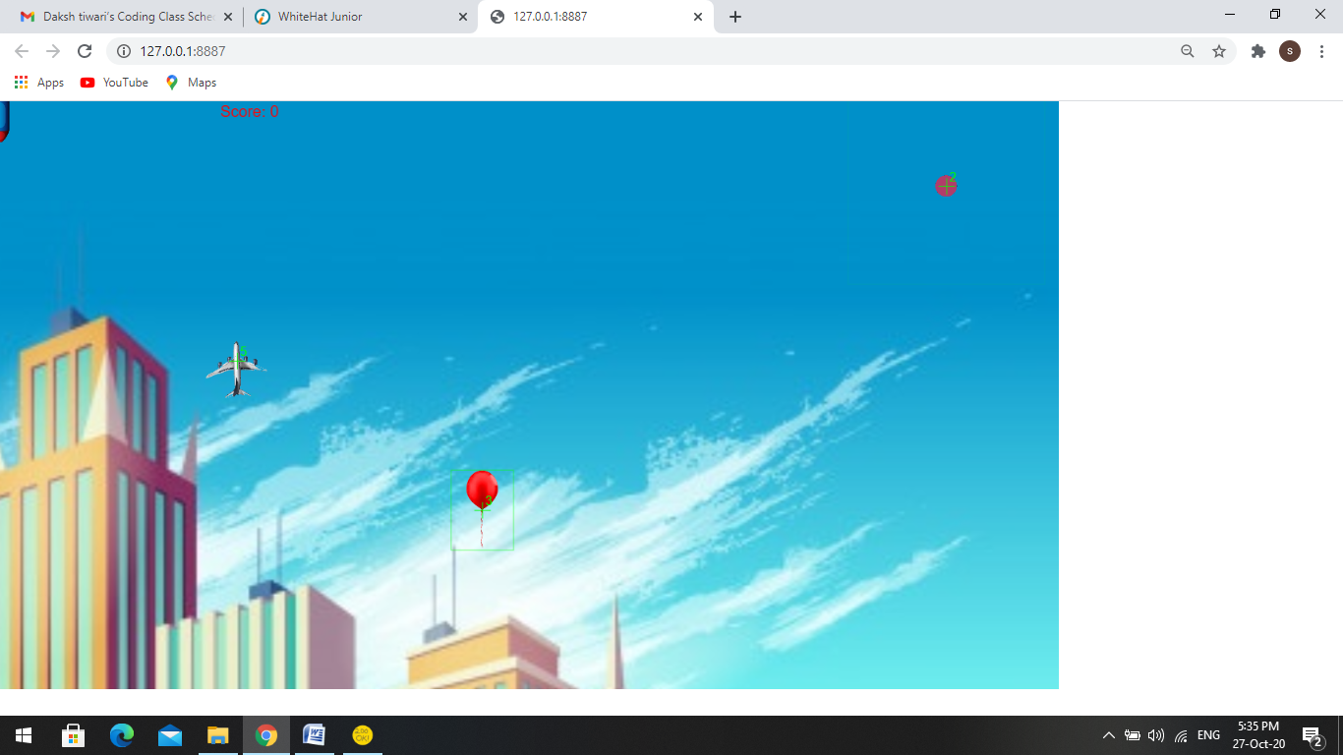

How do you plan to make your game engaging?