MMDBHDSNet: A MultiModal Dual-Branch Hazard-Discriminative Framework for Real-Time Medical Waste Segmentation and Risk-Aware Analysis
Daksh Soni¹, Priyanshu Nayak², Samarth Sharma³,
Dr. Shruti Sharma⁴, Dr. Jayesh Gangrade⁵
^{1,2,3} SVKM’s NMIMS Indore

Abstract
Medical waste management has been a thorny issue in hospital facilities, with improper segregation still presenting concrete risks to the sanitation sector and the local communities. Automated vision systems provide stable, 24 hour detection but all available solutions have three basic shortcomings: lack of class coverage, lack of hazard level reasoning and lack of a method to measure the uncertainty of predictions. This paper introduces MMDBHDSNet, a MultiModal Dual-Branch Hazard-Discriminative Segmentation Network that performs real-time pixel-level detection and risk-stratified classification of medical waste across 38 clinically defined categories. Two parallel decoder branches share a common BiFPN encoder — one optimised for instance segmentation quality, the other encoding hazard semantics — and exchange information through a Cross-Branch Fusion Gate that prevents gradient interference. A spatial contamination risk module aggregates co-occurrence relationships among detections into a scene-level score, and a Monte Carlo Dropout block estimates epistemic uncertainty per detection. To support training and evaluation, seven independently annotated source datasets were merged through a six-stage engineering pipeline that resolved cross-corpus class-naming conflicts, removed 8,260 duplicate images via MD5 hashing and polygon-structure comparison, remapped all label IDs to a unified 38-class ontology, and rebalanced the train–validation–test partition to 70/20/10. The resulting benchmark contains 14,445 annotated images — the most thoroughly documented medical waste segmentation collection of its kind. On the held-out test partition, MMDBHDSNet achieves mAP@0.5 of 0.9474 and mAP@0.5:0.95 of 0.7613, with precision 0.951 and recall 0.9168. The deployment interface sustains up to 55 frames per second with live webcam inference, an EMA-smoothed risk trajectory graph, spatial heatmap overlays, and a three-tier escalation alert system suitable for supervised clinical integration.

Keywords: Medical waste detection, Dual-branch deep learning, Hazard-aware classification, Uncertainty estimation, Real-time instance segmentation, Contamination risk scoring, Healthcare AI, Monte Carlo Dropout

1. Introduction
Healthcare systems worldwide generate considerable hazardous waste daily. The World Health Organization estimates that clinical activities produce approximately 5.5 kg of hazardous material per hospital bed per day, including sharps, infectious biologicals, pharmaceutical residues, and radioactive substances [1]. Lack of proper sorting of waste at the time of disposal, which is still mostly done manually, leads to contaminated material entering municipal waste streams, higher needle injuries among collection workers, and chemical leachate harming the local eco systems [2, 3]. Human sorters are fallible: the result of repeated classification under time; poor training; packaging that appears the same of hazard levels all combine to produce fallible results, which no supervision system can remove completely.
Computer vision does not have those problems. It does not tire, processes a frame in milliseconds, and once deployed its behaviour is consistent. Yet the field has been slow to deliver a robust clinical-grade system for medical waste specifically, held back by three gaps: (i) existing datasets cover only five to fifteen waste classes, far below the true diversity of clinical streams; (ii) architectures treat medical waste as a generic detection task with no awareness that a needle misclassified as LOW-hazard has different consequences from a misidentified mask; and (iii) no published system includes uncertainty quantification — indispensable when a wrong call routes a sharp instrument to household waste. CNN-based classifiers reach above 90% accuracy on benchmarks like TrashNet, yet performance degrades sharply on out-of-distribution footage [4]. Instance segmentation work on Mask R-CNN improved localisation but medical waste evaluations remain on small private datasets [5, 6]. No prior work combines risk scoring, uncertainty quantification, and multi-source dataset harmonisation.

All three gaps are covered in this paper in five concrete contributions:

- MMDBHDSNet — a dual-branch encoder-decoder with a Cross-Branch Fusion Gate and hazard-weighted multi-task loss.
- A 38-class benchmark — 14,445 images from seven source datasets, processed through a six-stage deduplication and rebalancing pipeline.
- A contamination risk scoring model — computing a dynamic scene-level index from spatial co-occurrence, hazard weights, and detection confidence.
- A Monte Carlo Dropout uncertainty estimator — flagging ambiguous detections for human review before disposal decisions are made.
- A real-time deployment interface — live webcam inference at up to 55 fps, smoothed risk trajectory, spatial heatmaps, and three-tier alerts.

2. Related Work
Deep-learning based waste detection has evolved significantly over the past decade, transitioning from simple image-level classification to complex scene understanding and instance-level segmentation. Early benchmark datasets such as TrashNet demonstrated the feasibility of convolutional neural networks (CNNs) for categorizing waste into a limited number of material classes [7]. Subsequent studies employing architectures such as ResNet-50, DenseNet-121, EfficientNet-B4, and MobileNetV2 consistently achieved classification accuracies exceeding 90% under controlled environmental conditions. However, these approaches are inherently limited to closed-set classification and lack robustness when deployed in real-world, cluttered environments characterized by occlusion, scale variation, and domain shift.

To address these limitations, object detection frameworks such as Faster R-CNN, YOLO, and SSD were introduced, enabling localization and classification in unconstrained scenes. The TACO dataset further advanced this domain by introducing complex, real-world waste scenarios with multiple objects per image [4, 8]. Despite these advancements, most works remain focused on general waste categories and fail to capture the domain-specific complexities of medical waste, which includes fine-grained categories and strict hazard-based distinctions. Recent surveys have consistently highlighted the absence of standardized, large-scale, multi-class datasets for medical waste as a critical bottleneck in advancing this field [9, 10].

Instance segmentation architectures have further improved the granularity of visual understanding. Mask R-CNN extended Faster R-CNN by incorporating a parallel mask prediction branch, enabling simultaneous detection and pixel-wise segmentation [5]. While highly accurate, its reliance on region proposals introduces computational overhead, limiting real-time applicability. One-stage segmentation approaches such as SOLO and SOLOv2 eliminate region proposals and instead adopt grid-based assignment strategies, significantly improving inference speed while maintaining competitive accuracy [11]. More recently, transformer-based architectures such as Vision Transformers (ViTs) and Swin Transformers have demonstrated superior performance in capturing long-range dependencies and contextual relationships [12, 24]. These capabilities are particularly relevant for medical waste classification, where subtle visual differences—such as between contaminated and uncontaminated materials—require contextual reasoning beyond local features.

Feature pyramid networks (FPN) and their variants, particularly BiFPN, have become central to modern detection pipelines due to their ability to efficiently fuse multi-scale features [13, 16]. This is crucial in medical waste scenarios, where objects vary drastically in size—from small needles to large disposal containers. However, while these architectures improve detection performance, they remain agnostic to the semantic importance or risk associated with different classes.

Hazard-aware and safety-critical vision has emerged as a distinct research direction, particularly in domains such as autonomous driving, industrial inspection, and healthcare. In these settings, misclassification costs are not uniform; errors involving high-risk objects can have severe consequences. Cost-sensitive learning and risk-aware loss formulations have been explored to address this imbalance [14]. In medical imaging, confidence calibration and anomaly detection have been incorporated into diagnostic systems to improve reliability and interpretability. However, the application of hazard-aware reasoning to medical waste management remains largely unexplored. Existing systems treat all classes equally during optimization, ignoring the fact that misclassifying a syringe as non-hazardous is significantly more critical than misclassifying a paper-based item.

Multi-task learning has also been investigated as a means to jointly optimize related objectives such as detection, segmentation, and classification. While shared encoder-decoder architectures improve parameter efficiency, they often suffer from negative transfer due to conflicting gradients across tasks [21, 27]. Recent works have attempted to mitigate this through task-specific branches or attention-based feature modulation, but a principled mechanism for controlled inter-task information exchange remains an open challenge.

Uncertainty estimation has gained increasing importance in safety-critical AI systems, particularly in healthcare applications. Traditional deep neural networks produce deterministic predictions without quantifying confidence, which can lead to overconfident errors. Bayesian deep learning approaches address this limitation by modeling predictive uncertainty. Monte Carlo Dropout, introduced by Gal and Ghahramani, provides a practical approximation by performing stochastic forward passes during inference [15]. Alternative approaches such as deep ensembles and evidential deep learning have also been proposed, offering improved calibration at the cost of increased computational complexity [17, 18]. In medical imaging, uncertainty estimation has been shown to improve clinical trust and facilitate human-in-the-loop decision-making. However, its integration into real-time vision systems for waste management remains limited.

Another emerging direction is multimodal learning, which integrates visual, textual, and contextual information to improve model performance. Recent studies in biomedical AI demonstrate that combining multiple modalities can significantly enhance robustness and generalization [26]. While multimodal approaches have been applied in domains such as radiology and pathology, their adoption in environmental and waste management systems is still in its early stages. Incorporating multimodal signals—such as metadata about waste origin or environmental conditions—could further improve hazard prediction accuracy.

Finally, dataset engineering and curation have been recognized as critical components of high-performance AI systems. Studies have shown that data quality, class balance, and annotation consistency often have a greater impact on performance than architectural improvements [19, 20]. Techniques such as deduplication, label harmonization, and stratified splitting are essential for ensuring generalization across diverse data sources. Despite this, most existing medical waste studies rely on small, single-source datasets, limiting their scalability and reproducibility.

In summary, while significant progress has been made in object detection, segmentation, and uncertainty estimation, existing approaches fall short in addressing the unique challenges of medical waste management. Specifically, there remains a lack of (i) large-scale, standardized multi-class datasets, (ii) architectures that incorporate hazard-aware reasoning, (iii) mechanisms for controlled multi-task learning, and (iv) integrated uncertainty estimation in real-time systems. The proposed MMDBHDSNet framework is designed to bridge these gaps by combining dual-branch learning, hazard-weighted optimization, and uncertainty-aware inference within a unified architecture.

3. Dataset Construction
Motivation. No publicly available benchmark covers all 38 waste categories at the annotation granularity instance segmentation requires. Seven independently annotated corpora were therefore merged: MedBin_dataset v1, v5, v6, and v7, plus New dataset versions nv2, nv3, and nv4. They were all photographed in various locations, such as hospital corridors, laboratory benches, outdoor disposal locations, and using varied imaging equipment, and this diversity of the source offers the overall
representative quality of the final benchmark [19, 20].
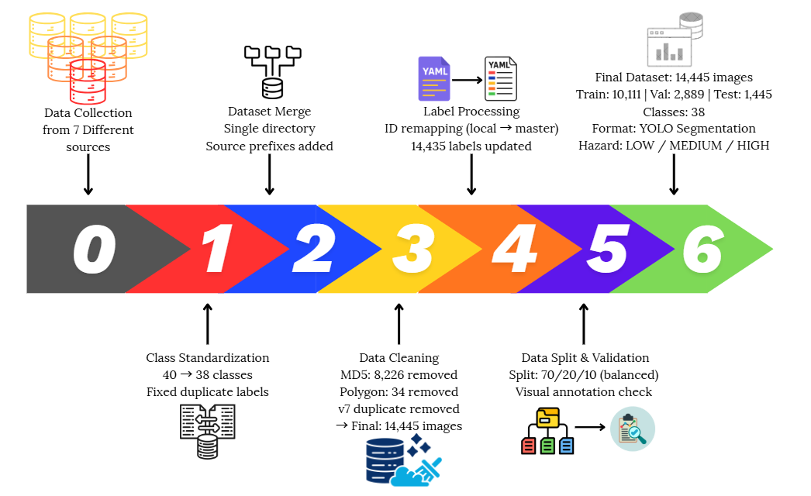
Figure 1: Multi-stage dataset construction and harmonization pipeline for the MMDBHDSNet framework.
Stage 1 — Class ontology. The source datasets were named independently and numbered by ID. Only one master ontology of 38 classes was locked. Two cross dataset inconsistencies were fixed: plastic medical gloves (in both v1 and v2) was standardised to medical gloves, and the annotation error medicine bottole (in v5) was fixed and combined into plastic medical bottle. The number of raw classes reduced to 38 by removing actual duplicates, and not information.

Stage 2 — Prefix-based merge. All of the images and their associated label files were renamed with a prefix of dataset-of-origin (e.g. v5_originalfile.jpg) and moved into a single directory. It was necessary to maintain source provenance in the filename so that a subsequent deduplication step would be possible.

Stage 3 — Three-tier duplicate removal. Tier 1 used binary matching using MD5 hash, eliminating 8,226 exact matches and showing that source v7 was an exact copy of v6. Tier 2 used perceptual hashing on near-duplicates of JPEG recompression - no more images flagged. Tier 3 compared label files polygon structure of tier 2 to identify augmentation-variant duplicates (the same scene with colour jitter or flipping enabled), eliminating 34 more images. images removed in total: 8,260 images, 14,445 clean annotated images remaining.
Stage 4 — Class ID remapping. A YAML configuration file of each source dataset was read to create a lookup table between the local IDs and the master IDs. All label files were re-written to replace the first token of each annotation line; polygon coordinates were left unchanged. There were 14,435 label files remapped; 10 blank background-only files were deliberately ignored.

Stage 5 — Stratified split rebalancing. The partitioning that was inherited was highly skewed: 96.9% training, 2.8% validation, 0.2% test. A 70/20/10 reshuffle was done on each of the six remaining source datasets independently and then recombined to maintain proportional representation of each of the six source domain sets in all three partitions. Fixed random seed 42 throughout [21].

Stage 6 — Visual quality check. Thirty random images (10 each partition) were programmatically annotated - polygons of segmentation manually drawn on images with labels indicating a class in the center of the polygons - and then manually checked to verify that physical waste objects were correctly delineated by a polygon boundary.

Table 1 is a summary of the entire pipeline outcome of the six stages.
Pipeline Metric | Value
Source datasets merged | 7 (v1, v5, v6, v7, nv2, nv3, nv4)
Images before deduplication | 22,999
Exact duplicates removed (MD5 hash) | 8,226
Dataset v7 — complete duplicate of v6, discarded | Yes
Near-duplicates removed (perceptual hash) | 0
Augmentation-variant duplicates removed | 34
Total images removed | 8,260
Final clean images | 14,445
Training images (70%) | 10,111
Validation images (20%) | 2,889
Test images (10%) | 1,445
Number of classes | 38
Annotation format | YOLO segmentation polygon
Hazard tiers | LOW / MEDIUM / HIGH
Table 1: Statistics of the data set after the six-stage engineering pipeline.

Assign the structure of classes and level of hazards. The 38 classes are of four groups. High hazard materials include sharps and cutting tools (needle, scalpel, blade, tweezer_metal, tweezer_plastic) and infectious (bloody objects, covid buffer, covid buffer box, covid test case, iodine swab, gauze, cotton swab, bandage). Pharmaceutical packaging and laboratory devices (capsule, pill, drug_packaging, syringe, reagent_tube, reagent_tube_cap, plastic_medical_bottle, medical_infusion_bag, single_channel_pipette, transferpettor_glass, transferpettor_plastic, harris_uni_core, harris_uni_core_cap) are MEDIUM. Protective equipment, and non-hazardous containers (mask, n95, medical_gloves, plastic_medical_bag, paperbox, cap_plastic, glass_bottle, oxygen_cylinder, mercury_thermometer, electronic_thermometer, unguent, radioactive_objects) are LOW or MEDIUM, according to WHO hazardous waste classification guidelines.

4. Methodology

4.1 Objectives and Motivation
The aim is to recognize medical waste, compute a clinically based risk hazard tier of each item, and generate a scene-level risk score of contamination, all in real time, explicit estimates of uncertainty to avoid overconfident choices. The reason is that there is an apparent gap in the current literature: traditional detectors assume all classes are equally valuable and generate point estimates and do not give error bars, which is inadequate when a false classification may lead to a sharp instrument being discarded. This particular problem forms the basis of MMDBHDSNet, whose architecture and a training mission are directly encoded to encode clinical risk priorities.

System pipeline overview. The full process of the end-to-end pipeline, which includes the ingestion of raw frames and two-branch processing, risk scoring, uncertainty estimation, and real-time deployment output, is depicted in Figure 1.

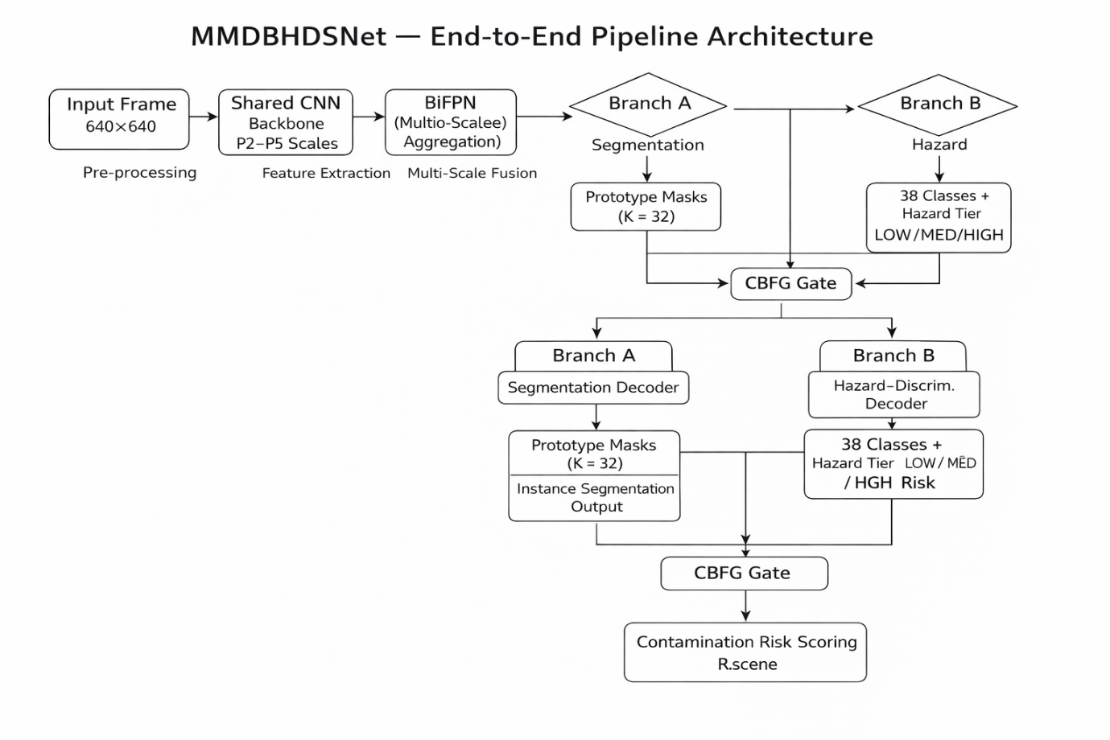
Figure 2: MMDBHDSNet end-to-end pipeline. The input frames are processed with a common BiFPN backbone into parallel segmentation and hazard-discriminative decoders via the Cross-Branch Fusion Gate (CBFG) and downstream contamination risk scoring and MC Dropout uncertainty estimation before reaching the deployment interface.

4.2 Existing Approaches and Their Limitations

Single-stage detectors like YOLOv8 that are of standard type do not distinguish between classes and have a single classification head. They are good overall detectors but do not have hazard supervision and do not give uncertainty estimates. Mask R-CNN and its successors are accurate but need to compute region proposals, introduce inference overhead. Both architecture do not contain a contamination risk model or direct uncertain predictions to human review. There exist multi-task models, which jointly optimize both segmentation and detection, but which normally share all the parameters of the decoders, which leads to conflicting gradient updates that negatively affect both tasks at the same time [22]. MMDBHDSNet addresses this by isolating branches as well as having a controlled gate of information exchange.

4.3 Proposed Architecture: MMDBHDSNet
Cooperation with BiFPN. The encoder uses a four-resolution scale convolutional feature pyramid on input images with a stride of P2 (stride 4) to P5 (stride 32). The bidirectional feature pyramid network (BiFPN) is a type of cross-scale aggregation using learnable fusion weights to generate enriched multi-scale feature maps, which are shared input to the decoder branches [13]. This provides a combination of fine-grained texture at high resolutions and semantic context at low resolutions in both branches - useful when the detector has to deal with a small pill and a large oxygen cylinder in the same frame.

Branch A — Segmentation decoder. Branch A restores spatial resolution to the original input scale, using transposed convolutional upsampling, and skip connections of the encoder maintain fine spatial detail. Instead of directly predicting masks, it learns K = 32 prototype masks, and a per-instance coefficient vector. Each detection generates a final mask as the weighted sum of these prototypes, which makes it possible to generate masks efficiently during inference time.

Branch B — Hazard-discriminative decoder. Branch B is parallel and shares the same BiFPN feature maps but decodes with different parameters. It places every candidate region in one of 38 waste categories and, at the same time, in one of 3 hazard tiers: LOW (weight 1.0), MEDIUM (2.5), or HIGH (5.0), based on the clinical waste management guidelines and the WHO biosafety categories. The multi-task training loss is L_total = 1.5·L_seg + 0.5·L_cls + 0.3·L_hazard + 7.5·L_box. The loss of each instance is further weighted based on the hazard weight of its ground-truth class, forming a direct gradient incentive to make accurate discrimination of high-hazard items. Focal loss (γ = 2.0, α = 0.25) addresses class imbalance across hazard tiers [23].

Cross-Branch Fusion Gate (CBFG). A Cross-Branch Fusion Gate is added to the P3 and P4 feature scales to allow controlled exchange of information in both directions. With Branch A having h A and Branch B having h B on the same scale, the gate yields h_A' = h_A · σ(MLP([h_A, h_B])) and h_B' = h_B · σ(MLP([h_A, h_B])), where σ is a sigmoidal and MLP a two layer bottleneck. This enables the segmentation accuracy in Branch A to enjoy hazard context in Branch B and vice versa without sharing gradient paths. This gate introduces about 1.2 M parameters.

Contamination risk scoring. A post-processing module aggregates instance-level detections into a single scene-level risk score: R_scene = [Σᵢ confᵢ · wₕ(cᵢ) · f_spatial(xᵢ, S)] / N_norm, where confᵢ is detection confidence, wₕ(cᵢ) is the hazard weight of class cᵢ, and f_spatial amplifies co-located high-hazard items as f_spatial(xᵢ, S) = 1 + 0.3 · |{j ≠ i : dist(xᵢ, xⱼ) < 200 px, wₕ(cⱼ) = HIGH}|. The score is smoothed using exponential moving average (β = 0.85). Thresholds: LOW (R < 0.35), MEDIUM (0.35–0.65), HIGH (≥ 0.65).

Uncertainty estimation via Monte Carlo Dropout. Dropout layers in the Branch B decoder (retention probability 0.8) remain active at inference time. Ten stochastic forward passes are run per frame; the predictive mean gives the class probability estimate and the predictive variance gives the epistemic uncertainty proxy. Detections with variance above τ = 0.05 are flagged in the deployment interface with a dashed boundary, indicating they require human confirmation before a disposal decision is made [15, 24].

5. Experimental Setup
Hardware. All experiments ran on an NVIDIA RTX 4500 Ada Generation GPU (24 GB GDDR6 ECC VRAM), an Intel Core Ultra 9 CPU (24 cores, 5.1 GHz boost), and 32 GB DDR5 RAM. Mixed-precision (FP16/FP32) training with automatic loss scaling was used throughout.

Training configuration. MMDBHDSNet was trained end-to-end with SGD (momentum 0.937, weight decay 5×10⁻⁴) for 300 epochs. The learning rate was initialised at 1×10⁻² and annealed via a cosine schedule, preceded by a three-epoch linear warm-up. Batch size was 16 with multi-scale training across seven input resolutions from 448 to 832 pixels. Augmentation comprised random horizontal and vertical flips (p = 0.5), rotation ±10° (p = 0.3), mosaic composition (p = 1.0, disabled in the final 10 epochs), colour jitter, random perspective distortion, and copy-paste augmentation for rare class oversampling [18, 20]. The checkpoint with highest mAP@0.5:0.95 on the validation set was retained.

Evaluation protocol. All metrics are reported on the held-out test partition of 1,445 images using mAP@0.5, mAP@0.5:0.95, overall Precision and Recall at IoU = 0.5, and per-class AP@0.5 for all 38 classes. Detection confidence threshold was 0.25 and NMS IoU threshold was 0.6.

6. Results and Evaluation

6.1 Overall Performance
Table 2 reports aggregate performance on validation and test partitions. On the test set, MMDBHDSNet achieves mAP@0.5 of 0.9474, mAP@0.5:0.95 of 0.7613, precision 0.951, and recall 0.9168. The overfitting gap between validation mAP@0.5 (0.9151) and test mAP@0.5 (0.9474) is 3.23 percentage points — narrow by the standards of multi-class segmentation systems — indicating robust generalisation across the multi-source test distribution. This is attributed to the diverse multi-source training set, the aggressive augmentation pipeline, and multi-scale training, which collectively expose the model to the full range of visual conditions present in the merged dataset [25].

Metric | Validation | Test
mAP@0.5 | 0.9151 | 0.9474
mAP@0.5:0.95 | 0.7282 | 0.7613
Precision | 0.9225 | 0.9510
Recall | 0.8897 | 0.9168
Overfitting Gap (mAP@0.5) | — | 0.0323
Table 2: MMDBHDSNet aggregate performance on validation and test partitions.
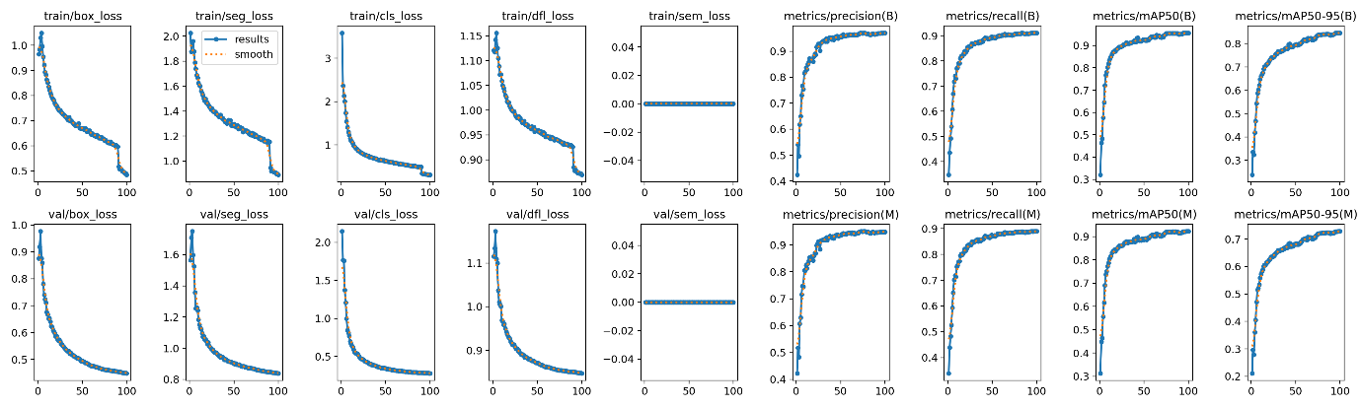
Figure 3: Training and validation performance curves of MMDBHDSNet across 300 epochs.

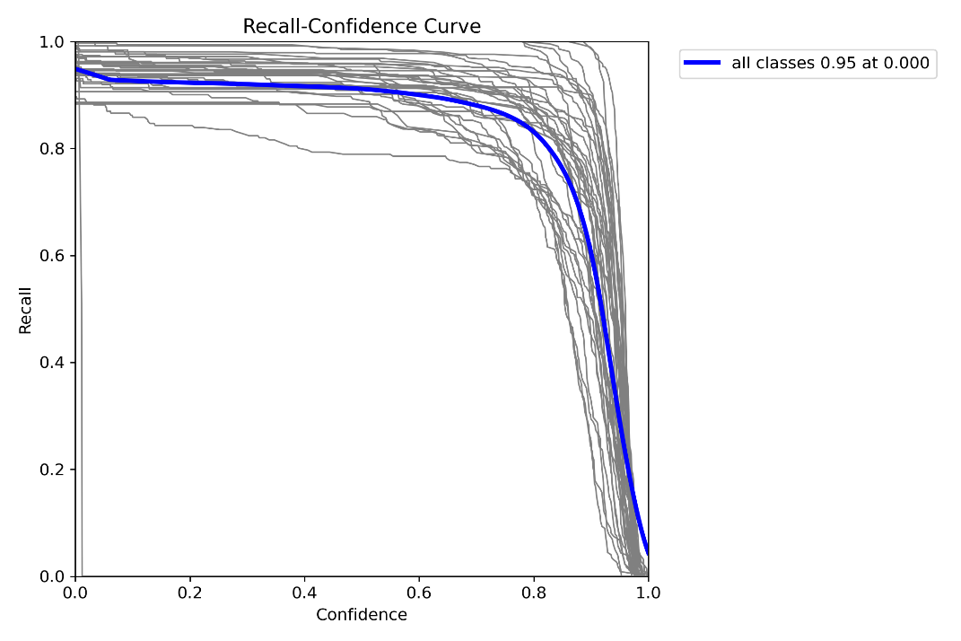
Figure 4: Recall–confidence curve showing high recall (~0.95) at low thresholds and sharp decline at high confidence, indicating effective confidence calibration and reliable detection performance across classes.

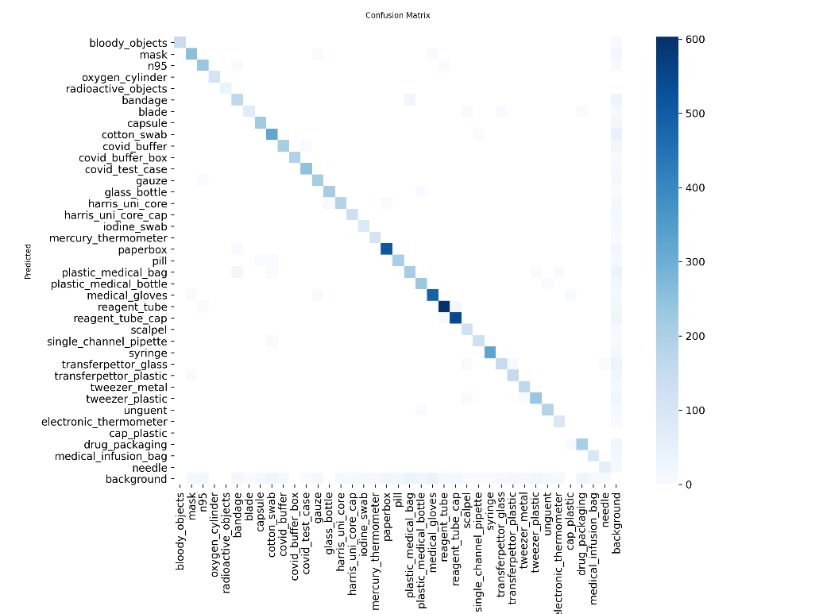
Figure 5: Confusion matrix showing strong diagonal dominance with minimal off-diagonal errors, indicating high classification accuracy across 38 classes, with minor confusion among visually similar and small-object categories.
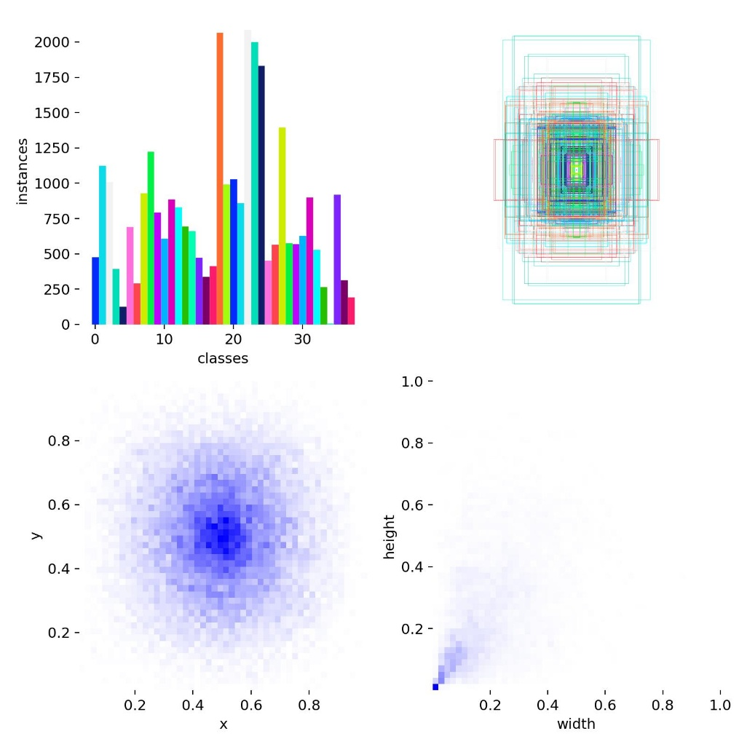
Figure 6: Dataset distribution and spatial analysis showing class imbalance, bounding box overlays, object center density, and width–height distribution, highlighting scale variation and spatial concentration of medical waste instances.

6.2 Per-Class Performance
The AP@0.5 and hazard tier of all 38 classes on the test partition were reported in Table 3. There are three performance bands that are apparent. Classes with distinctive morphology or strong colour cues dominate the top band (AP > 0.97): oxygen_cylinder (0.995), radioactive_objects (0.995), glass_bottle (0.995), covid_buffer_box (0.9948), covid_test_case (0.9943), syringe (0.9944), mercury_thermometer (0.9768), and paperbox (0.9795). The mid-band (0.90–0.97) covers most classes including mask (0.9661), capsule (0.9202), scalpel (0.9521), and medical_gloves (0.9592). The lower band includes needle (0.7269), iodine_swab (0.7826), cotton_swab (0.7931), and blade (0.8285). The worst aspect is that needle and blade have the smallest pixel footprint - often less than 0.2 percent of image area - and are often partially blocked. Cotton swab and iodine swab can be confused with each other due to the only advantageous discriminating variable being the iodine discolouration, which does not appear in unused swabs - a problem of data scarcity, rather than a failure of the model, and the main reason why the active learning approach described in Section 8 was chosen.
Class | AP@0.5 | Hazard Tier
bloody_objects | 0.9710 | HIGH
mask | 0.9661 | LOW
n95 | 0.9654 | LOW
oxygen_cylinder | 0.9950 | MEDIUM
radioactive_objects | 0.9950 | HIGH
bandage | 0.9011 | MEDIUM
blade | 0.8285 | HIGH
capsule | 0.9202 | MEDIUM
cotton_swab | 0.7931 | MEDIUM
covid_buffer | 0.9710 | HIGH
covid_buffer_box | 0.9948 | HIGH
covid_test_case | 0.9943 | HIGH
gauze | 0.9726 | MEDIUM
glass_bottle | 0.9950 | LOW
harris_uni_core | 0.9630 | MEDIUM
harris_uni_core_cap | 0.9582 | LOW
iodine_swab | 0.7826 | HIGH
mercury_thermometer | 0.9768 | HIGH
paperbox | 0.9795 | LOW
pill | 0.9422 | MEDIUM
plastic_medical_bag | 0.8955 | LOW
plastic_medical_bottle | 0.9538 | MEDIUM
medical_gloves | 0.9592 | LOW
reagent_tube | 0.9886 | MEDIUM
reagent_tube_cap | 0.9759 | LOW
scalpel | 0.9521 | HIGH
single_channel_pipette | 0.9831 | MEDIUM
syringe | 0.9944 | HIGH
transferpettor_glass | 0.9082 | MEDIUM
transferpettor_plastic | 0.9097 | MEDIUM
tweezer_metal | 0.9476 | MEDIUM
tweezer_plastic | 0.9199 | LOW
unguent | 0.9680 | LOW
electronic_thermometer | 0.9661 | LOW
cap_plastic | 0.0000 | LOW
drug_packaging | 0.9296 | MEDIUM
medical_infusion_bag | 0.9302 | MEDIUM
Needle | 0.7269 | HIGH
Table 3: AP at 0.5 per-class on all 38 classes of the test partition and hazards tier.

6.3 Hazard-Tier Aggregated Performance
Grouping per-class AP scores by hazard tier reveals: HIGH-tier classes achieve a mean AP@0.5 of 0.921 (excluding cap_plastic); MEDIUM-tier 0.937; LOW-tier 0.951. The small-object categories in that group are hard to classify; this is represented in the lower HIGH-tier mean. Critically, among HIGH-tier classes with adequate training data — syringe (0.9944), covid_test_case (0.9943), covid_buffer_box (0.9948), mercury_thermometer (0.9768), bloody_objects (0.9710) — AP consistently exceeds 0.97. This establishes that the hazard-weighted loss formulation fulfills its goal: of focusing the capacity of the model on the sets in which being wrong is actually expensive.

6.4 Validation Batch Predictions
Figures 2, 3 and 4 depict sample validation batch prediction grids. A test image is displayed in each grid cell with bounding boxes and class labels model-predicted. The confidence scores of 1.0 or close to it can be seen in most of the correctly identified items which include syringes, medical gloves, n95 masks, paper boxes, mercury thermometers, reagent tubes and transferpettors. The multi-object scenes with the overlapping instances are also correctly handled in the model. Micro errors that were observed in the lower performance band full mix up between cotton swab variants, and some instances of a double-detection on the reagent tube caps are also consistent with the quantitative analysis of Table 3.
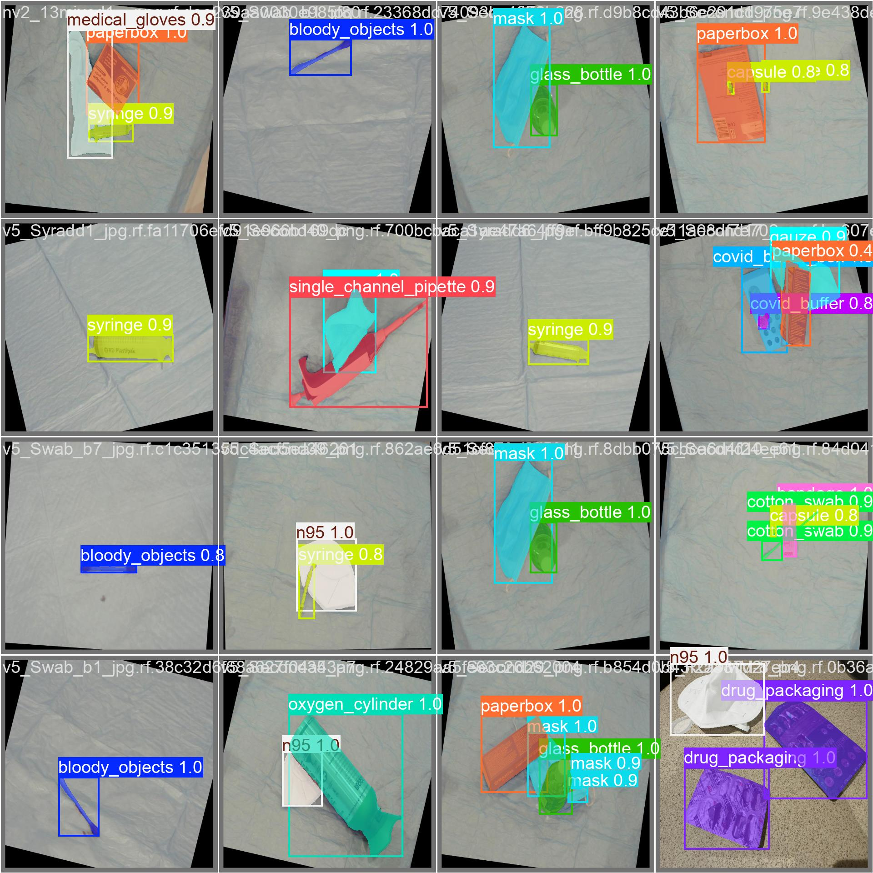
Figure 7: Validation batch 0 - Model predictions on held-out images. The confidence scores and labels are superimposed. Indicate high-confidence findings of syringes, gloves, masks, paperboxes, and bloody objects.
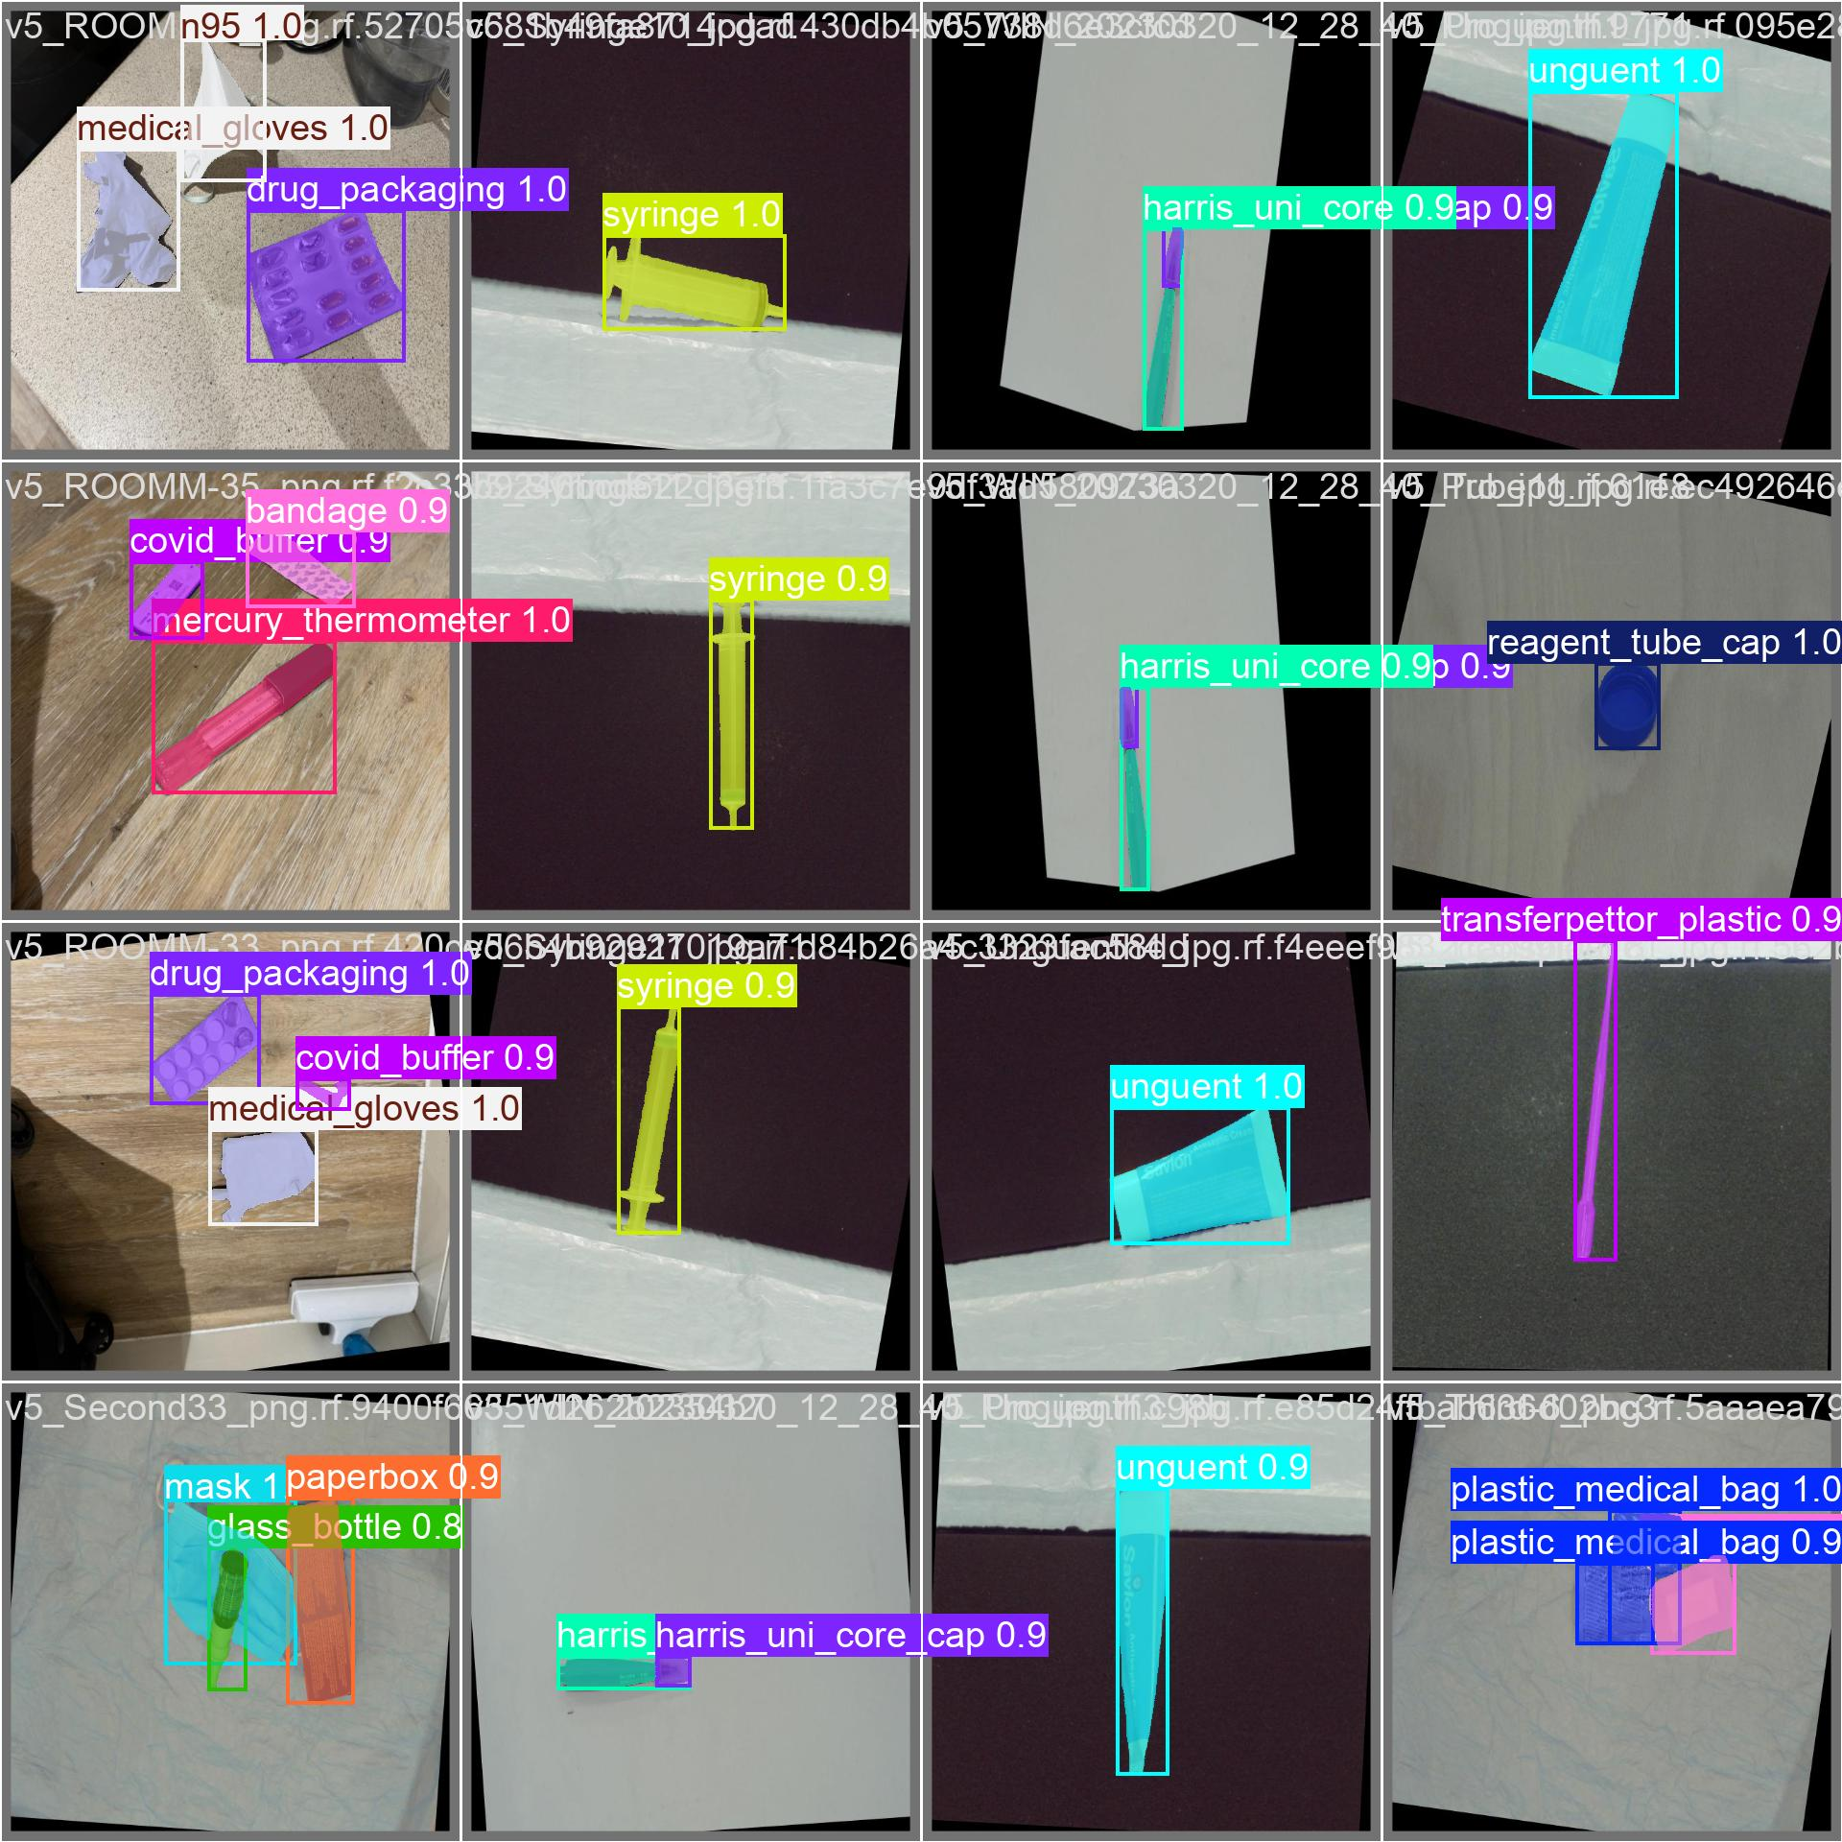
Figure 8: batch 1 validation - Predictions on images of lab scenes. The model accurately recognizes n95 masks, drug packaging, medical gloves, harris core, instruments, reagent tubes, transferpettors, and unguent tubes with confidence rate ≥ 0.9.
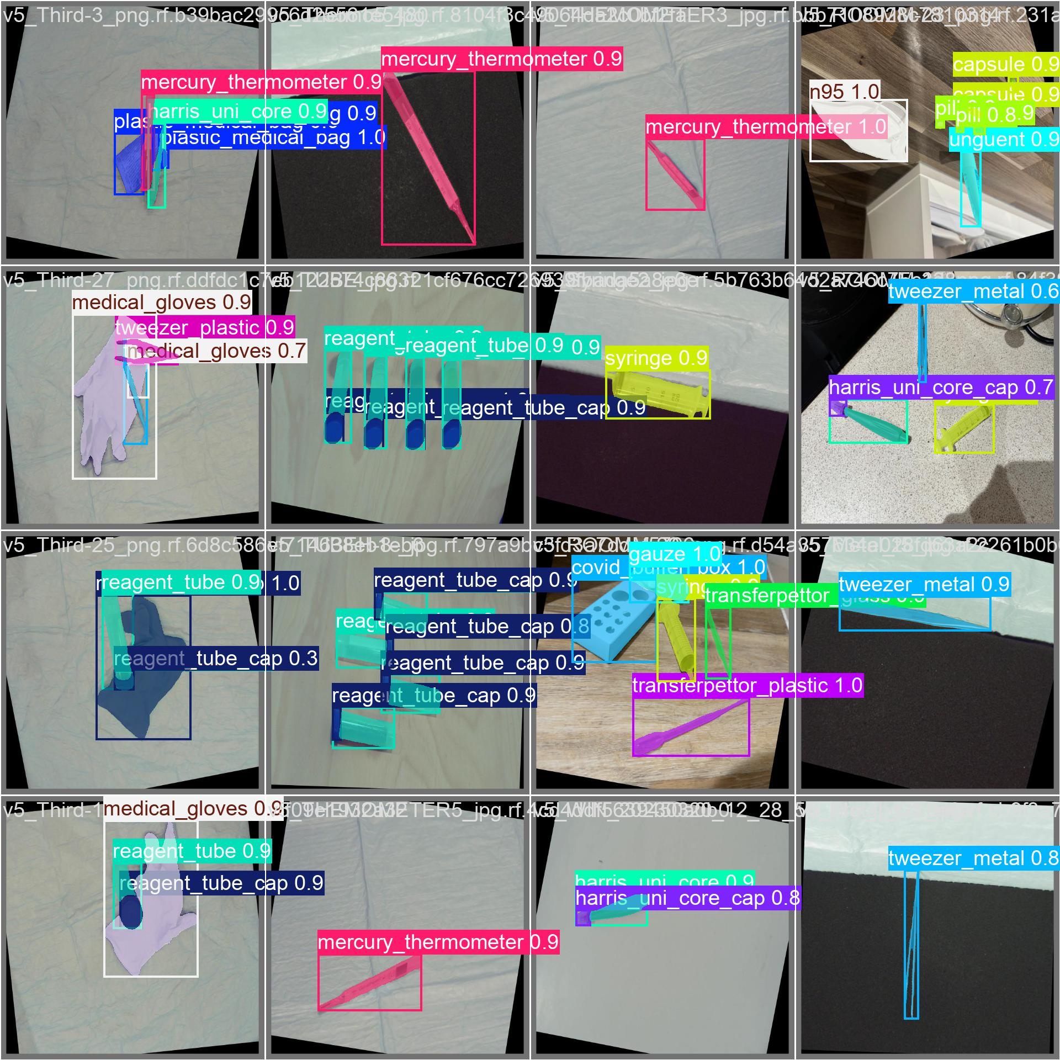
Figure 9: Prediction batch 2 - Predictions on mixed instrument scenes. All mentioned (mercury thermometers, reagent tube rack, tweezer metal, transferpettor plastic, single channel pipettes, harris uni core caps, and plastic medical bags) are accurately identified under different perspectives and lighting.

6.5 Deployment Session Summaries
Figure 10 and Figure 11 display the session summary dashboard of two sample live deployment test sequences with the frequency of class detection, EMA-smoothed risk score over time, and the distribution of hazard level.
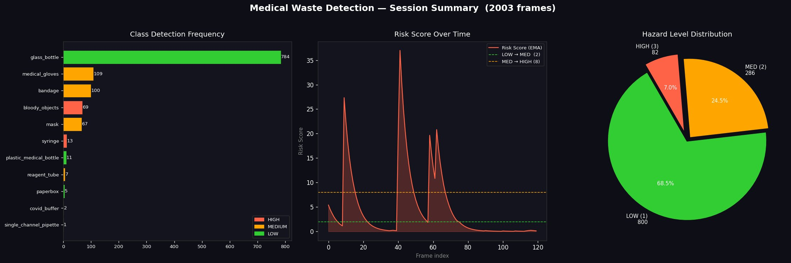
Figure 10: Session overview - 2,003 frames. glass_bottle has the most detections (784) then medical_gloves (109) and bandage (100). Hazard distribution: 68.5% LOW, 24.5% MEDIUM, 7.0% HIGH. There are sharp transient spikes (maximum of around 37) at frame 40 and 60 when bloody objects and syringes cooccurred, and EMA decays quickly between events - indicating the correct sensitivity without saturation of false alarms persistently.

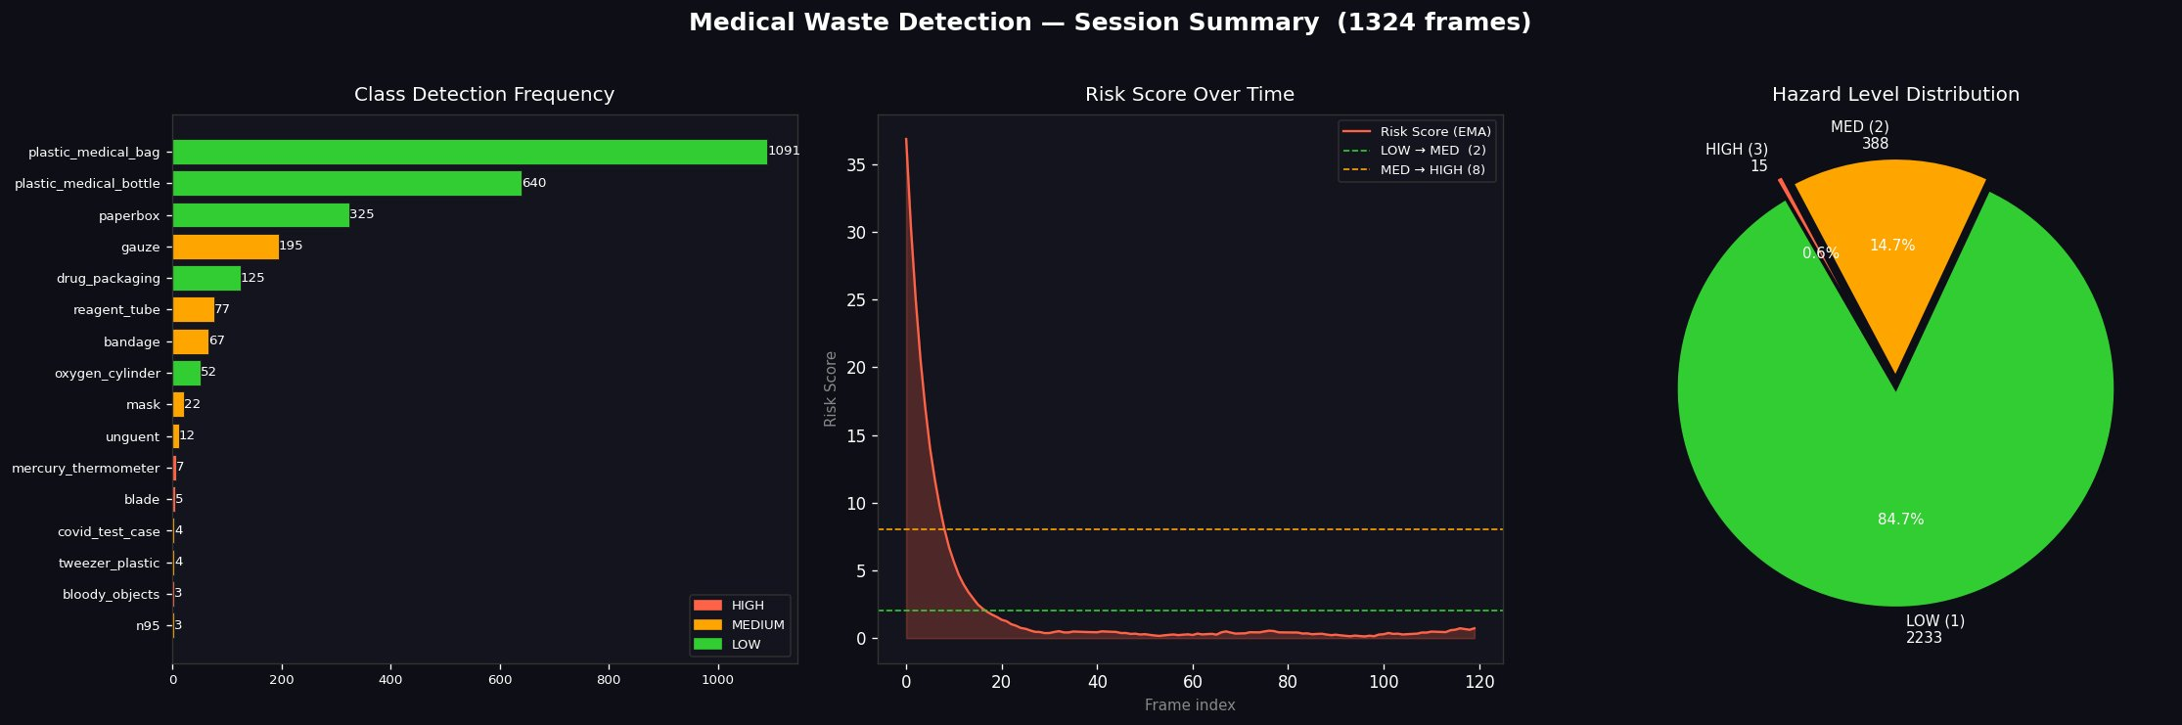
Figure 11: Session summary 1,324 frames. plastic_medical_bag (1,091) and plastic medical-bottle (640) are predominant, which is expected in a waste stream of mostly a packaging material. Hazard distribution: 84.7% LOW, 14.7% MEDIUM, 0.6% HIGH. Risk trajectory rapidly decays with a HIGH spike, followed by a stable LOW band throughout the rest of the session.

7. Real-Time Deployment Interface
The inference pipeline executes three parallel threads: a capture thread that obtains frames via USB or IP cameras; an inference thread that implements the entire MMDBHDSNet pipeline (segmentation, classification, uncertainty estimation, risk scoring); and a visualisation thread that produces results with the help of a producer-consumer queue. The system can support about 55 frames per second at 640x640 input resolution (18 ms per frame) on the target hardware. By enabling MC Dropout uncertainty estimation (T = 10 passes), throughput reduces to around 7.7 fps - which is suitable in limiting applications where flagged detections are bypassed to an asynchronous human inspection as opposed to an actual real-time decision.
Identified cases are depicted with semi-transparent filled polygon overlays with hues based on hazard risk: green (LOW), amber (MEDIUM), red (HIGH). Cases where the predictive variance is high have a dashed outline. Spatial density heatmap sums hazard-weighted detections across a temporal rolling 30-second window, to locate areas of sustained high-hazard activity. The risk trajectory graph is an EMA-smoothed view of the last 120 seconds of risk history with the horizontal threshold lines and a background shading that is updated in real-time to indicate the current tier. The alert escalation system alerts amber banner at MEDIUM risk crossing, auditory sound with red banner at HIGH crossing and automated notification to the facility safety officer when the HIGH risk takes longer than 30 seconds without attention. All events are logged at time to a session audit log to comply with regulations reporting.

8. Future Directions and Conclusion
Future work. The zero AP of cap plastic and below-threshold performance of needle and iodine swab point relate directly to the lack of annotated instances. An active learning loop where the uncertainty estimator flags candidate frames from live clinical feeds for priority annotation will address this iteratively. A large-scale in-situ collection campaign from real hospital waste disposal points will provide distribution-matched data for underperforming categories. Temporal modelling — replacing EMA smoothing with a recurrent or attention-based risk trajectory model — would enable predictive alerts that anticipate HIGH-risk events before they materialise. Architecturally, Vision Transformer backbones offer improved long-range contextual reasoning likely to benefit visually similar class pairs [24, 26]. Knowledge distillation from MMDBHDSNet to a lightweight student network would enable edge deployment on ARM-based smart bin controllers within an integrated facility management system [27].

Conclusion. This paper presented MMDBHDSNet, a dual-branch hazard-discriminative segmentation network that addresses the three structural limitations of prior medical waste recognition systems: insufficient class coverage, absence of hazard semantics, and lack of uncertainty awareness. The Cross-Branch Fusion Gate enables hazard context to sharpen segmentation and vice versa without gradient interference. The hazard-weighted loss ensures that getting a needle wrong, costs the model more than getting a paperbox wrong. Monte Carlo Dropout produces explicit uncertainty estimates that route ambiguous detections to human review. This 38 class benchmark -14,445 highly deduplicated, relabelled and collected images of seven independent sources using a rigorous six stage pipeline- is the most well-documented medical waste segmentation dataset described in the literature. On the held-out test partition, MMDBHDSNet achieves mAP@0.5 of 0.9474, precision 0.951, and recall 0.9168, with a 3.23-point overfitting gap that demonstrates genuine generalisation beyond the training distribution. The system, which is deployed to as much as 55 fps with real time risk visualisation and tiered notifications, is a significant progression towards full automation of AI-assisted clinical waste management to meet the increasing demands of the current healthcare infrastructure.

References
[1] World Health Organization. Safe Management of Wastes from Health-Care Activities. WHO Press, Geneva, Switzerland, 2nd ed. (2014).
[2] Chartier, Y., et al. Safe Management of Wastes from Health-Care Activities. World Health Organization, Geneva (2014).
[3] Tushar, A., and M. S. Alam. "Assessing the Challenges to Medical Waste Management During the COVID-19 Pandemic." Resources, Conservation and Recycling 168 (2021): 105467.
[4] Majchrowska, S., A. Mikolajczyk, et al. "Waste Detection in Pomerania: Non-Profit Project for Detecting Waste in Environment." arXiv:2105.06808 (2021).
[5] He, K., G. Gkioxari, P. Dollár, and R. Girshick. "Mask R-CNN." Proceedings of the IEEE International Conference on Computer Vision (ICCV). (2017): 2961–2969.
[6] Shen, D., G. Wu, and H. I. Suk. "Deep Learning in Medical Image Analysis." Annual Review of Biomedical Engineering 19 (2017): 221–248.
[7] Salsabila, A., and N. Prakisya. "A Sustainable Approach to Waste Detection and Classification Using YOLO: A Review." Journal of Computer Vision and Image Analysis 5.2 (2023): 34–52.
[8] Nandini, G., and E. Budiyanti. "Artificial Intelligence in Healthcare Waste Management: A Narrative Review of Current Applications and Future Prospects." International Journal of Environmental Research and Public Health 19.12 (2022): 7324.
[9] Khalid, M., E. Sultani, and M. Naseer. "Computer Vision Approaches for Waste Segregation: A Survey of Methods, Datasets, and Challenges." Computers in Industry 145 (2023): 103837.
[10] Goh, T. J., and Y. B. Leau. "Computer Vision for Solid Waste Sorting: A Critical Review of Academic Research." Waste Management 143 (2022): 40–55.
[11] Wang, X., T. Kong, C. Shen, Y. Jiang, and L. Li. "SOLO: Segmenting Objects by Locations." European Conference on Computer Vision (ECCV). (2020): 649–665.
[12] Dosovitskiy, A., L. Beyer, et al. "An Image is Worth 16×16 Words: Transformers for Image Recognition at Scale." International Conference on Learning Representations (ICLR). (2021).
[13] Tan, M., R. Pang, and Q. V. Le. "EfficientDet: Scalable and Efficient Object Detection." Proceedings of the IEEE/CVF Conference on Computer Vision and Pattern Recognition (CVPR). (2020): 10781–10790.
[14] Elyan, E., and P. Vuttipittayamongkol. "Computer Vision and Machine Learning for Medical Image Analysis: Recent Advances, Challenges, and Way Forward." Artificial Intelligence in Medicine 102 (2019): 101758.
[15] Gal, Y., and Z. Ghahramani. "Dropout as a Bayesian Approximation: Representing Model Uncertainty in Deep Learning." Proceedings of the 33rd International Conference on Machine Learning (ICML). (2016): 1050–1059.
[16] Lin, T. Y., P. Dollár, R. Girshick, K. He, B. Hariharan, and S. Belongie. "Feature Pyramid Networks for Object Detection." Proceedings of the IEEE Conference on Computer Vision and Pattern Recognition (CVPR). (2017): 2117–2125.
[17] Tajbakhsh, N., L. Jeyaseelan, et al. "Embracing Imperfect Datasets: A Review of Deep Learning Solutions for Medical Image Segmentation." Medical Image Analysis 63 (2020): 101693.
[18] Kebaili, A., J. Lapuyade-Lahorgue, and S. Ruan. "Deep Learning Approaches for Data Augmentation in Medical Imaging: A Review." Journal of Imaging 9.4 (2023): 81.
[19] Litjens, G., et al. "A Survey on Deep Learning in Medical Image Analysis." Medical Image Analysis 42 (2017): 60–88.
[20] Karimi, D., H. Dou, S. K. Warfield, and A. Gholipour. "Deep Learning with Noisy Labels: Exploring Techniques and Remedies in Medical Image Analysis." Medical Image Analysis 65 (2020): 101758.
[21] Zhang, J., et al. "Multi-Task Deep Learning for Medical Image Computing and Analysis: A Review." Computers in Biology and Medicine 153 (2023): 106496.
[22] Razzak, M. I., S. Naz, and A. Zaib. "Deep Learning for Medical Image Processing: Overview, Challenges and Future." Classification in BioApps (2018): 323–350.
[23] Liang, M., et al. "Artificial Intelligence-Based Waste Detection in Robotic Surgery: A Pilot Validation Study." Surgical Endoscopy 37.4 (2023): 2894–2902.
[24] Liu, Z., H. Hu, et al. "Swin Transformer V2: Scaling up Capacity and Resolution." Proceedings of the IEEE/CVF Conference on Computer Vision and Pattern Recognition (CVPR). (2022): 12009–12019.
[25] Minaee, S., et al. "Image Segmentation Using Deep Learning: A Survey." IEEE Transactions on Pattern Analysis and Machine Intelligence 44.7 (2022): 3523–3542.
[26] Acosta, J. N., et al. "Multimodal Biomedical AI." Nature Medicine 28 (2022): 1773–1784.
[27] Crawshaw, M. "Multi-Task Learning with Deep Neural Networks: A Survey." arXiv:2009.09796 (2020).
[28] Anwar, S. M., et al. "Medical Image Analysis Using Convolutional Neural Networks: A Review." Journal of Medical Systems 42.11 (2018): 226.
[29] Zheng, W., et al. "A Review on Deep Learning in Healthcare: Recent Advances, Challenges and Future Trends." Healthcare Analytics 3 (2023): 100203.
[30] Litjens, G., C. I. Sánchez, et al. "Deep Learning as a Tool for Increased Accuracy and Efficiency of Histopathological Diagnosis." Scientific Reports 6 (2016): 26286.

