How VerifAI Works
Technical walk-through in simple language | ET-03 Agentic AI Guardrail Validator, Team Delta
1. What it is
AI agents can now act: delete records, send emails, move money. VerifAI is a guard between the agent and the action. Before anything runs it answers ALLOW (safe, run it), REVIEW (risky, a person must say yes) or BLOCK (never allowed), and records the reasons in a log that cannot be quietly edited.
2. The big picture
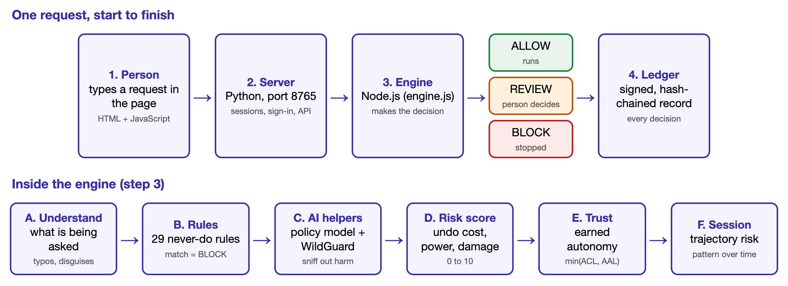
Programs: a web page (plain HTML/JS); a Python server on port 8765 (sessions, sign-in, API, ledger); the decision engine in Node.js (engine.js), which makes every verdict on the server so a user cannot edit it in the browser; WildGuard 7B on port 8000 (AI safety model, optional Llama Guard on 8002); and the agent model (Groq gpt-oss-20b), the only part that sends text off the computer.
3. How a request is judged
Stage | What happens in simple words
A. Understand | Turns text into an action: type, amount, count, target, scope. Repairs typos and undoes disguises (look-alike letters, base64, leetspeak, reversed text, a small Hindi list). Plain chat such as "my name is Asha" is recognised as harmless.
B. 29 hard rules | Fixed never-do rules: leaking passwords or personal data, forgery, impersonation, KYC bypass, structuring money, sanctions evasion, deleting backups or production data, harming people. A match is an instant BLOCK. Some rules check sanctions and consent lists.
C. AI helpers | A policy model (TF-IDF + logistic regression, trained on 11,492 examples) spots reworded violations: very confident (95%) blocks, medium (50%) goes to a person. WildGuard judges general harm and can add a warning but never remove one. If a helper is down, anything not read-only is held.
D. Risk score 0 to 10 | 50% reversal cost: the engine follows the database foreign keys to every dependent record and asks whether a restore would heal it or a real-world effect (invoice sent, payment taken) already happened. 25% policy points. 25% impact, from a model that rates LOW/MID/HIGH from words and amounts. Under 2 leans ALLOW, 2 to 5 REVIEW, 5 and over BLOCK.
E. Earned trust | Autonomy (AAL) starts at 6, rises 0.4 per clean action, and falls 1.2 per block, 0.3 per review, 1.5 for a flagged unsafe request and 2x the latest session risk; the floor is 1.5. An action needs min(capability ACL, AAL) to reach its required level. History lives on the server.
F. Trajectory risk | Scores the whole session: C total risk, W last 5 actions (newer count more), D dangerous orderings (read then export 3, export then message 3, update then delete 2), V rising speed. TR = 0.25C + 0.30W + 0.25D + 0.20V: under 0.35 normal, 0.35 to 0.65 a person, 0.65 and over stop. A structuring check adds up 3+ small actions to one target over ₹900 and lifts ALLOW to REVIEW.

4. People, review and the record
- Review flow. A REVIEW request first goes to the person who asked: approve and run, reject, or "Ask a reviewer" (it joins the Reviews tab; the page polls every 5 seconds). Maker is not checker: nobody approves their own request through a reviewer, and a guest cannot sign in as a reviewer afterwards to approve it.
- Roles. Requester (asha), reviewer (ravi), admin (meena: also changes limits, risk settings and the safety model). PINs are stored hashed (PBKDF2); five wrong tries lock the account. Demo PINs are samples.
- Ledger. Each decision is one row holding the SHA-256 hash of the row before it, so editing history breaks the chain. Hashes are signed (HMAC-SHA256) with a key outside the project; personal data is masked before storing; a verify call names the first bad row. Limit: whoever controls this Mac can read the key, so anchor the latest hash elsewhere.
- Agent and tools. The agent drafts answers and picks tools but never acts directly. Seven sandbox tools run on a SQLite database through a gateway that judges each structured call first. Drafts are safety-checked before they are shown.
5. Why it stays safe
- Fails closed: if the engine, a model or the server is down, nothing is allowed through.
- Local and server-side: listens on 127.0.0.1 only, checks Host and Origin, serves only the page files. Verdicts, trust history and ledger never live in the browser.
- Deterministic: the same input gives the same output, so every decision can be replayed and explained.
6. What was measured, and the limits
Check | Result
Automated tests | 331 pass, 0 fail (221 engine, 78 server, 32 browser)
Public datasets, harmful requests stopped (held-out halves) | 94.1% XSTest, 100% JailbreakBench, 99.0% AgentHarm
Fresh LLM-written attacks / disguised attacks | 0 of 120 prohibited allowed / 92 to 100% of 780 blocked
Hand-written tests | Impact model 92.8% and 96.7%; policy model right rule on 54 of 63 reworded violations
Real banking queries wrongly blocked | 8.3% before training, 0% after

Limits: it is cautious (about 39% of one harmless look-alike set wrongly blocked; about 42% of ordinary requests in one test held for a person). Weights and thresholds are hand-set. The reversal graph, lists, users and tools are samples. Most tests were written by the team or the same LLM family. No outside testers yet; multi-turn attacks, load and most non-English input are untested.
7. Run it
./start.sh then open http://localhost:8765 (./start.sh stop to stop; --llamaguard adds the second safety model).

