Machine Learning Approaches for Energy Demand Forecasting: A Focus on Neural Networks and LSTM Models

- Introduction
Energy demand prediction has an important role in the effective functioning of the modern power grids and energy management systems. With the global increase in energy consumption, prediction of energy demand at a high accuracy has become a necessity to the utility companies, grid operators and policy makers. Effective demand forecasting enables optimal generation, better grid stability, less cost of operation and increased future energy requirement planning. It also enables the incorporation of the renewable energy sources which are necessarily variable and intermittent, as it offers information on the changes of the loads and helps to balance the supply and demand in real-time.

In the past, statistical forecasting models like AutoRegressive Integrated Moving Average (ARIMA) and the exponential smoothing have been used in forecasting the energy demand. Although effective in some situations, these models tend to fail when the demand data follows a non-linear behavior or when the demand data is affected by several other variables, which cause dependency on each other like weather conditions, occupancy trends, socio-economic factors, and the time of year. Also, the traditional approaches are normally problematic in making long term forecasts or where the data encountered in the demand is highly seasonal, trend based or suffers a sudden shock. Machine learning (ML) algorithms have demonstrated significant potential in eliminating these challenges unlike classical statistical methods. ML methods can be used especially effectively to model complex and non-linear dependencies and interactions between variables. In comparison with conventional approaches, the ML algorithms are able to automatically discover patterns in data without necessarily defining relationships between the variables that input into it. This enables ML models to model complex temporal dependencies, and underlying trend which might otherwise be challenging to identify with traditional statistical models.

Neural networks have proven to be one of the most effective tools of time series forecasting among the other traditional ML techniques, especially when the time series of energy needs is involved. ANNs are meant to mimic non-linear relations between inputs and outputs that are usually complex, this makes them useful particularly in the prediction of energy demand since it is a product of numerous factors. ANNs are able to learn how to estimate any continuous function by using many layers of linked nodes. They can be used to learn to handle a wide range of input data in addition to historical load data. Nevertheless, simple neural networks do not always achieve good results because of the problems in parameterization of long-run effects and time-changing patterns of sequential data. To overcome these drawbacks, even more sophisticated neural nets, including Recurrent Neural Networks (RNNs) and specifically Long Short -Memory (LSTM) networks, have been created. LSTM networks are a form of RNNs which can be learned to capture long-range dependencies by using the specialized gating mechanisms to store information in the long run. This feature makes LSTMs specifically effective in solving time series prediction problems whereby the model is required to retain the data in the past in order to predict the future values correctly.

The relatively important benefits of LSTM in energy demand prediction work with the modeling of time relationship in the consumption trends. The dependencies they can learn would be well represented by LSTMs and be applied to actually predict the demand even in situations where the demand data may have complicated patterns like spikes during the high usage periods or slow gradual patterns that are experienced during the times of low usage. In addition, LSTM models can be trained to consider the various forecasting horizons such as short-term prediction (hours to days), medium-term forecasting (weeks to months), and long-term forecasting (years). This paper focuses on the forecast of energy using the sliding window approach by using past demand energy to forecast the future demand energy.This is more common in time series forecasting as the technique is used to generalize the patterns of a model over different time spans by only using the latest observations to make predictions.

In spite of the strengths of LSTM networks, there are still a number of challenges that remain in the application of ML techniques in energy demand forecasting. The major issue is that data of high quality and high resolution is needed. The data regarding energy demand tend to be imperialistic and incomplete, and the quality of the data used to construct the ML models can heavily depend on the quality of the data used. Also, the choice of input features is very important in the performance of models. Another weakness is the interpretability of the model. Although machine learning models and especially deep learning ones have been shown to perform better, they may be viewed as black-box models that do not provide insight into the way they make their predictions. Such an inability to be interpreted can become a major obstacle to the appeal of LSTM models in the energy demand forecasting domain where interested parties often need to have the idea behind predictions to build trust and guide decision-making.

Even more issues can occur in the implementation of machine learning models to predict energy demands of real-life objects. Several energy management systems run on a computational resource limited environment, e.g., edge devices or smart meters. This paper focuses on the development of efficient and lightweight models that can be deployed in these resource-constrained environments without sacrificing forecasting accuracy. Additionally, real time prediction programs need models that are also fast and capable of making predictions in a limited time frame which further reinforces the necessity of computationally efficient algorithms. The rapid development of the energy systems, the increasing popularity of the renewable energy sources, and the rise in the popularity of the smart grid technologies makes the task of energy demand prediction an even more important part of the present-day energy systems. The demand forecasting has to adapt with the changes in energy system which is becoming more intricate as they involve a more dynamic and decentralized generation. The purpose of this paper is to discuss how machine learning, , basic neural networks and LSTM models, can be used to overcome the issue of energy demand forecasting in relation to the modern energy systems.

The rest of this paper will discuss the specifics of other machine learning approaches to energy demand forecasting, and especially more recent developments in the form of LSTM networks.

- Literature Review: Trends and Insights (ML-Focused) Key.

A similar pattern has occurred in recent years towards using machine-learning (ML) algorithms, especially towards the use of ensemble methods (e.g., Random Forest, XGBoost, CatBoost, Extra Trees, Gradient Boosting) and hybrid/ensemble machine-learning frameworks, to predict energy demand (electricity load). This change can be explained by the necessity to model non-linear relationships, and non-homogenous consumption patterns that can not be easily modeled by traditional statistical frameworks or models which can be expressed using simple linear regressions. Recently, a comparative study with a large scale by Hussain et al. (2025) compared eleven ML models including linear models (Ridge and Lasso), tree-based (XGBoost, LightGBM, Extra Trees), support vector regression, k-nearest neighbours, multilayer perceptrons and Gaussian process using residential and electric-vehicle related energy consumption data [1]. Their results indicate that ensemble and tree-based models will always have better performance over linear and other simple models, which highlights ML’s ability to uncover dynamics in consumption. There is strong performance of ensemble methods combining a number of base learners. As an example, Gupta et al. (2025) created a voting-regressor ensemble that included Random Forest, Extra Trees, and Decision Tree, and whose performance in terms of short and medium term load forecasting was significantly better than the performance of the individual algorithms when used separately [2]. Gradient-boosting methods have become popular as an efficient option in terms of building-level forecasting or building-stock forecasting of loads. As demonstrated by Mustaffa et al. (2025), XGBoost based models can absorb the complex patterns of loads in buildings hence they support variability that can be attributed to usage, external conditions, as well as time change [3].

ML frameworks are effective, particularly when large-scale energy data (campus or building consumption) is needed, and the timefulness is high-resolution (e.g., hourly). The article by Alsamraee et al. (2025) shows that the scaling of ML-based forecasting to large quantities of data does not compromise its accuracy in the high-frequency settings [4]. Even less developed ensemble ML methods like the Random Forest are competitive. Magalhães et al. (2024) implemented the technique of Random Forest with hyperparameter optimization on the hourly load prediction of substations and presented strong and precise results [5]. Altogether, the current state of the art assumes that ensemble ML models, specifically gradient-boosting and tree-based models, are the most reliable, accurate, and scalable to forecast energy demand in a variety of settings (residential, building, grid segments) and forecast horizons (short to medium term).

Table 1 State of the art Forecasting Method
Year | Paper | Forecasting | ML Method used
2025 | Evaluating machine learning algorithms for energy consumption prediction in electric vehicles: A comparative study | Residential / EV energy consumption | Ridge Regression, Lasso Regression, K-Nearest Neighbors, Gradient Boosting, Support Vector Regression, Multi-Layer Perceptron, XGBoost, CatBoost, LightGBM, Gaussian Processes for Regression(GPR) and Extra Trees
2025 | An ensemble‑based enhanced short and medium term load forecasting | Electricity load forecasting | ensemble voting regressor method
2025 | Advanced forecasting of building energy loads with XGBoost and metaheuristic algorithms integration | Building energy consumption forecasting | XGBoost and other gradient-boosting ML methods (in a hybrid predictive approach)
2024 | High-resolution energy consumption forecasting of a university campus power plant based on advanced machine learning techniques | Hourly energy consumption from large dataset (campus | –Decision Tree (DT), Random Forest (RF), Support Vector Regressor (SVR), K-Nearest Neighbor (KNN), and eXtreme Gradient Boosting (XGBoost)
2024 | Short-Term Load Forecasting Based on Optimized Random Forest and Optimal Feature Selection | Short-term hourly load | Random Forest (RF) with hyperparameter tuning
2024 | Evaluation of electrical load demand forecasting using various machine learning algorithms | Forecasting of power load prediction | support vector machines (SVMs), long short-term memory (LSTM), ensemble classifiers, recurrent neural networks, and deep learning method

- Machine Learning Techniques for Forecasting

3.1 Linear Regression

Linear regression is an algorithm that is utilized to forecast continuous values over a single or more independent variables. Its theory assumes a linear correlation between the dependent variable and a single independent variable, i.e. future energy demand (y) and an independent variable (x) i.e. historical energy consumption, in a straight line. The formal representation of the linear regression model is.
$$y=β_{0}+β_{1}x+∈$$

where y represents the predicted value, x represents the feature, $β_{0}$is the intercept, $β_{1}$is the slope coefficient, and $∈$represents the error term. This algorithm is particularly useful when the data shows a linear relationship between the feature and target, thereby providing a simple, computationally efficient solution for energy demand forecasting. However, the weakness of standard linear regression is that it fails to reflect the non-linear trends, which are common in energy usage information.

3.2 Decision Trees

A decision tree is a supervised learning algorithm which can be used in both regression and classification problems. The method splits the input space into subsets, depending on the value of the features, so as to form a tree structure where each internal node represents a decision based about a specific feature, and each leaf node represents an outcome of prediction. The goal of decision-tree algorithms is to minimize the Residual Sum of Squares(RSS). At each node, the data is partitioned using the property of the node that presents the best reduction in RSS. Decision trees can represent the complex, non-linear interrelationships between the variables, which means that they can be useful in the energy demand prediction. Trees are however subject to overfitting, particularly the deeper the tree is, thereby regularization methods like pruning are frequently used to temper the complexity level of the tree and increase the performance of generalization.

3.3 AdaBoost

AdaBoost or Adaptive Boosting is an ensemble algorithm that makes use of weak learners to strengthen the predictive accuracy of weak learners through iteratively correcting the errors of previous models. The general idea is to build weak models sequentially and to address the inaccuracies on the previous predictions of the models. AdaBoost is especially significant in terms of forecasting energy demand, by focusing on sudden spikes or heavy in demand situations. AdaBoost is however sensitive to noise and outliers and this may hinder its predictive power. In spite of these constraints, its ability to strengthen simple decision trees makes it a powerful methodology in making improvements on the precision of overall predictions.

3.4 XGBoost

Extreme Gradient Boosting or XGBoost is an optimized version of gradient-boosting trees that has high predictive accuracy as well as computational efficiency. XGBoost reduces over-fitting by avoiding L1 (lasso) and L2 (ridge) regularization on top of all the outputs of many decision trees, as well as making use of shrinkage (learning rate) to refine the construction of individual trees. The ability of XGBoost to process massive amounts of data and complicated interactions between features makes it a favourable tool in energy demand forecasting, where there is a high-variance, non-linear relationship. Its feature-importance analysis also enables consideration of critical factors in energy consumption to increase the interpretability and utility of a model in turn.

- Experiments

In this section, the framework used to implement the Global Active power demand forecasting through the use of ML algorithms is defined.

A. Parallel Framework

In the parallel strategy the forecasting task is broken down in a series of parallel subproblems, one of which represents the prediction of each element of the multi predication forecast vector. Within the support vector machine (SVM) system, a series of h different SVMs are run in parallel to project an h-step ahead forecast, h using the multi-core processing ability of commercial GPUs and CPUs. The different models are specialized in a particular subproblem of the multi-step forecast. Similarly, in the artificial neural network (ANN) systems, one subproblem is solved by the same network topology retraining. In case of completion of the parallel training stage, the generation of the h-step-ahead forecast vectors is concurrently made thus enabling efficient forecasting.

B. Parameters Setup

We used the dataset used in reference, which is an active power consumption of a single household to test the performance of the forecasting techniques. The measurements were also taken after every minute throughout a period of four years giving over two million data points. A segment of the data was used to train the model and the rest was to be used to test the predictive accuracy.

In all the models, 120 step ahead predictions using an input sequences of the last 30 samples. This corresponds to an two hour forecasts based on the previous 30 minutes of the data. In the case of Linear Regression, Decision Tree, XGBoost, AdaBoost, SVM, a training set of 5,000 samples was used to maintain the same framework used in the baseline paper. Increasing the training size beyond this level only lead to marginal accuracy improvements. On the other hand, in the case of the long short-term memory (LSTM) model, the best accuracy of the model was obtained and had a training set of 100,000 samples, which consumed an acceptable training time on conventional hardware.

- Results
Next, we present the experimental results obtained through the parallel forecasting framework and the parameters setup of Section III.

Linear Regression:
Linear Regression assumes a linear relationship in the relationship between the predictor variable and the response variable. It works best when underlying data follow a linear structure, but does not work with temporal relationships and nonlinear behavior often found in energy consumption data. The measures of the mean absolute error (MAE), mean squared error (MSE), and error variance grow exponentially as the forecast horizon is extended, and this is the result to the inability of the model to generalize appropriately at long periods of time as seen in Figure 1. The lack of ability to reproduce the trends or other complex temporal contingencies makes its predictions increasingly inaccurate as the range of the forecast is widened. Therefore, although Linear Regression will be applicable in short-term forecasting, the accuracy of the tool will decrease significantly when it has a multi-step ahead forecast.
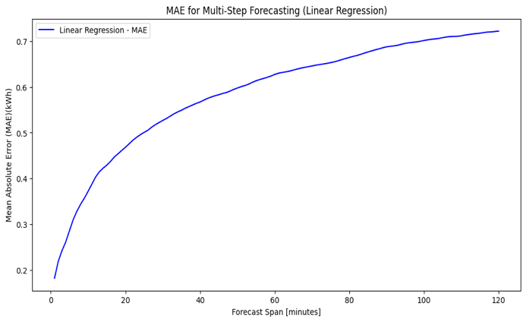
(a)
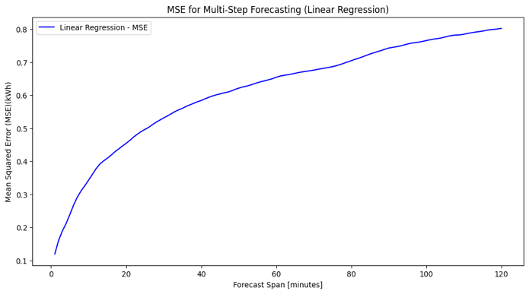
(b)
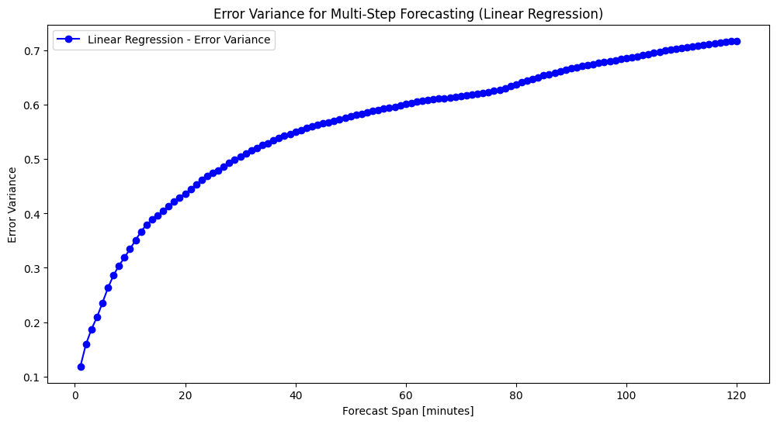
(c)
Figure 1 Forecasting using Linear Regression Model

AdaBoost:
AdaBoost is an ensemble learning algorithm that combines the performance of weak learners in order to complement the overall predictive fidelity.. When used in the context of energy demand forecasting, AdaBoost provides sufficient short-term results, but the MAE, MSE and error variance coefficients have slow increases as time to forecast increases. This implies that despite the fact that AdaBoost works towards reducing bias and increasing short-term accuracy, the model is incapable of modeling the time dependence that is necessary to achieve long-term forecasting. That error variance has increased over time is in agreement with an increasing uncertainty as time progresses and is indicative of the inability of the algorithm to capture complex, extended trends inherent in the data.
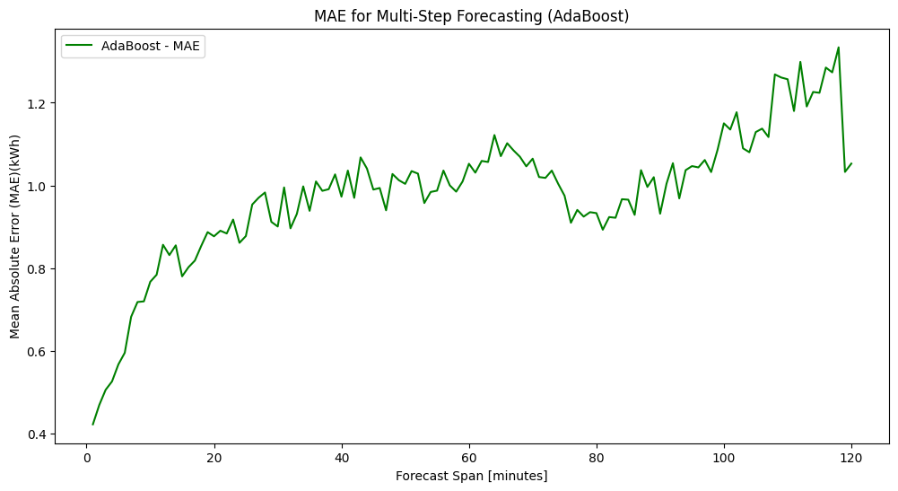
(a)
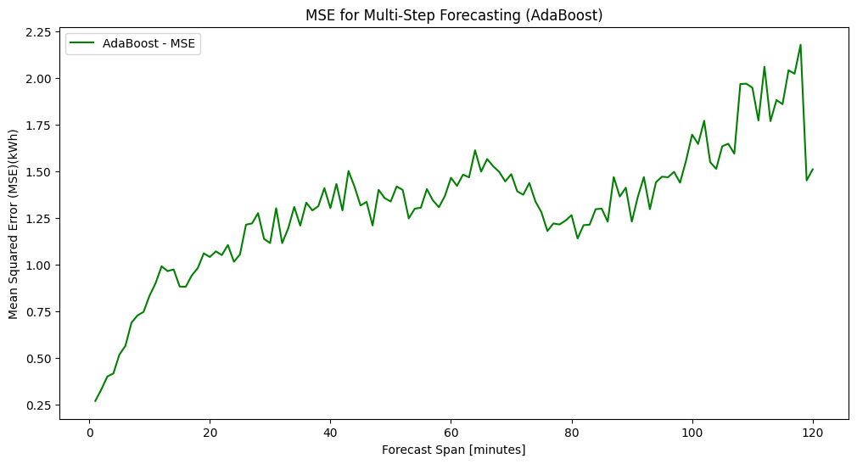
(b)
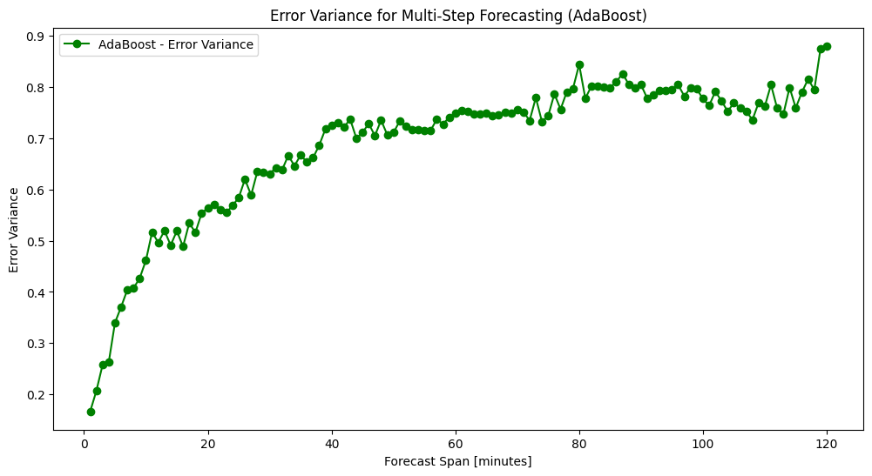
(c)
Figure 2 Forecasting using AdaBoost Model

Decision Tree:

The Decision Tree algorithm subdivides the feature space into different areas and makes predictions using the cut points. Despite being more suitable in the depiction of non-linear relationships than in pure linear models, Decision Trees cannot depict serial data or time based phenomena necessary in energy projections. The MAE, MSE and error variance increase gradually with the forecast horizon, which demonstrates that the model is not able to maintain the similarity with longer periods of time. This degradation is caused by the nature of the algorithm that ignores the dynamic temporally contingent characteristics of the dataset. Moreover, Decision Trees are also prone to overfitting, thus worsening the change in error variance with the increase of horizon, thus rendering them inapplicable to multi-step ahead forecasting exercises.

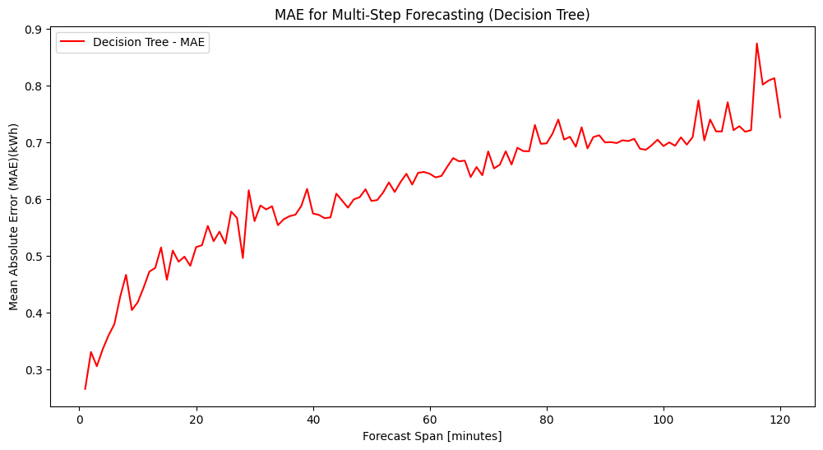
(a)
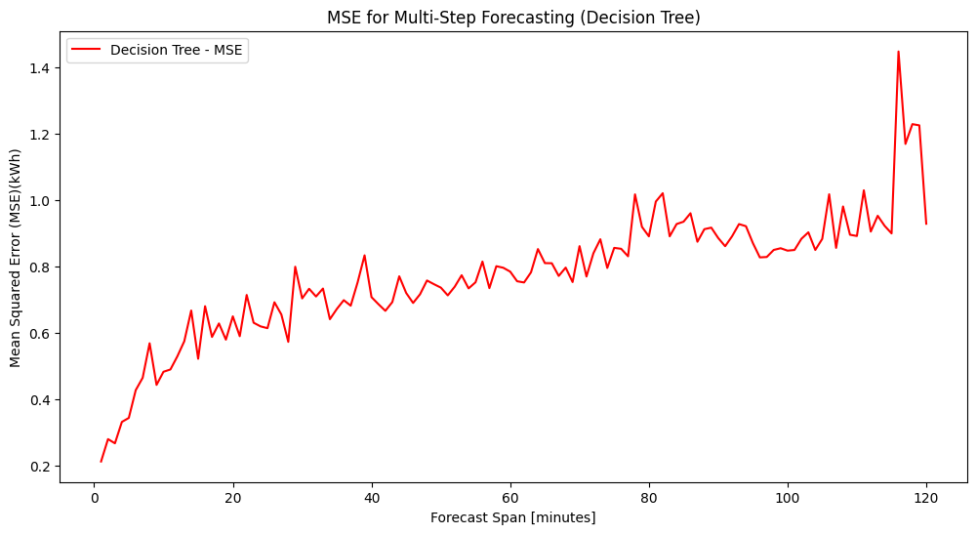
(b)
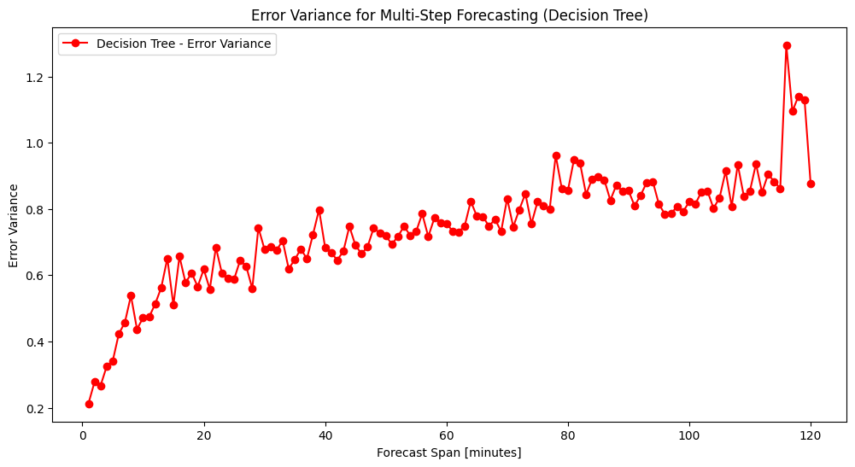
(c)
Figure 3 Forecasting using Decision Tree Model

XGBoost:

XGBoost is a complex ensemble algorithm that is based on gradient boosting and is designed to address the weaknesses of single decision trees by reducing the residual errors. The model performs better in short terms forecasting analysis, which exhibits comparatively low MAE and MSE values in the initial forecast cycle. However, further out the horizon, both the MAE and MSE grow exponentially and the error variance increases indicating increased predictive uncertainty. These observations indicate that even though the XGBoost is effective in addressing overfitting issues and accommodates nonlinearities better than individual tree, it is not doing it as well as addressing issues in the field of encoding the temporal connections that are critical to a proper long-term prediction. The lack of explicit time-series modeling features, including autoregressive models, or trend models, also leads to larger errors, and increased uncertainty, to longer forecasting horizons.

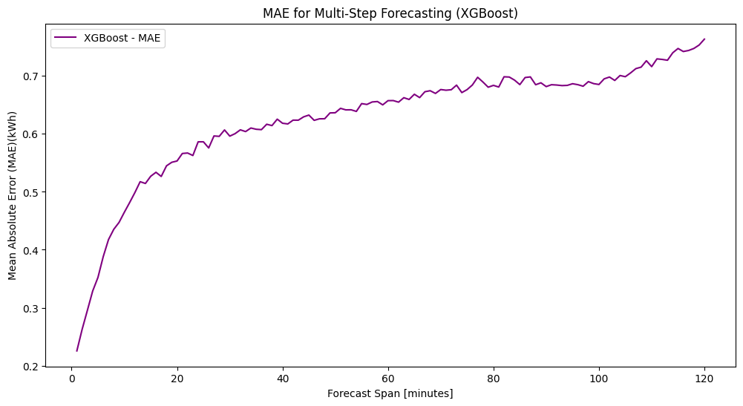
(a)
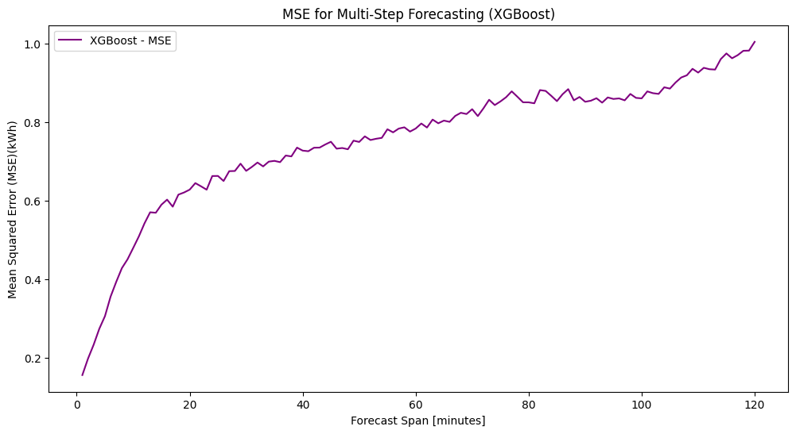

(b)
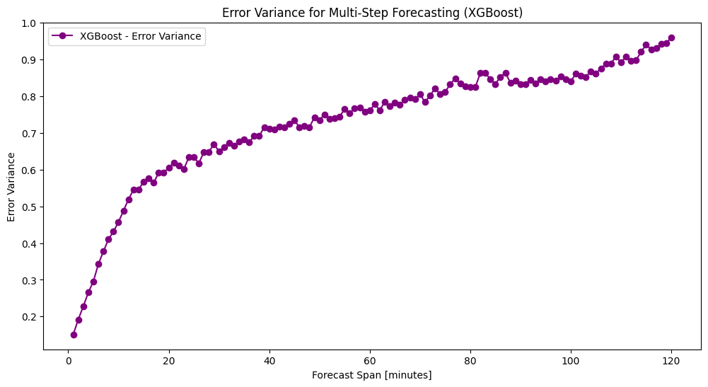
(c)
Figure 4 Forecasting using XGBoost Model

