**Design Specifications**

**Team:**EduEvolvers

**Date:**21/09/2023

**Languages Used:**

* Frontend:
* HTML
* CSS
* Javascript
* Backend:
* PHP
* Python
* MySql

**System Architecture:**

**ER Diagram**

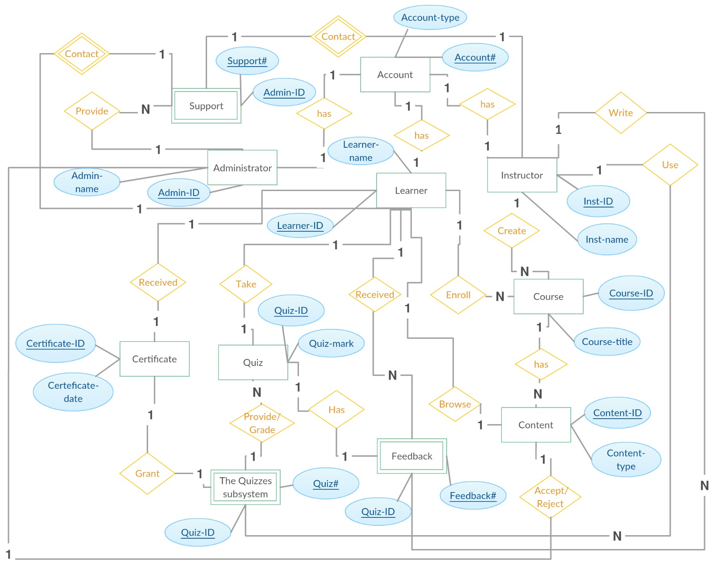

**CLASS DIAGRAM:**

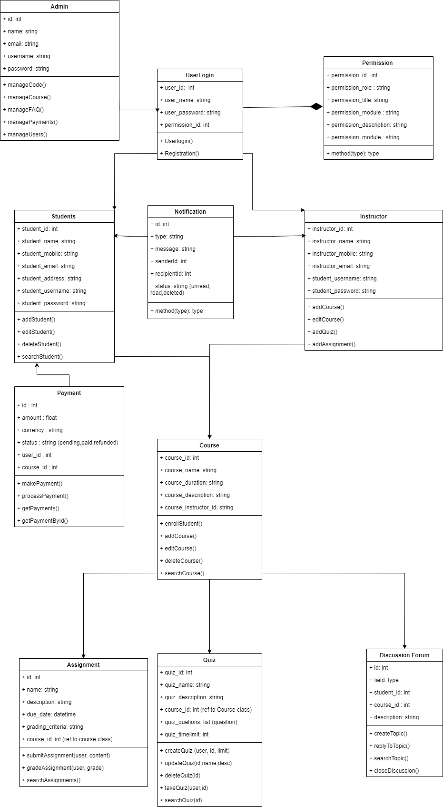

**Use Case Diagram**

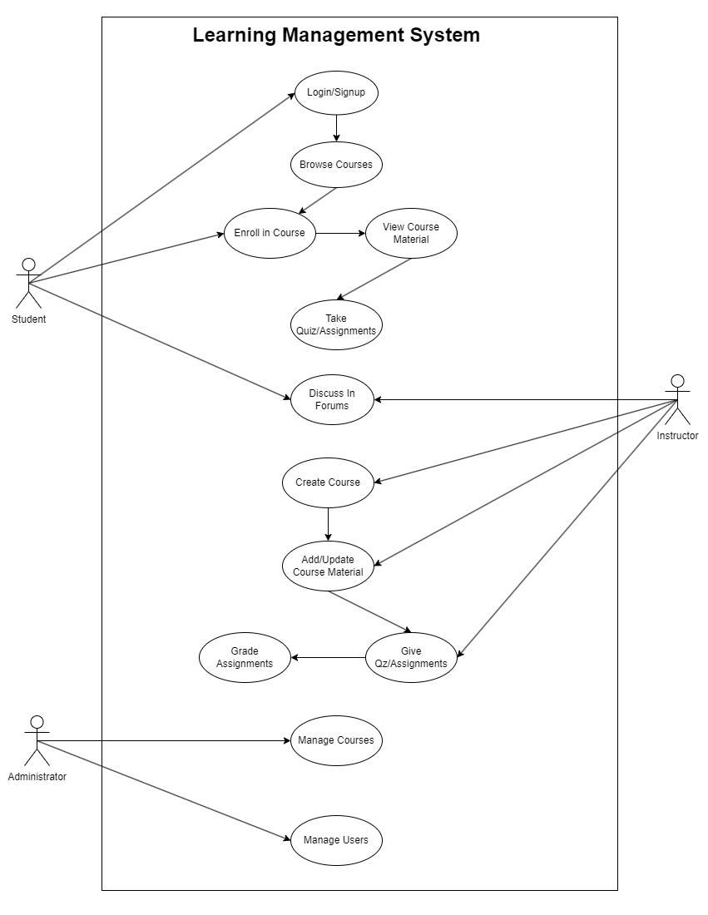

**Deployment Diagram**