**Project Title: E-Learning Platform**

Team name: **EduEvolvers**

**Project Date:**18/09/2023

**Project Manager(s):** Daksh Shukla

**Key members:**

* ARYAMAN **(21BCS3853)**
* DAKSH SHUKLA **(21BCS6432)**
* KIRTPREET KAUR **(21BCS3531)**
* JASLEEN KAUR **(21BCS11176)**
* SHUBHANSHU PANDEY **(21BCS3854)**
* SNEH SAGAR SUBEDI **(21CBS1048)**

**Requirement Analysis:**

Education is the most powerful weapon you can use to change the world and the next is the Internet. The era of coronavirus broke the long-time practice of conventional education in only classrooms and we got introduced to e-Learning platforms. Today we have many e-learning platforms moodle, one of Chandigarh University’s own LMS, etc. The education industry is evolving and what it needs is an efficient e-learning platform to provide distance education as well as maintain the interest of students and keep them motivated and at the same time maintain quality of education. It should be flexible and must offer a wide variety of courses on a single platform without having to get into the hassle of traveling and is hence cost-effective.

**So what are we going to do?**

· Create a web application for online and distance learning.

· Develop an onboarding process for new users (both instructors and students) to familiarize them with the platform's features and functionalities.

· Provide training materials or resources to help users make the most of the platform.

· Provide content in the form of PPTs, videos, audio, lecture notes, or other documents.

· Inclusion of gamification elements, such as badges, leaderboards, etc. to enhance user engagement and motivation.

· Establish a data backup and recovery strategy to prevent data loss and ensure business continuity.

· Include feedback mechanisms within the platform for users to report issues, suggest improvements, or seek assistance.

**What are the critical factors we need to accomplish? (Ranked by priority)**

1.  **User Registration and Login**: Develop user registration and login functionality with secure password handling.

2. **Course Catalogue and Enrolment:** Create a user-friendly course catalogue displaying available courses, Enable Users to browse search, and filter courses, and Implement a seamless enrolment process.

3. **User Profiles:** Develop user profiles where learners and instructors can manage their information, Include features like bio description.

4.  **Interactive Course Material:** Implement course content delivery, including video lectures, text material, quizzes, and assignments, Ensure content is accessible and responsive across various devices

5. **Content Management System(CMS):** Create a CMS for instructors to upload and manage course content, implement version control easily

6. **Quiz and Assignment Management:** Build a system for creating, grading, and managing quizzes and assignments, including auto and manual grading.

7. **Engagement and Retention:** Implement features and strategies to enhance user experience such as multimedia content, attractive UI/UX, etc.

8.  **Feedback and Improvement:** Collect feedback from learners as well as tutors to continuously improve platform performance.

9. **Rewards:** Provide rewards and badges on completion of tasks to keep users engaged and motivated.

10. **Progress Tracking**: Develop Tracking mechanisms to monitor learner's progress within courses, Provide visual representations of progress such as progress bars and completion percentages.

11. **Database Implementation:** Setup Database structure to store user profiles, course data, progress records, quiz scores

12.  **User Authentication and Authorization:** Develop authentication processes to verify user identifies during login, implement role-based access control

13.  **Analytics and Reporting:** Implement analytics to track user behavior, such as course completion rates, quiz performance, and time spent on the platform, and generate reports for both learners and instructors.

14. **Weekly Goals:** Reminders to set and accomplish weekly goals.

**Key Personas**

* **Student Persona:** Pursuing higher education or professional development.

Goals and Motivations: Access high-quality educational content, engage in interactive learning, improve skills and knowledge, obtain certifications.

Challenges: Limited time, need for a flexible learning schedule, desire for clear progress tracking and feedback.

Behaviour and Preferences: Prefers mobile-friendly interface, values peer interaction and collaboration, appreciates clear navigation and intuitive design.

* **Instructor Persona:** A seasoned academic or industry expert.

Goals and Motivations: Share expertise, create engaging courses, track student progress, provide constructive feedback, and facilitate effective learning.

Challenges: Need for an easy-to-use platform, desire for comprehensive analytics, time constraints due to teaching commitments.

Behaviour and Preferences: Values a simple course creation process, appreciates real-time analytics on student performance, and seeks a platform that minimizes administrative tasks.

* **Administrator Persona:** A technical administrator responsible for managing and supervising the working of the platform.

Goals and Motivations: Ensure platform reliability, scalability, and security, optimize performance, manage user data, and provide technical support.

Challenges: Balancing performance with scalability, ensuring data privacy and security, and responding to technical support requests.

Behavior and Preferences: Values a robust and secure technical infrastructure, appreciates a clear and efficient user management system, and seeks easy integration and maintenance.

**Success Metrics**

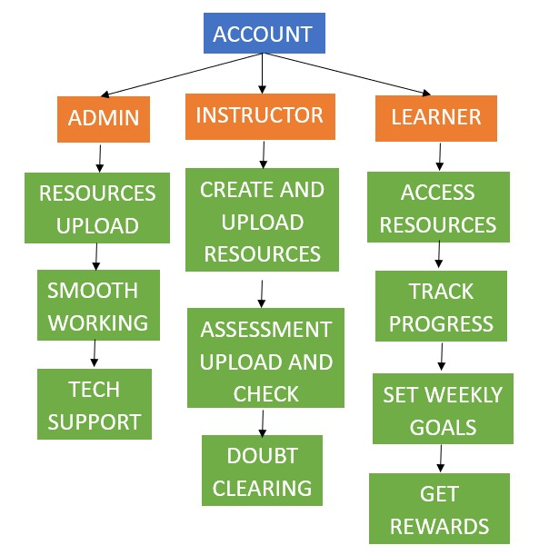

**Functional Specs:**

**A scenario for persona in e learning platform,**

Mukesh is a 24 year old software developer with a passion for marketing and business. He has been working in the field for several years and wants to expand his skillset at his own pace.

**User registration and profile Setup:**

* During his free time mukesh can log in to the e learning platform and find his preferred courses.

**Going through the courses and enrolling:**

* He can choose the course according to his requirements such as time,budget and skill based.
* The course will be added to his dashboard.

**Attempting the test And quiz:**

* He can learn it according to his course(pause and resume the learning according to his preferences) and submit assignments and quizzes given by the instructor.

**Tracking progress:**

* He can also track his progress and can practice some quizzes.

**Reminders:**

* The notification or pop ups of the assignment or test deadlines will be shown on the dashboard.

**Feedback:**

* He will also be able to review the course that will be shown to other users.
* He can also give feedback about the video quality and content of the courses.

**System Overview:**

**1.System Purpose:**

It is designed to facilitate online learning and education by providing a user-friendly and feature-rich environment for students to access and manage educational content.

**Primary Purpose:** The primary purpose of the system is to offer a comprehensive and flexible online education platform that allows users to access courses, collaborate with peers, interact with instructors, and track their learning progress.

**Secondary Purposes**:Provide a platform for instructors to create and deliver courses. Offer a marketplace for users to discover and enroll in a wide range of courses. Facilitate communication and interaction among students and instructors.

**2.Key Features**

**User Registration and Authentication:** Users can create accounts, log in, and reset passwords securely.

**User Roles**: Support for multiple user roles, including students, instructors, and administrators, each with specific permissions.

**User Profiles:** Users can personalize their profiles with details such as profile pictures, bios, and contact information.

**Content Delivery:** Various content types, including video lectures, documents, quizzes, and assignments, can be delivered to students.

**Enrollment:** Students can browse a course catalog, enroll in courses, and access enrolled courses from their dashboards.

**Progress Tracking:** Users can monitor their progress within courses, view grades, and receive performance analytics.

**Assessments and Grading:** Instructors can create assessments and assignments, while students can submit work and receive grades.

**Payment and Subscriptions:** Support for payments, subscriptions, and billing for premium courses.

**Notifications:** Users receive notifications for important events, such as course updates and messages.

**3.Target Audience**

**Students:** Individuals seeking online education and skill development.

**Instructors:** Educators and subject matter experts interested in creating and delivering courses.

**Administrators:** Platform administrators responsible for system management and content moderation.

**4. System Architecture**

**Front-End:** The platform will have a web-based front-end accessible from various devices and browsers.

**Back-End:** The back-end will consist of servers, databases, and application logic responsible for managing users, courses, and content.

**Database**: Data storage for user profiles, course content, user progress, and more.

**Open Issues:**

* Incorporation of WCAG.
* Creation of Classroom.
* Utilization Elastic Cloud.
* Making Chatbot.

**External Interface Specification for EduLearn:**

**i. User Interfaces:**

* EduLearn provides a web-based user interface accessible via popular web browsers such as Chrome, Firefox, and Safari.

**ii. User Authentication:**

* EduLearn supports various authentication methods, including manual username/password, email-based self-registration, and integration with external authentication sources (e.g., OAuth).

**iii. API Integrations:**

* EduLearn supports integration with external systems through APIs, allowing for single sign-on (SSO), content integration, and reporting.

**iv. Authentication and Single Sign-On (SSO) :**

* just like apple id

**v. Payment:**

* Incorporation of payment gateways.

**vi. Google analytics and custom analytics**

**vii. Messaging**:

* Real-time notifications.

**Technical Specifications:**

**Hardware Details:**

* **Processor:** Compatible with Windows server hardware recommendations.
* **Boards:** Server boards compatible with Windows Server.

**Operating System:**

* **OS:** Windows Server (e.g., Windows Server 2019).

**Performance Constraints:**

* **Power Consumption:** Optimize for energy efficiency in Windows server configurations.
* **Speed:** Ensure high throughput for concurrent operations on Windows Server.

**Programming Languages and Technologies:**

* **Backend:** Utilize languages and frameworks compatible with Windows, such as ASP.NET with C#.
* **Frontend:** HTML5, CSS3, JavaScript with support for Internet Explorer (if required).
* **Database:** Microsoft SQL Server for Windows environments.
* **Web Server:** Internet Information Services (IIS) as the web server.
* **IDE:** Visual Studio.
* **Version Control:** Git with Windows-compatible tools.
* **Build System:** Use Windows-compatible build tools.
* **APIs:** Implement RESTful APIs compatible with Windows server.
* **Security:** Implement Windows Server security features, SSL/TLS encryption, and authentication.

**Software Versions (as of 2021):**

* **Windows Server:** Windows Server 2019.
* **.NET Framework:** Utilize the appropriate version compatible with Windows Server 2019.
* **HTML/CSS/JavaScript:** Latest standards compatible with Windows browsers.
* **Microsoft SQL Server:** Latest version compatible with Windows Server.
* **IIS:** Latest version compatible with Windows Server.
* **Visual Studio:** Latest version.
* **Git:** Latest version with Windows support.
* **Node.js:** LTS version with Windows compatibility.
* **npm:** Latest version with Windows support.

**Communication Plan**

* ARYAMAN **(21BCS3853)** (Frontend and Backend)
* DAKSH SHUKLA **(21BCS6432)** (Development)
* JASLEEN KAUR **(21BCS11176)** (Frontend and Design)
* KIRTPREET KAUR **(21BCS3531)** ( Project Manager and Team Leader)
* SHUBHANSHU PANDEY **(21BCS3854)** (Backend and Bug Fixing)
* SNEH SAGAR SUBEDI **(21CBS1048)** (Design and Bug Fixing)