**UI SPECIFICATIONS**

**Team-** EduEvolvers

**Project:** E-Learning Platform

**Date:** 20/09/23

**Sign in Page**

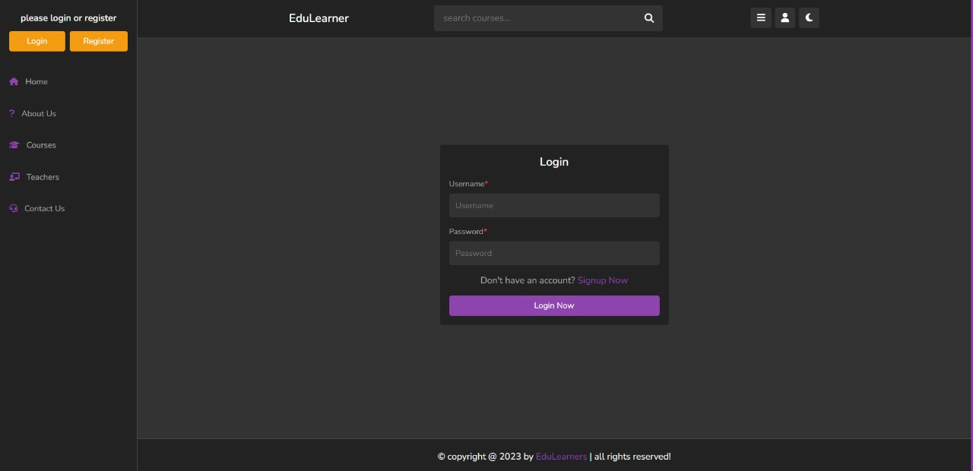

**Home page:**

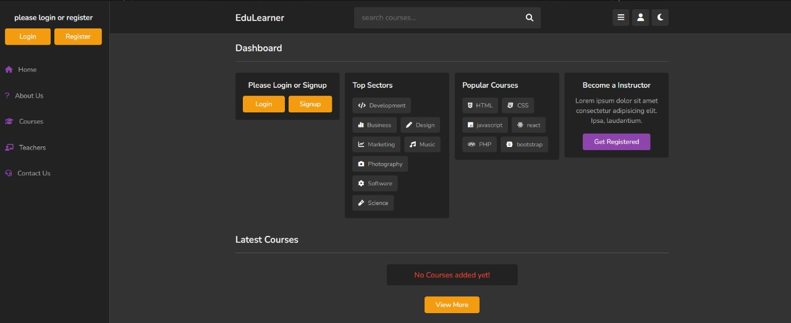

**Dashboard:**

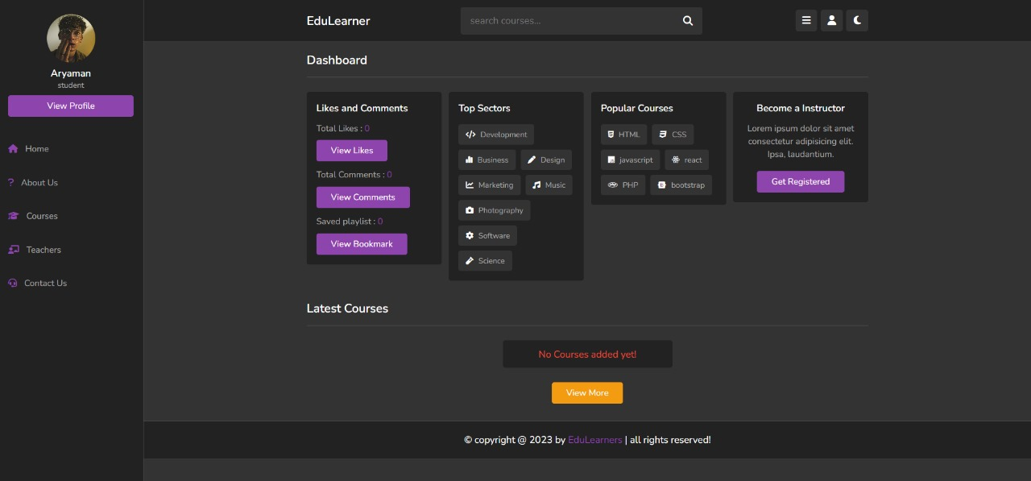

**Profile Page:**

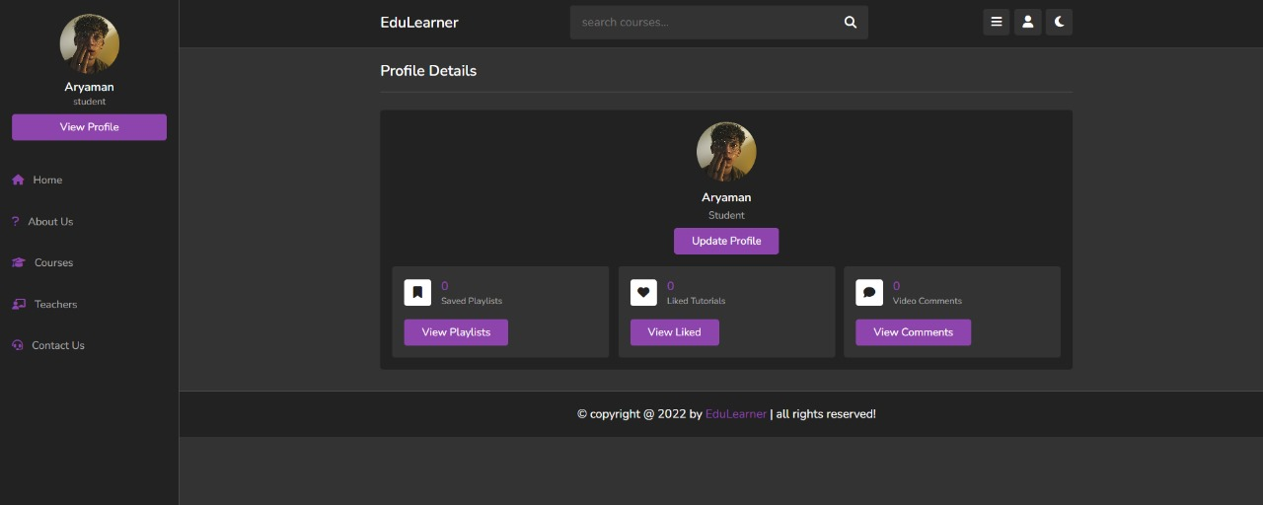

**Add playlist:**

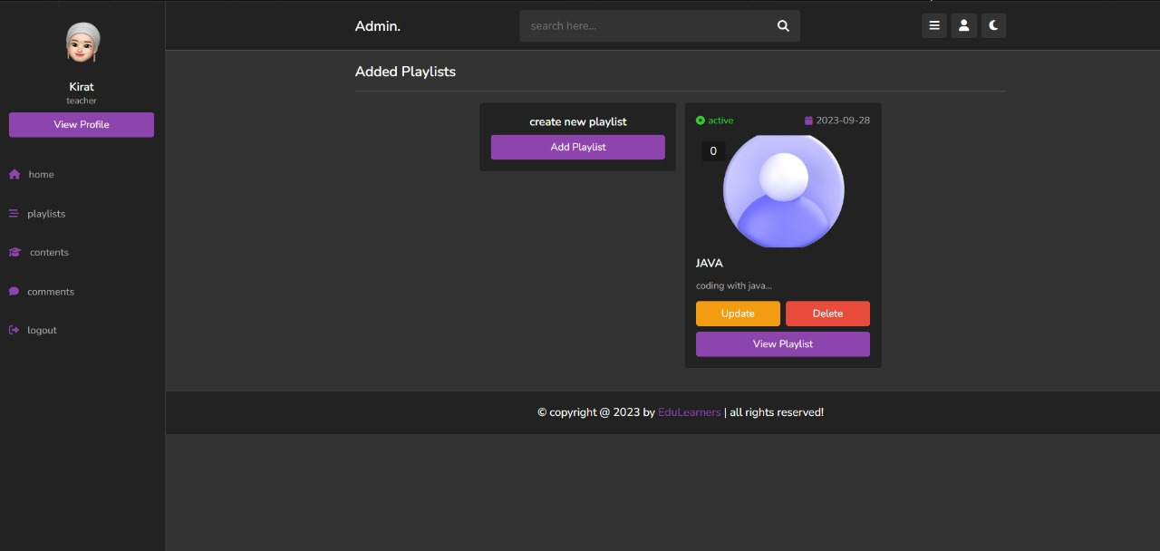

**Tutors (Student View):**

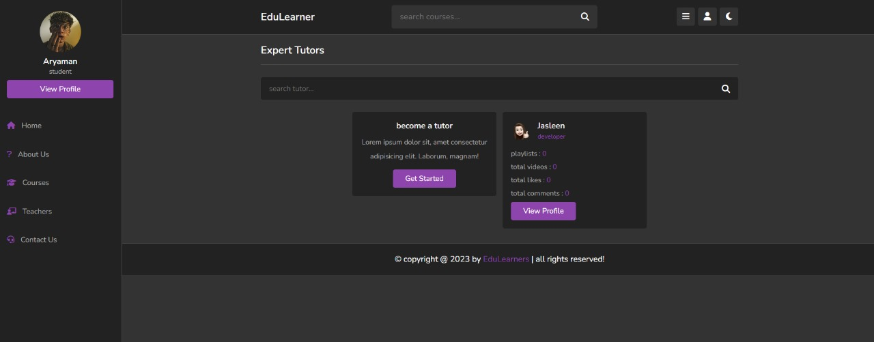

**Tutor profile (Tutor View) :**

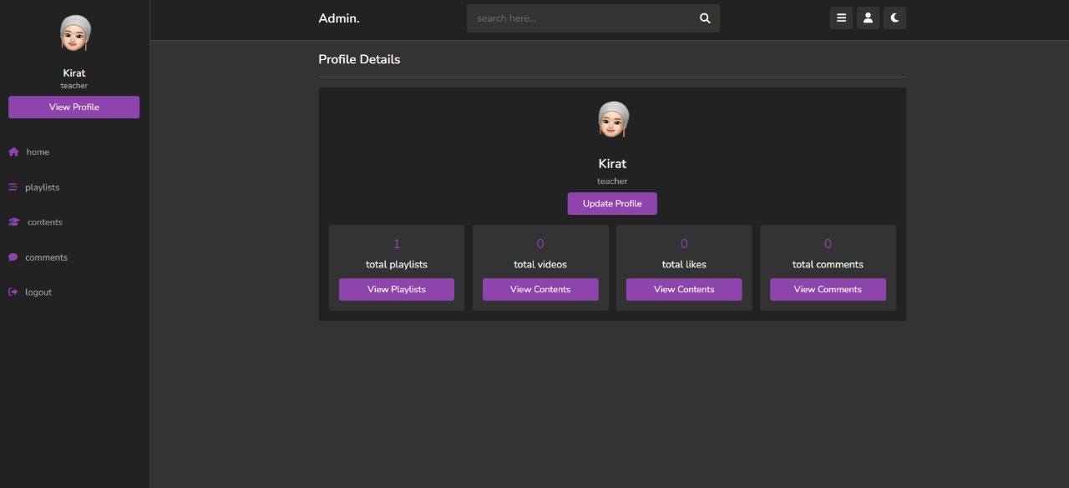

**Tutor profile (Student View):**



**Upload content:**

