**UI SPECIFICATIONS**

**Team-** EduEvolvers

**Project:** E-Learning Platform

**Date:** 20/09/23

**Sign in Page**

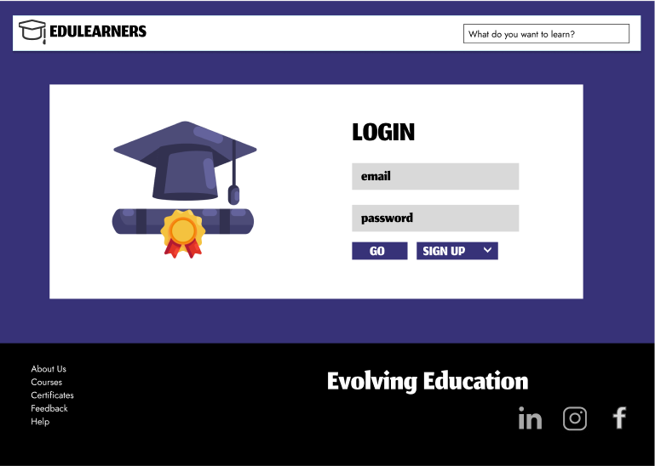

**Sign Up:**

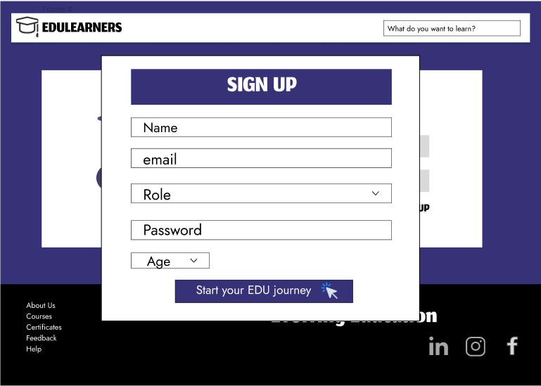

**Dashboard:**

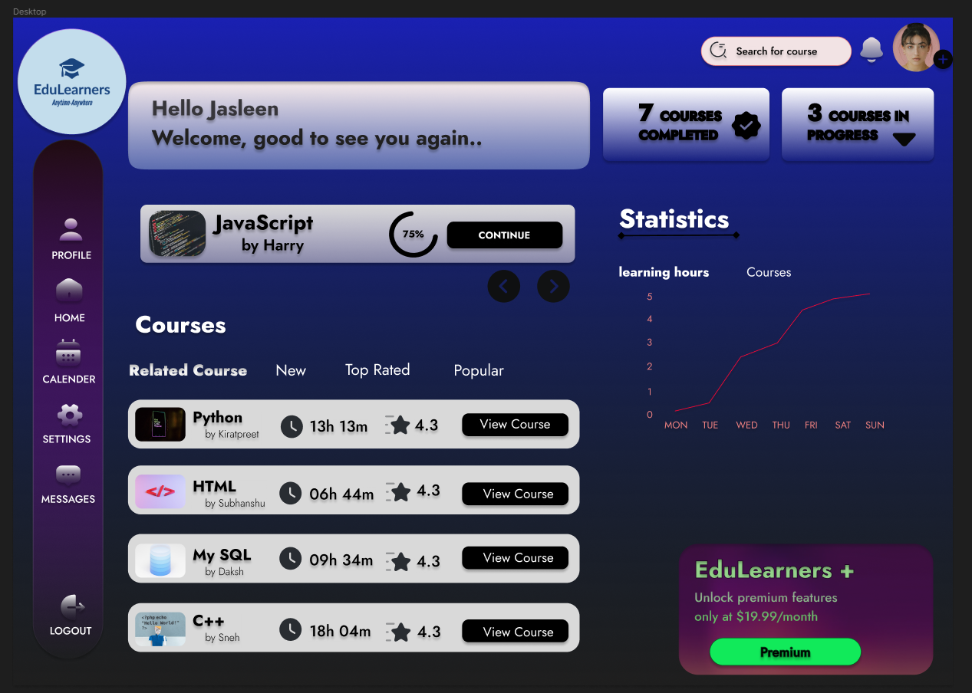

**Course Catalog**

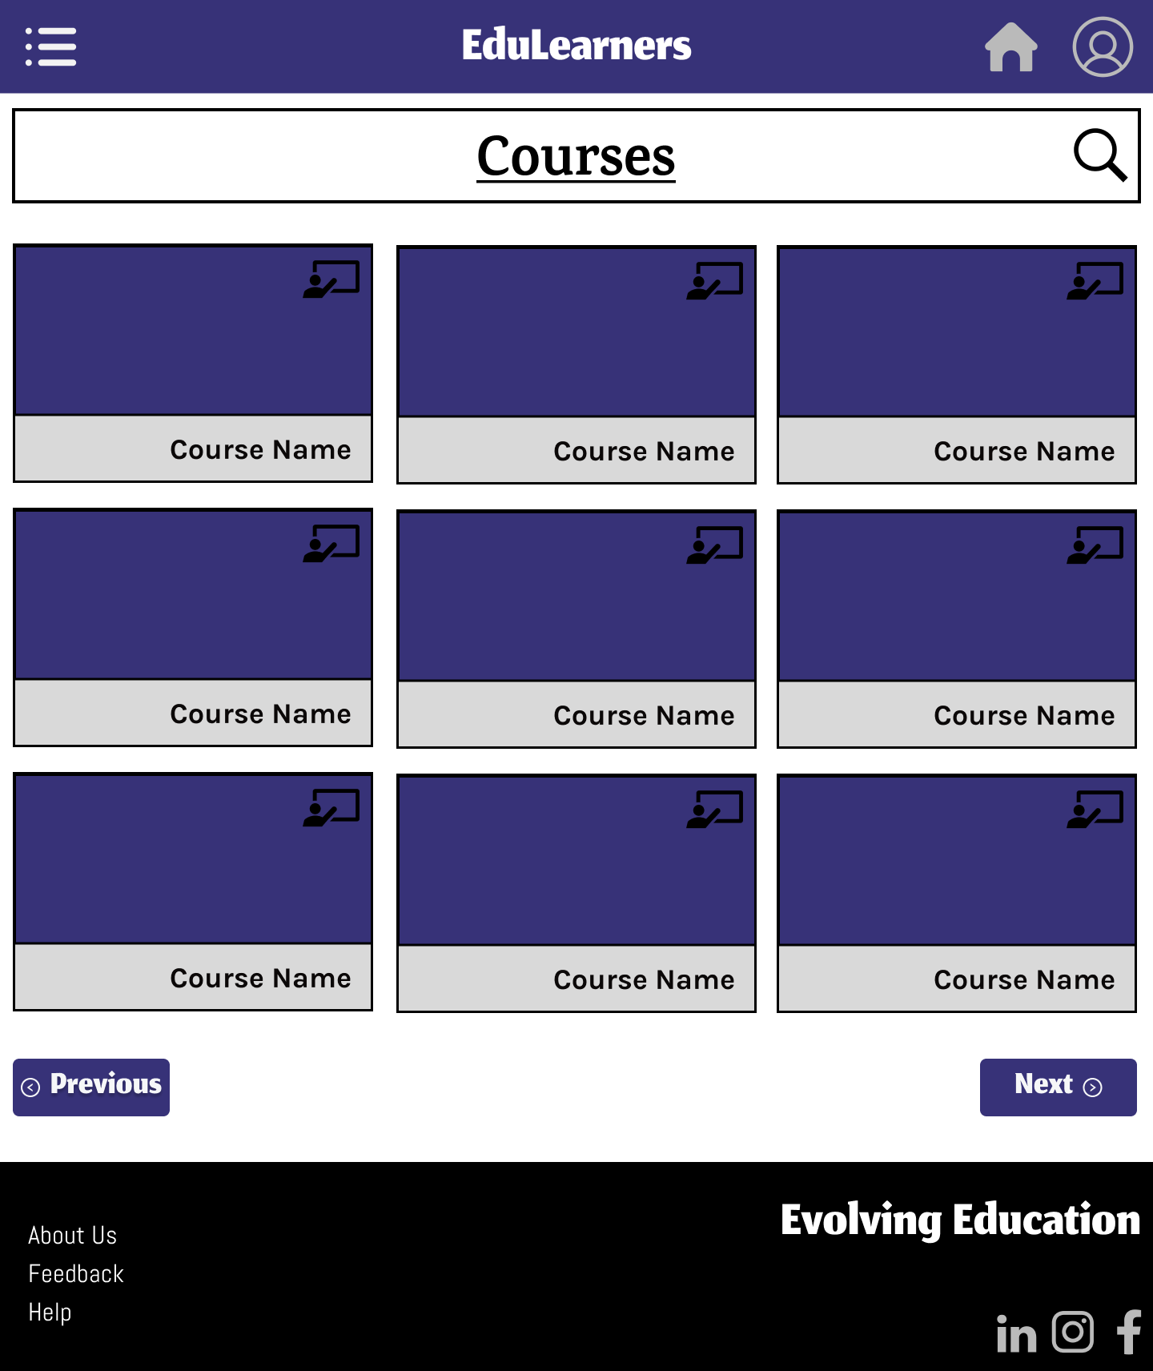

**Profile Page**





**Open Course Window**

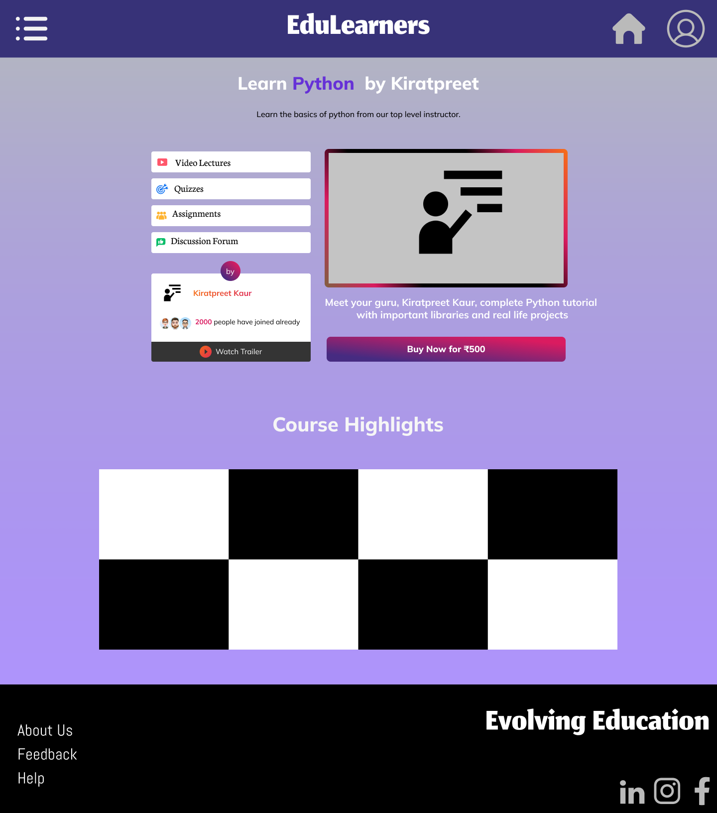

**Leaderboard:**

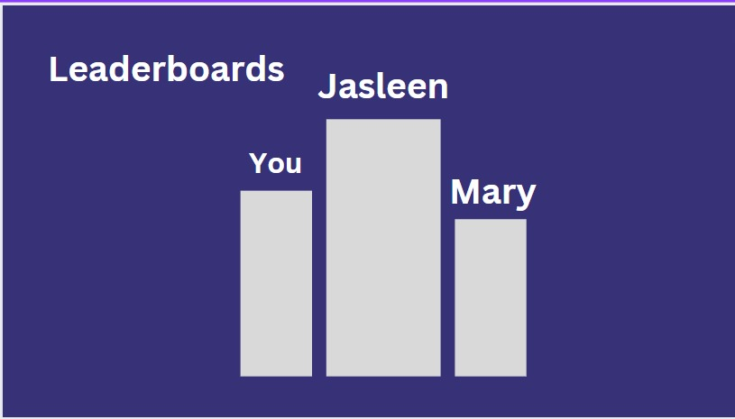



**Discussion Forum**

