Psychological effects – Psychological horror game – (game title)

Fight/flight/freeze responses in psychological horror games:

Any good horror game will attempt to appeal to the player’s adrenaline responses of fight, flight or freeze; where a player will be given the option to run away from the stressor or confront it directly. Commonly a horror game will try and force its player into uncomfortable situations where they have to overcome their natural adrenaline response, for example: making the player fight when their response is to run and hide. A good horror game should balance out states of activation of the sympathetic nervous system and the parasympathetic nervous system. The sympathetic nervous system being the activation of the fight or flight responses where other unnecessary functions to survival are inhibited as the brain enters into survival mode, and the parasympathetic nervous system being the normal resting state of the nervous system. Distinguishing between times in the game where the player will be in a heightened state of arousal and where the player will feel a sense of security in their environment will allow for a player to have a well-rounded and fun horror experience.

Limitations:

Limiting a player’s abilities is essential to horror games as it appeals to a player’s sense of helplessness. The less information a player is receiving the scarier the experience, however this must also be balanced out with providing the player with enough information and control for the game to be both playable and enjoyable. Examples of limitations involve limiting movement, vision, and overall limiting information given to the player. Limiting vision and information on potential threats in a horror game appeals to a player’s natural fear of the unknown, where they may become unnerved by potential dangers and take cautious steps to avoid any threats. Limiting the amount of movement and control of their in-game character induces panic in the player as they have limited solutions to the problem at hand. In order for the game to feel fair and not infuriating for the player, the game must give the player the opportunity to make the right decision. Whether this be in hints or in tutorials within the game. The player must be given ample time to react to information they have been given.

Uncanny valley:   
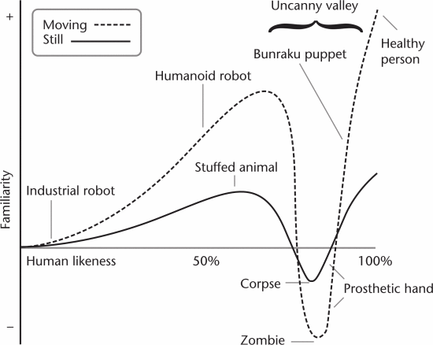

Figure 1.

Masahiro mori's graphical representation of the uncanny valley. The graph demonstrates a gap in familiarity as near-human likenesses approach realism.

Uncanny valley is said to be the middle ground between a human person and a robot/object. This valley has been observed to cause discomfort in some people. It is hypothesized to be because of the natural fear of death and dying makes us enter the uncanny valley. Many suggest that the “Uncanny Valley” doesn’t exist and that it was created out of pure speculation. Despite the doubts put upon uncanny valley, some of the concepts do translate to real life and have been scientifically tested. Main sources of uncanny valley effects in videogames appear as dolls, animatronics and the undead. A main aspect of the uncanny valley effect is the eyes of the creature or object, this is likely the main focal point for the player and hyper realistic and human like eyes are likely to unnerve the player. Creating almost human creatures may produce an unsettling experience for the player, which if utilised correctly can majorly contribute to the horror experience.

Application to our game:

Our horror game will involve all aspects of the previously mentioned and described concepts. Where the player will be forced into startling events that activate their sympathetic nervous system and therefore their fight/flight/freeze responses, and also have periods of rest where the player will have time to investigate and explore the games story. Our players will have a limited experience in terms of vision, movement and choices they can make at any given point in time. Given this our player will still be given the opportunity to succeed at the game and have some autonomy over the choices they make throughout the game. At times we also involve the illusion of choice where we provide our player with a false sense of security in their ability to decide their own fate. Our game also incorporates the concept of the “Uncanny Valley” with creatures that look almost human and also dolls.

References:

T. Geller, "Overcoming the Uncanny Valley," in IEEE Computer Graphics and Applications, vol. 28, no. 4, pp. 11-17, July-Aug. 2008, doi: 10.1109/MCG.2008.79.