VISVESVARAYA TECHNOLOGICAL UNIVERSITY
Jnana Sangama, Belgaum-590018


Mini Project Report on

“AEROMODELING SIMULATION USING MATLAB”
Submitted in partial fulfillment of the requirements for the
Second Semester of the Bachelor of Engineering Degree, towards the completion of the Mini Project under the Innovation & Design Patent Laboratory,
Department of Basic Sciences. by

SN | Name | USN/Roll number
1 | Daksha s | 1CR25EC052

Under the Guidance

Dr. Naveen Kumar GN Assoc.
Professor, Dept. of ECE


CMR INSTITUTE OF TECHNOLOGY
#132, AECS LAYOUT, IT PARK ROAD, KUNDALAHALLI, BANGALORE-560037

CMR INSTITUTE OF TECHNOLOGY
#132, AECS LAYOUT, IT PARK ROAD, KUNDALAHALLI, BANGALORE-560037
DEPARTMENT OF BASIC SCIENCES


CERTIFICATE
This is to certify that the File Structures mini project entitled “AEROMODELING SIMULATION USING MATLAB” has been successfully carried out by CHINMAYA R BHAT(ECE-51), DAKSHA S(ECE-52), G THARUN(CSE-51), GAGAN D H(CSE-52) Bonafide students of CMR Institute of Technology.
The project is submitted in partial fulfillment of the requirements for the First Semester of the Bachelor of Engineering Degree, towards the completion of the Mini Project under the Innovation & Design Patent Laboratory, Department of Basic Sciences.
It is further certified that all corrections and suggestions indicated during the Internal Assessment have been duly incorporated in the project report submitted to the departmental library. This File Structures mini project report has been reviewed and approved as it satisfies the academic requirements prescribed for the said degree.

----------------------- |  | ----------------------
Signature of Guide |  | Signature of HOD
Dr. Naveen Kumar GN Assoc. Professor  Dept. of ECE, CMRIT |  | Dr.Raveesha K H HoD,  Dept. of Physics, CMRIT
 | External Viva
Name of the examiners |  | Signature with date
1.
2.

ACKNOWLEDGEMENT

I sincerely express my gratitude to Dr. Sanjay Jain, Principal, CMR Institute of Technology, Bangalore, for providing a supportive academic environment.

I extend my thanks to Dr. Raveesha K H, HoD, Dept. of Physics, CMRIT for his valuable guidance and support.

I am especially grateful to my internal guide, Dr.NAVEEN KUMAR G.N, Associate Professor, Department of electronics and communication and Engineering, for his constant encouragement and guidance throughout this project.

I also thank all the faculty members, non-teaching staff, and others who contributed directly or indirectly to the successful completion of this work.

CHINMAYA R BHAT(ECE-51),

DAKSHA S(ECE-52),

G THARUN (CSE-51)

GAGAN D H (CSE-52)

Abstract

Aeromodelling is a crucial field in aerospace engineering that involves the design, analysis, and performance evaluation of aircraft models before physical prototyping. This project focuses on simulating aero-models using MATLAB, leveraging its computational and visualization capabilities to study aerodynamic behavior, stability, and control characteristics. The simulation integrates mathematical modeling of flight dynamics, including lift, drag, thrust, and weight forces, to predict aircraft performance under varying conditions. MATLAB’s toolboxes enable numerical analysis, plotting of aerodynamic curves, and visualization of flight trajectories, providing insights into wing design, airfoil efficiency, and stability margins. By simulating different configurations, the project aims to optimize design parameters, reduce experimental costs, and enhance understanding of aerodynamics. The outcome demonstrates how MATLAB can serve as a powerful platform for aeromodelling, bridging theoretical concepts with practical applications in aircraft design and control systems.

TABLE OF CONTENT

Title

Acknowledgement
Abstract

Chapter 1
INTRODUCTION ……………………………………………………………

  - Brief History of Aeromodelling …………………………………………..

  - Primary Goals of Aeromodelling simulation ………………………………

Chapter 2

  - Problem Statement ………………………………………………………….

  - Innovation and design patent …………………………………………….

  - Scope of the Project …………………………………………………..

  - Approach/methodology ………………………………………………………..

  - Project implementation ………………………………………...

  - System Design ………………………………………………….

  - Research Model ………………………………………………………..

  - Work Plan ………………………………………………………………..

Chapter 3

  - User testing and feedback , improvements

  - Future plan

Chapter 4

  - Images

Chapter 5
CONCLUSION AND FUTURE WORK
…………………………………………………….

Chapter 1

- Introduction

Aeromodelling has long been an essential tool in the study of aerodynamics and flight
mechanics, serving as a bridge between theoretical concepts and practical
experimentation. Traditionally, scaled aircraft models were built and tested to
understand lift, drag, thrust, and stability before attempting full-scale designs. With
the advancement of computational tools, aeromodelling has shifted from purely
physical prototypes to digital simulations, enabling faster, safer, and more cost
effective analysis. MATLAB, widely used in engineering and scientific research,
provides a versatile environment for modeling flight dynamics, analyzing
aerodynamic parameters, and visualizing aircraft behavior under different
conditions. This project explores the application of MATLAB in aeromodelling
simulation, aiming to enhance understanding of aerodynamic principles, evaluate
design efficiency, and demonstrate how computational methods can complement
traditional aeromodelling practices.

  - Brief History of Aeromodelling

- Aeromodelling has a rich history that stretches back centuries, beginning with simple flying toys in ancient civilizations and gradually evolving into a scientific discipline that laid the foundation for modern aviation.

- Early examples include the wooden Sakkara Bird of Egypt (around 300 B.C.) and toy helicopters in medieval Europe.

- In the late 18th century, pioneers like Sir George Cayley in England and Alphonse Pénaud in France used small models to study aerodynamics and flight stability, with Pénaud’s Planophore becoming one of the first successful rubber-powered airplanes.

- The 19th century saw further advances, such as John Stringfellow’s steam-powered monoplane and Chuhachi Ninomiya’s propeller-driven aircraft in Japan.

- By the early 20th century, aeromodelling had become both a hobby and a testing ground for aviation breakthroughs, with competitions emerging worldwide.

- The post-war era introduced radio control technology, transforming aeromodelling into a precise and interactive pursuit.

- Today, it is recognized globally as both a sport and an engineering practice, encompassing gliders, helicopters, jets, and electric aircraft, and continues to inspire innovation in aerospace design and education.

  - Primary Goals for Design of Aeromodelling

- To analyse aerodynamic forces and flight stability using mathematical models implemented in MATLAB.
- To simulate flight trajectories and dynamic responses of aero models under varying input conditions.
- To evaluate the efficiency of different wing, tail, and air foil configurations through computational experiments.
- To validate theoretical aerodynamics concepts by comparing simulated results with expected physical behaviour.
- To optimize design parameters such as aspect ratio, angle of attack, and wing loading for improved performance.
- To visualize aerodynamic curves, stability margins, and flight paths using MATLAB’s plotting and animation tools.
- To reduce dependency on physical prototyping by providing a cost-effective and safe simulation environment.
- To enhance student understanding of aircraft design principles by bridging theory with practical simulation.
- To demonstrate the role of computational tools in modern aeromodelling and aerospace engineering research.
- To establish a foundation for future projects involving advanced simulations, such as CFD (Computational Fluid Dynamics) or AI-based optimization.

Chapter 2 Problem Statement

The study of aerodynamics and aircraft design has traditionally relied on physical aero models, wind tunnel experiments, and full-scale prototypes to validate theoretical concepts. While these methods provide valuable insights, they are often expensive, time-consuming, and limited by the availability of specialized equipment. For students and researchers, this creates a significant barrier in exploring flight mechanics, as access to advanced testing facilities is not always feasible. Moreover, physical models are prone to construction inaccuracies and environmental influences, which can affect the reliability of experimental results.

With the advancement of computational tools, simulation has emerged as a powerful alternative to bridge the gap between theory and practice. MATLAB, with its robust numerical and visualization capabilities, offers an accessible platform for modelling aerodynamic forces, analysing flight stability, and simulating aircraft trajectories. However, many learners struggle to connect theoretical equations of lift, drag, and thrust with practical applications, resulting in a gap in understanding.

This project addresses the problem of limited accessibility to traditional aeromodelling resources by developing a MATLAB-based simulation framework. The aim is to provide a cost-effective, safe, and flexible environment where students can experiment with different wing designs, air foil profiles, and flight conditions without the need for physical prototypes. By doing so, the project seeks to overcome the challenges of resource constraints, reduce dependency on trial-and-error experimentation, and enhance the educational value of aeromodelling through computational analysis.

  - INNOVATION AND DESIGN THINKING PROCESS:

Innovation in aeromodelling lies in developing new methods to study and optimize flight dynamics without relying solely on physical prototypes. Traditional approaches often face limitations such as high costs, resource constraints, and restricted access to wind tunnel facilities.
By introducing MATLAB-based aeromodelling simulation, this project provides a novel framework for analyzing aerodynamic forces, stability, and performance virtually. The innovation here is the integration of computational modeling with educational and research applications, making aerodynamics more accessible to students and engineers.
The design patent process ensures that such innovations are legally protected and recognized. In the context of this project, the simulation outputs—such as aerodynamic plots, trajectory visualizations, and optimized wing configurations—can serve as technical documentation to support a patent application. The process begins with idea generation, where the need for cost-effective aeromodelling tools is identified.
It then moves to concept development, where MATLAB simulations refine the design. A prior art search ensures originality, while design documentation uses simulation results to highlight unique features. Filing a patent application formalizes the innovation, followed by examination and grant by the patent office.
Once approved, the innovator gains exclusive rights to the methodology, enabling commercialization through educational software, aerospace R&D tools, or AI-based optimization systems.
Thus, the innovation and patent process not only protects creative work but also encourages further development of aeromodelling simulations as a valuable contribution to aerospace engineering education and research.

  - Scope of the Project

This project focuses on the application of MATLAB for simulating aeromodelling concepts, with the aim of bridging theoretical aerodynamics and practical experimentation. The scope includes:
- Aerodynamic Analysis: Studying fundamental forces such as lift, drag, thrust, and weight through mathematical modeling.

- Simulation of Flight Dynamics: Implementing MATLAB programs to simulate stability, control, and trajectory of aeromodels under varying flight conditions.

- Design Evaluation: Comparing different wing shapes, airfoil profiles, and configurations to assess performance efficiency.

- Visualization Tools: Using MATLAB’s plotting and animation features to represent aerodynamic curves, flight paths, and stability margins.

- Educational Application: Providing a cost-effective and accessible platform for students to understand aerodynamics without reliance on physical prototypes.

- Innovation Linkage: Demonstrating how computational simulation can support patent documentation and design innovation in aeromodelling.

  - Approach / Methodology

The project adopts a computational approach using MATLAB to simulate aeromodelling concepts. The methodology involves:
- Modelling equations of lift, drag, thrust, and stability.
- Coding in MATLAB to implement these equations and create simulation scripts.
- Running simulations under varying flight conditions (angle of attack, wing shape, air foil profile).
- Visualizing results through plots, graphs, and animations.
- Analysing performance to validate theoretical concepts and optimize design parameters.

  - Project Implementation

The implementation is carried out in MATLAB through:
- Development of scripts for aerodynamic force calculations.
- Use of MATLAB’s plotting tools to visualize flight trajectories and stability curves.
- Simulation of different wing and airfoil designs to compare efficiency.
- Documentation of results for educational and research purposes.

2.5 System Design
The simulation framework is structured as follows:
- Inputs: Aerodynamic parameters (airfoil shape, angle of attack, velocity, wing dimensions).
- Processes: MATLAB computations of lift, drag, thrust, and stability equations.
- Outputs: Graphs, trajectory plots, and performance metrics.
- Feedback Loop: Iterative testing of different designs to refine efficiency.

2.6 Research Method
The research method combines theoretical aerodynamics with computational validation:
- Literature review of aerodynamic principles and existing aeromodelling techniques.
- Mathematical formulation of governing equations.
- MATLAB implementation for simulation and visualization.
- Comparative analysis of results against expected theoretical outcomes.

2.7 Work Plan

The project is executed in stages:
- Stage 1 – Literature Review: Study of aerodynamics and aeromodelling basics.
- Stage 2 – Mathematical Modeling: Formulation of equations for lift, drag, and stability.
- Stage 3 – MATLAB Coding: Development of scripts for simulation.
- Stage 4 – Simulation & Visualization: Running tests and generating plots.
- Stage 5 – Analysis: Evaluating results and identifying design improvements.
- Stage 6 – Documentation: Preparing report, conclusions, and linking innovation to patent process.

3 Chapter

3.1 User Testing & Feedback

Testing Approach:
- Conducted simulation runs with different wing profiles and flight conditions.
- Shared MATLAB visualizations (graphs, trajectories, stability curves) with peers and faculty for evaluation.
- Compared simulation outputs against theoretical expectations from textbooks and lecture notes.

Feedback Collected:
- Peers: Found the visualizations intuitive and helpful for understanding aerodynamics; suggested adding more interactive plots for clarity.
- Faculty: Appreciated the accuracy of the mathematical modeling; recommended expanding the scope to include damping and turbulence effects.
- Self-Evaluation: Identified areas where coding efficiency could be improved (e.g., modular functions instead of long scripts).

Key Improvements Based on Feedback:
- Enhanced plotting with labeled axes, legends, and annotations for better readability.
- Added comparative simulations (different airfoil shapes) to highlight performance differences.
- Optimized MATLAB code structure for easier reuse in future projects.

  - Future Plan

The current project establishes a foundation for aeromodelling simulations using MATLAB. Moving forward, the plan is to expand this work into practical and advanced applications:
- Integration with Hardware: Extend simulations to physical prototypes using microcontrollers and sensors, enabling real-time validation of MATLAB models.
- Advanced Simulation Techniques: Incorporate Computational Fluid Dynamics (CFD) and turbulence modeling to achieve more accurate flight predictions.
- Aeromodelling Projects: Design and test scaled aircraft models, drones, and gliders, using simulation results to guide construction.
- AI-Driven Optimization: Apply machine learning algorithms to optimize wing shapes, airfoil profiles, and stability parameters.
- Collaborative Research: Partner with academic and industrial labs to explore aeromodelling applications in aerospace education and innovation.
- Patent & Innovation Pathway: Document simulation-based designs for potential intellectual property filings, linking academic work to real-world engineering solutions.

    - Images

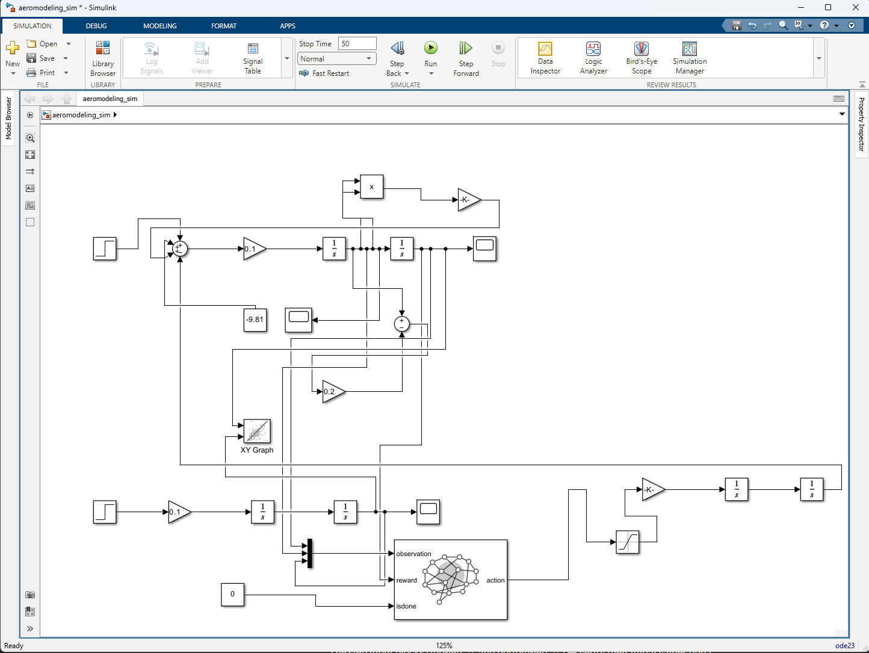

Fig 1 : Aeromodelling simulation in MatLab
Image contains the necessary blocks that simulate the functioning of a real aircraft , example – thrust , landing , gravity , velocity , drag etc
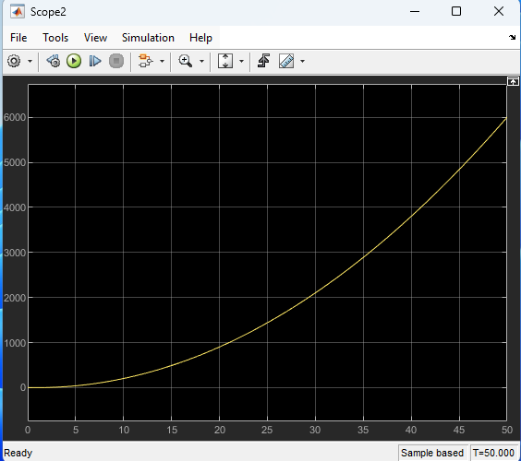

Fig 2 : Velocity curve of the aircraft

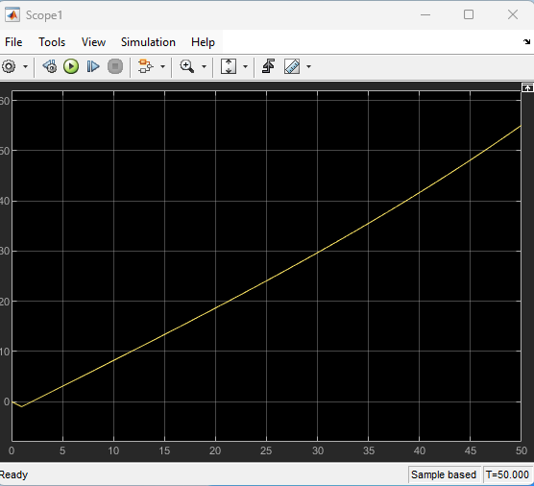

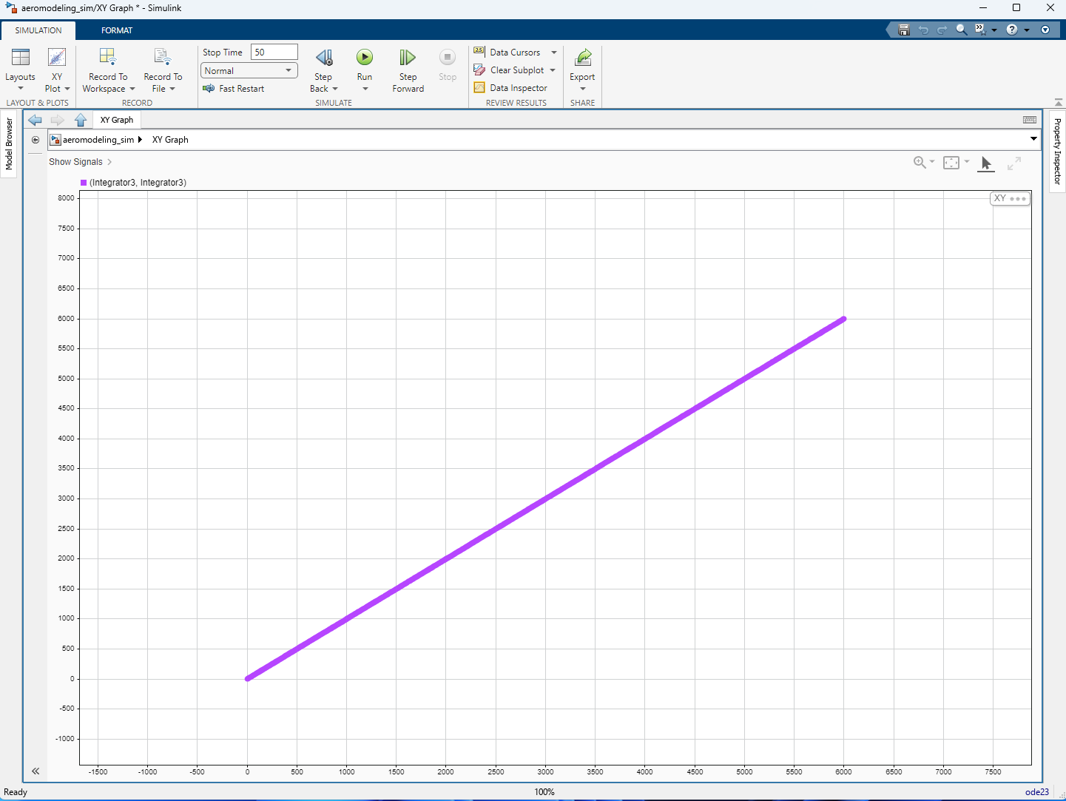
  - Conclusion

The project successfully demonstrated the use of MATLAB for simulating aeromodelling concepts, including aerodynamic forces, stability, and flight behaviour. Through modelling, coding, visualization, and user feedback, the study provided clear insights into aircraft performance and design optimization. This work serves as a foundation for future aeromodelling projects, bridging theoretical physics with practical aerospace applications.

