NASA C-MAPSS
Remaining Useful Life (RUL) Prediction
Benchmark Report

Comprehensive evaluation of 13 machine-learning, deep-learning, and graph models
on turbofan engine datasets FD001–FD004

Primary metric: last-cycle RMSE per test engine | Training RUL cap: 125 cycles
All numerical values verified against results/*.csv and docs/epoch_metrics_*.csv

Executive Summary
This benchmark evaluates RUL prediction across four NASA C-MAPSS subsets with increasing difficulty. The best models achieved RMSE of 13.89 (FD001 — single condition, single fault, ExtraTrees), 26.57 (FD002 — six conditions, single fault, Transformer), 17.13 (FD003 — single condition, dual fault, HistGradientBoosting), and 29.39 (FD004 — six conditions, dual fault, HistGradientBoosting). Tree-based ML with engineered features dominates single-condition datasets; the Transformer excels on multi-condition FD002. Key degradation sensors: sensor_11, sensor_4, and sensor_12 (FD001).

Table of Contents

1. Dataset Overview
NASA C-MAPSS (Commercial Modular Aero-Propulsion System Simulation) provides multivariate time-series from simulated turbofan jet engines. Each row is one operational cycle. Training trajectories run until engine failure; test trajectories end before failure with provided final RUL labels. The benchmark is split into four subsets — FD001 through FD004 — each differing in the number of operating conditions and fault modes.
Note: FD001–FD004 are standard NASA C-MAPSS identifiers. FD = Failure Dataset. Higher numbers generally indicate more operating conditions and/or fault modes, making prediction harder.

Dataset Code | Train Engines | Test Engines | Operating Conditions | Fault Modes | Difficulty
FD001 | 100 | 100 | 1 (Sea Level) | 1 (HPC Degradation) | Easy
FD002 | 260 | 259 | 6 | 1 (HPC Degradation) | Medium
FD003 | 100 | 100 | 1 (Sea Level) | 2 (HPC + Fan Degradation) | Medium
FD004 | 248 | 249 | 6 | 2 (HPC + Fan Degradation) | Hard

1.2 Dataset Code Reference (FD001–FD004)
Throughout this report, tables and figures use the codes FD001–FD004 to identify each benchmark subset. Use this reference when reading any results table:
Code | Description
FD001 | Single operating condition (sea level), single fault mode (HPC degradation), 100 train / 100 test engines — easiest subset
FD002 | Six operating conditions, single fault mode (HPC), 260 train / 259 test engines — medium difficulty
FD003 | Single operating condition, dual fault modes (HPC + Fan), 100 train / 100 test engines — medium difficulty
FD004 | Six operating conditions, dual fault modes (HPC + Fan), 248 train / 249 test engines — hardest subset

1.3 Why FD004 Is Harder Than FD001
- FD004 has six operating conditions vs one in FD001 — models must generalize across flight regimes.
- FD004 has two fault modes (HPC + Fan) vs one in FD001 — more complex degradation patterns.
- Best RMSE on FD004 (29.39) vs FD001 (13.89) — 2.1× higher error.
- FD004 has a larger fleet (248 engines) with more heterogeneity and sensor noise.
- Feature distribution shift between conditions makes global models harder to fit.

2. Data Preparation & Preprocessing
- Load train/test/RUL files per FD subset (FD001, FD002, FD003, or FD004).
- Compute RUL per row; cap training RUL at 125 cycles.
- Drop constant sensors (zero variance on training set).
- ML features: raw + unit-relative + rolling mean (window=5) + rolling std (window=5).
- DL/Graph features: unit-relative scaling + StandardScaler; 30-step sequences.
- Graph edges: temporal chain connecting consecutive time steps within each sequence.
- Evaluation: last observed cycle per test engine — RMSE, MAE, R².

3. Models Benchmarked
Thirteen models were evaluated across three families: classical machine learning (6), deep learning (5), and graph neural networks (2).
ML (6): Ridge, ElasticNet, RandomForest, ExtraTrees, HistGradientBoosting, XGBoost
DL (5): LSTM, GRU, CNN1D, TCN, Transformer (PyTorch CUDA)
Graph (2): TemporalGCN — graph convolution over temporal node chains; TemporalGAT — graph attention over temporal node chains (PyTorch Geometric)

4. Best Model Per Dataset
Note: The Dataset column uses FD001–FD004 codes defined in Section 1.2. RMSE, MAE, and R² are last-cycle metrics on the test set for that subset.

Dataset | Model | Family | RMSE | MAE | R²
FD001 — Single operating condition (sea level) | ExtraTrees | ML | 13.89 | 10.20 | 0.8883
FD002 — Six operating conditions | Transformer | DL | 26.57 | 19.12 | 0.7525
FD003 — Single operating condition | HistGradientBoosting | ML | 17.13 | 12.85 | 0.8288
FD004 — Six operating conditions | HistGradientBoosting | ML | 29.39 | 21.66 | 0.7095

5. Complete Results — RMSE (Last-Cycle)
Note: Column headers FD001–FD004 are the four NASA C-MAPSS benchmark subsets (see Section 1 for full descriptions). Each column shows model performance on that dataset. All values are computed at the last observed cycle of each test engine.

Model | FD001 (1 cond., 1 fault) | FD002 (6 cond., 1 fault) | FD003 (1 cond., 2 faults) | FD004 (6 cond., 2 faults)
CNN1D | 23.87 | 29.42 | 25.05 | 33.96
ElasticNet | 17.67 | 30.81 | 20.26 | 34.32
ExtraTrees | 13.89 | 29.48 | 17.16 | 30.67
GRU | 19.78 | 29.36 | 20.37 | 35.13
HistGradientBoosting | 14.30 | 28.28 | 17.13 | 29.39
LSTM | 17.69 | 29.98 | 21.33 | 33.87
RandomForest | 14.14 | 28.75 | 17.63 | 30.19
Ridge | 17.79 | 28.51 | 20.33 | 31.25
TCN | 21.86 | 27.79 | 24.33 | 30.95
TemporalGAT | 16.60 | 29.92 | 19.58 | 32.70
TemporalGCN | 18.69 | 30.19 | 18.54 | 31.80
Transformer | 18.98 | 26.57 | 18.29 | 30.01
XGBoost | 14.35 | 27.71 | 18.05 | 29.39

5.1 Complete Results — R² (Last-Cycle)
Note: Column headers FD001–FD004 are the four NASA C-MAPSS benchmark subsets (see Section 1 for full descriptions). Each column shows model performance on that dataset. All values are computed at the last observed cycle of each test engine.

Model | FD001 (1 cond., 1 fault) | FD002 (6 cond., 1 fault) | FD003 (1 cond., 2 faults) | FD004 (6 cond., 2 faults)
CNN1D | 0.6700 | 0.6966 | 0.6339 | 0.5932
ElasticNet | 0.8192 | 0.6717 | 0.7605 | 0.6037
ExtraTrees | 0.8883 | 0.6995 | 0.8282 | 0.6835
GRU | 0.7734 | 0.6978 | 0.7578 | 0.5647
HistGradientBoosting | 0.8815 | 0.7236 | 0.8288 | 0.7095
LSTM | 0.8189 | 0.6850 | 0.7346 | 0.5951
RandomForest | 0.8842 | 0.7142 | 0.8187 | 0.6934
Ridge | 0.8168 | 0.7190 | 0.7588 | 0.6716
TCN | 0.7232 | 0.7294 | 0.6545 | 0.6620
TemporalGAT | 0.8404 | 0.6863 | 0.7762 | 0.6228
TemporalGCN | 0.7976 | 0.6806 | 0.7995 | 0.6432
Transformer | 0.7913 | 0.7525 | 0.8048 | 0.6822
XGBoost | 0.8808 | 0.7345 | 0.8100 | 0.7094

5.2 Complete Results — MAE (Last-Cycle)
Note: Column headers FD001–FD004 are the four NASA C-MAPSS benchmark subsets (see Section 1 for full descriptions). Each column shows model performance on that dataset. All values are computed at the last observed cycle of each test engine.

Model | FD001 (1 cond., 1 fault) | FD002 (6 cond., 1 fault) | FD003 (1 cond., 2 faults) | FD004 (6 cond., 2 faults)
CNN1D | 19.16 | 21.69 | 18.74 | 26.48
ElasticNet | 14.29 | 22.12 | 16.28 | 27.68
ExtraTrees | 10.20 | 20.37 | 12.68 | 22.84
GRU | 15.73 | 21.63 | 15.57 | 26.71
HistGradientBoosting | 10.90 | 19.76 | 12.85 | 21.66
LSTM | 13.87 | 22.44 | 16.56 | 26.55
RandomForest | 10.53 | 20.10 | 13.19 | 22.20
Ridge | 14.37 | 20.22 | 16.33 | 24.60
TCN | 17.26 | 20.22 | 18.42 | 23.24
TemporalGAT | 13.07 | 22.18 | 14.82 | 25.23
TemporalGCN | 14.68 | 21.94 | 14.06 | 24.44
Transformer | 15.02 | 19.12 | 13.65 | 22.17
XGBoost | 10.72 | 19.27 | 13.40 | 21.57

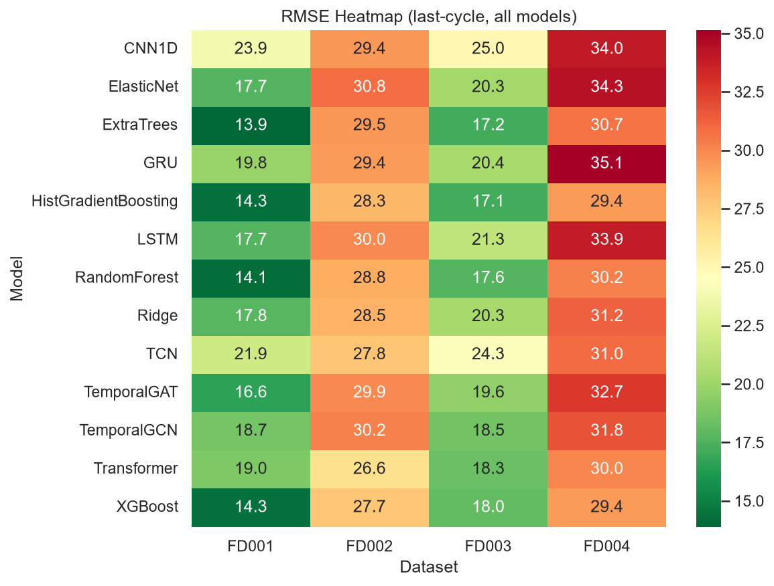
Figure 1: RMSE heatmap — rows are models, columns are FD001–FD004 datasets

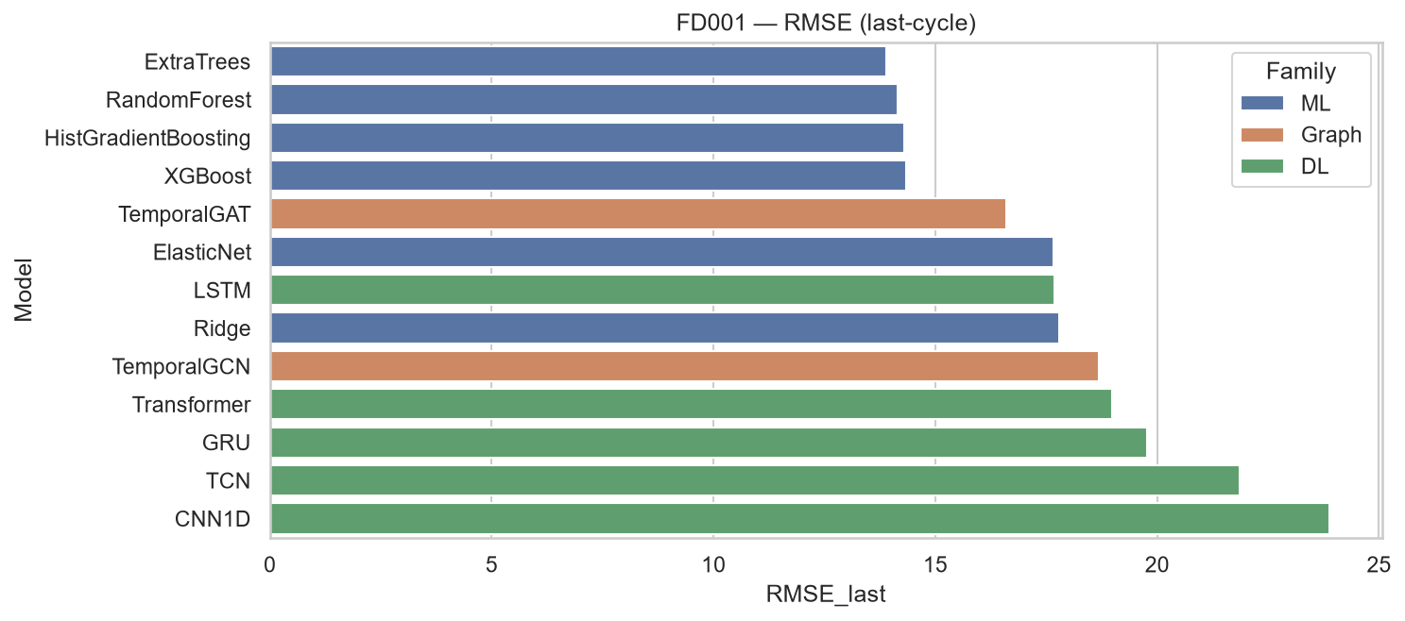
Figure: FD001 (Single operating condition (sea level)) — model comparison (RMSE)

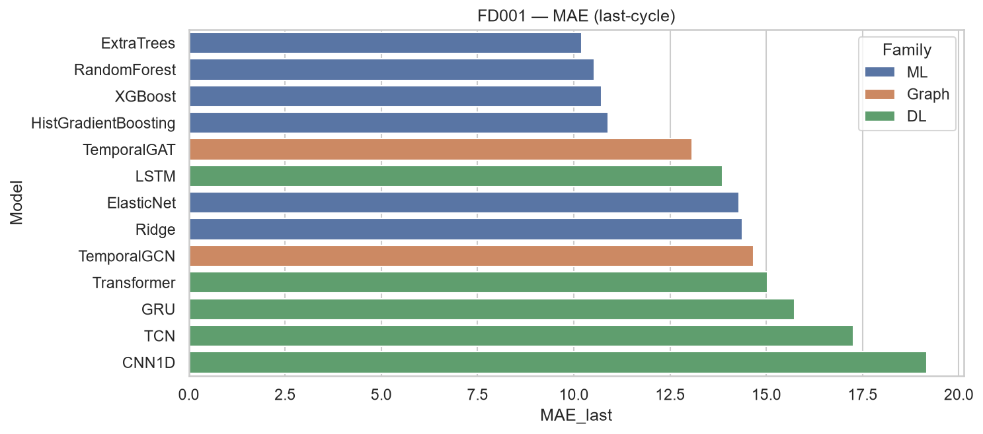
Figure: FD001 (Single operating condition (sea level)) — model comparison (MAE)

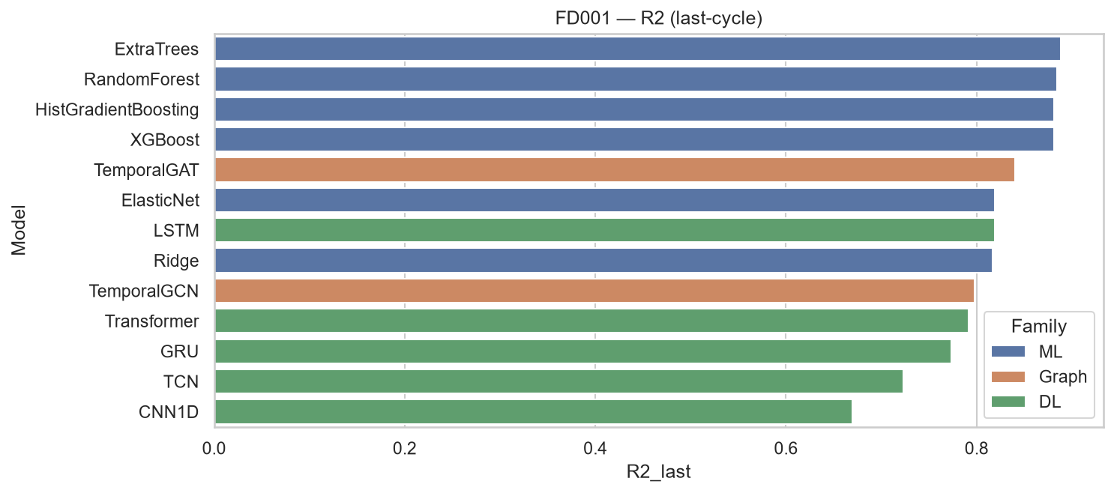
Figure: FD001 (Single operating condition (sea level)) — model comparison (R²)

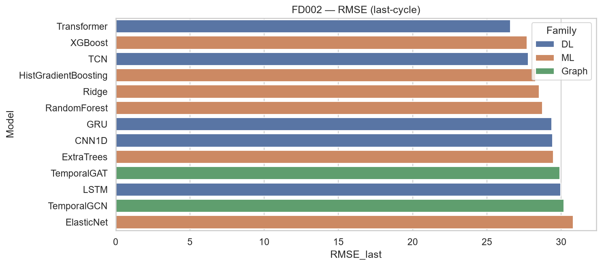
Figure: FD002 (Six operating conditions) — model comparison (RMSE)

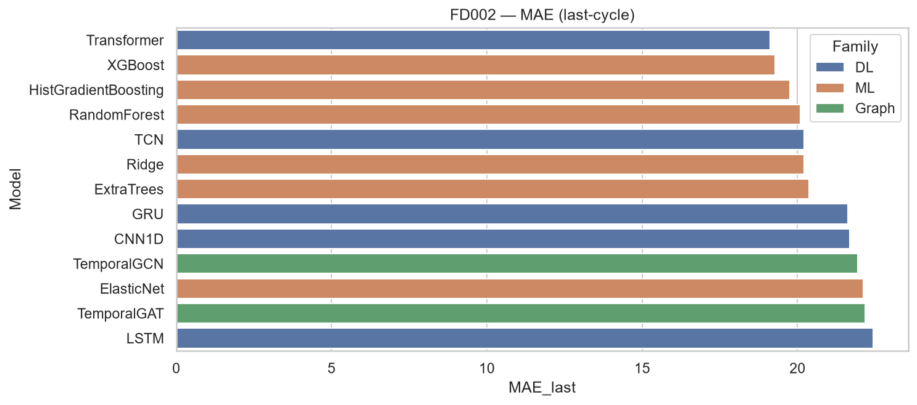
Figure: FD002 (Six operating conditions) — model comparison (MAE)

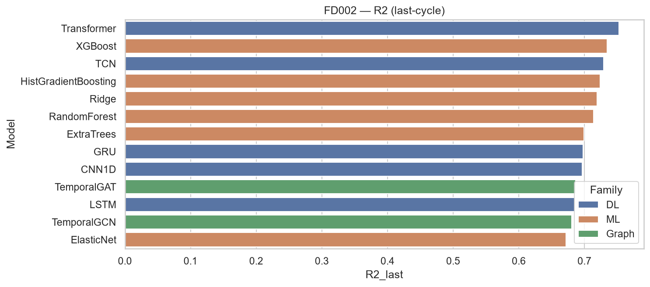
Figure: FD002 (Six operating conditions) — model comparison (R²)

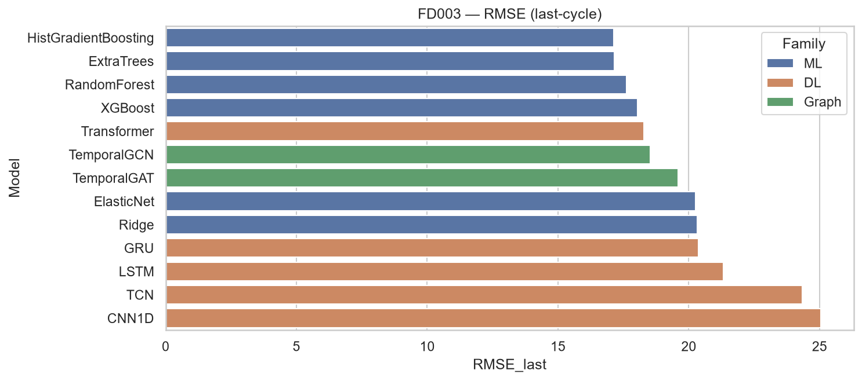
Figure: FD003 (Single operating condition) — model comparison (RMSE)

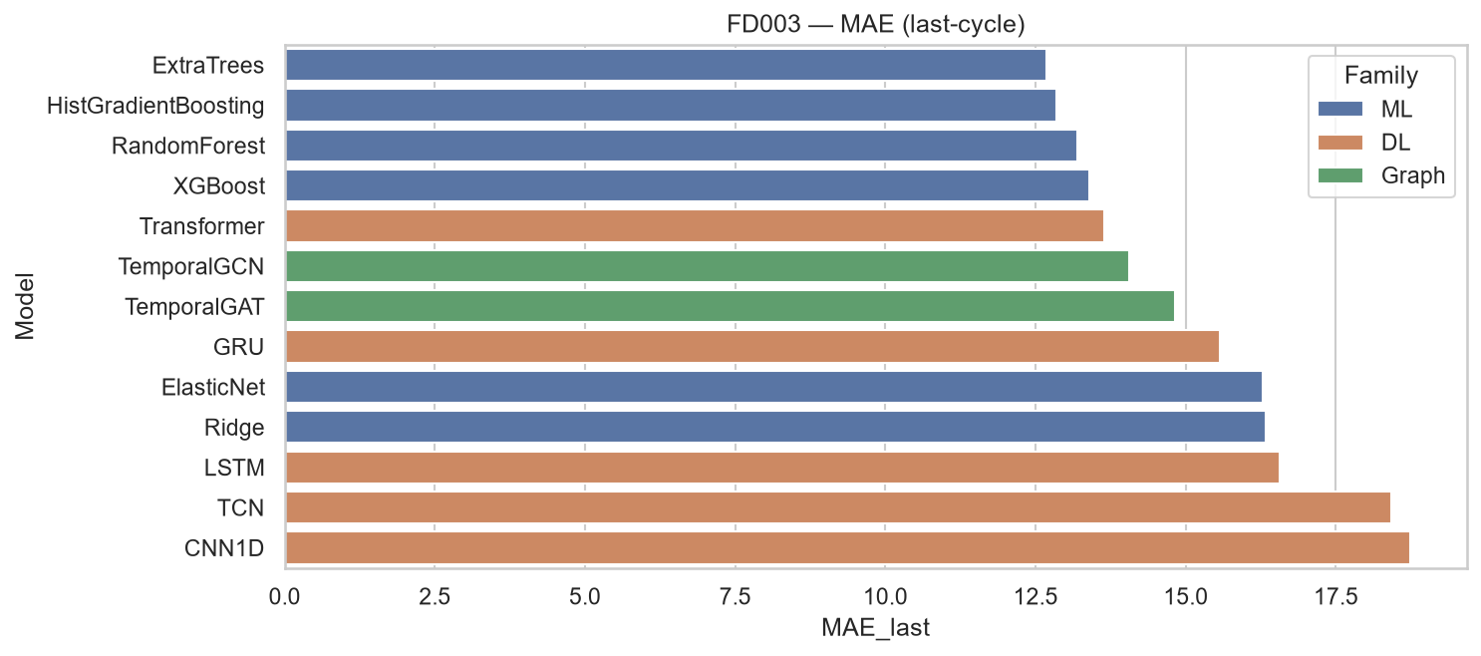
Figure: FD003 (Single operating condition) — model comparison (MAE)

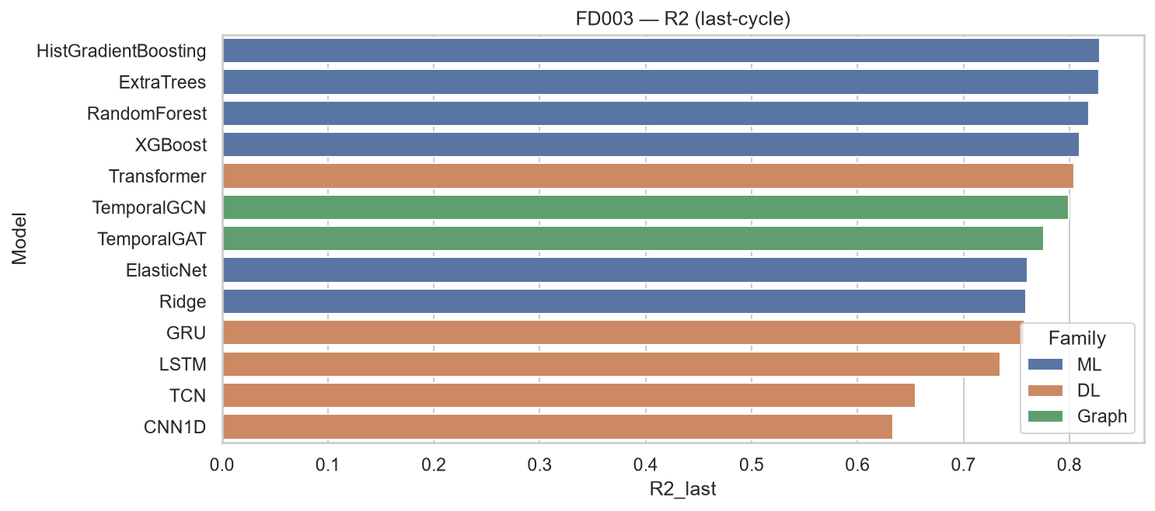
Figure: FD003 (Single operating condition) — model comparison (R²)

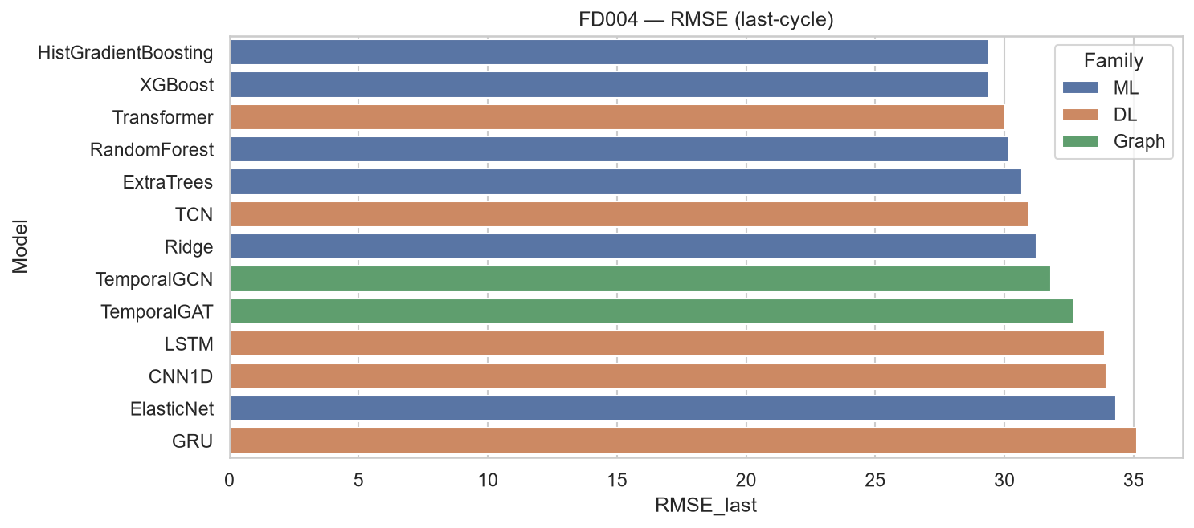
Figure: FD004 (Six operating conditions) — model comparison (RMSE)

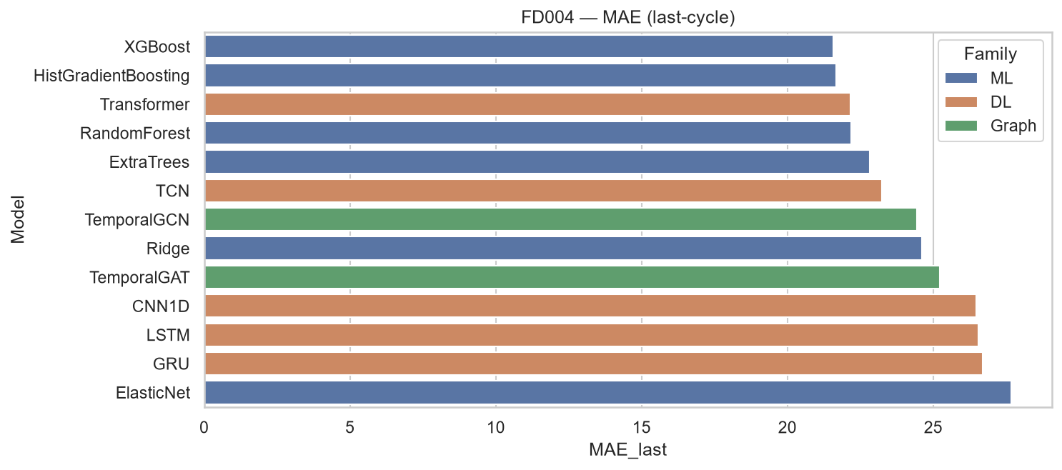
Figure: FD004 (Six operating conditions) — model comparison (MAE)

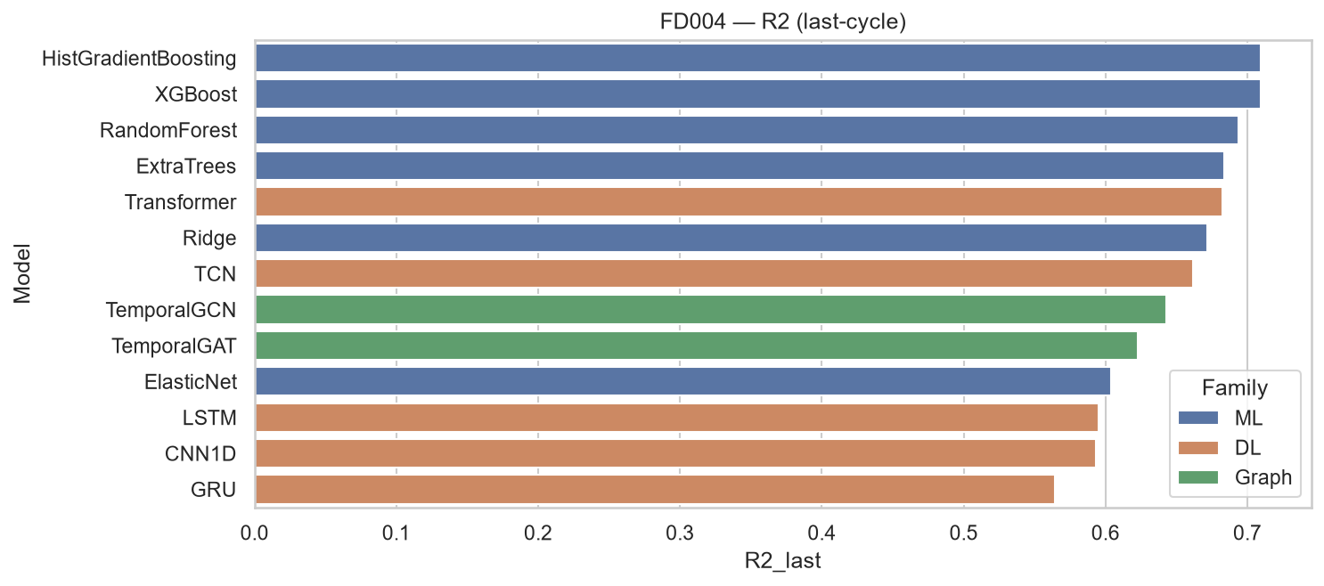
Figure: FD004 (Six operating conditions) — model comparison (R²)

6. Training Progression — ML Models
Note: Column headers Stage 10, Stage 50, Stage 100, and Stage 200 denote training progress checkpoints for each ML model. The number indicates how many estimators (trees) or maximum iterations were used when fitting the model. For example, ExtraTrees at Stage 50 was trained with 50 trees. Each cell shows last-cycle RMSE on the test set at that training stage.

The tables below show how each ML model's last-cycle RMSE improves as more estimators or iterations are added. Each subsection corresponds to one FD dataset.

6.1 FD001 — Single operating condition (sea level)
Model | Stage 10 | Stage 50 | Stage 100 | Stage 200
ExtraTrees | 14.47 | 13.83 | 14.04 | 13.98
HistGradientBoosting | 26.61 | 14.05 | 14.12 | 14.31
XGBoost | 28.42 | 14.57 | 14.35 | 14.41

6.2 FD002 — Six operating conditions
Model | Stage 10 | Stage 50 | Stage 100 | Stage 200
ExtraTrees | 30.11 | 29.77 | 29.52 | 29.60
HistGradientBoosting | 40.99 | 29.95 | 28.73 | 28.29
XGBoost | 41.97 | 29.65 | 28.30 | 27.84

6.3 FD003 — Single operating condition
Model | Stage 10 | Stage 50 | Stage 100 | Stage 200
ExtraTrees | 17.38 | 16.95 | 17.14 | 17.21
HistGradientBoosting | 28.82 | 17.49 | 17.30 | 17.21
XGBoost | 30.68 | 18.03 | 17.91 | 18.01

6.4 FD004 — Six operating conditions
Model | Stage 10 | Stage 50 | Stage 100 | Stage 200
ExtraTrees | 31.75 | 31.18 | 31.07 | 30.94
HistGradientBoosting | 42.04 | 31.06 | 30.11 | 29.69
XGBoost | 42.94 | 30.94 | 29.62 | 29.39

7. Training Progression — Deep Learning Models
Note: Column headers Epoch 10, Epoch 50, Epoch 100, and Epoch 200 denote training checkpoints during 200-epoch deep learning runs. The number is how many full passes through the training data completed before evaluation. Each cell shows last-cycle RMSE on the test set at that epoch.

Each DL model was trained for up to 200 epochs with checkpoints at epochs 10, 50, 100, and 200. Overfitting onset is the first epoch where validation loss exceeds training loss by >12%.

7.1 FD001 — Single operating condition (sea level)
Model | Epoch 10 | Epoch 50 | Epoch 100 | Epoch 200
CNN1D | 26.04 | 24.24 | 22.71 | 21.97
GRU | 20.59 | 22.73 | 21.45 | 21.68
LSTM | 22.07 | 22.16 | 21.31 | 21.05
TCN | 23.97 | 22.94 | 22.37 | 22.13
Transformer | 22.13 | 21.34 | 22.07 | 22.63

Overfitting onset (training epochs): CNN1D at epoch 6, GRU at epoch 6, LSTM at epoch 6, TCN at epoch 6, Transformer at epoch 6

7.2 FD004 — Six operating conditions
Model | Epoch 10 | Epoch 50 | Epoch 100 | Epoch 200
CNN1D | 33.90 | 33.05 | 32.86 | 32.90
GRU | 35.57 | 34.30 | 35.38 | 34.49
LSTM | 34.09 | 34.36 | 33.94 | 33.52
TCN | 33.91 | 33.60 | 31.80 | 32.01
Transformer | 31.77 | 31.30 | 32.46 | 33.88

Overfitting onset (training epochs): CNN1D at epoch 10, GRU at epoch 6, LSTM at epoch 11, TCN at epoch 17, Transformer at epoch 50

8. Loss Curve Analysis
Each plot shows train vs validation MSE (left) and the generalization gap val−train (right). Vertical dashed lines mark checkpoints at epochs 10, 50, 100, and 200 — the same epoch checkpoints used in Section 7 tables. Red dotted line marks estimated overfitting onset.
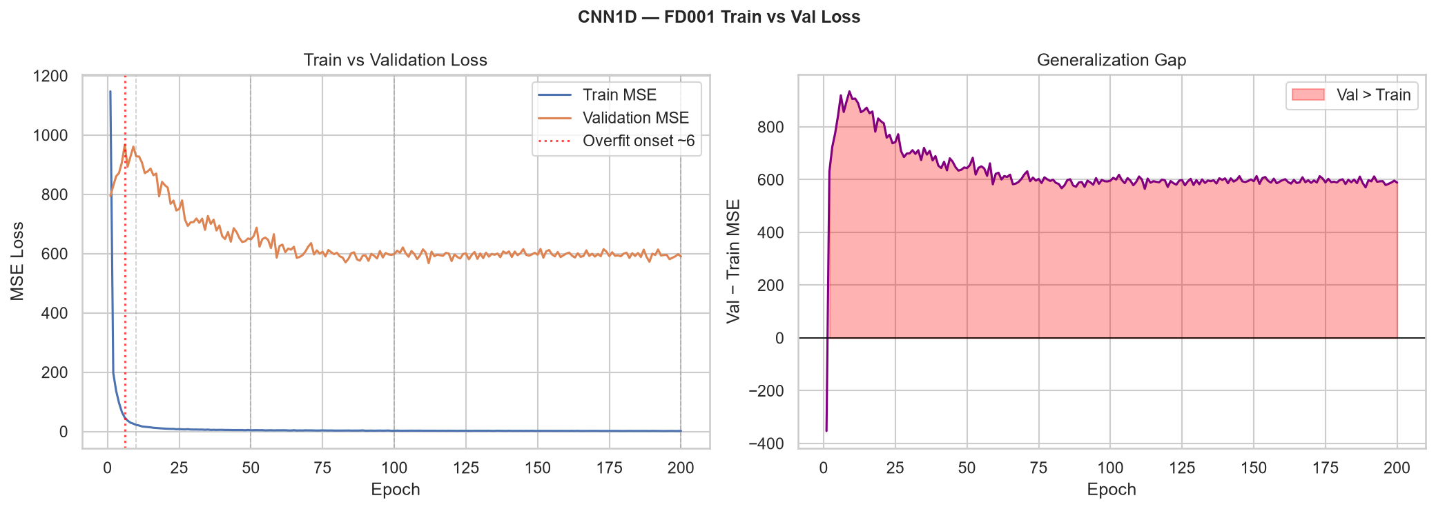
Loss curves: CNN1D on FD001

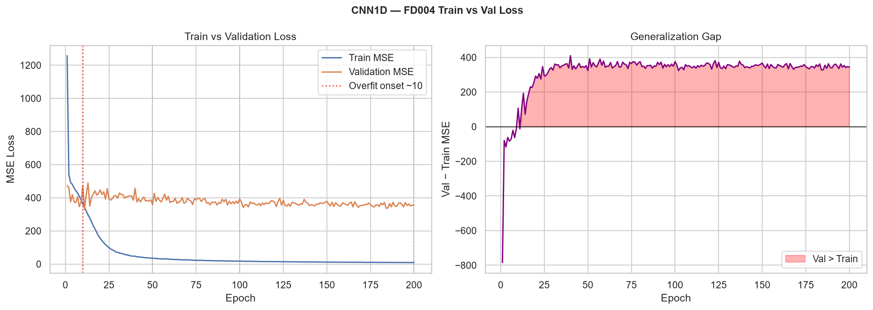
Loss curves: CNN1D on FD004

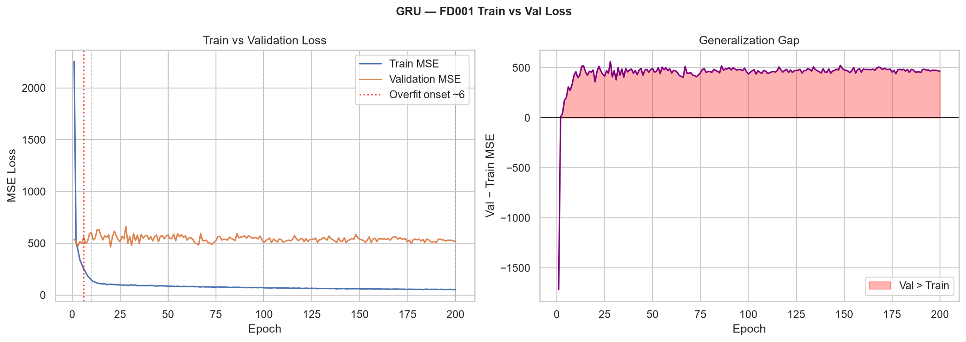
Loss curves: GRU on FD001

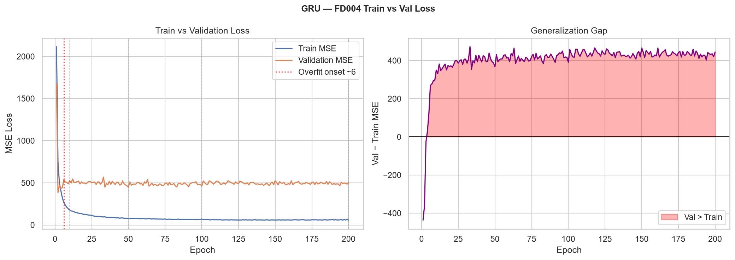
Loss curves: GRU on FD004

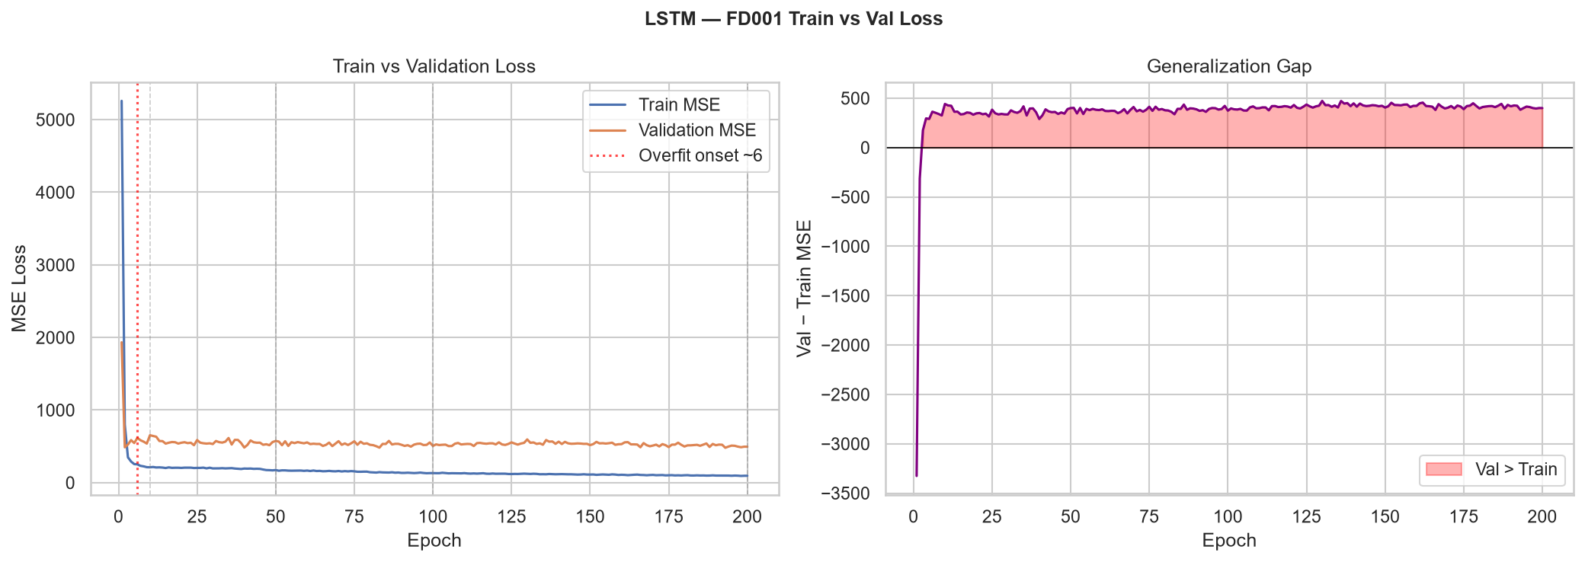
Loss curves: LSTM on FD001

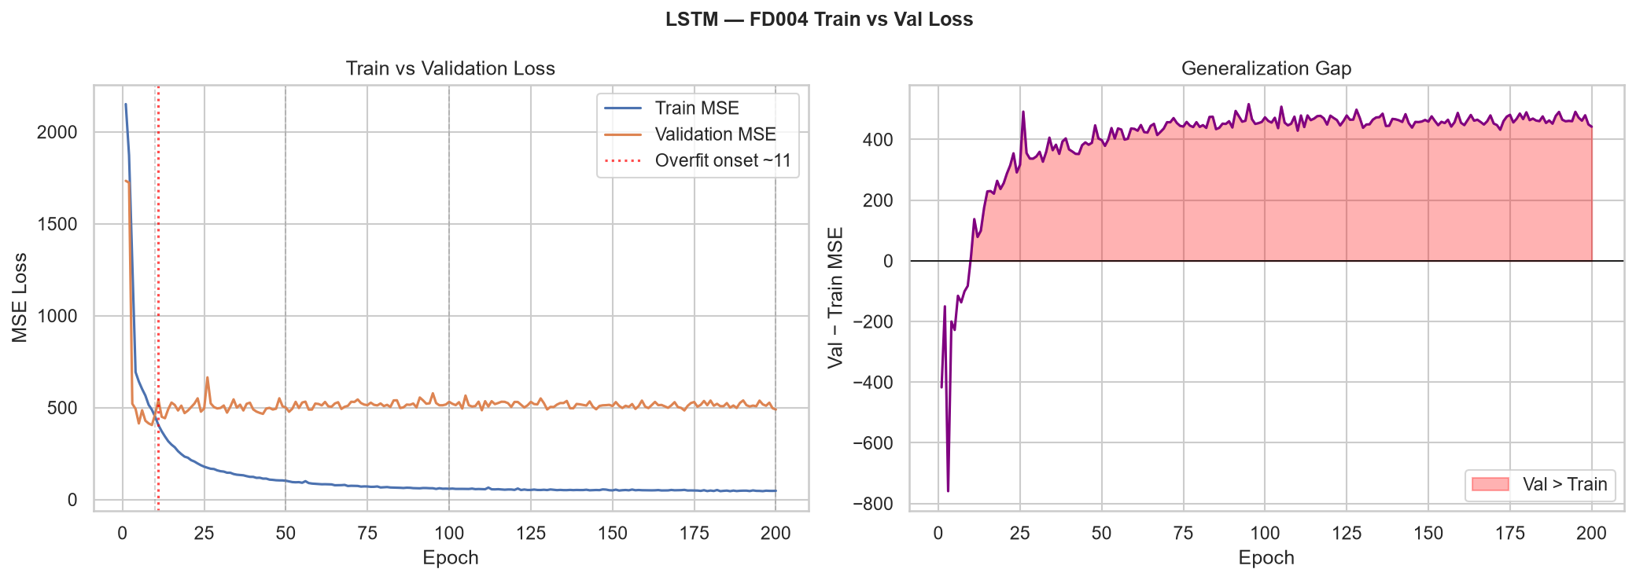
Loss curves: LSTM on FD004

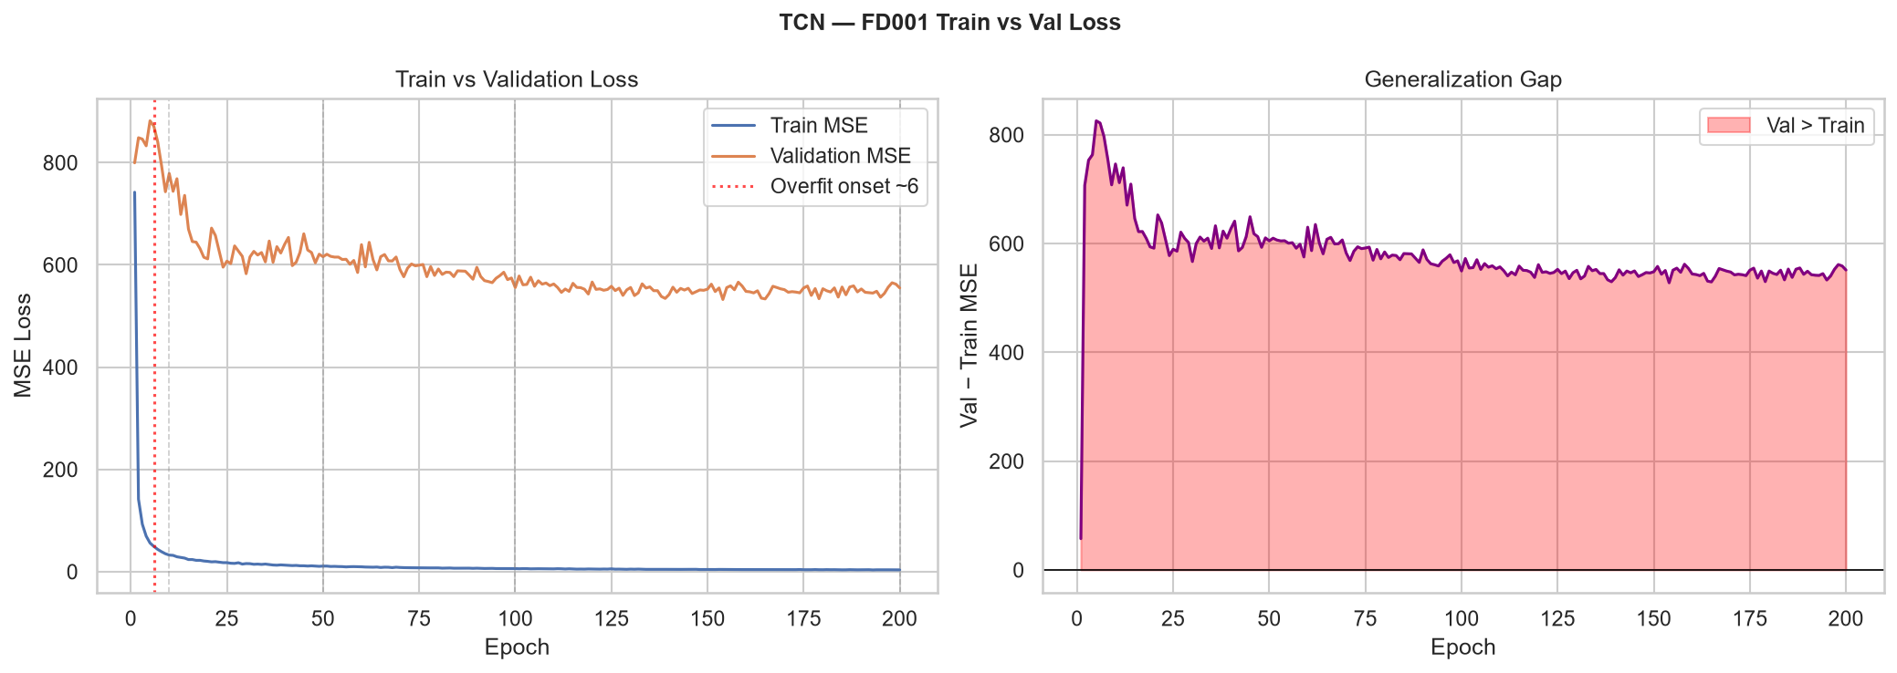
Loss curves: TCN on FD001

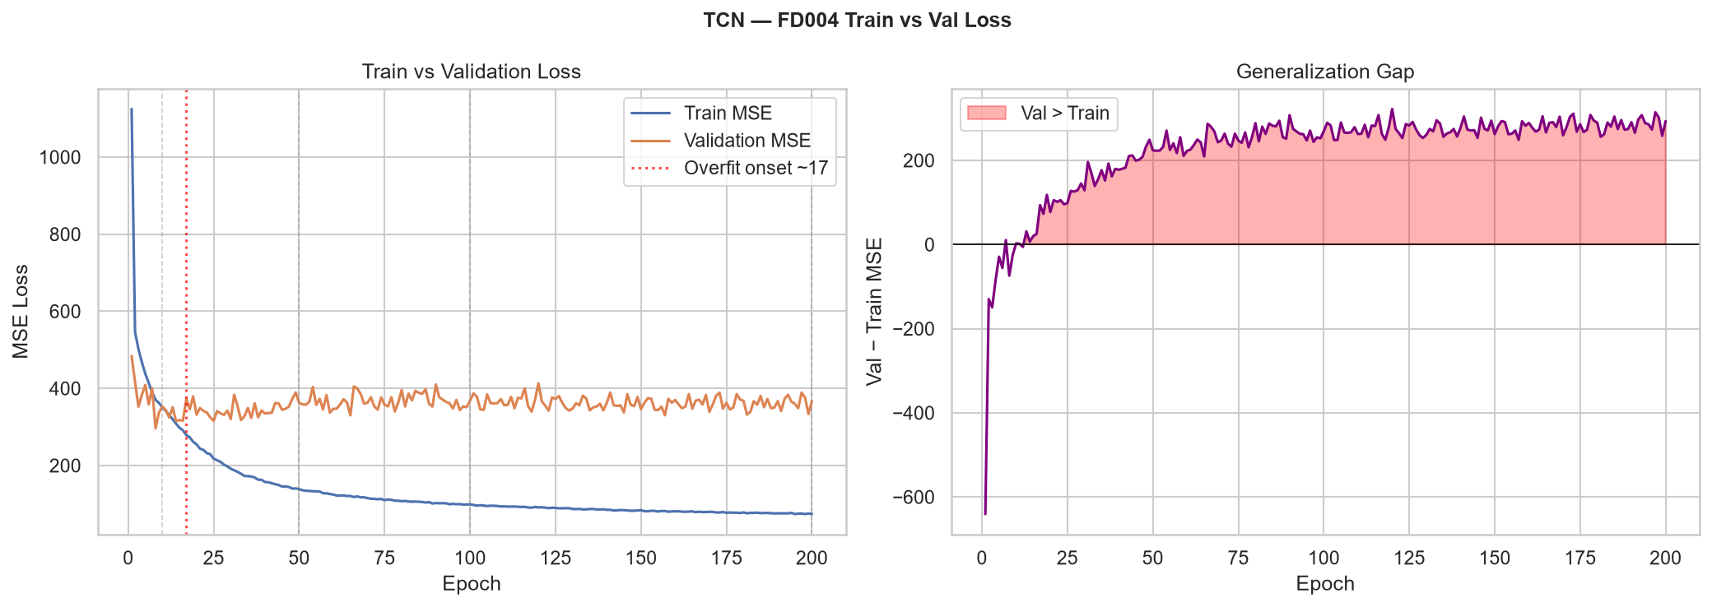
Loss curves: TCN on FD004

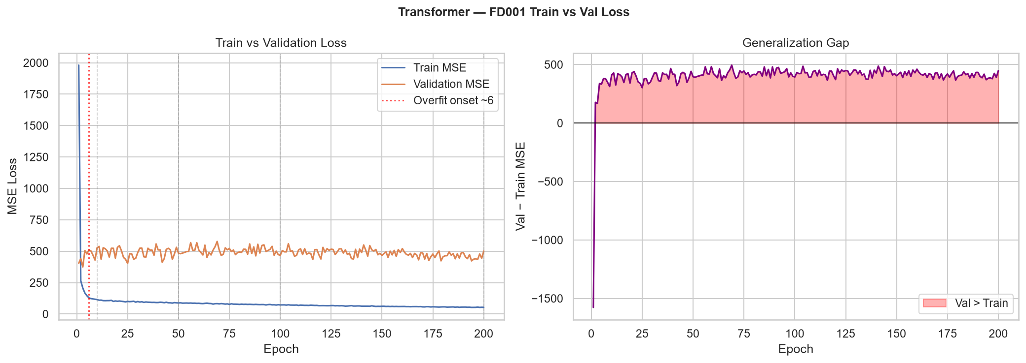
Loss curves: Transformer on FD001

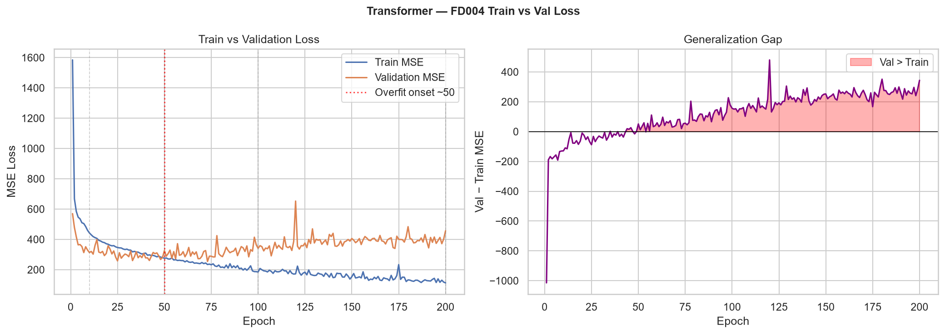
Loss curves: Transformer on FD004

9. Sensor Importance Analysis
Feature importance from ExtraTrees regressor, aggregated across engineered variants (raw, unit-relative, rolling mean/std). Higher values indicate stronger contribution to RUL prediction.

9.1 FD001 — Single operating condition (sea level)
Feature | Importance
sensor_11 | 0.1802
sensor_4 | 0.1321
sensor_20 | 0.0902
sensor_15 | 0.0790
sensor_21 | 0.0781
sensor_12 | 0.0780
sensor_2 | 0.0735
sensor_9 | 0.0616
sensor_17 | 0.0581
sensor_7 | 0.0480

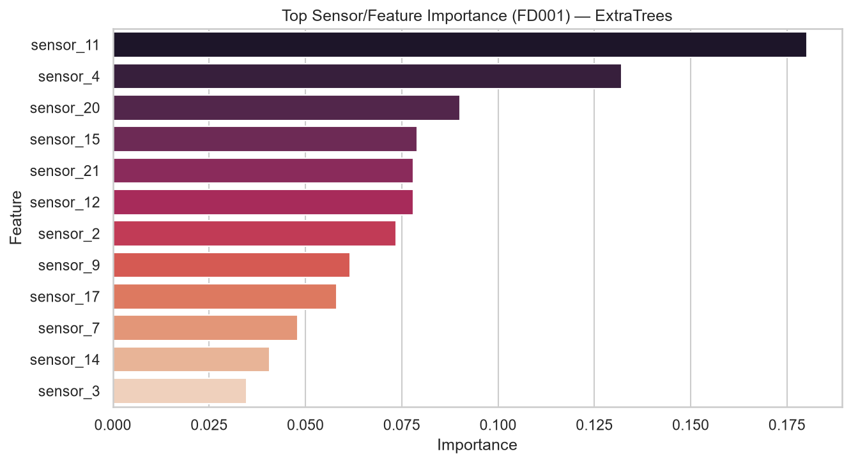
Top sensor importance — FD001

9.2 FD002 — Six operating conditions
Feature | Importance
sensor_15 | 0.1469
sensor_11 | 0.1466
sensor_13 | 0.1254
sensor_4 | 0.1046
sensor_14 | 0.0697
sensor_16 | 0.0432
sensor_17 | 0.0393
sensor_9 | 0.0348
sensor_3 | 0.0327
sensor_10 | 0.0306

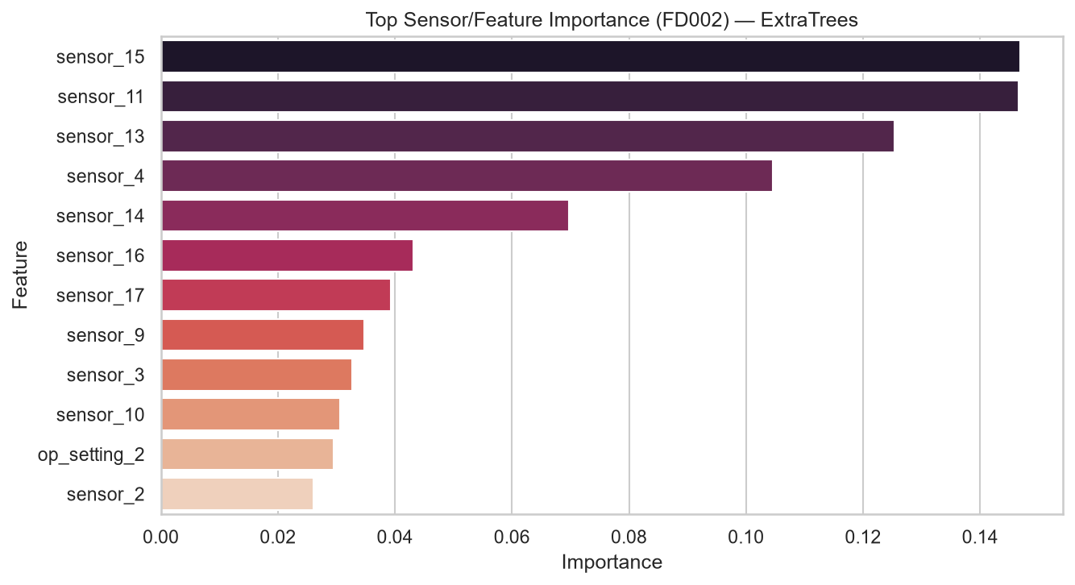
Top sensor importance — FD002

9.3 FD003 — Single operating condition
Feature | Importance
sensor_11 | 0.3072
sensor_17 | 0.1268
sensor_4 | 0.1173
sensor_3 | 0.0906
sensor_9 | 0.0535
sensor_14 | 0.0473
sensor_13 | 0.0455
sensor_12 | 0.0432
sensor_8 | 0.0430
sensor_2 | 0.0396

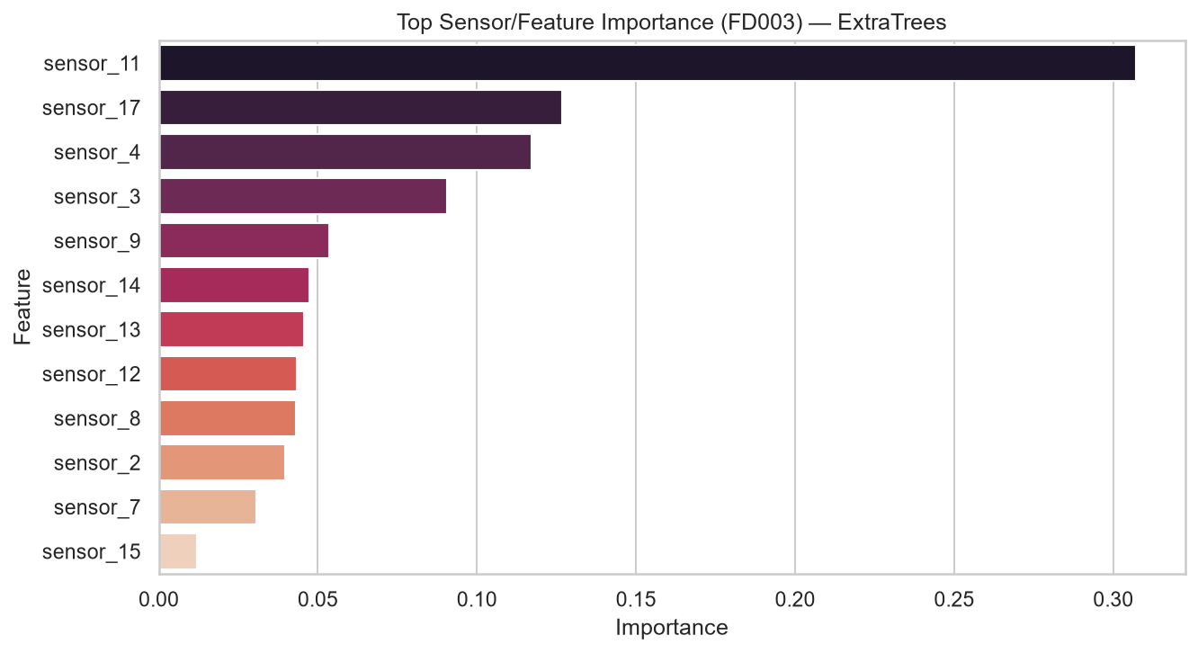
Top sensor importance — FD003

9.4 FD004 — Six operating conditions
Feature | Importance
sensor_13 | 0.1835
sensor_14 | 0.1302
sensor_11 | 0.1269
sensor_15 | 0.0836
sensor_4 | 0.0753
sensor_9 | 0.0403
sensor_16 | 0.0376
sensor_17 | 0.0353
sensor_10 | 0.0321
op_setting_2 | 0.0285

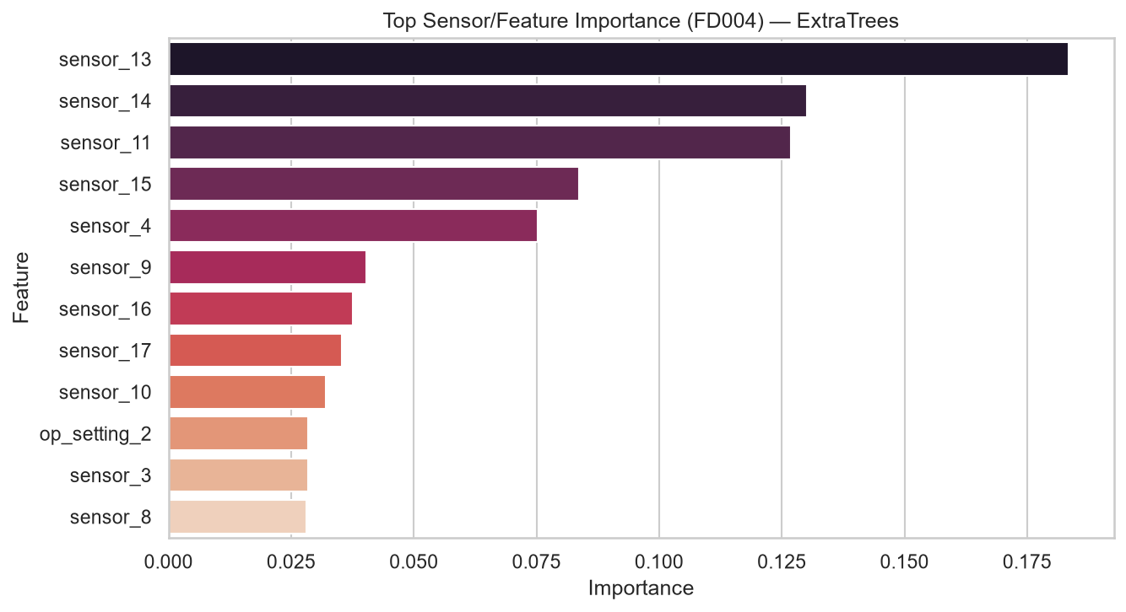
Top sensor importance — FD004

10. Model Behavior Classification
Note: Stage 10 / Stage 50 refer to ML training stages (Section 6). Epoch 6 refers to DL training epochs (Section 7). FD001–FD004 refer to the dataset subsets defined in Section 1.2.

Category | Models | Evidence
Underfitting (early ML) | XGBoost, HistGradientBoosting at Stage 10 | RMSE 28–43 before enough estimators on FD001–FD004
Stable (ML) | ExtraTrees, XGBoost at Stages 50–200 | RMSE change < 1.5 from Stage 50 to Stage 200
Overfitting (DL) | LSTM, GRU, CNN1D, TCN, Transformer on FD001 | Validation loss exceeds training loss after epoch 6
Best balance | ExtraTrees, TemporalGAT, Transformer | Strong RMSE with acceptable generalization gap

11. Model Architectures
Architecture diagrams for representative models from each family. Graph-based models use a temporal chain graph where each of the 30 time steps is a node.
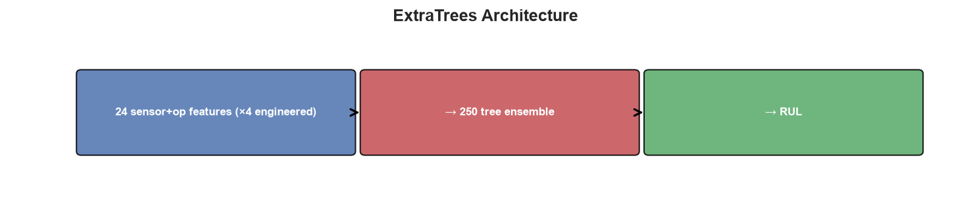
Architecture: ExtraTrees

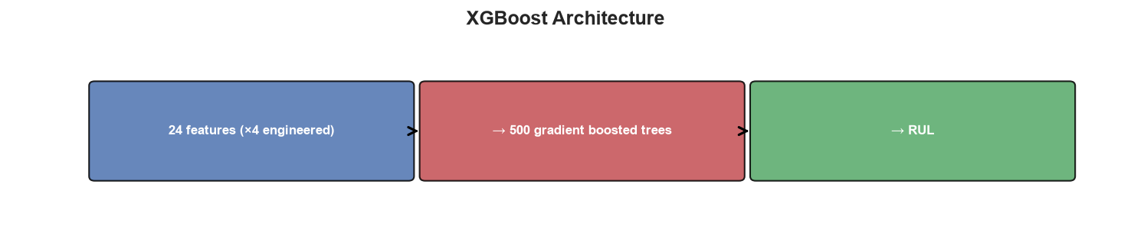
Architecture: XGBoost

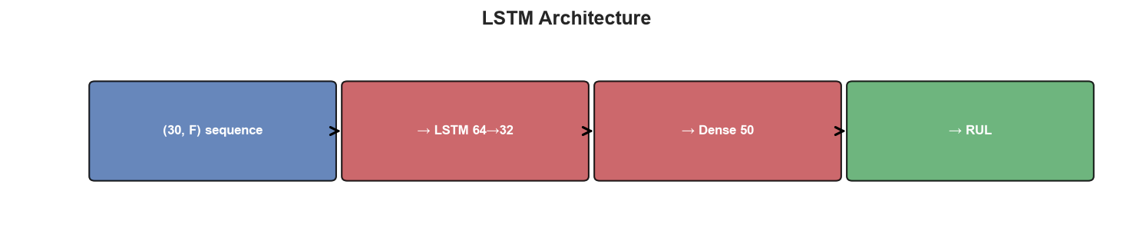
Architecture: LSTM

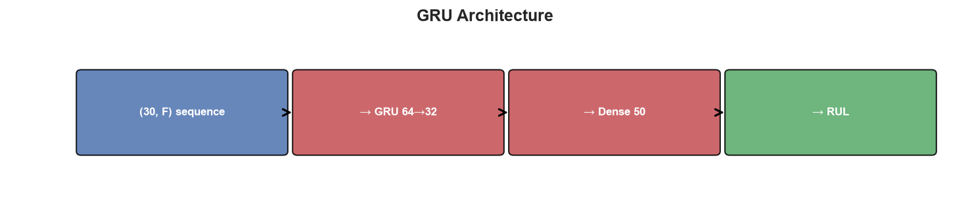
Architecture: GRU

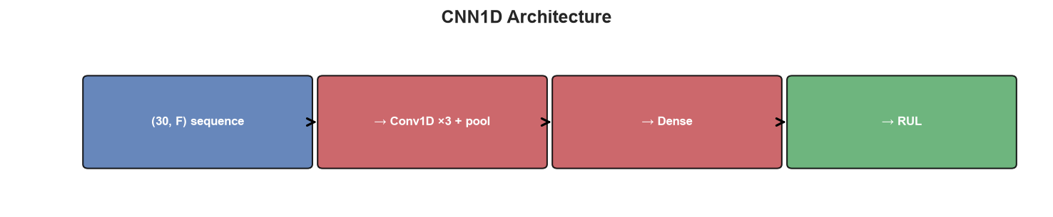
Architecture: CNN1D

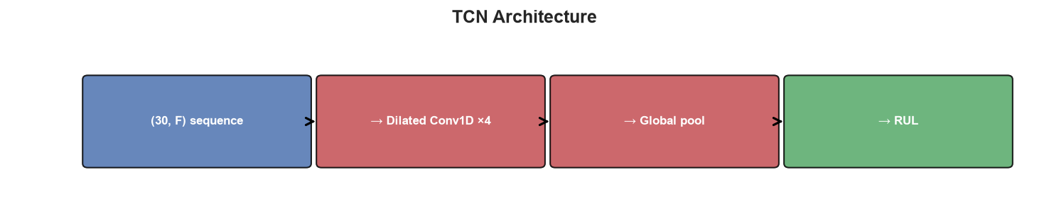
Architecture: TCN

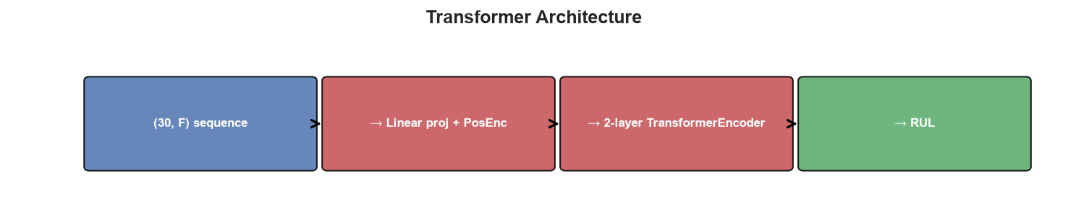
Architecture: Transformer

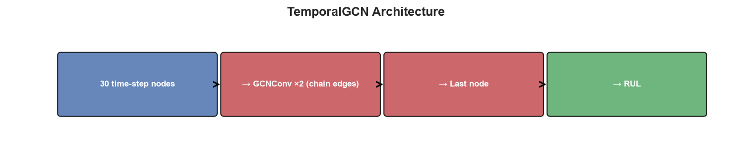
Architecture: TemporalGCN

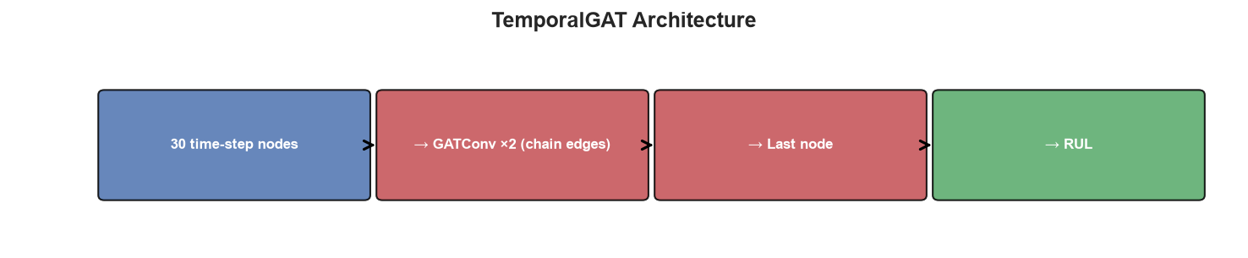
Architecture: TemporalGAT

12. Final Recommendations
FD001 — single condition, single fault: ExtraTrees (RMSE 13.89) — best overall. TemporalGAT (16.60) for graph-based approach.
FD002 — six conditions, single fault: Transformer (RMSE 26.57) — beats XGBoost (27.71). Use sequence models when GPU available.
FD003 — single condition, dual fault: HistGradientBoosting (RMSE 17.13) — fast and accurate.
FD004 — six conditions, dual fault (hardest): HistGradientBoosting (RMSE 29.39) — best overall on the hardest subset.
Interpretability: ExtraTrees + sensor importance. Top sensors: sensor_11, sensor_4, sensor_12.
Production baseline: ExtraTrees or HistGradientBoosting with engineered rolling features.
Graph-based RUL: TemporalGAT for attention-weighted temporal graphs; TemporalGCN for convolutional aggregation.

13. Presentation Summary
We benchmarked 13 models (6 ML + 5 DL + 2 Graph) on NASA C-MAPSS RUL prediction across four datasets (FD001–FD004). All metrics are last-cycle RMSE/MAE/R² per test engine.
- Best RMSE — FD001 (easiest): 13.89, FD002: 26.57, FD003: 17.13, FD004 (hardest): 29.39.
- ML with feature engineering wins on FD001/FD003/FD004; Transformer wins FD002.
- FD004 is ~2× harder than FD001 due to 6 operating conditions and 2 fault modes.
- DL models overfit after ~epoch 6 on FD001; early stopping at Stage/Epoch 50 is recommended.
- sensor_11 and sensor_4 are the dominant degradation indicators on FD001.
- TemporalGAT achieves competitive graph-based results (RMSE 16.60 on FD001).

14. Glossary & Table Reading Guide
Term | Meaning
FD001 | Failure Dataset 001 — 1 operating condition, 1 fault mode, easiest
FD002 | Failure Dataset 002 — 6 operating conditions, 1 fault mode
FD003 | Failure Dataset 003 — 1 operating condition, 2 fault modes
FD004 | Failure Dataset 004 — 6 operating conditions, 2 fault modes, hardest
Stage 10/50/100/200 | ML training checkpoints — number of estimators/trees used
Epoch 10/50/100/200 | DL training checkpoints — number of training passes completed
Last-cycle RMSE | Root mean squared error at the final observed cycle of each test engine
RUL cap (125) | Training labels capped at 125 cycles to reduce noise from early-life data
TemporalGCN | Graph Convolutional Network over temporal node chains
TemporalGAT | Graph Attention Network over temporal node chains

15. Data Files Reference
File | Description
results/all_model_results.csv | ML benchmark results (FD001–FD004)
results/dl_model_results.csv | DL benchmark results (FD001–FD004)
results/graph_model_results.csv | Graph benchmark results (FD001–FD004)
results/all_results_master.csv | All 13 models combined
results/best_per_dataset_all.csv | Best model per FD dataset
docs/epoch_metrics_ml.csv | ML staged metrics at Stages 10/50/100/200
docs/epoch_metrics_dl.csv | DL metrics at Epochs 10/50/100/200
docs/sensor_importance.csv | Feature importance scores per FD dataset
models/*.pkl, *.pth | Saved best models per dataset

