AGENDA:

VCS?

Types of VCS?

Changes from real word POV?

*Git and Github

**VCS**

Version – 3.03.16

**1st**

2 games a,b

2 games c,d

**2nd**

2 games a,b

2 games e,f

Commit id----

Unique thing! Helps me to track the changes

1.04.2

1.05.2

1.06.02

1.07.3 -- > error

VCS – Version control system

It is a tool that helps you to manage changes to source , code, documentation, or any data

Allows multiple people to work on a same project

Maintains history, enables team work.

**Types of version control system!!**

**CVCS - Centralised ..**

**DVCS – Distributed ..**

**Repository – Dedicated place where your code/progress/documentation is stored.**

**Local Repo- exists on system**

**Remote repo- exists on server**

**CVCS**

**Single Repo. – single server** that holds the version code, developers make changes to the committed file only,

**DVCS**

Remote and local repo.

Every developer has own copy of it, on theier local machine,

* Even if the server is down the developers can work on it
* Eg. Git , Bazaar, Murcurial

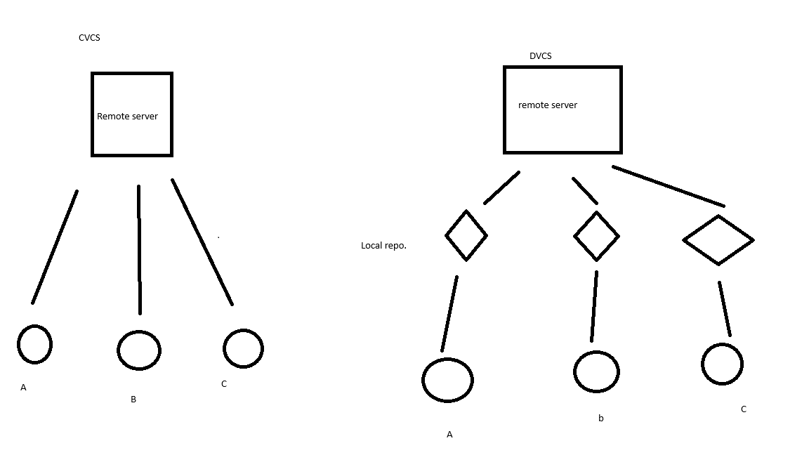

**Git & Git-hub**

Git –

<https://git-scm.com/downloads/win>

Git Hub –

<https://github.com/signup?ref_cta=Sign+up&ref_loc=header+logged+out&ref_page=%2F&source=header-home>