Lab Assignment - 4

**GITHUB REPOSITORY**: <https://github.com/dakshh3163/Assignment-4>

# **Q1:**

import numpy as np

print(f"Numpy Version: {np.__version__}")

user_input = input("Enter elements of the list: ")

elements = user_input.split()

freq = {}

for item in elements:

    if item in freq:

        freq[item] += 1

    else:

        freq[item] = 1

print("Frequency of each element: ")

for key, value in freq.items():

    print(f"'{key} : {value}")

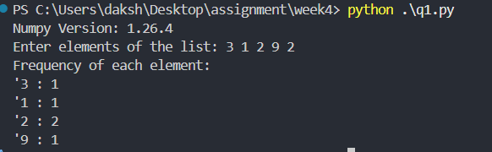

**Q2:**

import numpy as np

user_input = input("Enter the binary input: ")

arr = np.array(list(user_input), dtype=int)

arr = np.sort(arr)[::-1]

result = ''.join(arr.astype(str))

print("Result: ",result)

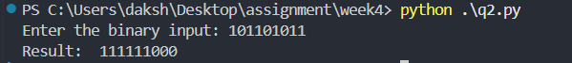

**Q3:**

import numpy as np

def removeNthChar(n):

    arr = np.array(list(user_input),dtype=str)

    arr = np.delete(arr,n-1)

    result = ''.join(arr.astype(str))

    return result

user_input = input("Enter the string: ")

n = int(input("Enter the value for nth index: "))

print(removeNthChar(n))

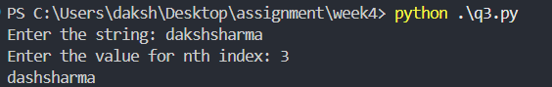

**Q4:**

import numpy as np

original_arr = np.ones((4,4))

arr = np.zeros((5,5))

for i in range(1, 4):

    for j in range(1, 4):

        arr[i][j] = 1

print(arr)

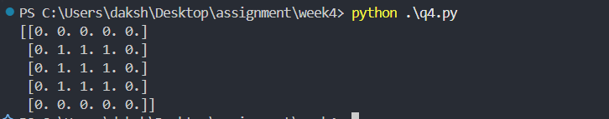

**Q5:**

import numpy as np

array1 = np.array([0, 10, 20, 40, 60])

array2 = np.array([0, 40])

array1 = np.array(list(map(int, input("Enter elements of first array: ").split())))

array2 = np.array(list(map(int, input("Enter elements of second array: ").split())))

*# Compare elements*

result = np.isin(array1, array2)

print(result)

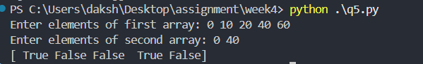

**Q6:**

import numpy as np

array1 = np.array(list(map(int, input("Enter elements of first array: ").split())))

array2 = np.array(list(map(int, input("Enter elements of second array: ").split())))

result = np.setxor1d(array1, array2)

print("Unique values that are in only one (not both) of the input arrays:")

print(result)

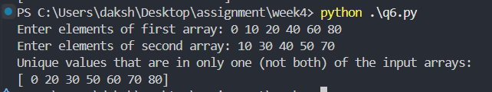

**Q7:**

import numpy as np

array1 = np.array(list(map(int, input("Enter elements of first array: ").split())))

array2 = np.array(list(map(int, input("Enter elements of second array: ").split())))

result = np.column_stack((array1, array2))

print("Stack arrays column-wise:")

print(result)

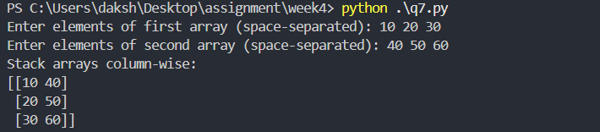

**Q8:**

import numpy as np

r = int(input("Enter the number of rows: "))

c = int(input("Enter the number of columns: "))

print("Enter the elements row-wise:")

matrix = []

for i in range(r):

    row = list(map(float, input(f"Row {i+1}: ").split()))

    matrix.append(row)

matrix = np.array(matrix)

print("\nInput Matrix:")

print(matrix)

rank = np.linalg.matrix_rank(matrix)

trace = np.trace(matrix)

det = np.linalg.det(matrix) if r == c else None  *# determinant only for square matrices*

print("\nMatrix Properties:")

print("Rank of the matrix:", rank)

print("Trace of the matrix:", trace)

if det is not None:

    print("Determinant of the matrix:", det)

else:

    print("Determinant not defined for non-square matrices.")

