**Lab Assignment - 5**

**Github Repository:** [**https://github.com/dakshh3163/Assignment-5**](https://github.com/dakshh3163/Assignment-5)

**Matplotlib**

**Q7:**

# problem 7

x = np.array([-np.pi, -np.pi/4, -np.pi/2, 0, np.pi/4, np.pi/2, np.pi])

# Calculate function values

tan_x = np.tan(x)

cot_x = 1 / np.tan(x)

sec_x = 1 / np.cos(x)

cosec_x = 1 / np.sin(x)

# Create subplots

plt.figure(figsize=(10, 6))

plt.plot(x, tan_x, 'r-o', label='tan(x)')

plt.plot(x, cot_x, 'g-s', label='cot(x)')

plt.plot(x, sec_x, 'b-^', label='sec(x)')

plt.plot(x, cosec_x, 'm-d', label='cosec(x)')

# Add grid, legend, and labels

plt.axhline(0, color='black', linewidth=0.5)

plt.axvline(0, color='black', linewidth=0.5)

plt.title('Trigonometric Functions at Specific x Values')

plt.xlabel('x')

plt.ylabel('Function Value')

plt.legend()

plt.grid(True)

plt.show()

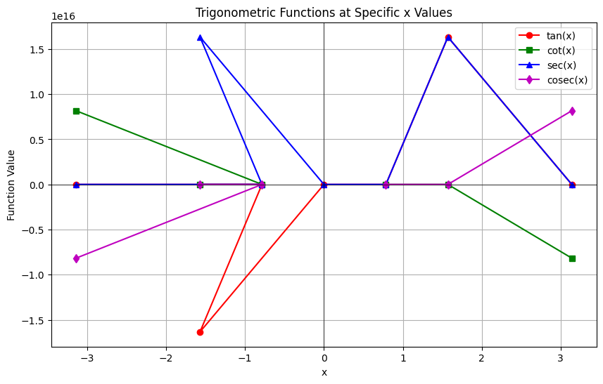

**Q8:**

# problem 8

methods = ['A', 'B', 'C', 'D']

result1 = [2, 5, 8, 5]

result2 = [3, 2, 5, 7]

# Bar positions

x = np.arange(len(methods))

width = 0.35 # width of the bars

# Plotting

plt.bar(x - width/2, result1, width, label='Result1', color='skyblue')

plt.bar(x + width/2, result2, width, label='Result2', color='salmon')

# Labels and title

plt.xlabel('Method')

plt.ylabel('Results')

plt.title('Bar Chart Representation of Results')

plt.xticks(x, methods)

plt.legend()

plt.grid(True, axis='y', linestyle='--', alpha=0.7)

# Show plot

plt.tight_layout()

plt.show()

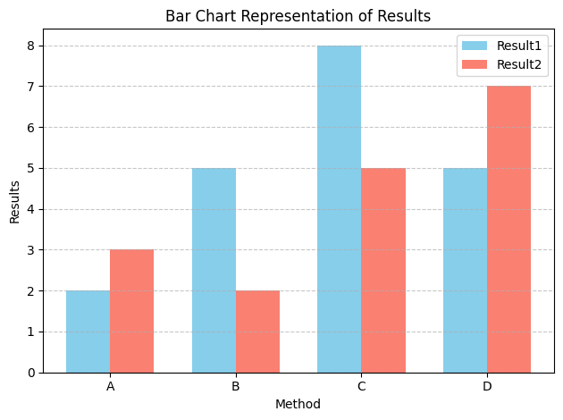

**SciPy Library**

