Lab Assignment - 7

Github Repository: https://github.com/dakshh3163/Assignment-6

import requests
from bs4 import BeautifulSoup
from pymongo import MongoClient

from bs4 import BeautifulSoup
import requests

# Get website from user
url = input("Enter a website to extract URLs from: ").strip()

# Ensure it starts with http/https
if not url.startswith(("http://", "https://")):
url = "https://" + url # safer default

# Set headers to avoid 403
headers = {
"User-Agent": "Mozilla/5.0 (Windows NT 10.0; Win64; x64) "
"AppleWebKit/537.36 (KHTML, like Gecko) "
"Chrome/124.0.0.0 Safari/537.36"
}

try:
# Fetch webpage
r = requests.get(url, headers=headers, timeout=10)
r.raise_for_status() # raises error for 4xx/5xx

# Parse HTML
soup = BeautifulSoup(r.text, 'lxml')

# Extract and print title
if soup.title:
title = soup.title.string.strip()
tag_name = soup.title.name
print(f"\nPage Title: {title}\nTag Name: {tag_name}\n")
else:
print("No title found.\n")

# Extract and print URLs
print("All found URLs:\n")
for link in soup.find_all('a', href=True):
print(link['href'])

except requests.exceptions.RequestException as e:
print(f"Error fetching the site: {e}")

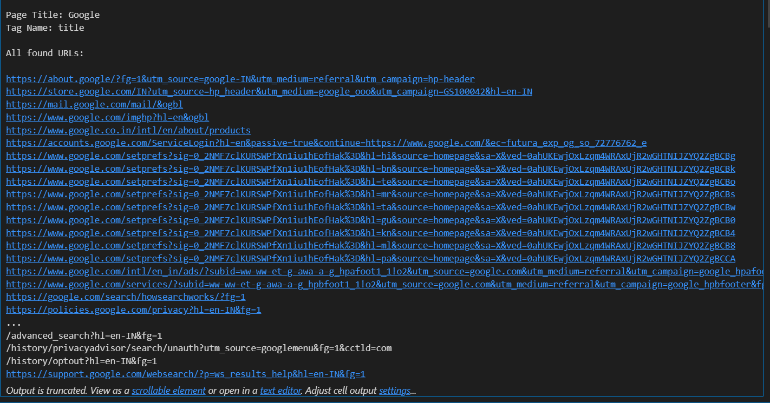
url = 'http://www.usamega.com/mega-millions-history.asp?p=1'

headers = {
"User-Agent": "Mozilla/5.0 (Windows NT 10.0; Win64; x64) "
"AppleWebKit/537.36 (KHTML, like Gecko) "
"Chrome/124.0.0.0 Safari/537.36"
}

req = requests.get(url, headers=headers)
soup = BeautifulSoup(req.text, 'lxml')

tables = soup.find_all('table')

if len(tables) > 4:
rows = tables[4].find_all('tr')
if len(rows) > 1:
cells = rows[1].find_all('td')
if len(cells) > 3:
try:
draw_date = cells[1].a.string.strip() if cells[1].a else "No link text"
jackpot_b = cells[3].b.string.strip() if cells[3].b else "No <b> tag"
jackpot_strong = cells[3].strong.string.strip() if cells[3].strong else "No <strong> tag"

print("Draw Date:", draw_date)
print("Jackpot (b tag):", jackpot_b)
print("Jackpot (strong tag):", jackpot_strong)
except Exception as e:
print("Error extracting data:", e)
else:
print("Not enough <td> elements in the row.")
else:
print("Not enough rows in the table.")
else:
print("Not enough tables on the page.")
# MongoDB setup
MONGO_URI = "mongodb://localhost:27017/"
DATABASE = "lotto"
COLLECTION = "mega_millions"

def mongo_connection():
client = MongoClient(MONGO_URI)
col = client[DATABASE][COLLECTION]
return col

def scrape_page(page_num):
url = f"https://www.usamega.com/mega-millions-history.asp?p={page_num}"
headers = {
"User-Agent": "Mozilla/5.0 (Windows NT 10.0; Win64; x64) "
"AppleWebKit/537.36 (KHTML, like Gecko) "
"Chrome/124.0.0.0 Safari/537.36"
}

response = requests.get(url, headers=headers)
response.raise_for_status()
soup = BeautifulSoup(response.text, "lxml")

tables = soup.find_all("table")
if len(tables) < 5:
print(f"Page {page_num}: expected table not found.")
return []

rows = tables[4].find_all("tr")
results = []

for row in rows[1:]: # skip header
tds = row.find_all("td")
if len(tds) < 4:
continue

draw_link = tds[1].find("a")
jackpot_cell = tds[3]

if not draw_link or not jackpot_cell:
continue

draw_date = draw_link.get_text(strip=True)
numbers_text = jackpot_cell.find("b")
mega_text = jackpot_cell.find("strong")

if not numbers_text or not mega_text:
continue

# Split numbers, BeautifulSoup already decodes &middot;
numbers = [int(n) for n in numbers_text.get_text(strip=True).split("·")]
mega_number = int(mega_text.get_text(strip=True))

results.append({
"date": draw_date,
"numbers": numbers,
"mega_number": mega_number
})
return results

def main():
col = mongo_connection()
total_pages = 63

for page_num in range(1, total_pages + 1):
print(f"Scraping page {page_num}...")
data = scrape_page(page_num)
if data:
col.insert_many(data)
print(f"Inserted {len(data)} records from page {page_num}")
else:
print(f"No data on page {page_num}")

if __name__ == "__main__":
main()

from pymongo import MongoClient

# Connect to your Atlas cluster
uri = "MONGO_DB_URL"
client = MongoClient(uri)

# Select database and collection
db = client["lotto"]
collection = db["mega_millions"]

# Example data to insert
draws = [
{
"date": "2025-10-25",
"numbers": [5, 12, 28, 36, 48],
"mega_number": 17
},
{
"date": "2025-10-22",
"numbers": [1, 8, 19, 32, 45],
"mega_number": 10
},
{
"date": "2025-10-18",
"numbers": [7, 16, 24, 39, 42],
"mega_number": 6
}
]

# Insert multiple documents
result = collection.insert_many(draws)
print("Inserted IDs:", result.inserted_ids)

# Optional: verify insertion
for doc in collection.find():
print(doc)

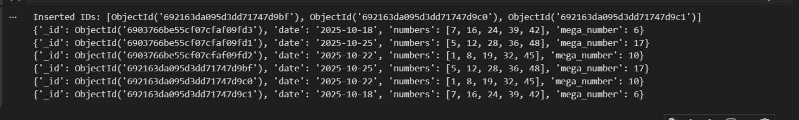
import requests
from bs4 import BeautifulSoup
from pymongo import MongoClient
import datetime

# === Configuration ===
MONGO_URI = "MONGO_DB_URL"
DATABASE = "lotto"
COLLECTION = "mega_millions"
# Website that lists the latest Mega Millions results
RESULTS_URL = "https://en.wikipedia.org/wiki/Computer" # example source

# === Database connection ===
client = MongoClient(MONGO_URI)
db = client[DATABASE]
col = db[COLLECTION]

# === Function to fetch latest draw ===
def fetch_latest_draw():
resp = requests.get(RESULTS_URL, headers={
"User-Agent": "Mozilla/5.0 (Windows NT 10.0; Win64; x64) "
"AppleWebKit/537.36 (KHTML, like Gecko) "
"Chrome/124.0.0.0 Safari/537.36"
}, timeout=10)
resp.raise_for_status()

soup = BeautifulSoup(resp.text, "lxml")

# Example: from lotteryusa page we might extract first draw info
# (This part **must** be adapted to the actual HTML structure)
# For example: the latest draw date might be in a <div> with class “results__header” etc
# Here we make a guess:
date_div = soup.select_one("section.results-section h3") # this is speculative
if not date_div:
raise RuntimeError("Could not find draw date element")

draw_date_str = date_div.get_text(strip=True)
# parse date (depends on format)
draw_date = datetime.datetime.strptime(draw_date_str, "%A, %b %d, %Y") # adjust format accordingly

numbers_div = soup.select_one("ul.drawresult-numbers") # speculative selector
if not numbers_div:
raise RuntimeError("Could not find numbers element")

number_spans = numbers_div.find_all("li")
# We expect 5 white + 1 mega ball
if len(number_spans) < 6:
raise RuntimeError("Unexpected numbers count")

whites = [int(span.get_text()) for span in number_spans[:5]]
mega_ball = int(number_spans[5].get_text())

return {
"date": draw_date.strftime("%Y-%m-%d"),
"numbers": whites,
"mega_number": mega_ball
}

def main():
try:
draw = fetch_latest_draw()
print("Fetched draw:", draw)

# Check if we already have this draw in DB
existing = col.find_one({"date": draw["date"]})
if existing:
print("Draw for date", draw["date"], "already in database. Skipping insert.")
else:
result = col.insert_one(draw)
print("Inserted draw with _id:", result.inserted_id)

except Exception as e:
print("Error during fetching/inserting:", e)

if __name__ == "__main__":
main()

import pandas as pd
import folium

# Example data
data = {
'Name': ['Alice', 'Bob', 'Charlie'],
'Age': [25, 30, 22],
'Location': ['37.7749,-122.4194', '34.0522,-118.2437', '31.2304,121.4737']
}

# Create DataFrame
df2 = pd.DataFrame(data)

# Create base map
world_map = folium.Map(location=[35, 100], zoom_start=4)

# Add markers
for i in range(len(df2)):
lat, lon = map(float, df2.Location[i].split(','))
popup_text = f"{df2.Name[i]}, age: {df2.Age[i]}"
folium.Marker(location=[lat, lon], popup=popup_text).add_to(world_map)

# Display the map (in Jupyter) or save to file
world_map.save("world_map.html")
world_map

