Lab Assignment - 7

Github Repository: https://github.com/dakshh3163/Assignment-7

Q1: Linear Regression (Regression Task)

import numpy as np
import pandas as pd
import matplotlib.pyplot as plt

from sklearn.preprocessing import StandardScaler
from sklearn.model_selection import train_test_split
from sklearn.linear_model import LinearRegression
from sklearn.metrics import mean_squared_error, r2_score

df = pd.read_csv('housing.csv')
df.head()
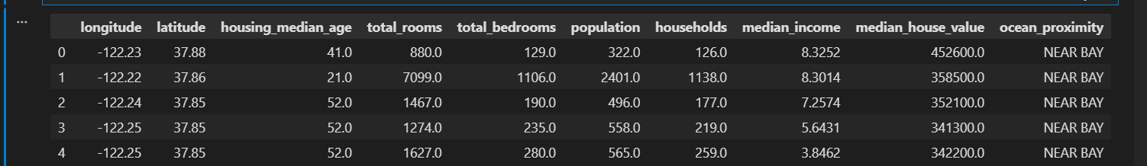
df.dropna(inplace=True)
df.shape
df = pd.get_dummies(df,columns=['ocean_proximity'])
X = df.drop('median_house_value',axis = 1)
y = df['median_house_value']
X_train, X_test, y_train, y_test = train_test_split(X, y, test_size=0.2, random_state=42)
scaler = StandardScaler()
X_train_scaled = scaler.fit_transform(X_train)
X_test_scaled = scaler.transform(X_test)
model = LinearRegression()
model.fit(X_train_scaled,y_train)
print(f"Regression Coefficients : {model.coef_}\n")
print(f"Regression Intercepts : {model.intercept_:.2f}")
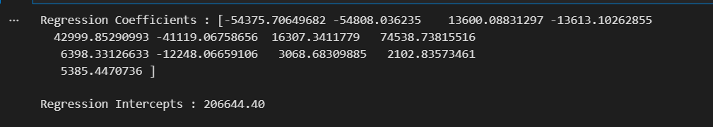
y_pred = model.predict(X_test_scaled)
print(f"Targeted Value for test data : {y_pred}")
mse = mean_squared_error(y_test,y_pred)
r2 = r2_score(y_test,y_pred)
print(f"MSE: {mse:.2f}")
print(f"R2 Score: {r2:.2f}")
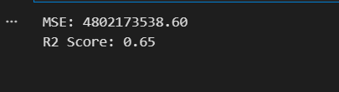
plt.figure(figsize=(6,6))
plt.scatter(y_test, y_pred, alpha=0.4)
plt.xlabel("Actual House Prices")
plt.ylabel("Predicted House Prices")
plt.title("Predicted vs Actual House Prices")

plt.show()
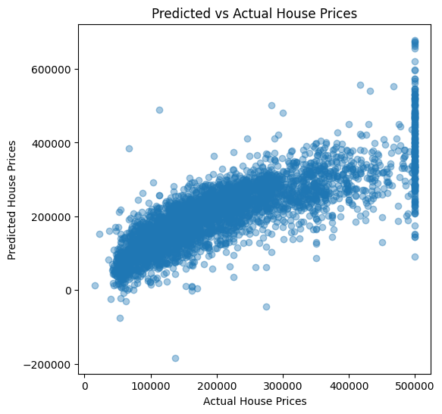
Q2: Logistic Regression (Classification Task)

import pandas as pd
import numpy as np
import matplotlib.pyplot as plt

from sklearn.preprocessing import StandardScaler, LabelEncoder
from sklearn.linear_model import LogisticRegression
from sklearn.model_selection import train_test_split
from sklearn.metrics import accuracy_score, precision_score, recall_score, f1_score, confusion_matrix
df = pd.read_csv('Iris.csv')
df.head()
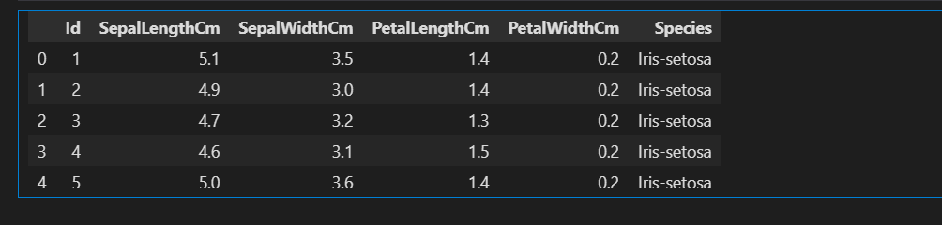X = df.drop('Species',axis = 1)
y = df['Species']

# label encoding the target
y = LabelEncoder().fit_transform(y)
X_train, X_test, y_train, y_test = train_test_split(X, y, test_size=0.2, random_state=42)
scaler = StandardScaler()
X_train_scaled = scaler.fit_transform(X_train)
X_test_scaled = scaler.transform(X_test)
model = LogisticRegression(max_iter=200)
model.fit(X_train_scaled,y_train)
print("\nCoefficients for each class:")
for cls, coef in zip(model.classes_, model.coef_):
print(f"Class {cls}: {coef}")

print("\nIntercepts for each class:")
print(model.intercept_)
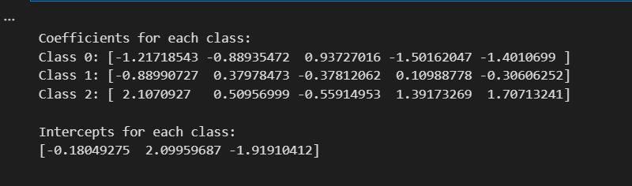
y_pred = model.predict(X_test_scaled)
y_pred
cm = confusion_matrix(y_test, y_pred)
print(f"Confusion Matrix :\n {cm}")
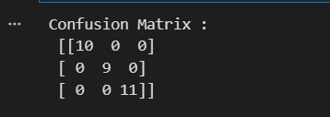
accuracy = accuracy_score(y_test, y_pred)
precision = precision_score(y_test, y_pred,average='weighted')
recall = recall_score(y_test, y_pred,average='weighted')
f1Score = f1_score(y_test,y_pred,average='weighted')
print("Classification Report\n")
print(f"Accuracy : {accuracy}\nPrecision : {precision}\nRecall : {recall}\nF1 Score : {f1Score}")

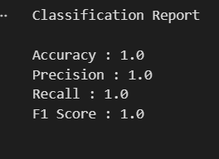
X_train_2 = X_train_scaled[:, :2]
X_test_2 = X_test_scaled[:, :2]

model_2 = LogisticRegression()
model_2.fit(X_train_2, y_train)

x_min, x_max = X_train_2[:, 0].min() - 1, X_train_2[:, 0].max() + 1
y_min, y_max = X_train_2[:, 1].min() - 1, X_train_2[:, 1].max() + 1
xx, yy = np.meshgrid(np.linspace(x_min, x_max, 500),
np.linspace(y_min, y_max, 500))

Z = model_2.predict(np.c_[xx.ravel(), yy.ravel()])
Z = Z.reshape(xx.shape)

cmap_bold = ['red', 'green', 'blue']

plt.figure(figsize=(8, 6))
plt.contourf(xx, yy, Z, alpha=0.35)

for idx, cls in enumerate(np.unique(y_train)):
plt.scatter(X_train_2[y_train == cls, 0],
X_train_2[y_train == cls, 1],
label=f"Class {cls} (train)",
color=cmap_bold[idx], edgecolor='k', s=70)

plt.scatter(X_test_2[:, 0], X_test_2[:, 1],
c=y_test, marker='x', s=70,
label='Test points')

plt.xlabel("Petal Length (scaled)")
plt.ylabel("Petal Width (scaled)")
plt.title("Decision Boundary — Logistic Regression")
plt.legend()
plt.show()
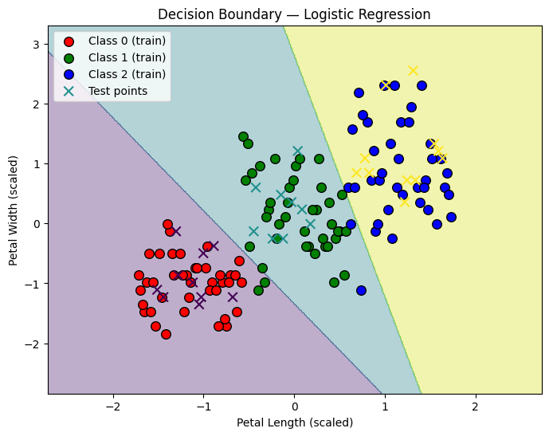

Q3: Decision Tree Classifier

import pandas as pd
import matplotlib.pyplot as plt
import seaborn as sns

from sklearn.model_selection import train_test_split
from sklearn.tree import DecisionTreeClassifier,plot_tree
from sklearn.datasets import load_iris
from sklearn.preprocessing import LabelEncoder
from sklearn.metrics import accuracy_score, confusion_matrix,classification_report
df = pd.read_csv('Iris.csv')
df.head()
X = df.drop('Species',axis = 1)
y = df['Species']

y = LabelEncoder().fit_transform(y)
X_train, X_test, y_train , y_test = train_test_split(X,y, test_size=0.25,random_state=42,stratify=y)
depths = [3,5,None]
models = {}
results = {}

for d in depths:
clf = DecisionTreeClassifier(max_depth=d,random_state=42)
clf.fit(X_train, y_train)
y_train_pred = clf.predict(X_train)
y_test_pred = clf.predict(X_test)

train_acc = accuracy_score(y_train, y_train_pred)
train_acc = accuracy_score(y_test, y_test_pred)

train_acc = accuracy_score(y_train, y_train_pred)
test_acc = accuracy_score(y_test, y_test_pred)

models[d] = clf
results[d] = {'train_acc':train_acc,'test_acc':test_acc}
for d in depths:
print(f"Depth = {d}: train_acc={results[d]['train_acc']:.3f}, test_acc={results[d]['test_acc']:.3f}")
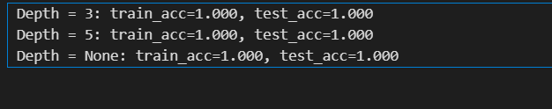feature_names = df.drop('Species', axis=1).columns
class_names = df['Species'].unique()

for d in depths:
clf = models[d]
y_test_pred = clf.predict(X_test)
print(f"\n=== Decision Tree (max_depth={d}) ===")
print("Test accuracy:", accuracy_score(y_test, y_test_pred))
print("\nClassification report:\n", classification_report(y_test, y_test_pred, target_names=class_names))

cm = confusion_matrix(y_test, y_test_pred)
plt.figure(figsize=(5,4))
sns.heatmap(cm, annot=True, fmt='d', cmap='Blues', xticklabels=class_names, yticklabels=class_names)
plt.xlabel('Predicted')
plt.ylabel('Actual')
plt.title(f'Confusion Matrix (max_depth={d})')
plt.show()
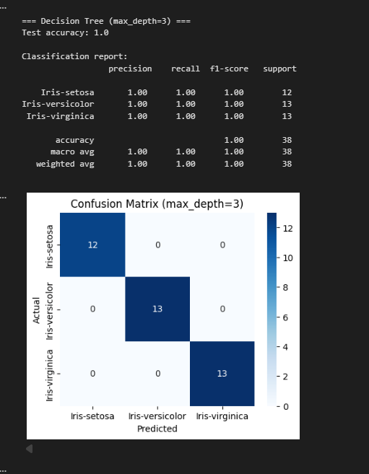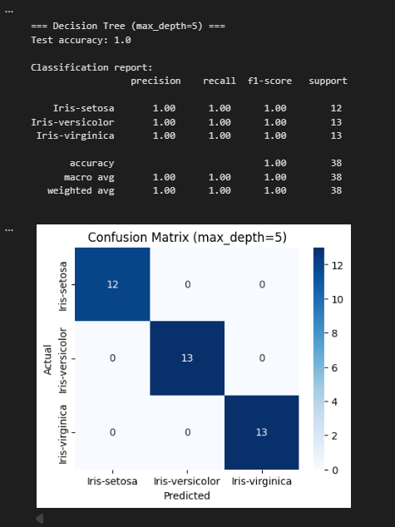
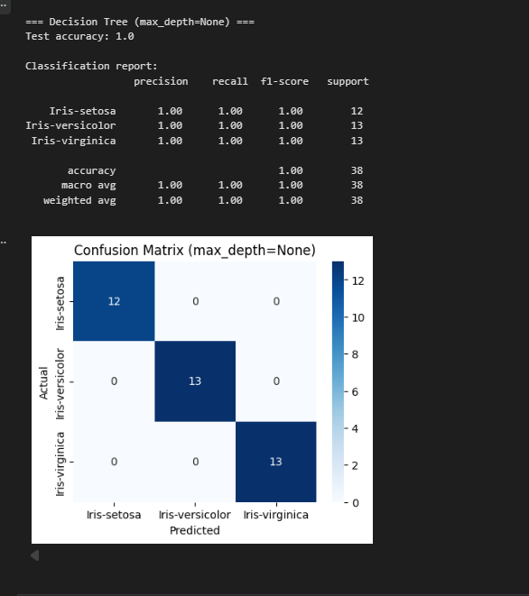

from sklearn.linear_model import LogisticRegression
from sklearn.preprocessing import StandardScaler

# Scale features for LR
scaler = StandardScaler()
X_train_scaled = scaler.fit_transform(X_train)
X_test_scaled = scaler.transform(X_test)

lr = LogisticRegression(multi_class='multinomial', solver='lbfgs', max_iter=200, random_state=42)
lr.fit(X_train_scaled, y_train)
y_test_pred_lr = lr.predict(X_test_scaled)

print("Logistic Regression test accuracy:", accuracy_score(y_test, y_test_pred_lr))
print("\nLogistic classification report:\n", classification_report(y_test, y_test_pred_lr, target_names=class_names))

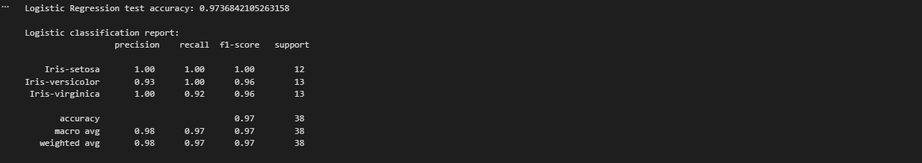
from sklearn.tree import plot_tree

# Pick the tree to visualize (e.g., depth=3)
tree_to_plot = models[3]

plt.figure(figsize=(18,10))
plot_tree(tree_to_plot,
feature_names=feature_names,
class_names=class_names,
filled=True, rounded=True,
fontsize=10)
plt.title("Decision Tree (max_depth=3)")
plt.show()

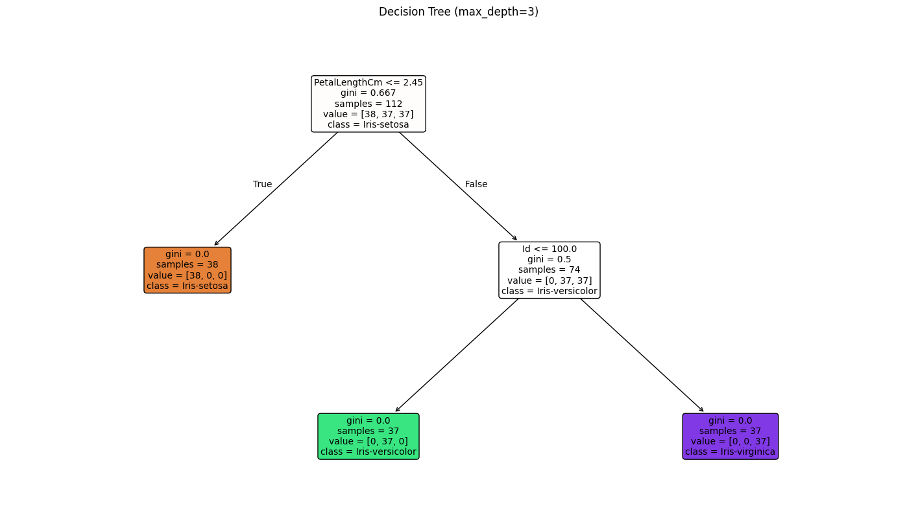

Q4: K-Means Clustering (Unsupervised Task)

import numpy as np
import pandas as pd
import matplotlib.pyplot as plt

from sklearn.cluster import KMeans
from sklearn.preprocessing import StandardScaler
from sklearn.metrics import silhouette_score, silhouette_samples
import matplotlib.cm as cm
df = pd.read_csv('Mall_Customers.csv')
df.head()
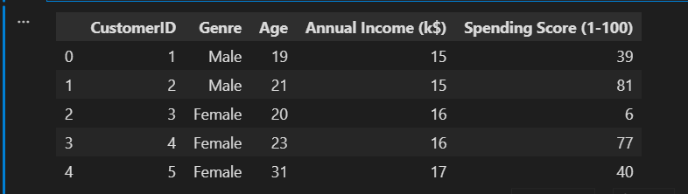df = df.rename(columns={
'Annual Income (k$)': 'Annual Income',
'Spending Score (1-100)': 'Spending Score'
})

scaler = StandardScaler()
X = df[['Annual Income', 'Spending Score']].values
X_scaled = scaler.fit_transform(X)
k = 3
kmeans = KMeans(n_clusters=k, random_state=42, n_init=10)
kmeans.fit(X_scaled)
labels = kmeans.labels_
centroids = kmeans.cluster_centers_
plt.figure(figsize=(8,6))
palette = ['#2E8B57', '#FF6347', '#1E90FF']
for i in range(k):
plt.scatter(X_scaled[labels == i, 0], X_scaled[labels == i, 1],
s=60, c=palette[i], label=f'Cluster {i}', alpha=0.7, edgecolor='k')

# Plot centroids
plt.scatter(centroids[:, 0], centroids[:, 1], marker='X', s=200,
c='gold', edgecolor='k', linewidth=1.2, label='Centroids')

plt.xlabel('Annual Income (standardized)')
plt.ylabel('Spending Score (standardized)')
plt.title(f'K-Means Clusters (k={k}) — Mall Customers')
plt.legend()
plt.grid(alpha=0.2)
plt.show()
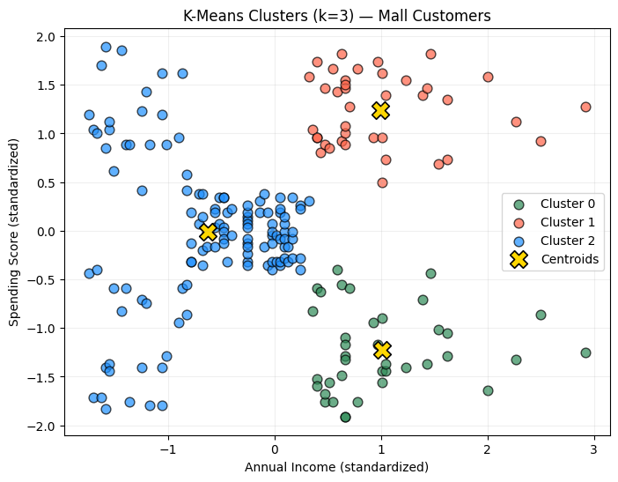
print("Inertia (sum of squared distances to centroids):", kmeans.inertia_)
k = 3
kmeans = KMeans(n_clusters=k, random_state=42, n_init=10)
kmeans.fit(X_scaled)

print("Inertia Score:", kmeans.inertia_)
inertias = []
K_range = range(1, 11)

for k in K_range:
kmeans = KMeans(n_clusters=k, random_state=42, n_init=10)
kmeans.fit(X_scaled)
inertias.append(kmeans.inertia_)

plt.figure(figsize=(8,5))
plt.plot(K_range, inertias, marker='o')
plt.xlabel('Number of Clusters (k)')
plt.ylabel('Inertia')
plt.title('Elbow Method — Optimal k Detection')
plt.grid(alpha=0.3)
plt.show()

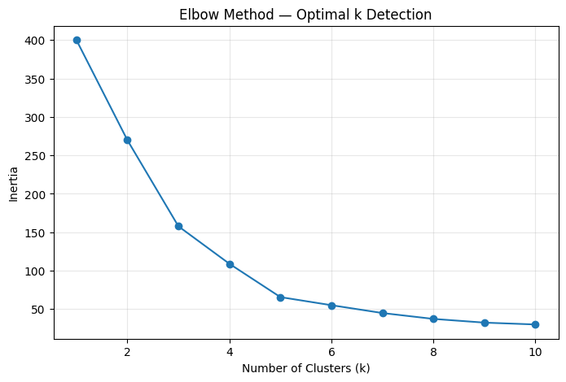
sil_score = silhouette_score(X_scaled, labels)
print(f"Silhouette Score (k={k}): {sil_score:.4f}")

if k <= 1 or k >= len(X_scaled):
print("Silhouette plot not available for k <=1 or k >= n_samples.")
else:
sample_sil_values = silhouette_samples(X_scaled, labels)
y_lower = 10
plt.figure(figsize=(8, 6))
cmap = cm.get_cmap("tab10")

for i in range(k):
ith_cluster_sil_vals = sample_sil_values[labels == i]
ith_cluster_sil_vals.sort()
size_cluster_i = ith_cluster_sil_vals.shape[0]
y_upper = y_lower + size_cluster_i

color = cmap(i)
plt.fill_betweenx(np.arange(y_lower, y_upper),
0, ith_cluster_sil_vals,
facecolor=color, edgecolor=color, alpha=0.7)
plt.text(-0.03, y_lower + 0.5 * size_cluster_i, f"Cluster {i} ({size_cluster_i})", fontsize=10)
y_lower = y_upper + 10

plt.axvline(x=sil_score, color="red", linestyle="--", label=f"Average Silhouette = {sil_score:.3f}")
plt.xlabel("Silhouette coefficient values")
plt.ylabel("Cluster")
plt.title(f"Silhouette Plot for k = {k}")
plt.legend(loc="upper right")
plt.xlim([-0.1, 1])
plt.tight_layout()
plt.show()

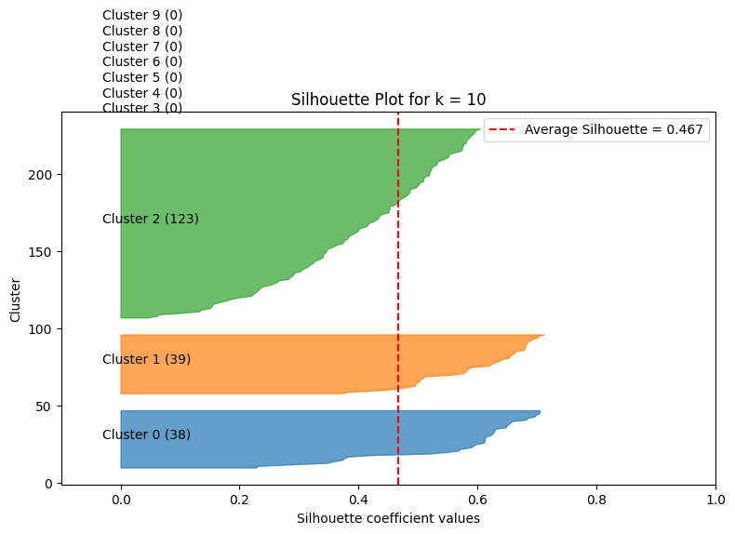
Q5: Cross Validation & Ensemble
import numpy as np
import pandas as pd
import matplotlib.pyplot as plt

from sklearn.datasets import load_iris
from sklearn.model_selection import train_test_split
from sklearn.preprocessing import StandardScaler
from sklearn.svm import SVC
from sklearn.model_selection import cross_val_score
from sklearn.ensemble import RandomForestClassifier
from sklearn.metrics import confusion_matrix, classification_report

iris = load_iris()
X = iris.data
y = iris.target
feature_names = iris.feature_names
class_names = iris.target_names
X_train, X_test, y_train, y_test = train_test_split(
X, y, test_size=0.2, random_state=42, stratify=y
)
scaler = StandardScaler()
X_train_scaled = scaler.fit_transform(X_train)
X_test_scaled = scaler.transform(X_test)

print("Train shape:", X_train_scaled.shape)
print("Test shape:", X_test_scaled.shape)

svm_clf = SVC(kernel='rbf', random_state=42)

# 5-fold CV accuracy
cv_scores = cross_val_score(svm_clf, X_train_scaled, y_train, cv=5)

print("SVM Cross-Validation Accuracies:", cv_scores)
print("Average Accuracy:", cv_scores.mean())
print("Std Deviation:", cv_scores.std())

# Train on full training set and test once
svm_clf.fit(X_train_scaled, y_train)
svm_test_acc = svm_clf.score(X_test_scaled, y_test)
print("\nSVM Test Accuracy (single train-test split):", svm_test_acc)
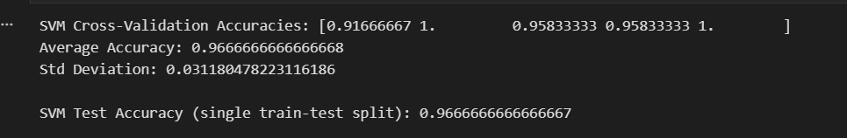
rf_clf = RandomForestClassifier(n_estimators=200, random_state=42)

# Train on full training data
rf_clf.fit(X_train, y_train)
rf_test_acc = rf_clf.score(X_test, y_test)
print("\nRandom Forest Test Accuracy:", rf_test_acc)

# 5-fold CV
rf_cv_scores = cross_val_score(rf_clf, X_train, y_train, cv=5)
print("Random Forest CV Scores:", rf_cv_scores)
print("Average CV Accuracy:", rf_cv_scores.mean())
print("Std Dev:", rf_cv_scores.std())

# Confusion matrix + classification report
y_pred_rf = rf_clf.predict(X_test)
print("\nConfusion Matrix:\n", confusion_matrix(y_test, y_pred_rf))
print("\nClassification Report:\n", classification_report(y_test, y_pred_rf, target_names=class_names))

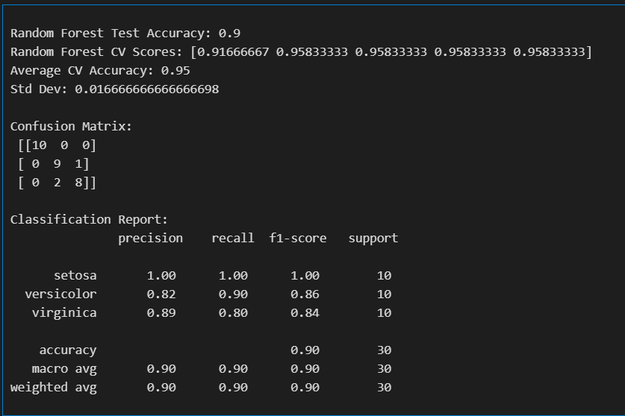

importances = rf_clf.feature_importances_

plt.figure(figsize=(8, 5))
plt.barh(feature_names, importances, color='green')
plt.xlabel("Feature Importance")
plt.title("Random Forest — Feature Contributions")
plt.show()

for f, score in zip(feature_names, importances):
print(f"{f}: {score:.4f}")
