Lab Assignment – 8

Github URL : https://github.com/dakshh3163/Assignment-8

Q1:
HelloUserServlet.java
import java.io.IOException;
import java.io.PrintWriter;
import javax.servlet.ServletException;
import javax.servlet.annotation.WebServlet;
import javax.servlet.http.HttpServlet;
import javax.servlet.http.HttpServletRequest;
import javax.servlet.http.HttpServletResponse;

@WebServlet("/HelloUserServlet")
public class HelloUserServlet extends HttpServlet {
private static final long serialVersionUID = 1L;

protected void doPost(HttpServletRequest request, HttpServletResponse response)
throws ServletException, IOException {

// Get user input from the form
String name = request.getParameter("name");
String email = request.getParameter("email");

// Set content type
response.setContentType("text/html");
PrintWriter out = response.getWriter();

// Output HTML with modern styling
out.println("<!DOCTYPE html>");
out.println("<html lang='en'>");
out.println("<head>");
out.println("<meta charset='UTF-8'>");
out.println("<meta name='viewport' content='width=device-width, initial-scale=1.0'>");
out.println("<title>Welcome</title>");
out.println("<style>");
out.println("body { font-family: 'Segoe UI', Tahoma, Geneva, Verdana, sans-serif;");
out.println("background: #f0f2f5; display: flex; justify-content: center; align-items: center;");
out.println("height: 100vh; margin: 0; }");
out.println(".card { background: #fff; padding: 40px; border-radius: 12px; box-shadow: 0 10px 25px rgba(0,0,0,0.15); text-align: center; }");
out.println("h1 { color: #007BFF; margin-bottom: 20px; }");
out.println("p { font-size: 18px; color: #333; }");
out.println("a { display: inline-block; margin-top: 20px; padding: 10px 20px; text-decoration: none; background: #007BFF; color: #fff; border-radius: 6px; transition: 0.3s; }");
out.println("a:hover { background: #0056b3; }");
out.println("</style>");
out.println("</head>");
out.println("<body>");
out.println("<div class='card'>");
out.println("<h1>Welcome, " + name + "!</h1>");
out.println("<p>Your registered email is <strong>" + email + "</strong></p>");
out.println("<a href='index.html'>Go Back</a>");
out.println("</div>");
out.println("</body>");
out.println("</html>");
}
}

Index.html

<!DOCTYPE html>
<html lang="en">
<head>
<meta charset="UTF-8">
<meta name="viewport" content="width=device-width, initial-scale=1.0">
<title>User Registration</title>
<style>
body {
font-family: 'Segoe UI', Tahoma, Geneva, Verdana, sans-serif;
background: #f0f2f5;
display: flex;
justify-content: center;
align-items: center;
height: 100vh;
margin: 0;
}

.container {
background: #fff;
padding: 30px 40px;
border-radius: 10px;
box-shadow: 0 8px 20px rgba(0,0,0,0.15);
width: 350px;
}

h2 {
text-align: center;
color: #333;
}

form {
display: flex;
flex-direction: column;
}

label {
margin-top: 15px;
margin-bottom: 5px;
font-weight: bold;
color: #555;
}

input[type="text"],
input[type="email"] {
padding: 10px;
border: 1px solid #ccc;
border-radius: 6px;
outline: none;
transition: 0.3s;
}

input[type="text"]:focus,
input[type="email"]:focus {
border-color: #007BFF;
}

button {
margin-top: 20px;
padding: 12px;
background-color: #007BFF;
color: white;
border: none;
border-radius: 6px;
cursor: pointer;
font-size: 16px;
transition: 0.3s;
}

button:hover {
background-color: #0056b3;
}

.message {
margin-top: 15px;
text-align: center;
color: #333;
}
</style>
</head>
<body>
<div class="container">
<h2>Register</h2>
<form action="HelloUserServlet" method="post">
<label for="name">Name:</label>
<input type="text" id="name" name="name" placeholder="Enter your name" required>

<label for="email">Email:</label>
<input type="email" id="email" name="email" placeholder="Enter your email" required>

<button type="submit">Submit</button>
</form>
</div>
</body>
</html>

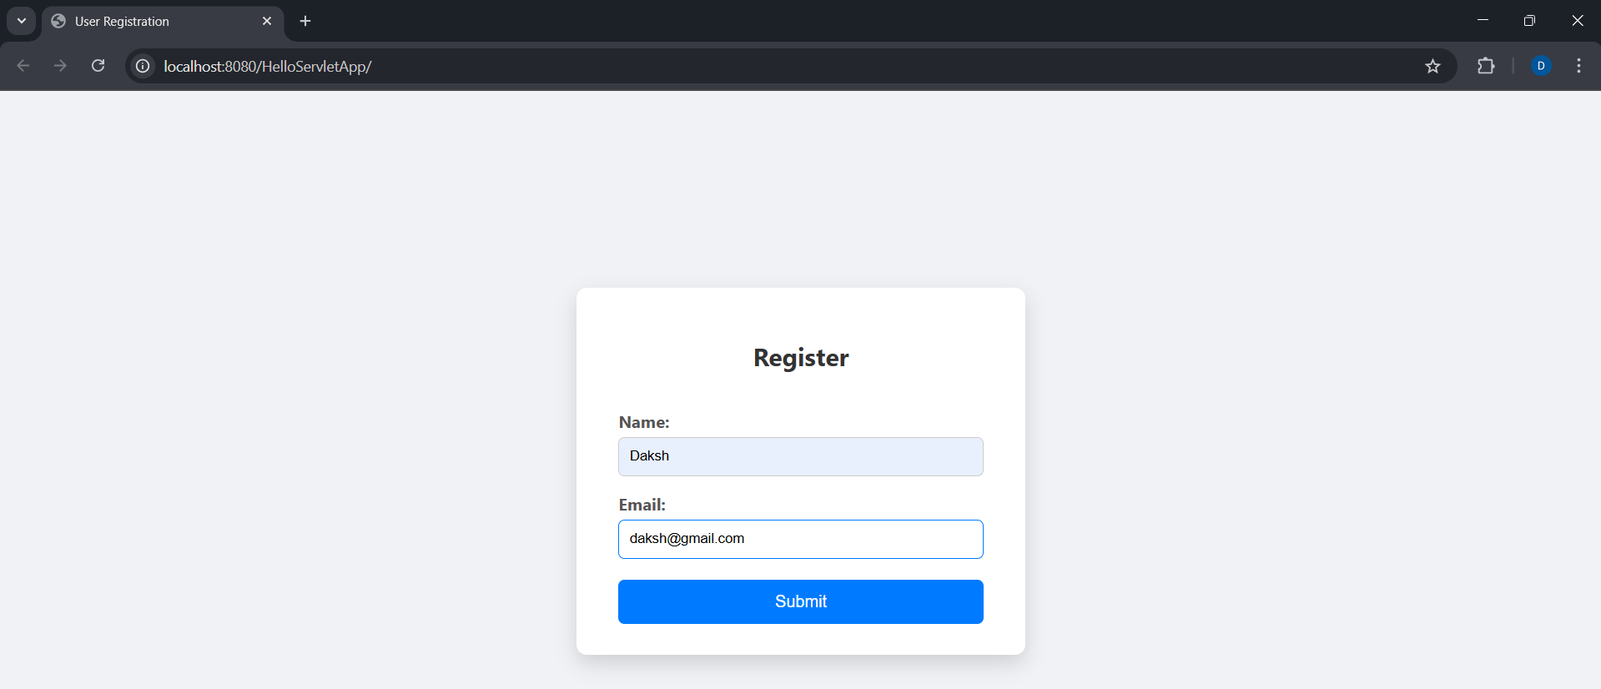
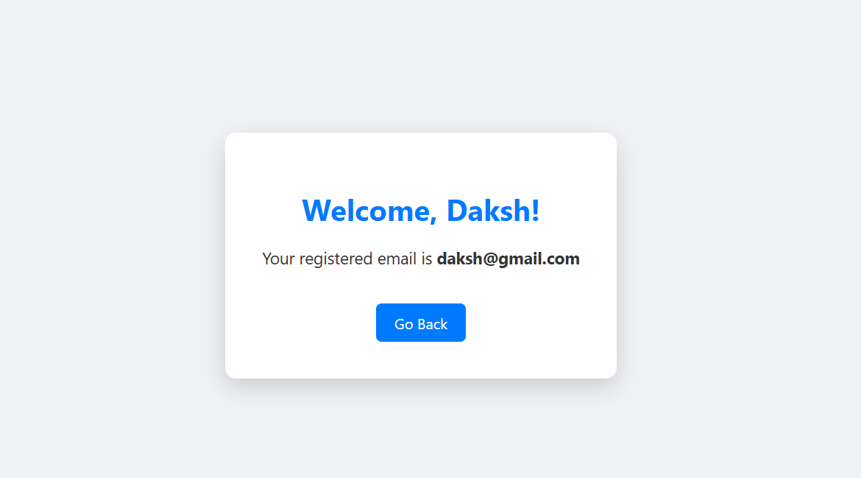

Q2:

LoginServlet.java

import java.io.IOException;
import java.io.PrintWriter;
import javax.servlet.ServletException;
import javax.servlet.annotation.WebServlet;
import javax.servlet.http.HttpServlet;
import javax.servlet.http.HttpServletRequest;
import javax.servlet.http.HttpServletResponse;
import javax.servlet.http.HttpSession;

@WebServlet("/LoginServlet")
public class LoginServlet extends HttpServlet {
private static final long serialVersionUID = 1L;

// Hardcoded credentials for demo purposes
private final String USERNAME = "admin";
private final String PASSWORD = "1234";

protected void doPost(HttpServletRequest request, HttpServletResponse response)
throws ServletException, IOException {

String username = request.getParameter("username");
String password = request.getParameter("password");

response.setContentType("text/html");
PrintWriter out = response.getWriter();

if(USERNAME.equals(username) && PASSWORD.equals(password)) {
// Create session
HttpSession session = request.getSession();
session.setAttribute("username", username);

// Display welcome page
out.println("<!DOCTYPE html>");
out.println("<html lang='en'>");
out.println("<head>");
out.println("<meta charset='UTF-8'>");
out.println("<meta name='viewport' content='width=device-width, initial-scale=1.0'>");
out.println("<title>Welcome</title>");
out.println("<style>");
out.println("body { font-family: 'Segoe UI', Tahoma, Geneva, Verdana, sans-serif;");
out.println("background: #f0f2f5; display: flex; justify-content: center; align-items: center;");
out.println("height: 100vh; margin: 0; }");
out.println(".card { background: #fff; padding: 40px; border-radius: 12px; box-shadow: 0 10px 25px rgba(0,0,0,0.15); text-align: center; }");
out.println("h1 { color: #007BFF; margin-bottom: 20px; }");
out.println("a { display: inline-block; margin-top: 20px; padding: 10px 20px; text-decoration: none; background: #007BFF; color: #fff; border-radius: 6px; transition: 0.3s; }");
out.println("a:hover { background: #0056b3; }");
out.println("</style>");
out.println("</head>");
out.println("<body>");
out.println("<div class='card'>");
out.println("<h1>Welcome, " + username + "!</h1>");
out.println("<p>Your Session ID: <strong>" + session.getId() + "</strong></p>");
out.println("<a href='LogoutServlet'>Logout</a>");
out.println("</div>");
out.println("</body>");
out.println("</html>");
} else {
// Invalid login
out.println("<script>alert('Invalid username or password!'); window.location='login.html';</script>");
}
}
}

Login.html
<!DOCTYPE html>
<html lang="en">
<head>
<meta charset="UTF-8">
<meta name="viewport" content="width=device-width, initial-scale=1.0">
<title>Login</title>
<style>
body {
font-family: 'Segoe UI', Tahoma, Geneva, Verdana, sans-serif;
background: #f0f2f5;
display: flex;
justify-content: center;
align-items: center;
height: 100vh;
margin: 0;
}
.container {
background: #fff;
padding: 40px;
border-radius: 12px;
box-shadow: 0 10px 25px rgba(0,0,0,0.15);
width: 350px;
text-align: center;
}
input[type="text"], input[type="password"] {
width: 100%;
padding: 10px;
margin-top: 10px;
margin-bottom: 20px;
border-radius: 6px;
border: 1px solid #ccc;
}
button {
padding: 12px 20px;
background: #007BFF;
color: #fff;
border: none;
border-radius: 6px;
cursor: pointer;
font-size: 16px;
width: 100%;
}
button:hover {
background: #0056b3;
}
</style>
</head>
<body>
<div class="container">
<h2>Login</h2>
<form action="LoginServlet" method="post">
<input type="text" name="username" placeholder="Username" required>
<input type="password" name="password" placeholder="Password" required>
<button type="submit">Login</button>
</form>
</div>
</body>
</html>

LogOutServlet.java

import java.io.IOException;
import javax.servlet.ServletException;
import javax.servlet.annotation.WebServlet;
import javax.servlet.http.HttpServlet;
import javax.servlet.http.HttpServletRequest;
import javax.servlet.http.HttpServletResponse;
import javax.servlet.http.HttpSession;

@WebServlet("/LogoutServlet")
public class LogoutServlet extends HttpServlet {
private static final long serialVersionUID = 1L;

protected void doGet(HttpServletRequest request, HttpServletResponse response)
throws ServletException, IOException {

HttpSession session = request.getSession(false); // Get existing session
if(session != null) {
session.invalidate(); // Invalidate session
}
response.sendRedirect("login.html"); // Redirect to login page
}
}
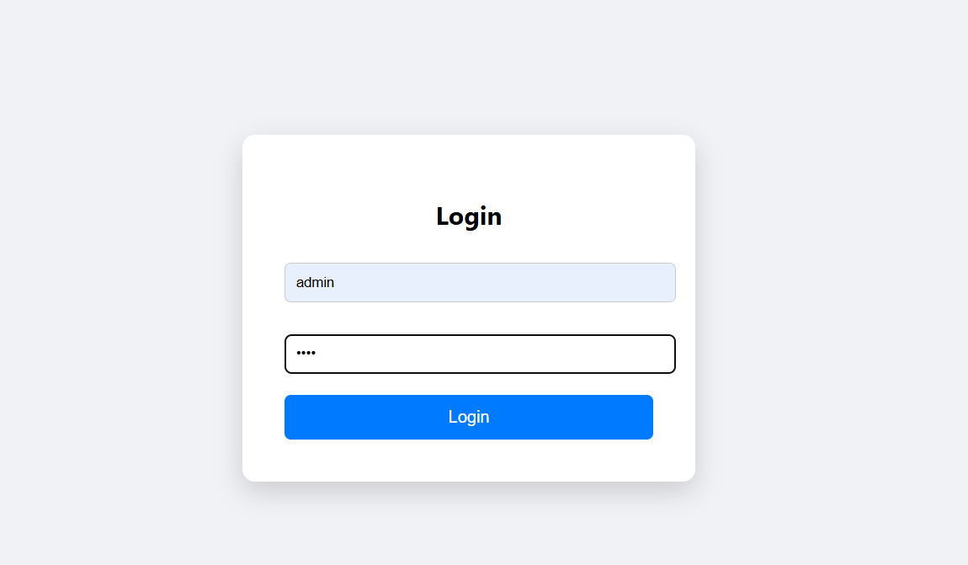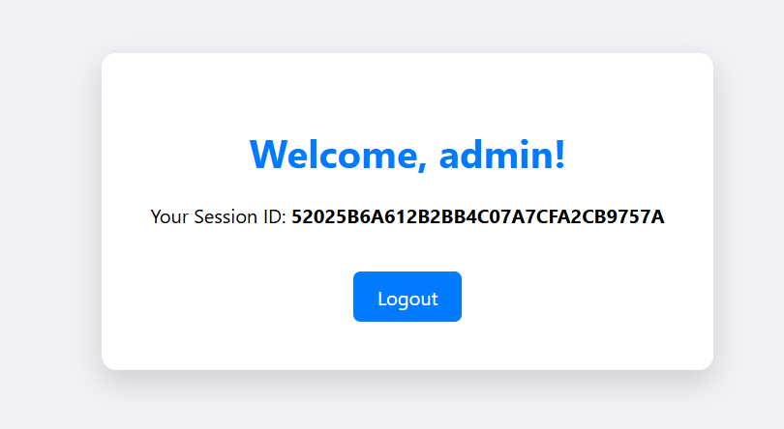

Q3:

Index.html

<!DOCTYPE html>
<html lang="en">
<head>
<meta charset="UTF-8">
<meta name="viewport" content="width=device-width, initial-scale=1.0">
<title>Calculator App</title>
<style>
body { font-family: 'Segoe UI', sans-serif; display: flex; justify-content: center; align-items: center; height: 100vh; background: #f0f2f5; }
.container { background: #fff; padding: 30px 40px; border-radius: 12px; box-shadow: 0 10px 25px rgba(0,0,0,0.15); text-align: center; width: 350px; }
input, select, button { width: 100%; padding: 10px; margin-top: 10px; border-radius: 6px; border: 1px solid #ccc; }
button { background: #007BFF; color: #fff; border: none; margin-top: 15px; cursor: pointer; }
button:hover { background: #0056b3; }
</style>
</head>
<body>
<div class="container">
<h2>Simple Calculator</h2>
<form action="CalculatorServlet" method="post">
<input type="number" step="any" name="num1" placeholder="Enter first number" required>
<input type="number" step="any" name="num2" placeholder="Enter second number" required>
<select name="operation" required>
<option value="add">Addition (+)</option>
<option value="subtract">Subtraction (-)</option>
<option value="multiply">Multiplication (×)</option>
<option value="divide">Division (÷)</option>
</select>
<button type="submit">Calculate</button>
</form>
</div>
</body>
</html>
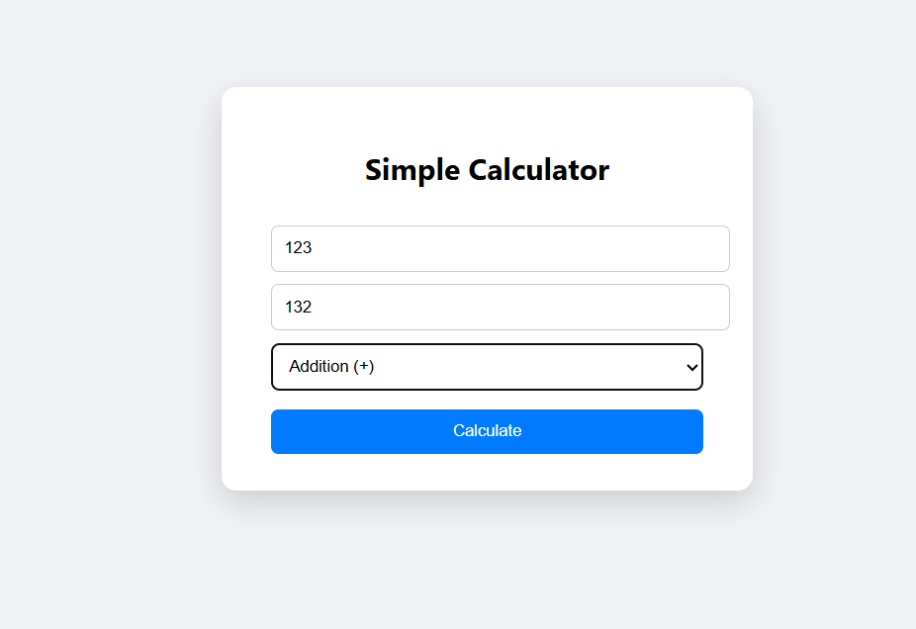

CalculatorBean.java
public class CalculatorBean {
private double num1;
private double num2;
private double result;

// Getters and setters
public double getNum1() { return num1; }
public void setNum1(double num1) { this.num1 = num1; }

public double getNum2() { return num2; }
public void setNum2(double num2) { this.num2 = num2; }

public double getResult() { return result; }
public void setResult(double result) { this.result = result; }

// Methods for arithmetic
public void add() { result = num1 + num2; }
public void subtract() { result = num1 - num2; }
public void multiply() { result = num1 * num2; }
public void divide() {
if(num2 != 0) result = num1 / num2;
else result = Double.NaN;
}
}

CalculatorServlet.java

import java.io.IOException;
import javax.servlet.ServletException;
import javax.servlet.annotation.WebServlet;
import javax.servlet.http.HttpServlet;
import javax.servlet.http.HttpServletRequest;
import javax.servlet.http.HttpServletResponse;

@WebServlet("/CalculatorServlet")
public class CalculatorServlet extends HttpServlet {
private static final long serialVersionUID = 1L;

protected void doPost(HttpServletRequest request, HttpServletResponse response)
throws ServletException, IOException {

double num1 = Double.parseDouble(request.getParameter("num1"));
double num2 = Double.parseDouble(request.getParameter("num2"));
String operation = request.getParameter("operation");

CalculatorBean calc = new CalculatorBean();
calc.setNum1(num1);
calc.setNum2(num2);

switch(operation) {
case "add": calc.add(); break;
case "subtract": calc.subtract(); break;
case "multiply": calc.multiply(); break;
case "divide": calc.divide(); break;
}

// Store bean in request scope
request.setAttribute("calcBean", calc);

// Forward to JSP
request.getRequestDispatcher("result.jsp").forward(request, response);
}
}

