Person1:- Shivam pandey
post:-tech head
linkdin:- https://www.linkedin.com/in/shivampandeyrj/
Photo:-


Person2:-Kiran patil
post:-managing head
linkdin:- https://www.linkedin.com/in/basanagowda-patil-917a02315/
Photo:-

Person3:-Samim mondal
post:-design head
Linkdin:- https://www.linkedin.com/in/samim-mondal-8a8933374/
Photo:-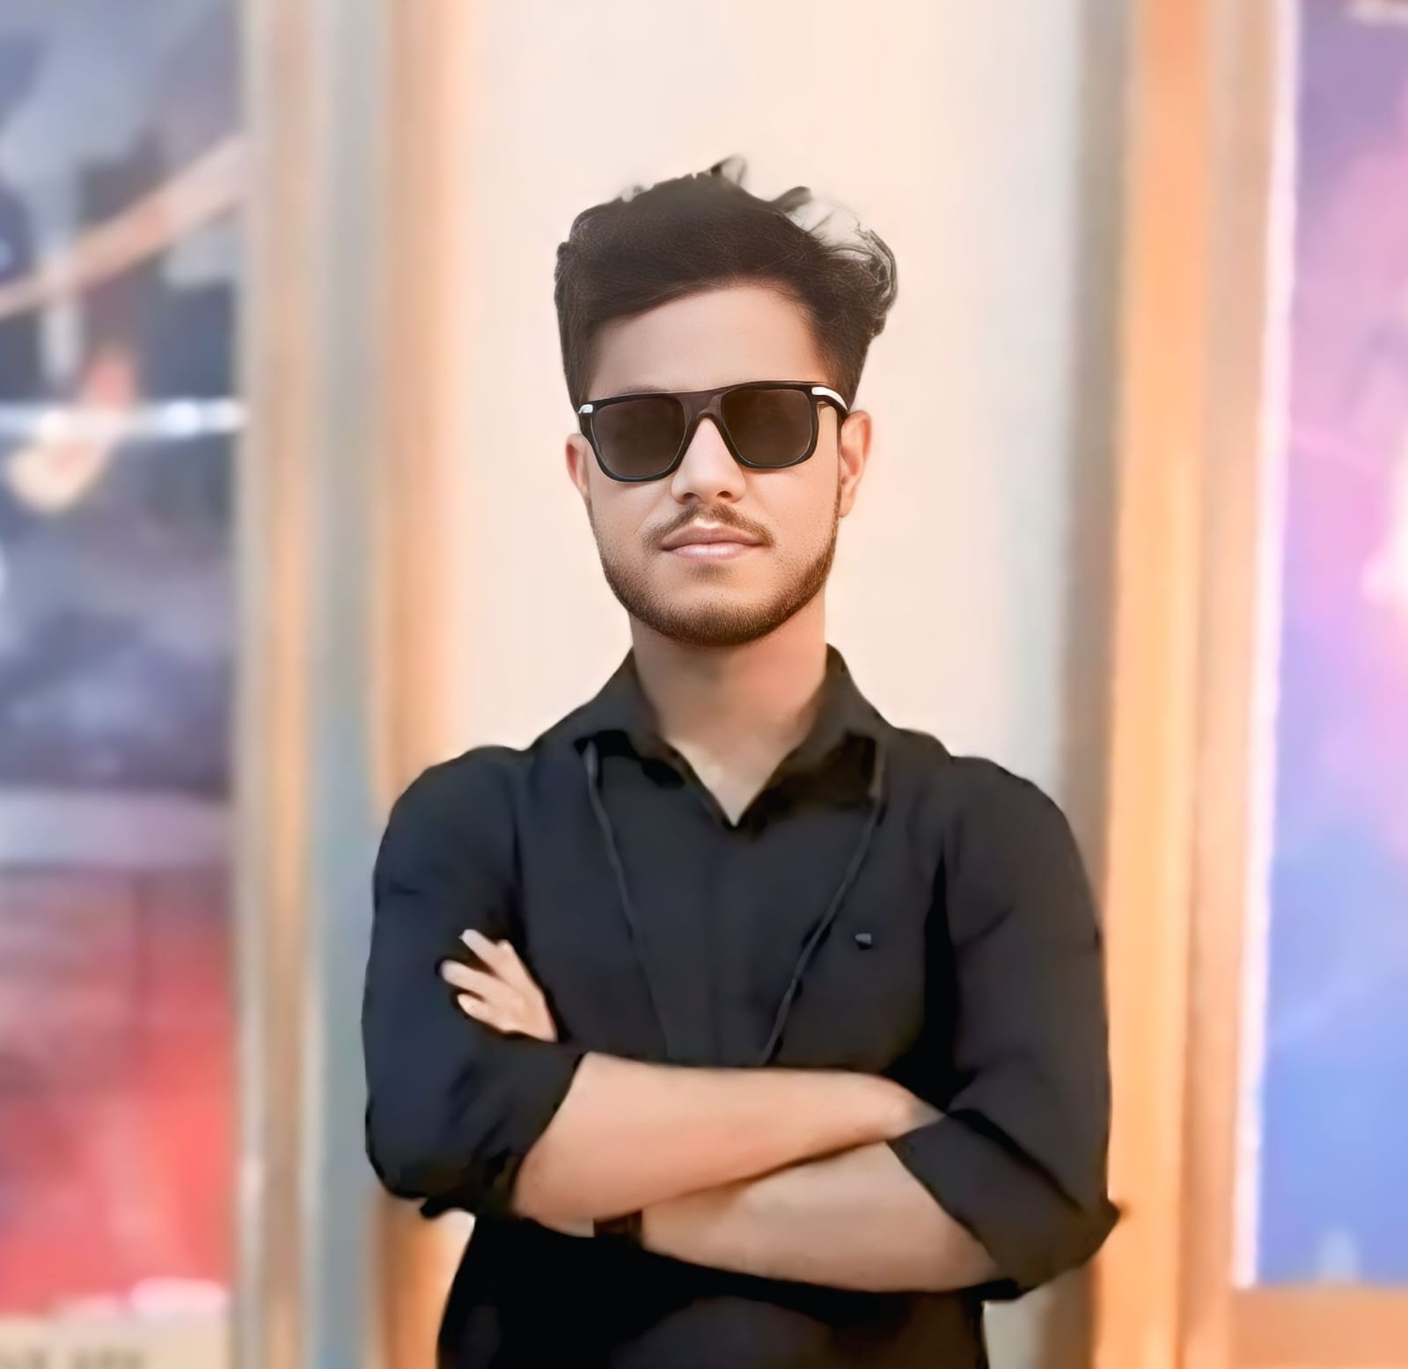

Person4:-kishan m patil
Post:-organising head
Linkdin:- https://www.linkedin.com/in/kishan-m-patil-2955a9383/
photo:-