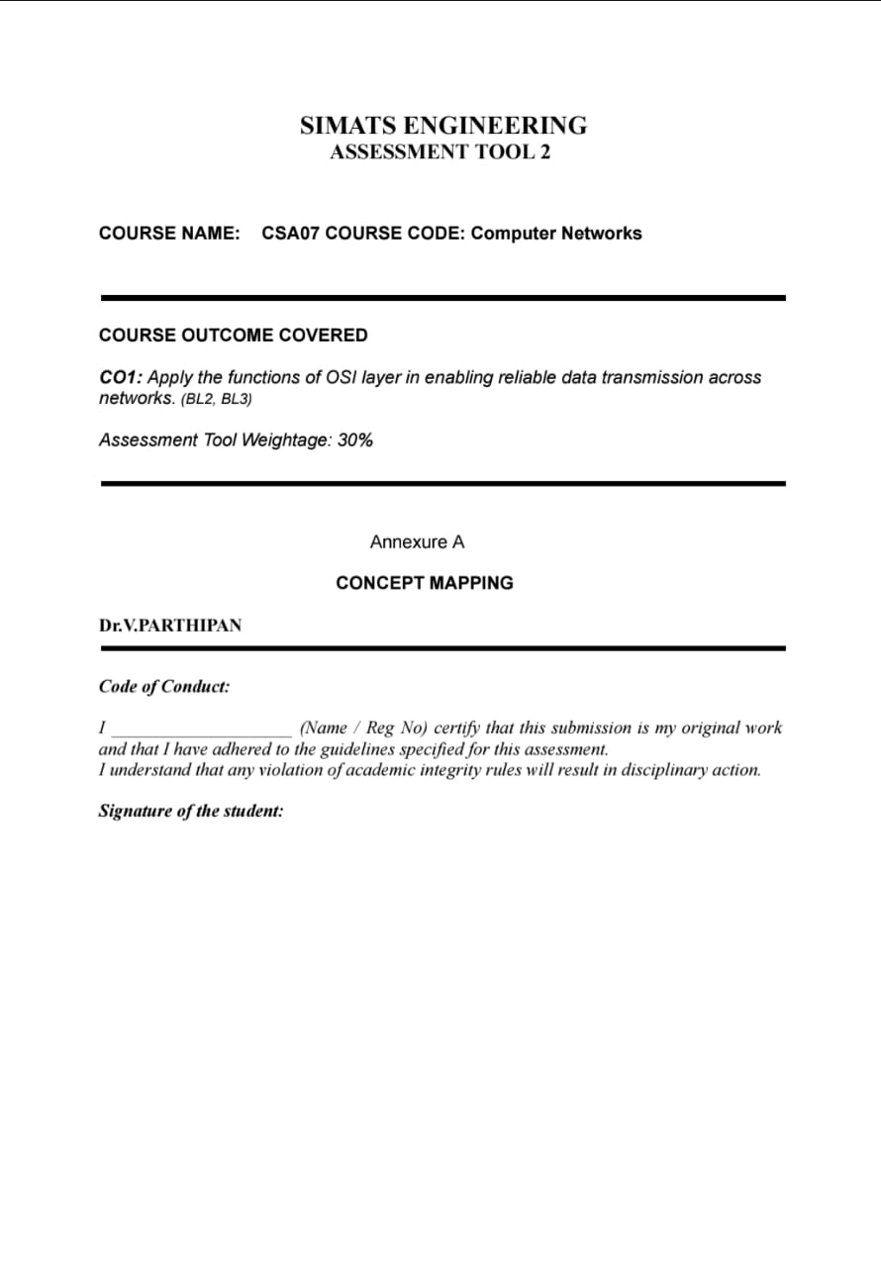
Dakshin S
Dakshin S(192511431)





Question 1: Missing layers in the concept map


Application


Presentation
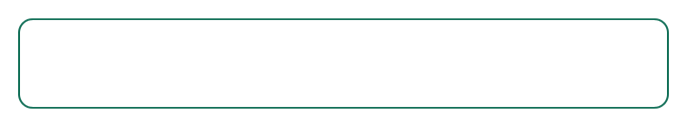

Session (missing)
Dialogue control & sync

Transport

Network


Data link (missing)
Framing, MAC, error check

Physical
Theory
The two missing layers are Session and Data Link.
Session layer establishes, manages, and terminates the dialogue between two communicating
applications. It handles synchronization (checkpoints so a long transfer can resume rather than restart)
and dialogue control (coordinating who transmits when), keeping the conversation coherent across
multiple exchanges.
Data Link layer sits between Network and Physical. It organizes raw bits into frames, performs error
detection (CRC/checksums) on a hop-by-hop basis, handles MAC addressing so frames reach the right
device on the local segment, and manages flow control between directly connected nodes.
Without Session, applications would lose conversational structure across exchanges. Without Data Link, raw
bits would have no framing, local addressing, or error checking — together the two layers bridge application
logic and physical transmission.





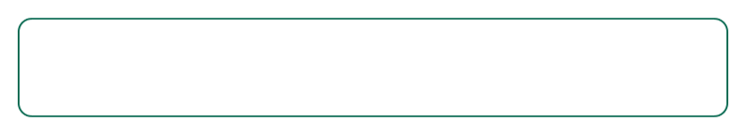

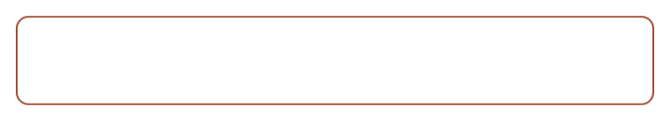

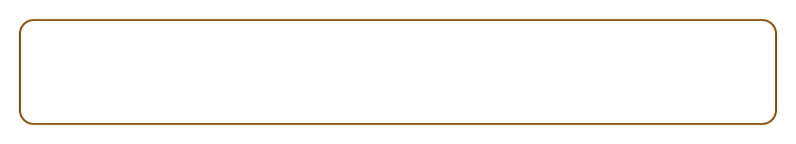

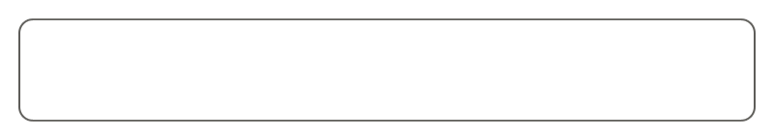
Question 2: Data units and their OSI layers
Application / Presentation / Session
produces Data
Transport layer
produces Segment
Network layer
produces Packet
Data link layer
produces Frame
Physical layer
produces Bits
Theory
Each layer wraps (“encapsulates”) the layer above's output with its own header as data moves down the
stack.
Data (the application message) is handed to Transport, which breaks it into Segments, adding port
numbers and sequencing info — enabling reliable, ordered delivery and multiplexing between applications.
Segments become Packets at the Network layer, wrapped with source/destination IP addresses —
enabling routing across different networks.
Packets become Frames at the Data Link layer, wrapped with MAC addresses and a trailer for error
checking — enabling delivery to the correct device on the local link.
Frames become Bits at the Physical layer — encoded as electrical, optical, or radio signals for actual
transmission. This layered encapsulation (and reverse decapsulation at the receiver) is what makes
large-scale, heterogeneous networks manageable and reliable.



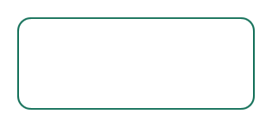

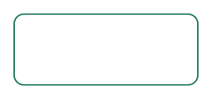

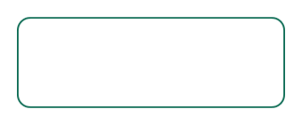

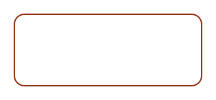

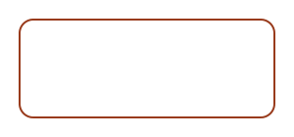

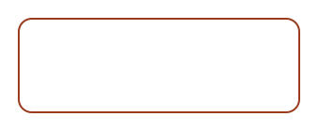
Question 3: Local delivery vs. global delivery
Data link layer | MAC address | Local delivery

Network layer | IP address | Global delivery

Theory
MAC addresses are physical/hardware addresses, meaningful only within a single local network segment
(LAN). Switches use them to deliver frames to the correct device on that segment.
IP addresses are logical addresses identifying a device's network and host location globally, across
interconnected networks. Routers use them to forward packets network to network until they reach the
destination.
Global delivery cannot happen without local delivery at each hop. IP decides the overall path; at every hop
(source → router → router →destination), the Data Link layer re-wraps the packet in a frame with the
correct local MAC address for that segment. This repeated handoff at each router is what lets data travel
reliably across the entire internet.



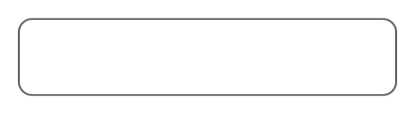








Question 4: Error control across layers
Error control

Data link layer Transport layer
Error detection Error correction
Theory
Data Link (Error Detection) : uses CRC/checksums to detect corruption over a single physical link. It
typically only detects errors and discards the bad frame — it does not guarantee end-to-end retransmission.
Transport (Error Correction/Recovery) : uses checksums, acknowledgments, sequence numbers, and
retransmission (e.g. TCP) to ensure the complete end-to-end message eventually arrives correct, even if a
frame was lost or corrupted somewhere along the path.
This is defense-in-depth: Data Link catches problems early, close to where they occur, preventing bad data
from being forwarded further. Transport compensates by working end-to-end, since Data Link alone cannot
guarantee the message survives multiple hops intact. Together they balance efficiency with reliability.









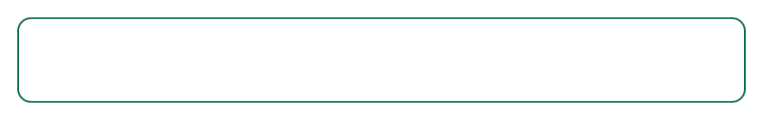



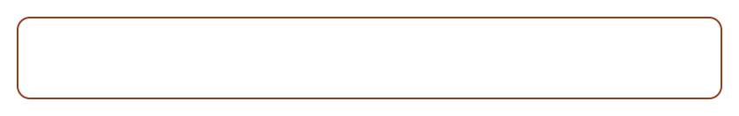

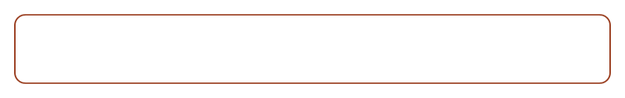
Question 5: Web browsing across OSI layers
Application
HTTP request sent
Presentation
TLS encryption applied
Session
Connection held with server
Transport
TCP handshake, segments
Network
IP routing across networks
Data link
Framing per hop, MAC address
Physical
Bits over cable or Wi-Fi
Theory
Each layer plays a specific role in loading a page: Application sends the HTTP request, Presentation applies
TLS encryption, Session holds the connection, Transport handles the TCP handshake and segmentation,
Network routes packets via IP, Data Link frames and addresses each hop, and Physical carries the bits.
Because OSI layers are sequentially dependent , a failure at any single layer cascades upward and breaks
the whole process — e.g. a TLS error at Presentation blocks the page even if Physical and Data Link work
perfectly.
This is why network troubleshooting conventionally works bottom-up : check physical connectivity first, then
move up layer by layer.



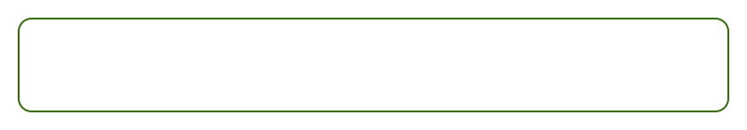



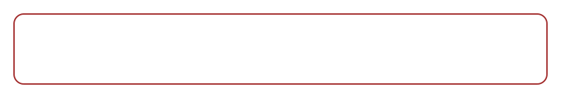




Question 6: Troubleshooting a network fault
Physical
Working
Data link
Working
Network
Failed — fault originates here
Transport
Failed — consequence of Network
Application
Failed — consequence of Network

Theory
Physical and Data Link working means: the cable/Wi-Fi signal is present, and local communication with the
immediate neighbor (switch/access point) via MAC addressing is functional.
The failure starts at Network, and Transport/Application fail only as a consequence — they depend on
Network to function, not because they have independent problems.
Likely causes: incorrect or missing IP configuration, wrong gateway or subnet mask, no route to the
destination network, or a down router.
Troubleshooting value : the map isolates the fault immediately (no need to check cables or MAC-level
issues), explains the cascading failures as expected rather than separate bugs, and directs corrective action
precisely to Network-layer fixes — turning a vague “the internet isn't working” complaint into a precise,
layer-specific diagnosis.

