
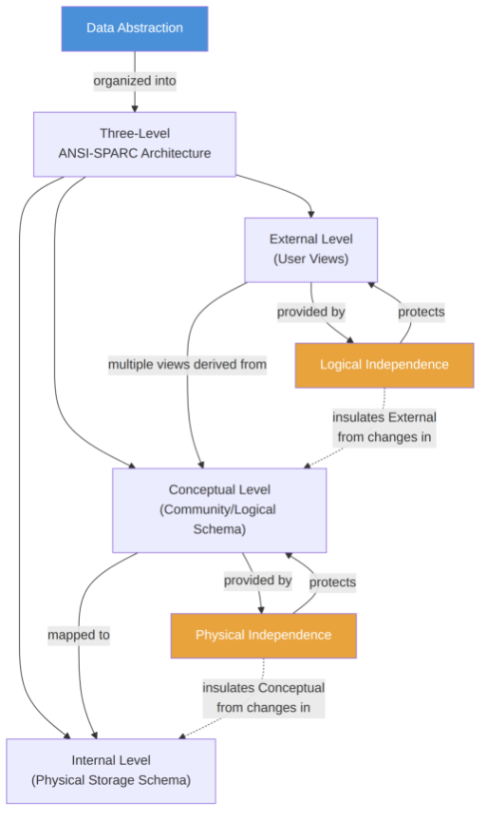
DBMS Concept Maps
Name: Dakshin S
Reg.No: 192511431
Course: DBMS
Code: CSA0510

1. Data Abstraction — Three-Level Architecture
Key relationships

Data Abstraction is realized through the three-level architecture (External → Conceptual →Internal).
Logical Independence = ability to change the Conceptual schema without altering External schemas/applications.

Physical Independence = ability to change the Internal schema without altering the Conceptual schema.

Independence increases as you move outward: physical changes are the easiest to isolate, external-facing changes
the hardest.


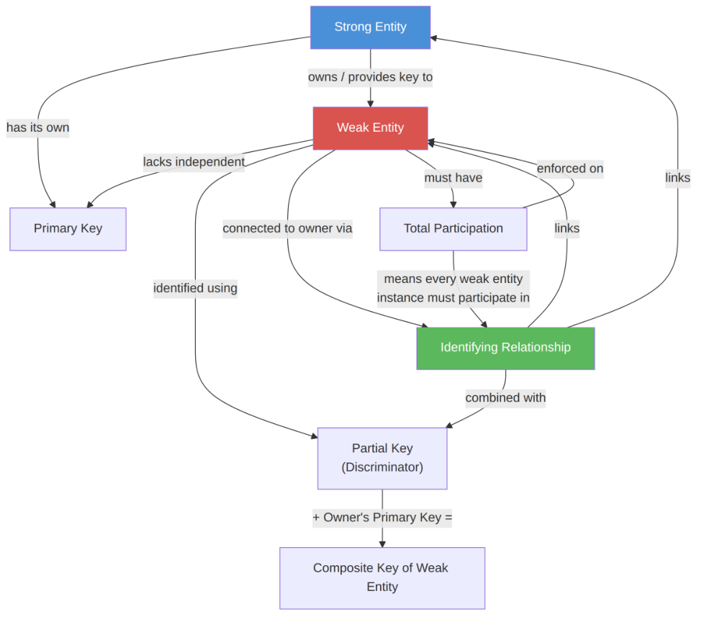
2. Entity Types in ER Modeling
Key relationships

A Strong Entity has a self-sufficient primary key and exists independently.
A Weak Entity has no standalone primary key; it depends on a Strong (owner) Entity .

The Identifying Relationship (shown with a double diamond) is the dependency link between weak and owner entity
— it must exist for the weak entity to be identified.
The Partial Key (discriminator, shown underlined-dashed) distinguishes weak entities belonging to the *same* owner;
combined with the owner's primary key it forms the weak entity's composite key.

Weak entities always have Total Participation in their identifying relationship — a weak entity instance cannot exist
without its owner.


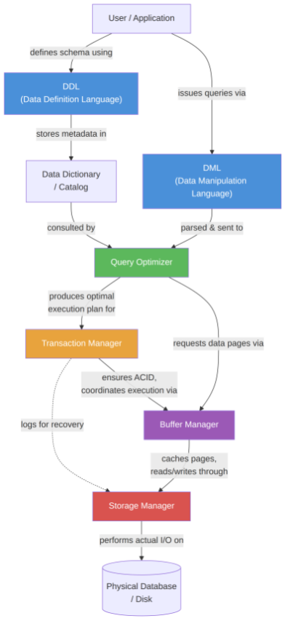
3. DBMS Components
Key relationships

DDL defines/alters schema objects; metadata lands in the data dictionary.
DML expresses data retrieval/manipulation requests, which the Query Optimizer turns into an efficient execution plan.

The Transaction Manager wraps execution in ACID guarantees and coordinates with the buffer/storage layers for
concurrency control and recovery (logging).
The Buffer Manager sits between the optimizer/transaction layer and disk, caching pages to minimize I/O.

The Storage Manager is the lowest layer, translating logical page requests into actual reads/writes on physical storage.


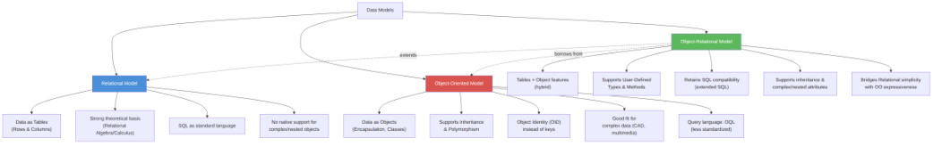
4. Comparing Data Models: Relational vs Object-Oriented vs
Object-Relational
Key relationships

Relational : simple, tabular, mathematically grounded, standardized (SQL) — but weak at modeling complex/nested
data.
Object-Oriented : models data as objects with encapsulation, inheritance, and identity — powerful for complex data
but lacks a universally standardized query language.

Object-Relational is a hybrid that extends the relational model with object features (UDTs, methods, inheritance) while
preserving SQL — positioned as a bridge between the other two.


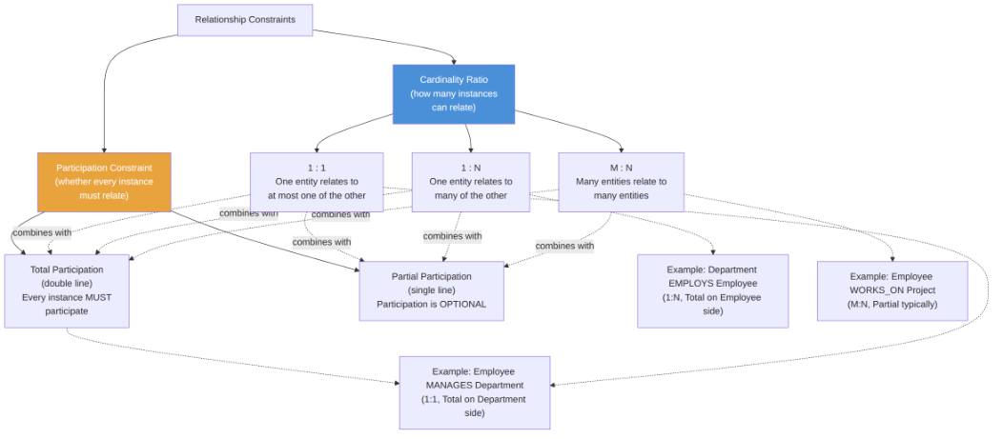
5. Cardinality Ratios & Participation Constraints in ER Diagrams
Key relationships
Cardinality Ratio (1:1, 1:N, M:N) specifies the *maximum* number of relationship instances an entity can participate in.

Participation Constraint (Total or Partial) specifies the *minimum* — whether participation is mandatory (total, drawn
as a double line) or optional (partial, single line).
These two constraints are independent dimensions and combine freely — every relationship in an ER diagram is
described by one cardinality ratio and a participation constraint on each side.

