
SIMATS ENGINEERING
Assessment Tool 2: Case Study
Cloud Computing and Big Data Analytics
Course Name | Cloud Computing and Big Data Analytics
Course Code | CSA15
Course Outcome | CO3 – Implement cloud-based solutions using cloud storage, web APIs, and platform services for real-world applications  (BL3)
Bloom's Taxonomy Level | Precision (Level 3)
Question Count | 3
Total Marks | 30
Student Name | Dakshin.S
Register Number | 19511431

Code of Conduct
I Dakshin.S (192511431) certify that this submission is my original work and that I have adhered to the guidelines specified for this assessment.
I understand that any violation of academic integrity rules will result in disciplinary action.
Signature of the Student: Dakshin S


Case Study 1: Smart Retail Inventory Management System
Given Scenario: A retail chain implements a cloud-based inventory system connected to store devices.
Clients (POS systems and dashboards) communicate via APIs to centralized cloud services. Cloud
storage stores product data, transaction logs, and analytics datasets. The system uses platform services
for analytics and demand forecasting. Secure access is maintained through VPNs, firewalls, and API
gateways.
1. Understanding of the Case
The retail chain requires a unified, always-available inventory system that connects hundreds of
Point-of-Sale (POS) terminals and management dashboards across multiple stores to a single source of
truth in the cloud. The core business requirement is real-time visibility of stock levels, sales transactions,
and demand trends so that replenishment decisions can be made quickly and accurately, while the core
technical requirement is a scalable, secure integration layer that allows heterogeneous store devices to
talk to centralized services without exposing sensitive data.
2. Application of Cloud Concepts
●​ Clients: POS systems and store dashboards act as thin clients that only capture and display data,
pushing computation to the cloud.
●​ Web APIs: RESTful/HTTPS APIs, exposed through an API Gateway, standardise how every
store device communicates with backend services, enabling consistent versioning and
rate-limiting.
●​ Cloud Storage: Object and database storage (e.g., blob storage for receipts/images and a
managed database for transactional data) persists product catalogues, transaction logs, and
analytics datasets durably and redundantly.
●​ Platform Services (PaaS): Managed analytics and machine-learning services are used for
demand forecasting, removing the need to provision and maintain dedicated forecasting
infrastructure.
●​ Security: VPN tunnels connect store networks to the cloud privately, firewalls filter unwanted
traffic, and the API Gateway enforces authentication, throttling, and input validation.
3. Analysis and Trade-offs
Centralising inventory data improves consistency and enables chain-wide analytics, but it introduces a
dependency on network connectivity — if a store loses its VPN link, POS systems need an
offline/cache-and-sync mode to keep selling. Using platform (managed) services for forecasting reduces
operational overhead and time-to-market, at the cost of some vendor lock-in and less fine-grained
control over the forecasting algorithm compared to a self-hosted solution. Routing every request through
a single API Gateway centralises security and monitoring, but the gateway must be deployed with
auto-scaling and redundancy so it does not become a single point of failure during peak sales periods.
4. Solution Design
●​ Deploy store-side POS/dashboard clients that call a cloud API Gateway (e.g., managed API
Gateway service) over an encrypted VPN/HTTPS tunnel.


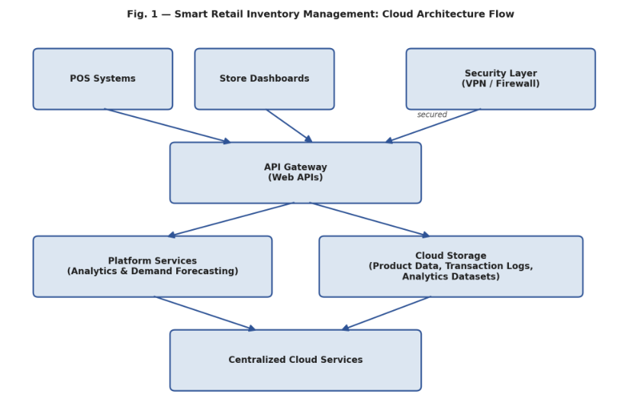
●​ Use the gateway to route requests to microservices for inventory updates, sales recording, and
analytics queries, each independently scalable.
●​ Persist transactional data in a managed relational database and bulk analytics datasets in object
storage, with automated backups and lifecycle policies.
●​ Feed daily transaction logs into a managed analytics/ML platform service to generate
demand-forecasting reports, which are then written back to a dashboard.
●​ Enforce role-based access control (RBAC), API keys/OAuth tokens, and firewall rules at every
layer so only authenticated store devices can read or write inventory data.
Architecture Flow Diagram
Fig. 1 — Smart Retail Inventory Management: Cloud Architecture Flow


Case Study 2: Cloud-Based Document Collaboration System
Given Scenario: An enterprise deploys a document collaboration tool similar to Google Docs. Users
access the platform via browsers, enabling real-time editing and sharing. Documents are stored in
distributed cloud storage with version control mechanisms. Web APIs enable synchronization across
multiple clients and devices. Network infrastructure ensures low latency and high availability globally.
Security includes encryption, identity management, and access permissions for collaboration.
1. Understanding of the Case
The enterprise needs a browser-based document editor that many geographically distributed users can
open and edit simultaneously, with changes reflected in near real time on every collaborator's screen.
The business requirement is seamless, reliable collaboration with a full history of edits; the technical
requirement is a globally distributed, low-latency infrastructure capable of resolving concurrent edits,
storing many document versions, and enforcing fine-grained access control.
2. Application of Cloud Concepts
●​ Clients: Modern web browsers act as the client, rendering the editor UI and sending incremental
edit operations rather than whole-document uploads.
●​ Web APIs: A synchronization API (often WebSocket-based for real-time push plus REST for
document/metadata operations) propagates edits to all connected clients and devices.
●​ Cloud Storage: Documents are stored in distributed, replicated storage with built-in version
control, so every save creates a retrievable revision and supports rollback.
●​ Network/Platform Infrastructure: A global content delivery network (CDN) and multi-region
deployment keep latency low and availability high for users in different countries.
●​ Security: Transport (TLS) and at-rest encryption protect document content; an Identity and
Access Management (IAM) service authenticates users and enforces per-document sharing
permissions (view/comment/edit).
3. Analysis and Trade-offs
Real-time collaborative editing requires conflict resolution (e.g., Operational Transformation or
CRDTs); choosing CRDTs simplifies offline editing and merging at the cost of higher implementation
complexity compared to a simple last-writer-wins model. Storing every edit as a version increases
storage cost and cloud storage spend, but is essential for audit trails and recovery from accidental
changes, so a trade-off is made through periodic version compaction. Global multi-region deployment
reduces latency but raises data-residency and consistency concerns, requiring careful selection between
strong consistency (safer, slower) and eventual consistency (faster, momentarily stale) for non-critical
metadata such as presence indicators.
4. Solution Design
●​ Build the editor as a single-page web application that connects to a WebSocket-based sync
service for live co-editing.
●​ Use a CRDT or Operational Transformation engine on the backend to merge concurrent edits
without conflicts.


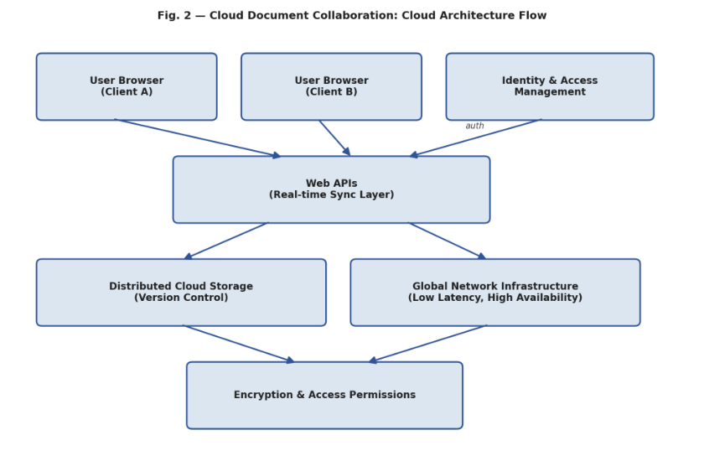
●​ Store documents and their version history in distributed cloud object/database storage, replicated
across regions for durability and availability.
●​ Front the platform with a CDN and multi-region load balancing to minimise latency for globally
distributed users.
●​ Integrate an IAM service for authentication (SSO/OAuth) and enforce document-level sharing
permissions, with all traffic encrypted end-to-end.
Architecture Flow Diagram
Fig. 2 — Cloud Document Collaboration: Cloud Architecture Flow


Case Study 3: Online Food Ordering Platform
Given Scenario: A startup builds a cloud-based food ordering system accessible via web browsers and
mobile clients. Frontend clients interact with backend services through RESTful Web APIs hosted on a
cloud platform. Cloud storage is used to store menu images, invoices, and customer data securely. The
infrastructure uses virtual machines and managed Kubernetes for scalability and reliability. Security is
enforced through authentication tokens, HTTPS, and role-based access control. The system
demonstrates integration of clients, APIs, storage, and platform services in real time.
1. Understanding of the Case
The startup must launch a food ordering platform that customers can use from both a website and a
mobile app, with backend systems that can scale quickly during demand spikes (e.g., meal times) while
keeping infrastructure costs manageable, since it is an early-stage business. The business requirement is
a smooth, reliable ordering experience across devices; the technical requirement is an elastic,
containerised backend with secure storage for sensitive customer and financial data.
2. Application of Cloud Concepts
●​ Clients: Web and mobile applications serve as the two client types, both consuming the same
backend through a common API contract.
●​ Web APIs: RESTful APIs expose endpoints for browsing menus, placing orders, processing
payments, and tracking delivery status.
●​ Cloud Storage: Object storage holds menu images and generated invoices, while a managed
database securely stores customer profiles and order history.
●​ Infrastructure/Platform Services (IaaS + PaaS): Virtual machines handle steady background
workloads, while a managed Kubernetes service auto-scales stateless order-processing containers
based on real-time traffic.
●​ Security: Short-lived authentication tokens (e.g., JWT/OAuth2) verify identity on every request,
HTTPS encrypts all traffic, and role-based access control (RBAC) restricts what customers,
restaurant staff, and delivery agents can each access.
3. Analysis and Trade-offs
Using managed Kubernetes gives elastic scalability and resilience to traffic spikes, but adds operational
complexity and cost relative to a single VM deployment, so the startup mitigates this with cluster
autoscaling to only pay for the extra capacity when needed. Splitting storage between object storage
(images/invoices) and a database (customer/order data) is more efficient than a single storage type, since
each is optimised for its access pattern, though it requires the team to keep the two in sync through
consistent order IDs. Enforcing RBAC and token-based authentication on every API call improves
security but adds a small latency overhead per request, which is an acceptable trade-off given the
sensitivity of payment and personal data involved.
4. Solution Design
●​ Develop responsive web and mobile clients that consume a shared set of RESTful APIs for
menu, ordering, and tracking functions.


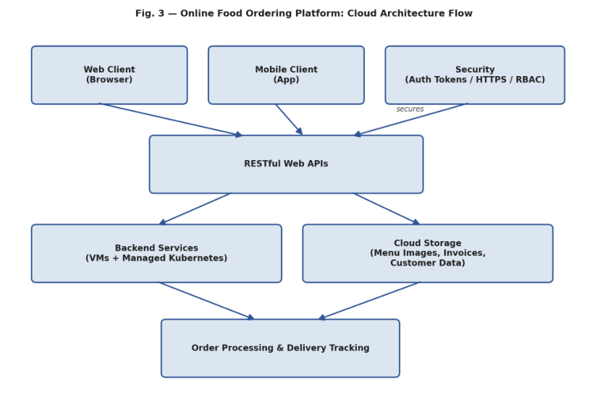
●​ Containerise the backend microservices and deploy them on a managed Kubernetes cluster with
horizontal auto-scaling for peak-hour traffic.
●​ Use virtual machines for lower-variability workloads (e.g., batch invoice generation) to balance
cost and performance.
●​ Store menu images and invoices in cloud object storage and transactional/customer data in a
managed, encrypted database.
●​ Secure every API call with HTTPS and short-lived auth tokens, applying RBAC so customers,
restaurants, and delivery staff each see only the data relevant to their role.
Architecture Flow Diagram
Fig. 3 — Online Food Ordering Platform: Cloud Architecture Flow


Case Study Rubric
Criteria | Weighta  ge | Level 4 – Exemplary | Level 3 – Proficient | Level 2 –  Developing | Level 1 –  Beginning
Understanding of Case | 25% | Clearly identifies all technical and business requirements | Identifies most  requirements | Basic understanding only | Poor understanding of case
Application of  Concepts | 25% | Applies suitable cloud concepts and tools  effectively | Good application with minor issues | Partial application | Weak or incorrect application
Analysis | 20% | Strong analysis with clear trade-off  reasoning | Reasonable analysis | Limited analysis | Minimal analysis
Solution Design | 20% | Solution is feasible,  practical, and well  justified | Reasonable solution with minor gaps | Basic solution | Unclear solution
Clarity | 10% | Well-structured and  easy to follow | Mostly clear | Somewhat unclear | Poorly organized

