**AGENDA**

1. AWS Account creation
2. AWS-EC2 setup and basics
3. Devops-Basics

**AWS**- Simply the platform that provides various services which can be used by an entity or individual e.g. Data base, storage, security , networking…!

**EC2**- Elastic cloud compute,

Instances- the VMs were you can perform your specific tasks and save it as well for the later reference.

**AMIs**- amazon machine images are templates that contains a software config. (os, application) need to be launched

**Devops Basics**

**1)What is devops?**

Dev-ops

Team collaboration

Collectively working

Cont. delivery

**2) why? Need?**

More efficient, effective, feedback cycle, slow process, no team collab, poor communication.

**3) adv? Works? Tools?**

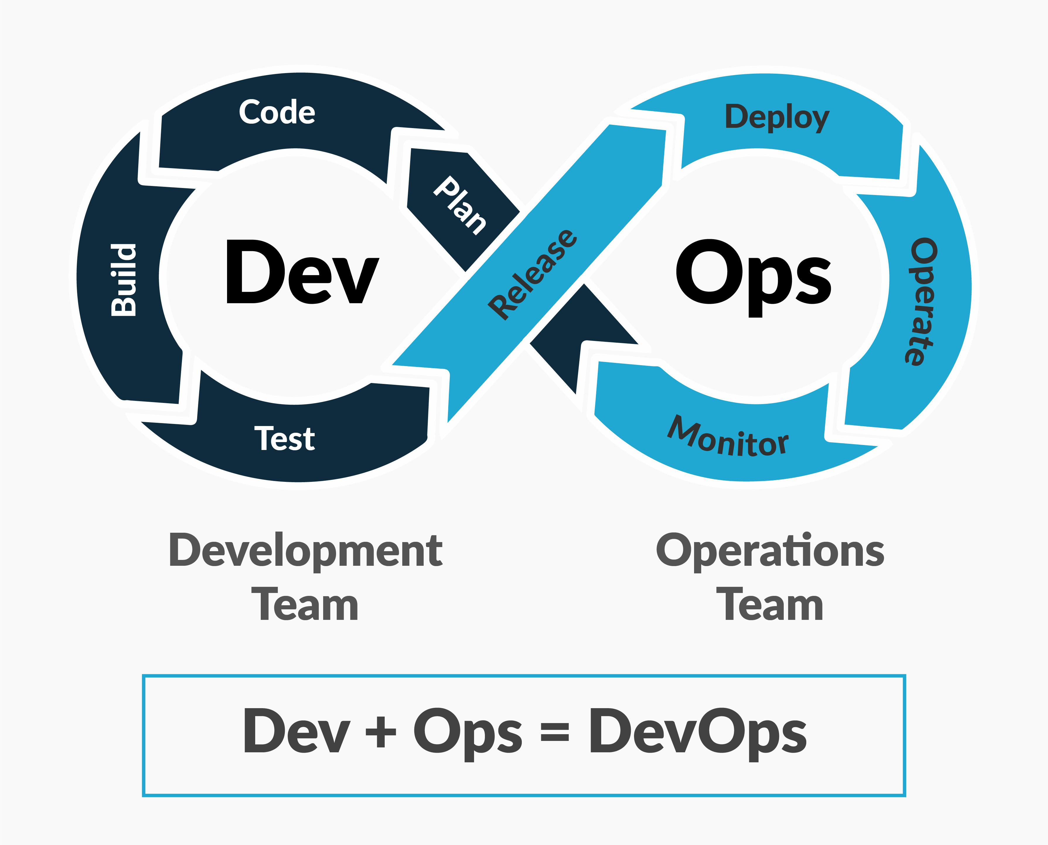

**4)adv? Works?**

Adv.

Faster delivery

Improved collab.

Imp. Quality

Security,

Resource utilization

**5)how it works?-7C’s of devops**

