**AGENDA**

**D1 : Version control and Version control system**

**D2: Commands of git(IMP.)**

**D3: Merging and merge conflict**

**D4: Hands-on**

**Todays Agenda(D1)**

1. **VC**
2. **VCS**
3. **Types of VCS**
4. **Git bash**
5. **Intro to git & github**
6. **Git lifecycle**

**Version Control**

**System that records and manages changes to any documentation, programs, software over time.**

**Helps in tracking changes when multiple people are working on same project.**

1. **Team collaboration**
2. **Parallel development**
3. **Tracking changes**
4. **Experimentation**

**Version Control System:**

**It is a tool/software which allows us to perform version control, simply record and manage changes to source code, documtn, programs, tracks modification, tracking history, …etc**

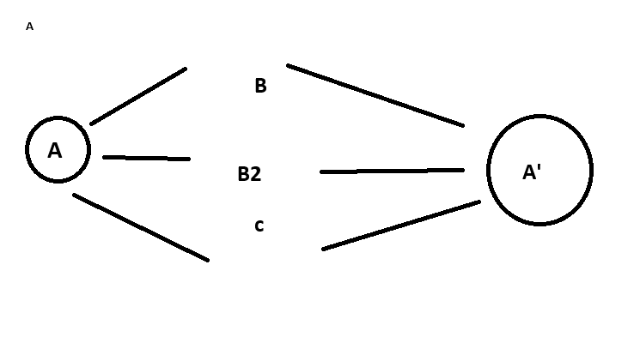

1. **g- Git and github, Mercurial, SVN**

**Types of version control system:**

1. **Central VCS**
2. **Distributed VCS**
3. **CVCS**

**One Server**

**Directly make changes to actual code**

**One single copy of code**

**It was slower**

**Not good for large files/projetcs**

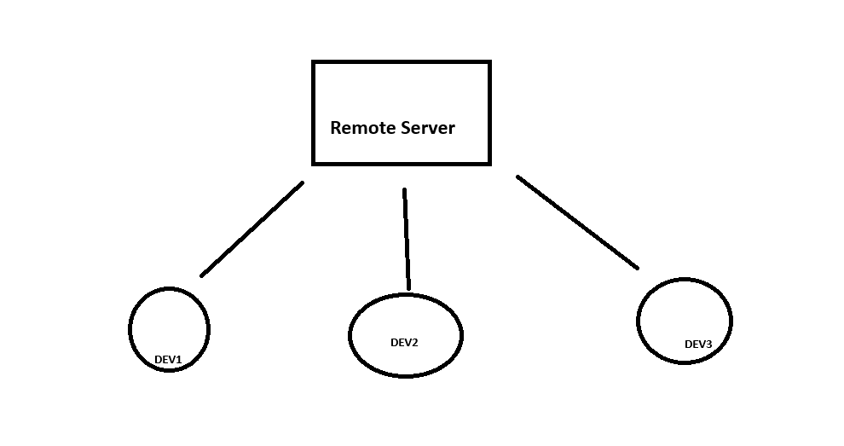

1. **Distributed VCS**

**-Local Repo. - first changes are made in local system then evaluated and then posted to actual server**

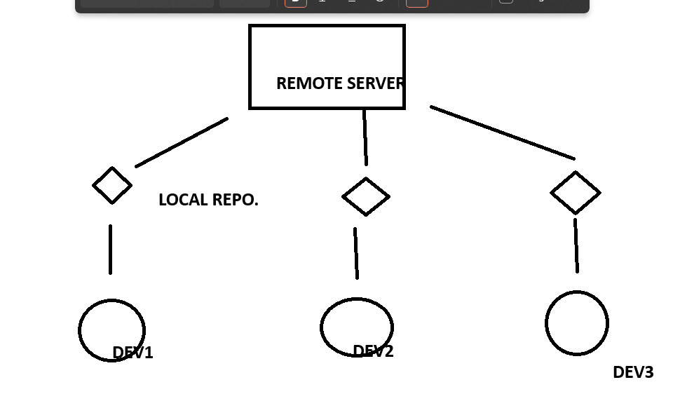

**- No internet is req.**

**- good for storing larger file**

**- cloning the repository**

**- faster**

**Eg - git and github!**

**Git and Git-Hub?**

**Git-hub- All the features of vcs are done by github**

**A platform which handels all the process of VCS**

[GitHub](https://github.com/)

**Git: Software which helps us interact with the git**

**Git bash download:**

[Git - Downloads (git-scm.com)](https://git-scm.com/downloads)

**Git-lifecycle**

|  |  |  |  |
| --- | --- | --- | --- |
| **Working Directory**  **---------->** | **Staging Area**  **----------->** | **Commit**  **--------->** | **GITHUB** |

1. **Working directory**

**Folder or place where code recides in local(your machine)**

**May or maynot be tracked by git**

**It can be tracked by (git init)- it creates a hidden file (.git)**

1. **Staging Area**

**(git add )**

**Here we stage a file,**

**Stage a file means we actually choose which file to commit and which not to commit\***

**Stage- simply, add or do not add a file, used for file selection.**

**\*Commit means making changes to original files**

1. **Commit**

**Once files are selected they can be saved in a repository.**

**Saving in git is called commit**

**git commit -m “updated file”**

1. **git hub**

**With the credentials the project is available to your profile/account of github.**