AI Usage DISCLOSURE FORM

1. TEAM DETAILS
Team Name: Pb&j
Project / Product Name: AmpUp
Organization / Institution (if any): MSRIT
Submission Date: 08/05/2026

2. AI USAGE DECLARATION
Did your team use any Artificial Intelligence (AI) in developing this project? Yes / No
YES

3. PURPOSE OF AI USAGE ( BRIEF DETAILS)
Idea generation / brainstorming : Idea generation / brainstorming: no, core idea of the project and the workflow and feature design were developed by the team itself.
Code generation or assistance :used for flutter development assistance in coding part, helped in Firebase integration, for debugging, helped in optimisation and for specific features' implementation and workflow.
UI / UX design: UI/UX concept and layout as well as design decisions were done by team. Only minor support for frontend and implementation has been used.
Content creation: used for documentation refinement, formatting of README and wording in presentation
Data analysis : used for predicting data/battery consumption and analytical features required.
Testing / debugging: extensively used for finding out the error during Flutter build process, debugging issues with Firebase integration and Gradle build, dealing with notifications problems and session/message flow and related issues.

4. FEATURE ORIGIN CLASSIFICATION ( PLEASE ADD/DELETE BASED ON THE NUMBER OF THE FEATURE)

1. Feature Name: Authentication & User Management (Email/Password, Username/Phone Login)
Origin: Both
Description: Tools: ChatGPT, Cursor AI. Prompt: 'Help implement Firebase email/password auth in Flutter with username and phone-number based login lookup using Firestore.' Output: Auth flow scaffolding using firebase_auth and Firestore queries. Modification: Integrated with our user model, added password reset, validation, and profile creation logic ourselves.

2. Feature Name: User Profile (Firestore-backed)
Origin: Self-Generated
Description: Schema (name, username, phone, email, avatar key, credits, permissions, device data, FCM token, online status, location) was designed by the team. AI was only used briefly to refine field naming.

3. Feature Name: Dashboard & Navigation
Origin: Self-Generated
Description: Layout, navigation entries (battery, data, files, media, contacts, AI, friends, messages, notifications, games, music, voice-to-document, charger, powerbank, emergency) and Provider-based theming were planned and implemented by the team.

4. Feature Name: Android Permission Handling (Location, Bluetooth, Storage/Media, Notifications)
Origin: Both
Description: Tools: ChatGPT. Prompt: 'How to request runtime permissions in Flutter using permission_handler for Android 13+'. Output: Sample permission flow. Modification: Wrapped into our PermissionService and integrated with onboarding.

5. Feature Name: Battery Sharing (battery_plus, nearby scan, request, sessions)
Origin: Both
Description: Tools: ChatGPT, Cursor AI. Prompt: 'Read device battery using battery_plus and create Firestore session document with feature type battery'. Output: Battery read snippet and session schema draft. Modification: Team designed full session lifecycle, six-digit verify_code generation, emergency vs. normal credit logic, and request flows.

6. Feature Name: QR & Passcode Verification (qr_flutter, mobile_scanner)
Origin: Both
Description: Tools: ChatGPT. Prompt: 'Generate and scan a QR code in Flutter and validate against a six-digit passcode'. Output: QR generation and scanning sample. Modification: Linked to SessionService.verifySession(), enforced verification before credit transfer.

7. Feature Name: Powerbank Sharing (availability toggle, powerbank_available collection)
Origin: Self-Generated
Description: Designed and implemented by the team: availability toggle, Firestore powerbank_available schema, request notifications, landmark/address metadata. AI used only for minor Firestore query syntax help.

8. Feature Name: Charger Discovery (Google Places + community charger_spots)
Origin: Both
Description: Tools: ChatGPT. Prompt: 'Call Google Places Nearby Search API from Flutter and merge with Firestore community spots'. Output: HTTP call template. Modification: Built our own charger_spots schema, reporting reward (10 credits), and UI; Places API key is currently a placeholder.

9. Feature Name: Nearby User Discovery (geolocator, bounding-box query)
Origin: Both
Description: Tools: ChatGPT. Prompt: 'Efficient Firestore nearby query using latitude bounding range then distance filter'. Output: Bounding-box query sketch. Modification: Implemented within NearbyService, added 1 km / 5 km radii, sorting by distance, integration into battery/data and ShareToFriendSheet.

10. Feature Name: Friend System (requests, accept/decline, friends collection)
Origin: Self-Generated
Description: Search-by-username, duplicate prevention, reciprocal friend documents, accept/decline flows, and notifications were designed and coded by the team.

11. Feature Name: Messaging & In-App Chat (chats + messages subcollection)
Origin: Both
Description: Tools: ChatGPT. Prompt: 'Build a basic Firestore chat with chats collection and messages subcollection'. Output: Chat schema and stream sample. Modification: Added chat list, new-message flow, share-to-friend integration, contact-card payloads, Firebase Storage uploads, and credit rewards.

12. Feature Name: File / Media / Contact / Voice-to-Document Sharing
Origin: Both
Description: Tools: ChatGPT. Prompt: 'Upload a file with file_picker to Firebase Storage and send link in chat'. Output: Upload code snippet. Modification: Implemented across multiple screens, native share via share_plus, share notifications, and post-share credit rewards. FileService is currently an empty placeholder; flows live in screens/widgets.

13. Feature Name: Session Management (SessionModel lifecycle: requested → accepted/rejected → completed)
Origin: Self-Generated
Description: Lifecycle, status values, timestamps, landmark and shared-location snapshot metadata, data session minimum-duration check, and completion notifications were designed by the team.

14. Feature Name: Credits System (wallet, transactions, rewards, daily caps)
Origin: Self-Generated
Description: Credit values (battery 10, emergency battery 20, data 12, min balance −10, daily game cap 50), TransactionModel, and CreditService were defined by the team. Some screen-level Firestore increments are intentionally direct.

15. Feature Name: Emergency / SOS Mode
Origin: Both
Description: Tools: ChatGPT. Prompt: 'Periodically update Firestore location every 30s while SOS is active and notify friends'. Output: Timer + Firestore update sample. Modification: Built emergencies collection, friend notifications, quick-call buttons (police, ambulance, fire), and Google Places hospital/police/pharmacy lookup structure (key still placeholder).

16. Feature Name: AI Insights (Battery & Data Prediction — AiPredictionService)
Origin: Both
Description: Tools: ChatGPT. Prompt: 'Simple local linear regression over recent battery/data samples in Dart'. Output: Linear trend snippet. Modification: Wrapped in AiPredictionService and surfaced in AI insights screen. Predictions are informational only.

17. Feature Name: AI Chat & Amp Assistant (OpenRouter integration, intent detection)
Origin: Both
Description: Tools: OpenRouter (runtime), ChatGPT (development). Prompt: 'Call OpenRouter chat completions from Flutter and store history under users/{uid}/ai_chats'. Output: HTTP client and history schema. Modification: Multiple response modes, intent detection for opening app areas, music, contact-sharing, voice hooks via Android platform channel com.dakshitha.battery_barter/speech. Note: API key is currently hardcoded in client and must be moved to a secure backend before production.

18. Feature Name: Music & Audio (just_audio, audio_service, flutter_tts)
Origin: Self-Generated
Description: MusicPlayerService, VoiceService, and assistant music/text-to-speech hooks implemented by the team using package documentation.

19. Feature Name: Notifications (FCM + Firestore notifications collection + flutter_local_notifications)
Origin: Both
Description: Tools: ChatGPT. Prompt: 'Wire FCM permission, token storage, foreground listener, and local notification channel for Android'. Output: Setup snippet. Modification: Integrated into NotificationService and main.dart, added Firestore notifications stream, mark-as-read, and notifications for requests, sessions, friends, shares, powerbank, and emergencies. Tap deep-link navigation is currently a TODO.

20. Feature Name: Dino Mini-Game (player, obstacles, score overlay, credits)
Origin: Both
Description: Tools: ChatGPT. Prompt: 'Simple endless-runner Dino game in Flutter with score overlay'. Output: Basic loop and obstacle scaffold. Modification: Integrated game credit rewards with daily cap of 50 via CreditService.

21. Feature Name: Documentation (README, AI Disclosure, presentation wording)
Origin: Both
Description: Tools: ChatGPT. Prompt: 'Refine and format README and disclosure documents for clarity'. Output: Cleaner structure and wording. Modification: Reviewed, edited, and approved by the team.

5. ETHICAL & COMPLIANCE CONFIRMATION
AI usage complies with guidelines and policies. Yes
No proprietary or copyrighted data misused. I Agree

6. DECLARATION & SIGN-OFF
Name of Team Representative:Dakshitha S
Role:Leader
Signature: 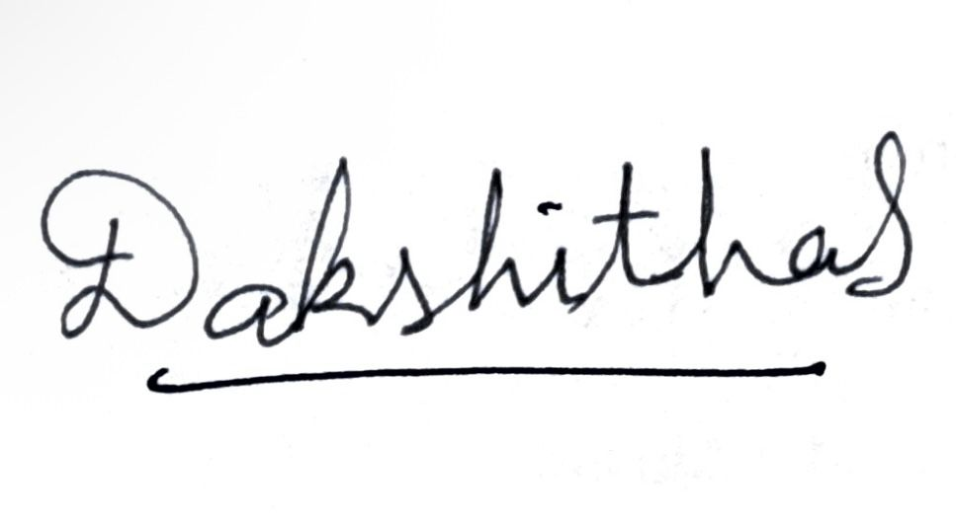
Date: 08/05/2026

