Topic
Understanding Physics-Informed Neural Network Failure Across Dielectric Interfaces in Electrostatic Boundary Value Problems

Methodology

1. Problem formulation and study design
This study examines why a physics-informed neural network (PINN) may achieve a small aggregate loss while still producing an inaccurate electrostatic field across a dielectric interface. The interface is therefore treated as part of the mathematical problem, not as an incidental geometric feature. The domain is split into material regions, electrostatic transmission conditions are derived explicitly, and the learned potential, field, flux, and interface residuals are evaluated separately. This follows the original PINN formulation and the domain-decomposition strategies developed for discontinuous media [“Physics Informed Deep Learning (Part I): Data-driven Solutions of Nonlinear Partial Differential Equations” (Raissi, Perdikaris, and Karniadakis, 2017); “Adaptive Interface-PINNs (AdaI-PINNs): An Efficient Physics-informed Neural Networks Framework for Interface Problems” (Roy et al., 2024)].
$$∇·(ε_m∇φ_m)=-ρ_m, m=1,2.$$
The electric field is E=-∇φ. On the outer boundary and Neumann data on Γ_N, ε∇φ·n=g_N. For a charge-free dielectric interface, the transmission conditions are
$$[φ]_Γ=φ_2-φ_1=0, [ε∇φ·n]_Γ=0.$$
If a surface charge σ_{s} is present, the second condition becomes [ε∇φ·n]_Γ=-σ_{s}, subject to the selected normal convention. The weighted flux condition is essential: when ε₁≠ε₂, the normal derivative of potential is generally discontinuous even though the normal displacement is continuous. The same distinction appears in “Physics-Informed Neural Networks for the Numerical Modeling of Steady-State and Transient Electromagnetic Problems with Discontinuous Media,” which derives weighted normal conditions for discontinuous electromagnetic coefficients.
The benchmark hierarchy contains a one-dimensional layered dielectric problem, a two-dimensional inclusion or layered geometry, and coefficient-contrast sweeps such as ε_2/ε_1∈1,10,10^2,10^3. A high-resolution interface-conforming finite-element or finite-volume solution supplies the reference for evaluation only. The reference is not used as training data, so the task remains a physics-constrained boundary-value problem.
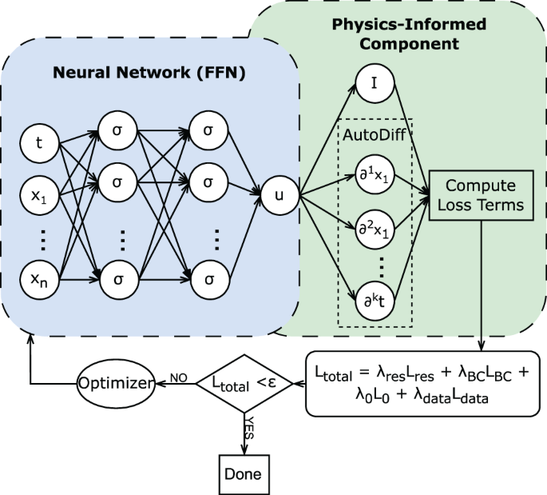

2. Baseline PINN and failure-inducing controls
The baseline is a fully connected network φ_θ(x), using a smooth activation such as tanh. Collocation points are sampled in each material, on the outer boundary, and on the interface. Automatic differentiation evaluates the gradient and conservative flux residual. The baseline objective is
$$L_base= λ_PDE MSE(r_PDE) +λ_D MSE(r_D) +λ_N MSE(r_N),$$
with r_PDE=∇·(ε∇φ_θ)-ρ, r_D=φ_θ-g_D, and r_N=ε∇φ_θ·n-g_N. Two controls deliberately expose common failure modes. In the first, one network receives the discontinuous coefficient directly. This tests whether a globally smooth representation can capture a material-induced change in derivative. In the second, the coefficient is smoothed across a narrow band. This tests whether apparent convergence is actually convergence to a regularized, nonphysical interface.
A third control omits the interface residuals [φ]_Γ and [ε∇φ·n]_Γ. Satisfying the PDE on both sides and the outer boundary does not, by itself, select the correct transmission solution. The interface conditions are needed to eliminate nonphysical members of the piecewise solution family.
Training uses Adam followed by L-BFGS, with identical seeds, collocation budgets, schedules, and stopping criteria across variants. Each component loss is logged separately. This is required because “Parallel Physics-Informed Neural Networks with Bidirectional Balance” links PINN failure to imbalance in forward scales and backward gradient flow. In the dielectric problem, the flux residual may dominate the potential-continuity residual, while sparse interface points may make the interface appear numerically unimportant.

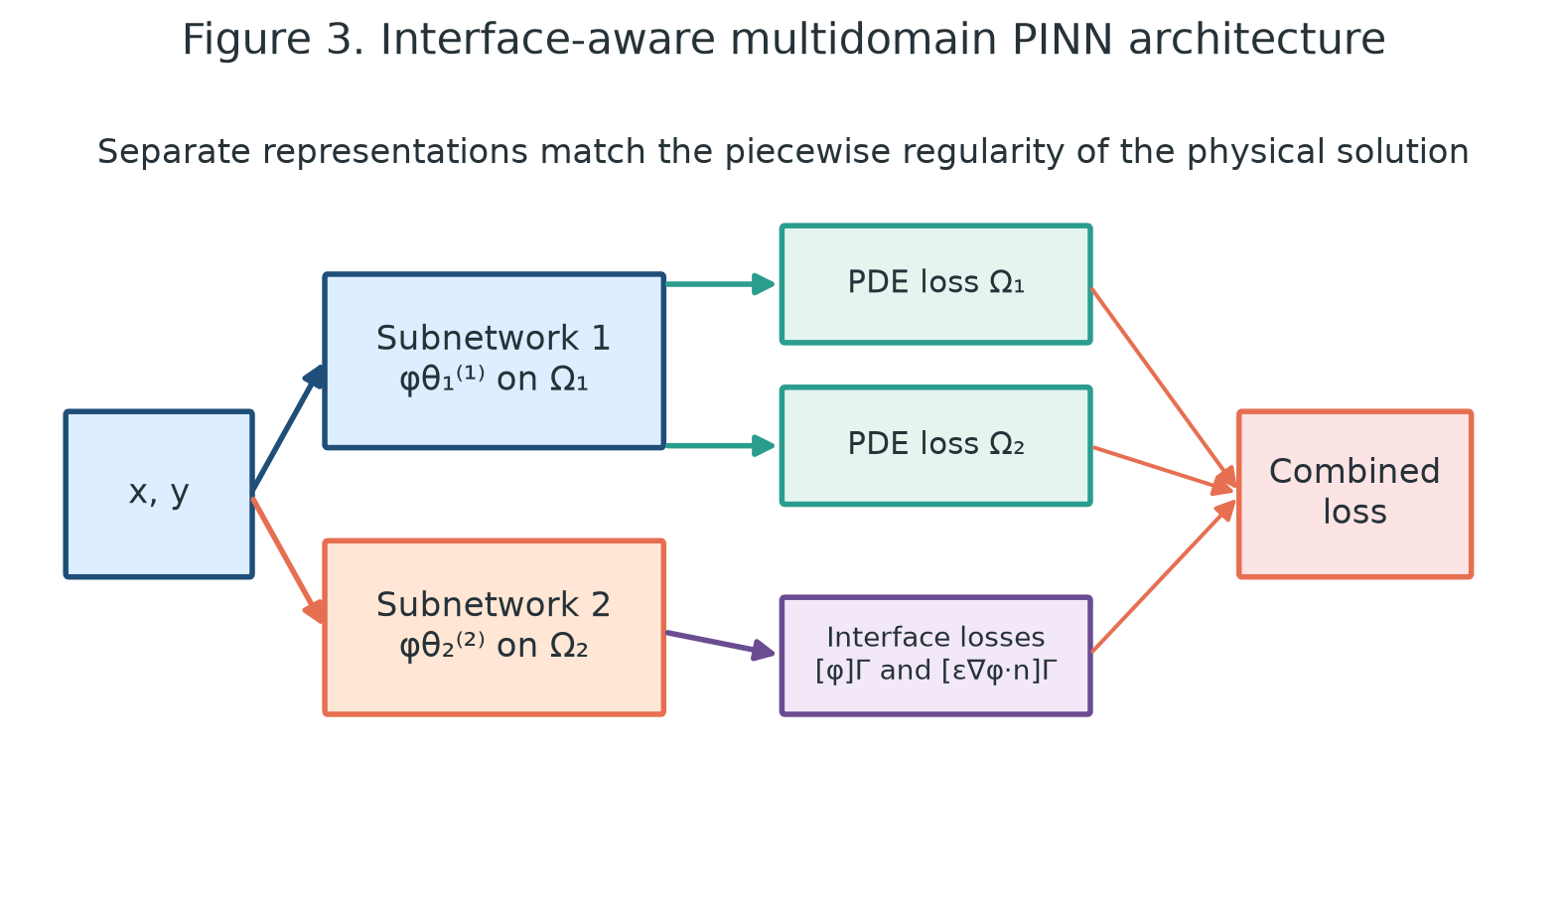

3. Interface-aware model variants
The first proposed model is a multidomain PINN with subnetworks φ_θ_1^(1) and φ_θ_2^(2) on Ω_1 and Ω_2. Its loss is
$$L_MD=λ_PDE∑_mMSE_Ω_m(r_m) +λ_DMSE_Γ_D(r_D) +λ_NMSE_Γ_N(r_N) +λ_Γ,φMSE_Γ([φ]_Γ) +λ_Γ,DMSE_Γ([ε∇φ·n]_Γ+σ_s).$$
Interface points are paired at identical physical coordinates on both sides. This prevents sampling mismatch from being confused with a physical jump. The design follows “Adaptive Interface-PINNs (AdaI-PINNs): An Efficient Physics-informed Neural Networks Framework for Interface Problems,” which uses subdomain approximations and explicit solution/flux jump penalties, and “Extended physics-informed neural networks (XPINNs): A generalized space-time domain decomposition based deep learning framework for nonlinear partial differential equations,” which communicates information between subdomains through interface losses.
The second model shares weights and biases but allows region-specific trainable activation slopes:
$$h_ell+1^(m)=tanh(a_ell^(m)(W_ell h_ell^(m)+b_ell)).$$
The slopes are constrained positive with a=softplus(â). This is an interface-aware representation with fewer duplicated parameters than fully independent subnetworks. An ablation uses identical fixed activations in both regions. The comparison tests whether the improvement comes from domain separation itself or from locally adaptive regularity.
The third model uses overlapping subdomains. In the overlap, an agreement penalty is added:
$$L_ov=λ_ov MSE(φ_θ_1^(1)-φ_θ_2^(2)).$$
Overlap is a stabilization device, not a substitute for the dielectric flux jump. “Physics-Informed Neural Networks for the Numerical Modeling of Steady-State and Transient Electromagnetic Problems with Discontinuous Media” reports improved convergence from overlapping decomposition and argues that first-order formulations are better suited to interface problems. The electrostatic analogue is to differentiate the potential within each material and enforce transmission at Γ, rather than differentiating one global second-order expression through an unsmoothed coefficient jump.

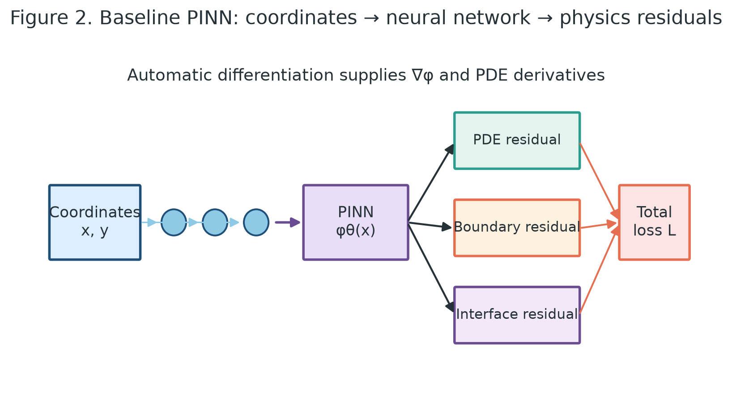

4. Diagnostics and loss balancing
Failure is diagnosed with metrics that separate physical error from optimization error. The relative potential error and electric-field error are reported independently in each subdomain. The maximum interface violation is
$$E_Γ=max_x∈Γ|[φ]_Γ|, |[ε∇φ·n]_Γ+σ_s|.$$
An integral flux-balance error is also computed on small Gaussian surfaces around the interface. This catches conservative violations that may be hidden by pointwise cancellation.
For optimization diagnosis, define g_k=|∇_θL_k|_2 for each PDE, boundary, and interface term. The ratio g_max/g_min measures gradient imbalance. Three weighting modes are compared: equal fixed weights, manually nondimensionalized weights, and adaptive balancing that keeps gradient magnitudes within a prescribed range. This integrates the balancing mechanism discussed in “Parallel Physics-Informed Neural Networks with Bidirectional Balance.” It also incorporates the electrostatic finding from “An Investigation of Physics Informed Neural Networks to solve the Poisson-Boltzmann Equation in Molecular Electrostatics” that input/output scaling, trainable activations, Fourier features, and loss balancing materially affect multidomain PINN accuracy.
Coordinates are scaled to comparable numerical ranges and potential is mapped to an order-one variable; physical units are restored when reporting E and D=εE. A Fourier-feature ablation uses γ(x)=[sin(Bx),cos(Bx)] with fixed bandwidth. Interface sampling is increased independently of interior sampling. If total loss decreases but E_Γ does not, the failure is classified as under-resolved interface enforcement. If E_Γ is small but field error remains high, it is classified as subdomain approximation or optimization error. If scaling or adaptive weights are required for both metrics to improve, the dominant cause is conditioning imbalance.

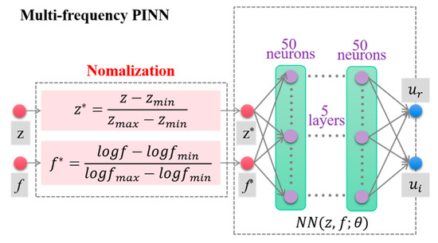

5. Reproducibility and comparison protocol
Each model is evaluated over at least five random seeds. The report includes mean and standard deviation of potential error, field error, interface violation, training time, trainable parameters, and automatic-differentiation evaluations. The geometry, coefficient contrast, collocation sets, reference solver, and stopping thresholds are saved with the configuration. A model is successful only when it maintains low subdomain field error, low potential and displacement jumps, and stable behavior as dielectric contrast increases.
The expected baseline behavior is acceptable accuracy at low contrast followed by a smeared gradient or incorrect normal flux at high contrast. Multidomain and adaptive-interface models should improve this behavior by matching the representation to the piecewise regularity of the physical solution. The methodology does not assume that one architecture always wins. By logging each residual, gradient balance, and sampling sensitivity, it attributes failure to representation, interface enforcement, sampling, or optimization. This makes the study explanatory rather than merely comparative.

References
1. "Physics Informed Deep Learning (Part I): Data-driven Solutions of Nonlinear Partial Differential Equations"
2. "Physics-Informed Neural Networks for the Numerical Modeling of Steady-State and Transient Electromagnetic Problems with Discontinuous Media"
3. "Adaptive Interface-PINNs (AdaI-PINNs): An Efficient Physics-informed Neural Networks Framework for Interface Problems"
4. "Parallel Physics-Informed Neural Networks with Bidirectional Balance"
5. "An Investigation of Physics Informed Neural Networks to solve the Poisson-Boltzmann Equation in Molecular Electrostatics"
6. "Physics-Informed Neural Networks for the Time-Domain Maxwell Equations with Split-Field Perfectly Matched Layers"
7. "Extended Interface Physics-Informed Neural Networks Method for Moving Interface Problems"
8. "Extended physics-informed neural networks (XPINNs): A generalized space-time domain decomposition based deep learning framework for nonlinear partial differential equations"

Guide to Symbols and Their Purpose(For Our understanding)
This guide explains the notation used in the equations and why each symbol is needed in the electrostatic PINN methodology. The symbols describe the physical problem, the neural-network approximation, the loss function, and the diagnostics used to identify failure.
Symbol | Meaning | Why it is used
Ω | Computational domain | Defines the full region in which the electrostatic boundary-value problem is solved.
Rᵈ | d-dimensional real coordinate space | Specifies the spatial dimension; d = 1 gives a layered test and d = 2 gives an inclusion or curved-interface test.
Γ | Material interface | Separates two dielectric materials and is where transmission conditions must be enforced.
Ω₁, Ω₂ | Subdomains/material regions | Allow the potential and PDE residual to be represented separately on each side of the interface.
εₘ | Permittivity in region m | Measures how strongly a material responds to an electric field and weights the flux in the PDE.
ρₘ | Free charge density in region m | Represents volumetric electric charge and acts as the source term of Poisson’s equation.
φ or φₘ | Electric potential | The unknown scalar field learned by the PINN; the electric field is obtained from its gradient.
∇ | Gradient/differential operator | Calculates spatial derivatives needed to form the electric field and the conservative PDE residual.
E | Electric field | Defined by E = −∇φ; it is used to evaluate the physical field error after training.
D | Electric displacement | Defined by D = εE; its normal component is continuous across a charge-free dielectric interface.
Γᴅ | Dirichlet boundary | The part of the outer boundary where the potential value is prescribed.
Γɴ | Neumann boundary | The part of the outer boundary where the normal electric flux is prescribed.
gᴅ, gɴ | Prescribed boundary data | Provide the target potential and flux values used in the boundary-condition residuals.
n | Outward/interface unit normal | Provides the direction used to compute normal flux and state the interface jump condition.
σₛ | Surface charge density | Allows a nonzero jump in normal displacement when free charge is concentrated on the interface.
[·]Γ | Jump operator across Γ | Means the value on side 2 minus the value on side 1; it measures discontinuity or transmission error.
θ | Neural-network parameters | Collects weights, biases, and any trainable activation parameters optimized during PINN training.
rPDE, rD, rN | PDE, Dirichlet, and Neumann residuals | Measure how strongly the network violates the governing equation and outer boundary conditions.
λ | Loss weight/penalty coefficient | Balances PDE, boundary, interface, and overlap constraints in the composite objective.
MSE | Mean squared error | Aggregates squared residuals over collocation points into a differentiable training objective.
m | Material-region index | Labels the region-specific equation, permittivity, source, or network output; here m = 1, 2.
L or ℒ | Loss function | The scalar objective minimized by Adam and L-BFGS to obtain a physics-consistent solution.
hₗ, Wₗ, bₗ | Hidden activation, weight matrix, and bias at layer ℓ | Define the feed-forward neural-network transformation in each subdomain.
aₗ⁽ᵐ⁾ | Trainable activation slope | Lets the network adapt its local response to different regularity or scale on each side of the interface.
∑ | Summation operator | Combines residual contributions from multiple subdomains or collocation points.
max | Maximum operator | Finds the worst interface violation rather than only its average value.
EΓ | Maximum interface error | Combines potential and weighted-flux jumps into a direct measure of transmission-condition failure.
gₖ | Gradient magnitude of loss term k | Diagnoses optimization imbalance by comparing how strongly each constraint changes the network parameters.
γ(x) | Fourier-feature map | Adds sine and cosine features that help represent localized or high-frequency interface structure.
B | Fourier-feature frequency matrix | Controls the spatial frequencies supplied to the network through γ(x).
PINN, MD, ov | Model labels: physics-informed network, multidomain, and overlap | Identify the baseline and interface-aware variants compared in the methodology.

