Practical - 10
Practical Title: Secure Login/Logout with Sessions, Role-Based Access, Timeout, and Remember-Me Token

Develop secure login and logout functionality using PHP sessions. Verify password using password_verify(), regenerate session ID after login, restrict dashboard access, implement role-based redirection, session timeout, and optional secure remember-me token.

Theory :

1. Are sessions started and destroyed securely?

Answer :
Sessions are started securely after successful login. Session data is cleared, and the session is destroyed during logout to prevent unauthorized access.

2. Is password_verify() used correctly?

Answer :
The password_verify() function checks the entered password against the hashed password stored in the database. This helps protect user passwords from being stored in plain text.

3. Is unauthorized dashboard access blocked?

Answer :
The system checks whether the user is logged in before allowing dashboard access. Unauthorized users are redirected to the login page.

4. Is session timeout implemented?

Answer :
The system checks the session's activity time to identify inactive users. After the specified timeout period, the session expires, and the user must log in again.

5. Are admin and student users redirected to appropriate dashboards?

Answer :
The system checks the user's role after successful login. Admin users are redirected to the admin dashboard, while students are redirected to the student dashboard.

Implementation :

The system implements secure login and logout using PHP sessions. Passwords are verified using the password_verify() function. Unauthorized users are prevented from accessing dashboards without logging in. Session timeout is used to log out inactive users automatically. Admin and student users are redirected to their respective dashboards based on their roles.

Evidence of Work (Screenshots)

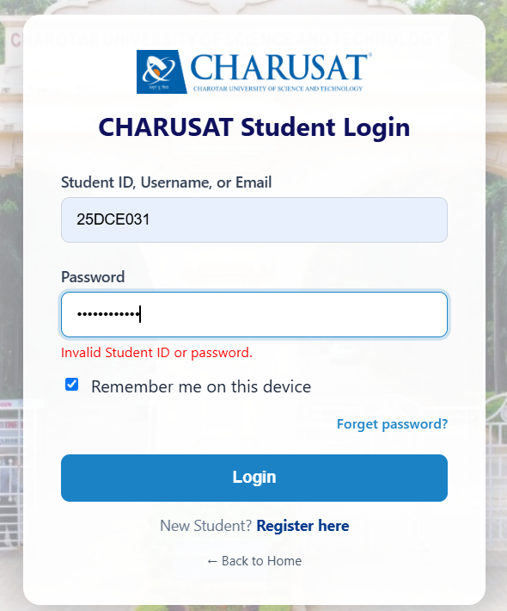

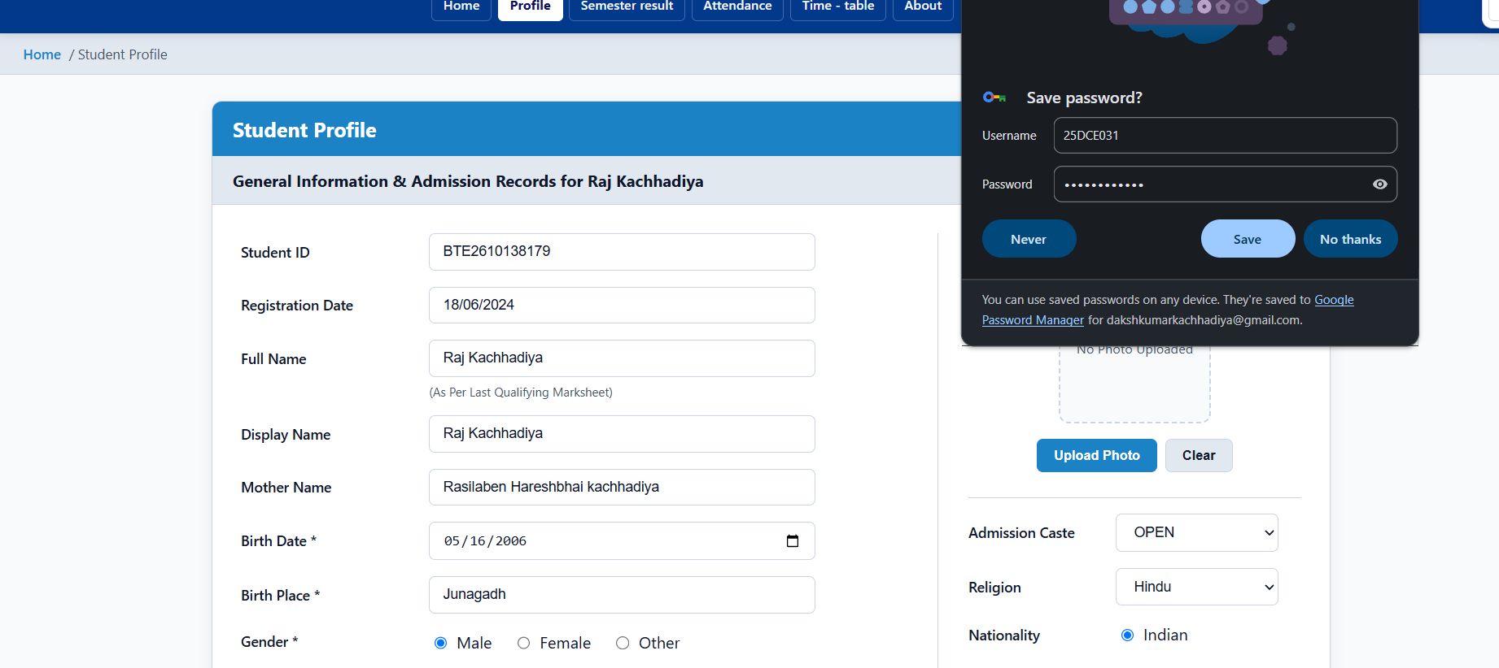

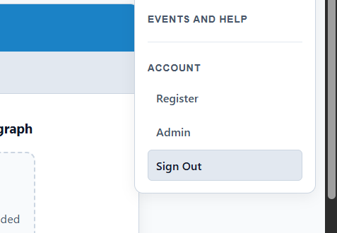

After 5 minute session is expires and again login

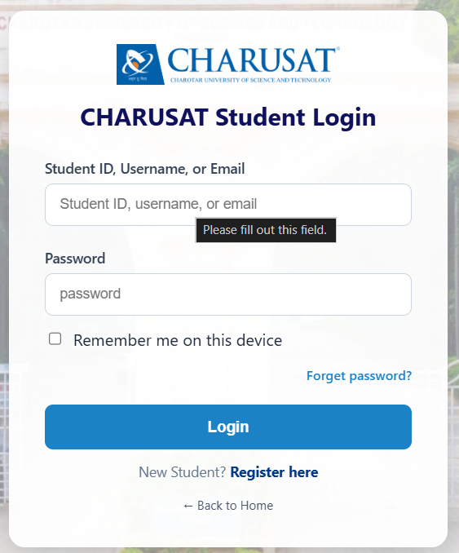

GitHub Repository Link :

htts://github.com/dakshpatel025/Practical_1-2_web

Challenges Faced:

The main challenges were managing PHP sessions securely and verifying user passwords correctly. Preventing unauthorized dashboard access and implementing session timeout were also challenging. Another challenge was redirecting admin and student users to their correct dashboards based on their role

Learning Outcomes:
Learned how to implement secure login and logout using PHP sessions. Understood password verification using password_verify(). Learned how to prevent unauthorized dashboard access and manage session timeouts. Also understood how to redirect admin and student users to their respective dashboards based on their roles.

Faculty Remarks :

