Practical - 11
Practical Title: Student Management CRUD with Search and Filter

Create a student management module to add, view, edit, delete, search and filter student records. All database operations must use MYSQLi statements and clear success/failure messages.

Theory :

1. Are SELECT, INSERT, UPDATE, and DELETE operations working?

Answer :
Yes, all CRUD operations are working correctly. SELECT is used to display records, INSERT adds new records, UPDATE modifies existing records, and DELETE removes records from the database. These operations help manage student information efficiently.

2. Is search by name/email/course implemented?

Answer :
Yes, the search functionality is implemented to find records by name, email, or course. Users can enter a search keyword to find matching records. This makes it easier to locate specific student information quickly.

3. Are delete operations confirmed before execution?

Answer :
Yes, a confirmation message is displayed before deleting any record. The user can confirm or cancel the deletion. This helps prevent accidental deletion and protects important student information.

Implementation :

The system implements CRUD operations to manage student records efficiently. Users can add new records, view existing records, update details, and delete records from the database. A search feature is provided to find student records by name, email, or course. A confirmation message is displayed before deleting any record to prevent accidental deletion. These features make student data management simple and user-friendly.

Evidence of Work (Screenshots)

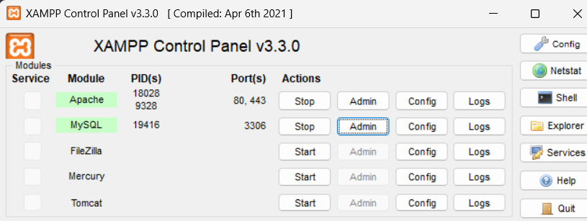

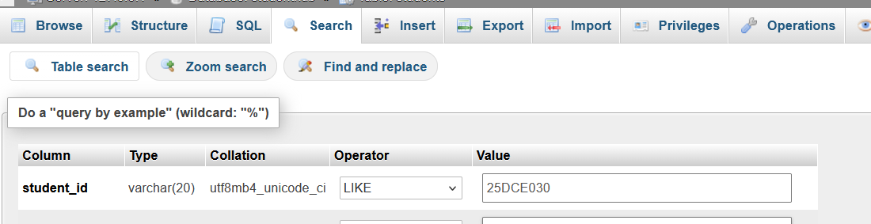

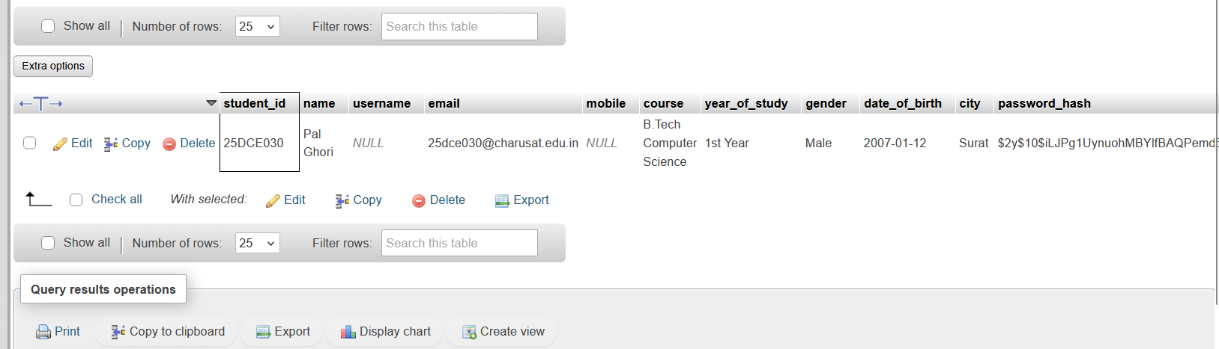

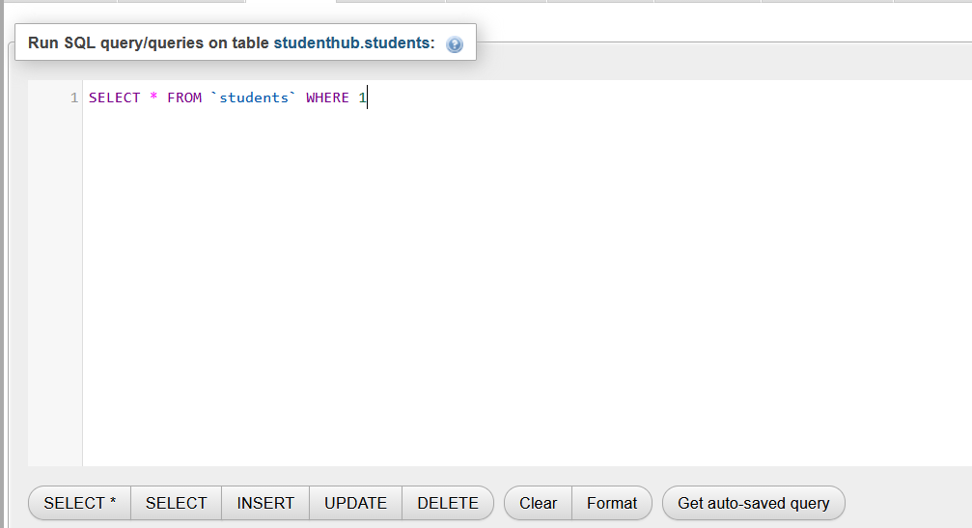

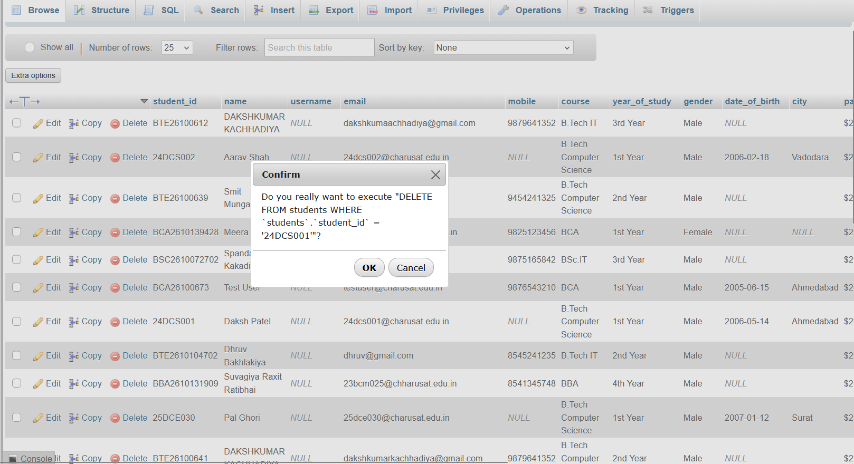

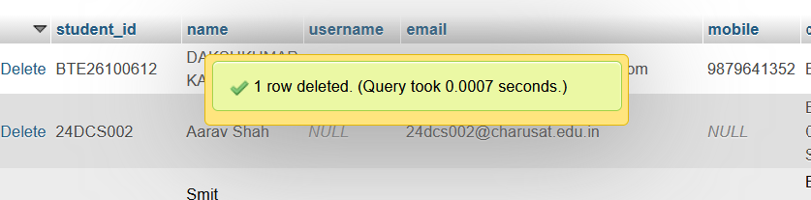

GitHub Repository Link :

htts://github.com/dakshpatel025/Practical_1-2_web

Challenges Faced:

• Connecting PHP with the MySQL database was challenging.
• Implementing CRUD operations correctly required careful testing.
• Creating a search feature for name, email, and course needed proper query handling.
• Preventing accidental deletion required adding a confirmation message.
• Handling invalid inputs and database errors was important for maintaining data accuracy.

Learning Outcomes:

- Learned how to perform CRUD operations using PHP and MySQL.
- Understood how to insert, display, update, and delete records.
- Learned to implement search functionality using name, email, and course.
- Understood the importance of confirmation messages before deleting records.
- Improved knowledge of database connectivity and student record management.

Faculty Remarks :

