Practical - 12
Practical Title: Event Management CRUD with Poster Upload and File Validation

Develop event management functionality for admin users. Admin can add, view, update, delete, and upload event posters with file type and file size validation.

Theory :

1. Are add, update, and delete functionalities implemented correctly?

Answer :
Yes, add, update, and delete functionalities are implemented to manage records efficiently. Users can add new records, update existing information, and delete unwanted records. Proper validation helps prevent incorrect data entry. These operations help maintain accurate database records.

2. Is the UI linked with the database correctly?

Answer :
Yes, the user interface is connected to the database through backend code. Users can add, view, update, and delete records through the interface. The backend processes requests and performs the required database operations. This ensures proper communication between the UI and database.

3. Are poster uploads validated for type and size?

Answer :
Yes, poster uploads are validated to allow only supported file types. The file size is checked before uploading. Invalid file types and oversized files are rejected. These validations help improve security and prevent unnecessary file uploads.

4. Are success and failure messages displayed?

Answer :
Yes, success and failure messages are displayed after performing operations. Success messages confirm that the requested action was completed. Error messages inform users when an operation fails. These messages help users understand the status of their actions.

Implementation :

The add, update, and delete functionalities are implemented to manage records in the database. The user interface is connected to the database using backend code to perform CRUD operations. Poster uploads are validated for file type and size to ensure security. Success and error messages are displayed to inform users about the results of their actions. All functionalities are tested to ensure proper working of the application.

Evidence of Work (Screenshots)

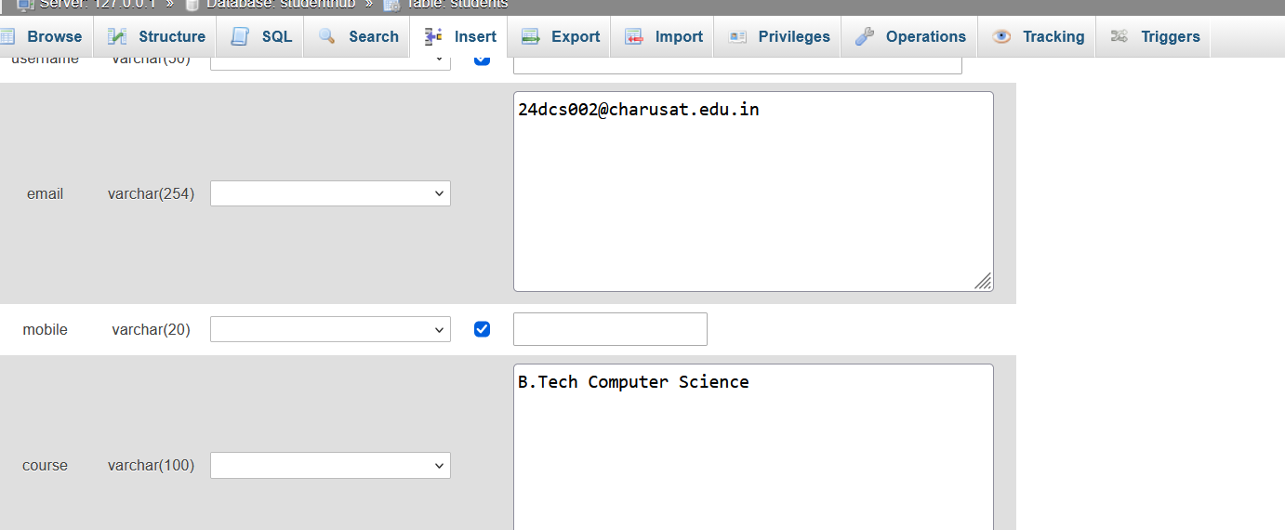

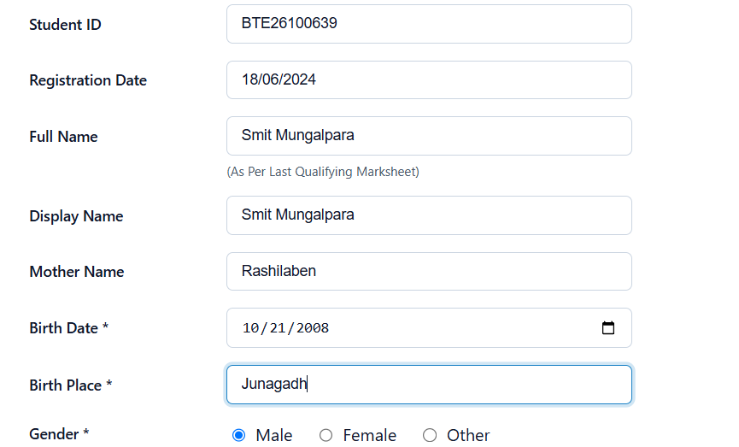



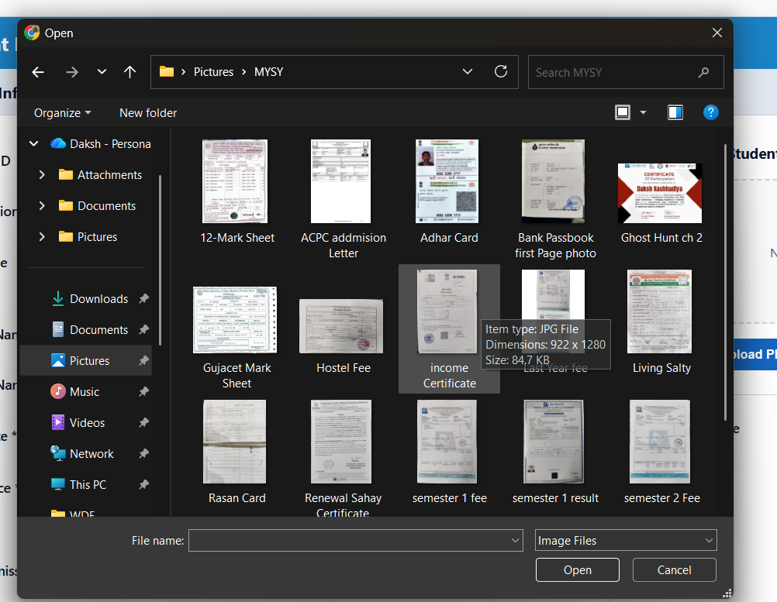

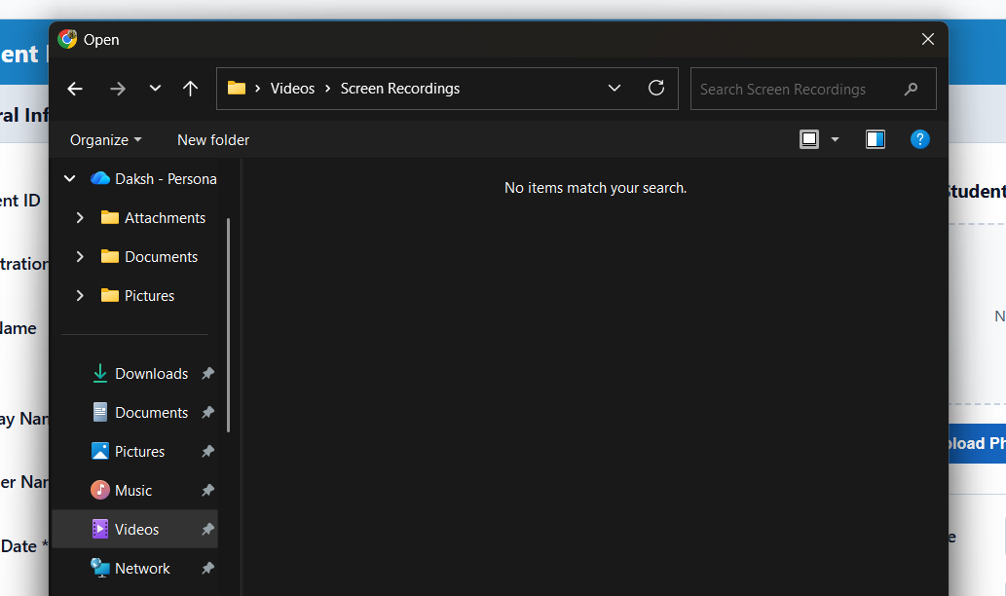

GitHub Repository Link :

htts://github.com/dakshpatel025/Practical_1-2_web

Challenges Faced:

The main challenges faced were connecting the UI with the database and implementing CRUD operations correctly. Validating poster file types and sizes was also challenging. Handling errors during database operations and file uploads required proper validation. Displaying appropriate success and failure messages helped improve the user experience.

F. Learning Outcomes:

Learned how to implement add, update, and delete functionalities using database operations. Understood how to connect the user interface with the database. Learned to validate poster uploads based on file type and size. Gained knowledge of displaying success and error messages and handling errors effectively.

Faculty Remarks :

