Practical - 13
Practical Title: PHP JSON API and AJAX/Fetch-Based CRUD without Page Reload

Problem Definition :

Create simple PHP JSON API endpoints for events or students and consume them using Fetch API. Perform list, add, update, and delete operations asynchronously without full page reload.

Theory :

1. Do PHP endpoints return valid JSON responses?

Answer :
Yes, PHP endpoints return valid JSON responses using json_encode(). Appropriate headers are set using Content-Type: application/json. The responses include success or error messages. This helps the frontend process server responses correctly.

2. Are GET and POST requests handled properly?

Answer :
Yes, GET requests are used to retrieve data from the database. POST requests are used to submit or insert data. The PHP code checks the request method before processing. This ensures that requests are handled according to their purpose.

3. Are loading, success, and error states shown on the frontend?

Answer :
Yes, loading messages are displayed while requests are being processed. Success messages appear when operations are completed successfully. Error messages are displayed when requests fail or problems occur. This improves user experience and provides clear feedback.

4. Is input validation performed before database operations?

Answer :
Yes, input validation is performed before database operations. Required fields and input formats are checked on the server side. Prepared statements are used to help prevent SQL injection. Invalid inputs are rejected, helping maintain data security and integrity.

Implementation :

PHP endpoints are implemented to handle GET and POST requests and return valid JSON responses. The frontend communicates with the backend to send and receive data. Loading, success, and error messages are displayed to provide proper user feedback. Server-side input validation and prepared statements are used to improve data security and ensure reliable database operations.

Evidence of Work (Screenshots)

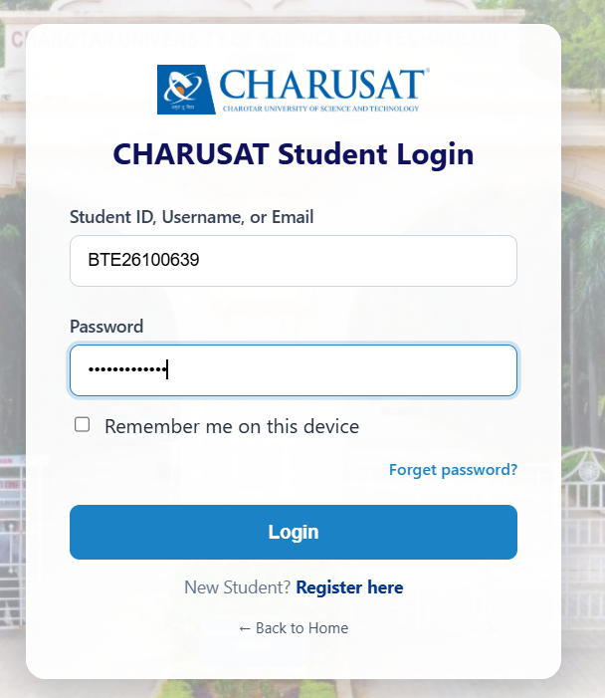

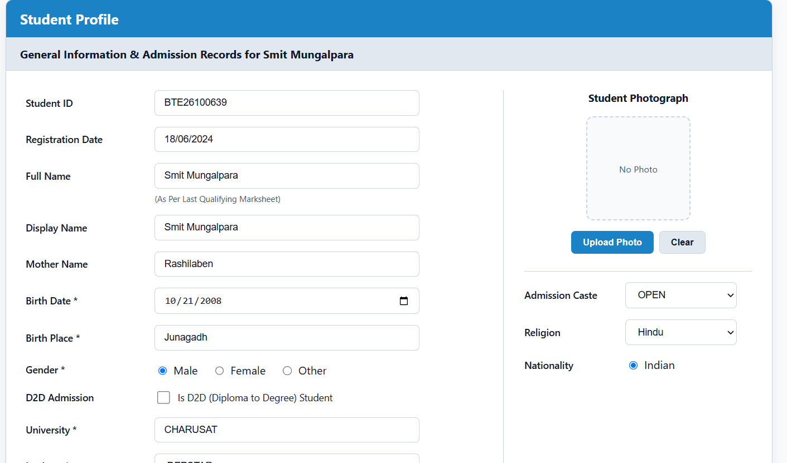

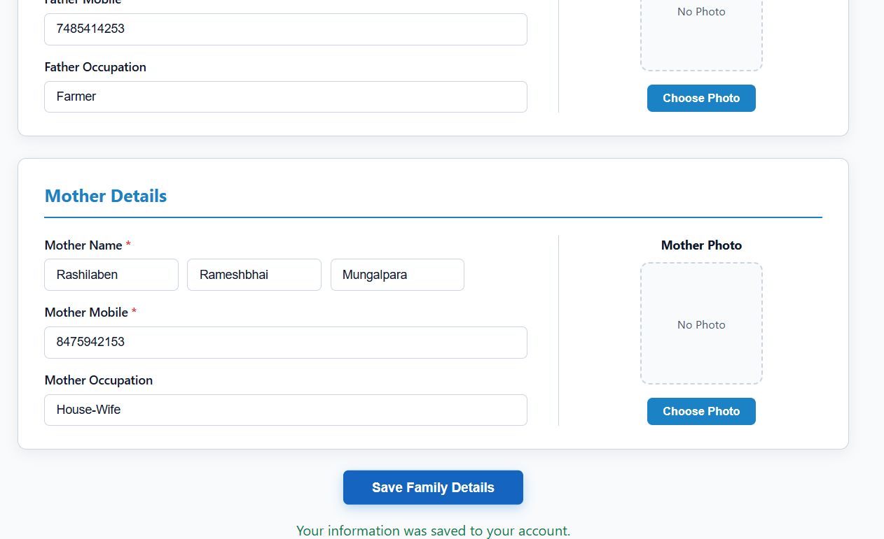

GitHub Repository Link :

htts://github.com/dakshpatel025/Practical_1-2_web

Challenges Faced:

- Handling GET and POST requests correctly in PHP was challenging.
- Returning valid JSON responses without PHP errors required careful coding.
- Displaying loading, success, and error messages on the frontend was difficult.
- Validating user inputs and handling database errors required proper checks.

F. Learning Outcomes:

- Learned how to handle GET and POST requests using PHP.
- Understood how to return valid JSON responses from PHP endpoints.
- Learned to display loading, success, and error messages on the frontend.
- Understood the importance of input validation and prepared statements for secure database operations.

Faculty Remarks :

