Practical - 14
Practical Title: Admin Dashboard with Role-Based Access Control, Dynamic Menu, and Audit Log

Problem Definition :

Develop an admin dashboard that displays user statistics, student count, event count and latest registrations. Restrict access to admin users only and show dynamic menu options based on role.

Theory :

1. Are dashboard values loaded dynamically from the database?

Answer :
Dashboard values are loaded dynamically from the database using PHP queries. The system displays updated information, such as total users and records. When database values change, the dashboard reflects the latest data. This helps administrators monitor the system easily.

2. Is access restricted to admin users?

Answer :
Access to the admin dashboard is restricted to authorized admin users. The system checks the user's role before allowing access. Unauthorized users are redirected to the login page or denied access. This helps protect sensitive administrative information.

3 Are role-based menus working?

Answer :
Role-based menus display options according to the user's role. Admin users can access administrative features, while student users can access student-related features. The system checks user roles before displaying the appropriate menus. This improves security and provides a better user experience.

4 Are important admin actions recorded in audit_logs?

Answer :
Important administrative actions are recorded in the audit_logs table. These records may include the admin ID, action performed, and date and time. Audit logs help track administrative activities and identify unauthorized changes. This improves system security and accountability.

Implementation :

The admin dashboard was implemented using PHP, MySQL, HTML, and CSS. Dashboard values are fetched dynamically from the database and displayed to the administrator. Role-based access control was implemented to ensure that admin and student users can access only their authorized features. Role-based menus were created to display options according to user roles. Important administrative activities are recorded in the audit_logs table to improve security and maintain activity records.

Evidence of Work (Screenshots)

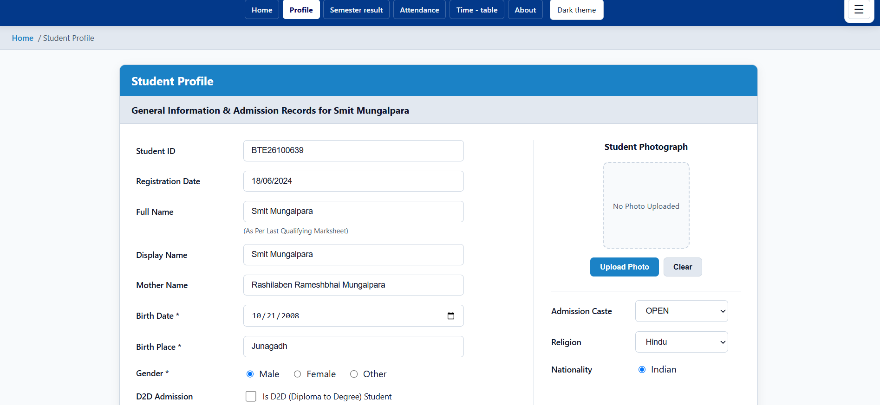

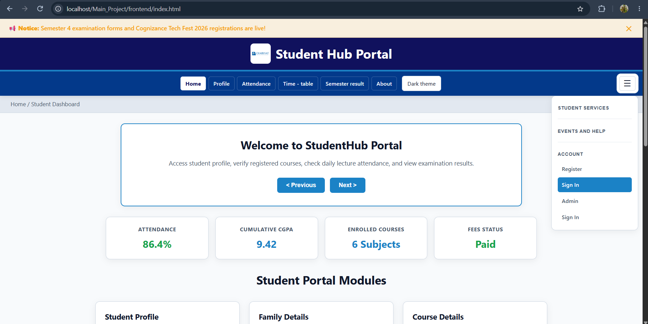

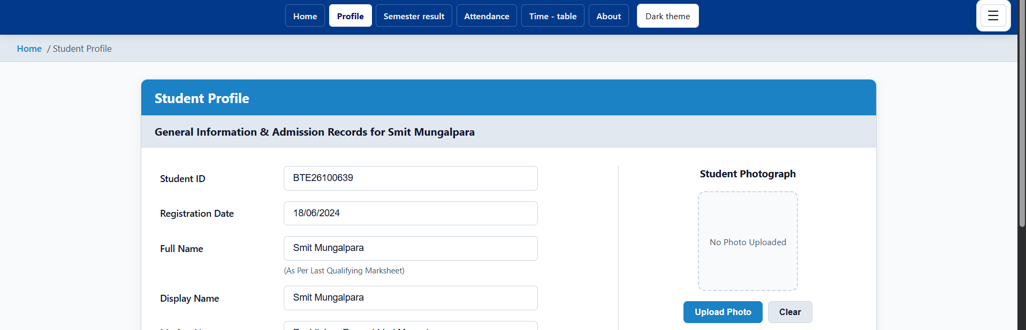

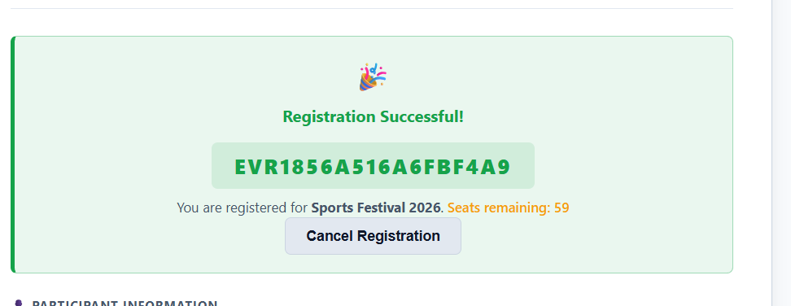

GitHub Repository Link :

htts://github.com/dakshpatel025/Practical_1-2_web

Challenges Faced:

During implementation, challenges were faced in fetching dashboard values dynamically from the database. Restricting dashboard access based on user roles required proper session management and authentication. Displaying the correct menus for admin and student users was also challenging. Recording administrative activities in the audit_logs table required proper database integration. These challenges were resolved through proper validation, testing_

F. Learning Outcomes:

I learned how to create an admin dashboard using PHP and MySQL. I understood how to fetch and display data dynamically from the database. I learned how to implement role-based access control and display menus according to user roles. I also understood how to record administrative activities in the audit_logs table. Overall, I gained knowledge of dashboard management, database integration, and application security.

Faculty Remarks :

