Practical - 2

Practical Title: Semantic HTML5 Pages with Accessibility-Ready Structure

Problem Definition: Develop static HTML5 skeletons for at least 10 StudentHub pages such as

Home, About, Register, Login, Dashboard, Events, Profile, Contact,

Admin, FAQ, and Feedback. Use semantic tags and accessibility-friendly

structure.

Theory :

1. Are semantic tags such as header, nav, main, section, article, aside, and
footer used properly?
Answer:

No, they are only partially used.

Used correctly :- <nav>, <main>, and <section> are used properly across the pages.

Not used at all :- <header>, <footer>, <article>, and <aside> are missing from the entire folder. (e.g., The <nav> is not wrapped in a <header>, and there are no <footer> tags at the bottom of any page).

2. Are form labels, headings, image alt text, and navigation links accessible ?
Answer :

Yes . Form labels are correctly bound to inputs using for and id attributes (e.g., <label for="enrollment">). Headings (<h1>, <h2>) and navigation links (<a>) are used semantically.

3. Is the page structure consistent across all pages?
Answer :

Yes . The page structure is perfectly consistent.

Every page utilizes the exact same <nav class="navbar"> block at the top, followed by a <main> container for the core content.

Implementation :

In this practical, the foundational structure of the StudentHub portal was developed.

Ten separate HTML pages (such as dashboard, courses, login, and result) were coded using core HTML5 elements.

Semantic tags, complex <table> structures for data presentation, and <form> elements for user input were implemented to build the raw, unstyled framework of the application.

Evidence of Work (Screenshots) :

Description: wireframe image of login page

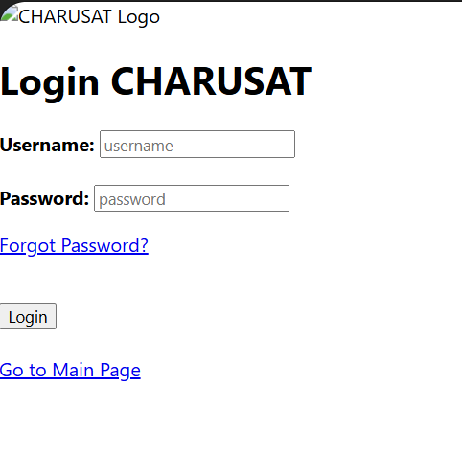

Description: wireframe image of Main page
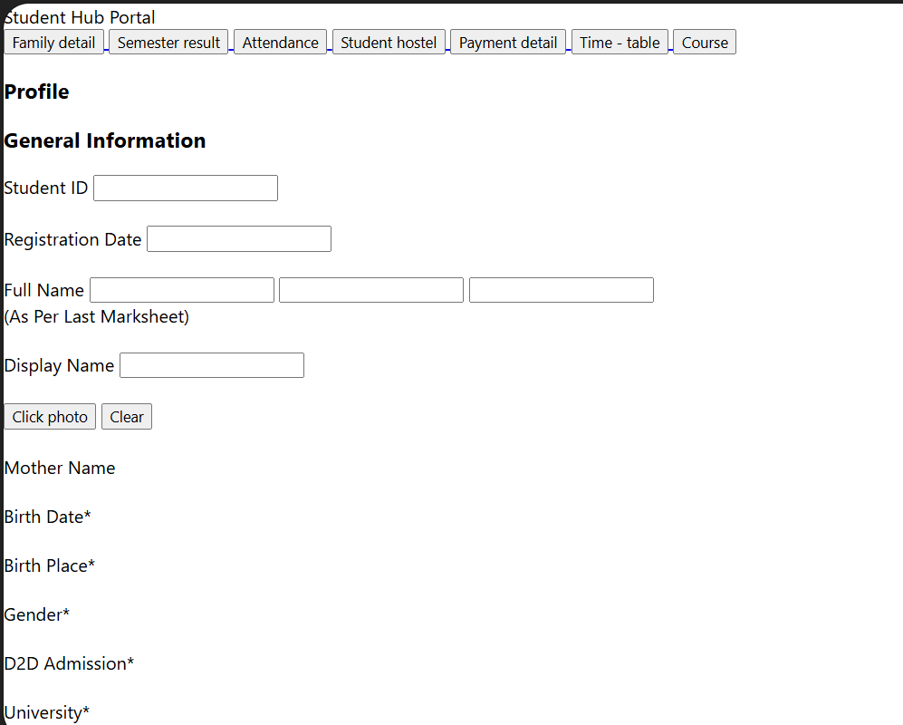

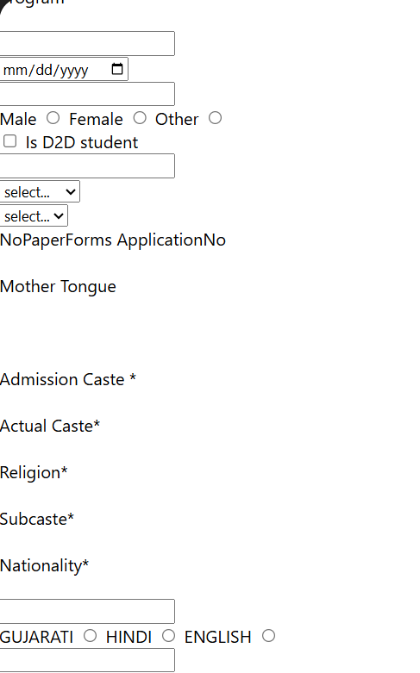
Description: wireframe image of Attendance page
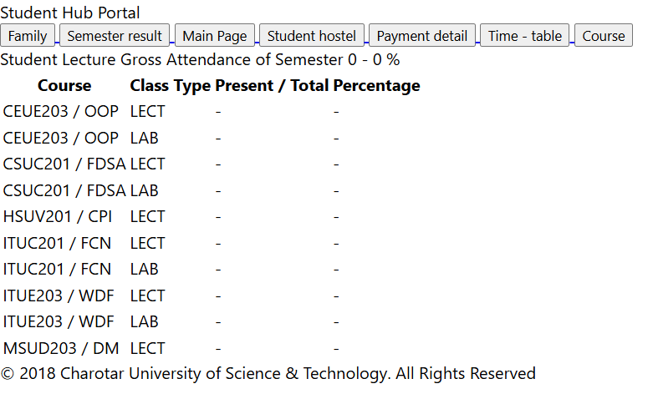

Description: wireframe image of Course page
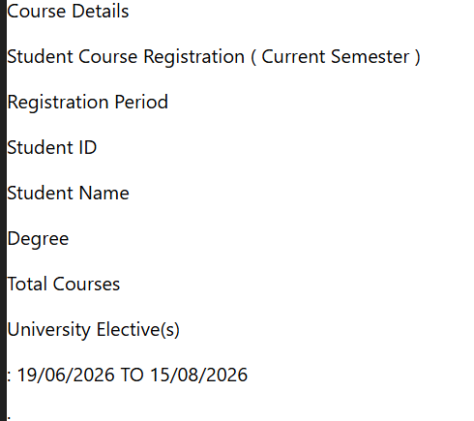

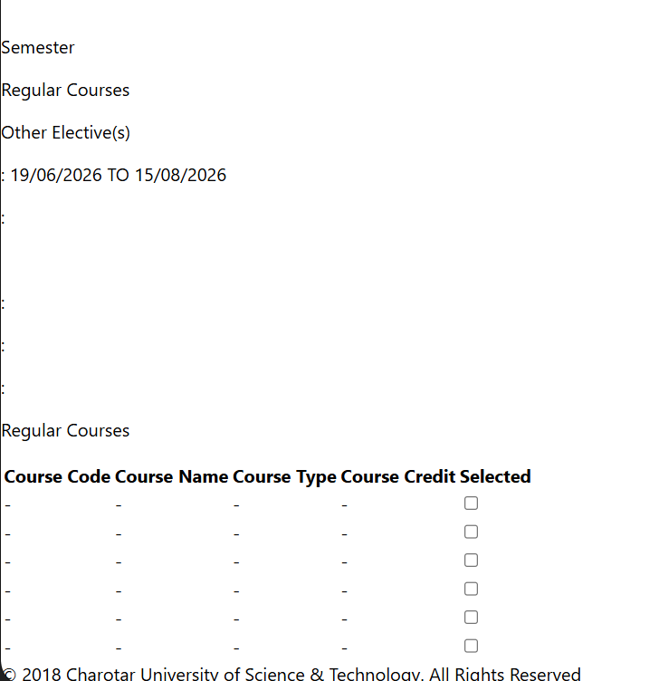

Description: wireframe image of Family Details page
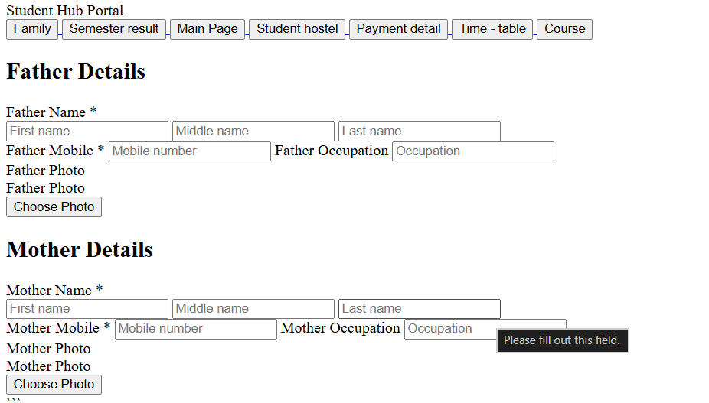

Description: wireframe image of Hostel page
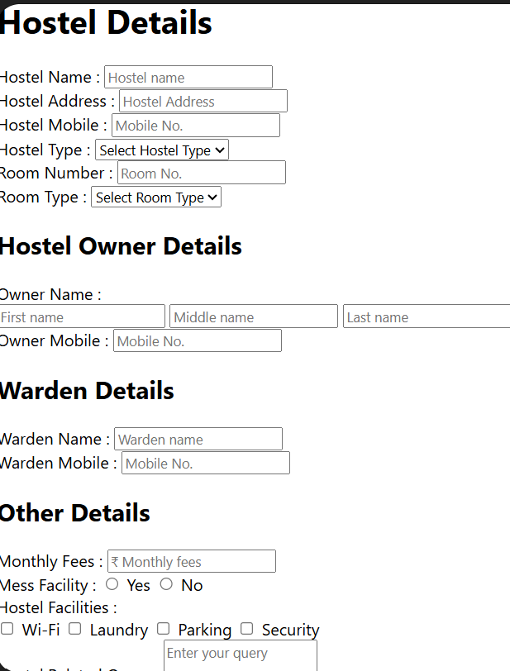

Description: wireframe image of Pyment page
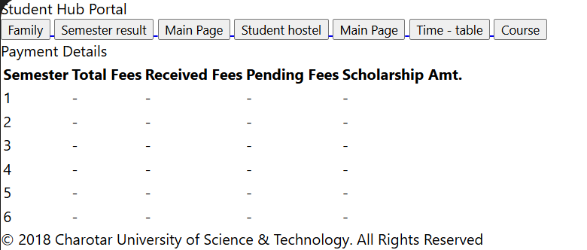

Description: wireframe image of Result page
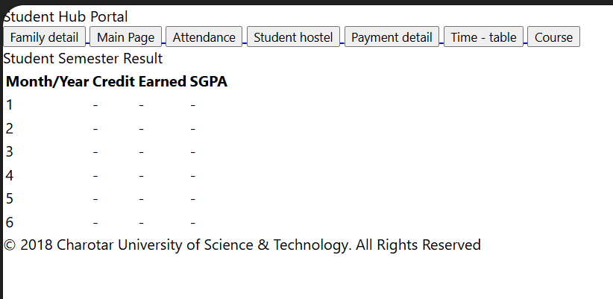

Description: wireframe image of Time Table page
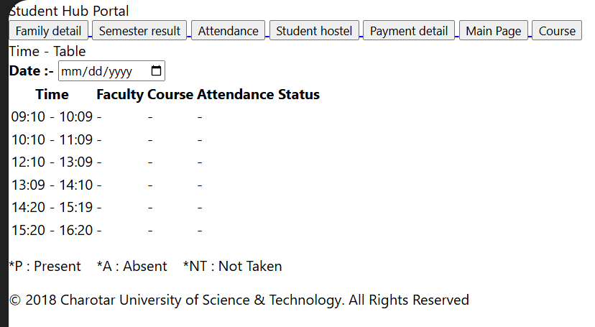

GitHub Repository Link:

https://github.com/dakshpatel025/Practical_1-2_web

Challenges Faced:

During Practical 2, the main challenge was building the portal strictly using unstyled HTML elements while ensuring the content remained logical and readable.

Creating complex pages like the results and dashboard required careful nesting of <table>, <tr>, and <td> tags to present data clearly.

Another hurdle was designing the forms for login and registration, ensuring all <input> fields had the correct attributes for future backend integration.

Furthermore, manually linking 10 distinct files using <a href="filename.html"> tags meant that testing the navigation flow and preventing dead links was a tedious and error-prone process.

Learning Outcomes:

Mastered the creation of structured, multi-page HTML5 documents

Learned how to build complex data tables and interactive user input forms.

Gained experience using semantic HTML to ensure clear document structure.

Understood how to manually link static web pages to form a cohesive portal.

Faculty Remarks:

