Practical - 3
Practical Title: Responsive UI Design using CSS Grid, Flexbox, and Bootstrap/Tailwind

Problem Definition: Design responsive layouts for Home, About, Registration, Dashboard, and Events pages using CSS Grid and Flexbox. Optional to use CSS framework such as Bootstrap or Tailwind. Ensure mobile-first responsiveness.

Theory :

1. How does the layout adapt for mobile, tablet, and desktop screens?
Answer :
The layout adapts fluidly. Instead of strict media queries, it uses responsive CSS properties like flex-wrap: wrap and min-width: 180px (seen in .feature-box). This allows elements to automatically stack on mobile/tablet screens and sit side-by-side on desktop screens.

2. Which layout technique is used and why?
Answer :
CSS Flexbox (display: flex;) is the primary layout technique used (specifically for .features and form containers). It is used because it provides a modern, efficient way to align elements, distribute space, and handle dynamic wrapping without relying on complex and outdated float rules.

3. Are typography, spacing, colors, and contrast readable?
Answer :
Yes. Typography uses clean, modern fonts (Segoe UI, Arial). Spacing is consistent (e.g., padding: 24px, gap: 15px). The color palette uses a warm, earthy theme (browns on beige), providing excellent contrast and high readability between the dark text (#3a2a1a) and light backgrounds (#fffdfa).

4. Is the framework used consistently without unnecessary inline CSS?
Answer :
Yes, perfectly. Pure CSS3 is used consistently via a single external stylesheet (../CSS/script.css). A scan of all HTML files in Practical 3 confirms there is zero inline CSS (no style="..." attributes used anywhere), ensuring a clean separation of structure and design.

Implementation :

This practical focused on UI design and project organization.

The flat file structure was reorganized into a professional architecture using CSS, JS,
and PAGES directories.

A central script.css stylesheet was created and linked to all pages, utilizing advanced CSS techniques like linear gradients, box shadows, Flexbox layouts, and hover effects to transform the raw HTML into a polished, modern interface.

Evidence of Work (Screenshots)

Description: wireframe image of login page



Description: wireframe image of Main page

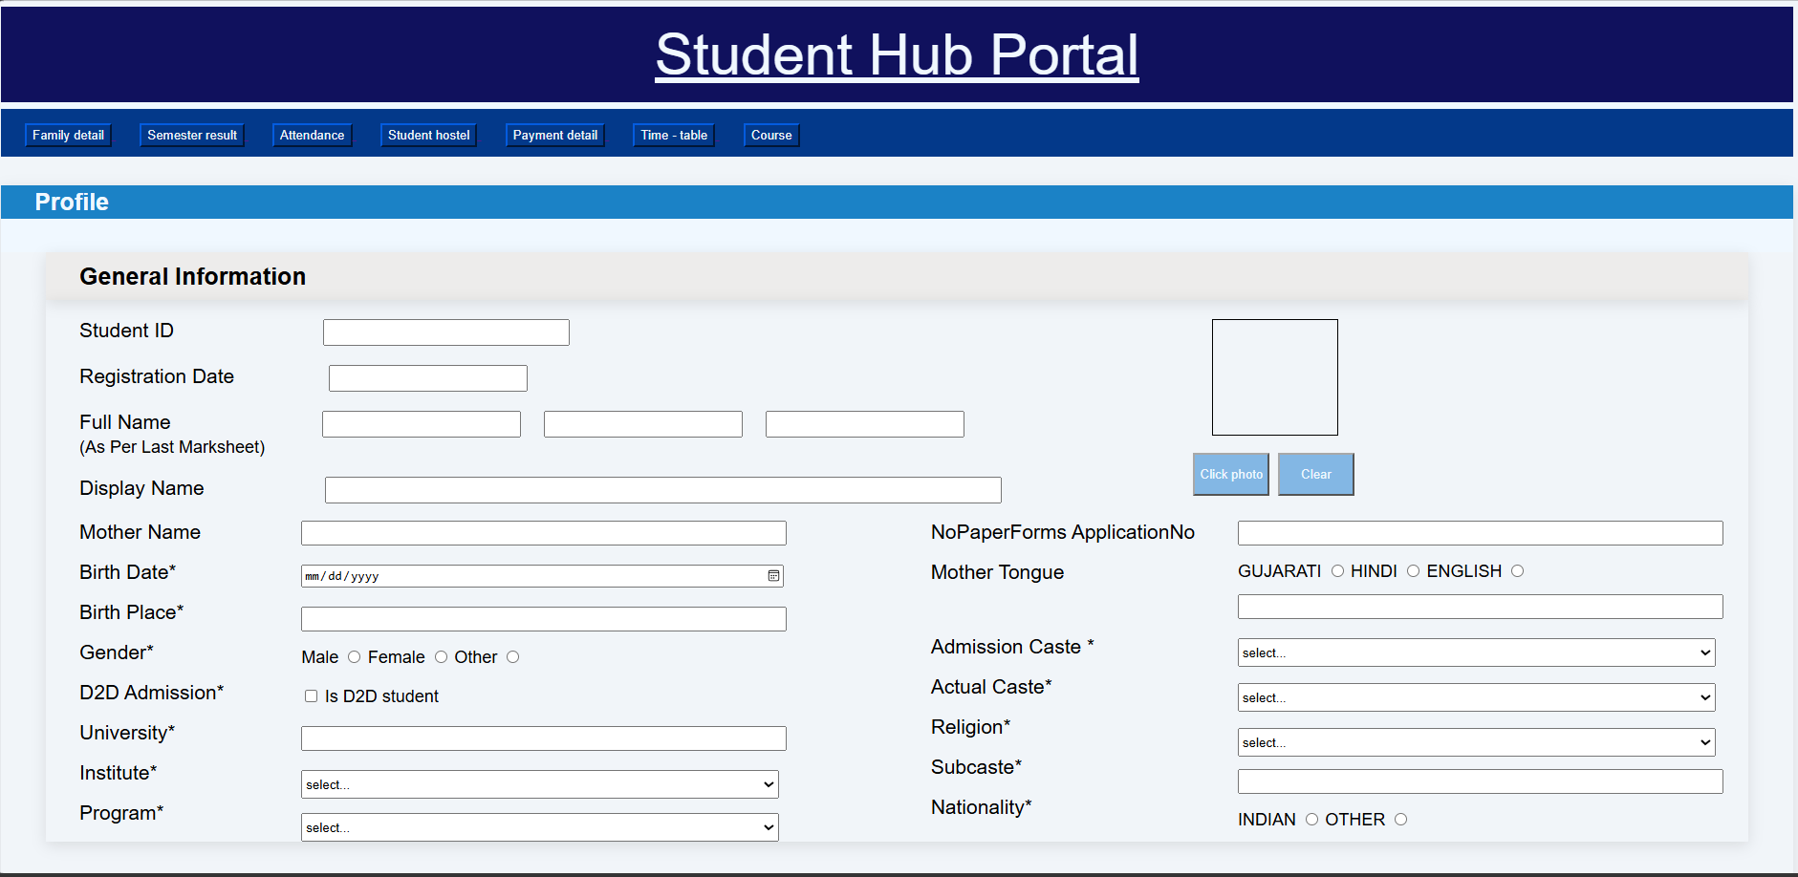

Description: wireframe image of Attendance page

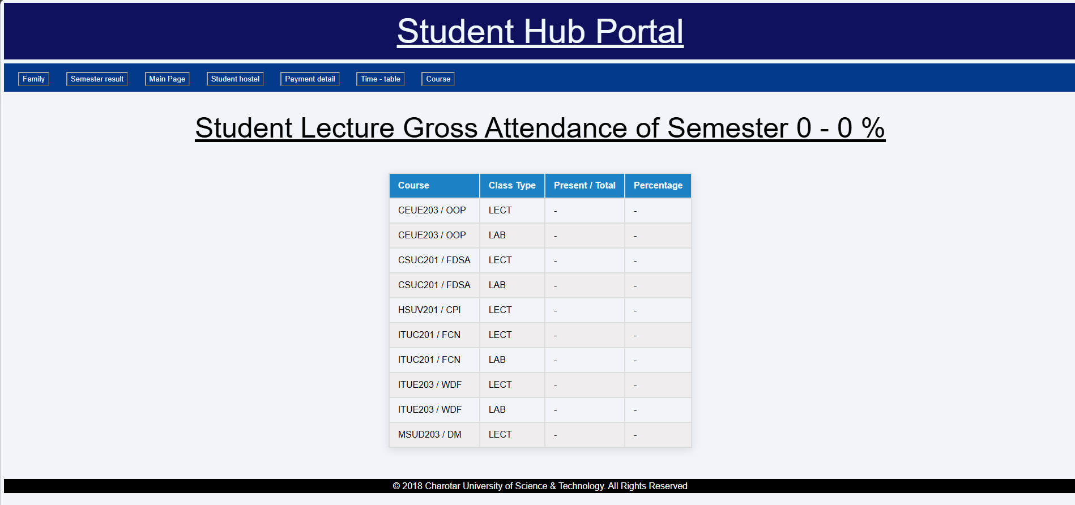

Description: wireframe image of Course page
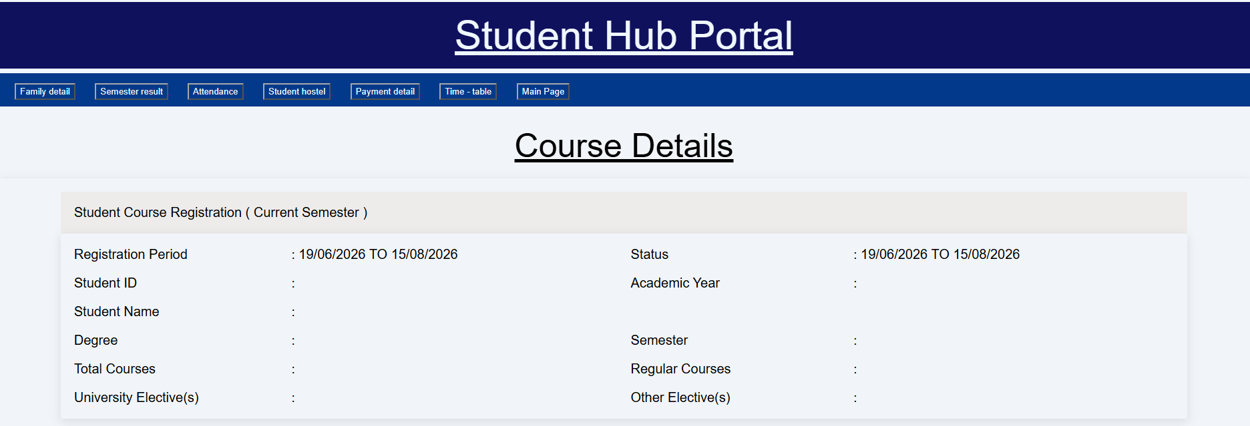
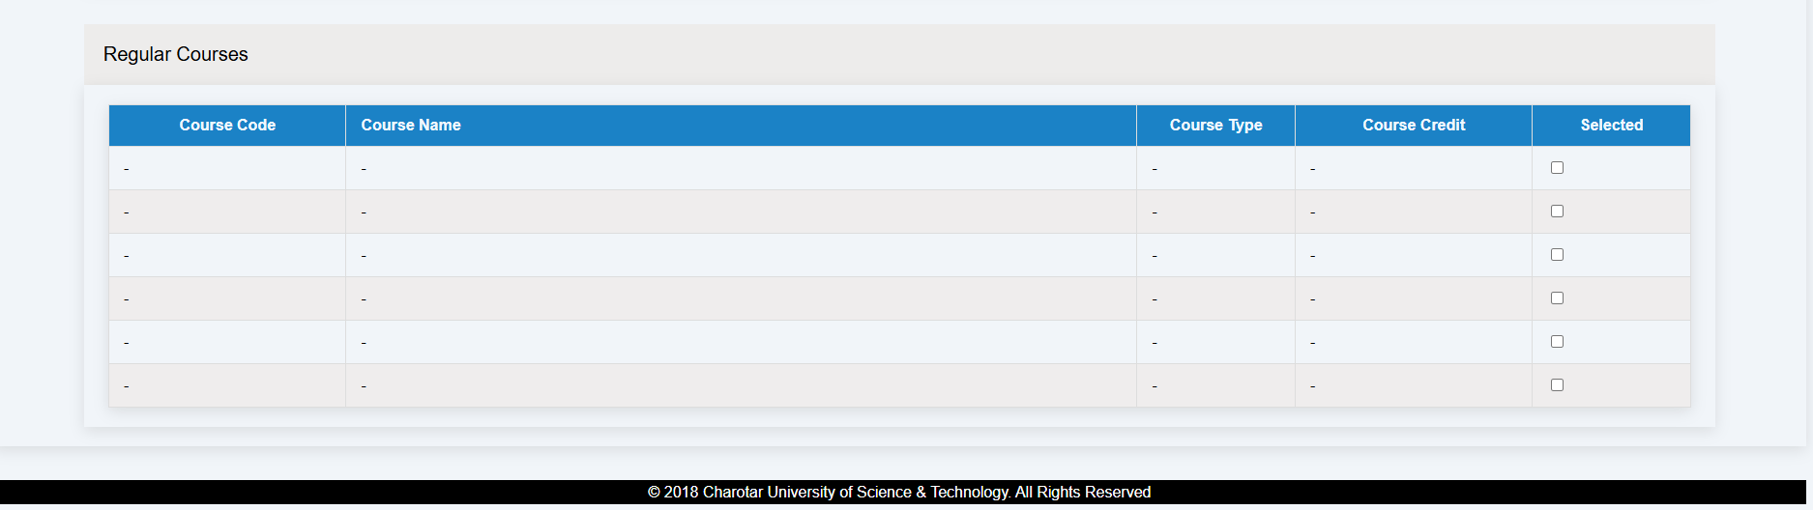

Description: wireframe image of Family Details page
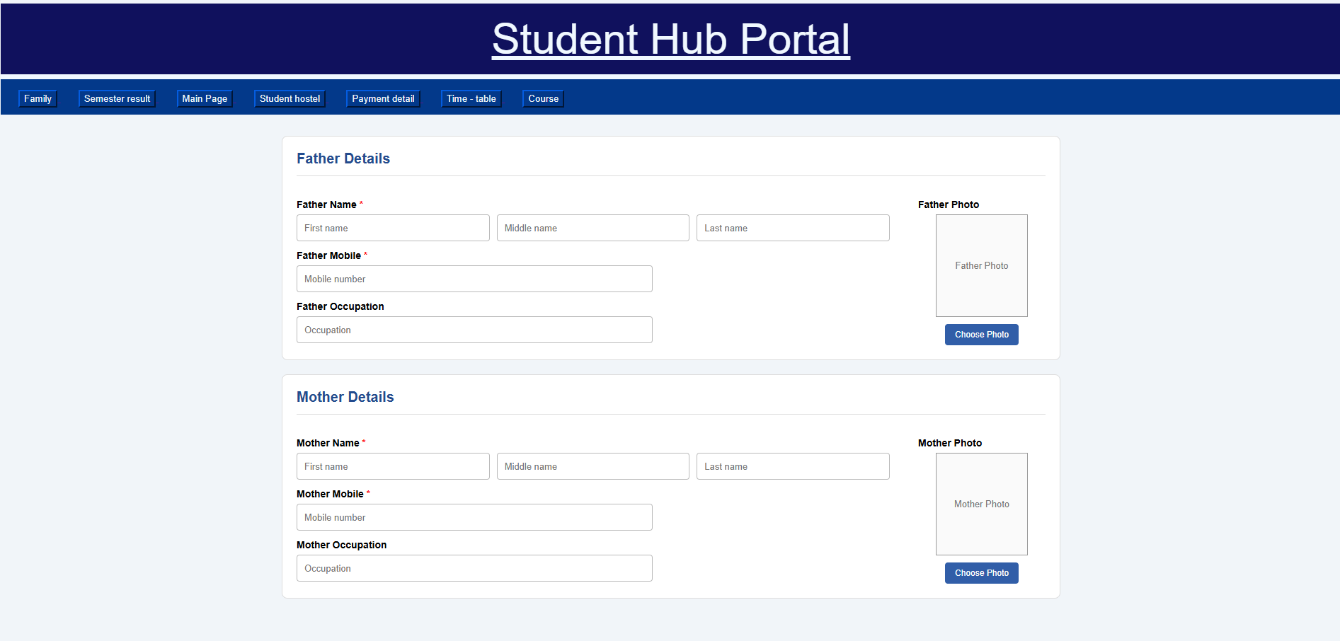

Description: wireframe image of Hostel page
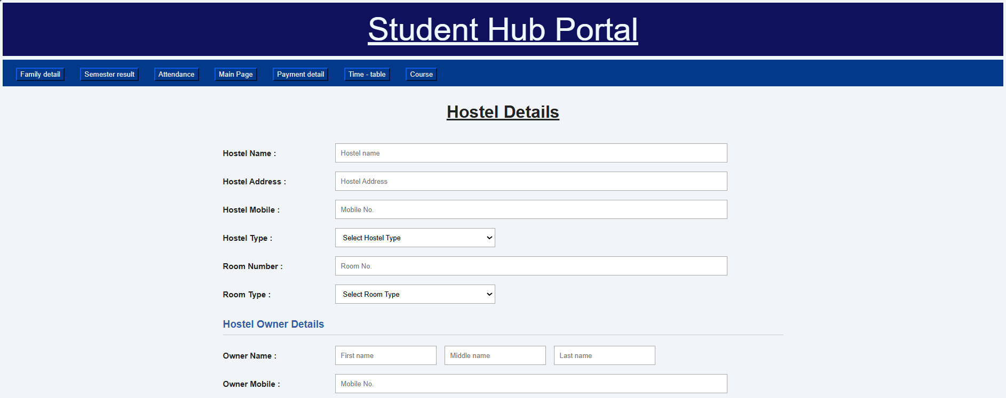

Figure 3.5

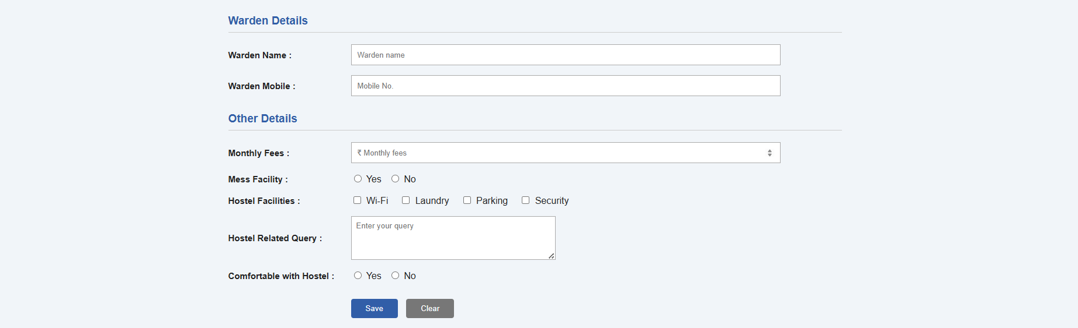

Description: wireframe image of Pyment page

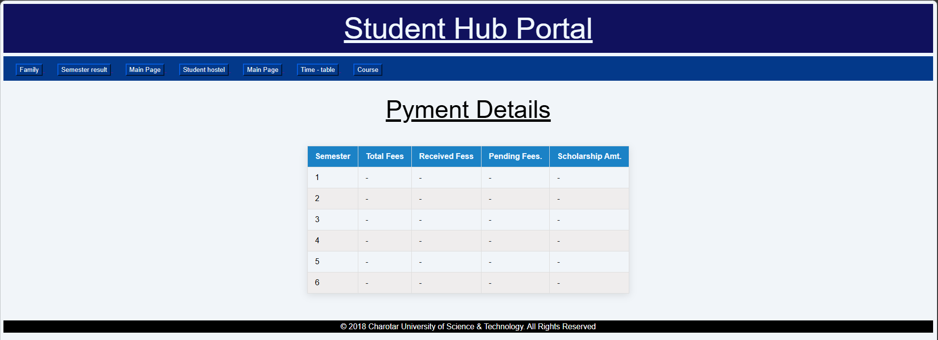

Description: wireframe image of Result page
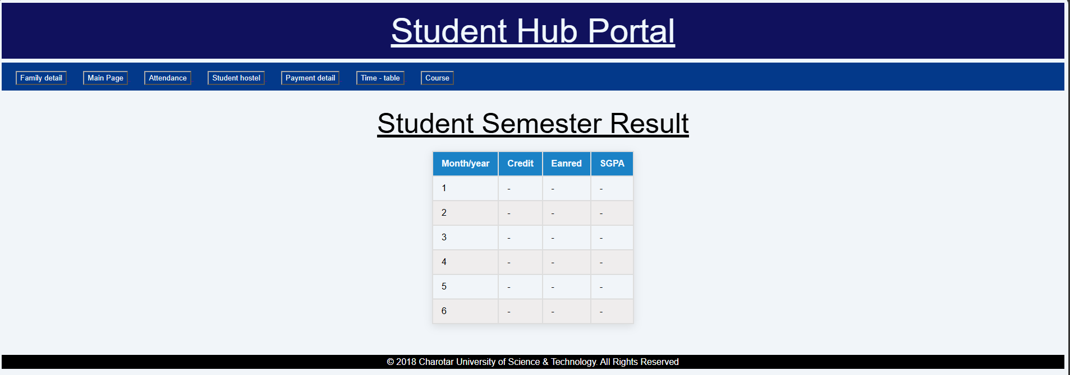

Description: wireframe image of Time Table page
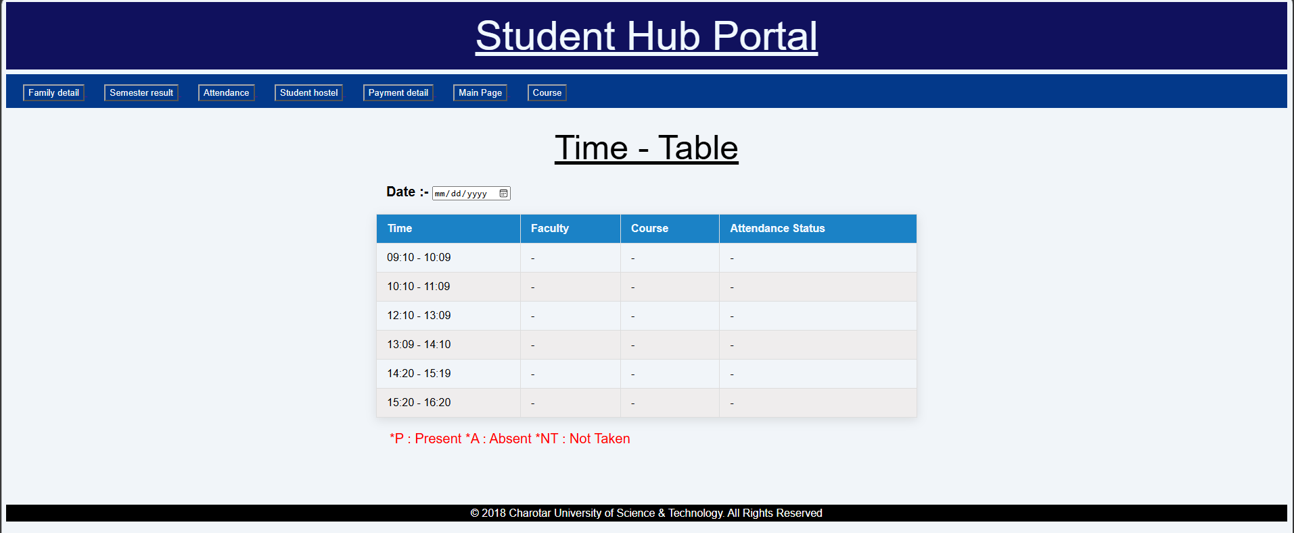

GitHub Repository Link :
https://github.com/dakshpatel025/Practical_1-2_web

Challenges Faced:

In Practical 3, moving the raw HTML into a structured directory architecture (PAGES, CSS, JS) broke all existing file links, which was challenging to fix by updating every ../ relative path.

When writing script.css, applying Flexbox to the feature boxes and form containers was tricky; getting the items to align and wrap correctly required constant tweaking.

Additionally, implementing consistent styling for tables and navigation bars across all pages meant I had to rely heavily on CSS classes and global rules, which was a significant shift in thinking.

Finally, debugging conflicting CSS rules where styles accidentally overrode each other took considerable time.

Learning Outcomes:

Learned to structure a web project professionally using dedicated directories.

Gained experience applying aesthetic properties like gradients, shadows.

Learned how to resolve relative path issues when linking external stylesheets.

Understood the importance of a single global stylesheet for maintaining UI
consistency.

Faculty Remarks :

