Practical - 4
Practical Title: JavaScript DOM Manipulation, Event Handling, and UI Interactivity

Add dynamic UI components such as collapsible FAQ, modal popup,
image/content slider, notification banner, hamburger menu, and light/dark
theme switcher using JavaScript.

Theory :

1. How are DOM elements selected and modified?

Answer :
DOM elements are selected using methods like getElementById(), querySelector(), and querySelectorAll(). They are modified using properties such as textContent, innerHTML, style, and classList.

2. Are event listeners attached correctly?

Answer :
Yes. Event listeners are attached using addEventListener(). They handle user actions such as clicks, form submissions, and input changes without using inline JavaScript.

3. Is localStorage used for remembering theme choice?

Answer :
Yes. localStorage can store the user's selected theme, such as light or dark mode, so the same theme is applied when the user opens the page again.

4. Does interactivity improve usability without breaking accessibility?

Answer:
Yes. Interactive features should make the website easier to use while keeping buttons, forms, navigation, keyboard access, and readable text accessible to all users.

Implementation :

1. DOM elements are selected using getElementById(), querySelector(), and querySelectorAll().
2. Elements are modified using textContent, innerHTML, style, and classList.
3. Event listeners are attached using addEventListener() for click, input, change, and submit events.
4. FAQ sections can be expanded and collapsed using JavaScript.
5. Modal popups and event details are controlled dynamically.
6. Photo preview and form validation improve user interaction.
7. localStorage is used for caching FAQ/events data and storing feedback.
8. Accessibility is improved using ARIA attributes and keyboard interactions.
9. Overall, JavaScript makes the StudentHub interface more interactive and user-friendly.

Evidence of Work (Screenshots)

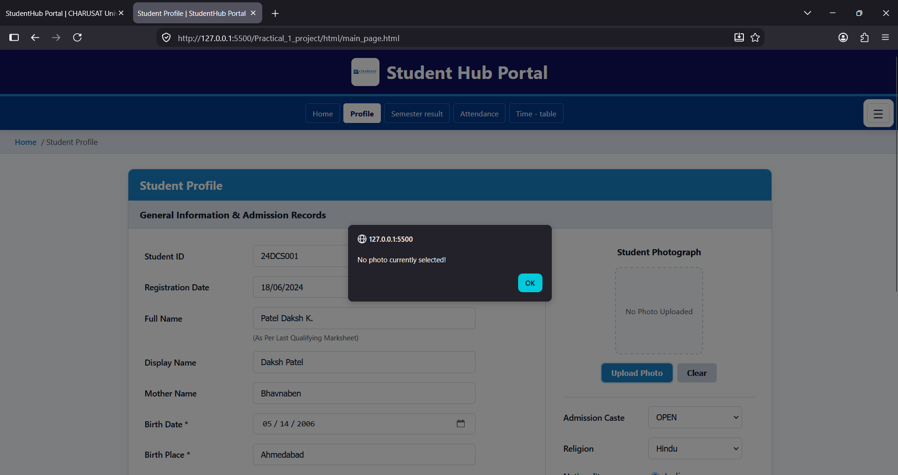

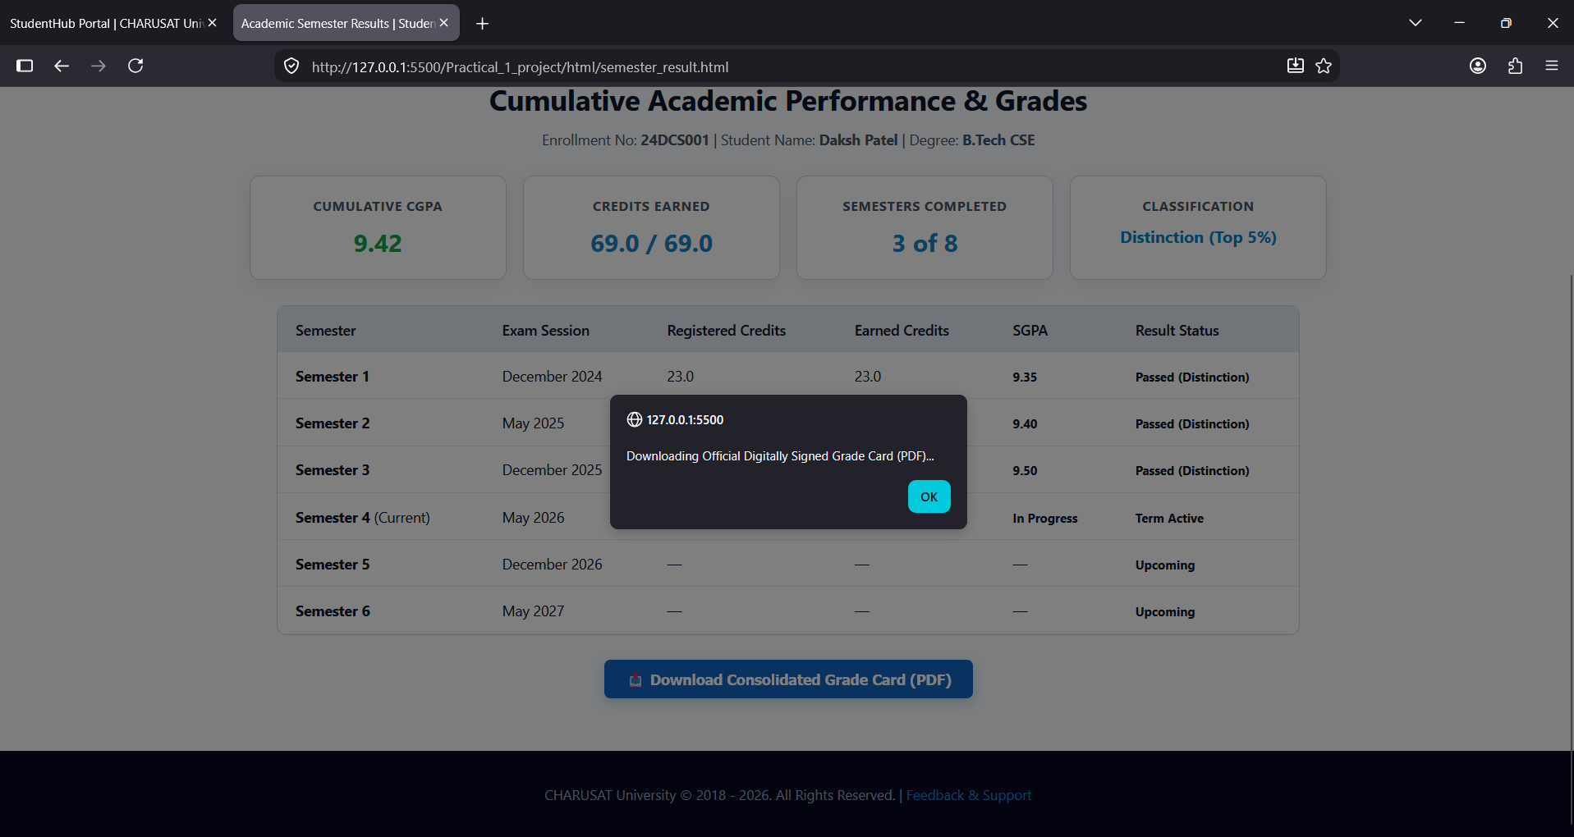
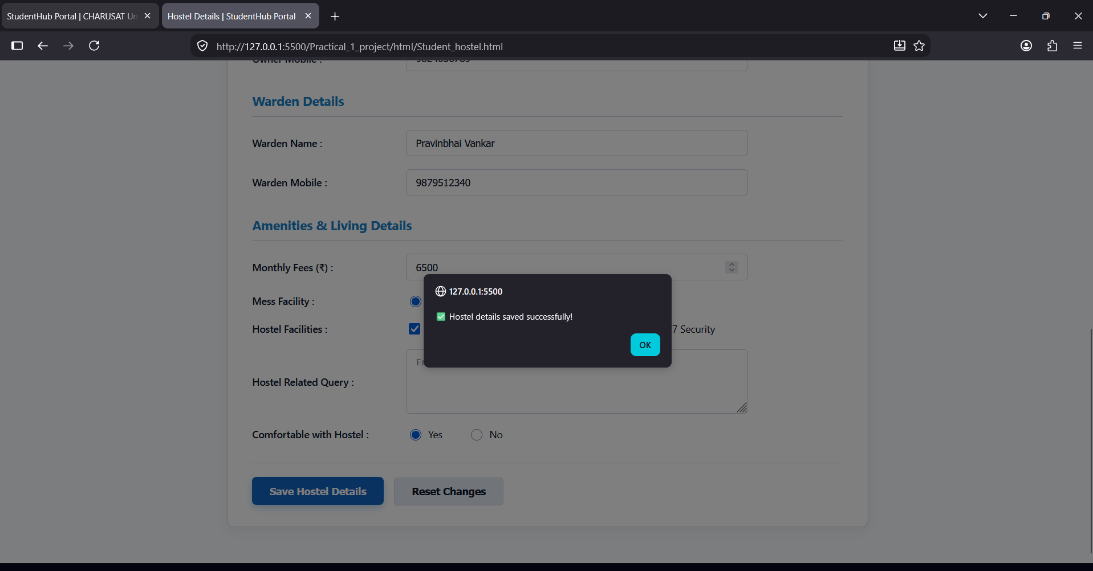

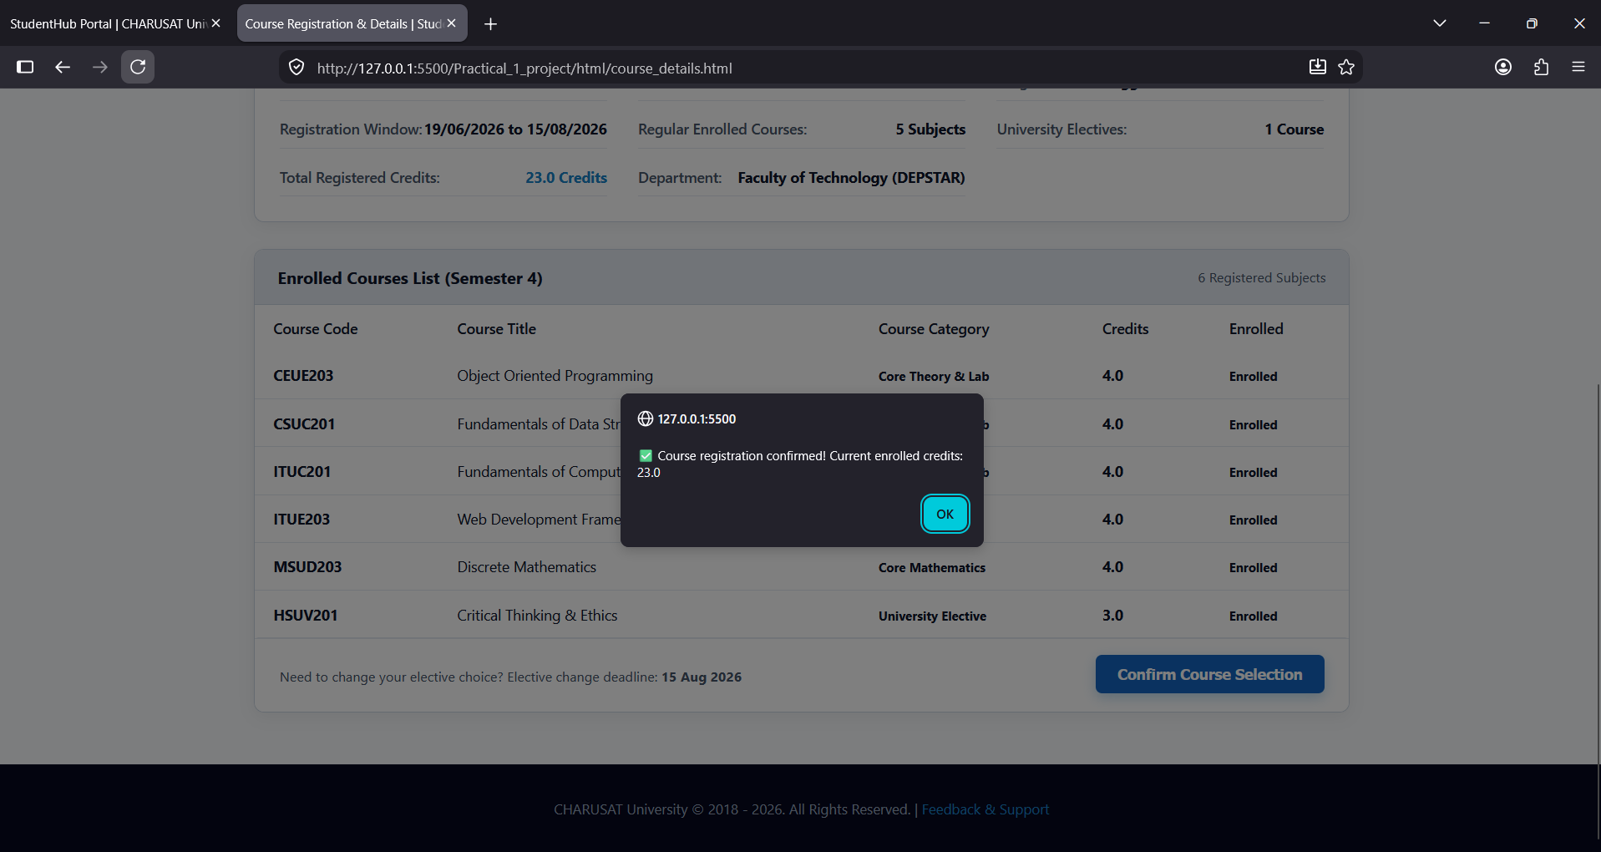
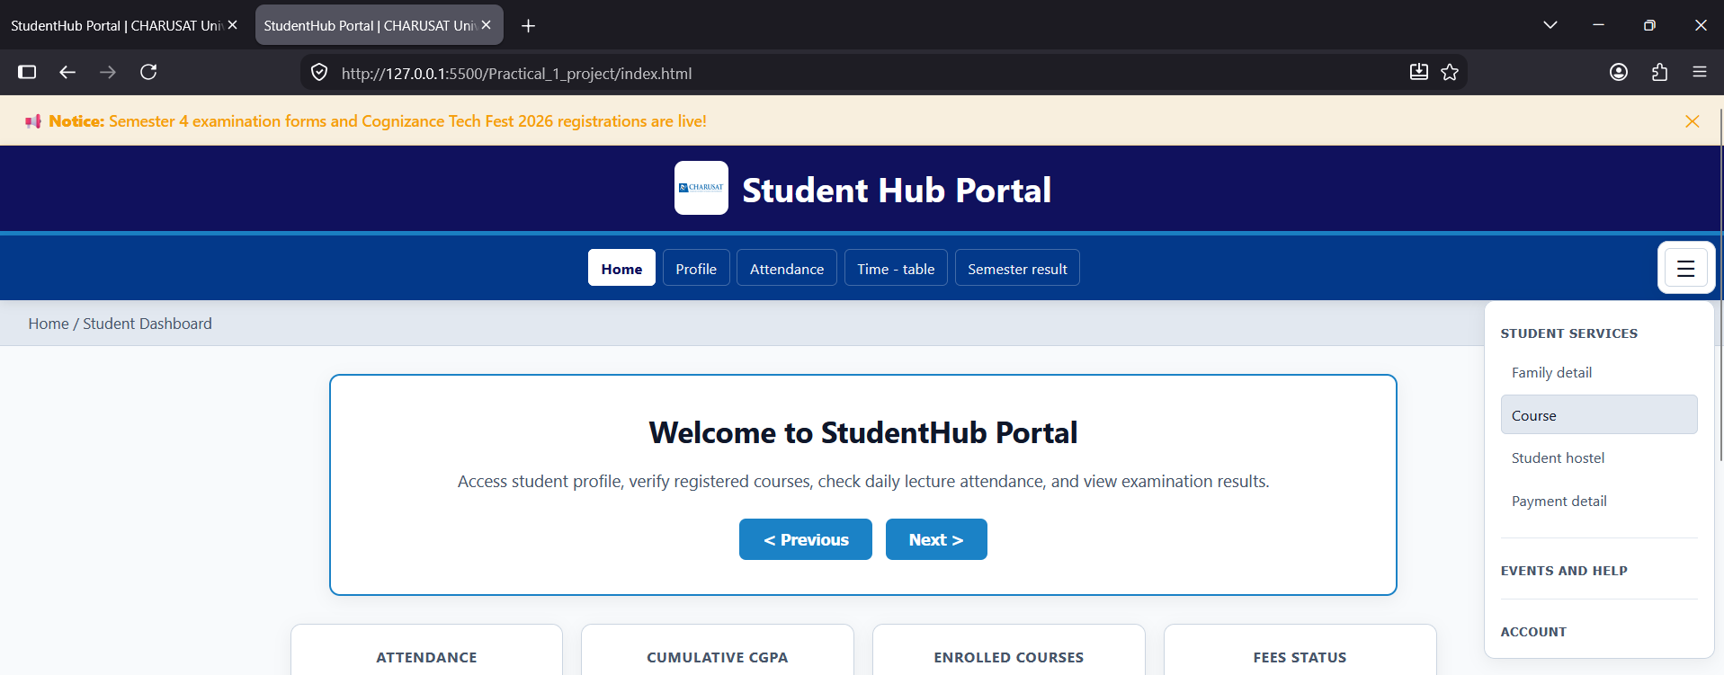
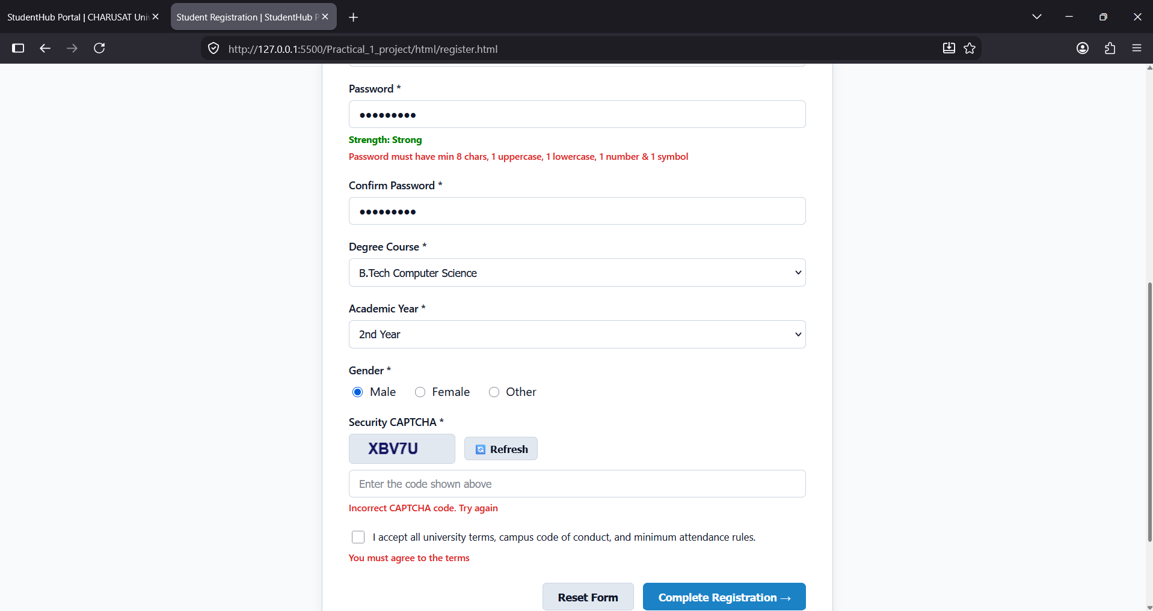

GitHub Repository Link :
https://github.com/dakshpatel025/Practical_1-2_web

Challenges Faced:

1. Understanding and selecting DOM elements correctly using JavaScript.

2. Handling multiple event listeners for different UI components.

3. Implementing FAQ, modal popup, and dynamic event interactions.

4. Managing form validation and displaying proper error messages.

5. Handling image/photo preview using JavaScript.

6. Using localStorage correctly for storing project data.

7. Maintaining accessibility while adding interactive features.

8. Debugging JavaScript errors using browser developer tools.

Learning Outcomes:

- Learned how to select and manipulate DOM elements using JavaScript.
- Learned to handle user events using addEventListener(). 1
- Implemented interactive FAQ and modal popup features.
- Learned to perform form validation using JavaScript.
- Implemented dynamic image/photo preview functionality.
- Learned to use localStorage for storing application data.
- Improved understanding of accessibility using ARIA attributes.
- Learned to debug JavaScript using browser developer tools.

Faculty Remarks :

