Practical - 5
Practical Title: Registration Form with Frontend Validation and User-Friendly Error Handling

Create a student registration form with HTML5 input types and JavaScript
validation for name, email, mobile number, password, confirm password,
course, year, gender, and terms acceptance. Use Regular Expression for
validations.

Theory :

1. Are correct input types and attributes used?

Answer :
Correct input types and attributes: Yes, appropriate input types such as text, email, password, date, and tel are used with suitable attributes like required, placeholder, minlength, and pattern.

2. Are validation errors displayed near the relevant fields?

Answer :
Validation errors: Yes, validation errors are displayed near the relevant input fields, making it easy for users to understand and correct their mistakes.3. Is localStorage used for remembering theme choice?

3. Is password strength checked?

Answer :
Password strength: Yes, password strength is checked using conditions such as minimum length, uppercase/lowercase letters, numbers, and special characters.

4. Is the form accessible using keyboard and screen-reader-friendly
labels?

Answer:
Keyboard and screen-reader accessibility: Yes, form fields can be accessed using the keyboard, and proper <label> elements are associated with inputs to make the form easier for screen readers.

Implementation :
1 Create an HTML registration form using input fields for Name, Email, Mobile Number, Password, Confirm Password, Course, Year, Gender, and Terms & Conditions.
2 Use suitable HTML5 input types such as email, tel, and password with required attributes.
3. Add <label> elements properly with every form field for better accessibility.
4. Create JavaScript validation functions to check all user inputs before form submission.
5. Use Regular Expressions (Regex) to validate name, email, mobile number, and password format.
6. Check whether the password and confirm password are the same and verify the required password strength.
7. Display clear and user-friendly error messages near the respective input fields.
8. Add real-time validation using keyup or change events for better user experience.
9. Prevent form submission when any input is invalid and allow submission only when all validations are successful.
10. Test the form using both valid and invalid inputs and verify the validation messages using browser developer tools.

Evidence of Work (Screenshots)

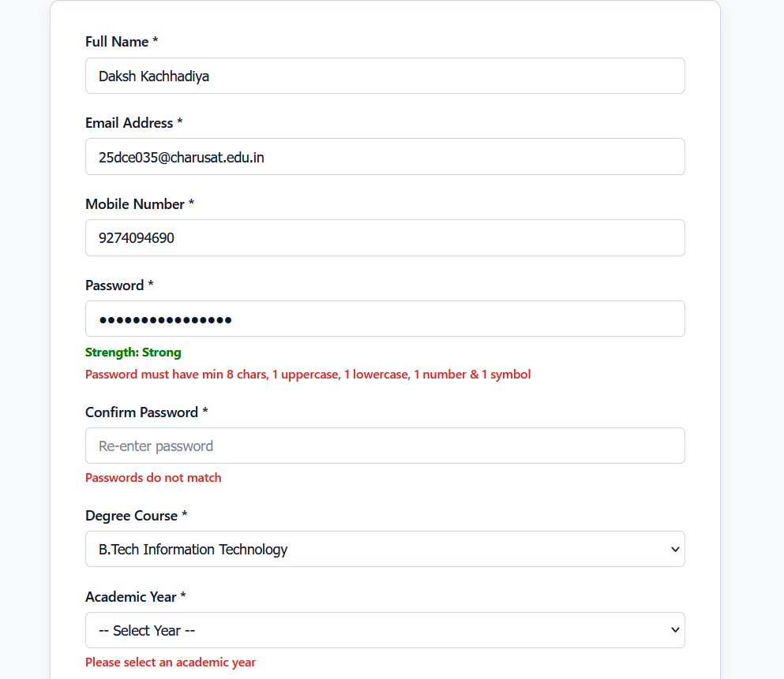

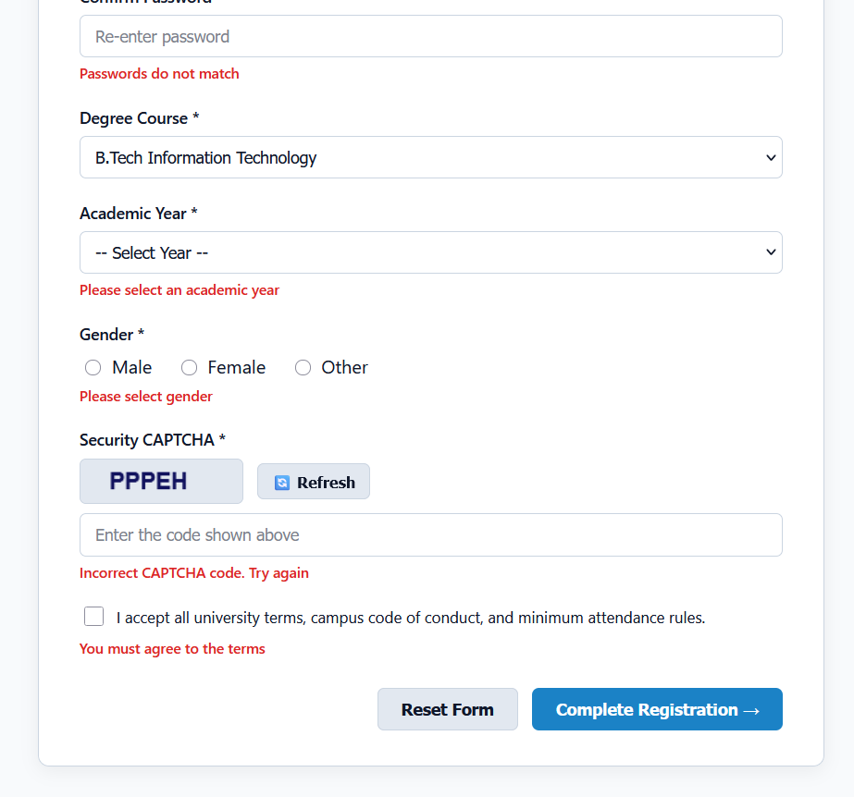

GitHub Repository Link :
htts://github.com/dakshpatel025/Practical_1-2_web

Challenges Faced:

- Creating proper HTML form fields with suitable input types.
- Writing Regular Expressions for different input validations.
- Checking password strength and matching the confirm password.
- Displaying error messages near the correct input fields.
- Handling invalid form submission using JavaScript.
- Making the form accessible and keyboard-friendly.

Learning Outcomes:

- Learned to create a student registration form using HTML5.
- Learned to use different HTML5 input types and attributes.
- Learned JavaScript form validation and Regular Expressions.
- Learned to validate password strength and confirm password.
- Learned to display user-friendly validation error messages.
- Learned basic accessibility practices for forms.
- Improved understanding of client-side validation and error handling.

Faculty Remarks :

