Practical - 6
Practical Title: Rendering External JSON Data using Fetch API, Search and Filter

Display event lists, student profiles, notices, or FAQs from external JSON
files using Fetch API. Implement dynamic rendering, search, filter,
sorting, and pagination.

Theory :

1. How is JSON fetched, parsed, and rendered?

Answer :
JSON data is fetched using the JavaScript fetch() method. The response is converted into JSON using response.json(). The data is then stored in an array and displayed dynamically on the webpage using DOM methods such as innerHTML. Loading and error messages are shown while fetching or if the request fails.

2. Which array methods are used for search, filter, sort, and pagination?

Answer :
- filter() – filters data based on search/category.
- find() – finds a specific item.
- sort() – sorts data in ascending or descending order.
- slice() – selects a limited set of items for pagination.
- map() – converts data into HTML elements/cards for display.

3. How are loading and error states handled??

Answer :
A loading message is displayed before fetching the JSON data. After successful fetching, the loading message is removed and the data is rendered. If an error occurs, the catch() block displays a clear error message to the user.

4. How is modularity maintained in JavaScript files?

Answer:
Modularity is maintained by dividing the JavaScript code into separate files or functions based on their responsibilities. For example, one module can handle data fetching, another can handle search/filter/sort, and another can handle UI rendering and pagination. export and import can be used to share functions between JavaScript modules.

Implementation :

- Create JSON files such as events.json, students.json, and faqs.json with at least 15 records.
- Create HTML pages with containers where the JSON data will be displayed dynamically.
- Use the JavaScript fetch() API to load the JSON data.
- Convert the response into JavaScript objects using response.json().
- Use map() to generate HTML cards/items and display the data on the webpage.
- Implement search and filtering using filter() and search input values.
- Use sort() to arrange records according to fields such as name, date, or category.
- Implement pagination using slice() to display a fixed number of records per page.
- Add loading and error messages using try...catch and proper response checking.
- Divide JavaScript into separate modules such as data fetching, filtering/sorting, pagination, and UI rendering using import and export.
- Test the application with different search terms, filters, pages, valid JSON, and error conditions.

Evidence of Work (Screenshots)

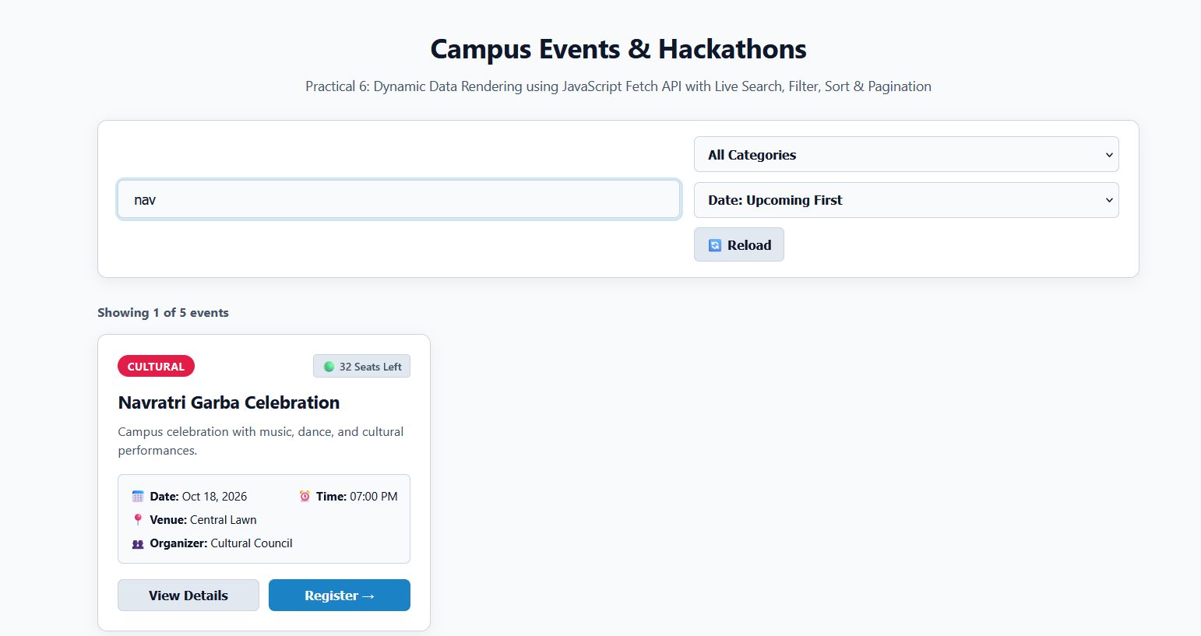

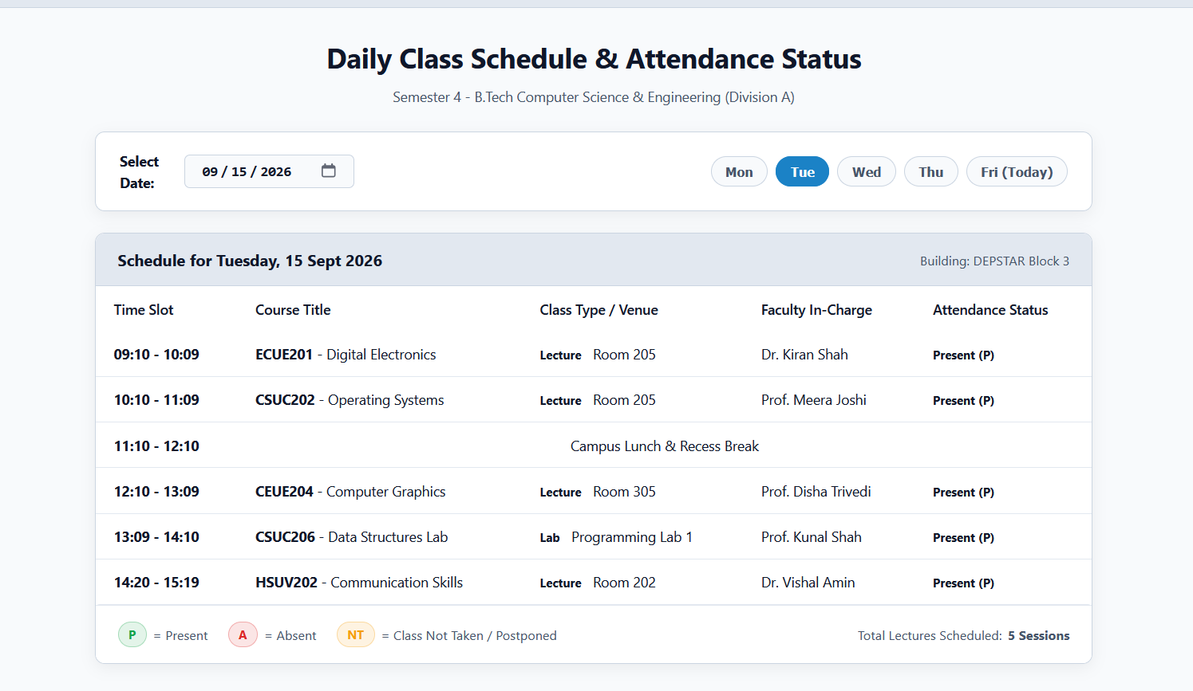

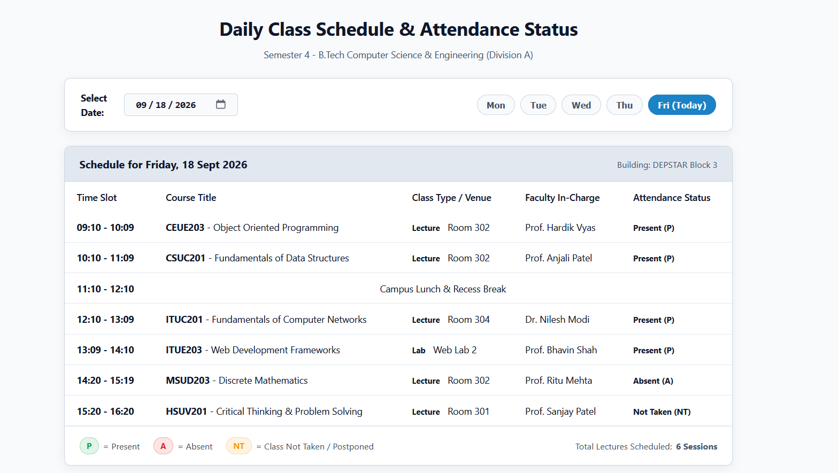

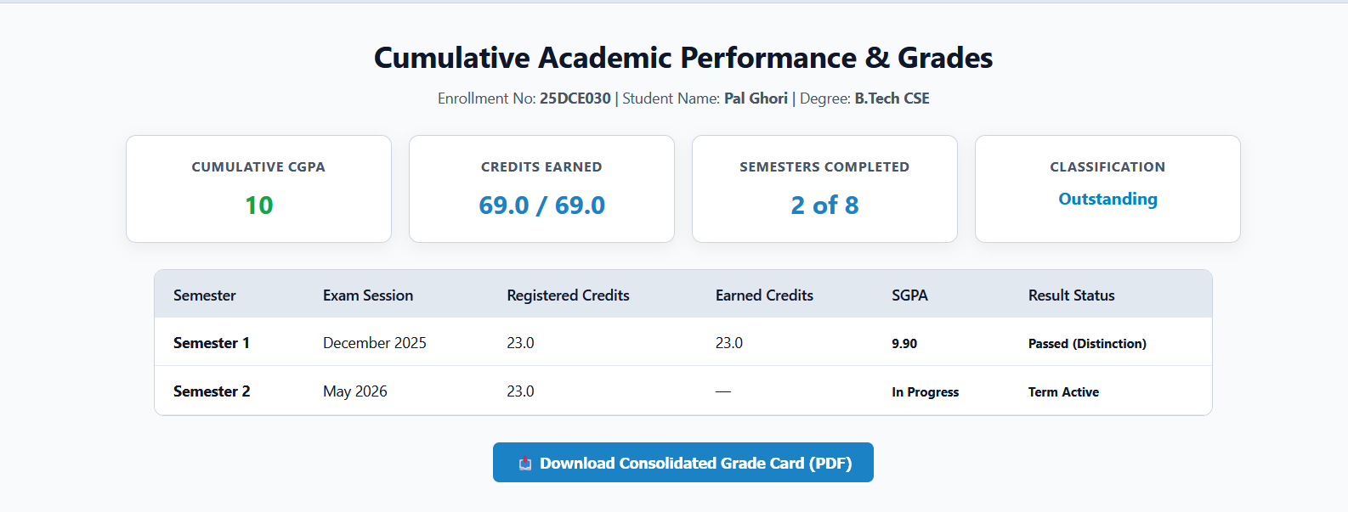

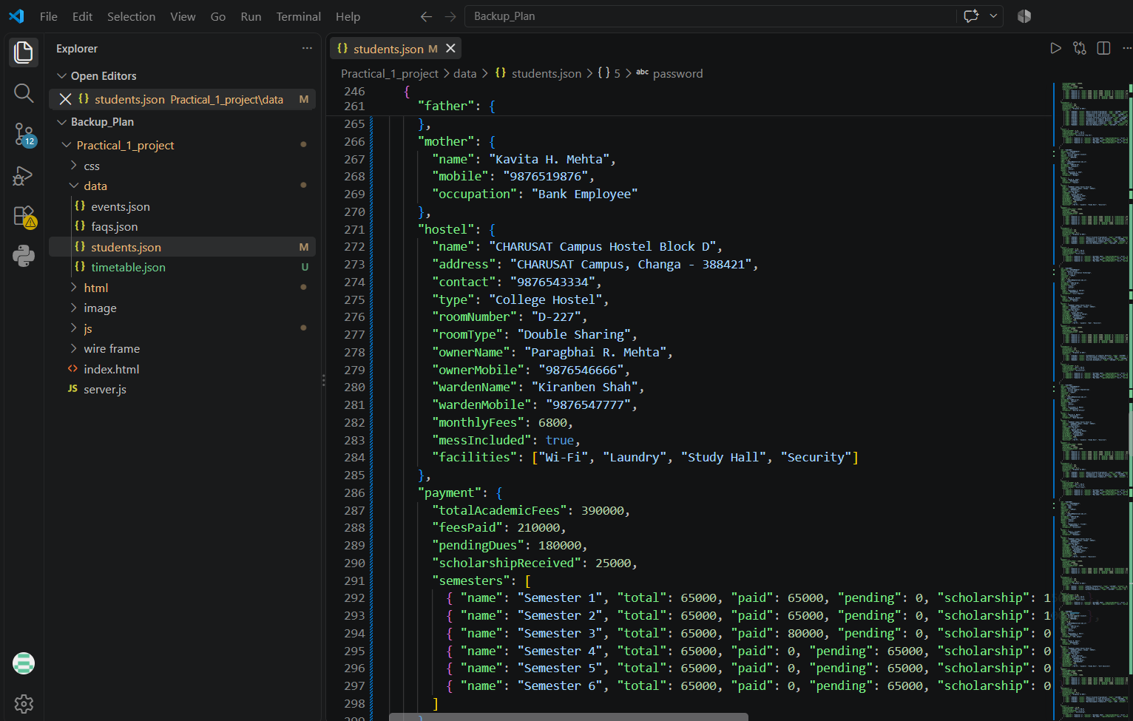

GitHub Repository Link :

htts://github.com/dakshpatel025/Practical_1-2_web

Challenges Faced:

• Fetching and parsing JSON data correctly using the Fetch API.
• Rendering JSON records dynamically on the webpage.
• Implementing search, filter, sorting, and pagination features.
• Handling loading and error states properly.
• Managing JavaScript code using separate modules.
• Debugging issues in JSON data and JavaScript functions.

Learning Outcomes:

- Learned how to fetch external JSON data using the Fetch API.
- Learned how to parse and display JSON data dynamically.
- Learned to use map(), filter(), sort(), and slice() methods.
- Learned to implement search, filtering, sorting, and pagination.
- Learned to handle loading and error conditions.
- Learned the importance of modular and reusable JavaScript code.

Faculty Remarks :

