Practical - 7
Practical Title: PHP Form Processing with Server-Side Validation and CSV/JSON File Storage

Process submitted registration/contact form data using PHP. Validate and
sanitize inputs on the server side and store records in CSV or JSON file
format. Display success/error messages.

Theory :

1. Is the form submitted using POST?

Answer :
Yes, if your form uses:
<form method="POST">
POST is better for sending form data because the data is not shown directly in the URL.

2. Which array methods are used for search, filter, sort, and pagination?

Answer :
Yes, PHP should check and clean the submitted values using functions such as:
trim($_POST["name"]);
htmlspecialchars($_POST["name"]);
Validation should happen on the server, not only with HTML/JavaScript.

3. How are loading and error states handled??

Answer :
Yes, if you check the data before writing and use a controlled filename/path. For example:
file_put_contents("data.txt", $data);
Avoid allowing users to directly control the file path.

4. How is modularity maintained in JavaScript files?

Answer:
Yes, the application should show messages such as:
- Success: Data saved successfully!
- Error: Please fill all required fields.

Implementation :

The form was implemented using HTML and PHP to collect user registration/contact details. The form uses the POST method to send data securely to the PHP server. On submission, PHP checks whether all required fields are filled and validates the email format. User input is sanitized using functions such as trim() and htmlspecialchars() to prevent unsafe data.

After successful validation, the data is stored safely in a CSV file using PHP's fputcsv() function. The file is opened in append mode so that new records can be added without deleting existing records. The application displays a clear success message when the data is stored successfully and an error message when validation fails.

Main implementation steps:

- Create an HTML form for user input.
- Submit the form using the POST method.
- Receive form data using $_POST.
- Validate required fields and email format.
- Sanitize the user input.
- Store the validated data in a CSV file using fputcsv().
- Display success or error messages clearly.

Evidence of Work (Screenshots)

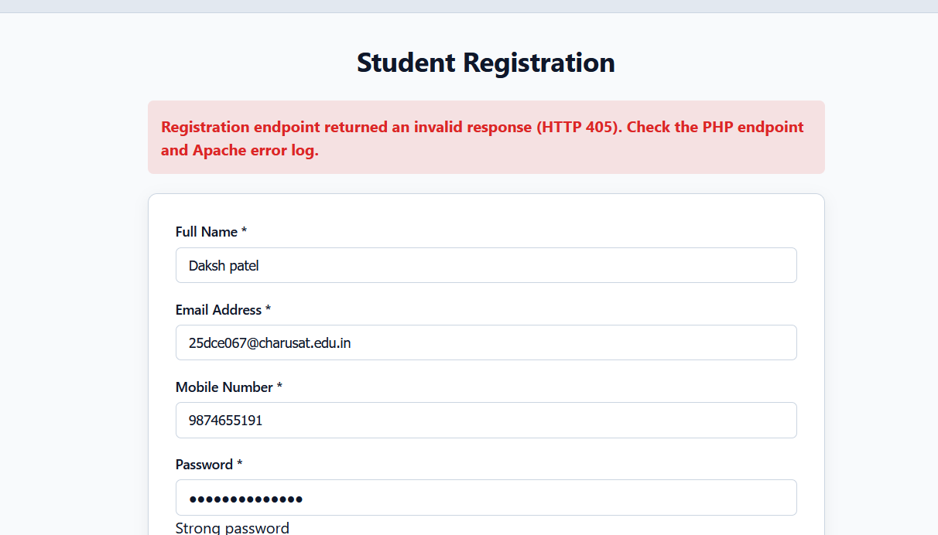

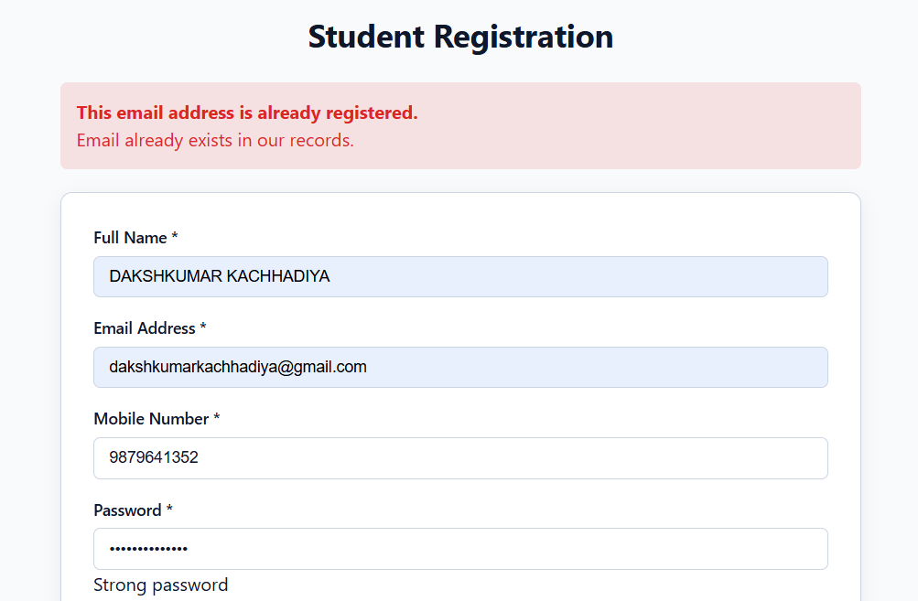



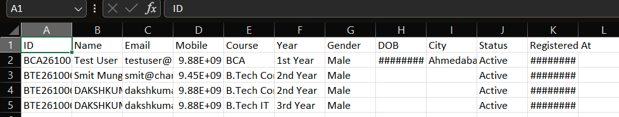

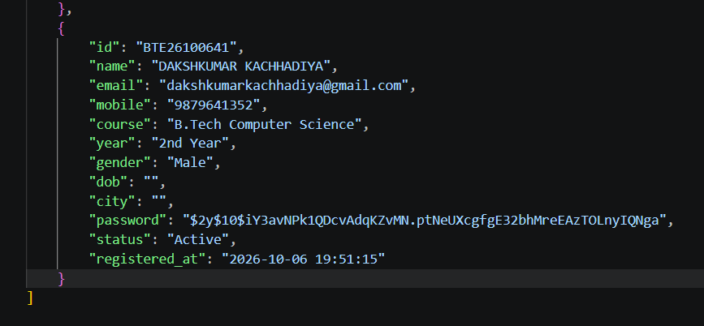

GitHub Repository Link :

htts://github.com/dakshpatel025/Practical_1-2_web

Challenges Faced:

• Handling form data correctly using the POST method.
• Performing proper server-side validation for required fields and email format.
• Sanitizing user input to prevent invalid or unsafe data.
• Writing data correctly into the CSV file without losing previous records.
• Handling file opening and writing errors safely.
• Displaying clear success and error messages to the user.

Learning Outcomes:

- Learned how to create and process PHP forms using the POST method.
- Learned how to perform server-side validation of user inputs.
- Learned how to sanitize form data for safer processing.
- Learned how to store submitted data in a CSV file using PHP.
- Learned how to handle file writing and errors safely.
- Learned how to display success and error messages based on form processing.
- Understood the basic process of creating a server-side form processing system.

Faculty Remarks :

