Practical - 8
Practical Title: MySQL Schema Design, ER Model, PDO Connectivity, and Prepared Statements

Design the database for StudentHub with students, events and registrations. Create PHP database connection using MYSQL statements.

Theory :

1. Is the schema normalized properly?

Answer :
The database tables are organized to reduce data duplication and maintain data consistency. Normalization helps avoid redundant data and makes database management easier.

2. Are primary keys and foreign keys correctly defined?

Answer :
Primary keys uniquely identify each record in a table, while foreign keys establish relationships between tables. These keys help maintain data integrity and prevent invalid relationships between records..

3. Is the database connection handled securely?

Answer :
The database connection should use secure configuration practices. Database credentials should not be hardcoded or uploaded to GitHub. Prepared statements should be used to prevent SQL injection, and database access should be restricted to authorized users.

Implementation :

The database was designed by creating tables with appropriate data types and relationships. Primary keys and foreign keys were defined to maintain data integrity. Normalization techniques were applied to reduce data duplication and improve consistency. The database connection was configured securely using proper credentials. Prepared statements were used to prevent SQL injection, and queries were executed to insert, update, delete, and retrieve records. The database was tested to verify that the tables, relationships, and operations worked correctly.

Evidence of Work (Screenshots)

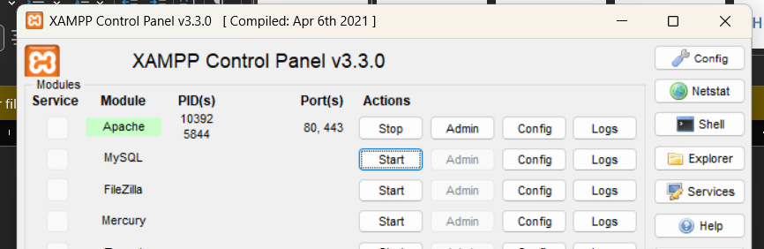



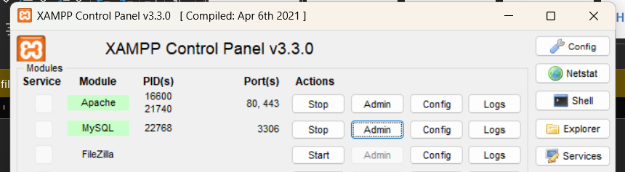
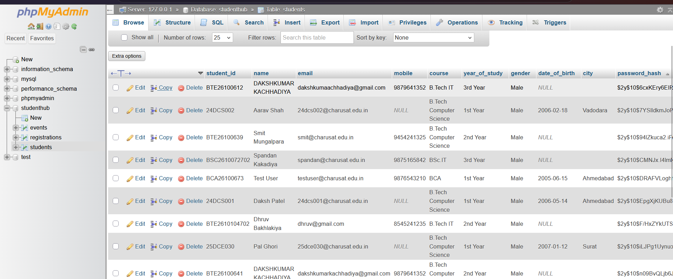



GitHub Repository Link :

htts://github.com/dakshpatel025/Practical_1-2_web

Challenges Faced:

• Database Normalization: Avoiding duplicate data and organizing tables properly was challenging.
• Primary and Foreign Keys: Establishing correct relationships between tables while maintaining data integrity required careful planning.
• SQL Queries: Writing and executing CREATE, INSERT, SELECT, UPDATE, DELETE, and JOIN queries required practice.
• Database Connection: Configuring the database connection and resolving connection errors was challenging.
• Data Integrity: Ensuring that valid data was inserted and that foreign key constraints were maintained required testing.
• Database Security: Protecting database credentials and using prepared statements to prevent SQL injection required attention.
• Testing and Debugging: Identifying and correcting SQL errors helped ensure that all database operations worked correctly.

Learning Outcomes:
- Database Design: Learned how to create and organize database tables using appropriate data types and relationships.
- Database Normalization: Understood how normalization reduces data duplication and improves data consistency.
- Primary and Foreign Keys: Learned how to define primary keys and foreign keys to establish relationships between tables and maintain data integrity.
- SQL Operations: Gained practical knowledge of CREATE, INSERT, SELECT, UPDATE, DELETE, and JOIN operations to manage and retrieve database records.
- Data Integrity: Understood the importance of constraints such as PRIMARY KEY, FOREIGN KEY, NOT NULL, and UNIQUE for maintaining accurate data.
- Database Connectivity: Learned how to configure a database connection and troubleshoot common connection errors.
- Database Security: Understood the importance of protecting database credentials and using prepared statements to prevent SQL injection.
- Testing and Debugging: Developed skills in testing SQL queries, identifying errors, and verifying database operations.
- Data Management: Learned how to insert, retrieve, update, and delete records while maintaining consistency across related tables.
- Practical Application: Gained hands-on experience in designing, implementing, securing, and testing a relational database.

Faculty Remarks :

