Practical - 9
Practical Title: Secure User Registration with Database Insert, Duplicate Email Check, and Password Hashing

Implement secure user registration by inserting user details into MySQL using MYSQLi. Validate input on frontend and backend, check duplicate email/username, hash passwords using password_hash(), and display appropriate messages.

Theory :

1. Is password_hash() used before storing passwords?

Answer :
Passwords should be hashed using password_hash() before storing them in the database.

2. Is duplicate email/username checked?

Answer :
Duplicate email addresses and usernames should be checked before registering a new user.

3. Are frontend and backend validations consistent? only give answe and copy form?

Answer :
Frontend and backend validations should be consistent, with backend validation ensuring security.

Implementation :

- Created a registration form with fields for username, email, and password.
- Used frontend validation to check required fields and input formats.
- Used PHP for server-side validation and sanitization of user inputs.
- Used password_hash() to securely store passwords.
- Checked for duplicate email addresses and usernames before registration.
- Displayed appropriate success and error messages based on validation results.

Evidence of Work (Screenshots)

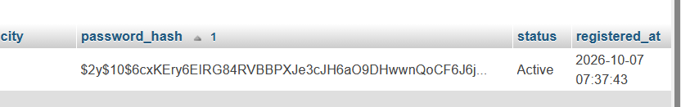

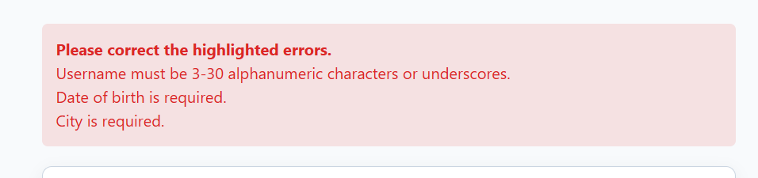

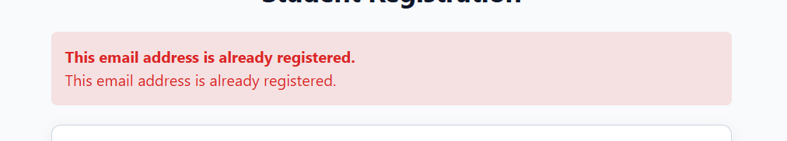





GitHub Repository Link :

htts://github.com/dakshpatel025/Practical_1-2_web

Challenges Faced:

• Implementing proper frontend and backend validation.
• Preventing duplicate email addresses and usernames.
• Securely storing passwords using password_hash().
• Displaying appropriate error messages for invalid inputs..

Learning Outcomes:
- Learned how to validate user inputs on the frontend and backend.
- Understood how to securely store passwords using password_hash().
- Learned how to check for duplicate email addresses and usernames.
- Understood the importance of data security and error handling in PHP applications.

Faculty Remarks :

