MongoDB CRUD Operations
On this page
- Create Operations
- Read Operations
- Update Operations
- Delete Operations
- Bulk Write
CRUD operations create, read, update, and delete documents.

Create Operations
Create or insert operations add new documents to a collection. If the collection does not currently exist, insert operations will create the collection.
MongoDB provides the following methods to insert documents into a collection:
- db.collection.insertOne() New in version 3.2
- db.collection.insertMany() New in version 3.2
In MongoDB, insert operations target a single collection. All write operations in MongoDB are atomic on the level of a single document.

For examples, see Insert Documents.

Read Operations
Read operations retrieves documents from a collection; i.e. queries a collection for documents. MongoDB provides the following methods to read documents from a collection:
- db.collection.find()
You can specify query filters or criteria that identify the documents to return.

click to enlarge
For examples, see:
- Query Documents
- Query on Embedded/Nested Documents
- Query an Array
- Query an Array of Embedded Documents

Update Operations
Update operations modify existing documents in a collection. MongoDB provides the following methods to update documents of a collection:
- db.collection.updateOne() New in version 3.2
- db.collection.updateMany() New in version 3.2
- db.collection.replaceOne() New in version 3.2
In MongoDB, update operations target a single collection. All write operations in MongoDB are atomic on the level of a single document.
You can specify criteria, or filters, that identify the documents to update. These filters use the same syntax as read operations.
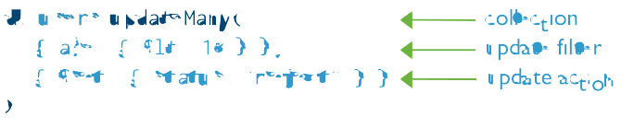
For examples, see Update Documents.

Delete Operations
Delete operations remove documents from a collection. MongoDB provides the following methods to delete documents of a collection:
- db.collection.deleteOne() New in version 3.2
- db.collection.deleteMany() New in version 3.2
In MongoDB, delete operations target a single collection. All write operations in MongoDB are atomic on the level of a single document.
You can specify criteria, or filters, that identify the documents to remove. These filters use the same syntax as read operations.
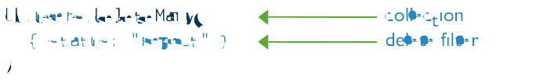
For examples, see Delete Documents.

