CEREBRUNO: BRAIN TUMOR DETECTION

A PROJECT REPORT

BY

TEAM NO. 03

CHANDNI GUPTA (E22CSEU0955)

JASWANTHI VEMURI (E22CSEU0958)

DAKSHPREET SINGH (E22CSEU0953)

SUBMITTED TO

SCHOOL OF COMPUTER SCIENCE ENGINEERING AND TECHNOLOGY, BENNETT UNIVERSITY

GREATER NOIDA, 201310, UTTAR PRADESH, INDIA

April 2024

# DECLARATION

We hereby declare that the work which is being presented in the report entitled “CEREBRUNO: Brain Tumor Detection”, is an authentic record of our own work carried out during the period from JAN, 2023 to April, 2023 at School of Computer Science and Engineering and Technology, Bennett University Greater Noida.

The matters and the results presented in this report have not been submitted by us for the award of any other degree elsewhere.

Signature



Chandni Gupta

(E22CSEU0955)



Jaswanthi Vemuri

(E22CSEU0958)



Dakshpreet Singh

(E22CSEU0953)

# ACKNOWLEDGEMENT

We would like to take this opportunity to express our deepest gratitude to our mentor, **Dr. Pratyush Pranay** for guiding, supporting, and helping us in every possible way. We were extremely fortunate to have him as our mentor as he provided insightful solutions to problems faced by us thus contributing immensely towards the completion of this capstone project. We would also like to express our deepest gratitude to Mr. Vineet Jain , Chancellor, Prof. (Dr.) Ajith Abraham, Vice Chancellor, Prof.(Dr.) Abhay Bansal, Dean of School of Computer Science Engineering and Technology, faculty members and friends who helped us in successful completion of this capstone project. We would also like to thank Dr.Parul, the Radiologist who helped us give insight throughout the project.

Signature



Chandni Gupta

(E22CSEU0955)



Jaswanthi Vemuri

(E22CSEU0958)



Dakshpreet Singh

(E22CSEU0953)

**TABLE OF CONTENTS**

<<Right click on the heading and click update flied. Your heading will be pulled here. Same goes with all the table of content in the subsequent pages>>

ABSTRACT vi

1. INTRODUCTION 1

1.1. Problem Statement 2

2. Background Research 3

3. RISK ANALYSIS 4

4. Project Planning 4

4.1. Stakeholders 5

4.2. Diagrams 6

4.2.1. Architecture Diagram 6

7

4.2.2. Class Diagram 7

4.2.3. Activity Diagrams 8

4.2.4. Sequence Diagram 9

5. PROPOSED solution 10

6. RESULTS 12

7. LEARNING OUTCOMES 12

8. Conclusion 13

REFERENCES 14

ABSTRACT

Brain tumors are a great challenge in the medical field due to their various characteristics and side effects. Early and accurate detection is important for timely intervention and better patient outcomes. Traditional methods of brain tumor detection rely heavily on radiologists to manually interpret medical image scans, which is time-consuming and prone to human error. However, with the advent of deep learning technology, the model has changed to an effective automated driver monitoring system.

Deep learning, a subset of machine learning, has shown remarkable capabilities in many areas, including image analysis. doctors In particular, convolutional neural networks (CNNs) have gained popularity for their ability to automatically learn hierarchical features from image data. In the context of brain tumor detection, CNNs have been extensively utilized to analyze magnetic resonance imaging (MRI), computed tomography (CT), and positron emission tomography (PET) scans.

One of the primary advantages of deep learning-based tumor detection systems is their ability to handle multi-modal data fusion. By integrating information from different imaging modalities, such as structural MRI and functional PET, these systems can provide a more comprehensive assessment of tumor characteristics, including size, location, and aggressiveness. This multi-modal approach enhances diagnostic accuracy and aids in treatment planning.

Several deep learning architectures have been proposed for brain tumor detection, ranging from traditional CNNs to more advanced models like recurrent neural networks (RNNs) and their variants. These architectures are often trained on large datasets comprising annotated medical images to learn discriminative features indicative of tumor presence. Transfer learning, a technique where pre-trained models are fine-tuned on medical imaging data, has also shown promise in overcoming data scarcity issues and accelerating model convergence.

Despite the remarkable progress in deep learning-based brain tumor detection, several challenges persist. Lack of data remains a major bottleneck, especially for rare tumor subtypes and specialized imaging techniques. Furthermore, ensuring the robustness and generalizability of deep learning models across diverse patient populations and imaging modalities is critical for international deployment. Furthermore, the interpretation of predictive models is important for clinicians to trust and guide clinical decision-making.

Ethical considerations in the development and deployment of tumor-based detection systems studied should also be addressed. Patient concerns, data security practices, and mitigation strategies for algorithmic change are important to protect patients' rights and ensure equitable access to health care. In addition, a legal framework should be established to regulate the ethical use of AI in medical imaging and promote transparency and accountability in algorithmic decision-making. Deep learning models use an advanced neural network architecture and multiple data fusion techniques to empower radiologists and improve patient outcomes. Addressing issues related to data uncertainty, interpretation, and ethical considerations are important for the widespread adoption and accountability of deep learning-based computer detection systems in practice..

1. INTRODUCTION

As of now, the field of profound learning-based brain tumor location is seeing fast headways driven by the merging of AI innovation and therapeutic imaging. Analysts and healthcare professionals are progressively leveraging profound learning strategies, especially convolutional neural systems (CNNs), to create computerized frameworks for recognizing and analyzing brain tumors from imaging information such as MRI, CT, and PET scans. One unmistakable drift is the investigation of multi-modal information combination strategies, which coordinated data from diverse imaging modalities to progress symptomatic exactness and give a more comprehensive appraisal of tumor characteristics. Another slant includes the improvement of progressed neural arrange structures and exchange learning methodologies to address challenges related to information shortage and demonstrate generalization. Furthermore, endeavors are being made to upgrade the interpretability of profound learning models to encourage their integration into clinical workflows and back clinical decision-making. Moral contemplations, counting quiet security, information security, and algorithmic inclination, are moreover accepting expanded consideration to guarantee the dependable arrangement of AI-based tumor location systems. Overall, there's a developing energy in leveraging profound learning for brain tumor location, with the potential to altogether affect understanding care and results. Be that as it may, tending to challenges such as information shortage, show interpretability and moral concerns remain basic for the proceeded headway and selection of these advances in clinical hone.

* 1. Problem Statement

CEREBRUNO points to address a few key challenges in brain tumor location and conclusion. Firstly, it looks for to identify tumors at an early organize with accuracy and viability, making strides quiet results by empowering convenient intercession. Furthermore, it points to decrease the time required for conclusion, advertising a speedier and more user-friendly approach compared to conventional strategies. This is often especially important in farther zones where get to to prepared experts like radiologists may be constrained. Thirdly, CEREBRUNO points to lighten healthcare costs by streamlining the demonstrative prepare, making it more available to underserved populaces. By leveraging progressed picture preparing methods on MRI filters, it can give precise tumor classification, making a difference to anticipate treatment delays related with late-stage analyze. Moreover, its operation in inaccessible ranges with restricted get to to radiologists guarantees far reaching accessibility of symptomatic administrations. Generally, CEREBRUNO not as it were spares time and exertion for healthcare suppliers but moreover improves symptomatic exactness and openness, eventually making strides persistent care and results.

1. Background Research

The main reason we chose this project was because brain tumros are life threatening and early detection can be crucial for effective treatment and improvement in patient’s life. By developing this we will contribute in saving lives and improve the quality of healthcare system in our country. This will help in a better detection method and will save time for the doctors which in return will save billions of lives. The other reason is an emotional one as one of the team members known ones were diagnosed with brain tumor and unfortunately passed away a few years ago. That is one of the reasons why we chose this field in medical technology as it is related to their experience and personal interest.

The innovation in this detection of brain tumor will be the merging of various imaging techniques with artificial intelligence (AI) programs. These multimodal imaging will fuse different types of imaging methods like MRI, CT, PET and others. This combination will offer additional details on brain structure, function, and metabolism. This will help and assist the radiologists and oncologists in real time by helping them analyze complicated imaging data more effectively leading to more precise diagnosis and treatement strategies. This system will not require the patient to wait for hours for the diagnosis to complete as it will be much faster because it will analyze from the knowledge it will gain from learning with the help of machine learning. Medical imaging also requires expensive and non-portable equipment but our solution will only require a simple computer with our software provided the required medical data which could also be used in remote areas. The second one will be that it can be integrated in any system that has camera and internet as it will need the camera to take the photo of the scan and then it will be able to detect the type of tumor if the patients want to know from their homes. The third and the final will be that it will keep on updating itself through previous tumor scans on its own with the help of machine learning and reports and researches done by doctors on monthly basis.

1. RISK ANALYSIS

The variations in tumor location, shape, and size make accurate segmentation and classification difficult. Additionally, the complexity of the brain as an organ contribute to the challenge of early detection and diagnosis. Unforeseen technical issues, such as software bugs, hardware failures, or compatibility issues between different components of the system, could disrupt the development and testing process. Limited access to high-quality annotated MRI datasets or unexpected delays in data collection could hinder algorithm development and validation. This can be solved by establishing collaborations with multiple medical institutions to access a diverse range of MRI datasets. Challenges in optimizing algorithm performance or difficulty in generalizing to diverse patient populations, may lead to inaccurate or unreliable tumor detection results but a thorough validation can be conducted using independent datasets to assess algorithm performance robustness.

1. Project Planning

Step1- Conduct initial research on brain tumor detection methods and available datasets.

Step2- Data Collection and Preprocessing: Identify and obtain MRI datasets with annotated tumor regions. Preprocess the datasets by standardizing imaging protocols, resizing images, and augmenting data to increase diversity.

Step3- Algorithm Development: Design and implement machine learning algorithms for brain tumor detection.

Step4- Software Development: Develop the software framework for data management, algorithm integration, and user interface design. Implement necessary APIs and database schemas for seamless integration of components.

Step5- Algorithm Optimization: Fine-tune machine learning models using advanced techniques such as hyperparameter tuning and transfer learning. Validate model performance on additional datasets and optimize for accuracy and efficiency.

Step6- System Integration and Testing: Integrate algorithms into the software framework and conduct end-to-end testing of the system. Identify and resolve any issues or bugs in the system functionality and user interface.

Step7- Clinical Validation: Collaborate with medical professionals to validate the system's performance on clinical data. Evaluate the system's accuracy, sensitivity, and specificity against ground truth annotations provided by experts.

Step8- User Feedback and Iteration: Gather feedback from radiologists, neurosurgeons, and other end-users on the system's usability and effectiveness. Incorporate user feedback to refine the system's features, improve user experience, and address any remaining issues.

Final Step- Documentation and Finalization

* 1. Stakeholders

Table 1:

|  |  |
| --- | --- |
| **Stakeholder** | **Role** |
| Pratyush Pranav | Mentor |
| Chandni Gupta | Team member |
| Jaswanthi Vemuri | Team member |
| Dakshpreet Singh | Team member |

* 1. Diagrams
     1. Architecture Diagram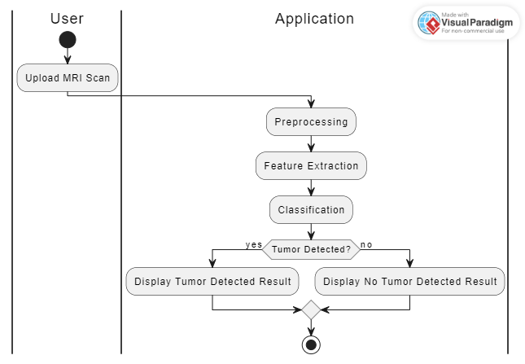

Figure 1

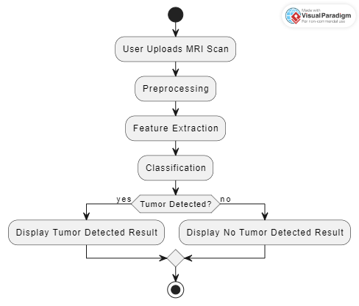

Figure 2

* + 1. Class Diagram

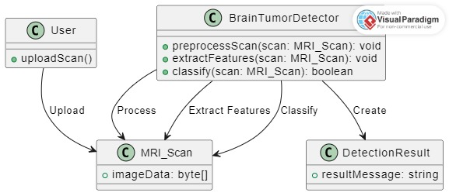

Figure 3

* + 1. Activity Diagrams

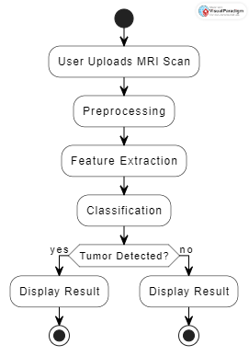

Figure 4

* + 1. Sequence Diagram

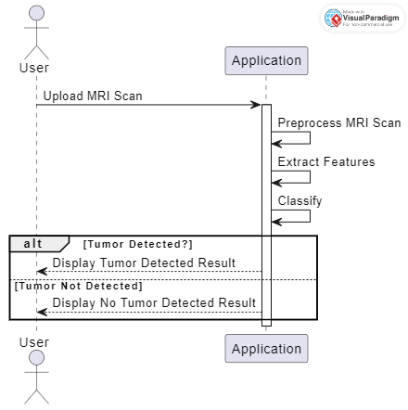

Figure 5

1. PROPOSED solution

To combine the force of technology, with medical imaging, a brain tumor detection app is developed.

Data Collection: Pick up different imaging modalities like MRI, CT Scans and label it with tumor status i.e. either presence or absence.

Preprocessing: Clean and process the images with features’ magnification and noise somehow be reduced. Techniques like normalization, filtering and resizing are some of the approaches that may be used.

Feature Extraction: Take advantage of CNN technology where the network should automatically find a way to determine the features from pre-processed images. The CNNs are perfect for solving task images because they can spy the spatial structures.

Model Training: Teach a machine learning model on two data sets: the extracted features and the responses provided by the experts. This task can be completed using many different deep learning techniques such as CNNs or even more advanced models like 3D CNNs. Also, transfer learning can be used here, thanks to the pre-trained models having prior experience on a large image dataset.

Validation and Optimization: Confirm the model using cross-validation techinques and optimize hyperparameters to guarantee reliable functioning, including using automatic learning, data preprocessing, feature engineering, e.g., use of deep learning.

Development of the App:

Backend: Settle on the system for the back end that will work well with the model that was trained. These could be APIs for inference, or any other custom process required.

Frontend: Implement a user-oriented interface to upload brain scans for users and get their reports instantaneously. The app interface should be user-friendly with clear visual instructions and reliable navigation.

Integration: Bear in mind a smooth combination of the crew and user part.

Deployment: Develop the app on a corresponding platform ensuring characteristics such as scalability, security, accessibility, etc are considered and implemented. Hosting on AWS or Google Cloud platform classes can be made possible by using cloud platforms such as these.

Testing and Evaluation: Perform thorough testing that shows the app reacts accurately on each device and situation. Apply your judgment concerning the characteristics to measure them by accuracy, fast-working, and user satisfaction.

Regulatory Compliance: Making the service rules consistent with applicable regulations and standards is very essential. However, they should be particular in the healthcare sector (e.g., U.S. HIPAA compliance).

Continual Improvement: Receive feedback from users and upgrade the application progressively; to ensure it runs smoothly, is easy to use and provide reliability.

1. RESULTS

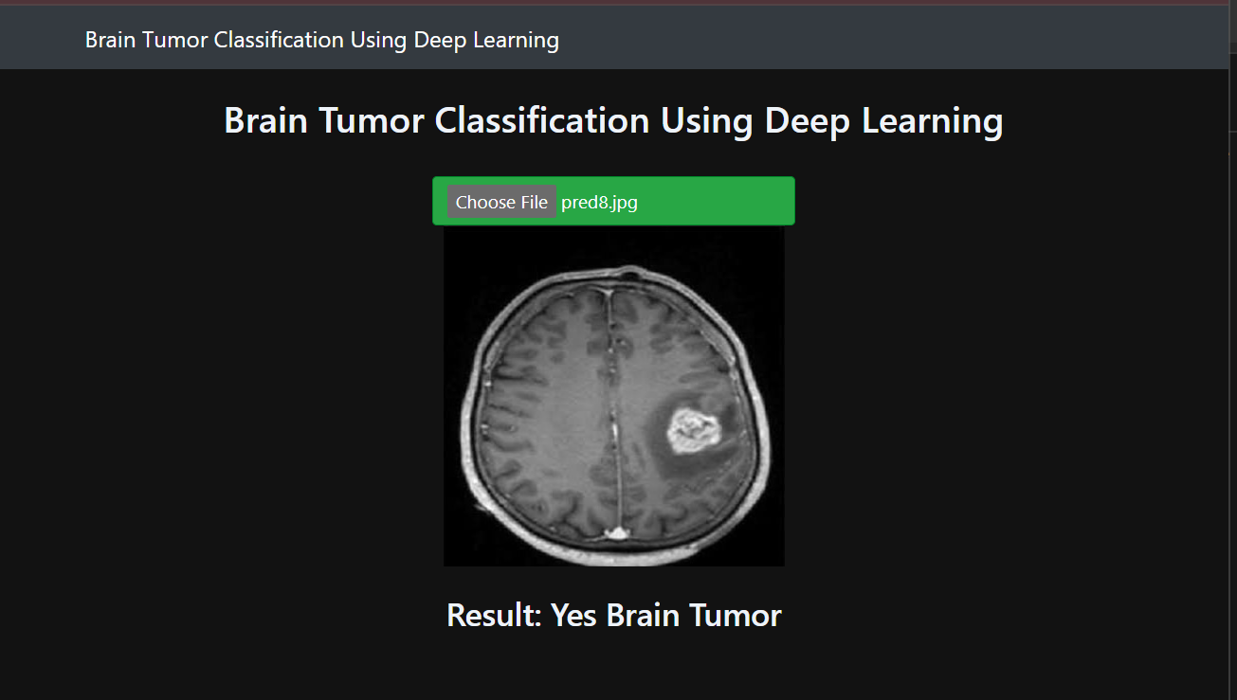

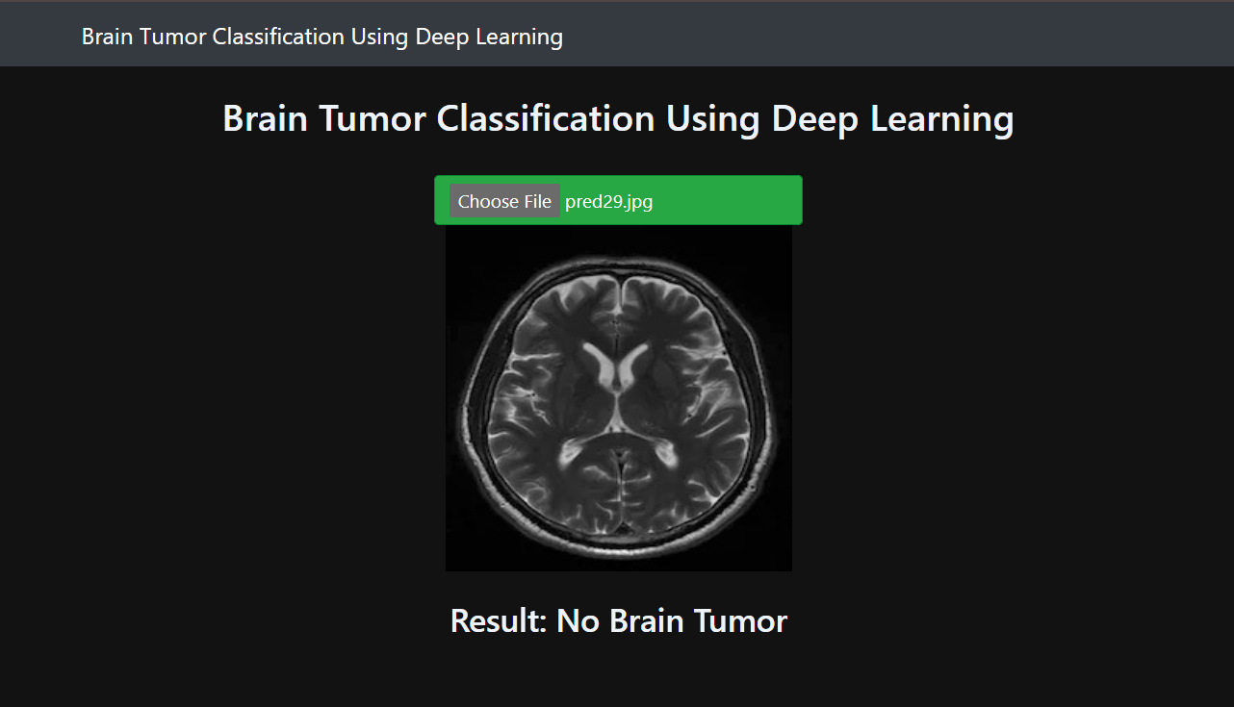

1. LEARNING OUTCOMES

In a brain tumor detection course, learners will develop a comprehensive understanding of the complexities involved in identifying and diagnosing brain tumors. Through this course, students will gain proficiency in recognizing different types of brain tumors, interpreting a variety of imaging techniques including MRI, CT scans, and PET scans, and analyzing radiological findings to pinpoint potential tumors. They will learn to integrate clinical data with imaging results to enhance diagnostic accuracy and generate differential diagnoses. Additionally, students will delve into the various treatment modalities available for brain tumors, understand prognostic factors influencing outcomes, and develop effective communication skills to convey findings to colleagues and patients. By staying updated with the latest advancements in brain tumor detection and management, learners will be equipped with the knowledge and skills necessary to contribute effectively to the field of neuro-oncology

1. Conclusion

In conclusion, brain tumor detection is a critical aspect of neuro-oncology, with advancements in imaging techniques and treatment modalities continually shaping the field. However, significant challenges persist. One notable challenge is the need for improved sensitivity and specificity in imaging modalities to accurately detect smaller or less conspicuous tumors. Additionally, the interpretation of imaging findings remains complex and subjective, requiring ongoing education and training for healthcare professionals. Another hurdle is the integration of multimodal data, including clinical information, genetic profiles, and imaging results, into a cohesive diagnostic and treatment plan. Furthermore, disparities in access to advanced imaging technologies and specialized expertise pose significant barriers, particularly in resource-limited settings. Overcoming these challenges will require collaborative efforts among researchers, clinicians, and policymakers to develop innovative solutions, improve accessibility, and enhance the overall efficacy of brain tumor detection strategies. Despite these obstacles, continued dedication to research, education, and technological innovation holds promise for advancing the field and improving outcomes for patients with brain tumors.

REFERENCES

[1] A. Sravanthi Peddinti, S. Maloji, and K. Manepalli, “Evolution in diagnosis and detection of brain tumor – review,” in *Journal of Physics: Conference Series*, IOP Publishing Ltd, Nov. 2021. doi: 10.1088/1742-6596/2115/1/012039.

[2] K. Tenghongsakul, I. Kanjanasurat, T. Archevapanich, B. Purahong, and A. Lasakul, “Deep transfer learning for brain tumor detection based on MRI images,” in *Journal of Physics: Conference Series*, Institute of Physics, 2023. doi: 10.1088/1742-6596/2497/1/012015.

[3] A. P. Reddy, G. Komala, G. Anitha, P. Rama krishna, and A. Professor, “BRAIN TUMOUR DETECTION USING DEEP LEARNING,” 2018.