System Architecture Document
D09 | Version 0.1 | 12 October 2026
Define component responsibilities and trust boundaries.

Architecture
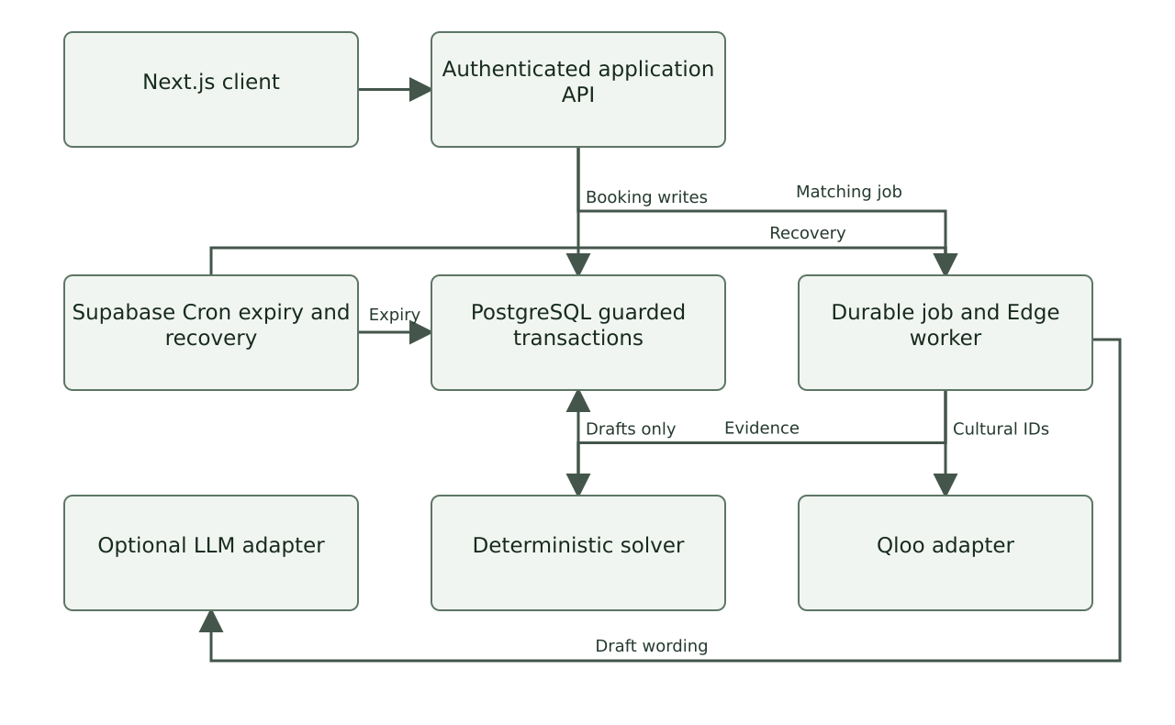
Provider calls and privileged operations remain behind authenticated server boundaries.
Component | Responsibility | Boundary
Next.js client | Forms, catalogue views, proposal comparison, status and role-scoped actions. | Untrusted inputs; no Qloo or service-role key.
Next.js API | Authenticate, authorise, validate DTOs, apply rate limits and request transactions. | Never trust IDs or roles supplied by the browser.
Domain services | Quote arithmetic, hard constraints, coalition scoring and lifecycle guards. | Deterministic code; independent of LLM output.
PostgreSQL | Immutable revisions, active reservations, membership checks, locks and audit records. | Fail-closed grants and RLS; critical writes through guarded functions.
Supabase Edge worker | Lease agent jobs, call Qloo and LLM, checkpoint bounded steps. | Server credentials; role-limited tool allowlist.
Supabase Cron | Expire proposals and recover abandoned leases. | Scheduled database maintenance; no browser dependency.
Qloo adapter | Entity lookup and rank evidence. | External service; no identity or access notes.
LLM adapter | Structured brief extraction and evidence-grounded draft wording. | Optional; cannot price, confirm or change permissions.

Chosen architecture and tradeoffs
Use one modular application and database. Durable asynchronous jobs isolate provider latency from booking transactions. A bounded worker handles initial execution; the database scheduler handles recovery and expiry. Vercel is not the durable queue.

Data flow
The worker sends consented cultural IDs to Qloo. Approved mappings connect returned entities to experiences. The solver writes sanitised DRAFT proposals; human publication and reservations use guarded database transactions.

Isolation
Each workspace contains one pilot exchange. Organisers and authorised operators can read private briefs; participants receive approved group summaries. Signed judge capabilities address isolated synthetic workspaces only.

Availability and failure
Qloo outages stop new cultural matching, while published terms remain usable. LLM failure permits deterministic explanations. Database outages block mutations and report retryable failure; never report a false success.
References
Related documents D10, D15, D19, D23
SRC10 Supabase Row Level Security
SRC11 Supabase Cron
SRC12 Vercel Cron usage and pricing

