LAB REPORT 1
C Programming Basics and Process Concepts
ST5039CMD Programming and Operating System
Name | Dakshya Aryal
Roll No. / ID | 250379
Section / Group | B
Instructor | Rupak sir
Date of Submission
GitHub Repository

Table of Contents

Introduction
This lab accompanies Lecture 2 and introduces the basics of C programming together with the idea of a process. A C program starts as human-readable source code, is translated by a compiler into an executable file, and only becomes a process when the operating system loads it into memory and starts running it. The lab walks through each of these steps and records the results with terminal screenshots.

Objectives
- Understand the basic structure of a C program.
- Understand the main() function and its return type.
- Understand the stages of compilation.
- Use GCC and its flags (-E, -S, -c, -o).
- Understand the distinction between a program and a process.
- Understand how the OS loads and executes a program.

Tools and Environment
Item | Details
Operating System | Linux (e.g. Ubuntu) — fill in your version
Compiler | gcc — fill in your version (gcc --version)
Language | C
Editor / Shell | Fill in (e.g. VS Code, bash)
Version Control | Git / GitHub

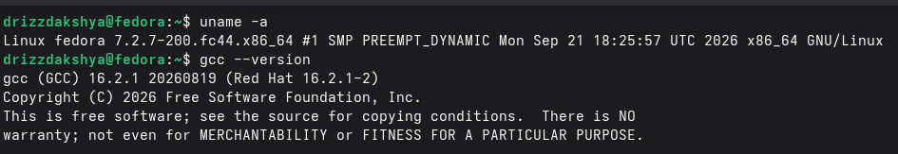
Figure 23: Environment: output of uname -a and gcc --version

Summary of Tasks
Task | Topic | Files
1 | GCC installation and Hello World | hello.c
2 | main() and return value | hello.c, fail.c
3 | Formatted output with printf() | format.c
4 | Stages of compilation | hello.i, hello.s, hello.o, hello
5 | Reading input with scanf() | number.c
6 | Program vs process | sleeper.c
7 | Knowledge test | —

Task 1: GCC Installation and Hello World

1.1 Objective
Set up the GCC compiler on a Linux system, verify the installation, and write, compile and run the first C program.

1.2 Theoretical Concept
Key idea: C is a compiled language: source code must be converted into machine-readable code by a compiler before it can run.
- Source code: a human-readable text file (.c) containing C instructions.
- Compiler: GCC (GNU Compiler Collection) translates source code into an executable file of machine instructions (0s and 1s).
- build-essential: the Debian/Ubuntu package that installs gcc, g++, make and the standard libraries.
- ./ prefix: tells the shell the executable is in the current directory (it is not in the system PATH).

1.3 Structure of a C Program
A C program begins with preprocessor directives (which include libraries), followed by the main() function containing statements and control flow, and ends with a return statement that reports the exit status to the OS. Comments may be used throughout.
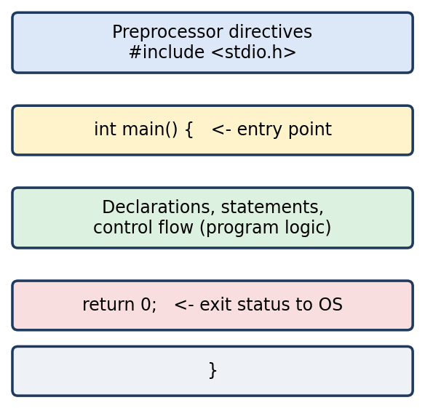
Basic structure of a C source file

1.4 Working Mechanism of C
The workflow has four steps: (1) create the source file, (2) compile it so the compiler checks for errors, (3) the compiler produces an executable file, and (4) run the executable to see the output.

1.5 Source Code (hello.c)
#include <stdio.h>

int main() {
printf("Hello, World!\n");
return 0;
}

1.6 Terminal Commands
# Install the compiler (Ubuntu/Debian)
sudo apt install build-essential

# Check the installed version
gcc --version

# Create, compile and run
gcc hello.c -o hello
./hello

1.7 Expected Output
gcc (Ubuntu x.x.x) x.x.x

Hello, World!

1.8 Terminal Output Screenshots
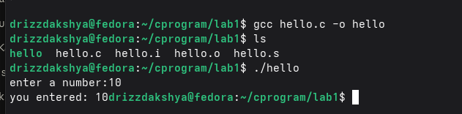
Figure 1: Installation of build-essential (or the message that it is already installed)
Figure 2: Output of gcc --version
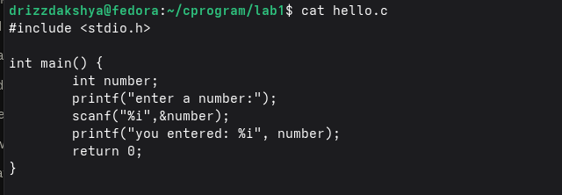
Figure 3: The hello.c source file shown in your editor or with cat hello.c

1.9 Observation
- gcc --version confirmed that the compiler is installed and ready to use.
- Compilation created the executable hello; running it printed the message.
- The program began executing at main(), as expected.

Task 2: The main() Function and Return Value

2.1 Objective
Understand that main() has return type int and that its return value tells the OS whether the program succeeded.

2.2 Theoretical Concept
Key idea: Execution starts at main(). A return value of 0 means success; any other value means an error.
- main(): the entry point of the programmer's code; its body is enclosed in { }.
- Return type int: the value returned is passed to the OS (parent shell) as the exit status.
- return 0: successful execution. return 1 (or any non-zero value): error.
- $?: shell variable that holds the exit status of the last command.

2.3 Source Code (hello.c (return 0, from Task 1))
#include <stdio.h>

int main() {
printf("Hello, World!\n");
return 0;
}

2.4 Source Code (fail.c (return 1))
#include <stdio.h>

int main() {
printf("Simulating a failed run\n");
return 1; // non-zero = error
}

2.5 Terminal Commands
gcc hello.c -o hello
./hello
echo $?

gcc fail.c -o fail
./fail
echo $?

2.6 Expected Output
Hello, World!
0

Simulating a failed run
1

2.7 Terminal Output Screenshots
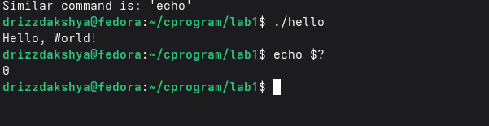
Figure 5: Running ./hello followed by echo $? showing 0
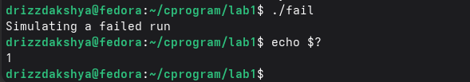
Figure 6: Running ./fail followed by echo $? showing 1

2.8 Observation
- A program returning 0 gives exit status 0, which means success.
- Changing the return value to 1 changes $? to 1, which signals an error to the OS.
- This confirms that the return value of main() is how a program reports its result.

Task 3: Formatted Output with printf()

3.1 Objective
Use printf() with format specifiers to display strings and integers.

3.2 Theoretical Concept
Key idea: printf() displays output; the first argument is a format string and the remaining arguments fill in the placeholders.
- %s: inserts a string.
- %i (or %d): inserts an integer.
- \n: newline character that moves the cursor to the next line.
- stdio.h: header that declares printf() and scanf(); it must be included with #include <stdio.h>.

3.3 Source Code (format.c)
#include <stdio.h>

int main() {
// %s inserts a string, %i inserts an integer
printf("Course: %s\n", "Programming and Operating System");
printf("Lab number: %i\n", 1);
return 0;
}

3.4 Terminal Commands
gcc format.c -o format
./format

3.5 Expected Output
Course: Programming and Operating System
Lab number: 1

3.6 Terminal Output Screenshots
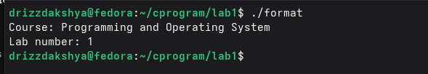
Figure 7: Compile and run format.c showing both lines of output

3.7 Observation
- %s was replaced by the given string and %i by the given integer.
- Without #include <stdio.h> the compiler would warn about an undeclared printf.

Task 4: Stages of Compilation

4.1 Objective
Run each stage of the GCC compilation process separately (preprocessing, compiling, assembling and linking), inspect the output of each stage, and capture a screenshot for every step.

4.2 Theoretical Concept
Key idea: When gcc is run normally, all four stages happen automatically. Using flags lets us stop after each stage and examine the intermediate file.
- Preprocessing: handles lines starting with #. It inserts the contents of header files such as stdio.h and expands macros. Output is still C code.
- Compiling: translates the preprocessed C code into assembly language specific to the CPU architecture.
- Assembling: converts assembly into machine code, producing a relocatable object file (binary).
- Linking: combines object files with library code (such as printf from the C library) to create the final executable. This happens automatically when no stop-flag is given.

4.3 Compilation Stages Summary
Stage | Command | Output File | Purpose
1. Preprocessing | gcc -E hello.c -o hello.i | .i | Expand headers and macros
2. Compiling | gcc -S hello.i -o hello.s | .s | Generate assembly code
3. Assembling | gcc -c hello.s -o hello.o | .o | Create object file
4. Linking | gcc hello.o -o hello | a.out / executable | Produce final executable

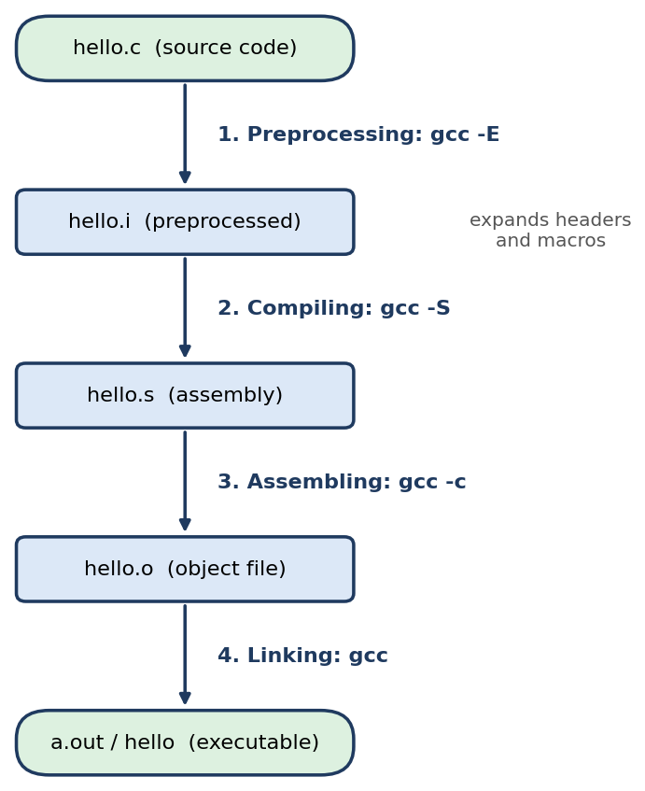
The four stages of C compilation

4.4 Source Code (hello.c)
#include <stdio.h>

int main() {
printf("Hello, World!\n");
return 0;
}

4.5 Stage 1: Preprocessing (gcc -E)
gcc -E hello.c -o hello.i
wc -l hello.i # many lines: stdio.h was inserted
tail -n 8 hello.i # your main() appears at the end

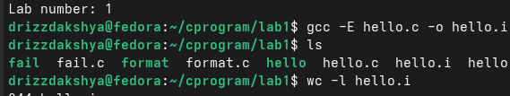
Figure 8: Command gcc -E hello.c -o hello.i
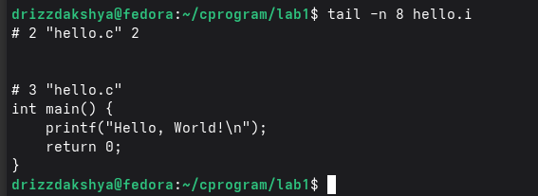
Figure 9: Output of wc -l hello.i and tail -n 8 hello.i
Observation: The file hello.i is far longer than hello.c because the contents of stdio.h were pasted in; the macros and comments were removed.

4.6 Stage 2: Compiling (gcc -S)
gcc -S hello.i -o hello.s
cat hello.s # assembly instructions (e.g. call printf)
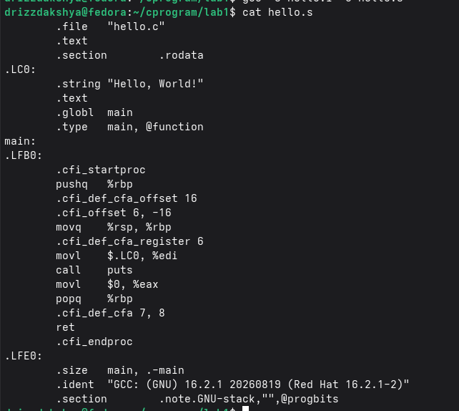
Figure 11: Output of cat hello.s showing the assembly code
Observation: hello.s contains human-readable assembly instructions such as a call to printf.

4.7 Stage 3: Assembling (gcc -c)
gcc -c hello.s -o hello.o
file hello.o # ELF relocatable object
ls -l hello.o

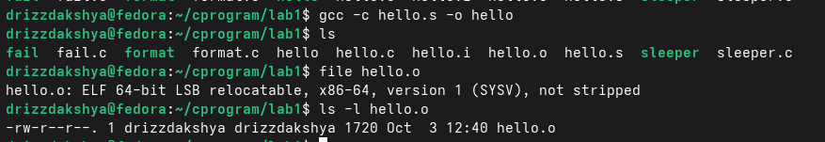
Figure 13: Output of file hello.o and ls -l hello.o
Observation: hello.o is a binary object file; it cannot be run yet because the printf reference is not resolved.

4.8 Stage 4: Linking (gcc)
gcc hello.o -o hello
./hello
file hello # ELF executable
ls -l

Figure 16: Output of ls -l hello
Observation: Linking produced a runnable executable and ./hello prints Hello, World!.

Task 5: Reading Input: Integer Variable Example

5.1 Objective
Declare an integer variable, read a value from the keyboard, and display it.

5.2 Theoretical Concept
Key idea: Variables must be declared with a type before use; scanf() stores input at the variable's address.
- int number: reserves memory for one integer on the stack.
- scanf("%d", &number): reads an integer from standard input and stores it in number. The & operator passes the variable's address.
- Local variables: live in the stack section of the process's memory.

5.3 Source Code (number.c)
#include <stdio.h>

int main() {
int number; // declare an integer variable

printf("Enter a number: ");
scanf("%d", &number); // read from keyboard (stdin)

printf("You entered: %d\n", number);
return 0;
}

5.4 Terminal Commands
gcc number.c -o number
./number
# Enter: 25

5.5 Expected Output
Enter a number: 25
You entered: 25

5.6 Terminal Output Screenshots
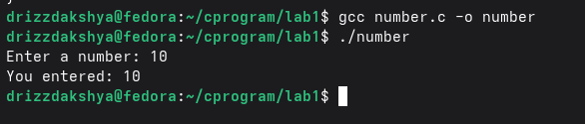
Figure 18: Compile and run number.c with your chosen input and the displayed result

5.7 Observation
- The program paused at scanf() until a value was typed, then printed it back.
- The value was stored in the integer variable number in memory.

Task 6: Program vs Process

6.1 Objective
Observe the difference between an executable file on disk (static) and a process in memory (dynamic).

6.2 Theoretical Concept
Key idea: A file is static and stored on disk. A process is dynamic: it exists in RAM only while the program is executing.
- Program / file: an executable stored on disk; it does not change and is inactive until run.
- Process: a program in execution, loaded into RAM, managed by the OS and given a unique Process ID (PID).
- PPID: the PID of the parent process that created it, usually the shell.
- Role of the OS: creates, schedules, manages and terminates processes.

6.3 How the OS Loads and Executes a Program
When the user runs ./hello, the shell creates a child process. The child replaces itself with the program using the execve() system call. The kernel then checks the executable, assigns memory, loads the code and data, and jumps to the entry point _start, which sets up the environment and calls main().
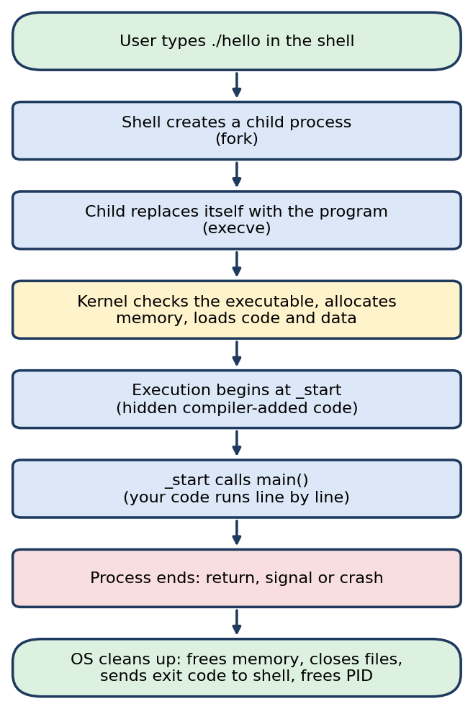
From ./hello to process termination

6.4 Process Memory Layout
When a process is created the OS organizes its memory into separate sections: code (instructions), data (global variables), heap (dynamic memory) and stack (local variables and function calls).
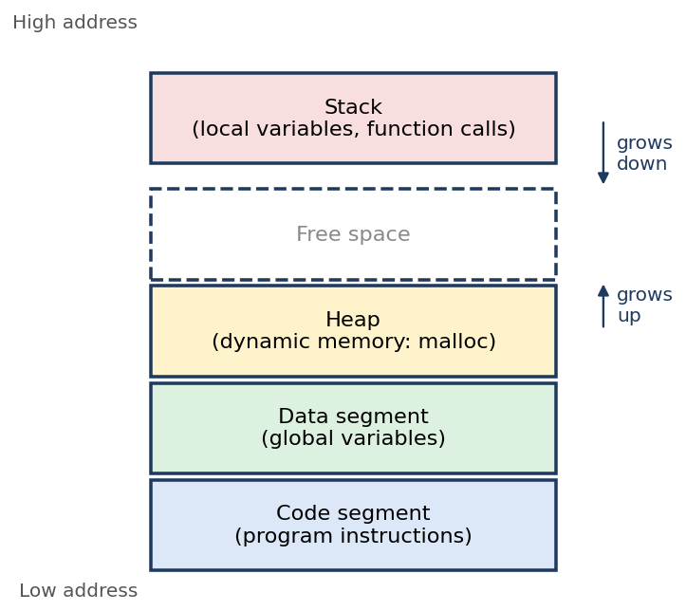
Memory layout of a process

6.5 Process Termination and Cleanup
Termination Type | Cause | Example
Normal exit | return from main() or exit() call | return 0;
Signal | External interrupt from OS or user | Ctrl+C (SIGINT)
Crash | Invalid operation | Accessing invalid memory

Cleanup Action | Explanation
Frees memory | All RAM allocated to the process is released
Closes file descriptors | Any open files are closed
Returns exit code | Status sent to parent process (shell)
Removes from process table | PID is freed for reuse

6.6 Source Code (sleeper.c)
#include <stdio.h>
#include <unistd.h>

int main() {
printf("Process running, PID = %d\n", getpid());
sleep(30); // keep the process alive so we can inspect it
return 0;
}

6.7 Terminal Commands
gcc sleeper.c -o sleeper
ls -l sleeper # the program: a file on disk
./sleeper & # start it as a process in the background
ps aux | grep sleeper # the process: running in memory

# After 30 seconds
ps aux | grep sleeper # process is gone, file still exists
ls -l sleeper

6.8 Expected Output
-rwxr-xr-x 1 user user 16000 ... sleeper
Process running, PID = 12345
user 12345 0.0 0.0 2344 560 pts/0 S 10:00 0:00 ./sleeper

# after 30 s: only the grep line remains; sleeper file still on disk

6.9 Terminal Output Screenshots
Figure 20: ls -l sleeper showing the executable file on disk
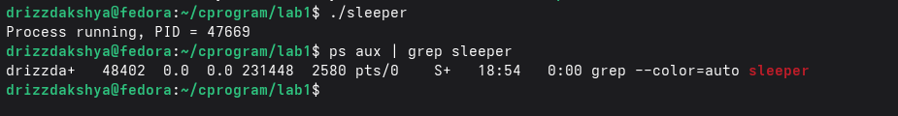
Figure 21: ./sleeper & and ps aux | grep sleeper showing the running process and its PID

6.10 Observation
- Before and after execution the file stays on disk unchanged: it is static.
- The process appeared in ps with a PID only while it was running, then the OS removed it from the process table.

Knowledge Test
Answers to the questions from Lecture 2.
No. | Question | Answer
1 | What is the difference between source code and an executable? | Source code is human-readable text written in a language such as C. An executable is the machine-code file (binary 0s and 1s) produced by the compiler, which the CPU can run.
2 | What command compiles a C program? | gcc filename.c -o outputname (for example gcc hello.c -o hello).
3 | What is a process? | A program in execution: the executable loaded into memory and managed by the OS.
4 | What does PID stand for? | Process ID, the unique number the OS gives each process.
5 | How do you check the exit code of the last command? | echo $?
6 | What does return 0; mean in main()? | The program finished successfully; 0 is passed to the OS as the exit status.
7 | What system call creates a new process? | fork() (the shell creates a child process this way).
8 | What system call replaces the current process with a new program? | execve()
9 | How do you see running processes in terminal? | ps (for example ps aux), or top / htop for a live view.
10 | What happens to memory when a process ends? | The OS reclaims it: all RAM allocated to the process is released (along with open files, and the PID is freed).
11 | Where is your program stored before execution? | On disk (secondary storage) as an executable file.
12 | Where is your program stored during execution? | In main memory (RAM), organized into code, data, heap and stack sections.
13 | Why does the OS assign a PID to each process? | So it can uniquely identify, track, schedule and manage every process.
14 | When does a process end? | When it returns from main() or calls exit() (normal exit), when it receives a signal such as Ctrl+C, or when it crashes (for example a segmentation fault).
15 | Who assigns the PID? | The OS kernel.

Conclusion
This lab showed how a C program travels from source code to a running process. We installed GCC, compiled programs, passed exit codes to the shell, examined every compilation stage (preprocess, compile, assemble, link), and observed that an executable is a static file on disk while a process is a dynamic entity in memory with its own PID that the OS creates, manages and cleans up.

Key Takeaways
- Source code is human-readable; the compiler turns it into an executable of machine instructions.
- GCC runs four stages: preprocessing, compiling, assembling and linking.
- main() returns an int; 0 means success and non-zero means error, readable with echo $?.
- A process is a program in execution with a PID, loaded into RAM and laid out as code, data, heap and stack.
- When a process ends, the OS frees its memory, closes files, returns the exit code and releases the PID.

GitHub Submission
Repository link: ________________________________________________
[ INSERT SCREENSHOT HERE ]
GitHub repository showing all source files and README.md
Figure 24: GitHub repository showing all source files and README.md

Submission Checklist
Requirement | Done
All source files properly named (hello.c, fail.c, format.c, number.c, sleeper.c) | [ ]
Screenshots for every compilation stage (Task 4) | [ ]
Knowledge test answered | [ ]
Code pushed to GitHub with README.md | [ ]

