LAB REPORT 3
Investigating Process Lifecycles and OS Interaction
Operating Systems
Name
Roll No. / ID
Section / Group
Instructor
Date of Submission
GitHub Repository

Table of Contents

1. Introduction
In Lecture 3 we learned that an operating system manages processes and resources. This lab brings that theory to life. Instead of writing programs that only print text, we write C code that interacts with the Linux kernel to query its own process identity, control its execution time, and report success or failure back to the OS shell.

1.1 Objectives
- Observe a long-running process from a second terminal using ps.
- Retrieve a process's PID and PPID with getpid() and getppid() and verify them against the OS.
- Return exit codes to the shell and read them with $?.
- Understand standard input and output streams (stdin and stdout).
- Control program flow using user input and communicate the outcome to the OS.

1.2 Tools and Environment
Item | Details
Operating System | Linux (e.g. Ubuntu) — fill in your version
Compiler | gcc — fill in your version (gcc --version)
Language | C (C99 or later)
Editor / Shell | Fill in (e.g. VS Code, bash)
Version Control | Git / GitHub

[ INSERT SCREENSHOT HERE ]
Environment: output of uname -a and gcc --version
Figure 13: Environment: output of uname -a and gcc --version

2. Background Theory

2.1 Processes and the Kernel
A program is a passive file on disk; a process is that program in execution. The kernel creates a process, assigns it a unique PID, allocates memory and tracks its state (running, sleeping, zombie, etc.). User programs request kernel services through system calls such as getpid(), getppid() and sleep()-related calls, usually via C library wrappers.

2.2 Process States
A process alternates between running on the CPU, waiting (sleeping) for an event or timer, and finally terminating. A process in sleep() is shown by ps as state S (interruptible sleep).

2.3 Process Hierarchy
Every process is created by another process, called its parent. The child records the parent's PID as its PPID. A program started from a terminal is a child of the shell.

2.4 Exit Status
When a process terminates, it passes an integer to its parent. By convention 0 means success and non-zero means failure. The shell exposes the last status in $?, and automation tools use it to decide whether to proceed.

2.5 Standard Streams
Stream | File Descriptor | Default Device | C Function Used
stdin | 0 | Keyboard | scanf
stdout | 1 | Terminal screen | printf
stderr | 2 | Terminal screen | fprintf(stderr, ...)

2.6 Summary of Commands and System Calls
Item | Purpose
getpid() | Returns the PID of the calling process
getppid() | Returns the PID of the parent process
sleep(n) | Suspends the process for n seconds
return n (from main) | Sets the exit status passed to the shell
& | Runs a command in the background
ps aux | grep name | Lists running processes and filters by name
ps -p PID -o pid,ppid,cmd | Shows selected fields for one process
echo $? | Prints the exit status of the last command

Task 1: The Long-Running Process

1.1 Objective
Create a C program that runs for 30 seconds using a loop and sleep(), run it in the background with &, and inspect it from a second terminal while it is alive.

1.2 Theoretical Concept
OS Insight: In enterprise servers, processes run for days or months. We must know how to monitor them while they are active.
- Process: a running instance of a program, with its own PID, memory and CPU state, managed by the kernel.
- sleep(n): a system-call wrapper that suspends the calling process for n seconds. While asleep the process stays alive but uses almost no CPU (state S).
- Background execution (&): the shell starts the program but returns the prompt immediately, so the terminal stays usable.
- ps aux | grep: ps lists processes; grep filters the line for our program. The STAT column shows S (sleeping).

1.3 Flow Diagram
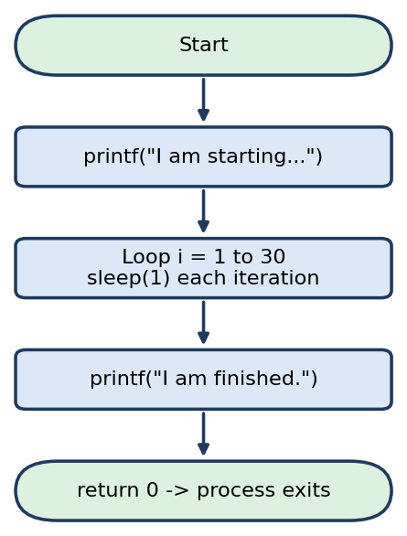
Flow diagram of task1_alive.c

1.4 Algorithm
- Print "I am starting...".
- Loop 30 times, calling sleep(1) on each iteration.
- Print "I am finished." and return 0.

1.5 Source Code (task1_alive.c)
#include <stdio.h>
#include <unistd.h>

int main() {
printf("I am starting...\n");

// Loop for 30 seconds
for(int i = 1; i <= 30; i++) {
sleep(1); // Pauses execution for 1 second
}

printf("I am finished.\n");
return 0;
}

1.6 Terminal Commands
# Terminal 1: compile and run in background
gcc task1_alive.c -o task1
./task1 &

# Terminal 2: find the running process
ps aux | grep task1

1.7 Expected Output
# Terminal 1
I am starting...
# Terminal 2 (while running)
user 12345 0.0 0.0 2344 560 pts/0 S 10:00 0:00 ./task1

1.8 Terminal Output Screenshots
[ INSERT SCREENSHOT HERE ]
Terminal 1: compile (gcc) and run with ./task1 &
Figure 1: Terminal 1: compile (gcc) and run with ./task1 &
[ INSERT SCREENSHOT HERE ]
Terminal 2: output of ps aux | grep task1 while the process is alive
Figure 2: Terminal 2: output of ps aux | grep task1 while the process is alive
[ INSERT SCREENSHOT HERE ]
Terminal 1: "I am finished." message after 30 seconds
Figure 3: Terminal 1: "I am finished." message after 30 seconds

1.9 Observation
- The program appeared in ps output with state S (sleeping) because it spends nearly all its time inside sleep().
- Using & returned the shell prompt immediately, allowing monitoring from another terminal.
- After 30 seconds the process printed its final message and disappeared from the process list.

Task 2: Process Identity (PID and PPID)

2.1 Objective
Use getpid() and getppid() to print a process's own ID and its parent's ID, then verify both values with the OS ps command.

2.2 Theoretical Concept
OS Insight: Every process in Linux has a unique Process ID (PID). The process that created it is the Parent Process ID (PPID), usually your terminal shell.
- PID: unique integer assigned by the kernel to each process; getpid() returns it.
- PPID: PID of the process that created (forked) this one; getppid() returns it. For a program launched from the terminal this is the shell (e.g. bash).
- Process tree: Linux processes form a hierarchy; every process except init/systemd has a parent.
- ps -p PID -o pid,ppid,cmd: asks the OS directly for the PID, PPID and command of a given process, which lets us cross-check the program's own output.

2.3 Flow Diagram
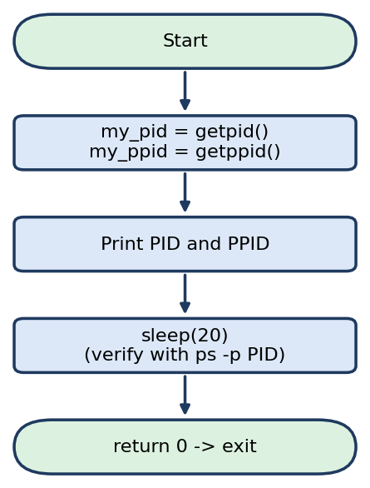
Flow diagram of task2_identity.c

2.4 Algorithm
- Call getpid() and store the result in my_pid.
- Call getppid() and store the result in my_ppid.
- Print both values, then sleep for 20 seconds so the process can be inspected.
- Run ps -p <PID> -o pid,ppid,cmd and compare the values.

2.5 Source Code (task2_identity.c)
#include <stdio.h>
#include <unistd.h>

int main() {
// Get current Process ID
pid_t my_pid = getpid();

// Get Parent Process ID
pid_t my_ppid = getppid();

printf("My PID is: %d\n", my_pid);
printf("My Parent PID is: %d\n", my_ppid);

printf("Sleeping for 20 seconds...\n");
sleep(20);

return 0;
}

2.6 Terminal Commands
gcc task2_identity.c -o task2
./task2 &

# Note the PID printed by the program (e.g., 12345)
ps -p 12345 -o pid,ppid,cmd

2.7 Expected Output
My PID is: 12345
My Parent PID is: 8901
Sleeping for 20 seconds...

PID PPID CMD
12345 8901 ./task2

2.8 Terminal Output Screenshots
[ INSERT SCREENSHOT HERE ]
Terminal: program output showing My PID and My Parent PID
Figure 4: Terminal: program output showing My PID and My Parent PID
[ INSERT SCREENSHOT HERE ]
Terminal: output of ps -p <PID> -o pid,ppid,cmd
Figure 5: Terminal: output of ps -p <PID> -o pid,ppid,cmd
[ INSERT SCREENSHOT HERE ]
(Optional) echo $$ in the same shell, showing it equals the PPID
Figure 6: (Optional) echo $$ in the same shell, showing it equals the PPID

2.9 Observation
- The PID printed by the program matched the PID reported by ps, confirming getpid() reads the real kernel value.
- The PPID equals the PID of the shell from which the program was launched (check with echo $$).
- The PID changes on every run because the kernel assigns a new one to each new process.

Task 3: Exit Codes and OS Feedback

3.1 Objective
Return different exit codes from main() depending on user input, and read them from the shell using $?.

3.2 Theoretical Concept
OS Insight: When a program finishes, it returns an integer to the OS. 0 means "Success", and any non-zero number (like 1) means "Error/Failure". The shell stores this in $?.
- Exit status: the integer returned from main() (or passed to exit()) is handed to the parent shell when the process terminates.
- $?: special shell variable holding the exit status of the most recently executed command.
- Convention: 0 = success, non-zero = failure. Scripts and CI/CD pipelines use this to decide whether to continue or stop (e.g. cmd1 && cmd2).
- Conditional logic: an if/else statement selects which return value is produced, based on the input read by scanf.

3.3 Flow Diagram
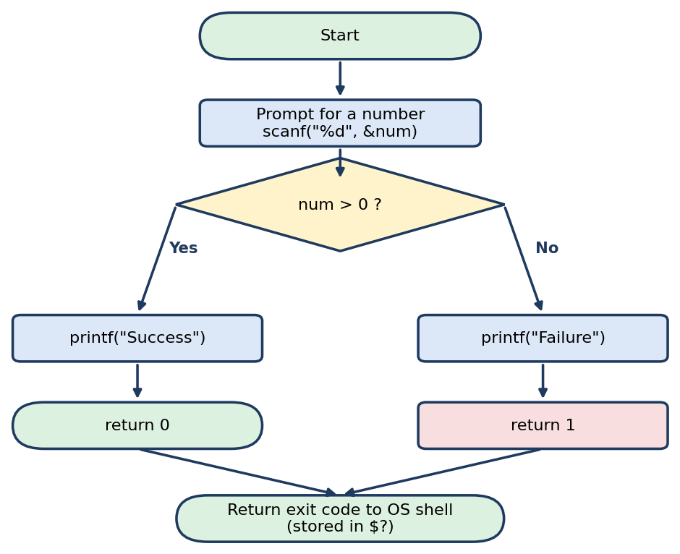
Flow diagram of task3_exit.c

3.4 Algorithm
- Read an integer using scanf.
- If num > 0, print "Success" and return 0.
- Otherwise print "Failure" and return 1.
- Run echo $? immediately after the program to read the exit code.

3.5 Source Code (task3_exit.c)
#include <stdio.h>

int main() {
int num;
printf("Enter a number (positive for success, negative for fail): ");
scanf("%d", &num);

if (num > 0) {
printf("Success\n");
return 0; // Tell OS: Success
} else {
printf("Failure\n");
return 1; // Tell OS: Error
}
}

3.6 Terminal Commands
gcc task3_exit.c -o task3

# Scenario A: positive input
./task3 # Enter: 5
echo $?

# Scenario B: negative input
./task3 # Enter: -5
echo $?

3.7 Expected Output
# Scenario A
Enter a number (positive for success, negative for fail): 5
Success
0

# Scenario B
Enter a number (positive for success, negative for fail): -5
Failure
1

3.8 Terminal Output Screenshots
[ INSERT SCREENSHOT HERE ]
Scenario A: input 5, output "Success", and echo $? showing 0
Figure 7: Scenario A: input 5, output "Success", and echo $? showing 0
[ INSERT SCREENSHOT HERE ]
Scenario B: input -5, output "Failure", and echo $? showing 1
Figure 8: Scenario B: input -5, output "Failure", and echo $? showing 1

3.9 Observation
- Positive input produced exit code 0 (success); non-positive input produced exit code 1 (failure).
- $? must be read immediately, because the next command overwrites it.
- This is the mechanism shells and automation tools use to detect whether a program succeeded.

Task 4: Standard I/O Streams

4.1 Objective
Read a string from standard input with scanf and write a greeting to standard output with printf.

4.2 Theoretical Concept
OS Insight: The OS provides standard input (stdin) and standard output (stdout) streams. scanf reads from stdin, and printf writes to stdout.
- stdin (fd 0): default input stream, normally connected to the keyboard; scanf reads from it.
- stdout (fd 1): default output stream, normally connected to the terminal screen; printf writes to it.
- stderr (fd 2): third standard stream used for error messages (not used in this task, but part of the same model).
- Note: scanf("%s") stops at the first whitespace, so only a single word is read; the buffer name[50] holds at most 49 characters plus the terminating '\0'.

4.3 Flow Diagram
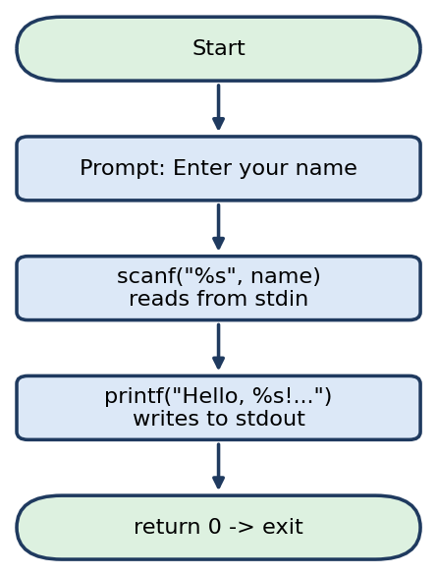
Flow diagram of task4_input.c

4.4 Algorithm
- Declare a character array name[50].
- Print the prompt "Enter your name: ".
- Read one word into name using scanf("%s", name).
- Print the greeting using the stored name and return 0.

4.5 Source Code (task4_input.c)
#include <stdio.h>

int main() {
char name[50];

printf("Enter your name: ");
// Read string from standard input
scanf("%s", name);

printf("Hello, %s! Welcome to OS Class.\n", name);
return 0;
}

4.6 Terminal Commands
gcc task4_input.c -o task4
./task4

4.7 Expected Output
Enter your name: John
Hello, John! Welcome to OS Class.

4.8 Terminal Output Screenshots
[ INSERT SCREENSHOT HERE ]
Terminal: compile and run, with your name entered and the greeting displayed
Figure 9: Terminal: compile and run, with your name entered and the greeting displayed
[ INSERT SCREENSHOT HERE ]
(Optional) Run with redirection: echo John | ./task4, showing stdin can come from a pipe
Figure 10: (Optional) Run with redirection: echo John | ./task4, showing stdin can come from a pipe

4.9 Observation
- The program received keyboard input through stdin and printed the greeting through stdout.
- Input is limited to one word because scanf("%s") stops at whitespace.

Task 5: Conditional Execution and Termination

5.1 Objective
Combine PID reporting, user-driven branching and exit codes: the program continues or aborts based on input and reports the outcome to the OS.

5.2 Theoretical Concept
OS Insight: Programs often branch based on user input. The OS tracks the final exit code to determine if the script or automation pipeline should continue or halt.
- Branching: the choice entered by the user decides which path the process takes (continue with sleep(5) or abort immediately).
- Exit code as control signal: return 0 signals success so a pipeline may proceed; return 1 signals abort so the pipeline halts.
- Runtime vs exit: in the "Yes" path the process stays alive for 5 seconds (visible in ps using the printed PID) before exiting; in the "No" path it exits at once.

5.3 Flow Diagram
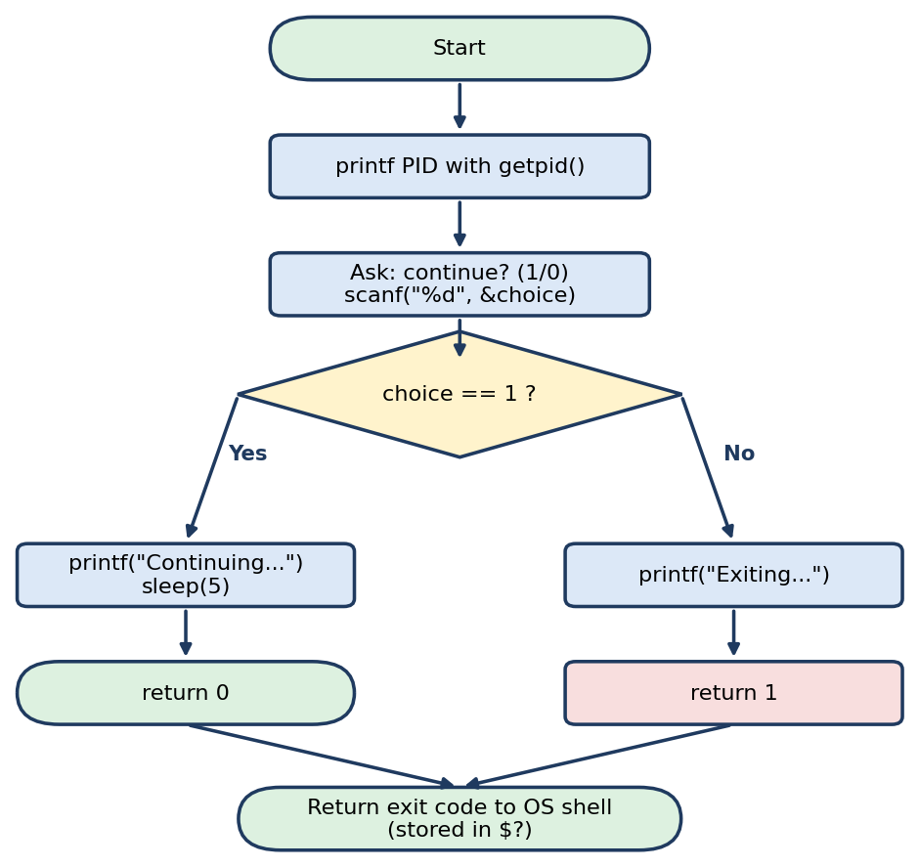
Flow diagram of task5_control.c

5.4 Algorithm
- Print the current PID using getpid().
- Ask the user whether to continue and read choice with scanf.
- If choice == 1: print "Continuing...", sleep 5 seconds, return 0.
- Otherwise: print "Exiting..." and return 1.
- Check the result with echo $?.

5.5 Source Code (task5_control.c)
#include <stdio.h>
#include <unistd.h>

int main() {
int choice;

// Print PID at start
printf("Current PID: %d\n", getpid());

printf("Do you want to continue? (1 for Yes, 0 for No): ");
scanf("%d", &choice);

if (choice == 1) {
printf("Continuing...\n");
sleep(5);
return 0; // Success
} else {
printf("Exiting...\n");
return 1; // Failure/Abort
}
}

5.6 Terminal Commands
gcc task5_control.c -o task5

# Run 1: choose Yes
./task5 # enter 1
echo $?

# Run 2: choose No
./task5 # enter 0
echo $?

5.7 Expected Output
# Run 1
Current PID: 12400
Do you want to continue? (1 for Yes, 0 for No): 1
Continuing...
0

# Run 2
Current PID: 12405
Do you want to continue? (1 for Yes, 0 for No): 0
Exiting...
1

5.8 Terminal Output Screenshots
[ INSERT SCREENSHOT HERE ]
Run 1: input 1, "Continuing...", and echo $? showing 0
Figure 11: Run 1: input 1, "Continuing...", and echo $? showing 0
[ INSERT SCREENSHOT HERE ]
Run 2: input 0, "Exiting...", and echo $? showing 1
Figure 12: Run 2: input 0, "Exiting...", and echo $? showing 1

5.9 Observation
- Choosing 1 kept the process alive for 5 seconds and ended with exit code 0.
- Choosing 0 ended the process immediately with exit code 1.
- The PID differs between runs, confirming that each execution is a new process.

Conclusion
This lab demonstrated that C programs do not exist in a vacuum; they are active processes managed by the Linux kernel. Using system calls such as getpid() and getppid(), timing control with sleep(), and return codes checked through $?, we bridged the gap between high-level C code and low-level OS process management.

Key Takeaways
- A running program is a process with a unique PID and a parent (PPID).
- Background execution and ps allow live monitoring of long-running processes.
- Exit codes (0 = success, non-zero = failure) are how programs report results to the shell and automation pipelines.
- stdin and stdout are OS-provided streams that connect programs to the user.

Summary of Results
Task | Program | Key Concept | Result / Exit Code
1 | task1_alive.c | Long-running process | Visible in ps for 30 s
2 | task2_identity.c | PID and PPID | Matches ps output
3 | task3_exit.c | Exit codes | 0 (positive), 1 (negative)
4 | task4_input.c | stdin / stdout | Greeting printed
5 | task5_control.c | Conditional execution | 0 (Yes), 1 (No)

GitHub Submission
Repository link: ________________________________________________
[ INSERT SCREENSHOT HERE ]
GitHub repository showing all 5 .c files and README.md
Figure 14: GitHub repository showing all 5 .c files and README.md

Submission Checklist
Requirement | Done
All 5 .c source files properly named (task1_alive.c ... task5_control.c) | [ ]
Documentation with theoretical concepts | [ ]
Flow diagrams for every task | [ ]
Screenshots of terminal outputs for all verification steps | [ ]
Code pushed to personal GitHub repository with README.md | [ ]

