Git是分布式的代码管理工具，远程的代码管理是基于SSH的，所以要使用远程的Git则需要SSH的配置。
Github的SSH配置如下：
_{一 、设置Git的user name和email：}
1 $ git config --global user.name "xuhaiyan"2 $ git config --global user.email "haiyan.xu.vip@gmail.com"

二、生成SSH密钥过程：
查看是否已经有了ssh密钥：cd ~/.ssh 如果没有密钥则不会有此文件夹，有则备份删除

1、生成新的Key：（引号内的内容替换为你自己的邮箱）
ssh-keygen -t rsa -C "your_email@youremail.com"

2、输出显示：
Generating public/private rsa key pair. Enter file in which to save the key (/Users/your_user_directory/.ssh/id_rsa):

3、直接回车，不要修改默认路劲。
Enter passphrase (empty for no passphrase): Enter same passphrase again:

设置一个密码短语，在每次远程操作之前会要求输入密码短语！闲麻烦可以直接回车，不设置。
4、成功：
Your identification has been saved in /Users/your_user_directory/.ssh/id_rsa.
Your public key has been saved in /Users/your_user_directory/.ssh/id_rsa.pub. The key fingerprint is: ... ...

三、提交公钥：
1、 找到.ssh文件夹，用文本编辑器打开“id_rsa.pub”文件，复制内容到剪贴板。
2、 打开 https://github.com/settings/ssh ，点击 Add SSH Key 按钮，粘贴进去保存即可。

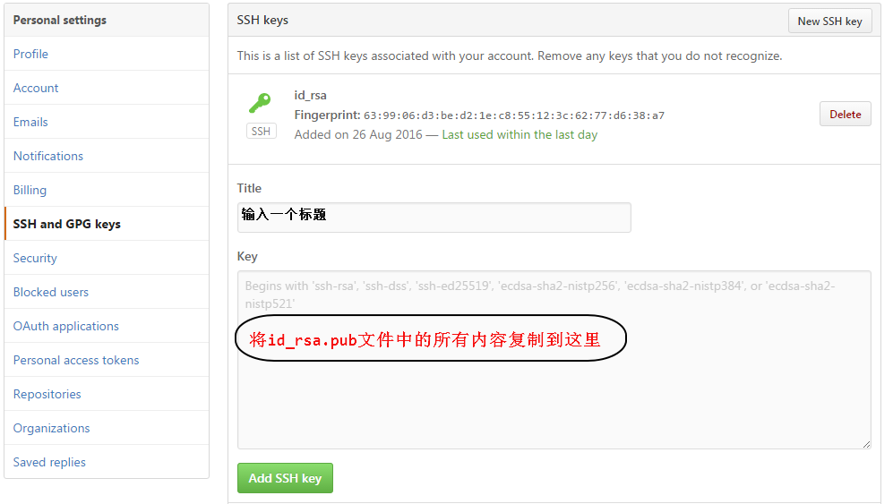

四、测试
$ssh git@github.com

The authenticity of host ‘github.com (207.97.227.239)’ can’t be established.
RSA key fingerprint is 16:27:ac:a5:76:28:2d:36:63:1b:56:4d:eb:df:a6:48.
Are you sure you want to continue connecting (yes/no)? yes
Warning: Permanently added ‘github.com,207.97.227.239′ (RSA) to the list of known hosts.
ERROR: Hi tekkub! You’ve successfully authenticated, but GitHub does not provide shell access
Connection to github.com closed.

最后 链接远程仓库

mkdir 仓库名
cd 仓库名
git init
echo "# 仓库名" >> README.md
git add README.md
git commit -m "first commit"
git remote add origin 仓库名的HTTPS地址
git push -u origin master

