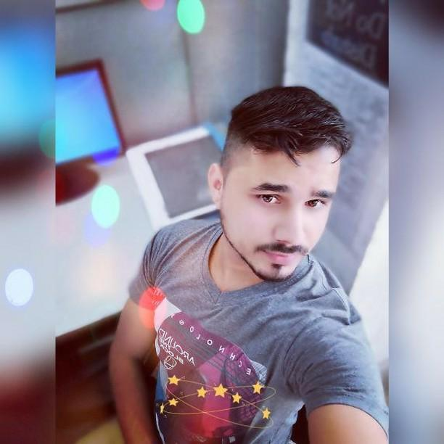
(Mechanical- Engineer) – 5 years of experience in CAD/CAM
(Designing & Development manufacturing Application)

DAINEE VERMA
_____________________________________________________________________
V.-BATAIL, P.O-BHAMBLA, DISTT.-MANDI (H.P.) 110027, (Mobile), 08350840133
(E-mail) dikshantverma360@gmail.com _____________________________________________________________________

OBJECTIVE
Looking forward for a challenging & rewarding career in the cad/cam manufacturing ,Designing & Application sector &also any type of mechanical field where I can utilize my interest aptitude & proficiency for the organization.
. Summary
- Comprehensive problem solving abilities, good communication skills, ability to deal with people technically Willingness to learn and team facilitator.

- Ability to work under pressure as well as in team environment, quick learner.

Qualifications

- Diploma in Mech. Eng. from N.I.E. (National Institute of Engineering).
- One Year AutoCAD, Unigraphics course From Parametric Designs & Solutions affiliated by (Siemens) & knowledge of CNC, VMC programming.
- 10th from Board of School Education Dharmshala, in the year 2006.
- B.A. appeared from H.P.U. Shimla.

Key skills

Technical Skills

- Autocad: 2D and 3D modelling.
- UG-NX8 & 7.5 :.Part modelling, Mold wizard, surfacing, assemblies and drafting.
- Catia v5: Mechanical design workbench complete. Also knowledge of Solid works to create sketch , 3d basic & assembly design, drafting and sheet metal basic .
- Knowledge of engineering drawings GD & T basic.
- MS office, MS Word, excel ,power point
- Knowledge of 5S,Kaizen & TPM.

Certificate
- Complete Nx , UG-CAD/CAM for CNC vmc machine Siemens certification Iso 9001,9100,14001, &18001 certified units.
Employment
- Cad/Cam Engineer:
Rider motor Parts: 3 years experience Time : July 2010 to Dec.2013
Job profile: Product design and mould design of plastic& Rubber components in unigraphics. software ( nx6.0) Include sheet metal tools die design. . Final Cross checks the programs for allotted jobs in m/c .every day planning for the job for machining.
- Cad/Cam Engineer:: Time : Jan. 2014 to Dec. 2016
Rockman Industries Pvt. ltd:
Job profile: To make product design & complete detail drawing of tool die . Cam programming in NX 8.0 for the shopfloor components manufacturing. Make changes in the program according to the customer requirements. & to make Electrode for Dies. Communicating with customers and suppliers to resolve design issues.
Projects.
- Wheel (6 Spoke RIB) Die FR & RR NEW Tool Die DESIGN 2D & 3D Parts Drg. For H.M.C.L
(2 ) FLANGE FINAL DRIVEN (FFD d2) Tool detail drawing..
(3) FFD Drilling Fixture For to make final size of Hole .
(4) PANEL REAR F RONT BRAKE SHOE Assy. Fixture .
(5) CYLINDER HEAD 3 Cavity dies (NXG ,FEF) TOOL DRG.
(6) CRANK CASE COVER RIGHT Drilling Fixture For HOLE FINISHING.
- Design & Development Engineer:: Time : Jan.2017
Maxima Watches (P. A. PINIONS) Current working
Job profile: Design & development micro gears and different types of parts of SPM Machine in CATIA v5 and solid works software. .Reverse engineering of new NPD parts , modification of attachments of swiss sliding head and turning centers. Designing of all type jigs and fixtures for like machining , inspection & other types .
Mechanical R&D For improvement of cnc Machines.like gear hobbing machine hyd. Press machine .tnc turning machine .and hydro bar loader new design.

Current Projects.
(1 ) Design and development of new cnc gear hobbing machine for spur gears , Helical Gears, and straight bevel gears.
(2) Design and development of fixture design Coupler component.
(3) Design and development of Solo quenching FURNACE inhouse.
(4) Designing of new automatic type basket jig (for all types of NPD parts )design for electroplating bath. Like copper, nickel ,silver zinc ,and gold plating bath.
(5) Design of new machining fixture of small part (ejector)on 4th axis machine in CNC milling machine.
(6) New attachment design for Ultrasonic machine top cover open & close by automatically geared motor by using of proximity sensor
Field of exposer:
Professional Summary-
Skilled in Design, & Manufacturing of parts, sheet metal components, automobile parts& Injection moulds ,& jigs & fixtures , and new SPM Machine attachment or modification on existing design also new design for machine stand like oil mist collector , or machine covers design for any type of machine ,Installation design and new layouts for upcoming Machines or shifting existing machines that are required for the plant. Design, Fabrication & Installation of Conveyor, Lifts & useful accessories at plant.
1.Well versed with ISO 9001-2000 System Documentation.
2.Exposure in Work Planning, cost-efficient and implementation of works.
3.well supervising skill in tool room & machine shop for the 100% job manufacturing and inspection.
4. Efficient communicator with strong negotiation, problem resolution & client need assessment aptitude.
5. Engineering drawing study & development with 2d AutoCAD (2010-2012), 3D model development with NX. (V 6.0-8.0).and Catia v5 software & solid works software.
6. Clear about job machining concept with cnc m/c, & conventional m/c with limited tolerance.
7. prepares the inspection report of final manufacturing jobs.
8.Knowledge of fixture development for various types of precision jobs, for mass production.

Strength:
- Positive attitude
- Hardworking
- Self Confident
- Good communicator
Personal Profile:

- Father’s Name :Sh. Swami Kumar
- Date of Birth : 26-06-1990
- Gender :Male
- Marital Status :Married
- Language known : Hindi and English
Hobbies
- Playing Volleyball
- Reading book

- Declaration:

- I hereby declare that the information given above is best to my knowledge and belief.
Dainee Verma

