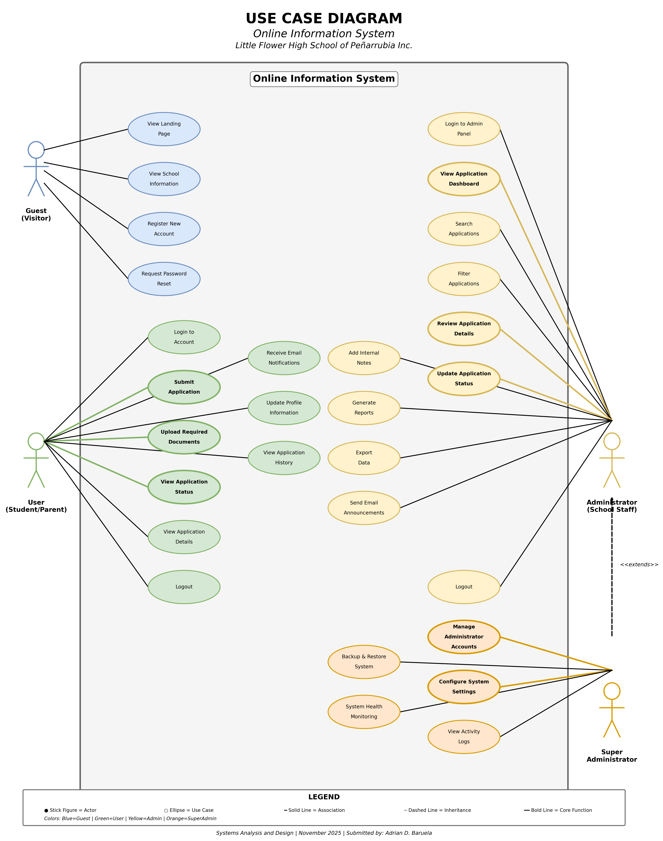

USE CASE DIAGRAM DETAILS

System Overview
The Online Information System for Little Flower High School of Peñarrubia Inc. manages the complete student admission process from initial application through enrollment decision.

Actors (4)
Actor | Use Cases | Description
Guest (Visitor) | 4 use cases | Unauthenticated users exploring the system and creating accounts
User (Student/Parent) | 9 use cases | Registered applicants submitting and tracking their applications
Administrator (School Staff) | 11 use cases | Information office staff processing and managing applications
Super Administrator | 5 use cases | Senior staff with elevated privileges for system configuration and management

Use Cases Summary

Guest Use Cases (4)
- View Landing Page
- View School Information
- Register New Account
- Request Password Reset

User Use Cases (9) - ⭐ indicates core functionality
- Login to Account
- ⭐ Submit Application
- ⭐ Upload Required Documents
- ⭐ View Application Status
- View Application Details
- Receive Email Notifications
- Update Profile Information
- View Application History
- Logout

Administrator Use Cases (11)
- Login to Admin Panel
- ⭐ View Application Dashboard
- Search Applications
- Filter Applications
- ⭐ Review Application Details
- ⭐ Update Application Status
- Add Internal Notes
- Generate Reports
- Export Data
- Send Email Announcements
- Logout

Super Administrator Use Cases (5)
- ⭐ Manage Administrator Accounts
- ⭐ Configure System Settings
- View Activity Logs
- Backup & Restore System
- System Health Monitoring

Key Relationships
Inheritance: Super Administrator extends Administrator (inherits all Administrator capabilities plus additional privileges)

Associations: Lines connecting actors to use cases indicate which actors can perform which functions. Bold lines indicate core/critical functionality.

Statistics
Total Use Cases | 29
Total Actors | 4
Core Functions | 8
System Boundary | Clearly defined

________________________________________________________________________________
Course: Systems Analysis and Design
Subject: Systems Integration & Architecture
Submitted by: Adrian D. Baruela
Date: November 2025
Little Flower High School of Peñarrubia Inc.
Peñarrubia, Abra, Philippines

