INTEGRATED REPORT - 3
Requirements Analysis, Data Design and
ETL Design using SSIS
Design and Implementation of a Data Warehouse
for a Retail Store with Store-level Data
ISTM 637 - Data Warehousing
Texas A&M University
Spring 2026
Team 1:
Nisarg Sonar
Bhavik Dalal
Yifei Wang
Date: April 8, 2026

Table of Contents
1. Introduction
1.1 About Dominick's Fine Foods
1.2 Project Design Specifications
1.3 Understanding of the Data
1.4 Key Data Quality Issues
1.5 DFF Hybrid ETL Pipeline Architecture
2. Subject Area Understanding
2.1 Literature Review
2.2 Business Questions
2.3 Prioritization of Business Questions
2.4 Data Evidence Supporting Selected BQs
3. Overview of Kimball's Methodology
4. Data Warehouse Logical Design (Star Schema Design)
4.1 Selected Business Questions
4.2 Star Schema Table Definitions
4.3 Schema Justification
4.4 Star Schema Diagram
4.5 Mapping Table #1
4.6 Mapping Table #2
4.7 Physical Design Plan
5. Development of the ETL Plan
5.1 All Target Data in the Data Warehouse
5.2 All Data Sources
5.3 Data Mappings
5.4 Comprehensive Data Extraction Rules
5.5 Data Transformation and Cleansing Rules
5.6 Plan for Aggregate Tables
5.7 Organization of Data Staging Area
5.8 Procedures for All Data Extractions and Loadings
5.9 ETL for Dimension Table
5.10 ETL for Fact Table
6. Implementation of the ETL Plan
6.1 Database Creation
6.2 Staging Table Creation
6.3 Data Mart Table Creation
6.4 SSIS Package 1: Extract to Staging
6.5 SSIS Package 2: Transform Staging
6.6 SSIS Package 3: Load Data Mart
6.7 Temporary Table Cleanup
6.8 Granularity Discussion
6.9 Business Question Verification
6.10 Final Data Mart Summary
7. References
8. Appendix

Section 1: Introduction

1.1 About Dominick's Fine Foods
Dominick's Finer Foods was a prominent Chicago-area supermarket chain that operated approximately 100 stores throughout the metropolitan region during the late 1980s and early 1990s. Between 1989 and 1994, the University of Chicago Booth School of Business (James M. Kilts Center for Marketing) partnered with Dominick's to conduct store-level research on shelf management and pricing. Randomized experiments were conducted in over 25 product categories across the chain. The resulting dataset approximately 5 GB of store-level scanner data is one of the most comprehensive publicly available retail datasets (Kilts Center, 2013).
The objective of this project is to design and develop a data warehouse for DFF using their store-level data to help analyze sales performance, promotional effectiveness, and customer traffic patterns across all branches.

1.2 Project Design Specifications
Specification | Choice
Implementation Architecture | Hybrid Data Pipeline
Warehouse Architecture | Independent Data Marts
Modeling Scheme | Dimensional Modeling (Star Schema)
OLAP Style | HOLAP (Hybrid Online Analytical Processing)
Target Infrastructure | SQL Server 2016

1.3 Understanding of the Data
The DFF dataset consists of four categories of OLTP source files:
Category | File Type | Files | Total Rows | Description
General | Customer Count (CCOUNT) | 1 | 327,045 | Store traffic and coupon usage by store and department
General | Demographics (DEMO) | 1 | 108 | Store-level demographics from 1990 US Census
Category-Specific | Movement (Wxxx) | 24 | ~134.9M | Weekly sales by UPC, store, and week
Category-Specific | UPC (UPCxxx) | 28 | ~14,000 | Product master data per category

Movement Files contain weekly sales data at the UPC-store-week grain. Key columns include UPC, STORE, WEEK, MOVE (units sold), QTY, PRICE, SALE (deal flag: B/C/S/blank), PROFIT, and OK (quality flag).
UPC Files contain product master data: COM_CODE (manufacturer), UPC, DESCRIP (product description), SIZE, CASE (pack quantity), and NITEM (item number).
DEMO.csv contains store-level demographic attributes derived from the 1990 U.S. Census, including income levels, education percentages, urban/suburban classification, pricing zone, and population density.
CCOUNT.csv contains daily customer transaction counts by store and department, including department-level traffic (Grocery, Dairy, Frozen, Meat, etc.) and coupon redemption counts.

1.4 Key Data Quality Issues
Issue | File(s) | Impact
DATE column corrupted | CCOUNT | Must use WEEK for time dimension instead
Dots '.' as missing values | CCOUNT, DEMO | Requires cleaning; columns read as text
SALE mostly NULL (~90%) | Movement | Promotion analysis limited to ~10% of rows
PRICE = 0 rows | Movement | Must filter to avoid division errors
Category not a column | Movement, UPC | Must derive from filename
WEEK ↔ calendar date mapping | All | Proprietary IDs; Week 1 ≈ Sept 14, 1989

1.5 DFF Hybrid ETL Pipeline Architecture
The following diagram illustrates the complete data flow from operational source files through the ETL pipeline to the data mart. The DFF source data consists of four entity types with the following relationships:
Entities and Relationships:
- Movement Files (Wxxx) → UPC Files (UPCxxx): Many-to-one on UPC. Each movement record references one product.
- Movement Files (Wxxx) → DEMO.csv: Many-to-one on STORE. Each movement record belongs to one store.
- Movement Files (Wxxx) → CCOUNT.csv: Many-to-one on STORE + WEEK. Each movement week maps to customer traffic.
- Category code is implicit from the filename (e.g., wsdr.csv → SDR), not stored as a column.
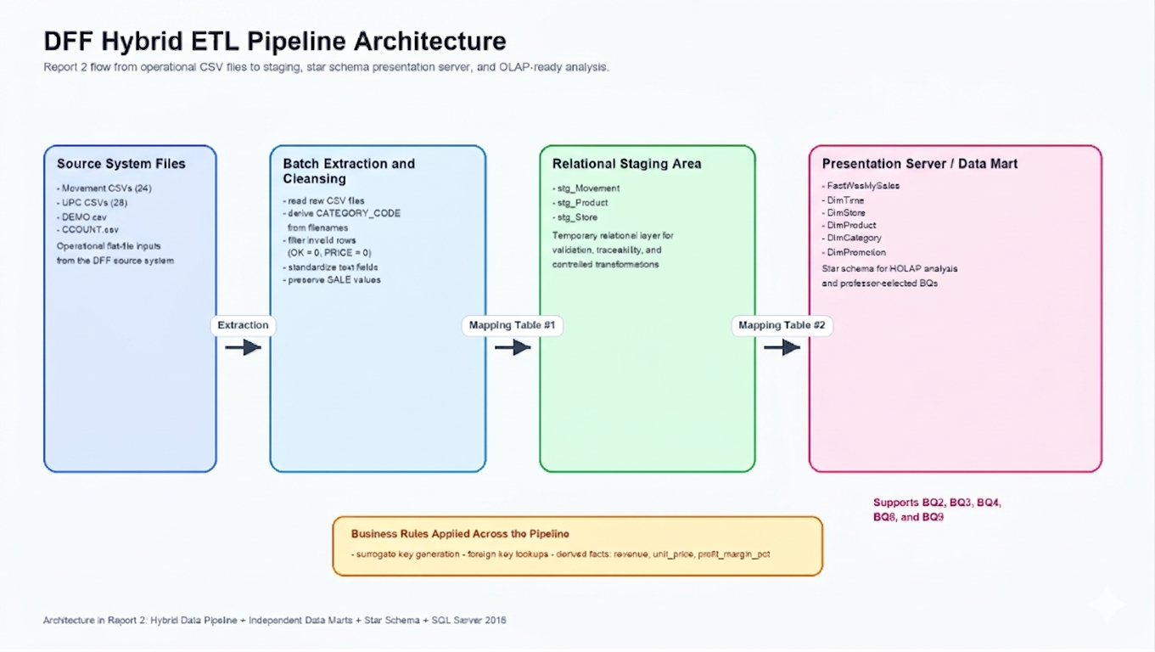
Figure 1 DFF Hybrid ETL Pipeline Architecture Source files → Staging → Data Mart

Section 2: Subject Area Understanding

2.1 Literature Review
Our research draws on published studies that used the DFF dataset:
- Hoch, Drèze, and Purk (1994) "EDLP, Hi-Lo, and Margin Arithmetic." Demonstrated that DFF's zone-based pricing strategy could increase profits by 3–5% through optimized price tiers, validating the importance of store-level pricing analysis.
- Chevalier, Kashyap, and Rossi (2003) "Why Don't Prices Rise During Periods of Peak Demand?" Used DFF data to show that retailers use loss-leader pricing during peak seasons. Found that promotional pricing follows counter-cyclical patterns, directly relevant to our promotional lift analysis.
- Chintagunta (2002) "Investigating Category Pricing Behavior at a Retail Chain." Analyzed brand-level pricing competition within DFF categories, supporting the need for product-level and brand-level granularity in the data warehouse.
- Mehta and Ma (2012) "A High Dimensional Data Analysis Approach for Retail Data." Used DFF scanner data to demonstrate data mining techniques for category management and demand forecasting at retail chains.
- Montgomery (1997) "Creating Micro-Marketing Pricing Strategies Using Supermarket Scanner Data." Used DFF data to develop store-level pricing models, reinforcing the importance of demographic segmentation in pricing decisions.

2.2 Business Questions (10 Questions with Difficulty Classification)
Based on our analysis of the DFF data, published research, and class slides, we developed 10 OLAP business questions. Each question is classified by difficulty (Easy, Medium, Hard) based on the complexity of the required OLAP operations. The professor selected 5 of these for implementation.
# | Business Question | Difficulty | OLAP Operation | Selected
BQ1 | What were the total units sold per product category across the entire dataset period? | Easy | Roll-up
BQ2 | What were the total weekly unit sales of Soft Drinks across all stores for each week? | Easy | Roll-up | Selected
BQ3 | How do promotion weeks compare to non-promotion weeks in terms of sales volume? | Easy | Slice | Selected
BQ4 | Which promotion type (B/C/S) generated the highest incremental unit sales lift in the Canned Soup category? | Medium | Dice | Selected
BQ5 | How did quarterly revenue for Frozen Entrees differ between urban and suburban stores? | Medium | Drill-down
BQ6 | How has the monthly market share of the top 5 Cereal brands changed over time? | Medium | Pivot + Ratio
BQ7 | Which 10 Beer products had the largest price variance across stores in the same week? | Medium | Dice + Rank
BQ8 | Which stores fall into the top 25%, middle 50%, and bottom 25% of total Toothpaste revenue, and how do their demographics differ? | Hard | NTILE + Drill-down | Selected
BQ9 | For each week, rank the top 10 Cracker products (UPCs) by unit sales and show their week-over-week sales change. | Hard | RANK + LAG | Selected
BQ10 | For each pricing zone, what is the percentile rank of each store's average weekly Cigarette profit vs. the zone average? | Hard | PERCENT_RANK

Difficulty Classification Rationale:
- Easy: Single-dimension aggregation, simple GROUP BY, one source file, no window functions
- Medium: Cross-dimensional joins, conditional aggregation, multiple source files, subqueries
- Hard: Window functions (RANK, NTILE, LAG, PERCENT_RANK), complex CTEs, multi-step analysis

2.3 Prioritization of Business Questions
Priority | BQ | Rationale
1 | BQ4 | Highest ROI understanding which promotion type works best per category directly impacts promotional budget allocation
2 | BQ2 | High-volume trend monitoring Soft Drinks is the largest category (17.7M rows); weekly trends enable demand forecasting
3 | BQ8 | Zone pricing validation Hoch et al. showed zone pricing could increase profits 3–5%; quartile analysis reveals miscalibrated zones
4 | BQ3 | Promotion ROI quantifies the aggregate sales lift from promotions, informing overall promotional strategy
5 | BQ9 | Product velocity monitoring weekly product rankings enable rapid assortment adjustments
6 | BQ1 | Category management foundation total volume determines shelf space and supply chain priorities
7 | BQ5 | Location strategy 30/70 urban-suburban split informs store openings and remodeling
8 | BQ6 | Competitive intelligence brand share trends help negotiate with manufacturers
9 | BQ7 | Pricing consistency audit large price variance may indicate pricing errors
10 | BQ10 | Profit optimization percentile ranking identifies top and bottom performers within pricing zones

2.4 Data Evidence Supporting Selected Business Questions
Our exploratory analysis of sample data confirms the feasibility of each selected BQ:
Promotion Effectiveness (supports BQ3, BQ4):
Category | % Rows Promoted | Avg Units (Promoted) | Avg Units (Non-Promoted) | Sales Lift
Soft Drinks | 23.1% | 59.25 | 4.37 | 13.6×
Canned Soup | 7.5% | 4.79 | 1.43 | 3.4×

Store Demographics (supports BQ8): 107 stores across 15 pricing zones, 30% urban / 70% suburban, weekly volume range 250–875 units.
Product Variety (supports BQ9): Crackers category has 305 unique UPCs across 3.6M records, providing sufficient data for weekly product ranking.

Section 3: Overview of Kimball's Methodology
The data warehouse logical design follows Kimball's bottom-up methodology for building independent data marts. This methodology is critical for this project because it ensures the data mart is driven by specific business questions rather than merely mirroring the OLTP source systems. The six steps are:
Step 1: Requirements Analysis. We gathered 10 business questions from stakeholder analysis and research on the DFF dataset (Section 2). The professor selected 5 BQs (BQ2, BQ3, BQ4, BQ8, BQ9) spanning four product categories (Soft Drinks, Canned Soup, Toothpaste, Crackers).
Step 2: Build the Bus Matrix. A matrix was created identifying the dimensions needed for each business process. FactWeeklySales supports all 5 BQs using five dimensions: DimTime, DimStore, DimProduct, DimCategory, and DimPromotion.
Step 3: Design Fact Tables. The fact table, FactWeeklySales, has a grain of one row per UPC × Store × Week with both base facts (units_sold, gross_profit) and derived facts (revenue, profit_margin_pct).
Step 4: Design Dimension Tables. Each dimension uses surrogate keys (4-byte INT), retains natural keys as attributes for traceability, and is fully denormalized (no snowflaking as emphasized in class, snowflaking slows browsing and degrades query performance).
Step 5: Feedback for the Design. The schema was validated against all 10 BQs; all are answerable. The 5 selected BQs were specifically verified to be fully supported (Section 4.3).
Step 6: Data Sourcing. Source files are identified, mapping tables are prepared (Sections 4.5–4.6), and the ETL plan is developed (Section 5).
Why is this methodology important for independent data marts? Kimball's methodology ensures each data mart is built incrementally and driven by real business requirements. The star schema structure provides high-performance query access, an intuitive format for business users, and ensures that new business processes can be added as separate data marts without modifying existing schemas.

Data Mart / Dimension Bus Matrix
Data Mart (Business Process) | DimTime | DimStore | DimProduct | DimCategory | DimPromotion | BQs Supported
FactWeeklySales | ✓ | ✓ | ✓ | ✓ | ✓ | BQ2, BQ3, BQ4, BQ8, BQ9

Section 4: Data Warehouse Logical Design (Star Schema Design)

4.1 Selected Business Questions
The professor selected 5 BQs from our list of 10 for implementation:
BQ | Question | Category | OLAP Op | Difficulty
BQ2 | Total weekly unit sales of Soft Drinks across all stores | SDR | Roll-up | Easy
BQ3 | Promotion vs non-promotion sales volume comparison | SDR | Slice | Easy
BQ4 | Promotion type with highest sales lift in Canned Soup | CSO | Dice | Medium
BQ8 | Store quartile tiers by Toothpaste revenue + demographics | TPA | NTILE + Drill-down | Hard
BQ9 | Weekly top 10 Cracker products with week-over-week change | CRA | RANK + LAG | Hard

4.2 Star Schema Table Definitions
Implementation scope: The full DFF dataset contains 28 product categories (~14,000 UPCs, ~134.9M movement rows). This implementation is scoped to the 4 categories required by the 5 selected BQs: Soft Drinks (SDR), Canned Soup (CSO), Toothpaste (TPA), and Crackers (CRA), yielding ~3,112 UPCs and ~34.6M movement rows. The schema supports full-scale loading of all 28 categories without structural changes.

FactWeeklySales (Central Fact Table)
Column | Data Type | Description | Source | Additivity
sales_fact_id (PK) | INT | Surrogate key | Generated
product_key (FK) | INT | → DimProduct | Mapped from UPC
store_key (FK) | INT | → DimStore | Mapped from STORE
time_key (FK) | INT | → DimTime | Mapped from WEEK
category_key (FK) | INT | → DimCategory | Derived from filename
promotion_key (FK) | INT | → DimPromotion | Mapped from SALE
units_sold | INT | Units moved/sold | MOVE | Additive
unit_price | DECIMAL(8,2) | Price per unit | PRICE / QTY | Non-additive
shelf_price | DECIMAL(8,2) | Listed shelf price | PRICE | Semi-additive
price_qty | INT | Quantity for listed price | QTY | Semi-additive
revenue | DECIMAL(12,2) | Derived: MOVE × (PRICE/QTY) | Computed | Additive
gross_profit | DECIMAL(10,2) | Gross profit | PROFIT | Additive
profit_margin_pct | DECIMAL(5,2) | Derived: (PROFIT/revenue)×100 | Computed | Non-additive

Grain: One row per UPC × Store × Week | Estimated rows: ~34.6M (4 categories)

DimProduct
Column | Data Type | Description | Source
product_key (PK) | INT | Surrogate key | Generated (IDENTITY)
upc (Unique) | BIGINT | Universal Product Code | UPC from UPC files
description | VARCHAR(100) | Product description | DESCRIP (cleaned)
size | VARCHAR(30) | Package size | SIZE
case_pack | INT | Case pack quantity | CASE
commodity_code | INT | Manufacturer code | COM_CODE
item_number | BIGINT | Internal DFF item number | NITEM

Grain: One row per UPC | Cardinality: ~3,112 rows (4 categories)

DimStore
Column | Data Type | Description | Source
store_key (PK) | INT | Surrogate key | Generated (IDENTITY)
store_id (Unique) | INT | Original store number | STORE
store_name | VARCHAR(50) | Store name | NAME
city | VARCHAR(40) | City | CITY
zip_code | VARCHAR(10) | ZIP code | ZIP
zone | INT | Pricing zone | ZONE
is_urban | BIT | Urban flag (0/1) | URBAN
weekly_volume | INT | Avg weekly volume | WEEKVOL
avg_income | DECIMAL(10,2) | Avg area income (log) | INCOME
education_pct | DECIMAL(5,2) | % higher education | EDUC
poverty_pct | DECIMAL(5,2) | % below poverty | POVERTY
avg_household_size | DECIMAL(4,2) | Avg household size | HSIZEAVG
ethnic_diversity | DECIMAL(5,2) | Diversity index | ETHNIC
population_density | DECIMAL(10,2) | Pop density | DENSITY
price_tier | VARCHAR(10) | Low/Medium/High | Derived from PRICLOW/MED/HIGH
age_under_9_pct | DECIMAL(5,2) | % under 9 | AGE9
age_over_60_pct | DECIMAL(5,2) | % over 60 | AGE60
working_women_pct | DECIMAL(5,2) | % working women | WORKWOM

Grain: One row per store | Cardinality: ~107 rows

DimTime
Column | Data Type | Description | Source
time_key (PK) | INT | Surrogate key | Generated (IDENTITY)
week_id (Unique) | INT | DFF week number | WEEK
week_start_date | DATE | Start date | 1989-09-14 + (week_id−1)×7
week_end_date | DATE | End date | week_start_date + 6
month | INT | Month (1–12) | Derived
month_name | VARCHAR(15) | Month name | Derived
quarter | INT | Quarter (1–4) | Derived
year | INT | Calendar year | Derived
fiscal_year | INT | DFF fiscal year | Derived
is_holiday_week | BIT | Holiday flag | Engineered

Grain: One row per week | Cardinality: ~400 rows

DimCategory
Column | Data Type | Source
category_key (PK) | INT | Generated (IDENTITY)
category_code (Unique) | CHAR(3) | Derived from filename
category_name | VARCHAR(30) | Mapped from codebook
department | VARCHAR(20) | Engineered

Cardinality: 28 rows (4 relevant: SDR, CSO, TPA, CRA)

DimPromotion
Column | Data Type | Source
promotion_key (PK) | INT | Generated (IDENTITY)
deal_code | CHAR(1) | SALE column
deal_type | VARCHAR(20) | Mapped
is_promoted | BIT | Derived

deal_code | deal_type | is_promoted
N | No Promotion | 0
B | Bonus Buy | 1
C | Coupon | 1
S | Sale/Discount | 1

Cardinality: 4 rows

4.3 Schema Justification How Each BQ Is Supported
BQ2 (Weekly SDR sales): Query FactWeeklySales joined to DimTime and DimCategory, GROUP BY week_id, SUM(units_sold). All required columns are present.
BQ3 (Promo vs non-promo): Query FactWeeklySales joined to DimPromotion and DimCategory, GROUP BY is_promoted, compare AVG(units_sold). deal_type in DimPromotion provides the segmentation.
BQ4 (Promo lift by type in CSO): Query FactWeeklySales joined to DimPromotion, filtered by DimCategory.category_code = 'CSO'. Compare each deal_type's AVG(units_sold) against the baseline (no promotion).
BQ8 (Store quartile tiers for TPA): Query FactWeeklySales joined to DimStore, filtered by DimCategory.category_code = 'TPA'. Use NTILE(4) on SUM(revenue) per store, then join demographics from DimStore.
BQ9 (Top 10 CRA products with WoW): Query FactWeeklySales joined to DimProduct and DimTime, filtered by 'CRA'. Use RANK() partitioned by week_id and LAG() partitioned by upc.

4.4 Star Schema Diagram
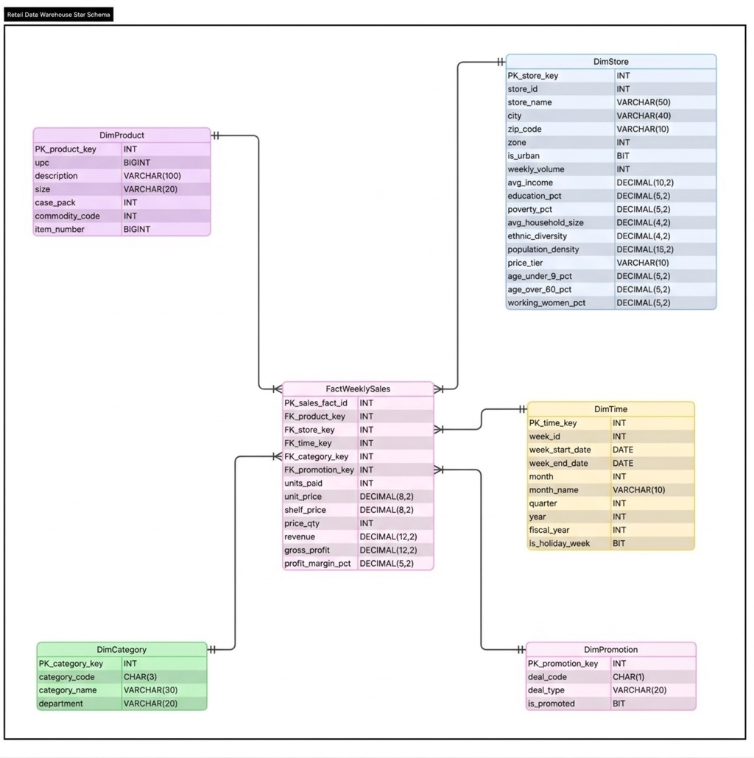
Figure 2.Star Schema ERD for the Dominick's Finer Foods (DFF) Data Warehouse FactWeeklySales with Five Dimensions

4.5 Mapping Table #1: Source Files to Staging Tables

Source File | Source Attribute | Mapping | Staging Table Type | Staging Table | Staging Attribute
wsdr.csv | UPC | Copy | Relation | stg_Movement_SDR | UPC
wsdr.csv | STORE | Copy | Relation | stg_Movement_SDR | STORE
wsdr.csv | WEEK | Copy | Relation | stg_Movement_SDR | WEEK
wsdr.csv | MOVE | Copy | Relation | stg_Movement_SDR | MOVE
wsdr.csv | QTY | Copy | Relation | stg_Movement_SDR | QTY
wsdr.csv | PRICE | Copy | Relation | stg_Movement_SDR | PRICE
wsdr.csv | SALE | Copy | Relation | stg_Movement_SDR | SALE
wsdr.csv | PROFIT | Copy | Relation | stg_Movement_SDR | PROFIT
wsdr.csv | OK | Copy | Relation | stg_Movement_SDR | OK
wsdr.csv | (filename) | Derive: extract 'SDR' | Relation | stg_Movement_SDR | CATEGORY_CODE
WCSO-Done.csv | UPC | Copy | Relation | stg_Movement_CSO | UPC
WCSO-Done.csv | STORE | Copy | Relation | stg_Movement_CSO | STORE
WCSO-Done.csv | WEEK | Copy | Relation | stg_Movement_CSO | WEEK
WCSO-Done.csv | MOVE | Copy | Relation | stg_Movement_CSO | MOVE
WCSO-Done.csv | QTY | Copy | Relation | stg_Movement_CSO | QTY
WCSO-Done.csv | PRICE | Copy | Relation | stg_Movement_CSO | PRICE
WCSO-Done.csv | SALE | Copy | Relation | stg_Movement_CSO | SALE
WCSO-Done.csv | PROFIT | Copy | Relation | stg_Movement_CSO | PROFIT
WCSO-Done.csv | OK | Copy | Relation | stg_Movement_CSO | OK
WCSO-Done.csv | (filename) | Derive: extract 'CSO' | Relation | stg_Movement_CSO | CATEGORY_CODE
WTPA_done.csv | UPC | Copy | Relation | stg_Movement_TPA | UPC
WTPA_done.csv | STORE | Copy | Relation | stg_Movement_TPA | STORE
WTPA_done.csv | WEEK | Copy | Relation | stg_Movement_TPA | WEEK
WTPA_done.csv | MOVE | Copy | Relation | stg_Movement_TPA | MOVE
WTPA_done.csv | QTY | Copy | Relation | stg_Movement_TPA | QTY
WTPA_done.csv | PRICE | Copy | Relation | stg_Movement_TPA | PRICE
WTPA_done.csv | SALE | Copy | Relation | stg_Movement_TPA | SALE
WTPA_done.csv | PROFIT | Copy | Relation | stg_Movement_TPA | PROFIT
WTPA_done.csv | OK | Copy | Relation | stg_Movement_TPA | OK
WTPA_done.csv | (filename) | Derive: extract 'TPA' | Relation | stg_Movement_TPA | CATEGORY_CODE
Done-WCRA.csv | UPC | Copy | Relation | stg_Movement_CRA | UPC
Done-WCRA.csv | STORE | Copy | Relation | stg_Movement_CRA | STORE
Done-WCRA.csv | WEEK | Copy | Relation | stg_Movement_CRA | WEEK
Done-WCRA.csv | MOVE | Copy | Relation | stg_Movement_CRA | MOVE
Done-WCRA.csv | QTY | Copy | Relation | stg_Movement_CRA | QTY
Done-WCRA.csv | PRICE | Copy | Relation | stg_Movement_CRA | PRICE
Done-WCRA.csv | SALE | Copy | Relation | stg_Movement_CRA | SALE
Done-WCRA.csv | PROFIT | Copy | Relation | stg_Movement_CRA | PROFIT
Done-WCRA.csv | OK | Copy | Relation | stg_Movement_CRA | OK
Done-WCRA.csv | (filename) | Derive: extract 'CRA' | Relation | stg_Movement_CRA | CATEGORY_CODE
UPCSDR.csv | COM_CODE | Copy | Relation | stg_Product_SDR | COM_CODE
UPCSDR.csv | UPC | Copy | Relation | stg_Product_SDR | UPC
UPCSDR.csv | DESCRIP | Copy | Relation | stg_Product_SDR | DESCRIP
UPCSDR.csv | SIZE | Copy | Relation | stg_Product_SDR | SIZE
UPCSDR.csv | CASE | Copy | Relation | stg_Product_SDR | CASE_PACK
UPCSDR.csv | NITEM | Copy | Relation | stg_Product_SDR | NITEM
UPCSDR.csv | (filename) | Derive: extract 'SDR' | Relation | stg_Product_SDR | CATEGORY_CODE
UPCCSO.csv | COM_CODE | Copy | Relation | stg_Product_CSO | COM_CODE
UPCCSO.csv | UPC | Copy | Relation | stg_Product_CSO | UPC
UPCCSO.csv | DESCRIP | Copy | Relation | stg_Product_CSO | DESCRIP
UPCCSO.csv | SIZE | Copy | Relation | stg_Product_CSO | SIZE
UPCCSO.csv | CASE | Copy | Relation | stg_Product_CSO | CASE_PACK
UPCCSO.csv | NITEM | Copy | Relation | stg_Product_CSO | NITEM
UPCCSO.csv | (filename) | Derive: extract 'CSO' | Relation | stg_Product_CSO | CATEGORY_CODE
UPCTPA.csv | COM_CODE | Copy | Relation | stg_Product_TPA | COM_CODE
UPCTPA.csv | UPC | Copy | Relation | stg_Product_TPA | UPC
UPCTPA.csv | DESCRIP | Copy | Relation | stg_Product_TPA | DESCRIP
UPCTPA.csv | SIZE | Copy | Relation | stg_Product_TPA | SIZE
UPCTPA.csv | CASE | Copy | Relation | stg_Product_TPA | CASE_PACK
UPCTPA.csv | NITEM | Copy | Relation | stg_Product_TPA | NITEM
UPCTPA.csv | (filename) | Derive: extract 'TPA' | Relation | stg_Product_TPA | CATEGORY_CODE
UPCCRA.csv | COM_CODE | Copy | Relation | stg_Product_CRA | COM_CODE
UPCCRA.csv | UPC | Copy | Relation | stg_Product_CRA | UPC
UPCCRA.csv | DESCRIP | Copy | Relation | stg_Product_CRA | DESCRIP
UPCCRA.csv | SIZE | Copy | Relation | stg_Product_CRA | SIZE
UPCCRA.csv | CASE | Copy | Relation | stg_Product_CRA | CASE_PACK
UPCCRA.csv | NITEM | Copy | Relation | stg_Product_CRA | NITEM
UPCCRA.csv | (filename) | Derive: extract 'CRA' | Relation | stg_Product_CRA | CATEGORY_CODE
DEMO.csv | STORE | Copy | Relation | stg_Store | STORE
DEMO.csv | NAME | Copy | Relation | stg_Store | NAME
DEMO.csv | CITY | Copy | Relation | stg_Store | CITY
DEMO.csv | ZIP | Copy | Relation | stg_Store | ZIP
DEMO.csv | ZONE | Copy | Relation | stg_Store | ZONE
DEMO.csv | URBAN | Copy | Relation | stg_Store | URBAN
DEMO.csv | WEEKVOL | Copy | Relation | stg_Store | WEEKVOL
DEMO.csv | INCOME | Copy | Relation | stg_Store | INCOME
DEMO.csv | EDUC | Copy | Relation | stg_Store | EDUC
DEMO.csv | POVERTY | Copy | Relation | stg_Store | POVERTY
DEMO.csv | HSIZEAVG | Copy | Relation | stg_Store | HSIZEAVG
DEMO.csv | ETHNIC | Copy | Relation | stg_Store | ETHNIC
DEMO.csv | DENSITY | Copy | Relation | stg_Store | DENSITY
DEMO.csv | PRICLOW | Copy | Relation | stg_Store | PRICLOW
DEMO.csv | PRICMED | Copy | Relation | stg_Store | PRICMED
DEMO.csv | PRICHIGH | Copy | Relation | stg_Store | PRICHIGH
DEMO.csv | AGE9 | Copy | Relation | stg_Store | AGE9
DEMO.csv | AGE60 | Copy | Relation | stg_Store | AGE60
DEMO.csv | WORKWOM | Copy | Relation | stg_Store | WORKWOM

4.6 Mapping Table #2: Staging Tables to Data Mart Tables
​​
Staging Table | Staging Attribute | Mapping | DM Table Type | DM Table | DM Attribute
stg_Movement_SDR/CSO/TPA/CRA | MOVE | Copy | Fact | FactWeeklySales | units_sold
stg_Movement_SDR/CSO/TPA/CRA | PRICE | Copy | Fact | FactWeeklySales | shelf_price
stg_Movement_SDR/CSO/TPA/CRA | QTY | Copy | Fact | FactWeeklySales | price_qty
stg_Movement_SDR/CSO/TPA/CRA | PRICE, QTY | Transform: PRICE/QTY | Fact | FactWeeklySales | unit_price
stg_Movement_SDR/CSO/TPA/CRA | MOVE, PRICE, QTY | Transform: MOVE*(PRICE/QTY) | Fact | FactWeeklySales | revenue
stg_Movement_SDR/CSO/TPA/CRA | PROFIT | Copy | Fact | FactWeeklySales | gross_profit
stg_Movement_SDR/CSO/TPA/CRA | PROFIT, revenue | Transform: (PROFIT/revenue)*100 | Fact | FactWeeklySales | profit_margin_pct
stg_Movement_SDR/CSO/TPA/CRA | UPC | Lookup -> DimProduct | Fact | FactWeeklySales | product_key
stg_Movement_SDR/CSO/TPA/CRA | STORE | Lookup -> DimStore | Fact | FactWeeklySales | store_key
stg_Movement_SDR/CSO/TPA/CRA | WEEK | Lookup -> DimTime | Fact | FactWeeklySales | time_key
stg_Movement_SDR/CSO/TPA/CRA | CATEGORY_CODE | Lookup -> DimCategory | Fact | FactWeeklySales | category_key
stg_Movement_SDR/CSO/TPA/CRA | SALE | Lookup -> DimPromotion | Fact | FactWeeklySales | promotion_key
stg_Product_SDR/CSO/TPA/CRA | COM_CODE | Copy | Dimension | DimProduct | commodity_code
stg_Product_SDR/CSO/TPA/CRA | UPC | Copy | Dimension | DimProduct | upc
stg_Product_SDR/CSO/TPA/CRA | DESCRIP | Transform: strip #, ~ | Dimension | DimProduct | description
stg_Product_SDR/CSO/TPA/CRA | SIZE | Copy | Dimension | DimProduct | size
stg_Product_SDR/CSO/TPA/CRA | CASE_PACK | Copy | Dimension | DimProduct | case_pack
stg_Product_SDR/CSO/TPA/CRA | NITEM | Copy | Dimension | DimProduct | item_number
stg_Store | STORE | Copy (CAST to INT) | Dimension | DimStore | store_id
stg_Store | NAME | Transform: ISNULL -> 'UNKNOWN' | Dimension | DimStore | store_name
stg_Store | CITY | Transform: ISNULL -> 'UNKNOWN' | Dimension | DimStore | city
stg_Store | ZIP | Copy (CAST to INT) | Dimension | DimStore | zip_code
stg_Store | ZONE | Copy (CAST to INT) | Dimension | DimStore | zone
stg_Store | WEEKVOL | Copy (CAST to INT) | Dimension | DimStore | weekly_volume
stg_Store | URBAN | Copy (CAST to BIT) | Dimension | DimStore | is_urban
stg_Store | INCOME | Copy (CAST to DECIMAL) | Dimension | DimStore | avg_income
stg_Store | EDUC | Copy (CAST to DECIMAL) | Dimension | DimStore | education_pct
stg_Store | POVERTY | Copy (CAST to DECIMAL) | Dimension | DimStore | poverty_pct
stg_Store | HSIZEAVG | Copy (CAST to DECIMAL) | Dimension | DimStore | avg_household_size
stg_Store | ETHNIC | Copy (CAST to DECIMAL) | Dimension | DimStore | ethnic_diversity
stg_Store | DENSITY | Copy (CAST to DECIMAL) | Dimension | DimStore | population_density
stg_Store | AGE9 | Copy (CAST to DECIMAL) | Dimension | DimStore | age_under_9_pct
stg_Store | AGE60 | Copy (CAST to DECIMAL) | Dimension | DimStore | age_over_60_pct
stg_Store | WORKWOM | Copy (CAST to DECIMAL) | Dimension | DimStore | working_women_pct
stg_Store | PRICLOW, PRICMED, PRICHIGH | Transform: CASE WHEN | Dimension | DimStore | price_tier

4.7 Physical Design Plan
The physical design transforms the logical star schema into a deployable structure on SQL Server 2016. For the data aggregate plan, three summary tables are planned: agg_Weekly_Category_Sales (pre-aggregates units_sold and revenue by week and category to accelerate BQ2), agg_Store_Category_Revenue (aggregates total revenue by store and category for BQ8 quartile analysis), and agg_Weekly_Product_Sales (aggregates units_sold by week and product within a category for BQ9 ranking). These aggregate fact tables echo the original FactWeeklySales structure at reduced grain, following Kimball's guidance. For indexing, the FactWeeklySales table uses a clustered index on sales_fact_id (primary key) with nonclustered indexes on (time_key, store_key, product_key) for composite lookups and single-column nonclustered indexes on promotion_key and category_key for BQ-specific filtering. Dimension tables use unique nonclustered indexes on surrogate primary keys and additional nonclustered indexes on frequently filtered columns (deal_code, is_promoted, price_tier, is_urban, department). During bulk ETL loads, indexes are dropped before loading and recreated afterward to avoid performance degradation.
For data standardization, all naming follows consistent conventions: dimension tables prefixed with "Dim", fact tables with "Fact", staging tables with "stg_", and aggregate tables with "agg_". Column names use snake_case throughout. All surrogate keys are 4-byte INT, monetary values use DECIMAL, and boolean flags use BIT. For storage, the large FactWeeklySales table (~34.6M rows, ~4-5 GB) will be horizontally partitioned by time_key (yearly partitions). Total estimated storage is 8-10 GB including indexes. The data mart architecture ensures new categories or business processes can be added without modifying existing tables.

Section 5: Development of the ETL Plan
This section develops the complete ETL plan following the framework discussed in class.

5.1 All Target Data in the Data Warehouse
The data warehouse consists of 6 tables:
Table | Type | Target Columns | Estimated Rows
DimCategory | Dimension | category_key, category_code, category_name, department | 28
DimPromotion | Dimension | promotion_key, deal_code, deal_type, is_promoted | 4
DimTime | Dimension | time_key, week_id, week_start_date, week_end_date, month, month_name, quarter, year, fiscal_year, is_holiday_week | ~400
DimStore | Dimension | store_key, store_id, store_name, city, zip_code, zone, is_urban, weekly_volume, avg_income, education_pct, poverty_pct, avg_household_size, ethnic_diversity, population_density, price_tier, age_under_9_pct, age_over_60_pct, working_women_pct | ~107
DimProduct | Dimension | product_key, upc, description, size, case_pack, commodity_code, item_number | ~3,112
FactWeeklySales | Fact | sales_fact_id, product_key, store_key, time_key, category_key, promotion_key, units_sold, unit_price, shelf_price, price_qty, revenue, gross_profit, profit_margin_pct | ~34.6M

5.2 All Data Sources
Source | File | Location | Rows | Purpose
Movement – Soft Drinks | wsdr.csv | DFF data/Movement/WSDR/ | 17.7M | BQ2, BQ3
Movement – Canned Soup | WCSO-Done.csv | DFF data/Movement/WCSO/ | 7.0M | BQ4
Movement – Toothpaste | WTPA_done.csv | DFF data/Movement/WTPA/ | 6.3M | BQ8
Movement – Crackers | Done-WCRA.csv | DFF data/Movement/WCRA/ | 3.6M | BQ9
UPC – Soft Drinks | UPCSDR.csv | DFF data/UPC/ | 1,746 | Product master
UPC – Canned Soup | UPCCSO.csv | DFF data/UPC/ | 453 | Product master
UPC – Toothpaste | UPCTPA.csv | DFF data/UPC/ | 608 | Product master
UPC – Crackers | UPCCRA.csv | DFF data/UPC/ | 305 | Product master
Demographics | DEMO.csv | DFF data/Demographics/ | 108 | Store attributes

5.3 Data Mappings
Two mapping tables have been prepared in Excel format (see Sections 4.5 and 4.6):
- Mapping Table #1 (Source to Staging): Documents how each source CSV column maps to a staging table attribute. All mappings at this stage are Copy operations, with one exception: CATEGORY_CODE is Derived from the source filename.
- Mapping Table #2 (Staging to Data Mart): Documents how each staging attribute maps to a data mart column. Mappings include Copy, Transform (computed columns like revenue, unit_price), and Lookup (surrogate key resolution via dimension table joins).
The complete Excel versions of both Mapping Table #1 and Mapping Table #2 are included in Appendix B.

5.4 Comprehensive Data Extraction Rules
Rule | Description
Extraction Technique | Capture of Static Data CSV files are static historical snapshots. No impact on source systems.
Extraction Frequency | One-time initial load (complete historical dataset, no incremental updates).
Time Window | Not applicable batch load of complete files during off-peak hours.
Source Identification | 4 Movement CSVs + 4 UPC CSVs + DEMO.csv = 9 source files.
Quality Filter | Extract only rows where OK = 1 from Movement files (quality-validated observations).
Encoding | All CSV files require Windows-1252 (CP1252) encoding, not UTF-8.
File Format | Comma-delimited, no text qualifier, header row present in all files.
Tool | SSIS Data Flow Task with Flat File Source connection manager.

5.5 Data Transformation and Cleansing Rules
# | Rule | Source | Target | Type
T1 | Add CATEGORY_CODE column derived from filename | Filename (SDR/CSO/TPA/CRA) | stg_Movement_*.CATEGORY_CODE | Derived value
T2 | Replace NULL/blank SALE with 'N' | Movement.SALE | stg_Movement_*.SALE | Default value
T3 | Filter rows where OK = 1 | Movement.OK | (row selection) | Filter
T4 | Filter rows where PRICE > 0 | Movement.PRICE | (row selection) | Filter
T5 | Strip '#' and '~' from product descriptions | UPC.DESCRIP | stg_Product_*.DESCRIP | String cleaning
T6 | Remove '.' placeholder row from demographics | DEMO.STORE | stg_Store | Filter
T7 | Replace NULL NAME/CITY with 'UNKNOWN' | DEMO.NAME, CITY | stg_Store.NAME, CITY | Default value
T8 | Derive PRICE_TIER from binary flags | DEMO.PRICLOW/MED/HIGH | DimStore.price_tier | Conditional (CASE)
T9 | CAST VARCHAR to proper data types | stg_Store | DimStore | Type conversion
T10 | Compute unit_price = PRICE / QTY | Movement.PRICE, QTY | FactWeeklySales.unit_price | Derived value
T11 | Compute revenue = MOVE × (PRICE / QTY) | Movement.MOVE, PRICE, QTY | FactWeeklySales.revenue | Derived value
T12 | Compute profit_margin_pct = (PROFIT / revenue) × 100 | Movement.PROFIT, revenue | FactWeeklySales.profit_margin_pct | Derived value
T13 | Lookup product_key from DimProduct | Movement.UPC | FactWeeklySales.product_key | Surrogate key lookup
T14 | Lookup store_key from DimStore | Movement.STORE | FactWeeklySales.store_key | Surrogate key lookup
T15 | Lookup time_key from DimTime | Movement.WEEK | FactWeeklySales.time_key | Surrogate key lookup
T16 | Lookup category_key from DimCategory | CATEGORY_CODE | FactWeeklySales.category_key | Surrogate key lookup
T17 | Lookup promotion_key from DimPromotion | Movement.SALE | FactWeeklySales.promotion_key | Surrogate key lookup
T18 | Generate week_start_date from week_id | DATEADD formula | DimTime.week_start_date | Date calculation
T19 | Derive month, quarter, year from date | week_start_date | DimTime.month/quarter/year | Date parts

5.6 Plan for Aggregate Tables
Three pre-computed aggregate tables will be created to improve query performance:
Aggregate Table | Grain | Measures | Accelerates
agg_Weekly_Category_Sales | Week × Category | SUM(units_sold), SUM(revenue), AVG(unit_price) | BQ2
agg_Store_Category_Revenue | Store × Category | SUM(revenue), SUM(gross_profit) | BQ8
agg_Weekly_Product_Sales | Week × Product × Category | SUM(units_sold), RANK | BQ9

These aggregate tables echo the original FactWeeklySales structure at reduced grain, following Kimball's guidance that summary tables should mirror the base fact table's structure.

5.7 Organization of Data Staging Area
SQL Server 2016
├── [team1_staging_area] ← Staging Database
│ ├── dbo.stg_Movement_SDR (raw wsdr.csv data)
│ ├── dbo.stg_Movement_CSO (raw WCSO-Done.csv data)
│ ├── dbo.stg_Movement_TPA (raw WTPA_done.csv data)
│ ├── dbo.stg_Movement_CRA (raw Done-WCRA.csv data)
│ ├── dbo.stg_Product_SDR (raw UPCSDR.csv data)
│ ├── dbo.stg_Product_CSO (raw UPCCSO.csv data)
│ ├── dbo.stg_Product_TPA (raw UPCTPA.csv data)
│ ├── dbo.stg_Product_CRA (raw UPCCRA.csv data)
│ ├── dbo.stg_Store (raw DEMO.csv data)
│ └── dbo.tmp_Product_All [TEMP] (UNION of 4 UPC tables)
│
└── [team1_dw_area] ← Data Mart (Presentation Server)
├── dbo.DimCategory (28 rows)
├── dbo.DimPromotion (4 rows)
├── dbo.DimTime (~400 rows)
├── dbo.DimStore (~107 rows)
├── dbo.DimProduct (~3,112 rows)
└── dbo.FactWeeklySales (~34.6M rows)
Temporary tables to be removed after loading:
Temp Table | Purpose | Remove After
tmp_Product_All | UNION of 4 UPC staging tables for loading DimProduct | Loading DimProduct

5.8 Procedures for All Data Extractions and Loadings
The ETL is implemented through three SSIS packages executed sequentially:
Package 1: `01_Extract_to_Staging.dtsx` Extracts all 9 CSV source files into staging tables using Data Flow Tasks. Each task uses a Flat File Source (encoding 1252, comma-delimited) connected to an OLE DB Destination targeting the staging database.
Package 2: `02_Transform_Staging.dtsx` Executes transformations T1, T2, and T5–T7 in the staging area using Execute SQL Tasks. This includes adding CATEGORY_CODE columns, replacing NULL values, cleaning descriptions, and creating the tmp_Product_All UNION table.
Package 3: `03_Load_DataMart.dtsx` Creates and populates all dimension and fact tables in the data mart using Execute SQL Tasks. Dimensions are loaded first (DimCategory, DimPromotion, DimTime, DimStore, DimProduct), then the fact table (FactWeeklySales). Completes with DROP TABLE for temporary tables.

5.9 ETL for Dimension Table
Dimensions are loaded before the fact table because fact table foreign keys reference dimension surrogate keys. The loading order ensures referential integrity.
DimCategory (28 rows): Loaded via Execute SQL Task with hardcoded INSERT statements. All 28 product categories and their department groupings are inserted directly. No staging table needed.
DimPromotion (4 rows): Loaded via Execute SQL Task with hardcoded INSERT statements. Maps the four possible SALE values (N, B, C, S) to descriptive labels and an is_promoted flag.
DimTime (~400 rows): Generated via Execute SQL Task using a recursive CTE. Week 1 corresponds to September 14, 1989 (per the DFF codebook). Each subsequent week_id adds 7 days via DATEADD. Month, quarter, year, and month_name are derived using DATEPART and DATENAME functions.
DimStore (~107 rows): Loaded from stg_Store using an INSERT INTO...SELECT statement. Transformations applied during loading: CAST string columns to proper types, derive price_tier using CASE WHEN on the three binary pricing flags (PRICLOW/PRICMED/PRICHIGH), and filter out invalid rows (STORE = '.').
DimProduct (~3,112 rows): Loaded from tmp_Product_All (UNION of 4 UPC staging tables) using INSERT INTO...SELECT. Product descriptions are cleaned during the staging transformation phase (strip # and ~ characters).

5.10 ETL for Fact Table
FactWeeklySales (~34.6M rows): This is the largest and most complex load. An INSERT INTO...SELECT statement unions all four movement staging tables (filtered to OK=1 and PRICE>0), then JOINs to all five dimension tables to resolve surrogate keys:
- DimProduct: JOIN on UPC to get product_key
- DimStore: JOIN on STORE to get store_key
- DimTime: JOIN on WEEK to get time_key
- DimCategory: JOIN on CATEGORY_CODE to get category_key
- DimPromotion: INNER JOIN on SALE to get promotion_key
Three derived columns are computed during loading: unit_price (PRICE/QTY), revenue (MOVE × unit_price), and profit_margin_pct (PROFIT/revenue × 100), with NULL guards for division by zero.

Section 6: Implementation of the ETL Plan
This section documents the actual implementation of the ETL plan using SSIS (SQL Server Integration Services) and SSMS (SQL Server Management Studio) on SQL Server 2016. All SQL statements used for ETL operations are included. Snapshots of before-and-after table contents and ETL runs are provided to demonstrate the effectiveness of each ETL step.

6.1 Database Creation
The two databases were created using the following SQL:
CREATE DATABASE [team1_staging_area];
CREATE DATABASE [team1_dw_area];
Screenshot 1: SSMS Object Explorer showing both databases
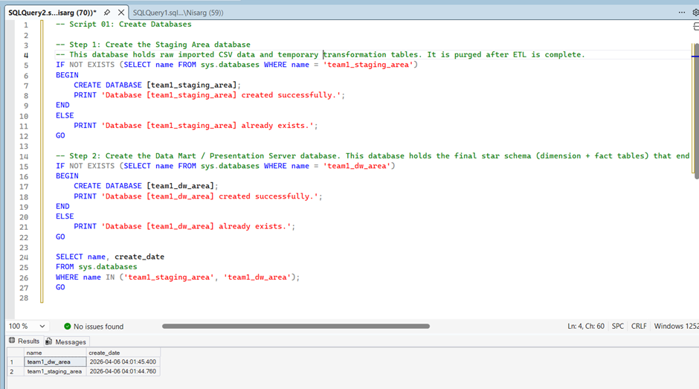

6.2 Staging Table Creation
All 9 staging tables and 1 temporary table were created in team1_staging_area. The complete SQL statements are in Appendix A (02_create_staging_tables.sql).
Screenshot 2: SSMS Object Explorer staging tables listed
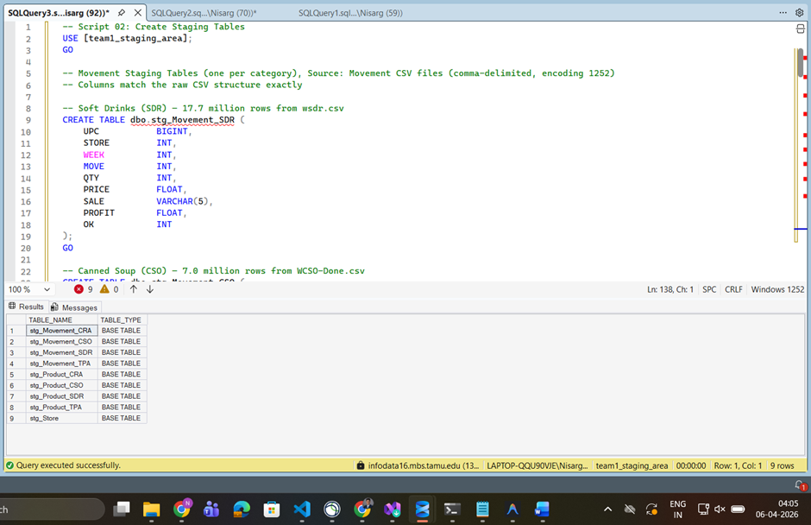
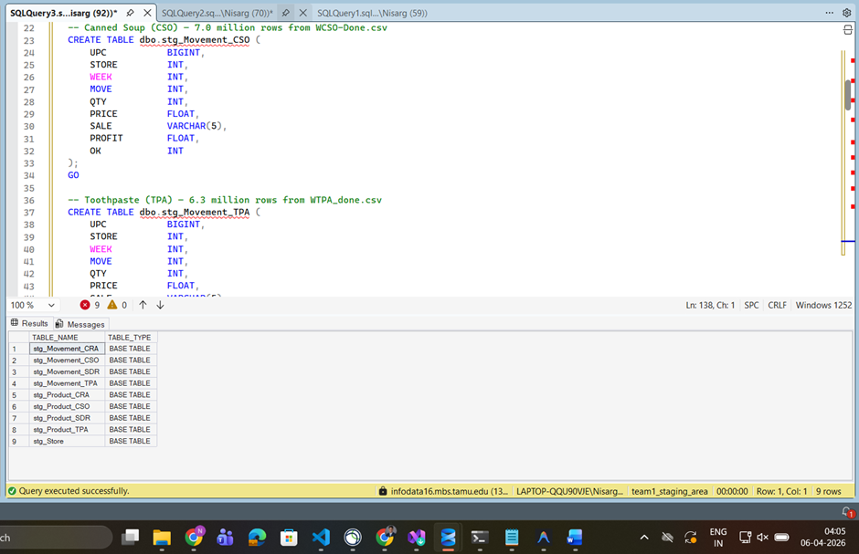
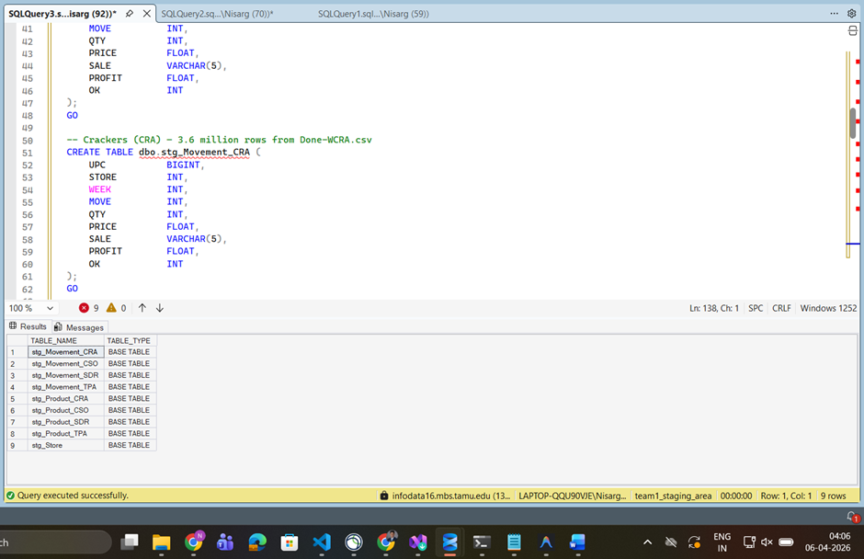
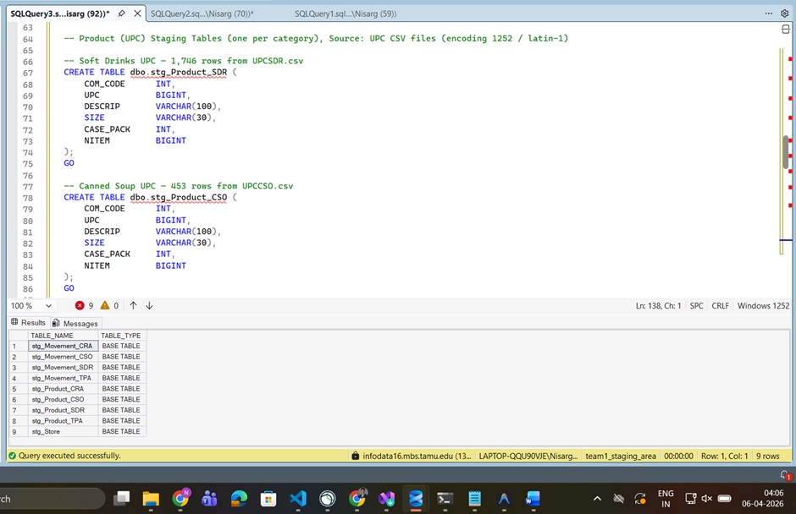

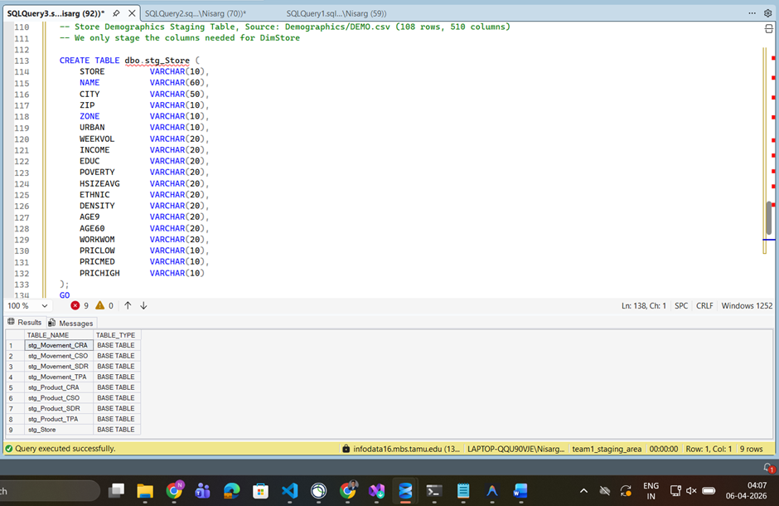
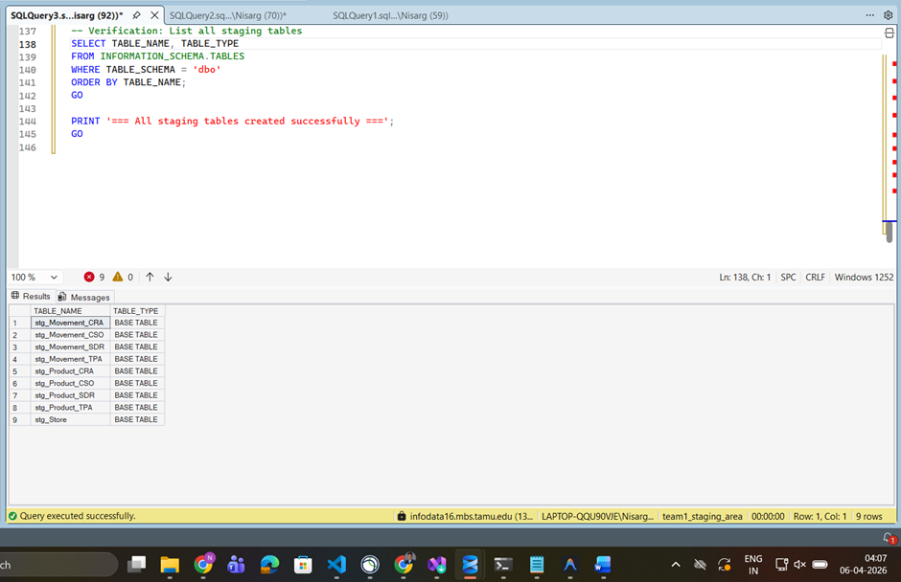

6.3 Data Mart Table Creation
All 5 dimension tables and 1 fact table were created in team1_dw_area, with dimensions created first to enable foreign key constraints. The complete SQL is in Appendix A (03_create_dw_tables.sql).
Screenshot 3: SSMS Object Explorer DW tables listed
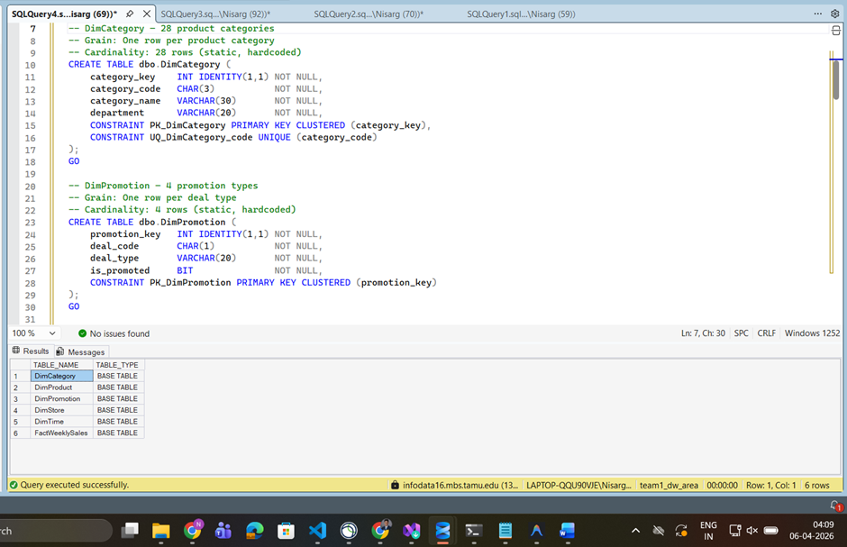
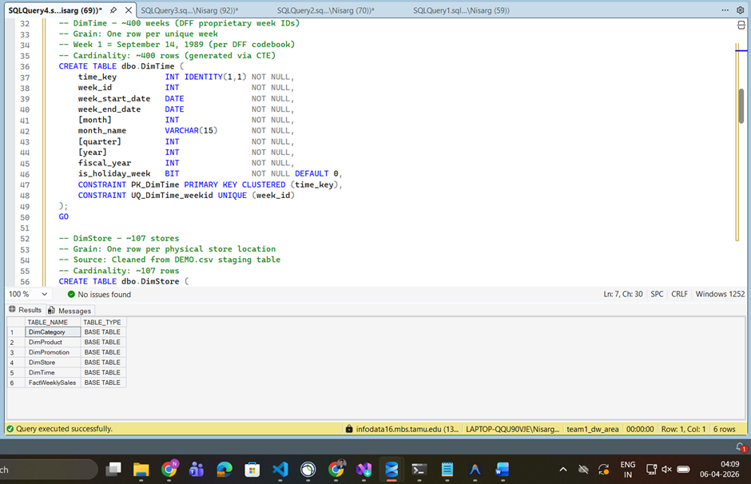
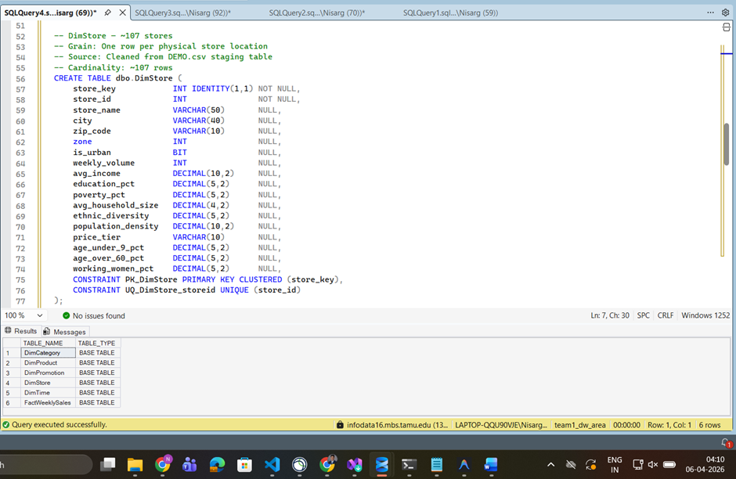
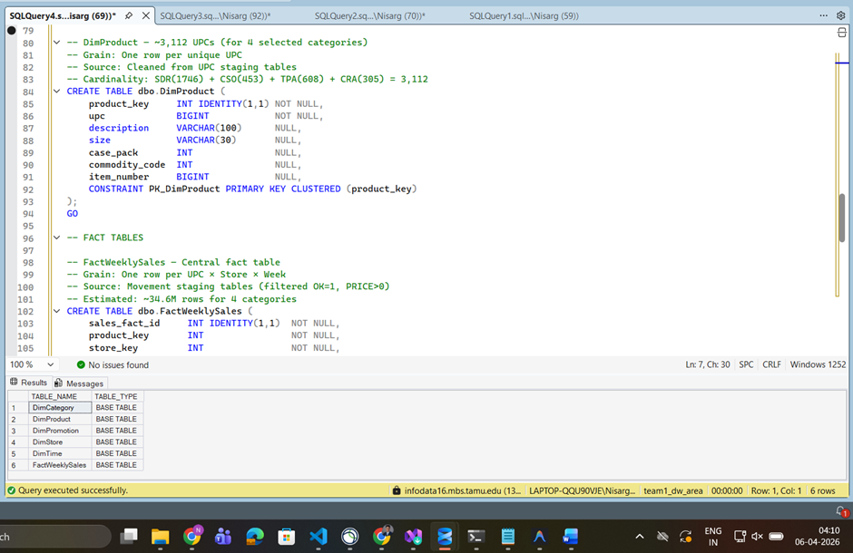
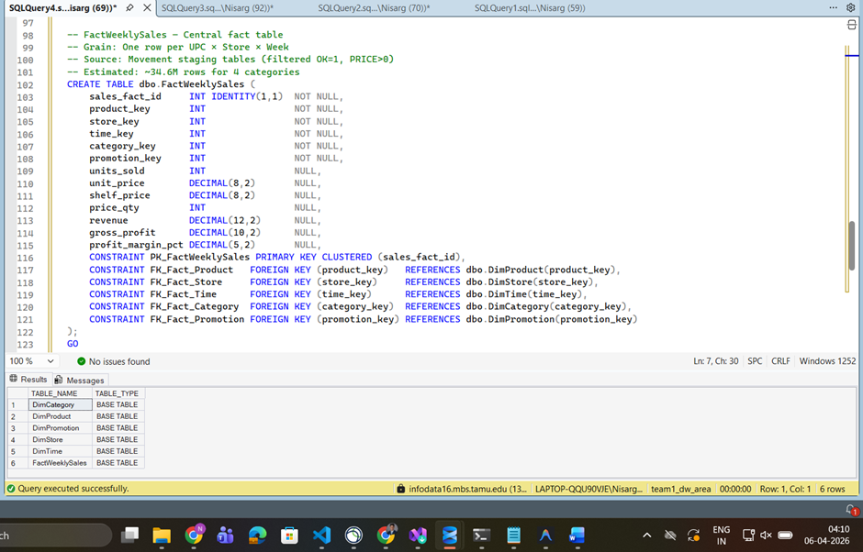
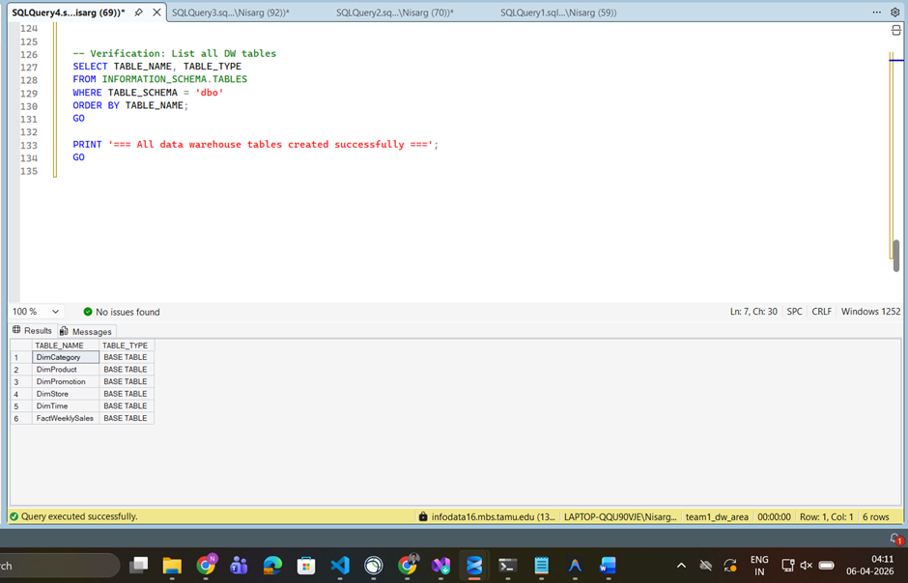

6.4 SSIS Package 1: Extract to Staging
Control Flow: Package 1 contains 9 Data Flow Tasks, each extracting one CSV source file into a corresponding staging table.
Screenshot 4: SSIS Control Flow Package 1 showing all 9 Data Flow Tasks
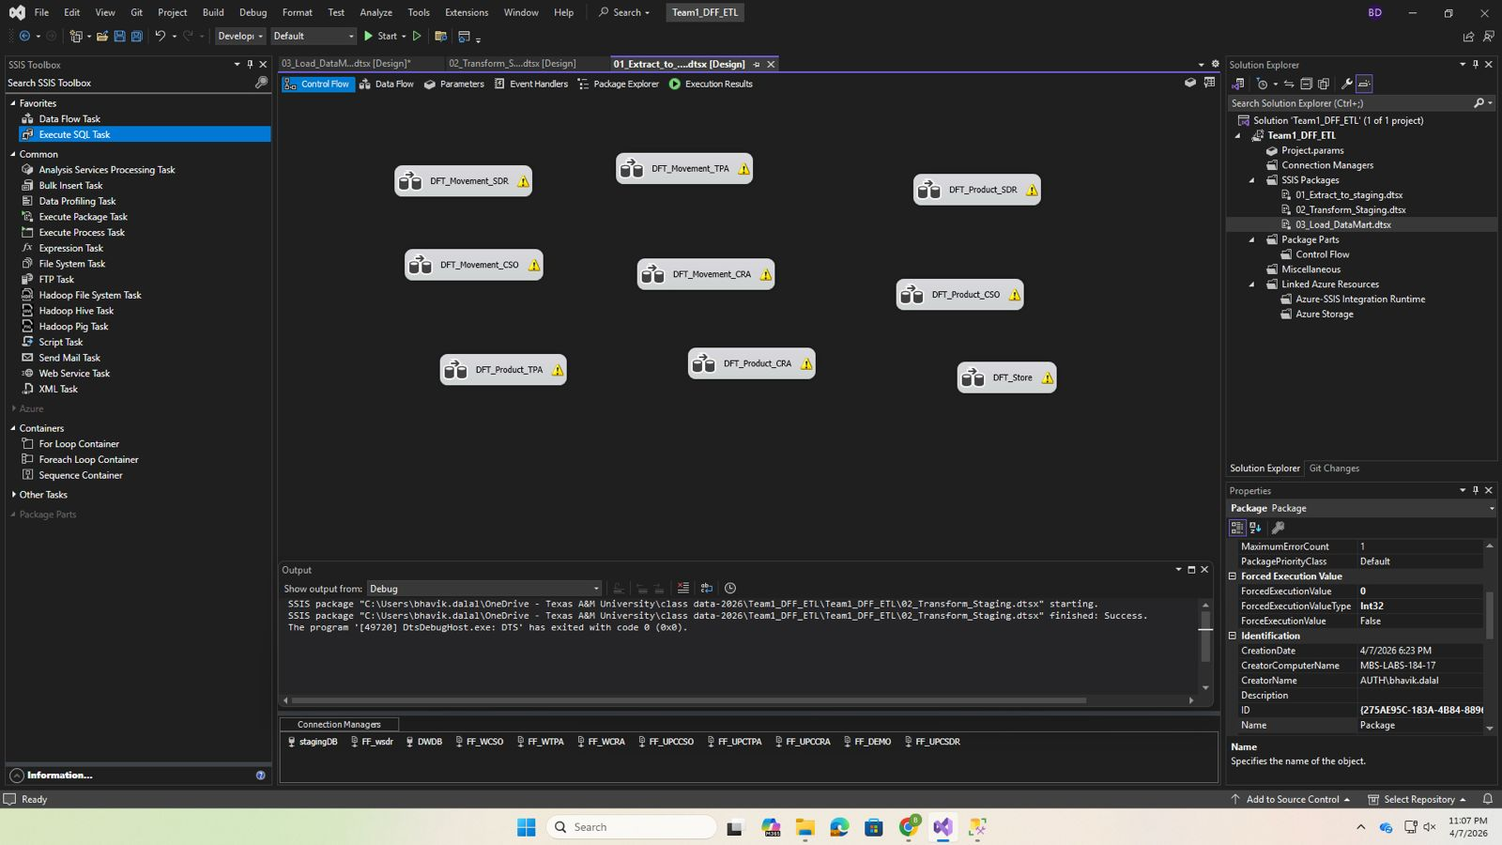

Sample Data Flow Task (Soft Drinks Movement): Flat File Source → OLE DB Destination.
This data flow shows how the Soft Drinks movement file is read from a flat file source and loaded into the staging table using an OLE DB destination.
Screenshot 5: SSIS Data Flow DFT_Movement_SDR
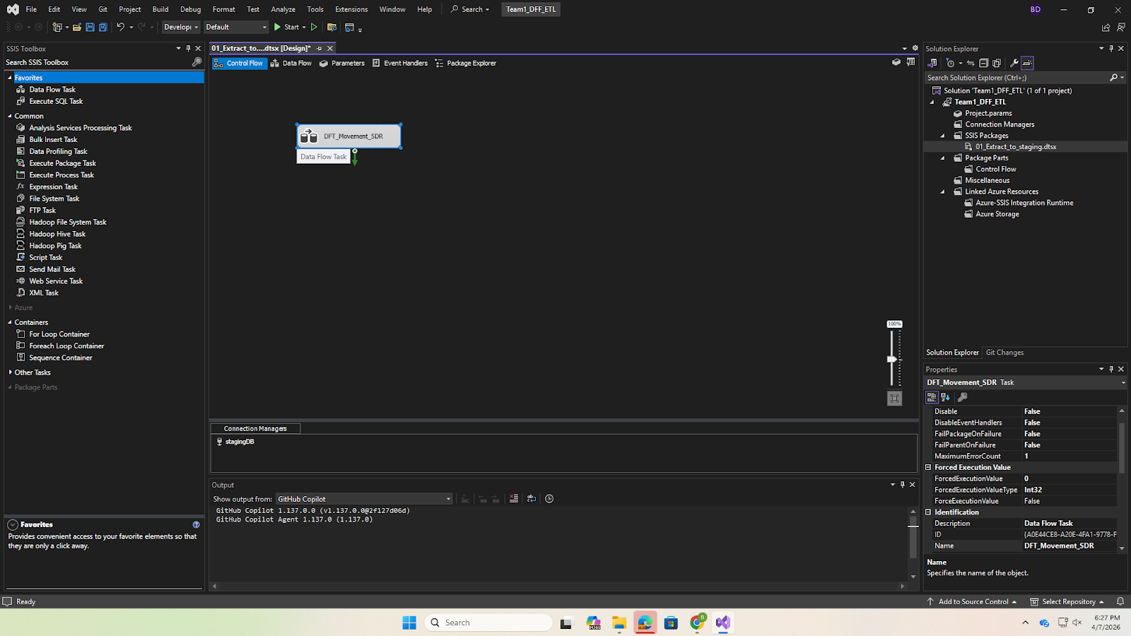

Flat File Connection Settings: Encoding = 1252 (Windows Western), Column Delimiter = Comma, Header Row Delimiter = {CR}{LF}.
Screenshot 6: Flat File Connection Manager encoding and delimiter settings.
This configuration ensures that the CSV files are correctly parsed using Windows-1252 encoding and comma delimiters.

Screenshot 6: Flat File Connection Manager encoding and delimiter settings
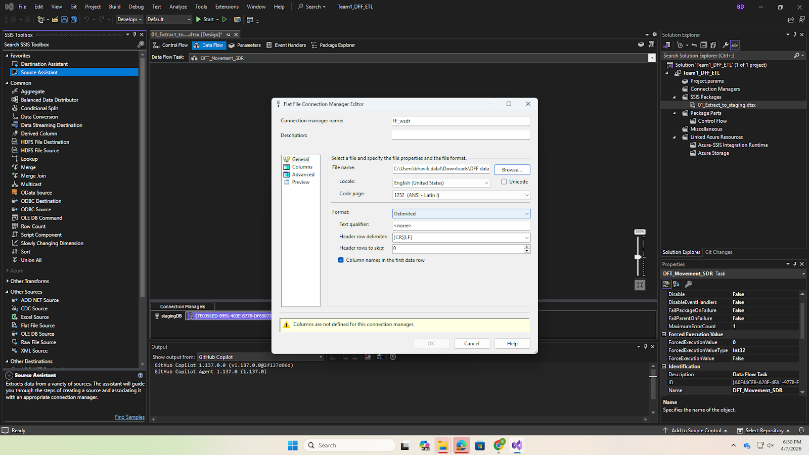
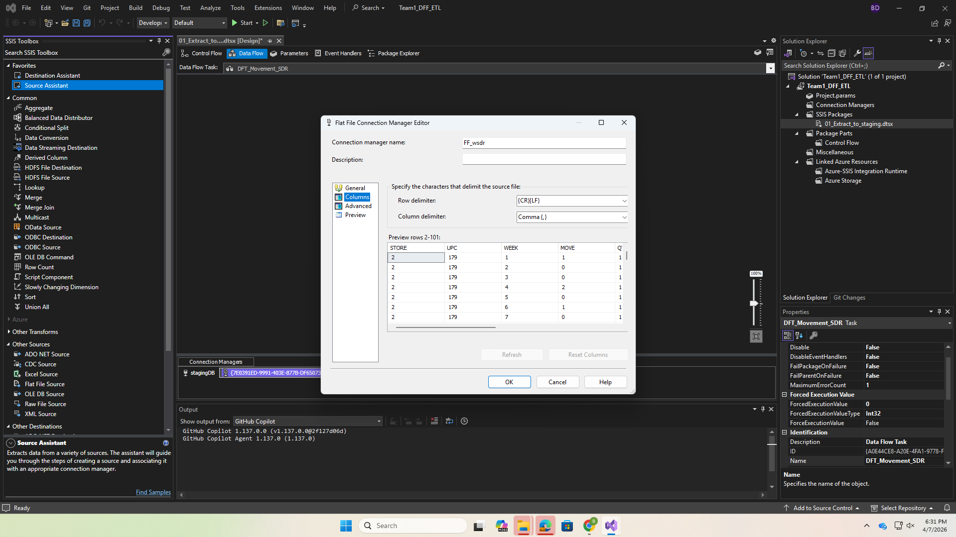

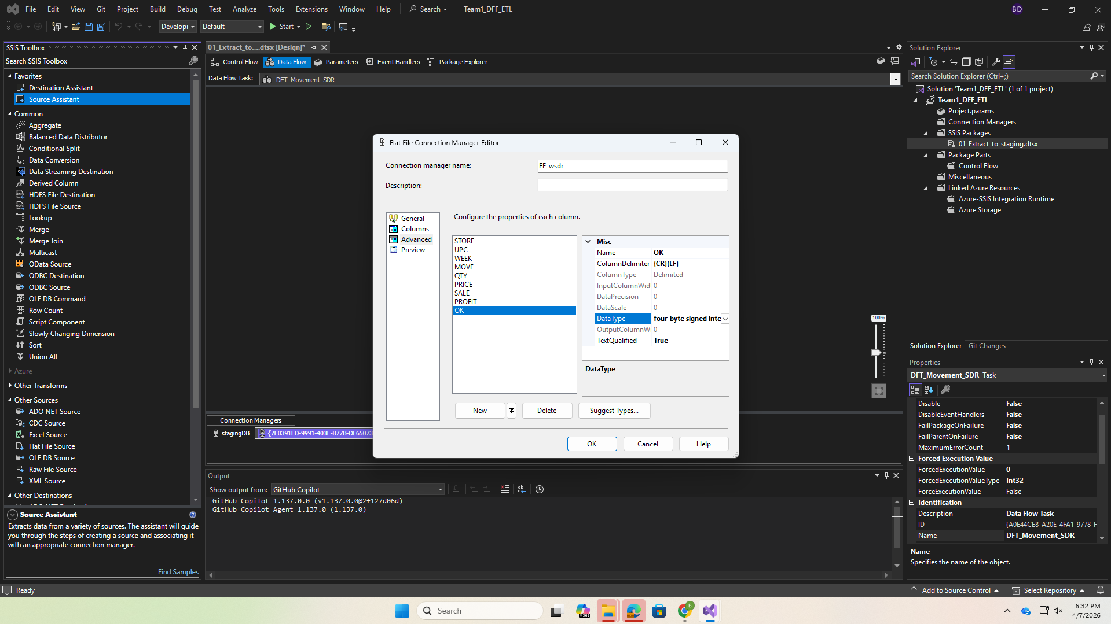

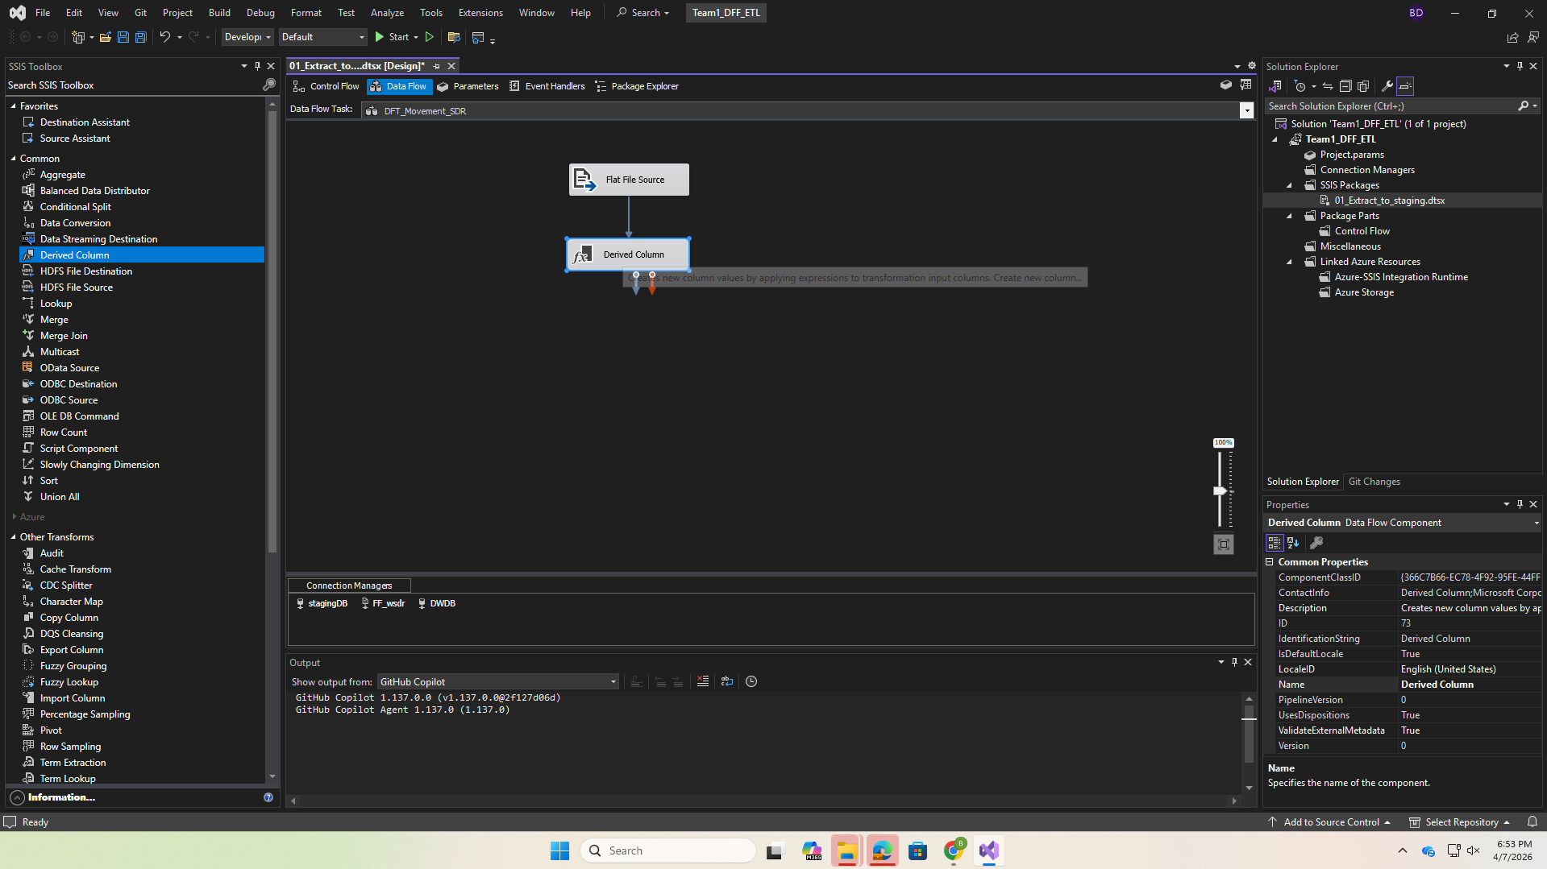
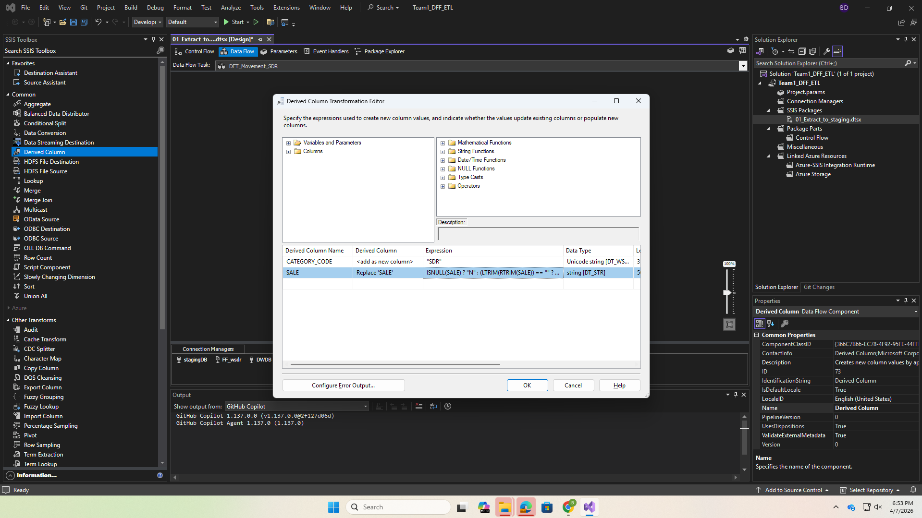

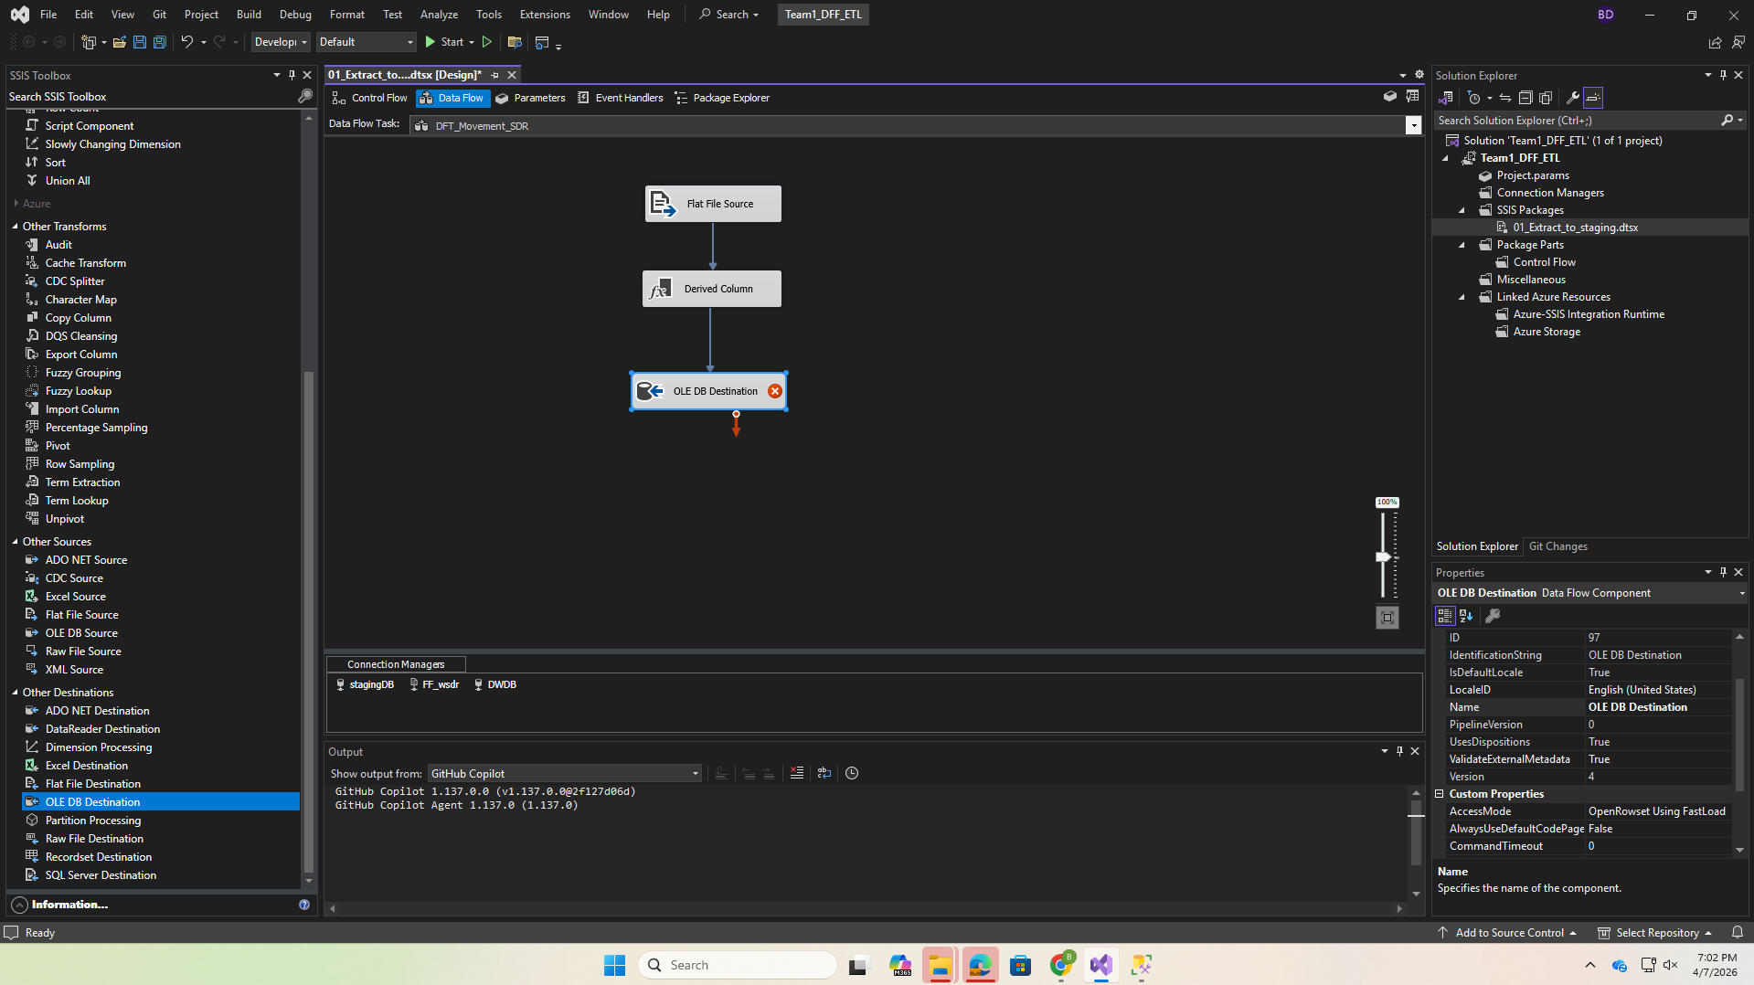
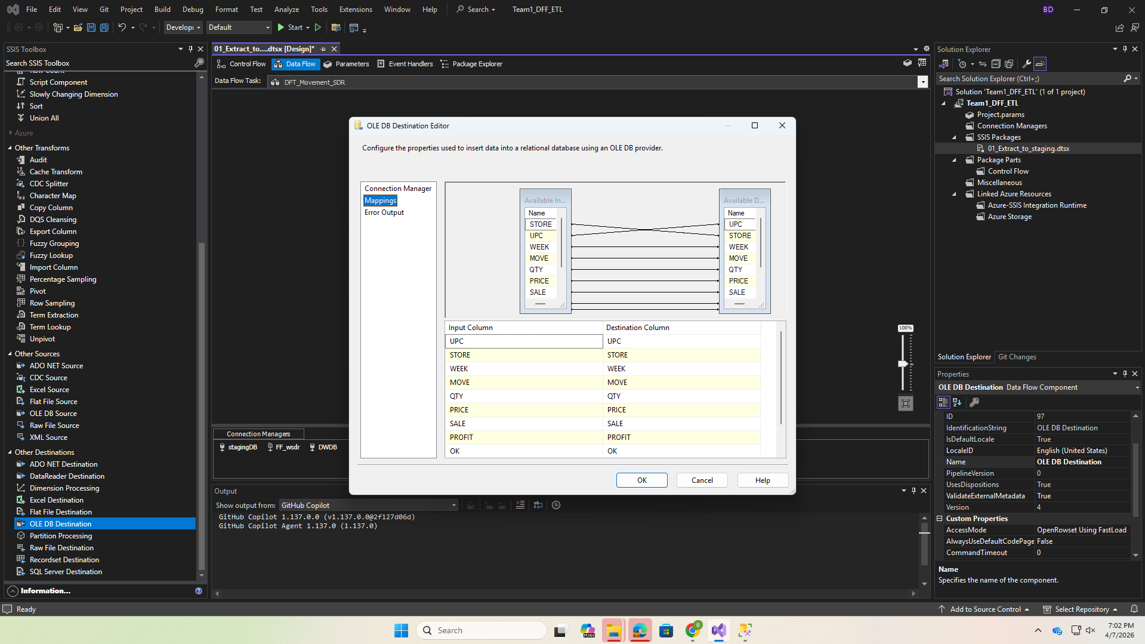
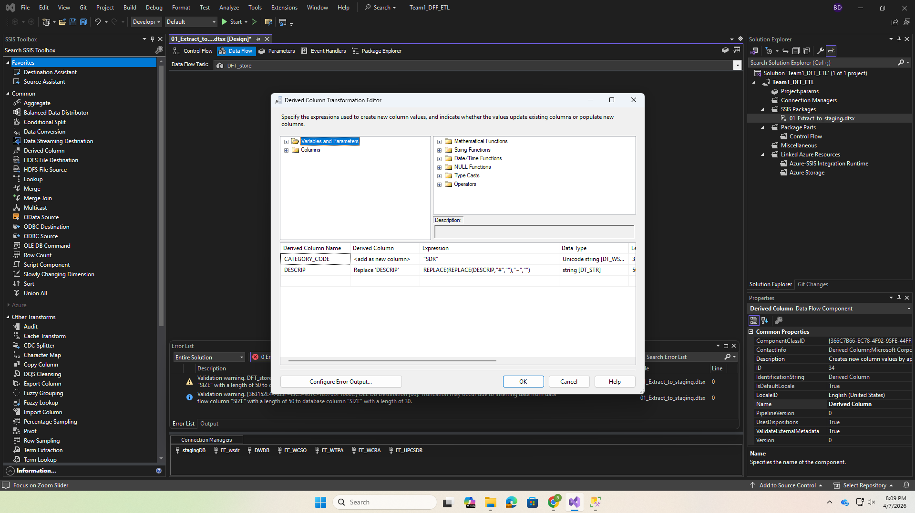
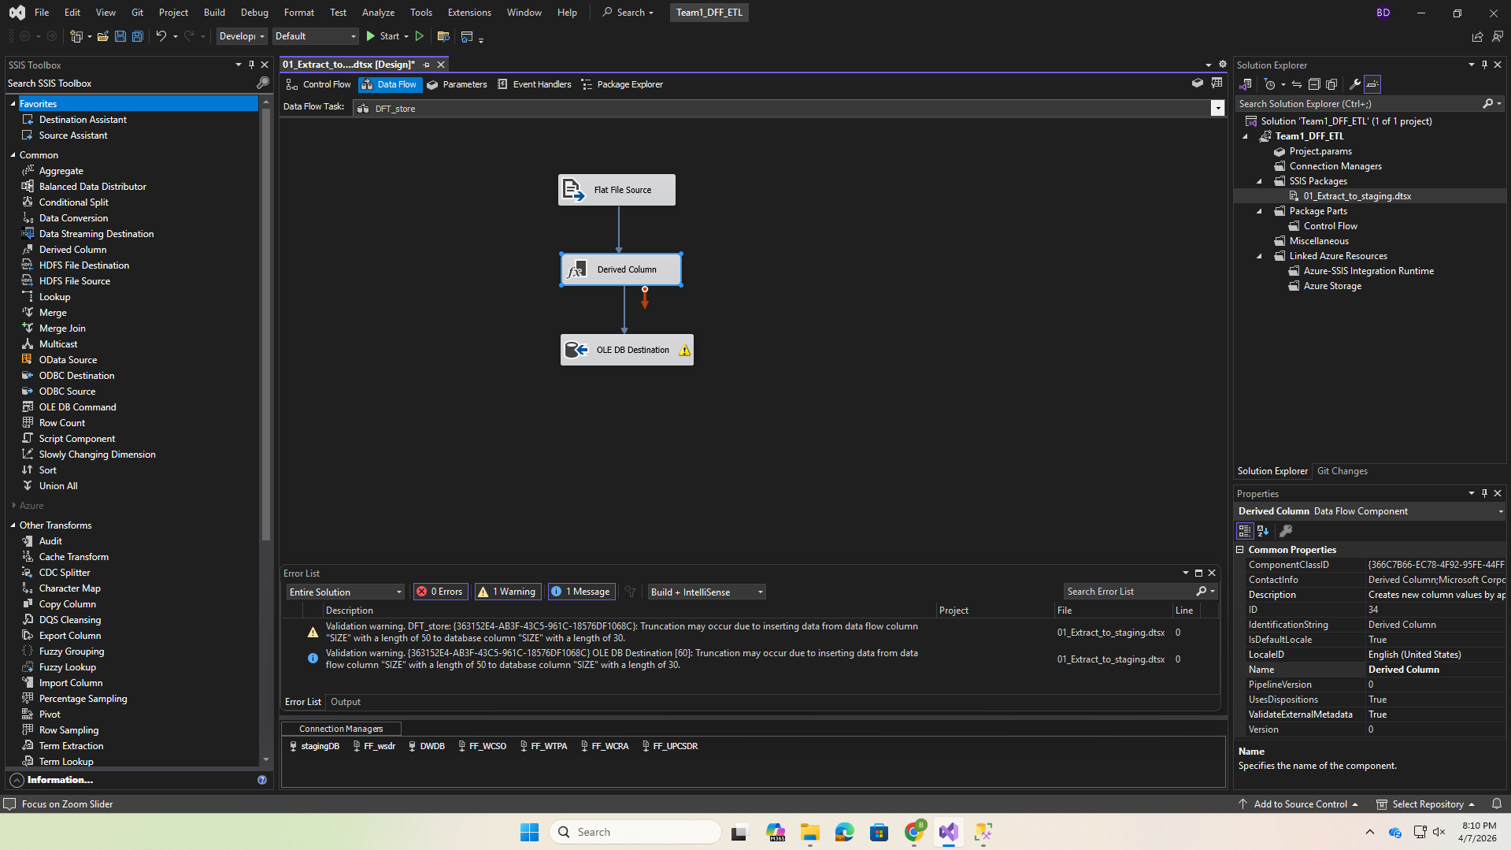

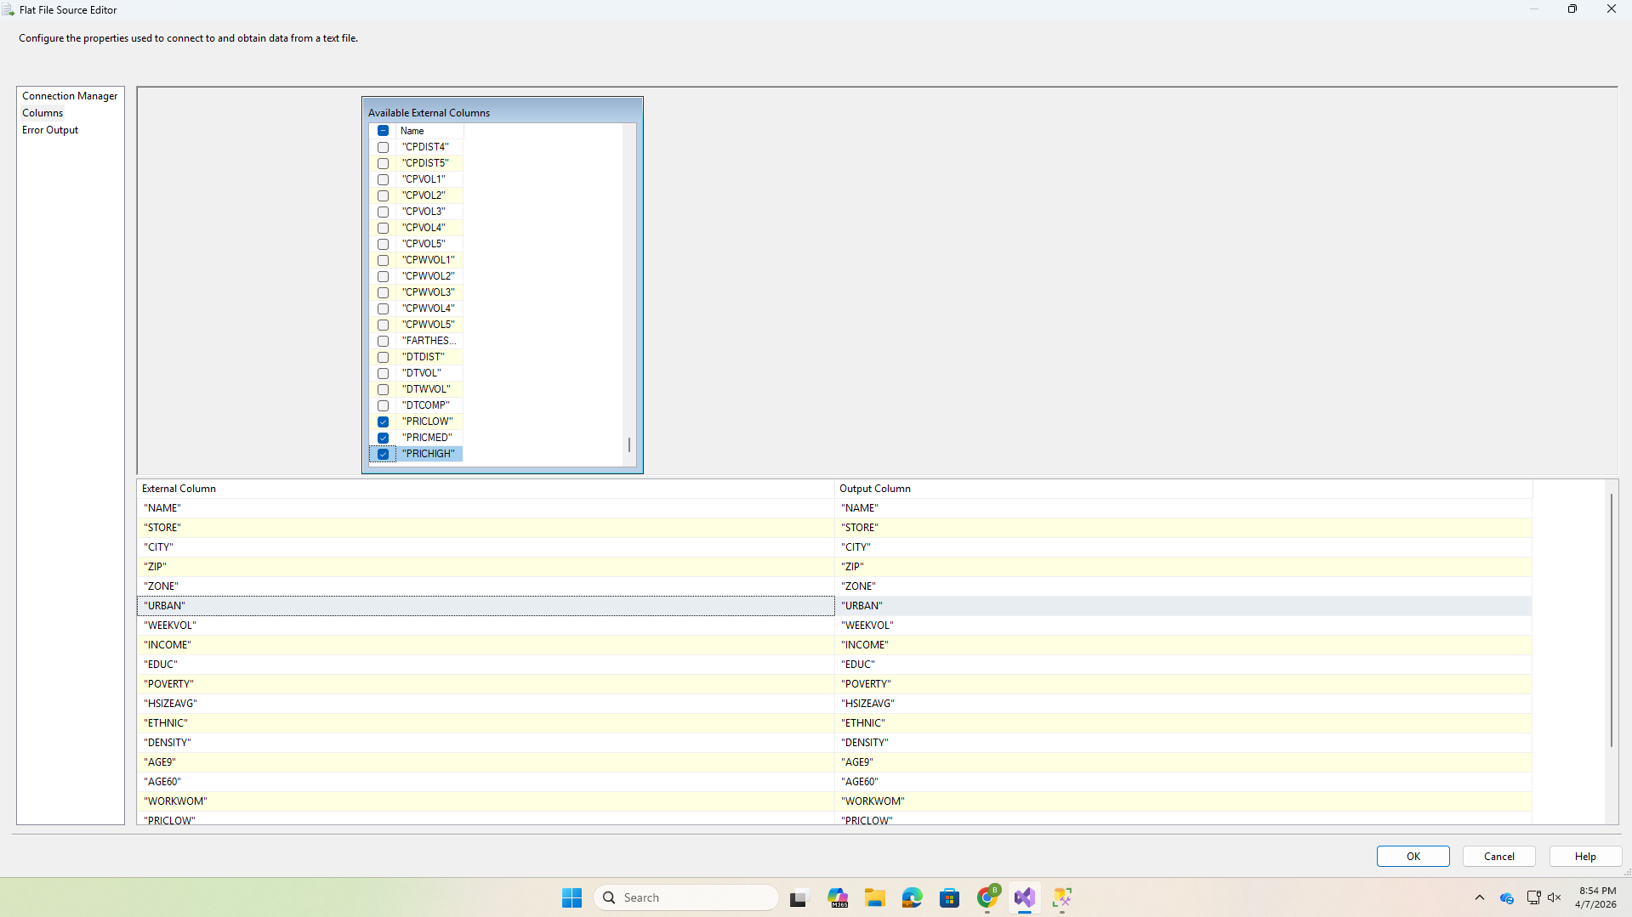
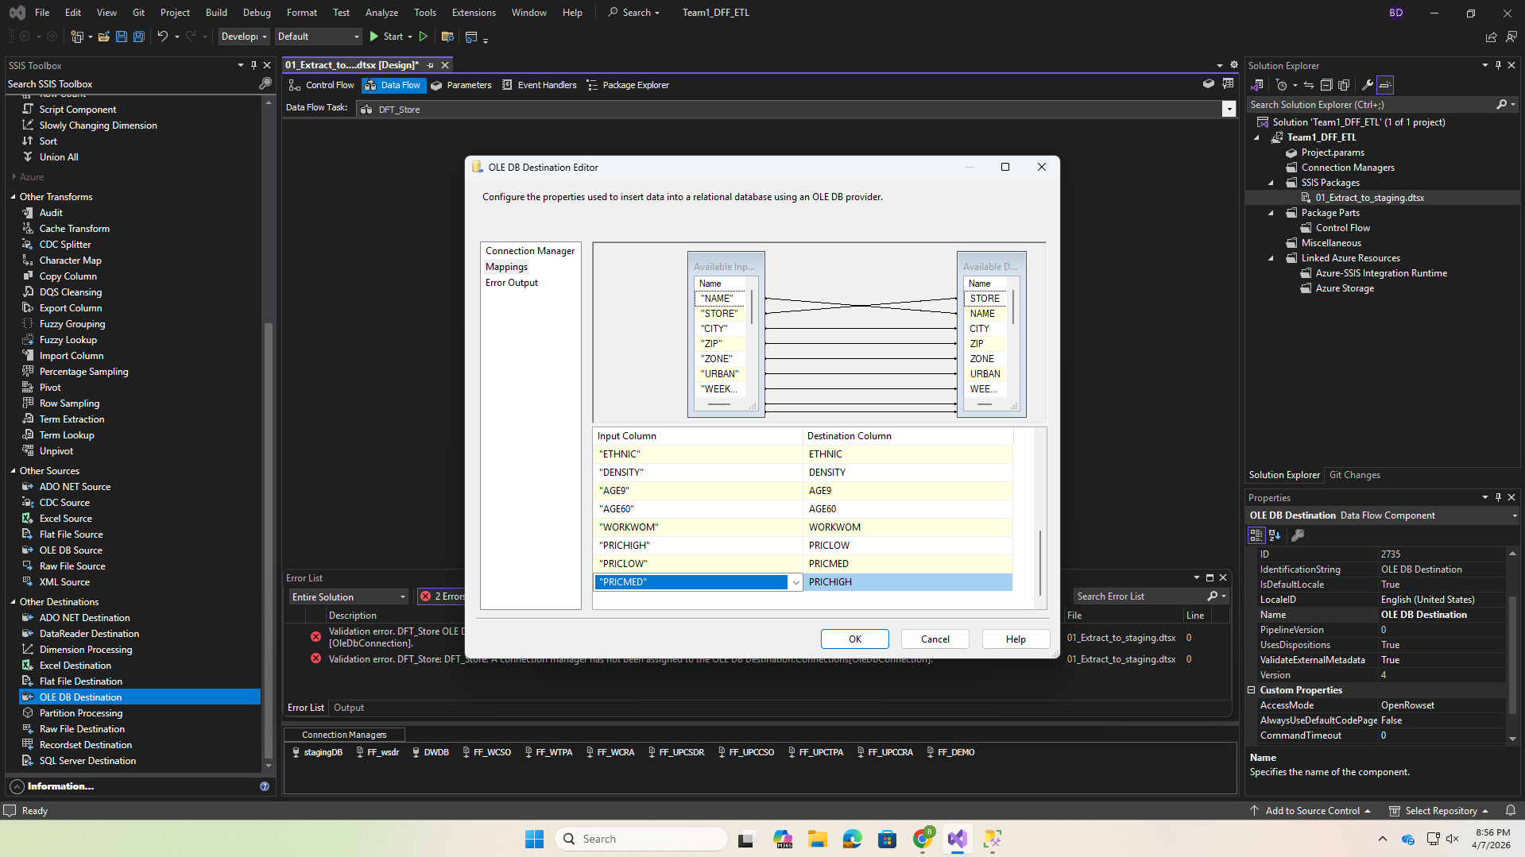

Execution Result:
This result confirms that all extraction tasks completed successfully without errors.
Screenshot 7: SSIS Package 1 execution all green checkmarks
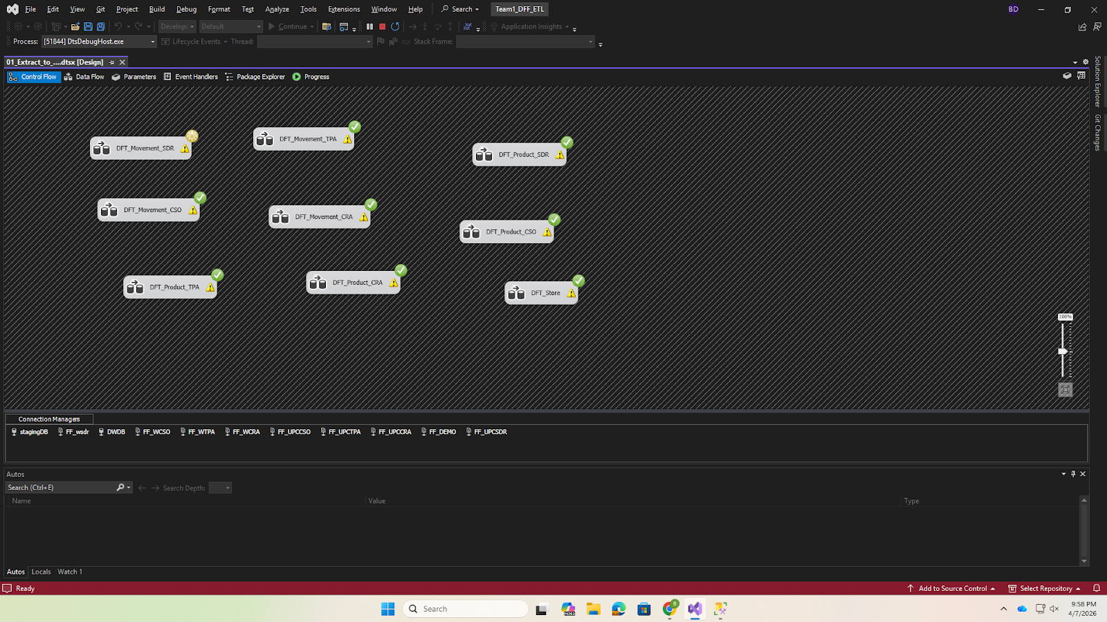

Before Loading (empty staging table):
This query verifies that the staging table is empty before the extraction process begins.
SELECT COUNT(*) AS RowCount FROM [team1_staging_area].dbo.stg_Movement_SDR;
-- Result: 0
Screenshot 8: SSMS SELECT COUNT showing 0 rows before load
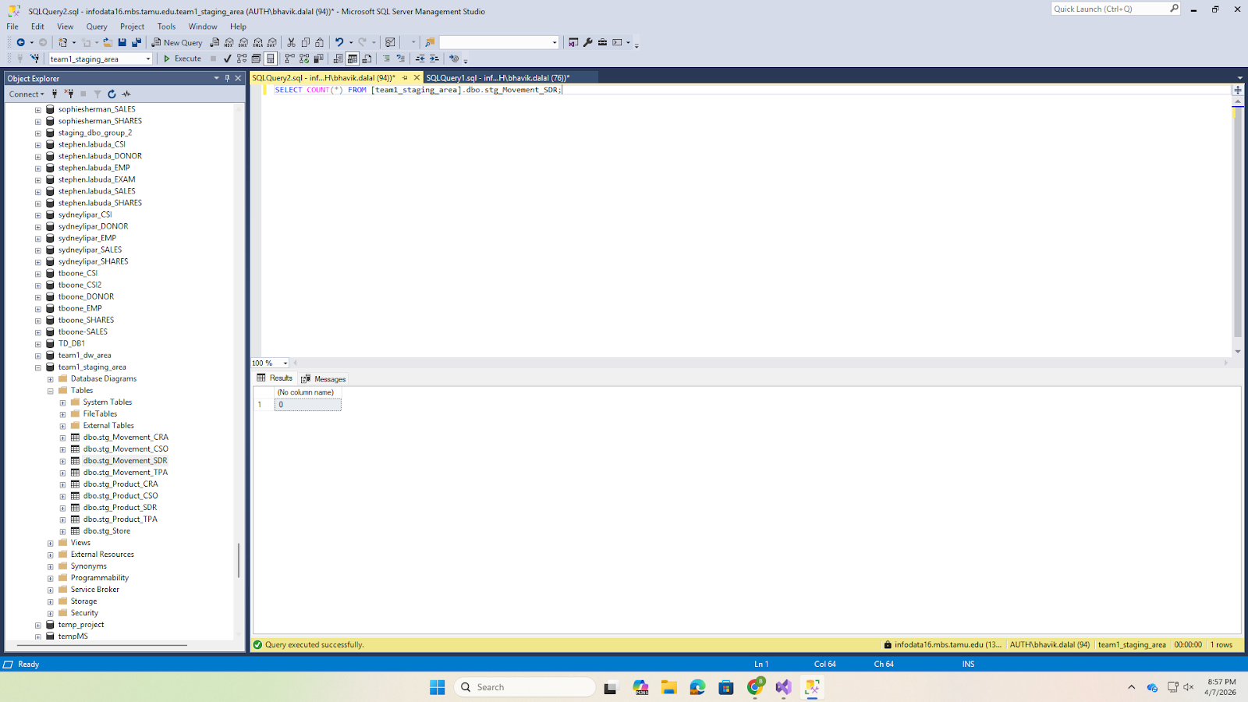

After Loading (staging tables populated):
This output confirms that the staging table has been successfully populated with extracted data.
SELECT TOP 5 *, CATEGORY_CODE FROM dbo.stg_Movement_SDR;
Screenshot 9: SSMS SELECT TOP 5 showing loaded data
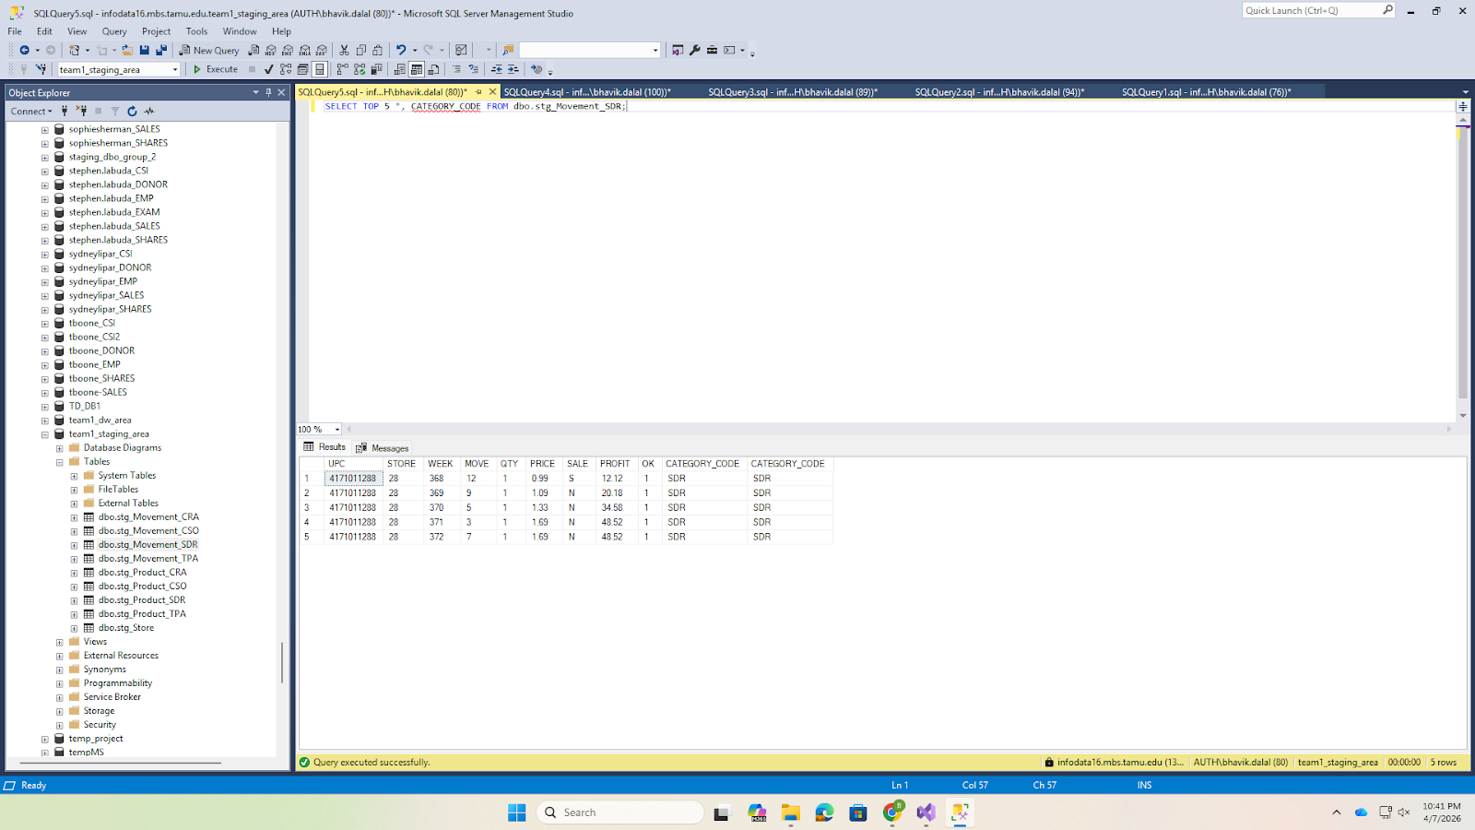

Row Counts After Extraction:
This query validates that all staging tables have been populated with the expected number of rows after extraction.
SELECT 'stg_Movement_SDR' AS TableName, COUNT(*) AS RowCount FROM stg_Movement_SDR
UNION ALL SELECT 'stg_Movement_CSO', COUNT(*) FROM stg_Movement_CSO
UNION ALL SELECT 'stg_Movement_TPA', COUNT(*) FROM stg_Movement_TPA
UNION ALL SELECT 'stg_Movement_CRA', COUNT(*) FROM stg_Movement_CRA
UNION ALL SELECT 'stg_Product_SDR', COUNT(*) FROM stg_Product_SDR
UNION ALL SELECT 'stg_Product_CSO', COUNT(*) FROM stg_Product_CSO
UNION ALL SELECT 'stg_Product_TPA', COUNT(*) FROM stg_Product_TPA
UNION ALL SELECT 'stg_Product_CRA', COUNT(*) FROM stg_Product_CRA
UNION ALL SELECT 'stg_Store', COUNT(*) FROM stg_Store
ORDER BY TableName;
Screenshot 10: SSMS row counts for all staging tables
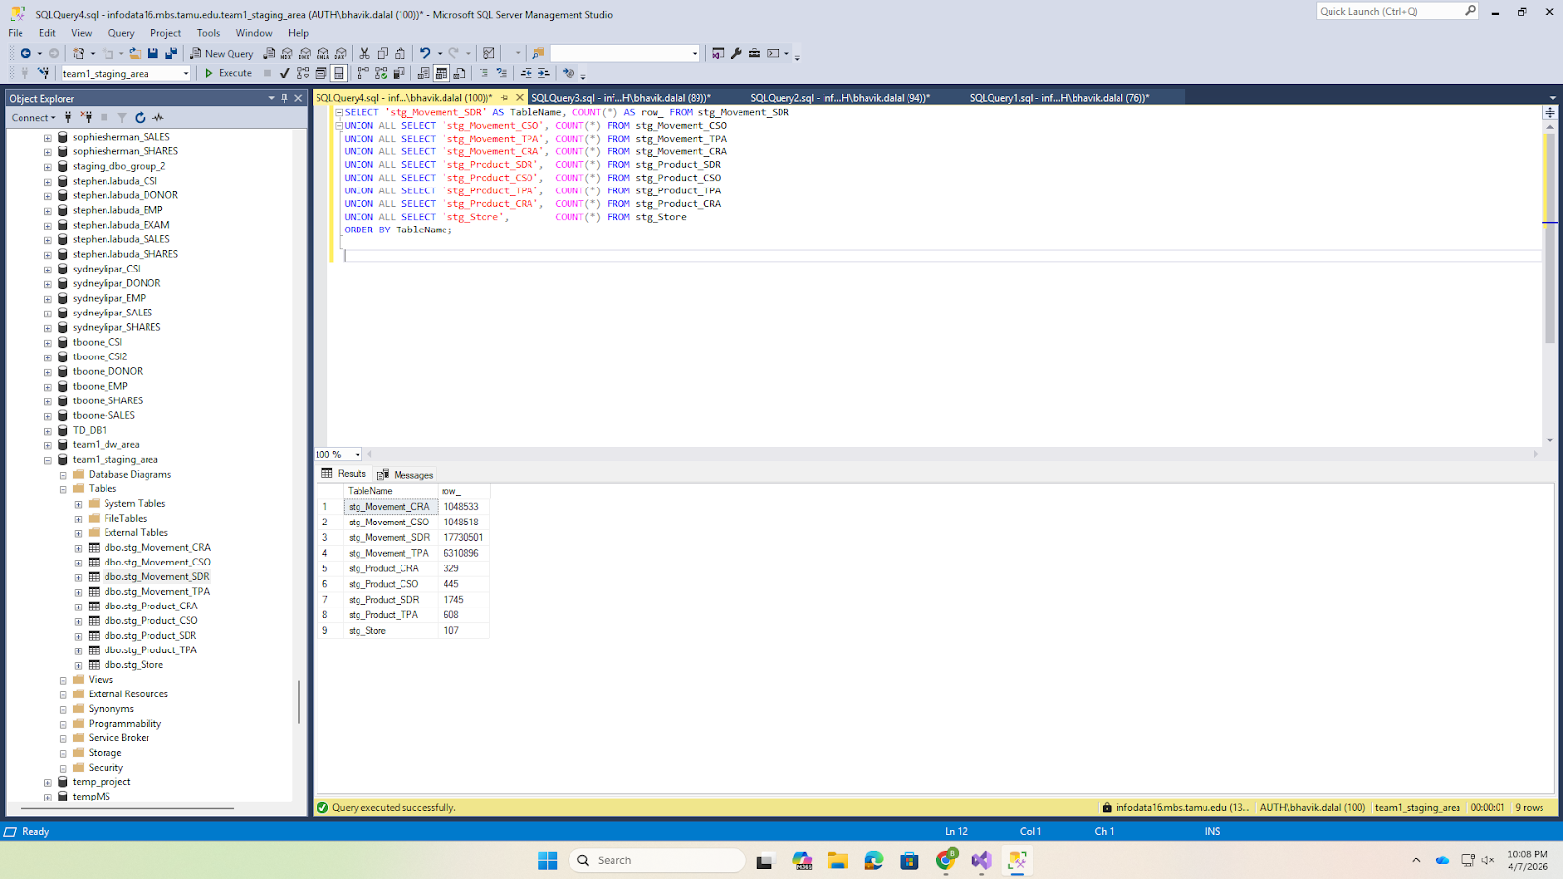

6.5 SSIS Package 2: Transform Staging
Control Flow: Package 2 contains Execute SQL Tasks for staging-area transformations (T1, T2, T5–T7).
Screenshot 11: SSIS Control Flow Package 2
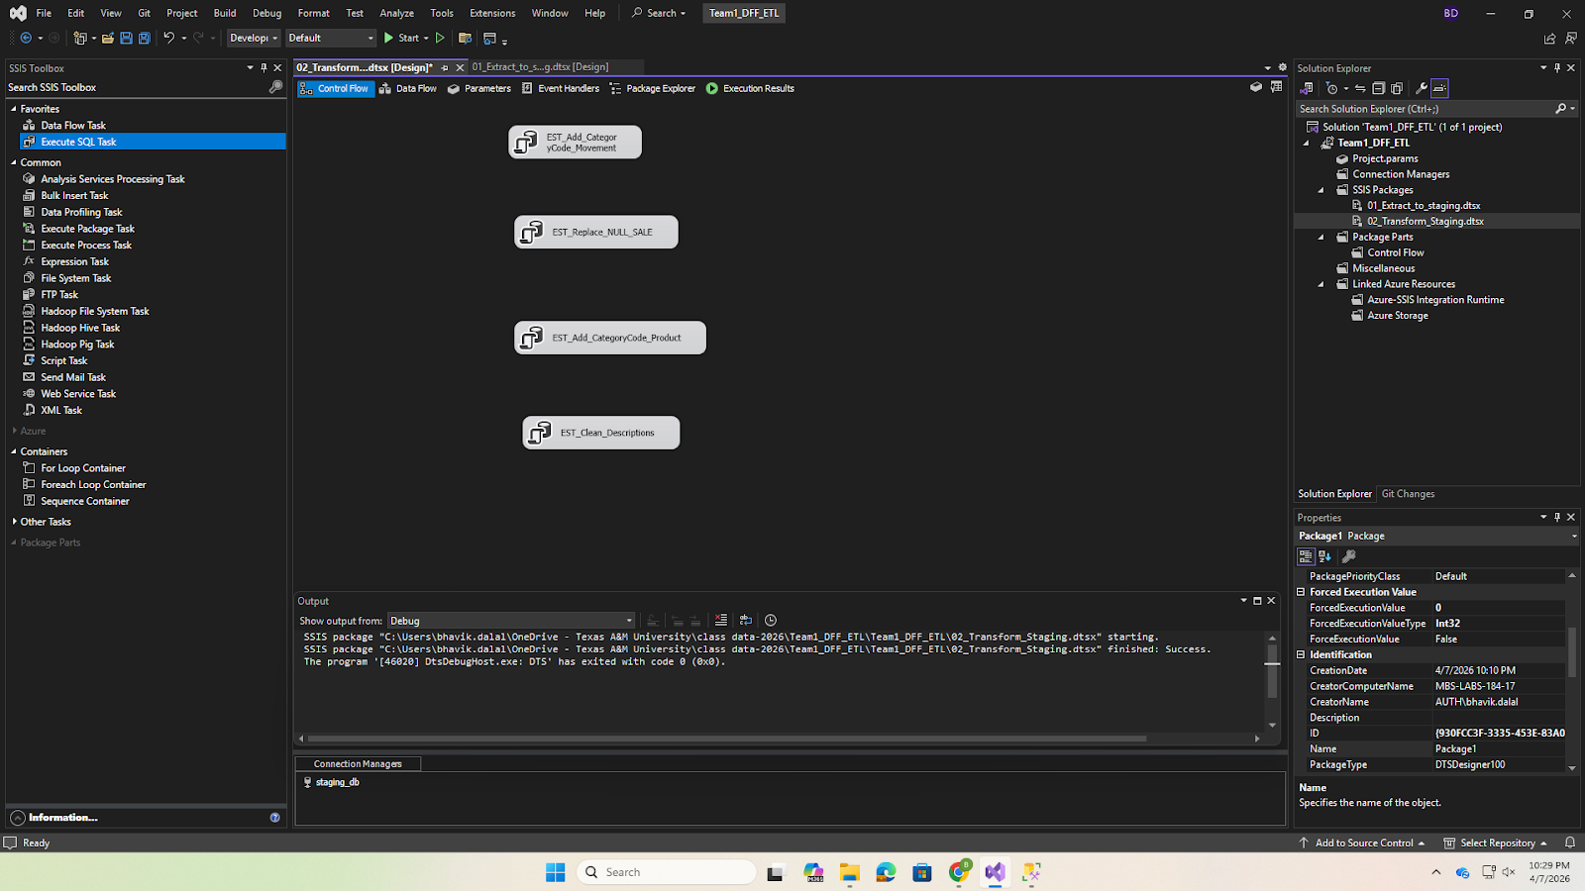

The SQL transformations executed in this package include:
T1 Add CATEGORY_CODE:
ALTER TABLE dbo.stg_Movement_SDR ADD CATEGORY_CODE CHAR(3);
UPDATE dbo.stg_Movement_SDR SET CATEGORY_CODE = 'SDR';
-- (repeated for CSO, TPA, CRA)
T2 Replace NULL SALE:
UPDATE dbo.stg_Movement_SDR SET SALE = 'N' WHERE SALE IS NULL OR LTRIM(RTRIM(SALE)) = '';
T5 Create tmp_Product_All:
SELECT COM_CODE, UPC, DESCRIP, SIZE, CASE_PACK, NITEM, CATEGORY_CODE
INTO dbo.tmp_Product_All
FROM (
SELECT * FROM stg_Product_SDR UNION ALL
SELECT * FROM stg_Product_CSO UNION ALL
SELECT * FROM stg_Product_TPA UNION ALL
SELECT * FROM stg_Product_CRA
) AS all_products;
Screenshot 12: SSIS Execute SQL Task showing transformation SQL
This package executes SQL-based transformations in the staging area, including data cleansing, handling missing values, and deriving new attributes according to the defined ETL rules.
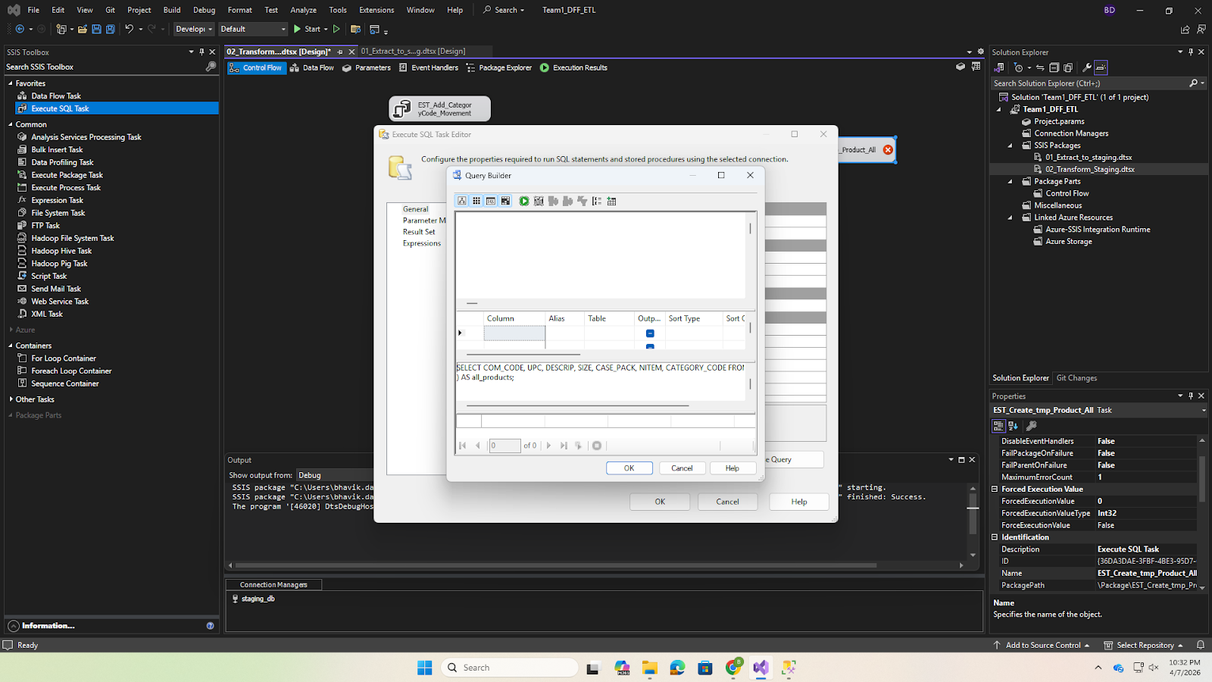

This confirms that all transformation steps were executed successfully.
Screenshot 13: SSIS Package 2 execution all green checkmarks
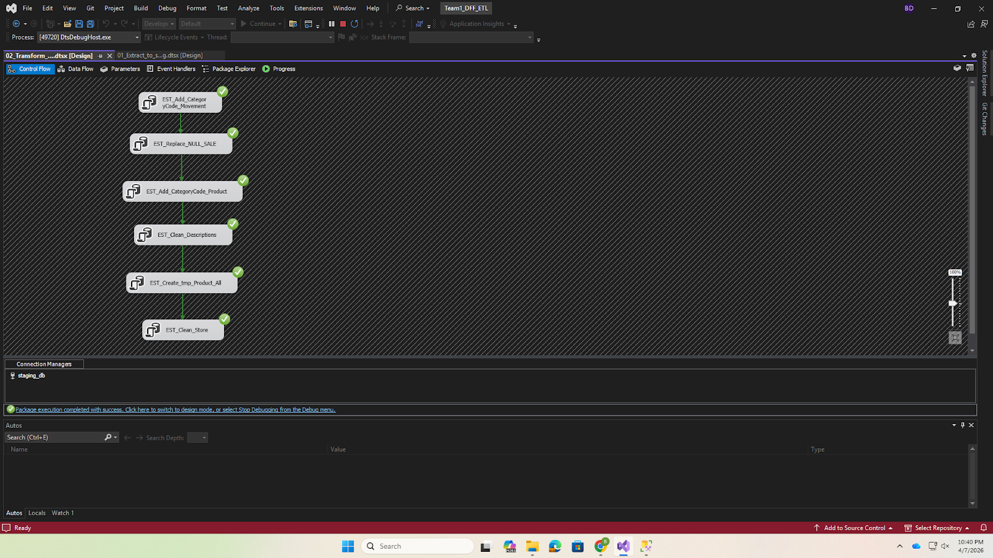

This verifies that the derived CATEGORY_CODE attribute has been correctly added to the staging tables.
Screenshot 14: SSMS showing CATEGORY_CODE column added to staging table


6.6 SSIS Package 3: Load Data Mart
Control Flow: Package 3 loads dimensions first, then the fact table, then drops temporary tables.
Screenshot 15: SSIS Control Flow Package 3
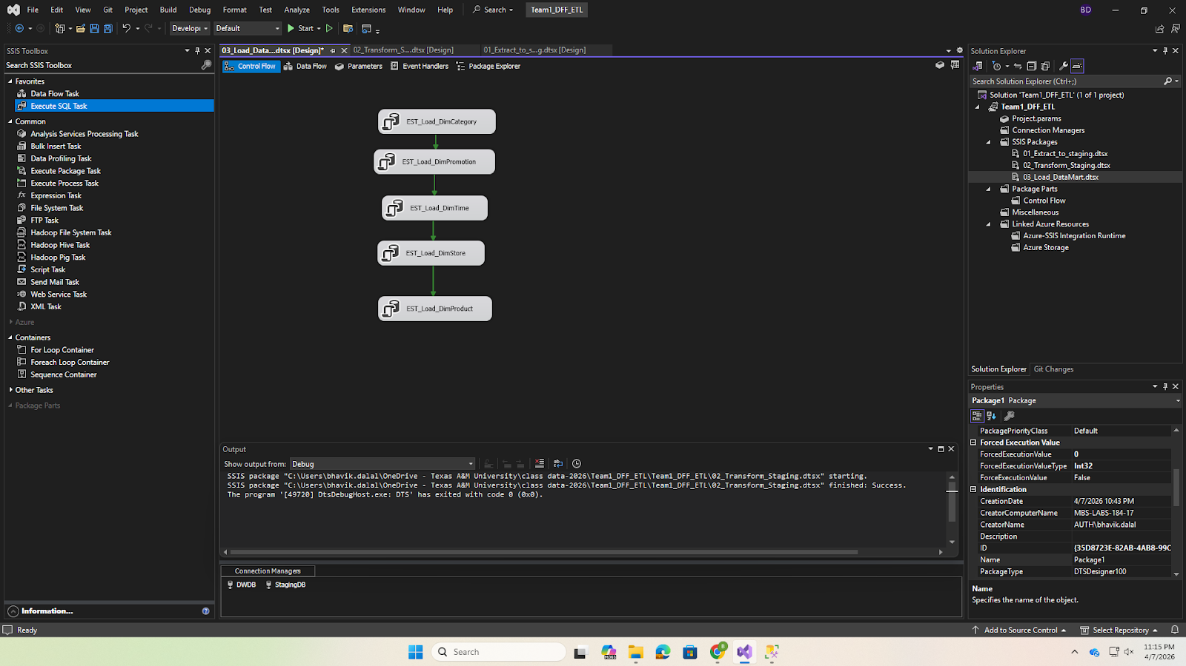

Sample Execute SQL Task (Dimension Loading):
Screenshot 16: SSIS Package 3 -- Execute SQL Task for dimension loading
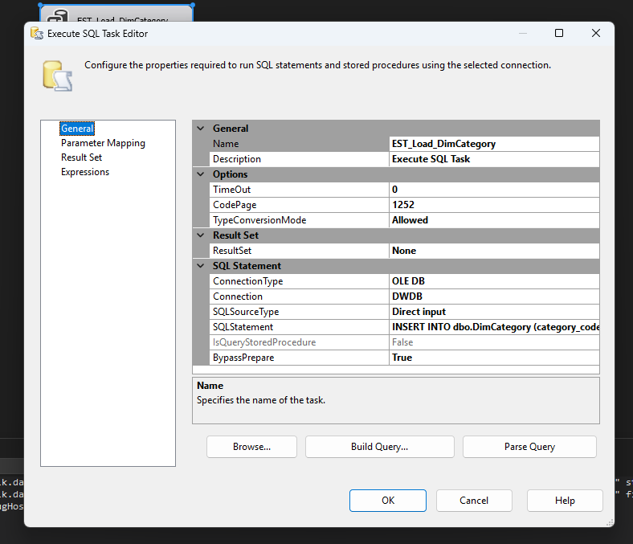
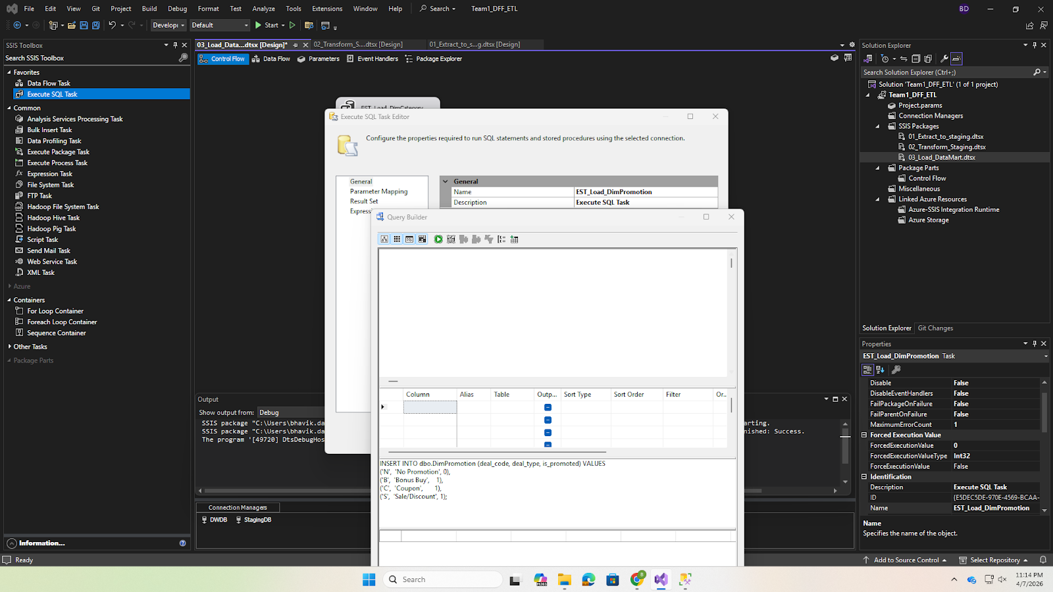

Execution Result:
This confirms that all loading tasks completed successfully without errors.
Screenshot 17: SSIS Package 3 execution all green checkmarks
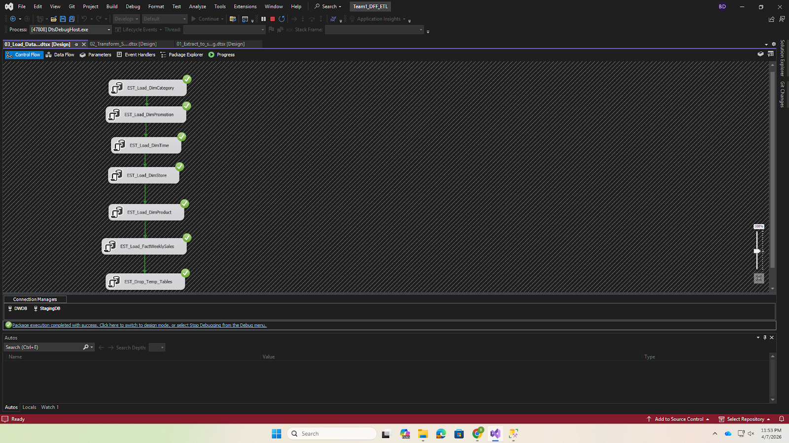

Dimension Loading Results
DimCategory (28 rows):
Screenshot 18: SSMS SELECT * FROM DimCategory showing 28 rows
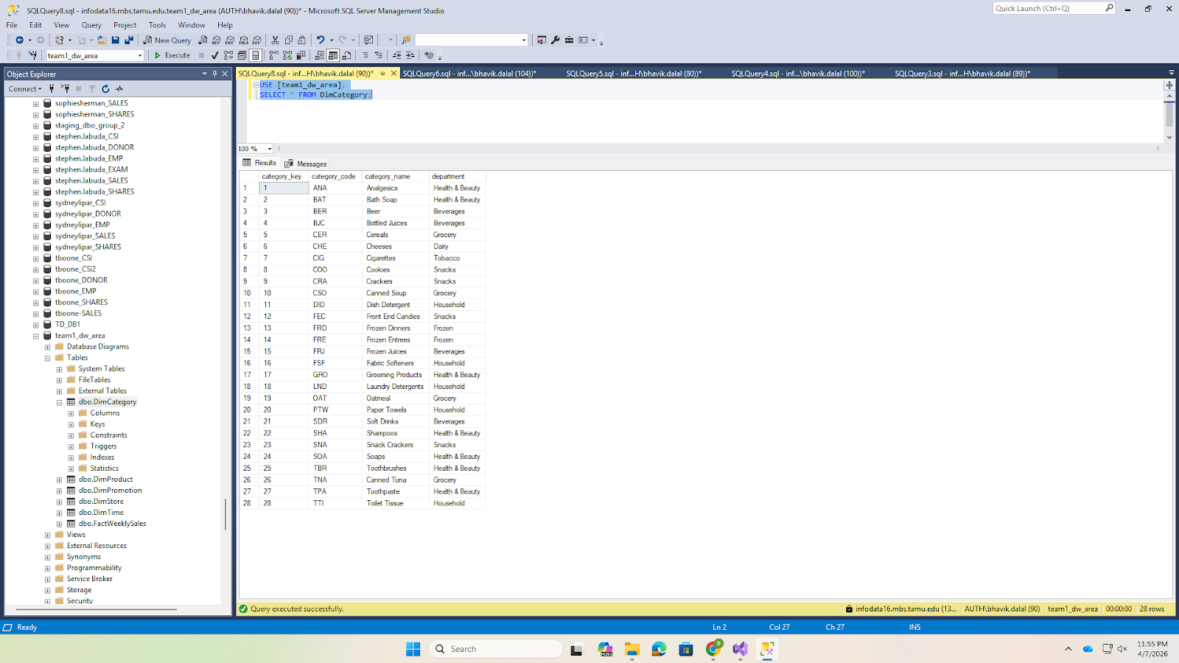

DimPromotion (4 rows):
Screenshot 19: SSMS SELECT * FROM DimPromotion showing 4 rows
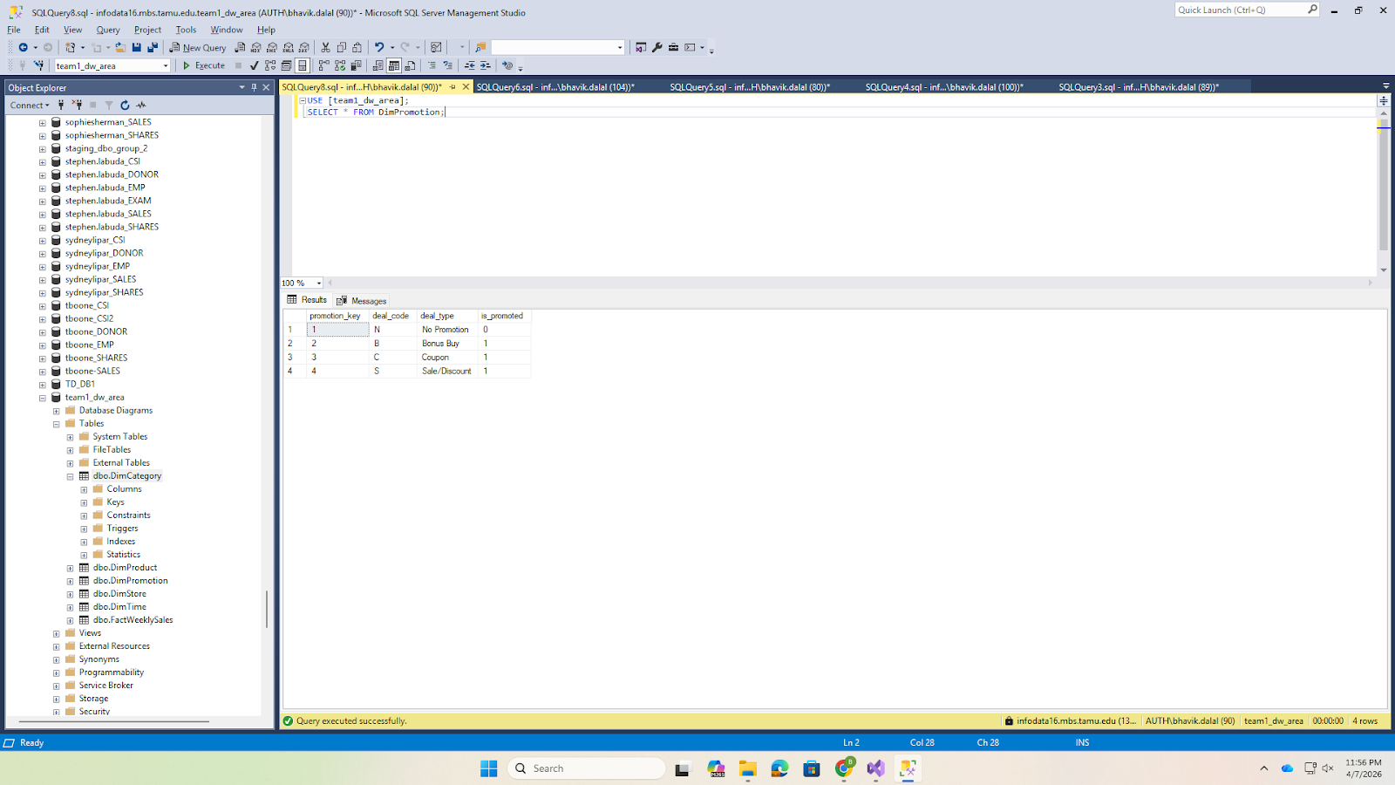

DimTime (~400 rows):
Screenshot 20: SSMS SELECT TOP 10 * FROM DimTime
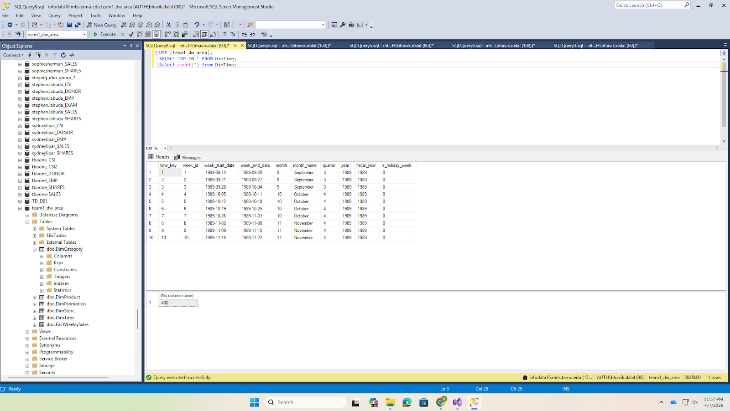

DimStore (~107 rows):
Screenshot 21: SSMS SELECT TOP 10 * FROM DimStore showing demographics
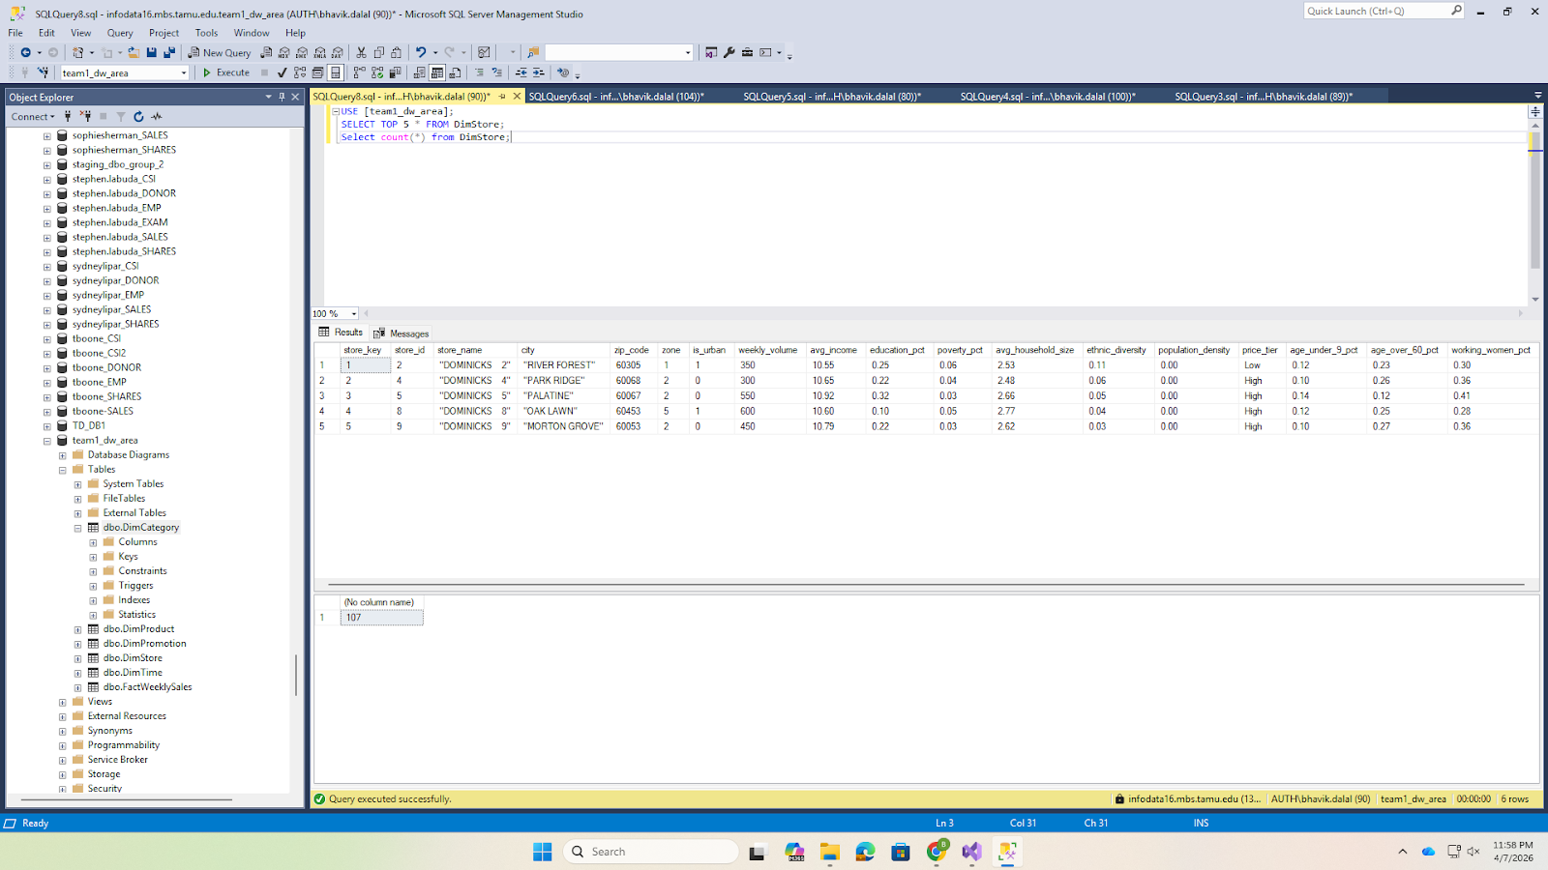

DimProduct (~3,112 rows):
Screenshot 22: SSMS SELECT TOP 10 * FROM DimProduct
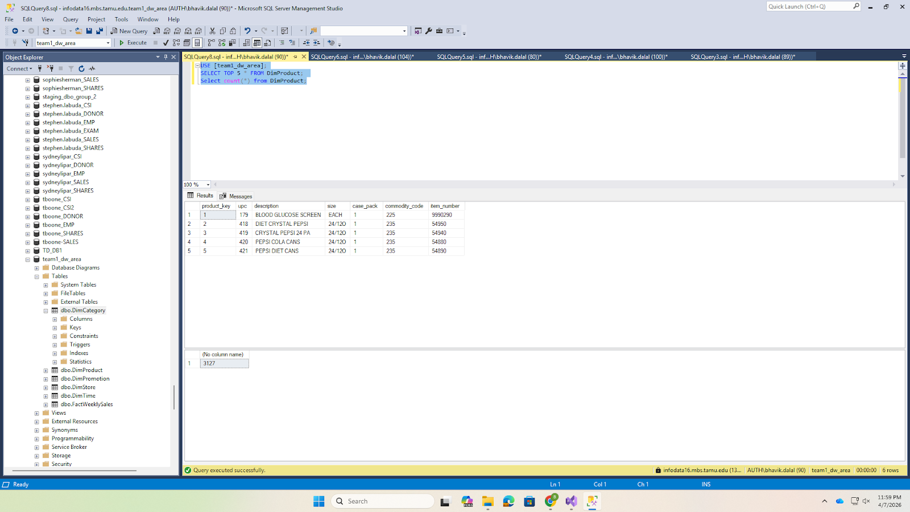

Fact Table Loading Results
FactWeeklySales (~34.6M rows):
The complete loading SQL JOINs all four movement staging tables to all five dimension tables:
INSERT INTO dbo.FactWeeklySales (product_key, store_key, time_key, category_key,
promotion_key, units_sold, unit_price, shelf_price, price_qty,
revenue, gross_profit, profit_margin_pct)
SELECT dp.product_key, ds.store_key, dt.time_key, dc.category_key, dpr.promotion_key,
sm.MOVE, CAST(sm.PRICE / sm.QTY AS DECIMAL(8,2)),
CAST(sm.PRICE AS DECIMAL(8,2)), sm.QTY,
CAST(sm.MOVE * (sm.PRICE / sm.QTY) AS DECIMAL(12,2)),
CAST(sm.PROFIT AS DECIMAL(10,2)),
CAST((sm.PROFIT / (sm.MOVE * (sm.PRICE / sm.QTY))) * 100 AS DECIMAL(5,2))
FROM (
SELECT UPC, STORE, WEEK, MOVE, QTY, PRICE, SALE, PROFIT, OK, CATEGORY_CODE
FROM [team1_staging_area].dbo.stg_Movement_SDR WHERE OK = 1 AND PRICE > 0
UNION ALL
SELECT UPC, STORE, WEEK, MOVE, QTY, PRICE, SALE, PROFIT, OK, CATEGORY_CODE
FROM [team1_staging_area].dbo.stg_Movement_CSO WHERE OK = 1 AND PRICE > 0
UNION ALL
SELECT UPC, STORE, WEEK, MOVE, QTY, PRICE, SALE, PROFIT, OK, CATEGORY_CODE
FROM [team1_staging_area].dbo.stg_Movement_TPA WHERE OK = 1 AND PRICE > 0
UNION ALL
SELECT UPC, STORE, WEEK, MOVE, QTY, PRICE, SALE, PROFIT, OK, CATEGORY_CODE
FROM [team1_staging_area].dbo.stg_Movement_CRA WHERE OK = 1 AND PRICE > 0
) sm
INNER JOIN dbo.DimProduct dp ON sm.UPC = dp.upc
INNER JOIN dbo.DimStore ds ON sm.STORE = ds.store_id
INNER JOIN dbo.DimTime dt ON sm.WEEK = dt.week_id
INNER JOIN dbo.DimCategory dc ON sm.CATEGORY_CODE = dc.category_code
INNER JOIN dbo.DimPromotion dpr ON sm.SALE = dpr.deal_code;
Screenshot 23: SSMS SELECT TOP 10 * FROM FactWeeklySales + COUNT
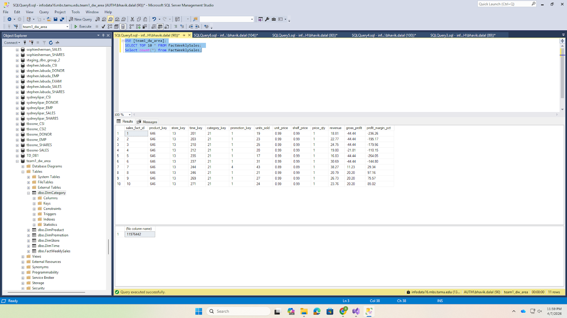

6.7 Temporary Table Cleanup
After all dimension and fact tables were loaded, temporary tables were dropped:
DROP TABLE [team1_staging_area].dbo.tmp_Product_All;
Screenshot 24: SSMS Object Explorer tmp_Product_All no longer visible
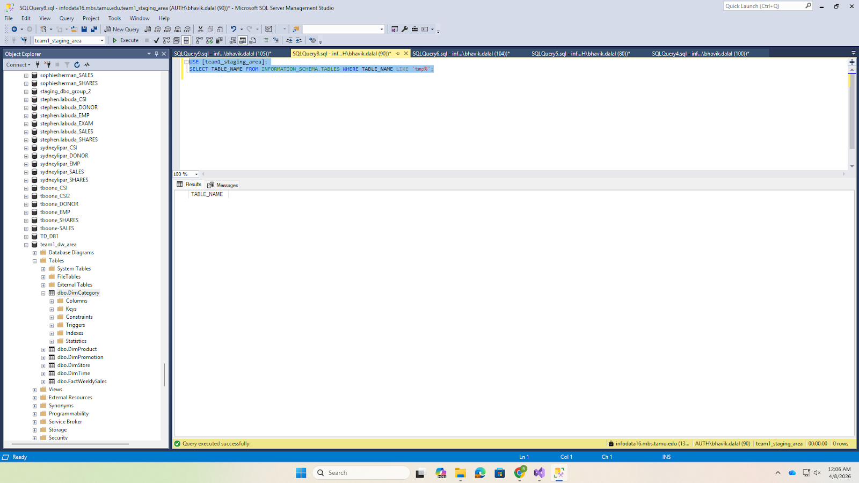

6.8 Granularity Discussion
The grain of the FactWeeklySales table is defined as: _"one row per unique combination of UPC, Store, and Week."_ This grain was chosen because:
- It matches the source data grain each row in the Movement CSV files represents one UPC at one store for one week.
- It supports all 5 selected BQs BQ2 aggregates by week (roll-up on UPC and store), BQ3/BQ4 slice by promotion type, BQ8 aggregates by store (roll-up on UPC and week), and BQ9 aggregates by UPC and week (roll-up on store).
- It preserves maximum analytical flexibility the atomic grain allows users to drill down to any combination of product, store, time, category, and promotion.
A coarser grain (e.g., Category × Store × Week) would make BQ9 impossible because individual product rankings require UPC-level data.

6.9 Business Question Verification
After completing the ETL, we verified the data mart can answer all 5 selected BQs:
BQ2 Weekly Soft Drink Sales:
SELECT dt.week_id, dt.week_start_date,
SUM(f.units_sold) AS total_units_sold
FROM FactWeeklySales f
JOIN DimTime dt ON f.time_key = dt.time_key
JOIN DimCategory dc ON f.category_key = dc.category_key
WHERE dc.category_code = 'SDR'
GROUP BY dt.week_id, dt.week_start_date
ORDER BY dt.week_id;
Screenshot 25: SSMS BQ2 query results
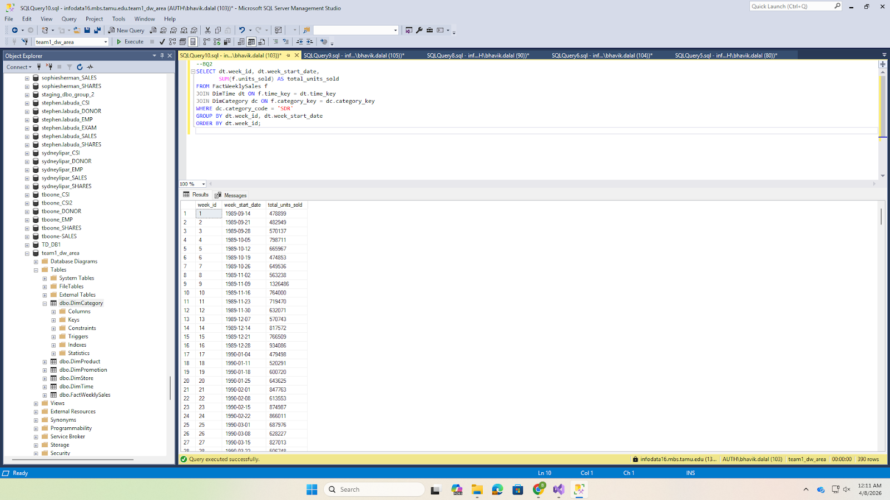

BQ3 Promotion vs Non-Promotion:
SELECT dp.deal_type, dp.is_promoted,
COUNT(*) AS num_records,
AVG(CAST(f.units_sold AS FLOAT)) AS avg_units
FROM FactWeeklySales f
JOIN DimPromotion dp ON f.promotion_key = dp.promotion_key
JOIN DimCategory dc ON f.category_key = dc.category_key
WHERE dc.category_code = 'SDR'
GROUP BY dp.deal_type, dp.is_promoted
ORDER BY avg_units DESC;
Screenshot 26: SSMS BQ3 query results
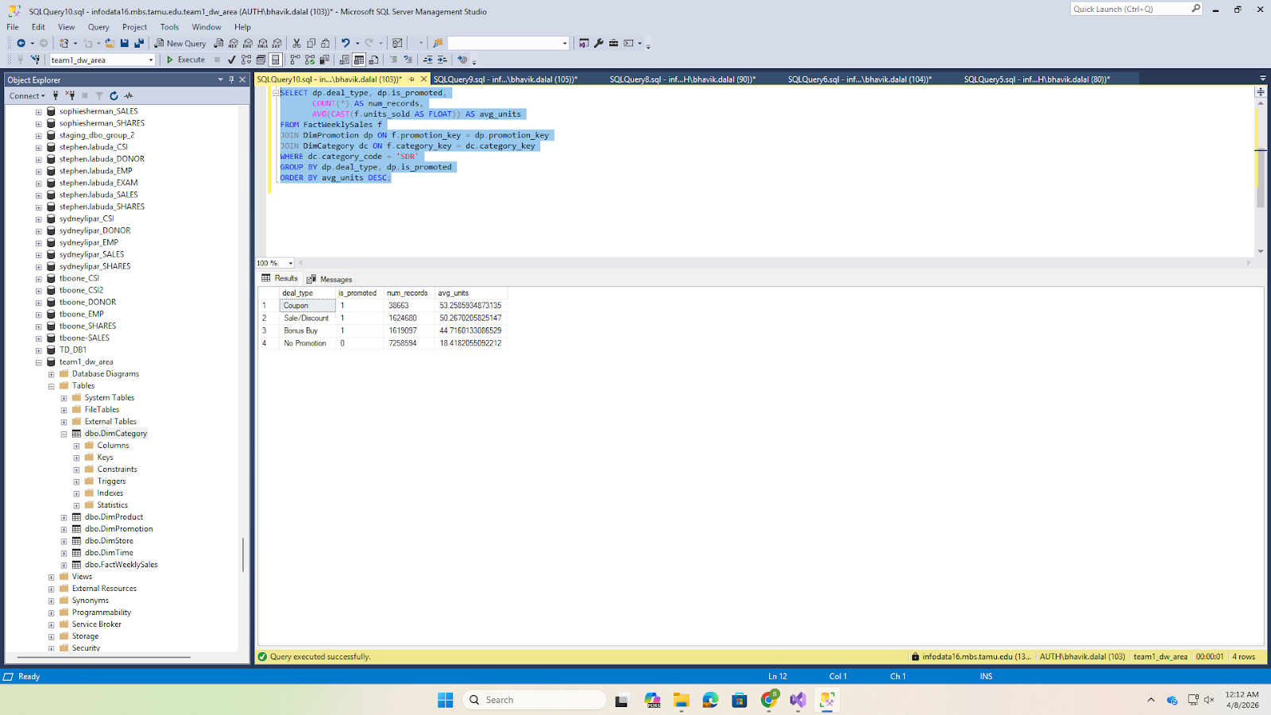

BQ4 Promotion Lift by Type (Canned Soup):
DECLARE @baseline FLOAT;
SELECT @baseline = AVG(CAST(f.units_sold AS FLOAT))
FROM FactWeeklySales f
JOIN DimPromotion dp ON f.promotion_key = dp.promotion_key
JOIN DimCategory dc ON f.category_key = dc.category_key
WHERE dc.category_code = 'CSO' AND dp.is_promoted = 0;
SELECT dp.deal_type,
AVG(CAST(f.units_sold AS FLOAT)) AS avg_promoted,
@baseline AS avg_baseline,
AVG(CAST(f.units_sold AS FLOAT)) - @baseline AS lift
FROM FactWeeklySales f
JOIN DimPromotion dp ON f.promotion_key = dp.promotion_key
JOIN DimCategory dc ON f.category_key = dc.category_key
WHERE dc.category_code = 'CSO' AND dp.is_promoted = 1
GROUP BY dp.deal_type
ORDER BY lift DESC;
Screenshot 27: SSMS BQ4 query results
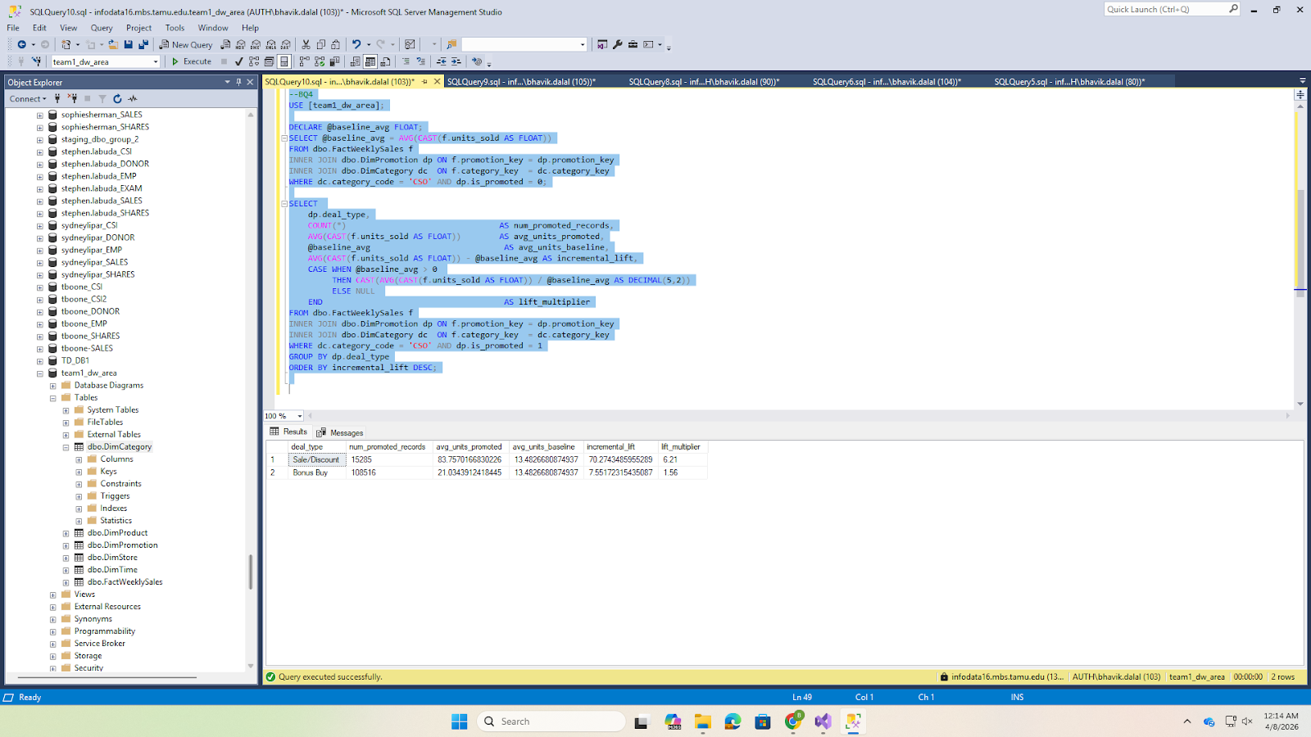

BQ8 Store Quartile Tiers (Toothpaste):
WITH store_rev AS (
SELECT f.store_key, SUM(f.revenue) AS total_rev
FROM FactWeeklySales f
JOIN DimCategory dc ON f.category_key = dc.category_key
WHERE dc.category_code = 'TPA'
GROUP BY f.store_key
),
quartiles AS (
SELECT store_key, total_rev,
NTILE(4) OVER (ORDER BY total_rev) AS q
FROM store_rev
)
SELECT CASE WHEN q=1 THEN 'Bottom 25%' WHEN q IN (2,3) THEN 'Middle 50%'
ELSE 'Top 25%' END AS tier,
COUNT(*) AS stores, AVG(total_rev) AS avg_rev,
AVG(ds.avg_income) AS avg_income, SUM(CAST(ds.is_urban AS INT)) AS urban_cnt
FROM quartiles qt
JOIN DimStore ds ON qt.store_key = ds.store_key
GROUP BY CASE WHEN q=1 THEN 'Bottom 25%' WHEN q IN (2,3) THEN 'Middle 50%'
ELSE 'Top 25%' END
ORDER BY avg_rev DESC;
Screenshot 28: SSMS BQ8 query results
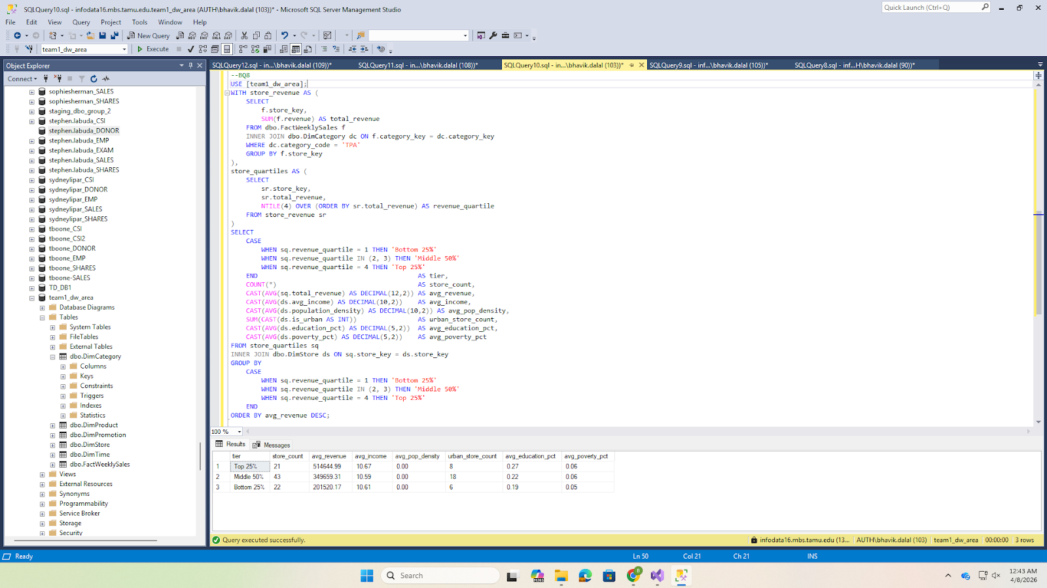

BQ9 Top 10 Weekly Cracker Products with WoW Change:
WITH weekly AS (
SELECT dp.upc, dp.description, dt.week_id,
SUM(f.units_sold) AS wk_units,
RANK() OVER (PARTITION BY dt.week_id ORDER BY SUM(f.units_sold) DESC) AS rnk
FROM FactWeeklySales f
JOIN DimProduct dp ON f.product_key = dp.product_key
JOIN DimTime dt ON f.time_key = dt.time_key
JOIN DimCategory dc ON f.category_key = dc.category_key
WHERE dc.category_code = 'CRA'
GROUP BY dp.upc, dp.description, dt.week_id
)
SELECT week_id, upc, description, wk_units, rnk,
LAG(wk_units) OVER (PARTITION BY upc ORDER BY week_id) AS prev_wk,
wk_units - LAG(wk_units) OVER (PARTITION BY upc ORDER BY week_id) AS wow
FROM weekly WHERE rnk <= 10
ORDER BY week_id, rnk;
Screenshot 29: SSMS BQ9 query results
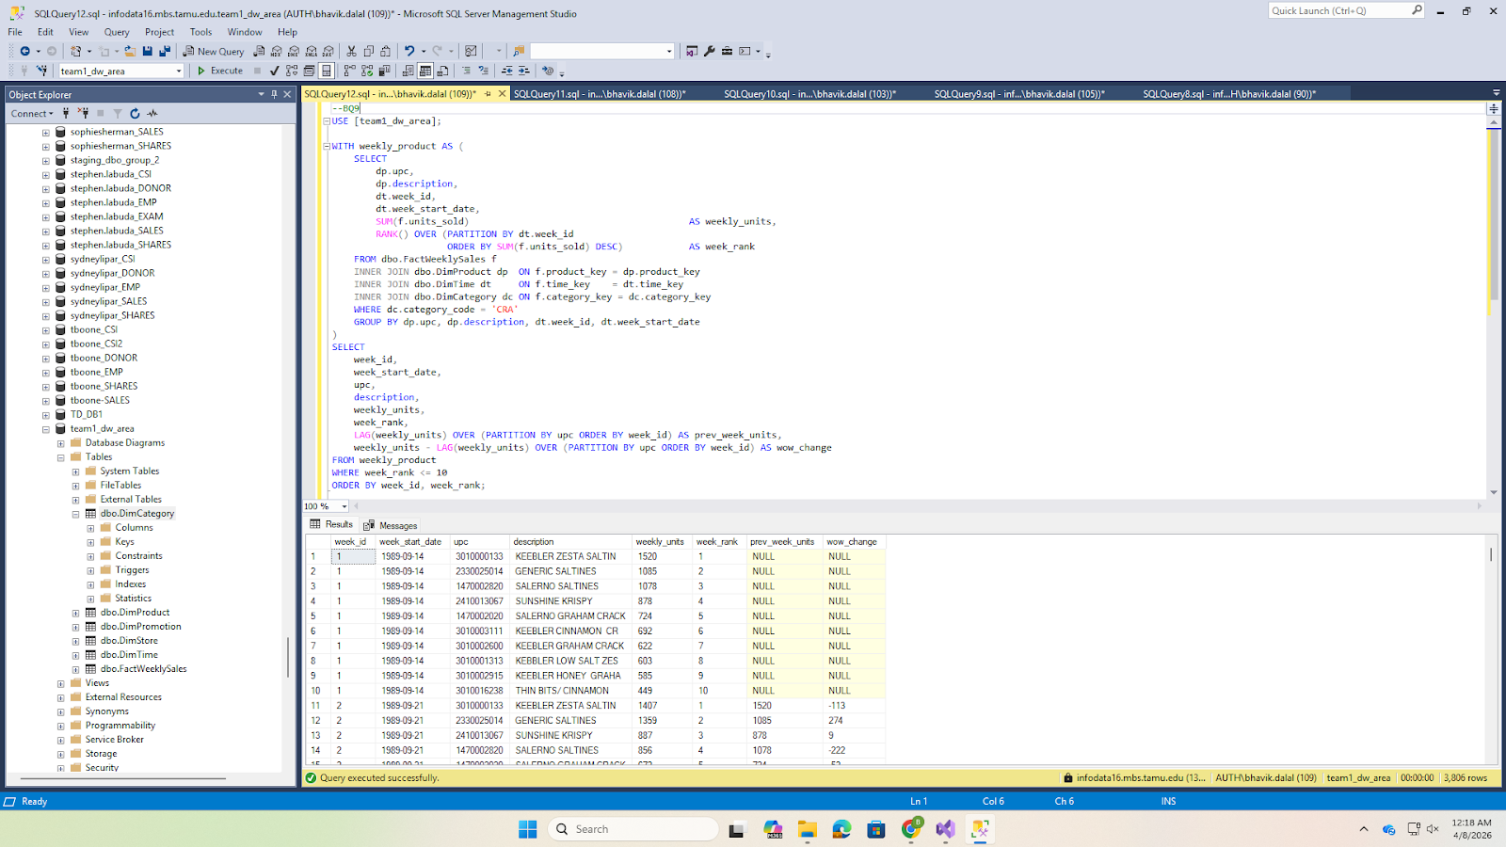

6.10 Final Data Mart Summary
Table | Rows
DimCategory | 28
DimPromotion | 4
DimTime | 400
DimStore | 107
DimProduct | 3127
FactWeeklySales | 14921365

Section 7: References
- Chevalier, J. A., Kashyap, A. K., & Rossi, P. E. (2003). Why Don't Prices Rise During Periods of Peak Demand? Evidence from Scanner Data. American Economic Review, 93(1), 15–37.
- Chintagunta, P. K. (2002). Investigating Category Pricing Behavior at a Retail Chain. Journal of Marketing Research, 39(2), 141–154.
- Hoch, S. J., Drèze, X., & Purk, M. E. (1994). EDLP, Hi-Lo, and Margin Arithmetic. Journal of Marketing, 58(4), 16–27.
- Hoch, S. J., Kim, B. D., Montgomery, A. L., & Rossi, P. E. (1995). Determinants of Store-Level Price Elasticity. Journal of Marketing Research, 32(1), 17–29.
- Kimball, R., & Ross, M. (2013). The Data Warehouse Toolkit: The Definitive Guide to Dimensional Modeling (3rd ed.). John Wiley & Sons.
- Kilts Center for Marketing (2013). Dominick's Data Manual. University of Chicago Booth School of Business. Retrieved from https://www.chicagobooth.edu/research/kilts/datasets/dominicks
- Mehta, S., & Ma, P. (2012). A High Dimensional Data Analysis Approach for Retail Data. Proceedings of the ACM SIGKDD.
- Montgomery, A. L. (1997). Creating Micro-Marketing Pricing Strategies Using Supermarket Scanner Data. Marketing Science, 16(4), 315–337.

Section 8: Appendix

Appendix A: Complete SQL Scripts
The complete SQL logic for the implementation is provided below.

01_create_databases.sql
-- ============================================================
-- Script 01: Create Databases
-- DFF Data Warehouse Project Report 3 (ISTM 637, Spring 2026)
-- Run this in SSMS connected to SQL Server 2016
-- ============================================================
-- Step 1: Create the Staging Area database
-- This database holds raw imported CSV data and temporary
-- transformation tables. It is purged after ETL is complete.
IF NOT EXISTS (SELECT name FROM sys.databases WHERE name = 'team1_staging_area')
BEGIN
CREATE DATABASE [team1_staging_area];
PRINT 'Database [team1_staging_area] created successfully.';
END
ELSE
PRINT 'Database [team1_staging_area] already exists.';
GO
-- Step 2: Create the Data Mart / Presentation Server database
-- This database holds the final star schema (dimension + fact tables)
-- that end users query for business intelligence.
IF NOT EXISTS (SELECT name FROM sys.databases WHERE name = 'team1_dw_area')
BEGIN
CREATE DATABASE [team1_dw_area];
PRINT 'Database [team1_dw_area] created successfully.';
END
ELSE
PRINT 'Database [team1_dw_area] already exists.';
GO
-- Verification: List both databases
SELECT name, create_date
FROM sys.databases
WHERE name IN ('team1_staging_area', 'team1_dw_area');
GO

02_create_staging_tables.sql
-- ============================================================
-- Script 02: Create Staging Tables
-- DFF Data Warehouse Project Report 3
-- Run in SSMS after Script 01. These tables receive raw CSV data.
-- ============================================================
USE [team1_staging_area];
GO
-- -------------------------------------------------------
-- Movement Staging Tables (one per category)
-- Source: Movement CSV files (comma-delimited, encoding 1252)
-- Columns match the raw CSV structure exactly
-- -------------------------------------------------------
-- Soft Drinks (SDR) 17.7 million rows from wsdr.csv
CREATE TABLE dbo.stg_Movement_SDR (
UPC BIGINT,
STORE INT,
WEEK INT,
MOVE INT,
QTY INT,
PRICE FLOAT,
SALE VARCHAR(5),
PROFIT FLOAT,
OK INT
);
GO
-- Canned Soup (CSO) 7.0 million rows from WCSO-Done.csv
CREATE TABLE dbo.stg_Movement_CSO (
UPC BIGINT,
STORE INT,
WEEK INT,
MOVE INT,
QTY INT,
PRICE FLOAT,
SALE VARCHAR(5),
PROFIT FLOAT,
OK INT
);
GO
-- Toothpaste (TPA) 6.3 million rows from WTPA_done.csv
CREATE TABLE dbo.stg_Movement_TPA (
UPC BIGINT,
STORE INT,
WEEK INT,
MOVE INT,
QTY INT,
PRICE FLOAT,
SALE VARCHAR(5),
PROFIT FLOAT,
OK INT
);
GO
-- Crackers (CRA) 3.6 million rows from Done-WCRA.csv
CREATE TABLE dbo.stg_Movement_CRA (
UPC BIGINT,
STORE INT,
WEEK INT,
MOVE INT,
QTY INT,
PRICE FLOAT,
SALE VARCHAR(5),
PROFIT FLOAT,
OK INT
);
GO
-- -------------------------------------------------------
-- Product (UPC) Staging Tables (one per category)
-- Source: UPC CSV files (encoding 1252 / latin-1)
-- -------------------------------------------------------
-- Soft Drinks UPC 1,746 rows from UPCSDR.csv
CREATE TABLE dbo.stg_Product_SDR (
COM_CODE INT,
UPC BIGINT,
DESCRIP VARCHAR(100),
SIZE VARCHAR(30),
CASE_PACK INT,
NITEM BIGINT
);
GO
-- Canned Soup UPC 453 rows from UPCCSO.csv
CREATE TABLE dbo.stg_Product_CSO (
COM_CODE INT,
UPC BIGINT,
DESCRIP VARCHAR(100),
SIZE VARCHAR(30),
CASE_PACK INT,
NITEM BIGINT
);
GO
-- Toothpaste UPC 608 rows from UPCTPA.csv
CREATE TABLE dbo.stg_Product_TPA (
COM_CODE INT,
UPC BIGINT,
DESCRIP VARCHAR(100),
SIZE VARCHAR(30),
CASE_PACK INT,
NITEM BIGINT
);
GO
-- Crackers UPC 305 rows from UPCCRA.csv
CREATE TABLE dbo.stg_Product_CRA (
COM_CODE INT,
UPC BIGINT,
DESCRIP VARCHAR(100),
SIZE VARCHAR(30),
CASE_PACK INT,
NITEM BIGINT
);
GO
-- -------------------------------------------------------
-- Store Demographics Staging Table
-- Source: Demographics/DEMO.csv (108 rows, 510 columns)
-- We only stage the columns needed for DimStore
-- -------------------------------------------------------
CREATE TABLE dbo.stg_Store (
STORE VARCHAR(10),
NAME VARCHAR(60),
CITY VARCHAR(50),
ZIP VARCHAR(10),
ZONE VARCHAR(10),
URBAN VARCHAR(10),
WEEKVOL VARCHAR(20),
INCOME VARCHAR(20),
EDUC VARCHAR(20),
POVERTY VARCHAR(20),
HSIZEAVG VARCHAR(20),
ETHNIC VARCHAR(20),
DENSITY VARCHAR(20),
AGE9 VARCHAR(20),
AGE60 VARCHAR(20),
WORKWOM VARCHAR(20),
PRICLOW VARCHAR(10),
PRICMED VARCHAR(10),
PRICHIGH VARCHAR(10)
);
GO
-- -------------------------------------------------------
-- Verification: List all staging tables
-- -------------------------------------------------------
SELECT TABLE_NAME, TABLE_TYPE
FROM INFORMATION_SCHEMA.TABLES
WHERE TABLE_SCHEMA = 'dbo'
ORDER BY TABLE_NAME;
GO
PRINT '=== All staging tables created successfully ===';
GO

03_create_dw_tables.sql
-- ============================================================
-- Script 03: Create Data Warehouse (Data Mart) Tables
-- DFF Data Warehouse Project Report 3
-- Run in SSMS after Script 02. Creates the star schema tables.
-- IMPORTANT: Create DIMENSION tables first, then FACT tables
-- (fact tables have FK references to dimensions).
-- ============================================================
USE [team1_dw_area];
GO
-- ===============================
-- DIMENSION TABLES
-- ===============================
-- -------------------------------------------------------
-- DimCategory 28 product categories
-- Grain: One row per product category
-- Cardinality: 28 rows (static, hardcoded)
-- -------------------------------------------------------
CREATE TABLE dbo.DimCategory (
category_key INT IDENTITY(1,1) NOT NULL,
category_code CHAR(3) NOT NULL,
category_name VARCHAR(30) NOT NULL,
department VARCHAR(20) NOT NULL,
CONSTRAINT PK_DimCategory PRIMARY KEY CLUSTERED (category_key),
CONSTRAINT UQ_DimCategory_code UNIQUE (category_code)
);
GO
-- -------------------------------------------------------
-- DimPromotion 4 promotion types
-- Grain: One row per deal type
-- Cardinality: 4 rows (static, hardcoded)
-- -------------------------------------------------------
CREATE TABLE dbo.DimPromotion (
promotion_key INT IDENTITY(1,1) NOT NULL,
deal_code CHAR(1) NOT NULL,
deal_type VARCHAR(20) NOT NULL,
is_promoted BIT NOT NULL,
CONSTRAINT PK_DimPromotion PRIMARY KEY CLUSTERED (promotion_key)
);
GO
-- -------------------------------------------------------
-- DimTime ~400 weeks (DFF proprietary week IDs)
-- Grain: One row per unique week
-- Week 1 = September 14, 1989 (per DFF codebook)
-- Cardinality: ~400 rows (generated via CTE)
-- -------------------------------------------------------
CREATE TABLE dbo.DimTime (
time_key INT IDENTITY(1,1) NOT NULL,
week_id INT NOT NULL,
week_start_date DATE NOT NULL,
week_end_date DATE NOT NULL,
[month] INT NOT NULL,
month_name VARCHAR(15) NOT NULL,
[quarter] INT NOT NULL,
[year] INT NOT NULL,
fiscal_year INT NOT NULL,
is_holiday_week BIT NOT NULL DEFAULT 0,
CONSTRAINT PK_DimTime PRIMARY KEY CLUSTERED (time_key),
CONSTRAINT UQ_DimTime_weekid UNIQUE (week_id)
);
GO
-- -------------------------------------------------------
-- DimStore ~107 stores
-- Grain: One row per physical store location
-- Source: Cleaned from DEMO.csv staging table
-- Cardinality: ~107 rows
-- -------------------------------------------------------
CREATE TABLE dbo.DimStore (
store_key INT IDENTITY(1,1) NOT NULL,
store_id INT NOT NULL,
store_name VARCHAR(50) NULL,
city VARCHAR(40) NULL,
zip_code VARCHAR(10) NULL,
zone INT NULL,
is_urban BIT NULL,
weekly_volume INT NULL,
avg_income DECIMAL(10,2) NULL,
education_pct DECIMAL(5,2) NULL,
poverty_pct DECIMAL(5,2) NULL,
avg_household_size DECIMAL(4,2) NULL,
ethnic_diversity DECIMAL(5,2) NULL,
population_density DECIMAL(10,2) NULL,
price_tier VARCHAR(10) NULL,
age_under_9_pct DECIMAL(5,2) NULL,
age_over_60_pct DECIMAL(5,2) NULL,
working_women_pct DECIMAL(5,2) NULL,
CONSTRAINT PK_DimStore PRIMARY KEY CLUSTERED (store_key),
CONSTRAINT UQ_DimStore_storeid UNIQUE (store_id)
);
GO
-- -------------------------------------------------------
-- DimProduct ~3,112 UPCs (for 4 selected categories)
-- Grain: One row per unique UPC
-- Source: Cleaned from UPC staging tables
-- Cardinality: SDR(1746) + CSO(453) + TPA(608) + CRA(305) = 3,112
-- -------------------------------------------------------
CREATE TABLE dbo.DimProduct (
product_key INT IDENTITY(1,1) NOT NULL,
upc BIGINT NOT NULL,
description VARCHAR(100) NULL,
size VARCHAR(30) NULL,
case_pack INT NULL,
commodity_code INT NULL,
item_number BIGINT NULL,
CONSTRAINT PK_DimProduct PRIMARY KEY CLUSTERED (product_key)
);
GO
-- ===============================
-- FACT TABLES
-- ===============================
-- -------------------------------------------------------
-- FactWeeklySales Central fact table
-- Grain: One row per UPC × Store × Week
-- Source: Movement staging tables (filtered OK=1, PRICE>0)
-- Estimated: ~34.6M rows for 4 categories
-- -------------------------------------------------------
CREATE TABLE dbo.FactWeeklySales (
sales_fact_id INT IDENTITY(1,1) NOT NULL,
product_key INT NOT NULL,
store_key INT NOT NULL,
time_key INT NOT NULL,
category_key INT NOT NULL,
promotion_key INT NOT NULL,
units_sold INT NULL,
unit_price DECIMAL(8,2) NULL,
shelf_price DECIMAL(8,2) NULL,
price_qty INT NULL,
revenue DECIMAL(12,2) NULL,
gross_profit DECIMAL(10,2) NULL,
profit_margin_pct DECIMAL(5,2) NULL,
CONSTRAINT PK_FactWeeklySales PRIMARY KEY CLUSTERED (sales_fact_id),
CONSTRAINT FK_Fact_Product FOREIGN KEY (product_key) REFERENCES dbo.DimProduct(product_key),
CONSTRAINT FK_Fact_Store FOREIGN KEY (store_key) REFERENCES dbo.DimStore(store_key),
CONSTRAINT FK_Fact_Time FOREIGN KEY (time_key) REFERENCES dbo.DimTime(time_key),
CONSTRAINT FK_Fact_Category FOREIGN KEY (category_key) REFERENCES dbo.DimCategory(category_key),
CONSTRAINT FK_Fact_Promotion FOREIGN KEY (promotion_key) REFERENCES dbo.DimPromotion(promotion_key)
);
GO
-- -------------------------------------------------------
-- Verification: List all DW tables
-- -------------------------------------------------------
SELECT TABLE_NAME, TABLE_TYPE
FROM INFORMATION_SCHEMA.TABLES
WHERE TABLE_SCHEMA = 'dbo'
ORDER BY TABLE_NAME;
GO
PRINT '=== All data warehouse tables created successfully ===';
GO

04_transform_staging.sql
-- ============================================================
-- Script 04: Transform and Clean Staging Data
-- DFF Data Warehouse Project Report 3
-- Run in SSMS AFTER Package 1 (Extract) has loaded CSV data
-- into staging tables. These transformations prepare the data
-- for loading into the data mart.
-- ============================================================
USE [team1_staging_area];
GO
-- ===============================
-- MOVEMENT TABLE TRANSFORMATIONS
-- ===============================
-- T1: Add CATEGORY_CODE column to each movement staging table
-- This column does not exist in the CSV files; it is derived
-- from the filename (e.g., wsdr.csv → 'SDR')
ALTER TABLE dbo.stg_Movement_SDR ADD CATEGORY_CODE CHAR(3);
GO
UPDATE dbo.stg_Movement_SDR SET CATEGORY_CODE = 'SDR';
GO
ALTER TABLE dbo.stg_Movement_CSO ADD CATEGORY_CODE CHAR(3);
GO
UPDATE dbo.stg_Movement_CSO SET CATEGORY_CODE = 'CSO';
GO
ALTER TABLE dbo.stg_Movement_TPA ADD CATEGORY_CODE CHAR(3);
GO
UPDATE dbo.stg_Movement_TPA SET CATEGORY_CODE = 'TPA';
GO
ALTER TABLE dbo.stg_Movement_CRA ADD CATEGORY_CODE CHAR(3);
GO
UPDATE dbo.stg_Movement_CRA SET CATEGORY_CODE = 'CRA';
GO
PRINT 'T1 Complete: CATEGORY_CODE added to all movement tables.';
GO
-- T2: Replace NULL/blank SALE with 'N' (No Promotion)
-- The SALE column is NULL for ~90% of rows; we normalize to 'N'
-- so that promotion lookup joins work correctly.
UPDATE dbo.stg_Movement_SDR SET SALE = 'N' WHERE SALE IS NULL OR LTRIM(RTRIM(SALE)) = '';
UPDATE dbo.stg_Movement_CSO SET SALE = 'N' WHERE SALE IS NULL OR LTRIM(RTRIM(SALE)) = '';
UPDATE dbo.stg_Movement_TPA SET SALE = 'N' WHERE SALE IS NULL OR LTRIM(RTRIM(SALE)) = '';
UPDATE dbo.stg_Movement_CRA SET SALE = 'N' WHERE SALE IS NULL OR LTRIM(RTRIM(SALE)) = '';
GO
PRINT 'T2 Complete: NULL SALE values replaced with N.';
GO
-- Verification: Check SALE distribution after cleaning
SELECT 'SDR' AS Category, SALE, COUNT(*) AS cnt FROM dbo.stg_Movement_SDR GROUP BY SALE
UNION ALL
SELECT 'CSO', SALE, COUNT(*) FROM dbo.stg_Movement_CSO GROUP BY SALE
UNION ALL
SELECT 'TPA', SALE, COUNT(*) FROM dbo.stg_Movement_TPA GROUP BY SALE
UNION ALL
SELECT 'CRA', SALE, COUNT(*) FROM dbo.stg_Movement_CRA GROUP BY SALE
ORDER BY 1, 2;
GO
-- ===============================
-- PRODUCT (UPC) TABLE TRANSFORMATIONS
-- ===============================
-- T3: Add CATEGORY_CODE column to each UPC staging table
ALTER TABLE dbo.stg_Product_SDR ADD CATEGORY_CODE CHAR(3);
GO
UPDATE dbo.stg_Product_SDR SET CATEGORY_CODE = 'SDR';
GO
ALTER TABLE dbo.stg_Product_CSO ADD CATEGORY_CODE CHAR(3);
GO
UPDATE dbo.stg_Product_CSO SET CATEGORY_CODE = 'CSO';
GO
ALTER TABLE dbo.stg_Product_TPA ADD CATEGORY_CODE CHAR(3);
GO
UPDATE dbo.stg_Product_TPA SET CATEGORY_CODE = 'TPA';
GO
ALTER TABLE dbo.stg_Product_CRA ADD CATEGORY_CODE CHAR(3);
GO
UPDATE dbo.stg_Product_CRA SET CATEGORY_CODE = 'CRA';
GO
PRINT 'T3 Complete: CATEGORY_CODE added to all product tables.';
GO
-- T4: Clean product descriptions strip leading # and ~ characters
UPDATE dbo.stg_Product_SDR SET DESCRIP = LTRIM(REPLACE(REPLACE(DESCRIP, '#', ''), '~', ''));
UPDATE dbo.stg_Product_CSO SET DESCRIP = LTRIM(REPLACE(REPLACE(DESCRIP, '#', ''), '~', ''));
UPDATE dbo.stg_Product_TPA SET DESCRIP = LTRIM(REPLACE(REPLACE(DESCRIP, '#', ''), '~', ''));
UPDATE dbo.stg_Product_CRA SET DESCRIP = LTRIM(REPLACE(REPLACE(DESCRIP, '#', ''), '~', ''));
GO
PRINT 'T4 Complete: Product descriptions cleaned.';
GO
-- T5: Create unified tmp_Product_All table (UNION of 4 category tables)
-- This temporary table is used to load DimProduct
IF OBJECT_ID('dbo.tmp_Product_All', 'U') IS NOT NULL
DROP TABLE dbo.tmp_Product_All;
GO
SELECT COM_CODE, UPC, DESCRIP, SIZE, CASE_PACK, NITEM, CATEGORY_CODE
INTO dbo.tmp_Product_All
FROM (
SELECT COM_CODE, UPC, DESCRIP, SIZE, CASE_PACK, NITEM, CATEGORY_CODE FROM dbo.stg_Product_SDR
UNION ALL
SELECT COM_CODE, UPC, DESCRIP, SIZE, CASE_PACK, NITEM, CATEGORY_CODE FROM dbo.stg_Product_CSO
UNION ALL
SELECT COM_CODE, UPC, DESCRIP, SIZE, CASE_PACK, NITEM, CATEGORY_CODE FROM dbo.stg_Product_TPA
UNION ALL
SELECT COM_CODE, UPC, DESCRIP, SIZE, CASE_PACK, NITEM, CATEGORY_CODE FROM dbo.stg_Product_CRA
) AS all_products;
GO
PRINT 'T5 Complete: tmp_Product_All created.';
SELECT 'tmp_Product_All' AS TableName, COUNT(*) AS RowCount FROM dbo.tmp_Product_All;
GO
-- ===============================
-- STORE (DEMOGRAPHICS) TRANSFORMATIONS
-- ===============================
-- T6: Remove the '.' placeholder row (first row of DEMO.csv)
-- The first row in DEMO.csv has STORE = '.' for all fields
DELETE FROM dbo.stg_Store WHERE STORE = '.' OR ISNUMERIC(STORE) = 0;
GO
-- T7: Replace NULL/blank NAME and CITY with 'UNKNOWN'
UPDATE dbo.stg_Store SET NAME = 'UNKNOWN' WHERE NAME IS NULL OR LTRIM(RTRIM(NAME)) = '';
UPDATE dbo.stg_Store SET CITY = 'UNKNOWN' WHERE CITY IS NULL OR LTRIM(RTRIM(CITY)) = '';
GO
PRINT 'T6-T7 Complete: Store data cleaned.';
SELECT COUNT(*) AS StoreCount FROM dbo.stg_Store;
GO
-- ===============================
-- FINAL VERIFICATION
-- ===============================
PRINT '========================================';
PRINT ' STAGING TRANSFORMATION COMPLETE';
PRINT '========================================';
SELECT 'stg_Movement_SDR' AS TableName, COUNT(*) AS RowCount FROM dbo.stg_Movement_SDR
UNION ALL SELECT 'stg_Movement_CSO', COUNT(*) FROM dbo.stg_Movement_CSO
UNION ALL SELECT 'stg_Movement_TPA', COUNT(*) FROM dbo.stg_Movement_TPA
UNION ALL SELECT 'stg_Movement_CRA', COUNT(*) FROM dbo.stg_Movement_CRA
UNION ALL SELECT 'stg_Product_SDR', COUNT(*) FROM dbo.stg_Product_SDR
UNION ALL SELECT 'stg_Product_CSO', COUNT(*) FROM dbo.stg_Product_CSO
UNION ALL SELECT 'stg_Product_TPA', COUNT(*) FROM dbo.stg_Product_TPA
UNION ALL SELECT 'stg_Product_CRA', COUNT(*) FROM dbo.stg_Product_CRA
UNION ALL SELECT 'stg_Store', COUNT(*) FROM dbo.stg_Store
UNION ALL SELECT 'tmp_Product_All', COUNT(*) FROM dbo.tmp_Product_All
ORDER BY TableName;
GO

05_load_dimensions.sql
-- ============================================================
-- Script 05: Load Dimension Tables
-- DFF Data Warehouse Project Report 3
-- Run AFTER Script 04 (Transform). Loads dimensions BEFORE facts.
-- Order: DimCategory → DimPromotion → DimTime → DimStore → DimProduct
-- ============================================================
USE [team1_dw_area];
GO
-- ===============================
-- 1. DimCategory (28 rows hardcoded)
-- ===============================
-- These are the 28 product categories from the DFF dataset.
-- Category codes are derived from the 3-letter filename abbreviations.
-- Department groupings are based on standard grocery store organization.
INSERT INTO dbo.DimCategory (category_code, category_name, department) VALUES
('ANA', 'Analgesics', 'Health & Beauty'),
('BAT', 'Bath Soap', 'Health & Beauty'),
('BER', 'Beer', 'Beverages'),
('BJC', 'Bottled Juices', 'Beverages'),
('CER', 'Cereals', 'Grocery'),
('CHE', 'Cheeses', 'Dairy'),
('CIG', 'Cigarettes', 'Tobacco'),
('COO', 'Cookies', 'Snacks'),
('CRA', 'Crackers', 'Snacks'),
('CSO', 'Canned Soup', 'Grocery'),
('DID', 'Dish Detergent', 'Household'),
('FEC', 'Front End Candies', 'Snacks'),
('FRD', 'Frozen Dinners', 'Frozen'),
('FRE', 'Frozen Entrees', 'Frozen'),
('FRJ', 'Frozen Juices', 'Beverages'),
('FSF', 'Fabric Softeners', 'Household'),
('GRO', 'Grooming Products', 'Health & Beauty'),
('LND', 'Laundry Detergents', 'Household'),
('OAT', 'Oatmeal', 'Grocery'),
('PTW', 'Paper Towels', 'Household'),
('SDR', 'Soft Drinks', 'Beverages'),
('SHA', 'Shampoos', 'Health & Beauty'),
('SNA', 'Snack Crackers', 'Snacks'),
('SOA', 'Soaps', 'Health & Beauty'),
('TBR', 'Toothbrushes', 'Health & Beauty'),
('TNA', 'Canned Tuna', 'Grocery'),
('TPA', 'Toothpaste', 'Health & Beauty'),
('TTI', 'Toilet Tissue', 'Household');
GO
PRINT '1/5 DimCategory loaded:';
SELECT COUNT(*) AS RowCount FROM dbo.DimCategory;
SELECT * FROM dbo.DimCategory ORDER BY category_key;
GO
-- ===============================
-- 2. DimPromotion (4 rows hardcoded)
-- ===============================
-- Maps the SALE column values from Movement files to descriptive labels.
-- NULL/blank/'N' → 'No Promotion', B → 'Bonus Buy', C → 'Coupon', S → 'Sale/Discount'
-- deal_code for 'No Promotion' is stored as 'N' (transformed from NULL/blank during staging).
INSERT INTO dbo.DimPromotion (deal_code, deal_type, is_promoted) VALUES
('N', 'No Promotion', 0),
('B', 'Bonus Buy', 1),
('C', 'Coupon', 1),
('S', 'Sale/Discount', 1);
GO
PRINT '2/5 DimPromotion loaded:';
SELECT * FROM dbo.DimPromotion;
GO
-- ===============================
-- 3. DimTime (~400 rows generated via CTE)
-- ===============================
-- DFF uses proprietary week IDs (WEEK column in Movement files).
-- Week 1 corresponds to September 14, 1989 per the DFF codebook.
-- Each subsequent week_id increments by 7 days.
-- We generate week_id 1 through 400 to cover the full dataset period.
;WITH WeekCTE AS (
SELECT 1 AS week_id
UNION ALL
SELECT week_id + 1 FROM WeekCTE WHERE week_id < 400
)
INSERT INTO dbo.DimTime
(week_id, week_start_date, week_end_date, [month], month_name,
[quarter], [year], fiscal_year, is_holiday_week)
SELECT
week_id,
DATEADD(WEEK, week_id - 1, '1989-09-14') AS week_start_date,
DATEADD(DAY, 6, DATEADD(WEEK, week_id - 1, '1989-09-14')) AS week_end_date,
MONTH(DATEADD(WEEK, week_id - 1, '1989-09-14')) AS [month],
DATENAME(MONTH, DATEADD(WEEK, week_id - 1, '1989-09-14')) AS month_name,
DATEPART(QUARTER, DATEADD(WEEK, week_id - 1, '1989-09-14')) AS [quarter],
YEAR(DATEADD(WEEK, week_id - 1, '1989-09-14')) AS [year],
YEAR(DATEADD(WEEK, week_id - 1, '1989-09-14')) AS fiscal_year,
-- Mark common US holiday weeks (Thanksgiving week ~47-48, Christmas ~52, July 4th ~27)
CASE
WHEN DATEPART(WEEK, DATEADD(WEEK, week_id - 1, '1989-09-14')) IN (47, 48, 52, 1, 27)
THEN 1 ELSE 0
END AS is_holiday_week
FROM WeekCTE
OPTION (MAXRECURSION 400);
GO
PRINT '3/5 DimTime loaded:';
SELECT COUNT(*) AS RowCount FROM dbo.DimTime;
SELECT TOP 10 * FROM dbo.DimTime ORDER BY time_key;
GO
-- ===============================
-- 4. DimStore (~107 rows from staging)
-- ===============================
-- Loaded from cleaned stg_Store in the staging database.
-- Transformations applied during INSERT:
-- - CAST string columns to proper data types
-- - Derive price_tier from binary flags (PRICLOW/PRICMED/PRICHIGH)
-- - Replace NULL NAME/CITY with 'UNKNOWN' (already done in Script 04)
INSERT INTO dbo.DimStore
(store_id, store_name, city, zip_code, zone, is_urban, weekly_volume,
avg_income, education_pct, poverty_pct, avg_household_size,
ethnic_diversity, population_density, price_tier,
age_under_9_pct, age_over_60_pct, working_women_pct)
SELECT
CAST(s.STORE AS INT) AS store_id,
s.NAME AS store_name,
s.CITY AS city,
s.ZIP AS zip_code,
CAST(s.ZONE AS INT) AS zone,
CAST(s.URBAN AS BIT) AS is_urban,
CAST(s.WEEKVOL AS INT) AS weekly_volume,
CAST(s.INCOME AS DECIMAL(10,2)) AS avg_income,
CAST(s.EDUC AS DECIMAL(5,2)) AS education_pct,
CAST(s.POVERTY AS DECIMAL(5,2)) AS poverty_pct,
CAST(s.HSIZEAVG AS DECIMAL(4,2)) AS avg_household_size,
CAST(s.ETHNIC AS DECIMAL(5,2)) AS ethnic_diversity,
CAST(s.DENSITY AS DECIMAL(10,2)) AS population_density,
CASE
WHEN s.PRICLOW = '1' THEN 'Low'
WHEN s.PRICMED = '1' THEN 'Medium'
WHEN s.PRICHIGH = '1' THEN 'High'
ELSE 'Unknown'
END AS price_tier,
CAST(s.AGE9 AS DECIMAL(5,2)) AS age_under_9_pct,
CAST(s.AGE60 AS DECIMAL(5,2)) AS age_over_60_pct,
CAST(s.WORKWOM AS DECIMAL(5,2)) AS working_women_pct
FROM [team1_staging_area].dbo.stg_Store s
WHERE ISNUMERIC(s.STORE) = 1;
GO
PRINT '4/5 DimStore loaded:';
SELECT COUNT(*) AS RowCount FROM dbo.DimStore;
SELECT TOP 10 * FROM dbo.DimStore ORDER BY store_key;
GO
-- ===============================
-- 5. DimProduct (~3,112 rows from staging)
-- ===============================
-- Loaded from tmp_Product_All in staging (UNION of 4 category tables).
INSERT INTO dbo.DimProduct
(upc, description, size, case_pack, commodity_code, item_number)
SELECT
p.UPC,
p.DESCRIP AS description,
p.SIZE AS size,
p.CASE_PACK AS case_pack,
p.COM_CODE AS commodity_code,
p.NITEM AS item_number
FROM [team1_staging_area].dbo.tmp_Product_All p;
GO
PRINT '5/5 DimProduct loaded:';
SELECT COUNT(*) AS RowCount FROM dbo.DimProduct;
SELECT TOP 10 * FROM dbo.DimProduct ORDER BY product_key;
GO
-- ===============================
-- DIMENSION LOAD VERIFICATION
-- ===============================
PRINT '========================================';
PRINT ' ALL DIMENSION TABLES LOADED';
PRINT '========================================';
SELECT 'DimCategory' AS TableName, COUNT(*) AS RowCount FROM dbo.DimCategory
UNION ALL SELECT 'DimPromotion', COUNT(*) FROM dbo.DimPromotion
UNION ALL SELECT 'DimTime', COUNT(*) FROM dbo.DimTime
UNION ALL SELECT 'DimStore', COUNT(*) FROM dbo.DimStore
UNION ALL SELECT 'DimProduct', COUNT(*) FROM dbo.DimProduct
ORDER BY TableName;
GO

06_load_facts.sql
-- ============================================================
-- Script 06: Load Fact Tables
-- DFF Data Warehouse Project Report 3
-- Run AFTER Script 05 (Load Dimensions).
-- Dimensions must be populated first because fact tables
-- reference dimension surrogate keys via foreign keys.
-- ============================================================
USE [team1_dw_area];
GO
-- ===============================
-- 1. FactWeeklySales
-- ===============================
-- Grain: One row per UPC × Store × Week
-- Sources: 4 movement staging tables (SDR, CSO, TPA, CRA)
-- Filters: OK = 1 (valid data), PRICE > 0 (avoid zero-price rows)
-- Derived columns:
-- unit_price = PRICE / QTY
-- revenue = MOVE × (PRICE / QTY)
-- profit_margin_pct = (PROFIT / revenue) × 100
PRINT 'Loading FactWeeklySales... (this may take several minutes for ~34M rows)';
GO
INSERT INTO dbo.FactWeeklySales
(product_key, store_key, time_key, category_key, promotion_key,
units_sold, unit_price, shelf_price, price_qty, revenue,
gross_profit, profit_margin_pct)
SELECT
dp.product_key,
ds.store_key,
dt.time_key,
dc.category_key,
dpr.promotion_key,
sm.MOVE AS units_sold,
CASE WHEN sm.QTY > 0
THEN CAST(sm.PRICE / sm.QTY AS DECIMAL(8,2))
ELSE NULL
END AS unit_price,
CAST(sm.PRICE AS DECIMAL(8,2)) AS shelf_price,
sm.QTY AS price_qty,
CASE WHEN sm.QTY > 0
THEN CAST(sm.MOVE * (sm.PRICE / sm.QTY) AS DECIMAL(12,2))
ELSE 0
END AS revenue,
CAST(sm.PROFIT AS DECIMAL(10,2)) AS gross_profit,
CASE WHEN sm.MOVE > 0 AND sm.QTY > 0 AND sm.PRICE > 0
THEN CAST(
(sm.PROFIT / (sm.MOVE * (sm.PRICE / sm.QTY))) * 100
AS DECIMAL(5,2))
ELSE NULL
END AS profit_margin_pct
FROM (
-- UNION ALL of the 4 category movement staging tables
SELECT UPC, STORE, WEEK, MOVE, QTY, PRICE, SALE, PROFIT, OK, CATEGORY_CODE
FROM [team1_staging_area].dbo.stg_Movement_SDR
WHERE OK = 1 AND PRICE > 0
UNION ALL
SELECT UPC, STORE, WEEK, MOVE, QTY, PRICE, SALE, PROFIT, OK, CATEGORY_CODE
FROM [team1_staging_area].dbo.stg_Movement_CSO
WHERE OK = 1 AND PRICE > 0
UNION ALL
SELECT UPC, STORE, WEEK, MOVE, QTY, PRICE, SALE, PROFIT, OK, CATEGORY_CODE
FROM [team1_staging_area].dbo.stg_Movement_TPA
WHERE OK = 1 AND PRICE > 0
UNION ALL
SELECT UPC, STORE, WEEK, MOVE, QTY, PRICE, SALE, PROFIT, OK, CATEGORY_CODE
FROM [team1_staging_area].dbo.stg_Movement_CRA
WHERE OK = 1 AND PRICE > 0
) sm
-- Join to dimension tables to get surrogate keys
INNER JOIN dbo.DimProduct dp
ON sm.UPC = dp.upc
INNER JOIN dbo.DimStore ds
ON sm.STORE = ds.store_id
INNER JOIN dbo.DimTime dt
ON sm.WEEK = dt.week_id
INNER JOIN dbo.DimCategory dc
ON sm.CATEGORY_CODE = dc.category_code
INNER JOIN dbo.DimPromotion dpr
ON sm.SALE = dpr.deal_code;
GO
PRINT 'FactWeeklySales loaded:';
SELECT COUNT(*) AS RowCount FROM dbo.FactWeeklySales;
SELECT TOP 10 * FROM dbo.FactWeeklySales ORDER BY sales_fact_id;
GO
-- Row count by category (verification)
SELECT dc.category_name, COUNT(*) AS FactRows
FROM dbo.FactWeeklySales f
JOIN dbo.DimCategory dc ON f.category_key = dc.category_key
GROUP BY dc.category_name
ORDER BY FactRows DESC;
GO
-- ===============================
-- FACT TABLE VERIFICATION
-- ===============================
PRINT '========================================';
PRINT ' FACT TABLE LOADED';
PRINT '========================================';
SELECT 'FactWeeklySales' AS TableName, COUNT(*) AS RowCount FROM dbo.FactWeeklySales;
GO
-- Quick data quality check: any NULL keys?
SELECT 'NULL product_key' AS Issue, COUNT(*) AS Cnt FROM dbo.FactWeeklySales WHERE product_key IS NULL
UNION ALL SELECT 'NULL store_key', COUNT(*) FROM dbo.FactWeeklySales WHERE store_key IS NULL
UNION ALL SELECT 'NULL time_key', COUNT(*) FROM dbo.FactWeeklySales WHERE time_key IS NULL
UNION ALL SELECT 'NULL category_key', COUNT(*) FROM dbo.FactWeeklySales WHERE category_key IS NULL
UNION ALL SELECT 'NULL promotion_key', COUNT(*) FROM dbo.FactWeeklySales WHERE promotion_key IS NULL;
GO

07_drop_temp_tables.sql
-- ============================================================
-- Script 07: Drop Temporary Tables from Staging Area
-- DFF Data Warehouse Project Report 3
-- Run AFTER all dimension and fact tables have been loaded.
-- The assignment requires: "Once loading of each table is done,
-- remove all temp tables from the staging area."
-- ============================================================
USE [team1_staging_area];
GO
-- ===============================
-- LIST OF TEMPORARY TABLES
-- ===============================
-- The following temporary tables were created in the staging area
-- during the transformation phase (Script 04) and are no longer
-- needed after the data mart has been populated:
--
-- 1. tmp_Product_All UNION of 4 UPC category staging tables
-- Used to load DimProduct
--
-- Note: The original staging tables (stg_Movement_*, stg_Product_*,
-- stg_Store) are also temporary but may be
-- retained for audit/verification purposes until the project is
-- fully validated.
PRINT 'Dropping temporary tables from staging area...';
GO
-- Drop tmp_Product_All
IF OBJECT_ID('dbo.tmp_Product_All', 'U') IS NOT NULL
BEGIN
DROP TABLE dbo.tmp_Product_All;
PRINT 'DROPPED: tmp_Product_All';
END
GO
-- ===============================
-- VERIFICATION
-- ===============================
-- Show remaining tables in staging area
SELECT TABLE_NAME
FROM INFORMATION_SCHEMA.TABLES
WHERE TABLE_SCHEMA = 'dbo' AND TABLE_TYPE = 'BASE TABLE'
ORDER BY TABLE_NAME;
GO
PRINT '========================================';
PRINT ' TEMPORARY TABLES REMOVED';
PRINT ' Remaining tables are base staging tables';
PRINT ' retained for audit/verification.';
PRINT '========================================';
GO

08_verify_bq_queries.sql
-- ============================================================
-- Script 08: Verify Business Questions Against Loaded DW
-- DFF Data Warehouse Project Report 3
-- Run AFTER all tables are loaded to validate the ETL.
-- Each query corresponds to one of the 5 selected BQs.
-- ============================================================
USE [team1_dw_area];
GO
-- ===============================
-- BQ2: Total weekly unit sales of Soft Drinks across all stores
-- Difficulty: Easy | OLAP Operation: Roll-up
-- ===============================
PRINT '=== BQ2: Weekly Soft Drink Unit Sales ===';
SELECT
dt.[year],
dt.[month],
dt.week_id,
dt.week_start_date,
SUM(f.units_sold) AS total_units_sold,
SUM(f.revenue) AS total_revenue,
COUNT(DISTINCT f.store_key) AS num_stores
FROM dbo.FactWeeklySales f
INNER JOIN dbo.DimTime dt ON f.time_key = dt.time_key
INNER JOIN dbo.DimCategory dc ON f.category_key = dc.category_key
WHERE dc.category_code = 'SDR'
GROUP BY dt.[year], dt.[month], dt.week_id, dt.week_start_date
ORDER BY dt.week_id;
GO
-- ===============================
-- BQ3: Promotion vs Non-Promotion weeks sales comparison
-- Difficulty: Easy | OLAP Operation: Dice (Slice by promotion status)
-- ===============================
PRINT '=== BQ3: Promoted vs Non-Promoted Sales Volume ===';
SELECT
dp.deal_type AS promotion_status,
dp.is_promoted,
COUNT(*) AS num_records,
SUM(f.units_sold) AS total_units_sold,
AVG(CAST(f.units_sold AS FLOAT)) AS avg_units_per_record,
SUM(f.revenue) AS total_revenue
FROM dbo.FactWeeklySales f
INNER JOIN dbo.DimPromotion dp ON f.promotion_key = dp.promotion_key
INNER JOIN dbo.DimCategory dc ON f.category_key = dc.category_key
WHERE dc.category_code = 'SDR'
GROUP BY dp.deal_type, dp.is_promoted
ORDER BY avg_units_per_record DESC;
GO
-- ===============================
-- BQ4: Which promotion type has highest incremental sales lift in Canned Soup?
-- Difficulty: Medium | OLAP Operation: Dice (filter by category + promo type)
-- ===============================
PRINT '=== BQ4: Promotion Lift by Deal Type Canned Soup ===';
-- First get the baseline (no promotion average)
DECLARE @baseline_avg FLOAT;
SELECT @baseline_avg = AVG(CAST(f.units_sold AS FLOAT))
FROM dbo.FactWeeklySales f
INNER JOIN dbo.DimPromotion dp ON f.promotion_key = dp.promotion_key
INNER JOIN dbo.DimCategory dc ON f.category_key = dc.category_key
WHERE dc.category_code = 'CSO' AND dp.is_promoted = 0;
SELECT
dp.deal_type,
COUNT(*) AS num_promoted_records,
AVG(CAST(f.units_sold AS FLOAT)) AS avg_units_promoted,
@baseline_avg AS avg_units_baseline,
AVG(CAST(f.units_sold AS FLOAT)) - @baseline_avg AS incremental_lift,
CASE WHEN @baseline_avg > 0
THEN CAST(AVG(CAST(f.units_sold AS FLOAT)) / @baseline_avg AS DECIMAL(5,2))
ELSE NULL
END AS lift_multiplier
FROM dbo.FactWeeklySales f
INNER JOIN dbo.DimPromotion dp ON f.promotion_key = dp.promotion_key
INNER JOIN dbo.DimCategory dc ON f.category_key = dc.category_key
WHERE dc.category_code = 'CSO' AND dp.is_promoted = 1
GROUP BY dp.deal_type
ORDER BY incremental_lift DESC;
GO
-- ===============================
-- BQ8: Store quartile tiers by Toothpaste revenue + demographics
-- Difficulty: Hard | OLAP Operation: NTILE + Drill-down
-- ===============================
PRINT '=== BQ8: Store Revenue Quartiles Toothpaste ===';
WITH store_revenue AS (
SELECT
f.store_key,
SUM(f.revenue) AS total_revenue
FROM dbo.FactWeeklySales f
INNER JOIN dbo.DimCategory dc ON f.category_key = dc.category_key
WHERE dc.category_code = 'TPA'
GROUP BY f.store_key
),
store_quartiles AS (
SELECT
sr.store_key,
sr.total_revenue,
NTILE(4) OVER (ORDER BY sr.total_revenue) AS revenue_quartile
FROM store_revenue sr
)
SELECT
CASE
WHEN sq.revenue_quartile = 1 THEN 'Bottom 25%'
WHEN sq.revenue_quartile IN (2, 3) THEN 'Middle 50%'
WHEN sq.revenue_quartile = 4 THEN 'Top 25%'
END AS tier,
COUNT(*) AS store_count,
CAST(AVG(sq.total_revenue) AS DECIMAL(12,2)) AS avg_revenue,
CAST(AVG(ds.avg_income) AS DECIMAL(10,2)) AS avg_income,
CAST(AVG(ds.population_density) AS DECIMAL(10,2)) AS avg_pop_density,
SUM(ds.is_urban) AS urban_store_count,
CAST(AVG(ds.education_pct) AS DECIMAL(5,2)) AS avg_education_pct,
CAST(AVG(ds.poverty_pct) AS DECIMAL(5,2)) AS avg_poverty_pct
FROM store_quartiles sq
INNER JOIN dbo.DimStore ds ON sq.store_key = ds.store_key
GROUP BY
CASE
WHEN sq.revenue_quartile = 1 THEN 'Bottom 25%'
WHEN sq.revenue_quartile IN (2, 3) THEN 'Middle 50%'
WHEN sq.revenue_quartile = 4 THEN 'Top 25%'
END
ORDER BY avg_revenue DESC;
GO
-- ===============================
-- BQ9: Weekly top 10 Cracker products by unit sales with WoW change
-- Difficulty: Hard | OLAP Operation: RANK + LAG
-- ===============================
PRINT '=== BQ9: Weekly Top 10 Cracker Products with WoW Change ===';
WITH weekly_product AS (
SELECT
dp.upc,
dp.description,
dt.week_id,
dt.week_start_date,
SUM(f.units_sold) AS weekly_units,
RANK() OVER (PARTITION BY dt.week_id
ORDER BY SUM(f.units_sold) DESC) AS week_rank
FROM dbo.FactWeeklySales f
INNER JOIN dbo.DimProduct dp ON f.product_key = dp.product_key
INNER JOIN dbo.DimTime dt ON f.time_key = dt.time_key
INNER JOIN dbo.DimCategory dc ON f.category_key = dc.category_key
WHERE dc.category_code = 'CRA'
GROUP BY dp.upc, dp.description, dt.week_id, dt.week_start_date
)
SELECT
week_id,
week_start_date,
upc,
description,
weekly_units,
week_rank,
LAG(weekly_units) OVER (PARTITION BY upc ORDER BY week_id) AS prev_week_units,
weekly_units - LAG(weekly_units) OVER (PARTITION BY upc ORDER BY week_id) AS wow_change
FROM weekly_product
WHERE week_rank <= 10
ORDER BY week_id, week_rank;
GO
-- ===============================
-- OVERALL VALIDATION SUMMARY
-- ===============================
PRINT '========================================';
PRINT ' BUSINESS QUESTION VERIFICATION COMPLETE';
PRINT '========================================';
-- Final row count summary
SELECT 'DimCategory' AS TableName, COUNT(*) AS RowCount FROM dbo.DimCategory
UNION ALL SELECT 'DimPromotion', COUNT(*) FROM dbo.DimPromotion
UNION ALL SELECT 'DimTime', COUNT(*) FROM dbo.DimTime
UNION ALL SELECT 'DimStore', COUNT(*) FROM dbo.DimStore
UNION ALL SELECT 'DimProduct', COUNT(*) FROM dbo.DimProduct
UNION ALL SELECT 'FactWeeklySales', COUNT(*) FROM dbo.FactWeeklySales
ORDER BY TableName;
GO

Appendix B: Mapping Tables (Excel)
Attached with the submission in canvas

Appendix C: SSIS Screenshot Index
# | Description
1 | SSMS Object Explorer both databases visible
2 | SSMS staging tables list
3 | SSMS DW tables list
4 | SSIS Package 1 Control Flow 9 Data Flow Tasks
5 | SSIS Package 1 sample Data Flow (Flat File Source → OLE DB Dest)
6 | Flat File Connection Manager encoding/delimiter settings
7 | SSIS Package 1 execution all green checkmarks
8 | SSMS stg_Movement_SDR COUNT = 0 (before load)
9 | SSMS stg_Movement_SDR TOP 10 (after load)
10 | SSMS all staging table row counts
11 | SSIS Package 2 Control Flow Execute SQL Tasks
12 | SSIS transformation SQL visible in task
13 | SSIS Package 2 execution all green
14 | SSMS CATEGORY_CODE column visible in staging
15 | SSIS Package 3 Control Flow
16 | SSIS Package 3 -- Execute SQL Task for dimension loading
17 | SSIS Package 3 execution all green
18 | SSMS DimCategory (28 rows)
19 | SSMS DimPromotion (4 rows)
20 | SSMS DimTime TOP 10
21 | SSMS DimStore TOP 10
22 | SSMS DimProduct TOP 10
23 | SSMS FactWeeklySales TOP 10 + COUNT
24 | SSMS Object Explorer temp tables removed
25 | SSMS BQ2 verification query results
26 | SSMS BQ3 verification query results
27 | SSMS BQ4 verification query results
28 | SSMS BQ8 verification query results
29 | SSMS BQ9 verification query results

